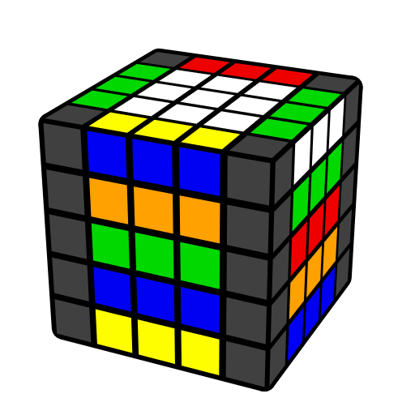
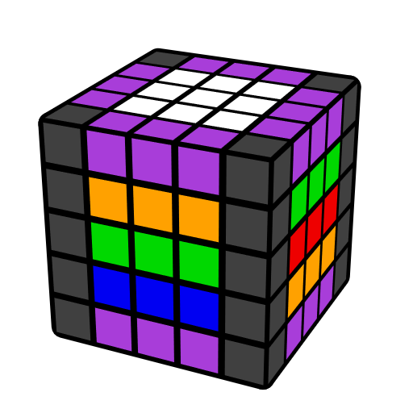
五阶F8E公式（前八棱）

本表包含五阶自由中层法对棱典型情况。紫棱表自由棱。
[Flip 1] = U' R' U R' F R F'; [Flip 2] = (R U R' F) (R' F' R).

二棱块
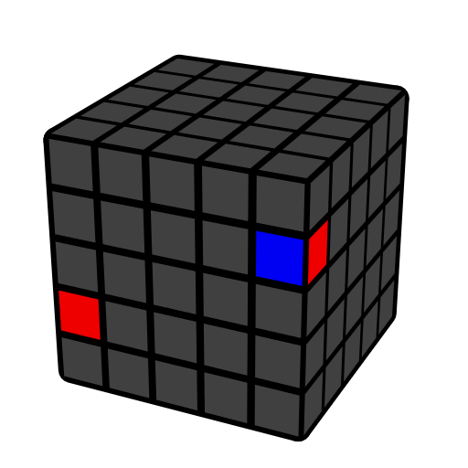 | 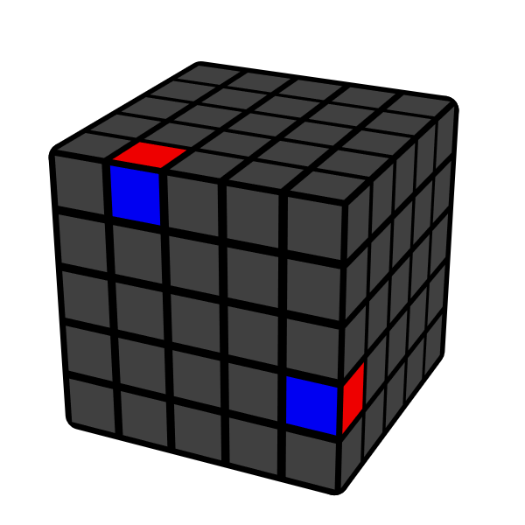 | 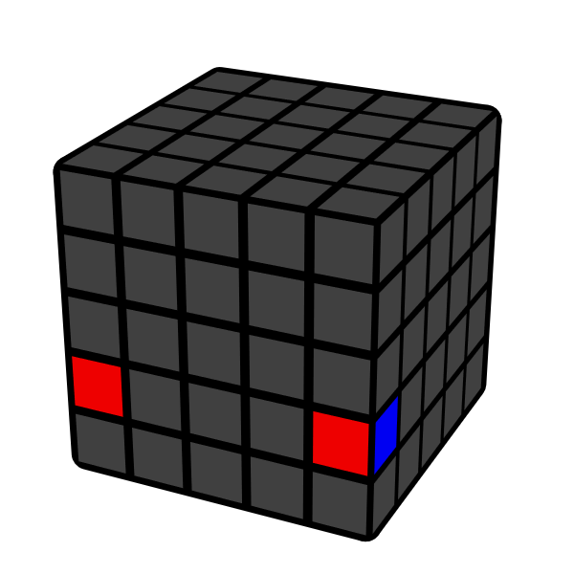 | 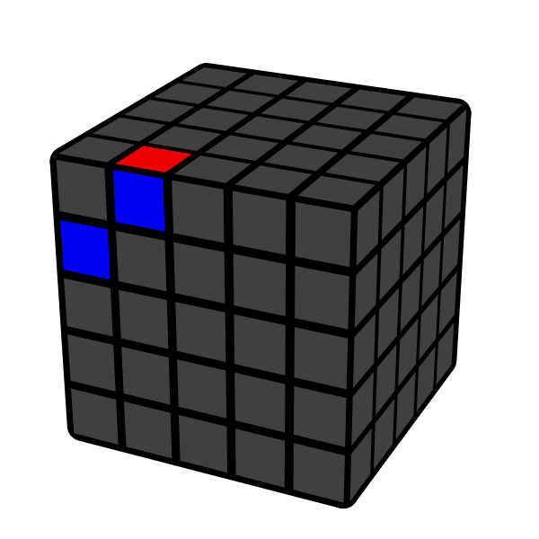
u | R' U' R u  U2 R' U R u  L' U L u' | [Flip 2] u | R U' R' u'
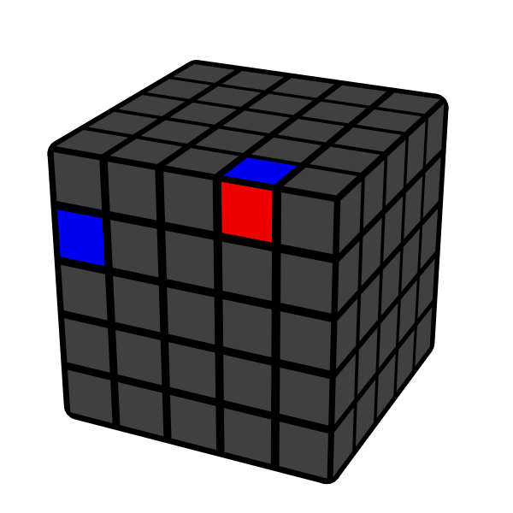 | 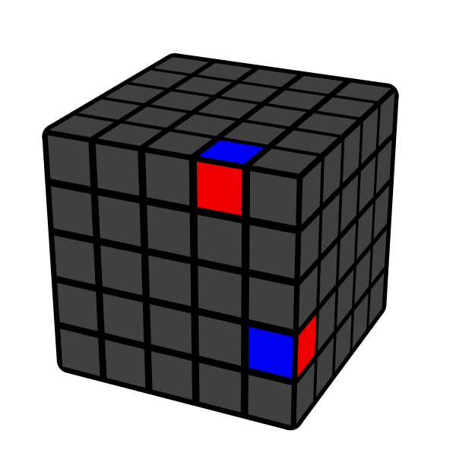 | 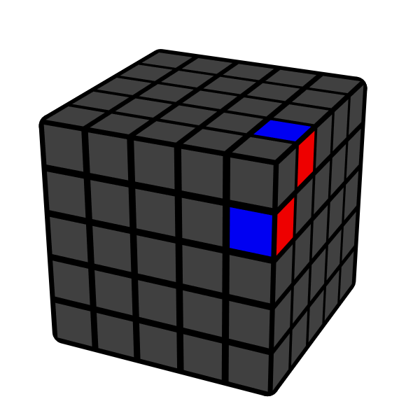 | 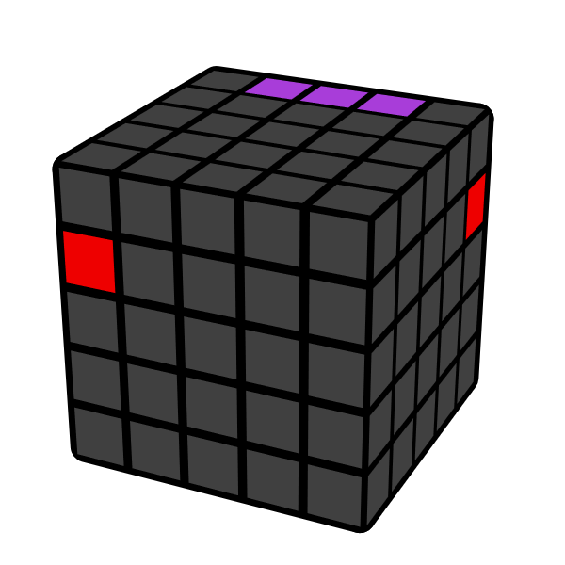
F R' F' R u'  y' U' R' U R u | Dw' R U' R' u  Dw R U R' u' | Uw' R U R' u | (R' U R2 U' R') u'
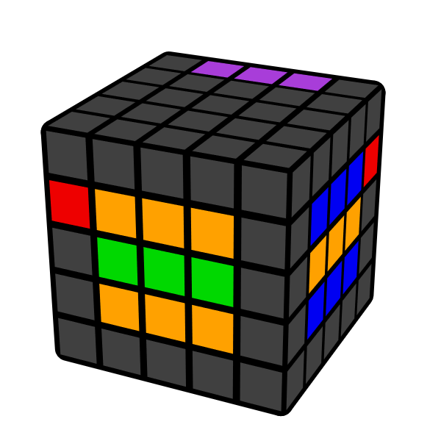 | 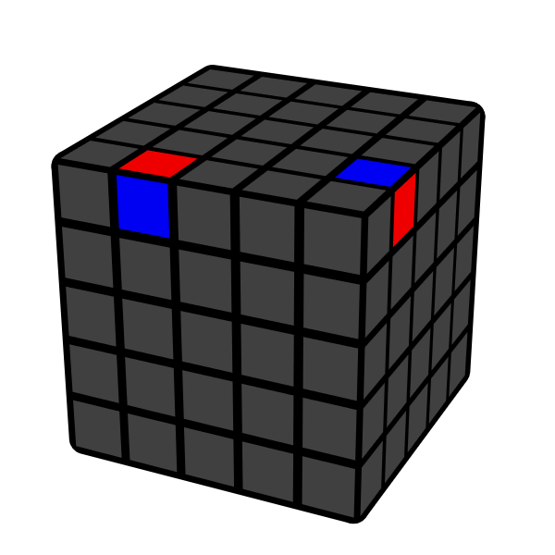 | 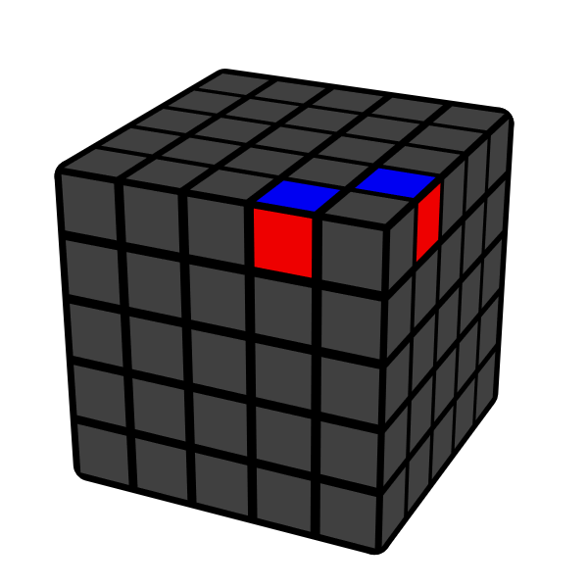 | 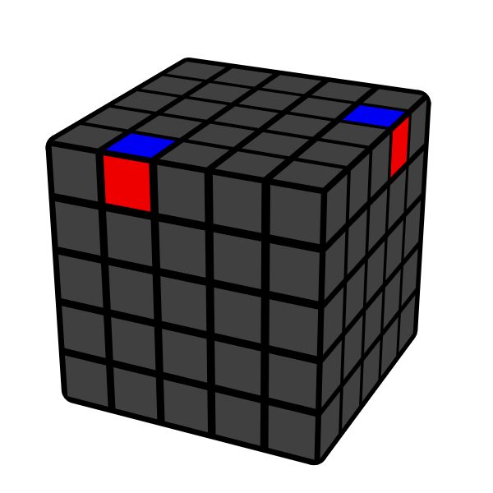
R2 u' | (R U' R' U) (R' U' R u)  U R U' R2' U' R u | (R U' R' u) (R U' R' u') | (R U' R') y (R U' R' u)
三棱块
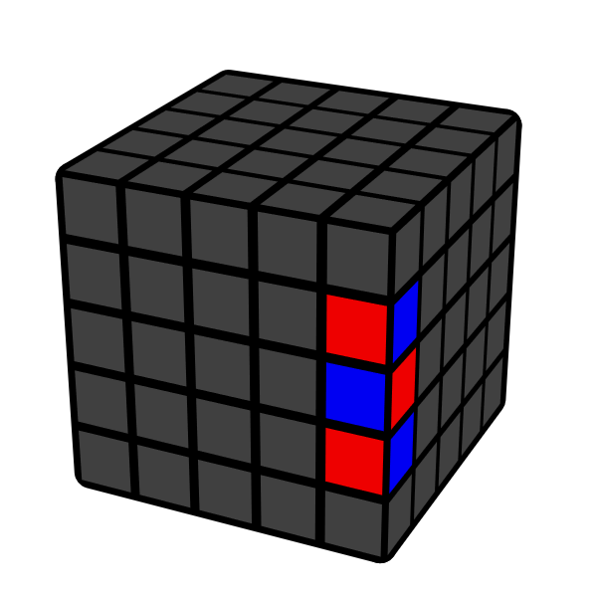 | 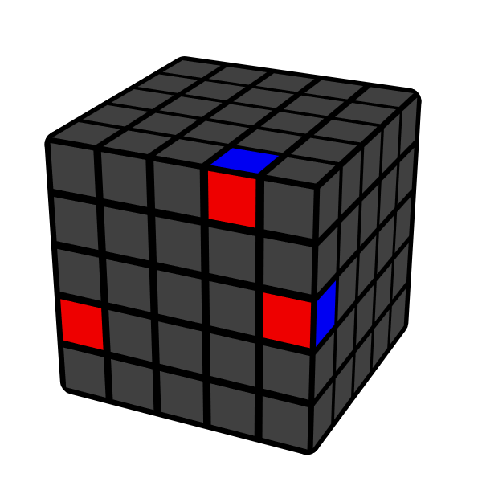 | 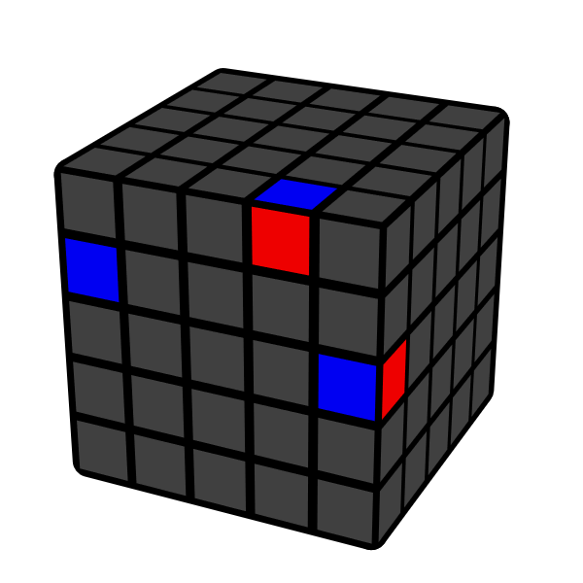 | 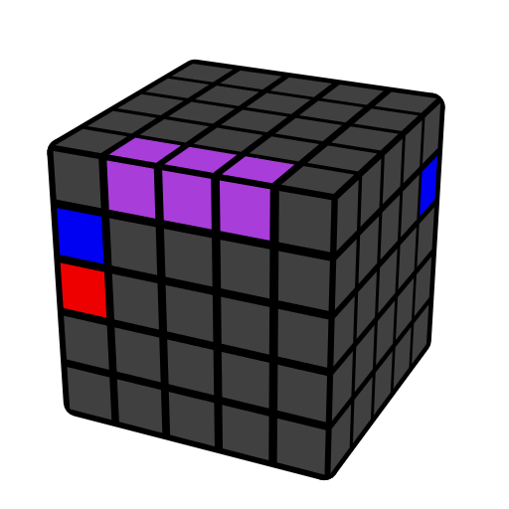
E [Flip 2] E'  z' M' [Flip 1] M | (R U' R' d) (R' U R E') | (F R' F' R) U' (R' U R E') | u2 (R' U R2 U' R') 3u'

