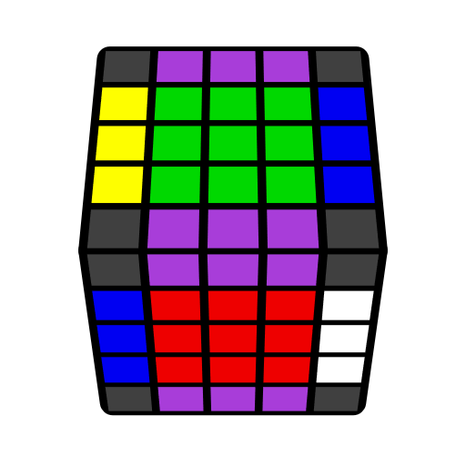
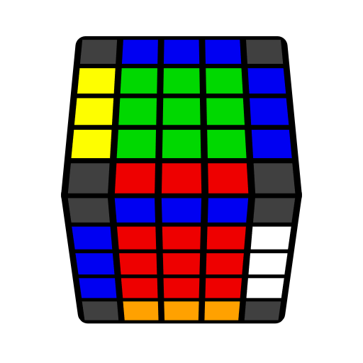
5x5 L4E Algorithms (Last Four Edges)

Purple edges denote free edges. [Flip 1] = U' R' U R' F R F'; [Flip 2] = R U R' F R' F' R; A: B = A B A'.

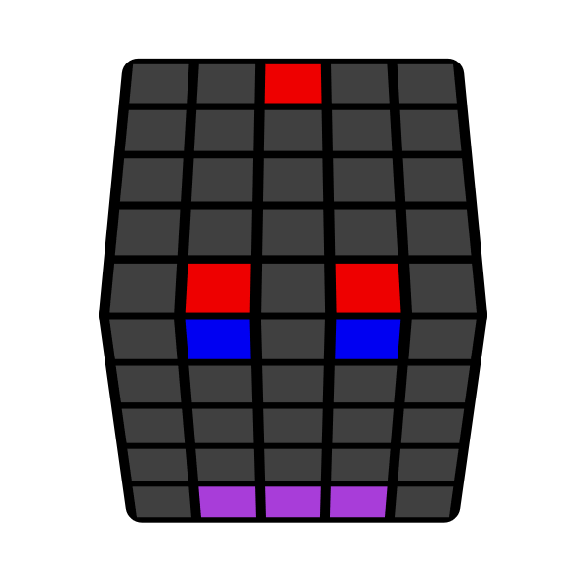 | 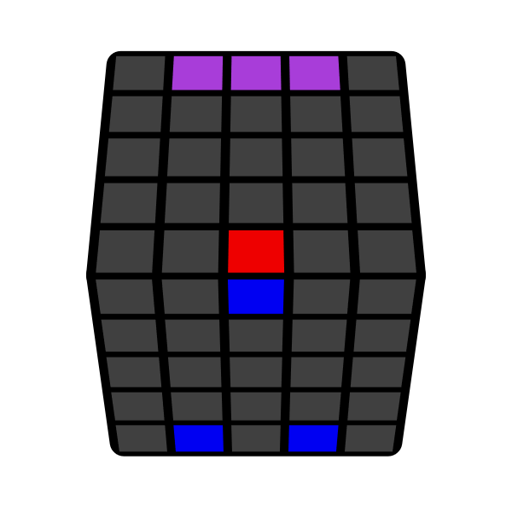 | 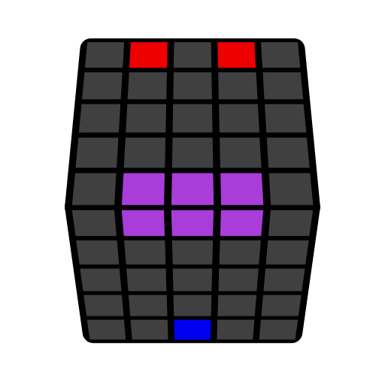 | 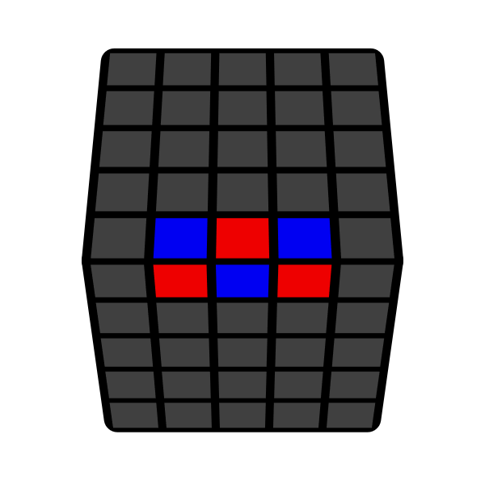
M' U2 M  y2 M U2 M' | M' U2 M | M' U2 M | M: [Flip 1]  z' y' E: [Flip 2]
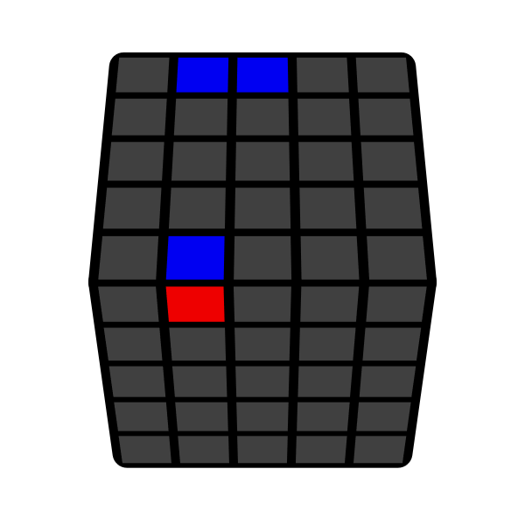 | 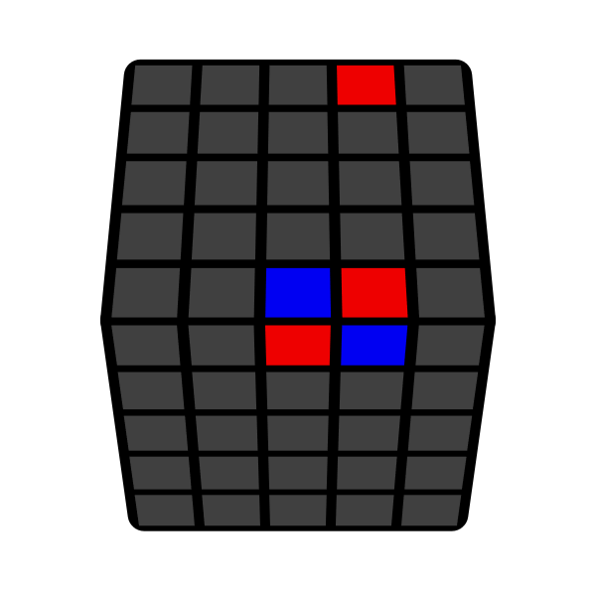 | 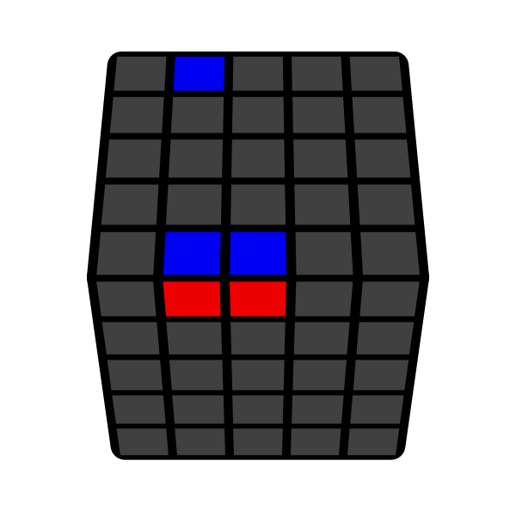 | 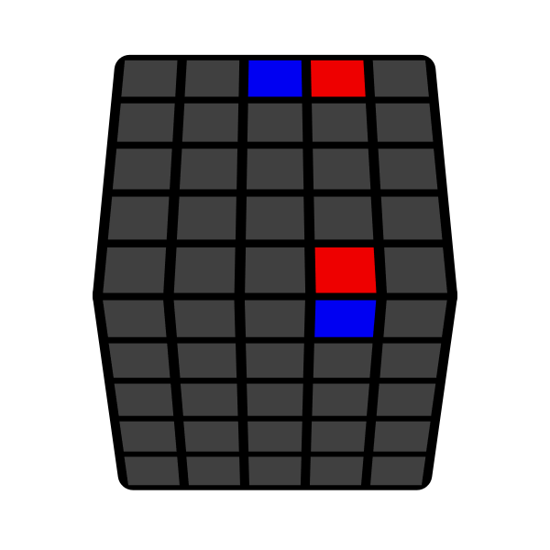
r': [Flip 1]  z' y' u': [Flip 2] | r' [Flip 1]  z' y' u' [Flip 2] u | 3l [Flip 1] r'  z' y' 3d [Flip 2] u' | 3l [Flip 1] r'  z' y' 3d [Flip 2] u'
 | 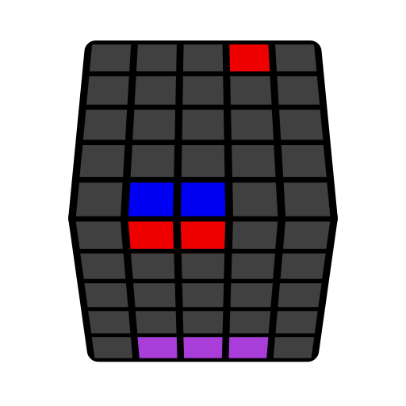 | 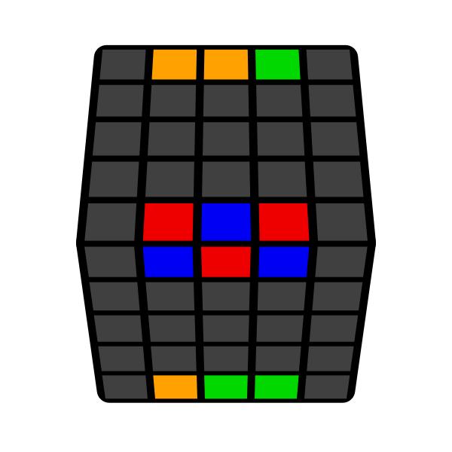
 | z' y' (R' U R u') U (R U' R' u) (3-cycle) | r' l': [Flip 1]

