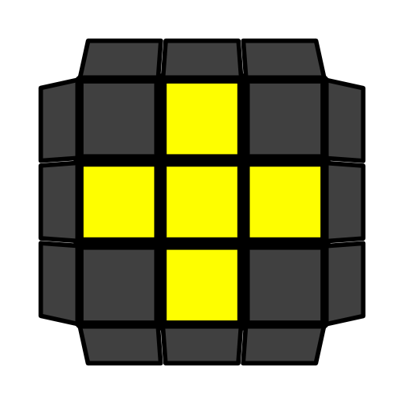
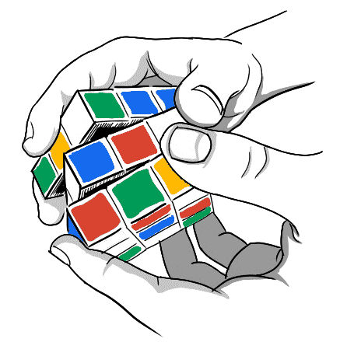
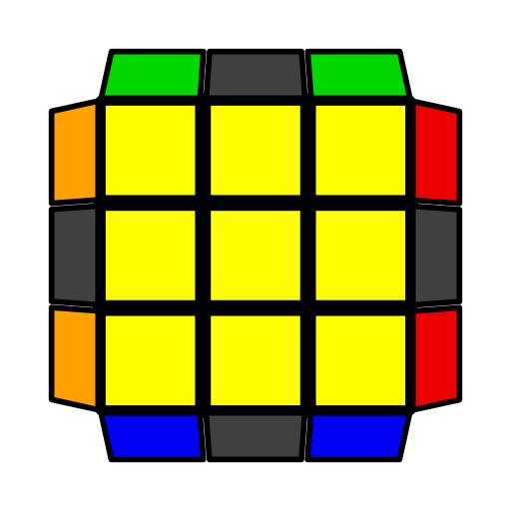
COLL公式和指法

推荐公式  可选公式   左单公式  高阶公式 | 右拇指, 右食指, 右无名指,右小指, 左食指  从顶, 底层起手 | COLL在顶层有十字棱时复原顶层角块。若 或紫色文本不存在，左单或高阶公式将是第一条。

COLL-H
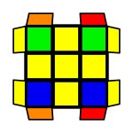 | (R U R' U) (R U' R' U) (R U2' R')  y (R U2' R' U') (R U R' U') (R U' R') |  | F (R U R' U')3 F' | 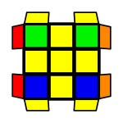
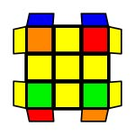 | F (R U' R' U) (R U2 R' U') (R U R' U') F' |  | (R U R' U) (R U L' U) R' U' L  (R' U' R U' R' U') (L U' R U L')  (R' F' R U2') (R U2' R' F) (U' R U' R') | 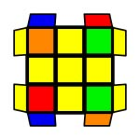
COLL-Pi
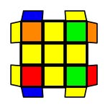 | R U2' R2' U' R2 U' R2' U2' R |  | (R U D') (R U R' D) (R2 U' R' U') R2' U2' R  (R U2' R') x (R' U R U')3 x' (R U2' R')  (R U' R' U2') (L' U R U') (L R') U2' (R U R')  y (R U2 R' U') F' (R U2' R' U') (R U' R') (F R U' R') | 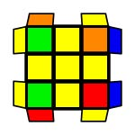
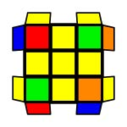 | F U (R U' R' U) (R U' R2' F') (R U R U' R')  (R U2' R' U' R U' R') (R' U L U' R U L') |  | (R U R' U') R' F (R2 U R' U') (R U R' U') F'  y' (R' U2' R U R' U R) (R U' L' U R' U' L) | 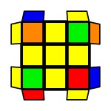
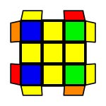 | y (R U R' U) F' (R U2' R' U2') (R' F R)  (L' U R U' L U') (R' U' R U' R') |  | F U (R U' R' U) (R U2' R' U') (R U R' F') | 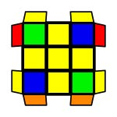
COLL-U
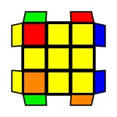 | y' (R U R' U R U2' R2') (U' R U' R' U2 R)  (L' U2 L U L' U L) (R U2' R' U' R U' R')  (R U R' U') (R U' R' U2')2 (R U R') |  | F (R U' R' U) (R U R' U) (R U' R' F')  x' R2 D2 (R' U2 R D2) (R' U2 R') x | 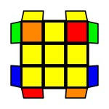
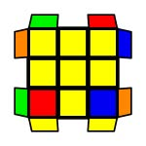 | R2 D (R' U2 R D') (R' U2 R') |  | R2' D' (R U2 R' D) (R U2 R) | 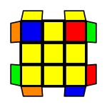
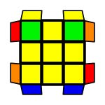 | R' F (R U' R' U') (R U R' F') (R U R' U') (R' F R F' R)  y F' (R U R' U) (R U R' F') (R U R' U')  (R' F R2 U') R' U2 (R U' R' F)  y2 (R' U R U') x' z (R U' R U R2')  z' (R U' R' U) x |  | (R' U2 R F) U' (R' U' R U) F' | 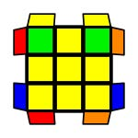
COLL-T
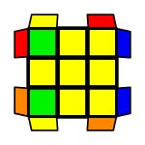 | y (R U2' R' U' R U' R2') (U2' R U R' U R)  (R U R' U R U2' R') (L' U' L U' L' U2 L)  (R U R' U R U2' R') U' (R U2' R' U' R U' R') |  | F (R U R' U') (R U' R' U') (R U R' F')  x' (R U2 R D2) (R' U2 R D2) R2' x | 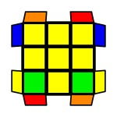
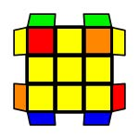 | (R' U R U2') L' (R' U R U') L  y2 (R U' R' U2) L (R U' R' U) L'  y2 R' F (R U R' U') (R' F' R2 U') (R' U2 R) |  | (R' U R2 D) (r' U2 r) (D' R2' U' R)  y2 (R U' R2' D') (r U2 r') (D R2 U R')  (R U2' R' U) (L U' R U L2' U) R' U' L  y2 R' U' (R U' R' U) (R U R' F') (R U R' U') R' F R2 | 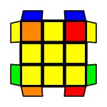
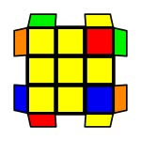 | y2 (l' U' L U) (R U' r' F)  (r' U' R U) (L U' R' U) x  y' x' (R U R' D) (R U' R' D') x |  | (r U R' U') (r' F R F')  (r U R' U') (L' U R U') x'  y' x' (D R U' R') (D' R U R') x | 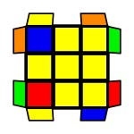
COLL-L
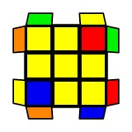 | (R U R' U) (R U' R' U)2 (R U2' R')  (R U2' R' U') (R U R' U')2 (R U' R') |  | r U2' (R2' F R F') R U2' r'  y' R U2' (L' U L) U2' R' (L' U L)  y2 L' U2' (R U' R' U2') L (R U' R')  y2 R' U' (R U R' F') (R U R' U') R' F R2 | 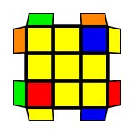
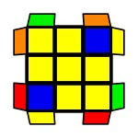 | (R U2 R D) (R' U2 R D') R2' |  | (R' U2 R' D') (R U2 R' D) R2 | 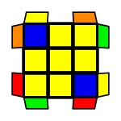
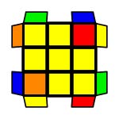 | (F R' F' r) (U R U' r')  L' (R U R' U') L (U R U' R')  y' (R U R' U') (R' F R U) (R U' R' F')  y' x' (R U' R' D) (R U R' D') x |  | F' (r U R' U') (r' F R)  y2 x' (U' R U L') (U' R' U r)  y F (R U' R' U') (R U2 R' U') F'  y x' (D R U R') (D' R U' R') x | 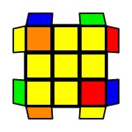
COLL-S
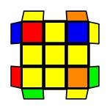 | R U R' U R U2' R' | F' (R U2' R' U2) R' F2 (R U R U') R' F'  R' U2' (L U' R U) L' (U R' U R)  y2 (R U R' F') (R U R' U R U2' R') (F R U' R') |  | 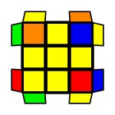
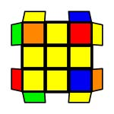 | R U' L' U R' U' L  y2 L U' R' U L' U' R | L' (R U R' U') L (U2 R U2' R') |  | 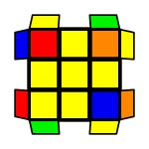
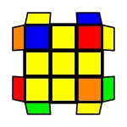 | (L' U2 L U2) R (U' L' U L) R'  (R U R2' F') (R U2 R U2') (R' F R U' R') | (R U R' U) (R U' R D) (R' U' R D') R2'  y2 (R' U' R U') (R2' F' R U) (R U' R' F) U2 R |  | 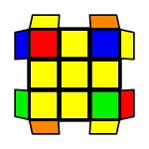
COLL-AS
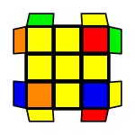 | R U2' R' U' R U' R' | (R U' R' U2)2 R' D' (R U R' D) R  y2 (R' U' R U') L (U' R' U L') U2' R  y2 (R U R' F') (R U2 R' U' R U' R') (F R U' R') |  | 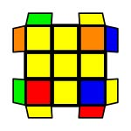
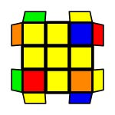 | L' U R U' L U R'  y2 R' U L U' R U L' U' | R (L' U' L U) R' (U2 L' U2 L)  (R U R' F') (R U2 R' U2') (R' F R2 U' R') |  | 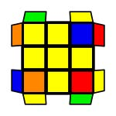
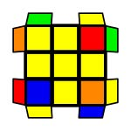 | (R U2' R' U2) L' (U R U' R') L | (R' U' R U') (R' U R' D') (R U R' D) R2 |  | 