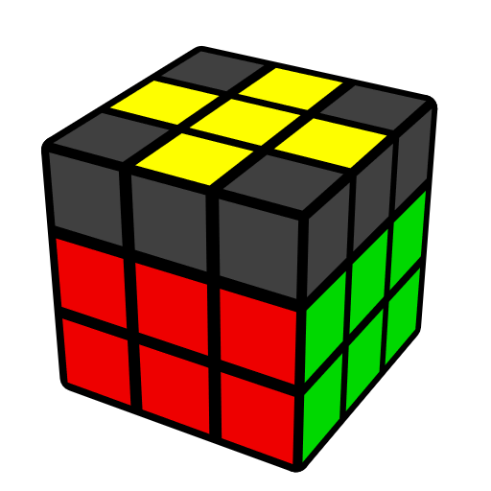
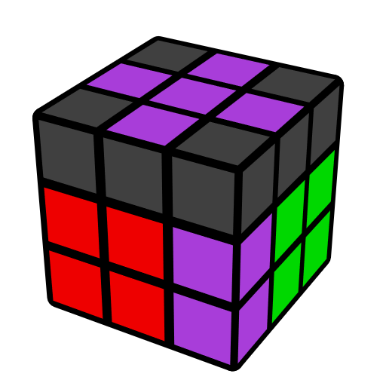
Easy EOLS Algorithms
(Edge Orientation Last Slot)

EOLS solves last F2L pair and orient LL edges. For the case where there are last F2L edge and 3 oriented yellow edges in U, if F2L edge is oriented, use only R, U-gen; Otherwise use y move first, then use R, U-gen.

Case 1 [14]
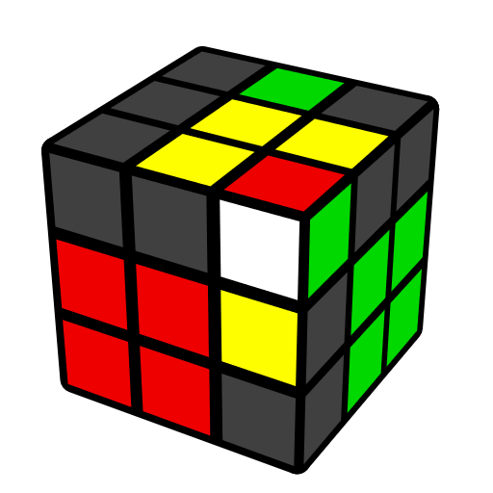 | 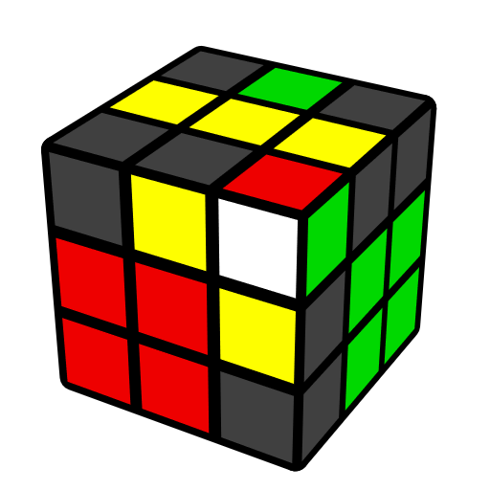 |  | 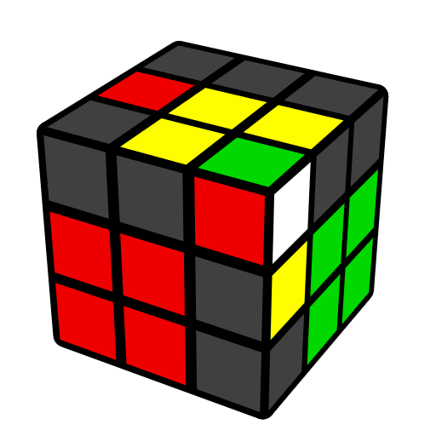 |  | 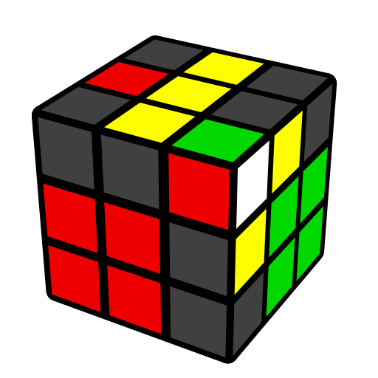
U' (R U' R' U) y' (R' U' R) | F (R U R' U') F' (R U' R') |  | y' U (R' U R d') (R U R')  U2 (r U' R' U') R U r' |  | y F' (L' U' L U) F (L' U L)
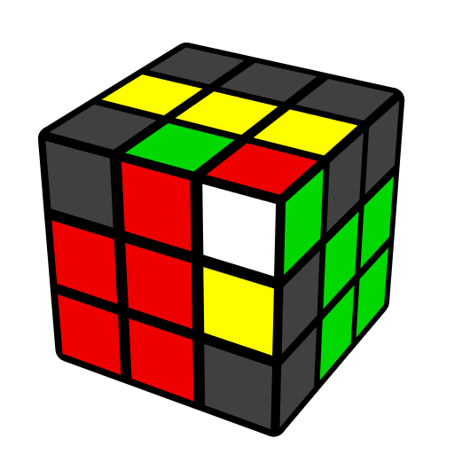 | 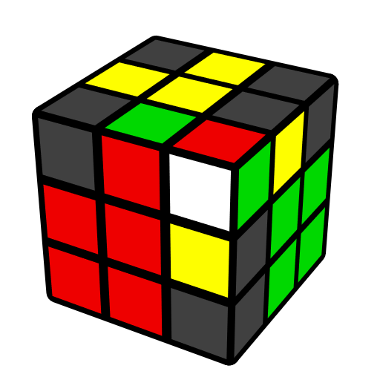 |  | 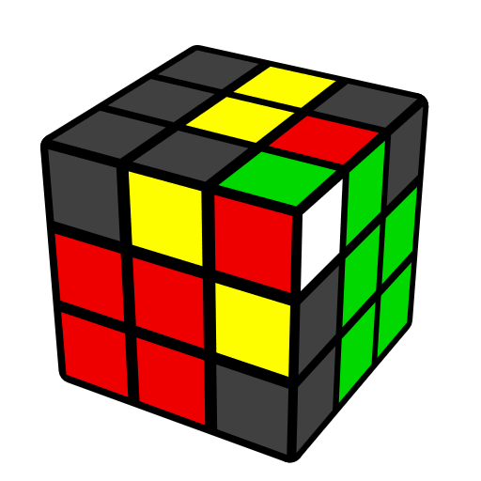 |  | 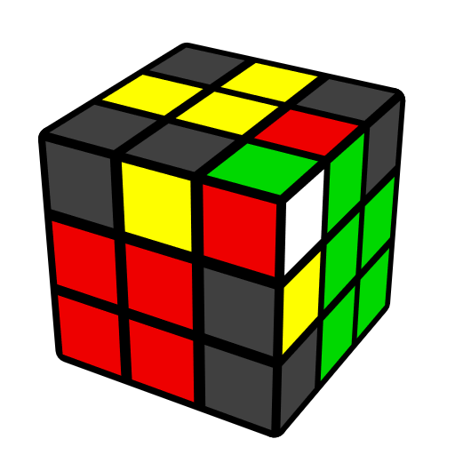
(R U R' U') y'  (R' U' R U)2 | (R U R' U) (R U' R')  (F' U' F) |  | U' (R U' R' U) (R U' R' U2) (R' F R F') |  | y' (R' U' R U') (R' U R)  y (R U R')
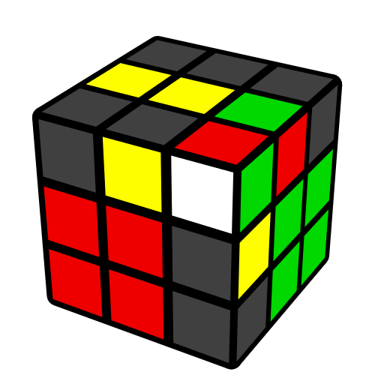 |  | 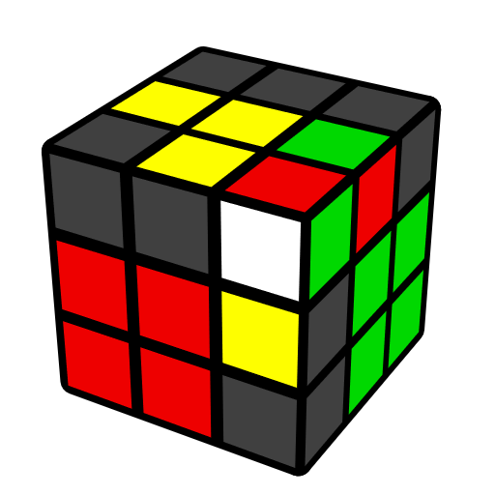 |  | 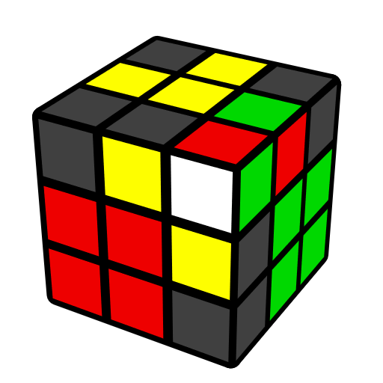
F' U (L' U2 L U2) F |  | U' (R U2' R' U) (F' U' F) |  | y' (R' U R U')2 (R B' R' B)
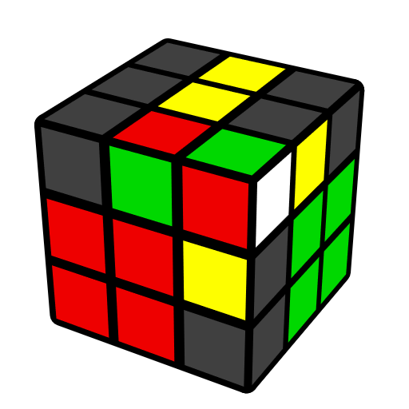 |  | 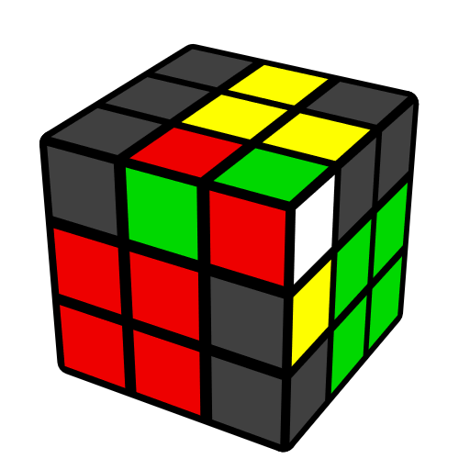 |  | 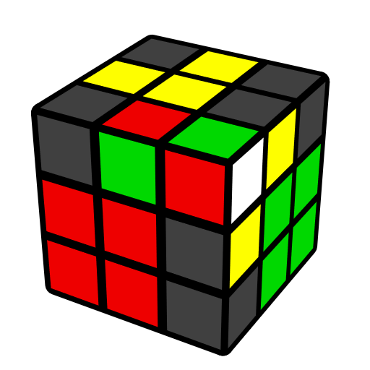
R d' (R U2' R' U2) F' |  | y' U (R' U2' R) y (U' R U R') |  | (R U' R' U)2 (R' F R F')
Case 2 [3]
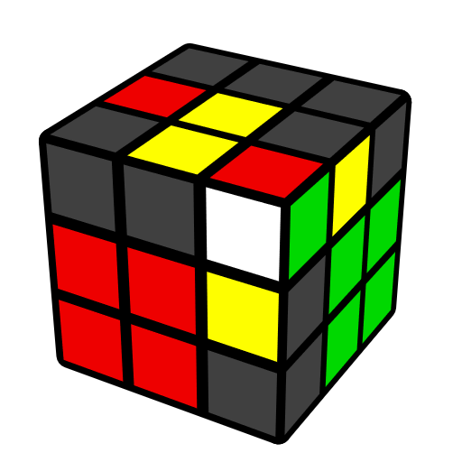 |  | 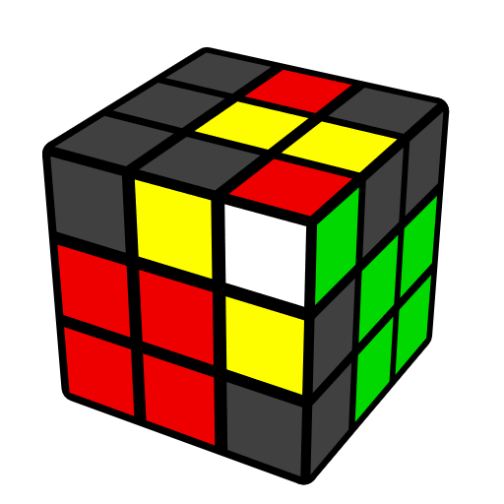 |  | 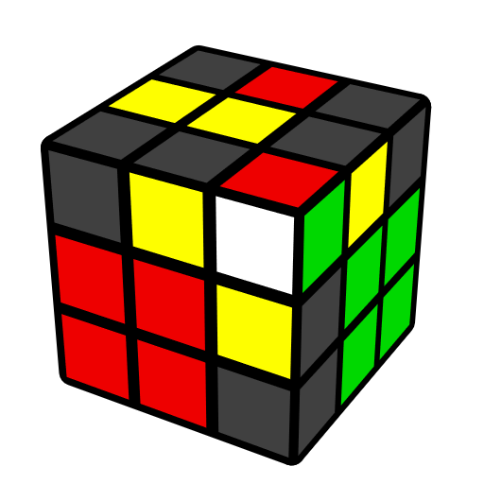
U2 (r U R' U') (R U' R' U) R U r' |  | U' (r U R' U') r' (R2 U2' R') |  | U' (r U R' U') M U2' (R' F R F')
Case 3 [4]
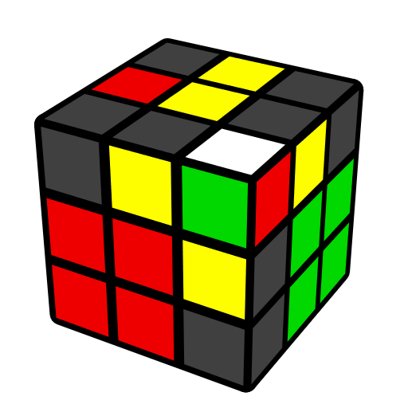 | 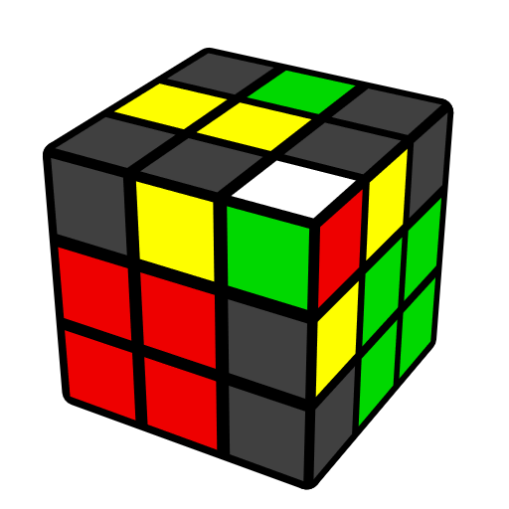 |  | 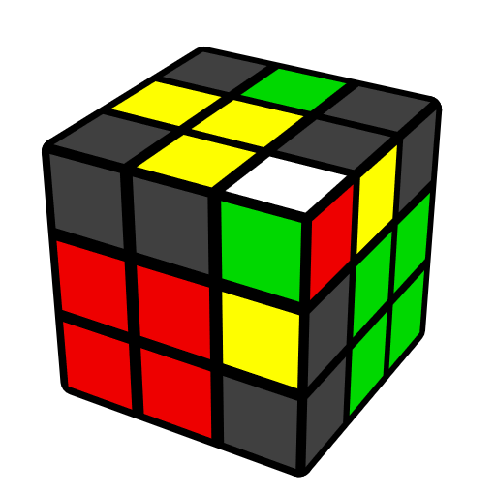 |  | 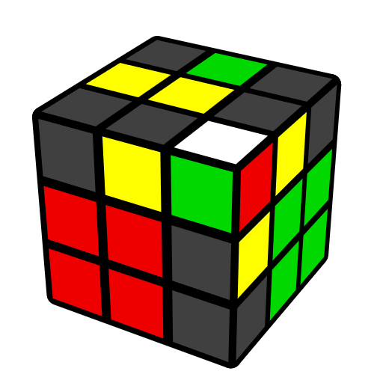
y F R U2 R' F' | F' L' U2 L F |  | y' U2 R' F R' F' R2 |  | y' R' F' U2' F R
Incorrectly Connected Pieces [26]
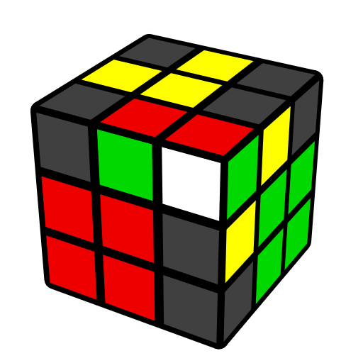 | 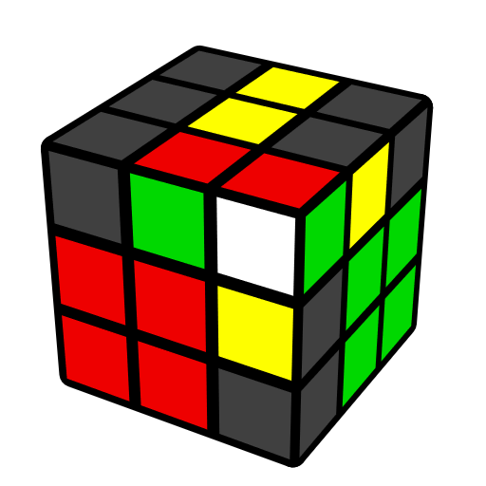 |  | 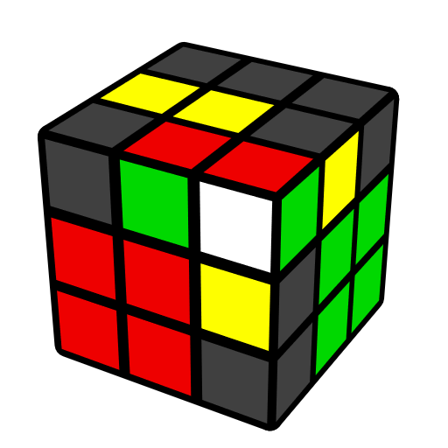 |  | 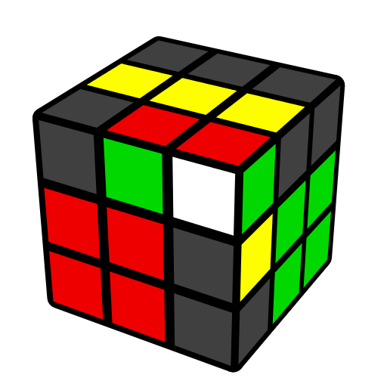
(F' U F) U2' (R U R') | (R U R' U2) R U'  (R2' F R F') |  | (R U R' U2) (F' U' F)  (U2 R U' R') |  | l U (r U' r' U') l'  x' R U (r U' r' U') R' x (OH)
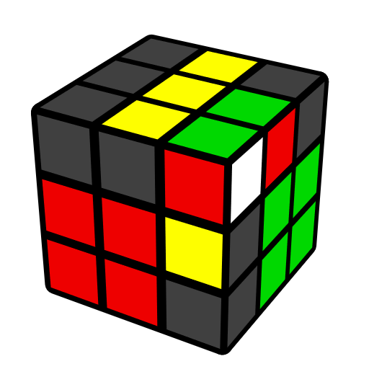 | 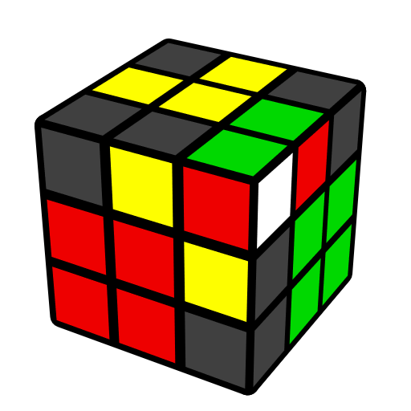 |  | 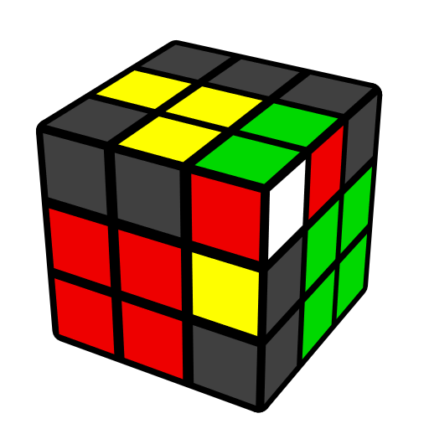 |  | 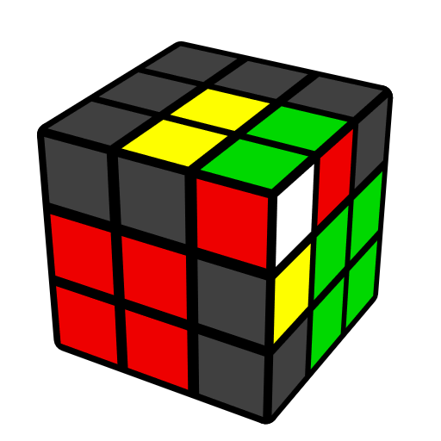
U F (R U R' U') F'  (U R U' R') | (R U' R' U2) (F' U' F) |  | (R2 B' R' B) (R' U2 R U' R') |  | U (r U' r' U2) (r U r' U') (R U R')
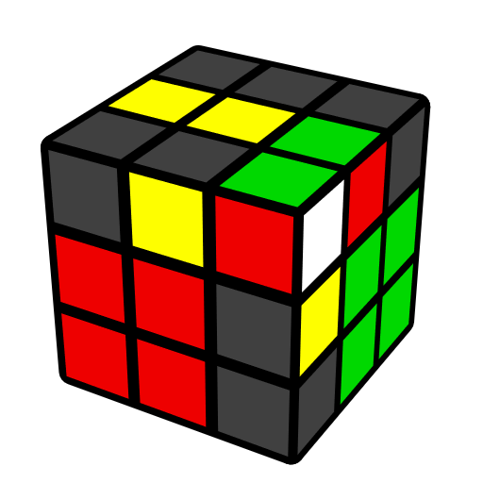
y' (R' U' R U2) R' U (R2 B' R' B)
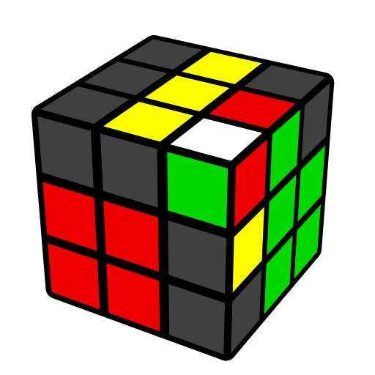 | 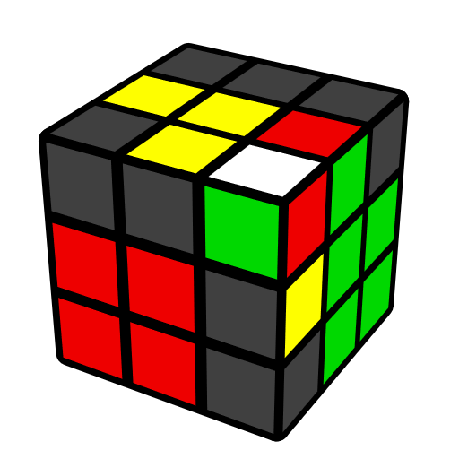 |  | 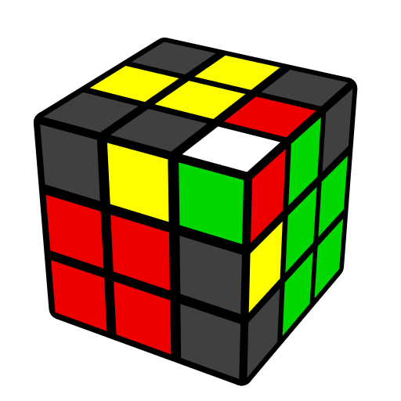 |  | 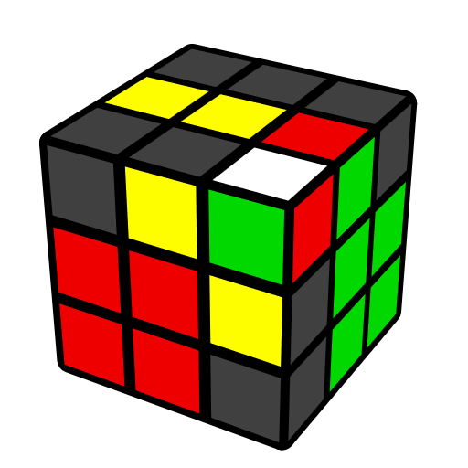
(F' U' F) U (R U' R' U)  (R U' R') | y' (R' U' R U) (R' U2 R)  y (R U2' R') |  | y' (R' U' R U) (R' U' R U2) y (R U' R') |  | U' (R U' R' U2) (R U2' R2' F R F')
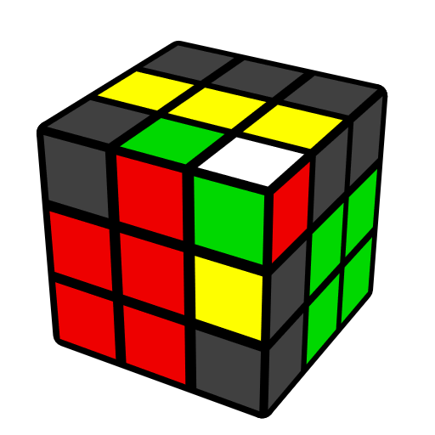 | 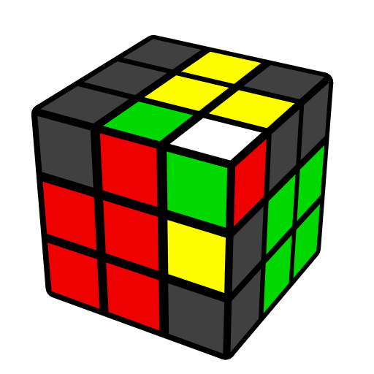 |  | 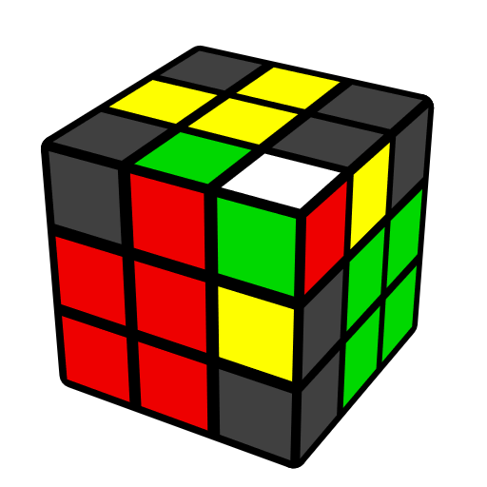 |  | 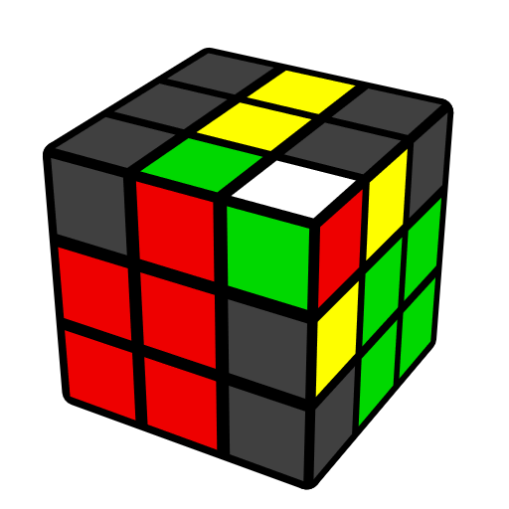
(R U R' U') y' (R' U R U') (R' U R) | (R U R' U') (R U2' R' U) y' (R' U R) |  | (R U R' U') (R U R' U2') (F' U F) |  | y U (L' U L U2) (L' U2 L2 F' L' F)
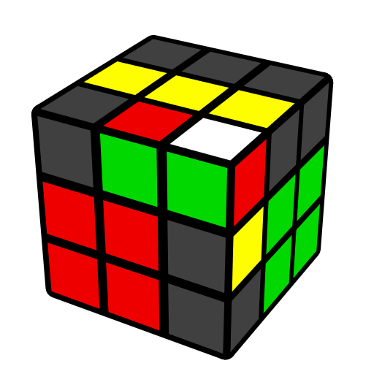 | 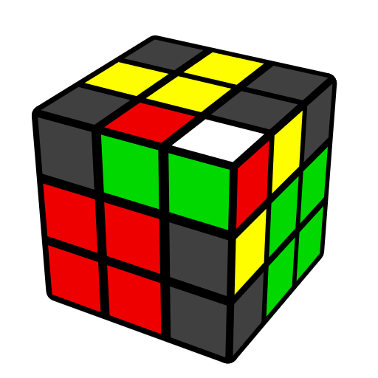 |  | 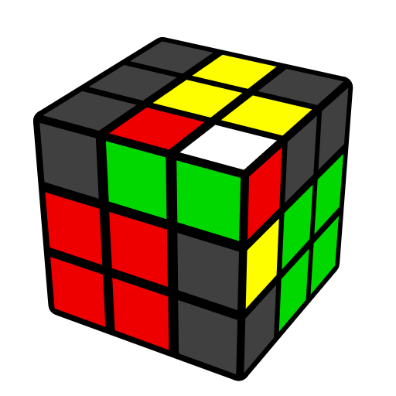 |  | 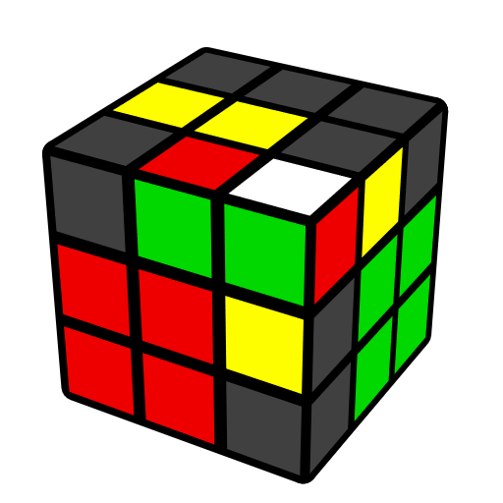
U (F' U F) U (R U R' U)  (R U' R') | y' (R' U' R U') (R' U' R U2) y (R U' R') |  | (F' U' F) U' (R U' R' U)  (R U' R') |  | (R U R') (F' U F) (R U R')
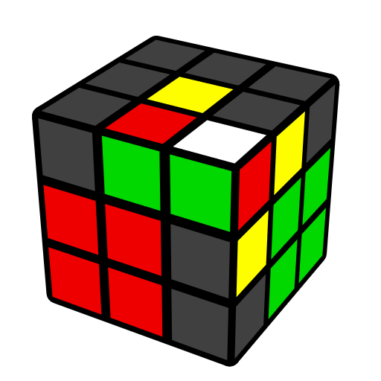
(F' U' F) U' R U' (R2' F R F')
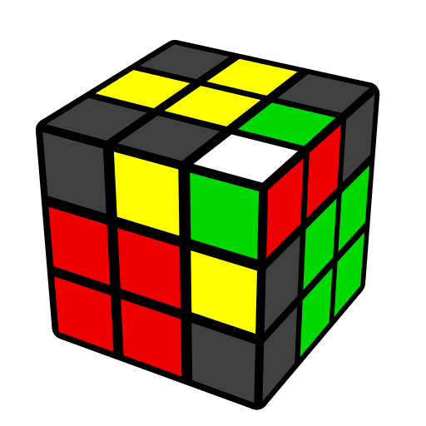 | 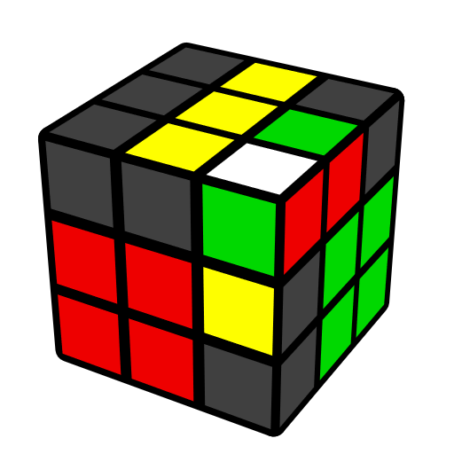 |  | 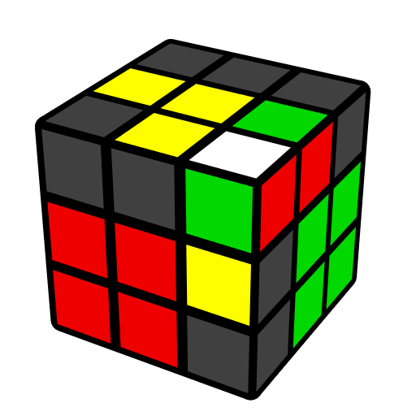 |  | 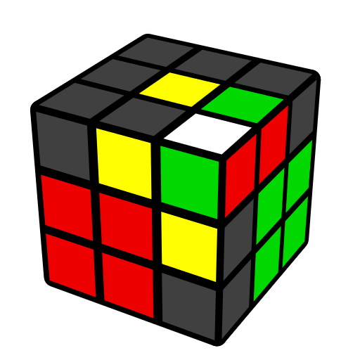
F (U R U' R') F' (R U' R') | (R U' R' U) (r U' R' U)  (R U r') |  | (R U R' U) y' (R' U R U') (R' U R) |  | (R U R' U) y' R' U  (R2 B' R' B)
Corner in Place, Edge in U Face [40]
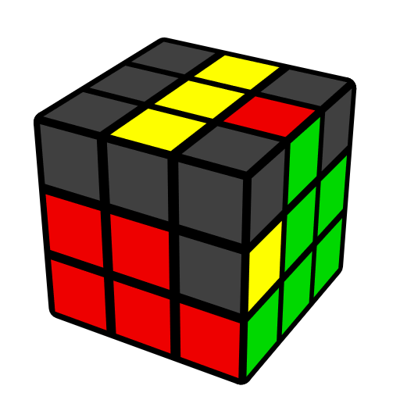 | 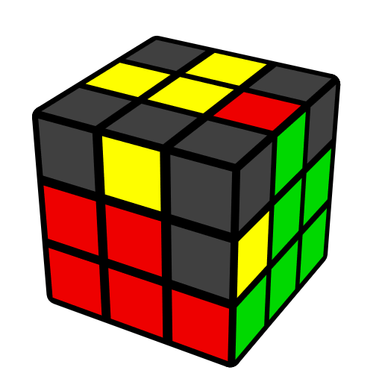 |  | 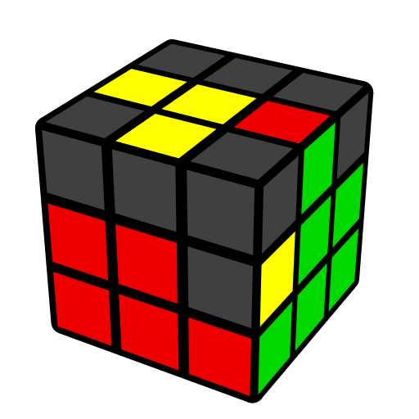 |  | 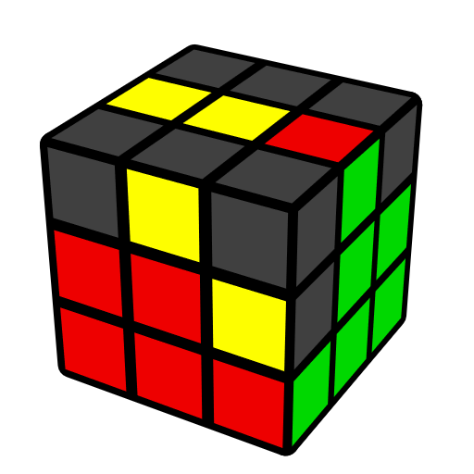
U' (R' F R F') (R U R') | y U' L' U L y' U R U' R' |  | y (U' L' U' L) U y' R U R' |  | y R' F2 U' (F' U F2 R)
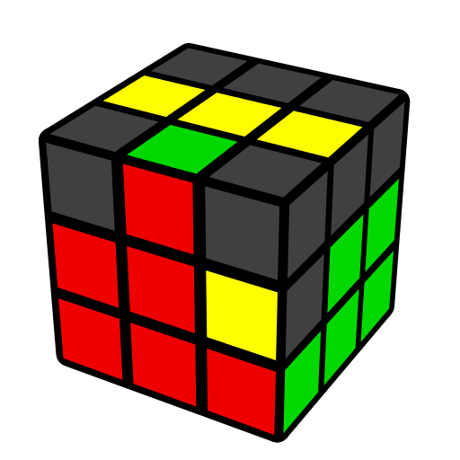 | 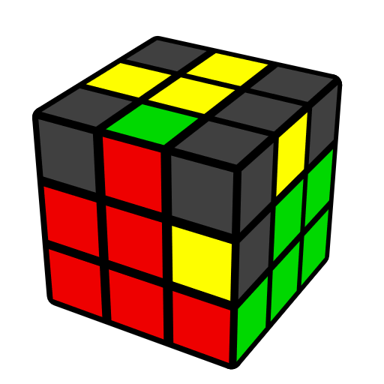 |  | 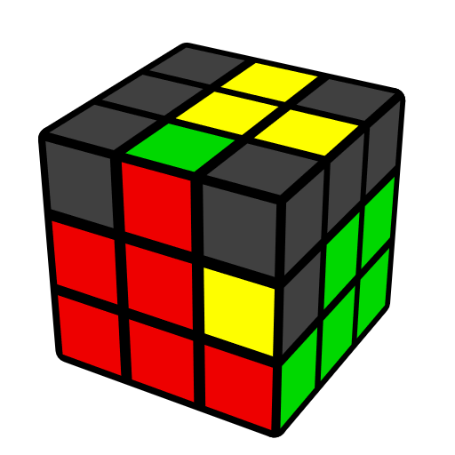 |  | 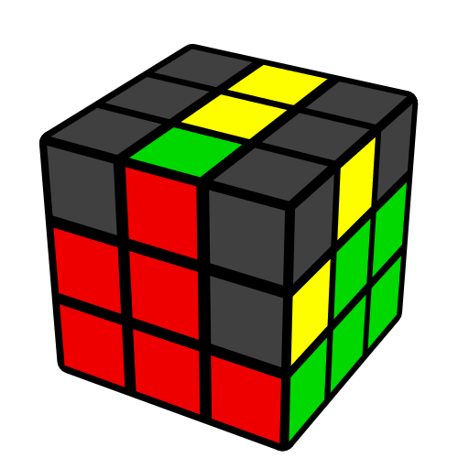
y' U x' R U' R' U x  R' U' R | U (R U' R') U' (F' U F) |  | U (R U R') U' (F' U' F) |  | r U2' z x' U (R U' R2' F')
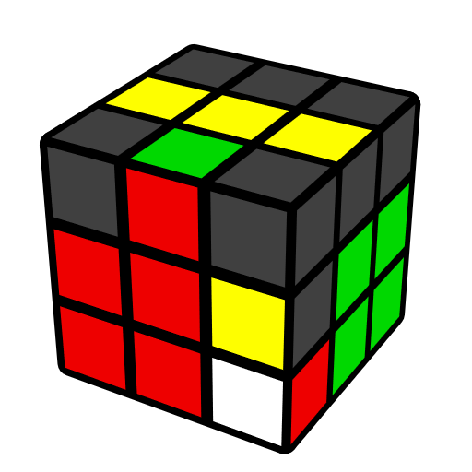 | 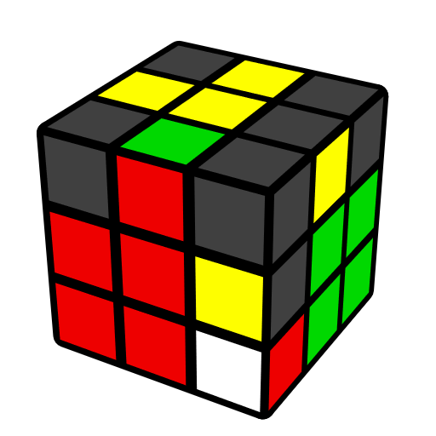 |  | 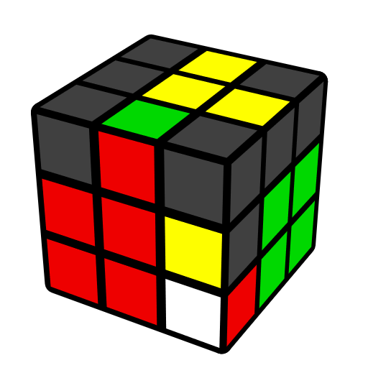 |  | 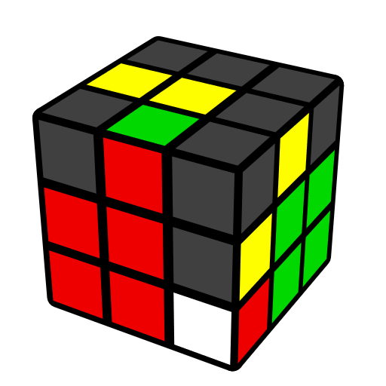
U2 (R U' R') (F' U' F) | (R' F R F')2 |  | R' U' R2 U' R2' U2' R  (F' U' F) |  | U (R' F R) y' (R2' U' R)
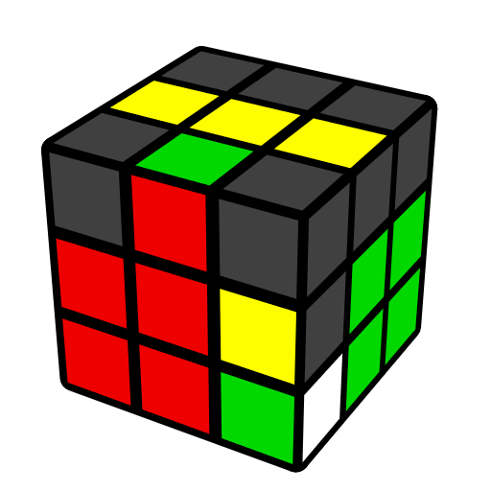 |  | 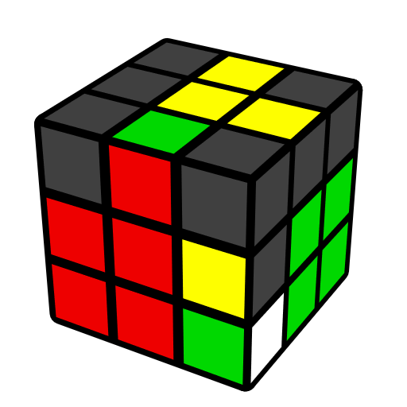 |  | 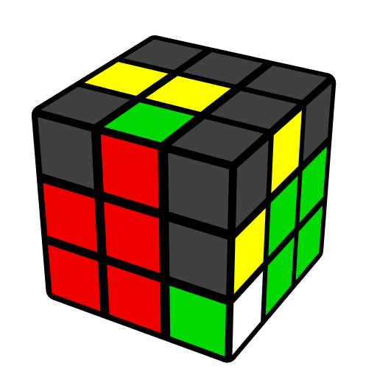
(R U R' U2') y' (R' U R) |  | (R U2' R' U) y' (R' U R) |  | y' R' U (R2 B' R' B)
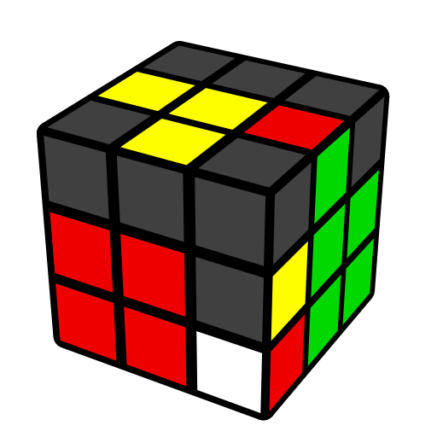 |  | 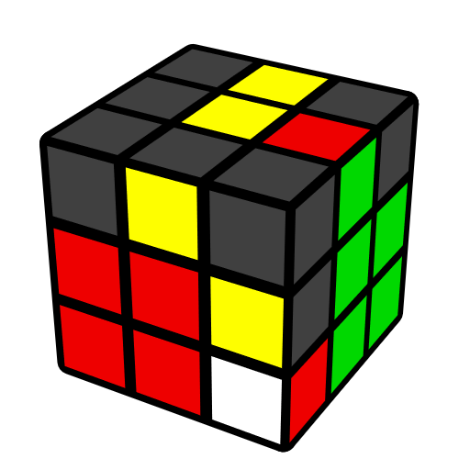 |  | 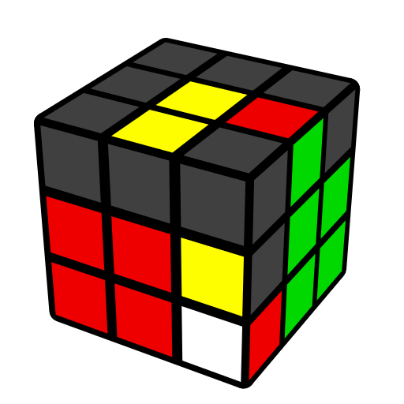
(F' U2' F) (R U2 R') |  | R U' (R2' F R F') |  | U r' R2 U' R' U r U' R'
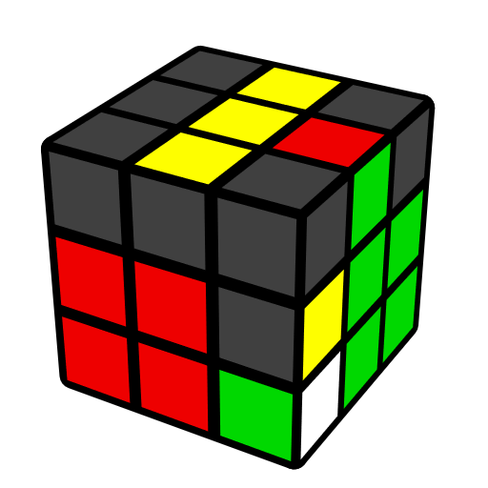 |  | 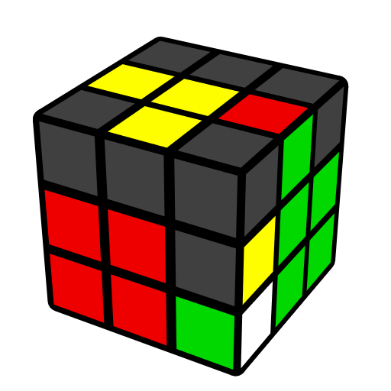 |  | 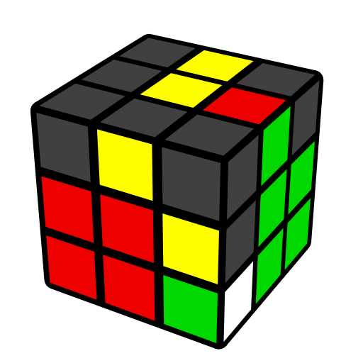
U2 (F' U F) (R U R') |  | y z U (R U2 R U2') R2' U' (F R F') z' |  | U' (F R' F' R2) U R'
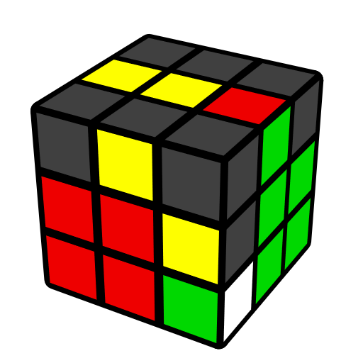 |  |  | 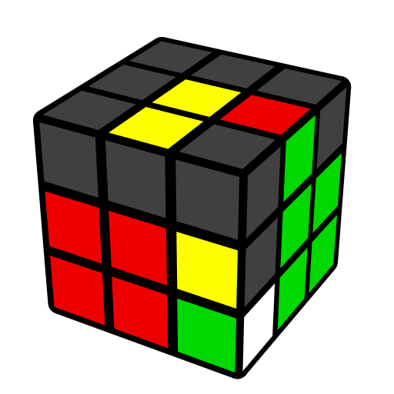
U' R d' (R U2' R') F' |  |  | R U r' U' R U R2' r
Edge in Place, Corner in U face [17]
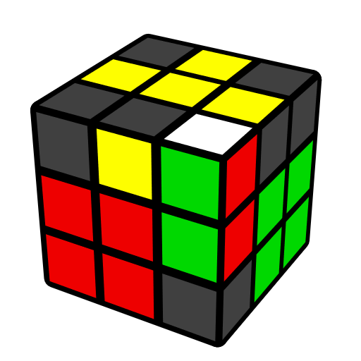 | 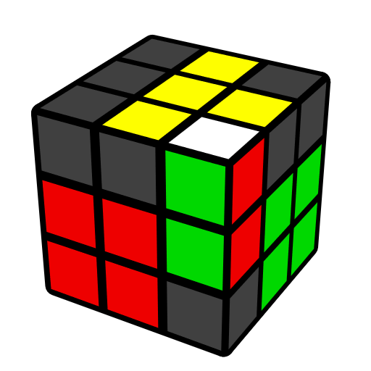 |  | 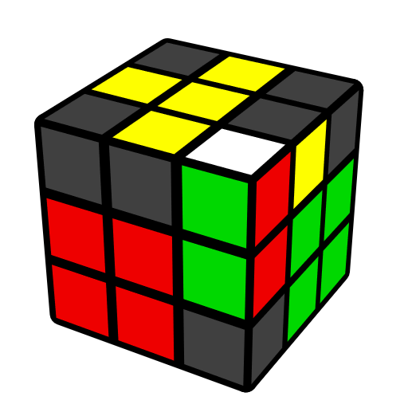 |  | 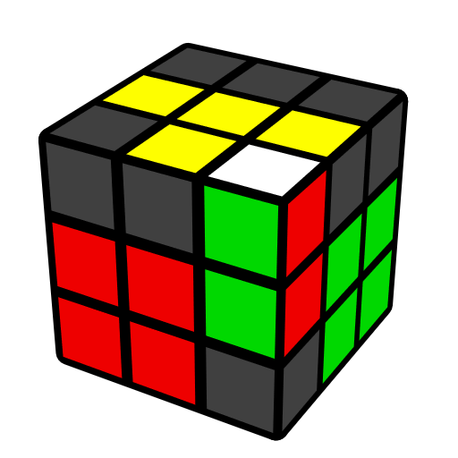
(R U' R' U) y' (R' U R) | U' (R' F R F') (R U' R') |  | (F' U F) (R U2 R') |  | (F' U2 F) U2 (R U' R')
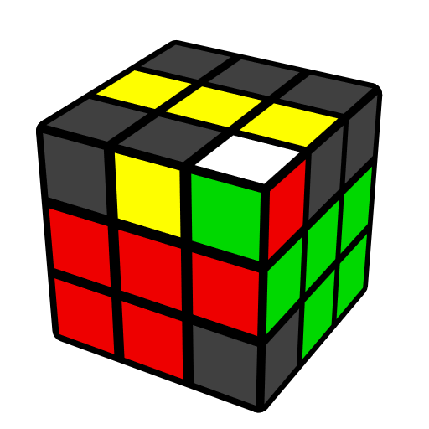 | 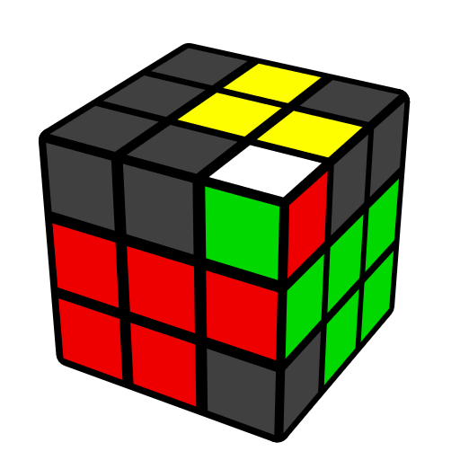 |  | 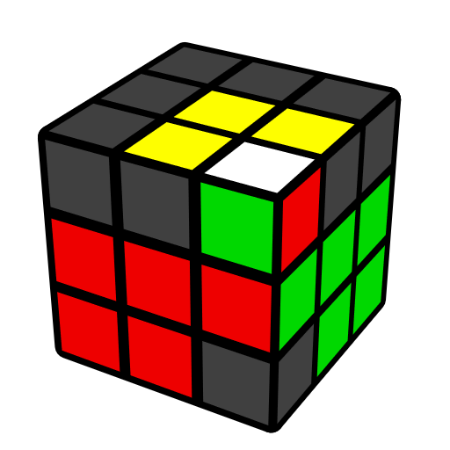 |  | 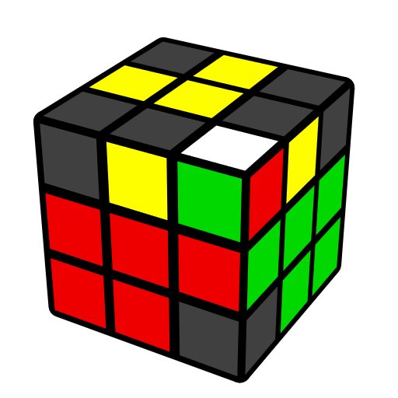
(U R U' R')2 (R' F R F') | U' (F R' F' R) (U' R U R') |  | (R U R' U) (F' U F)  (R U R') |  | r R U (R2' U R2 U2') R' r'
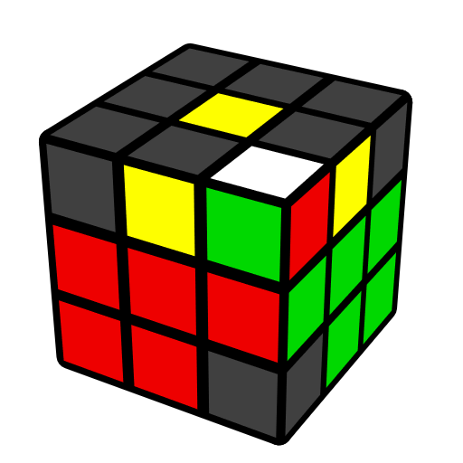
y U2 (R' F2 R U2') (R' F R U2') (R' F2 R)
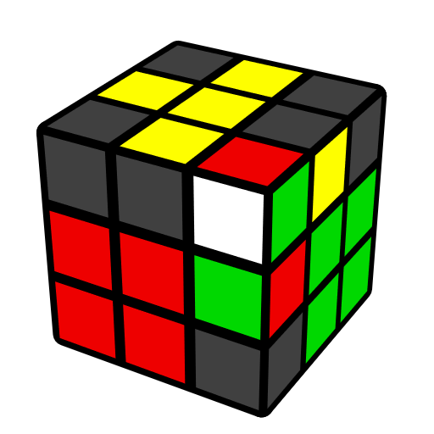 | 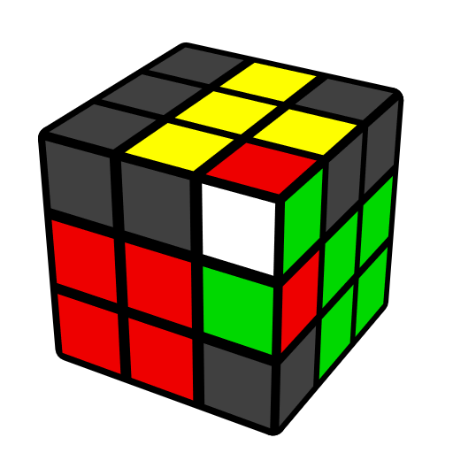 |  | 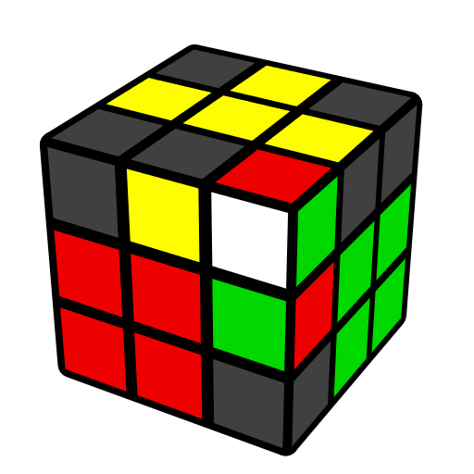 |  | 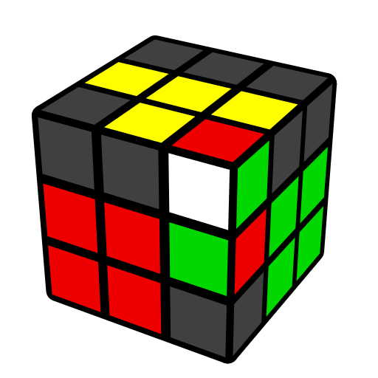
(U' R U R') d (R' U' R) | U2 (R U R') (F R' F' R) |  | U2 (R U R' U') (F' U F) |  | U2 (R U' R' U') (F' U' F)
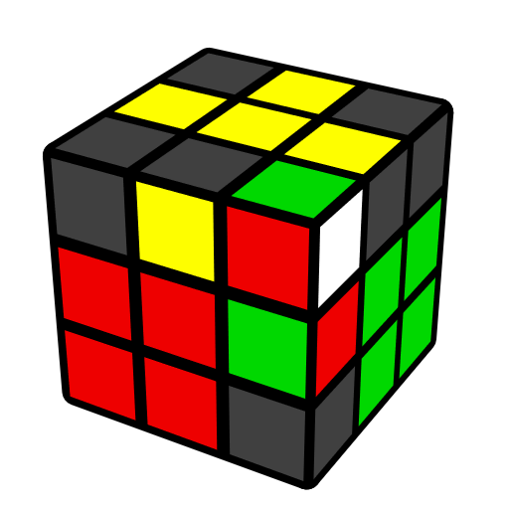 | 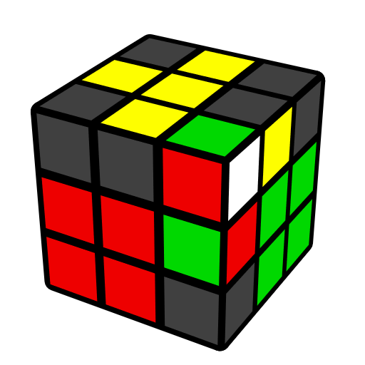 |  | 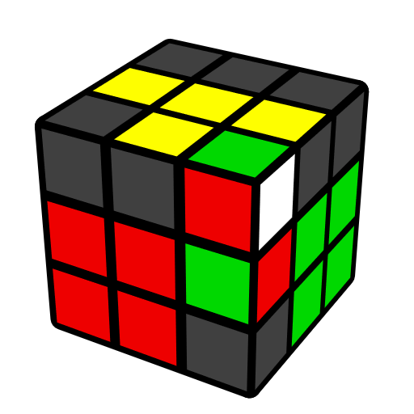 |  | 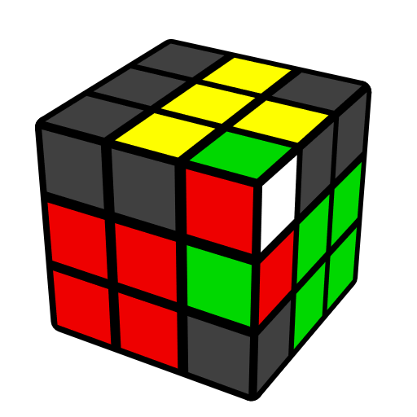
U (F' U' F) (U' R U R') | U2 (F' U' F) (U R U' R') |  | U2 (F' U' F) (R' F R F') |  | U2 (F' U F) (U R U R')
Edge and Corner in Place [10]
 | 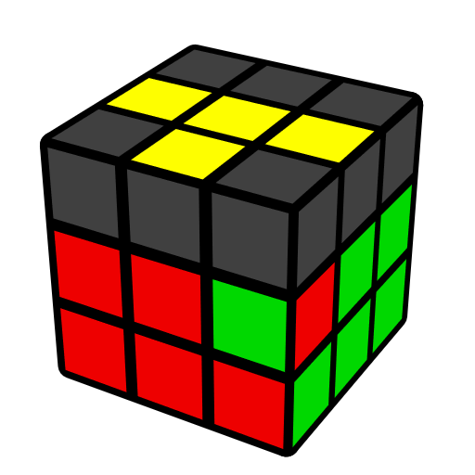 |  | 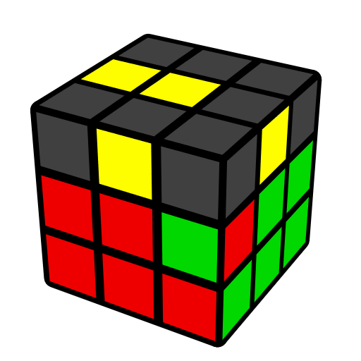
 | (R U2' R' U)2 y' (R' U' R) |  | (R U' R' U) y' (R' U2 R U') x' (R U' R' U) x
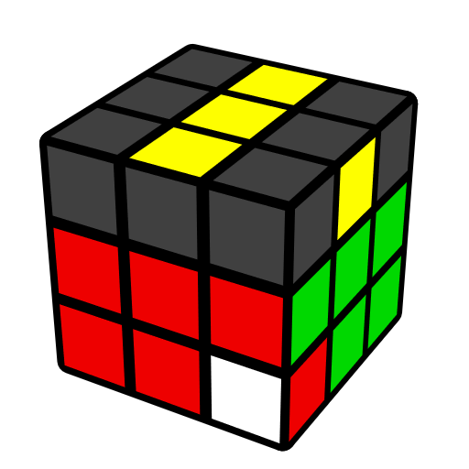 | 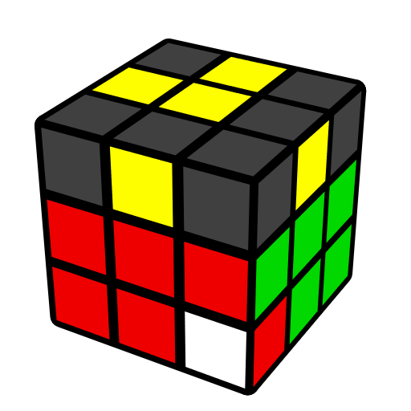 |  | 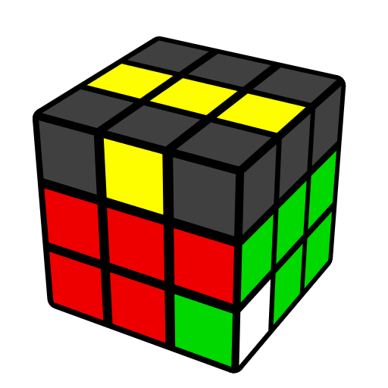 |  | 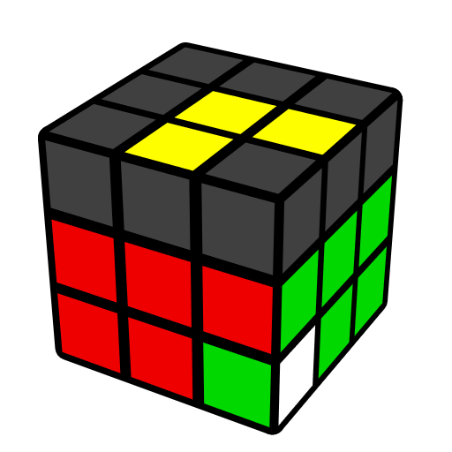
(R U' R' U') (R U R' U)  (R' F R F') | R U2 R U2 F R F' U2 R2 |  | y' (R' U R U) (R' U' R U')  (R B' R' B) |  | (R U' R' U) R U2  (R2' F R F')
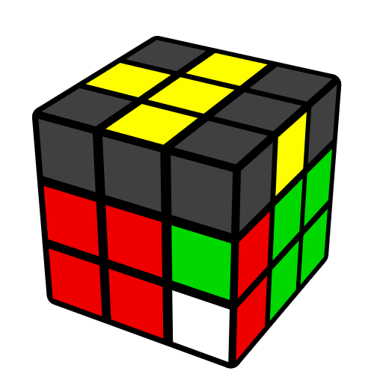 | 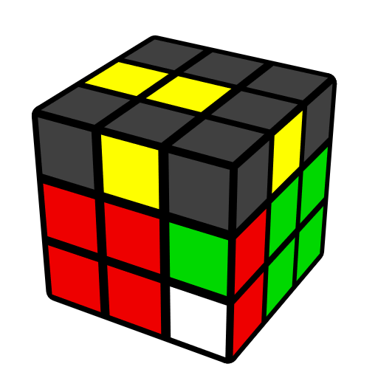 |  | 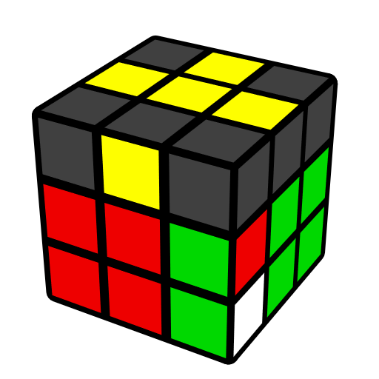 |  | 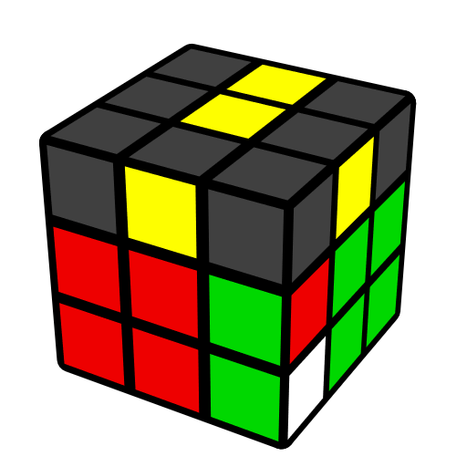
(F' U F) U2 (R U R' U)  (R U' R') | (r U' r') U2 (r U r')  (R U R') |  | (R U R' U') (R U' R')  U2 y' (R' U' R) |  | (R U' R') (r U' r' U2)  (r U r')

