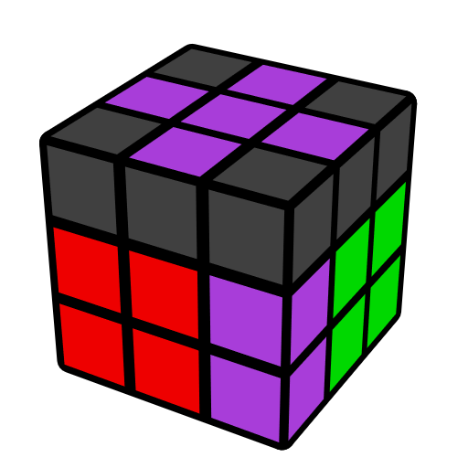
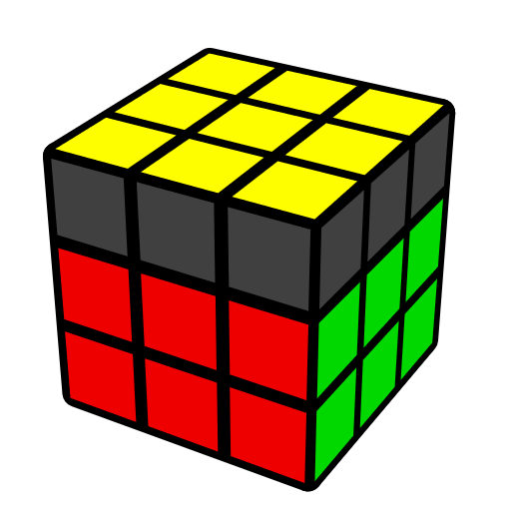
简单OLS公式 (末槽和顶层色向)

OLS [68] 还原最后一组F2L和OLL. 本文主要包含了连接态的末组F2L且顶层大多棱正向的一些情况. 先导内容：EOLS.

基态 [4]
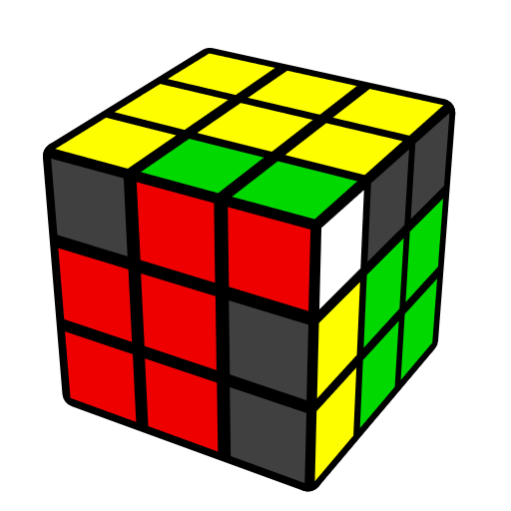 | 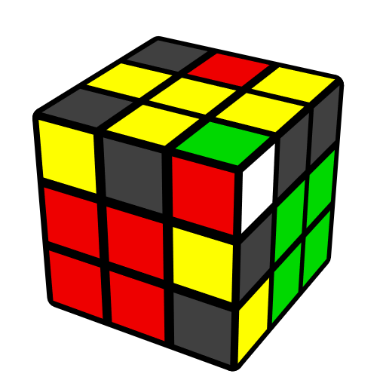 |  | 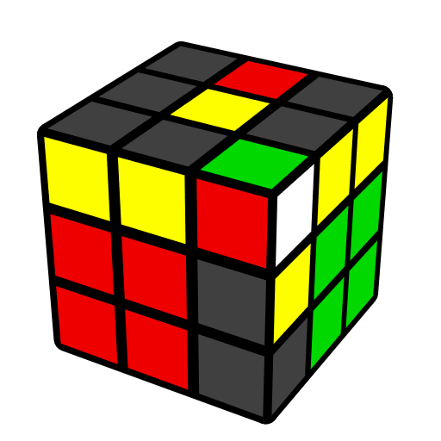 |  | 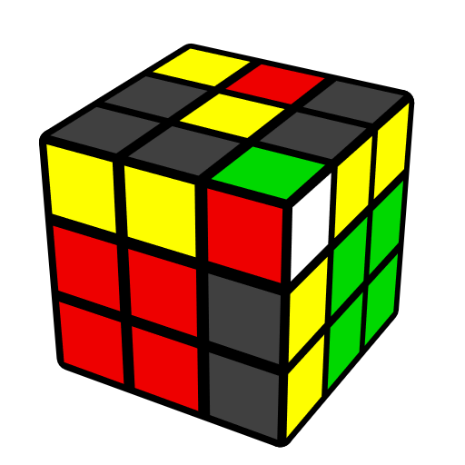
U' r' D' (r U r') D r | (R U' R' U') (R U' R') |  | (R U' R2' F R F')  U2 (R' F R F') |  | R' D' (r U r' D)  (R2 U R')
情况1 [10]
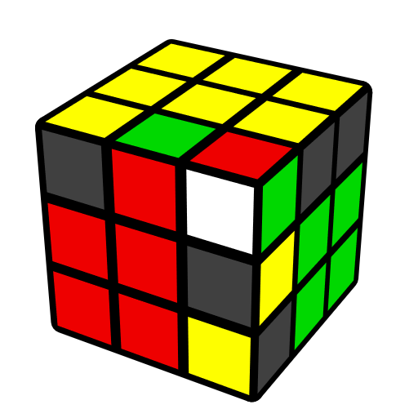 | 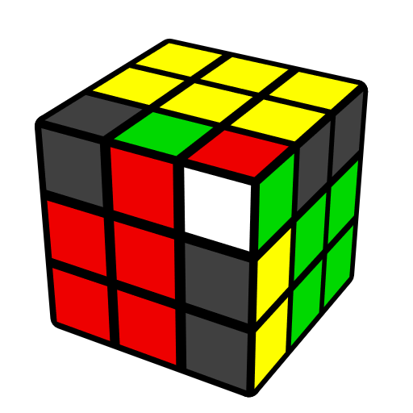 |  | 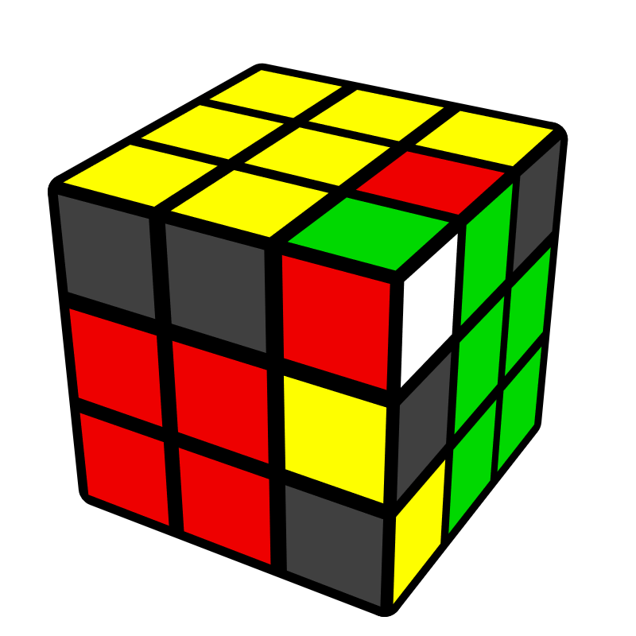 |  | 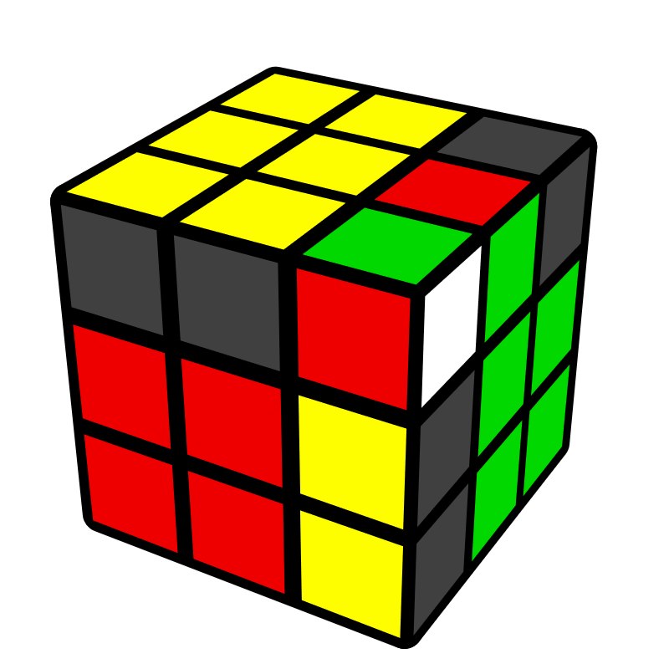
y' (R U2' R' U) (R2 U' R' U) (R' U R') | y' U R2' D' (R U' R' D) R2 |  | (R' U2 R U') (R2' U R  U') (R U' R) |  | U' R2 D (R' U R D') R2'
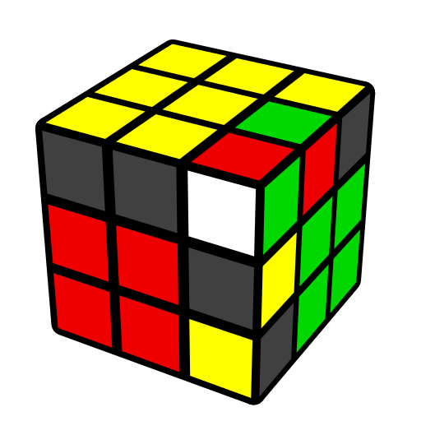 |  | 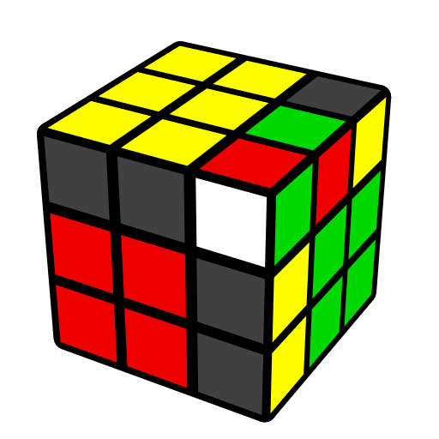 |  | 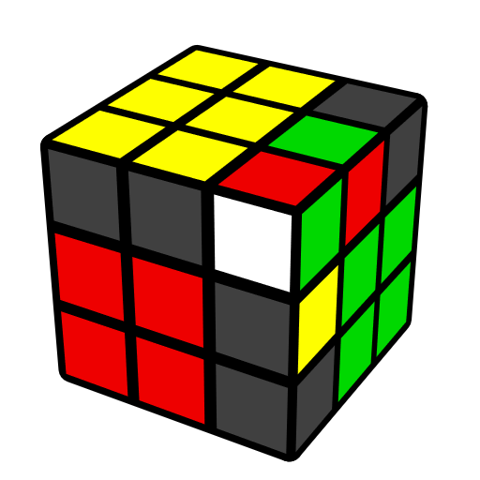
y' (R U2' R2' U' R2 U' R')  U' (R U R' U R U2 R') |  | y' U (R' U R U') (R U2' R2'  U' R2 U' R') |  | y' U (R U2' R2' U' R2 U' R')  (U2 R' U2' R)
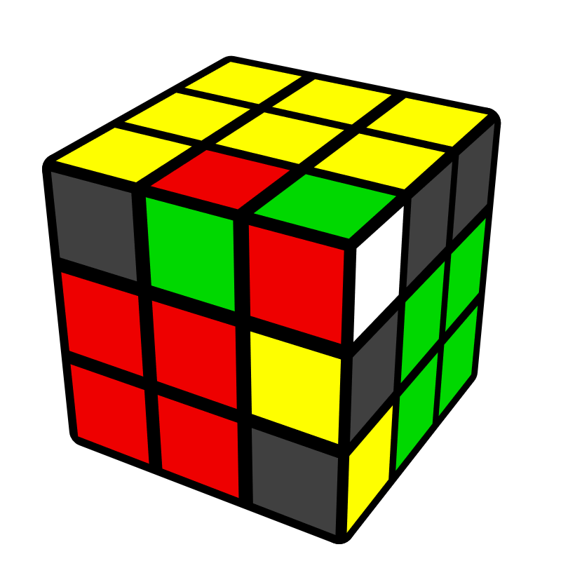 |  | 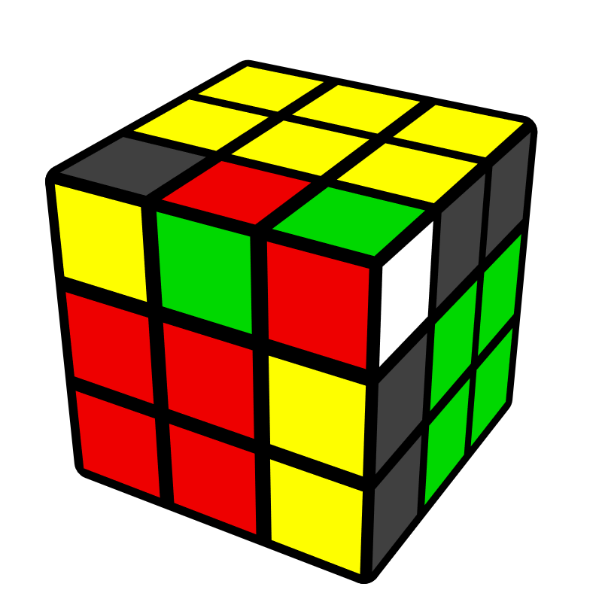 |  | 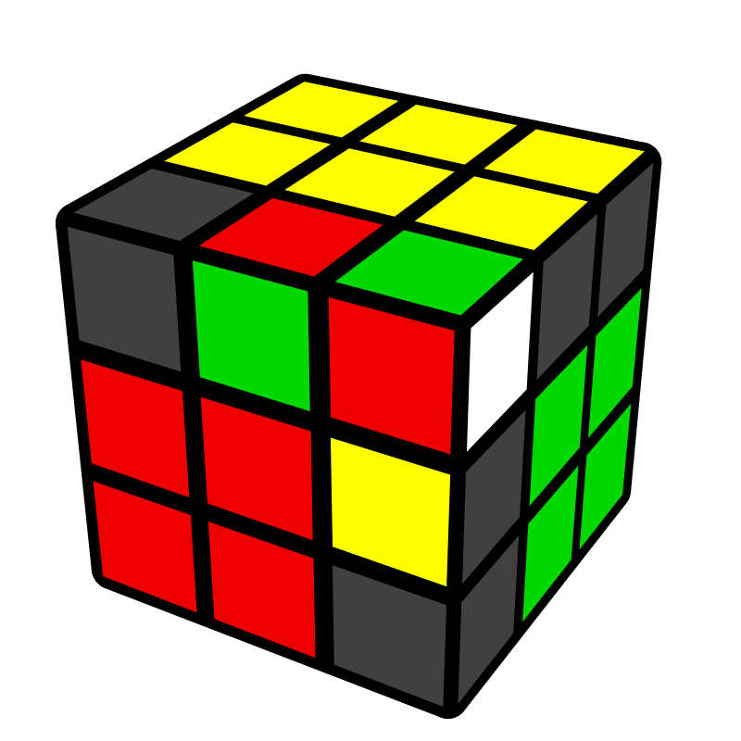
(R' U2' R2 U R2' U R) U2'  (R U2' R' U' R U' R') |  | U' (R U' R' U) (R' U2' R2 U R2' U R) |  | U' (R' U2' R2 U R2' U R)  (U2 R U2' R')
情况3 [2]
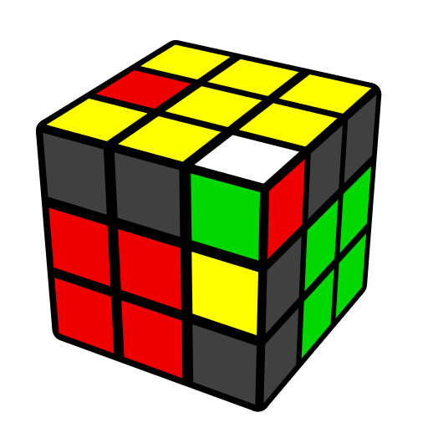 |  |  | 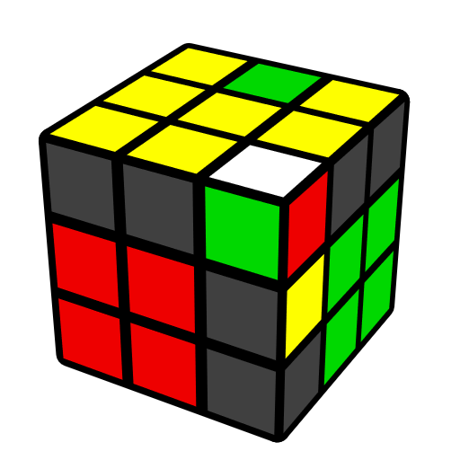
(R U' R' U2) (R U R') |  |  | y' (R' U R U2') (R' U' R)
错误连接 [24]
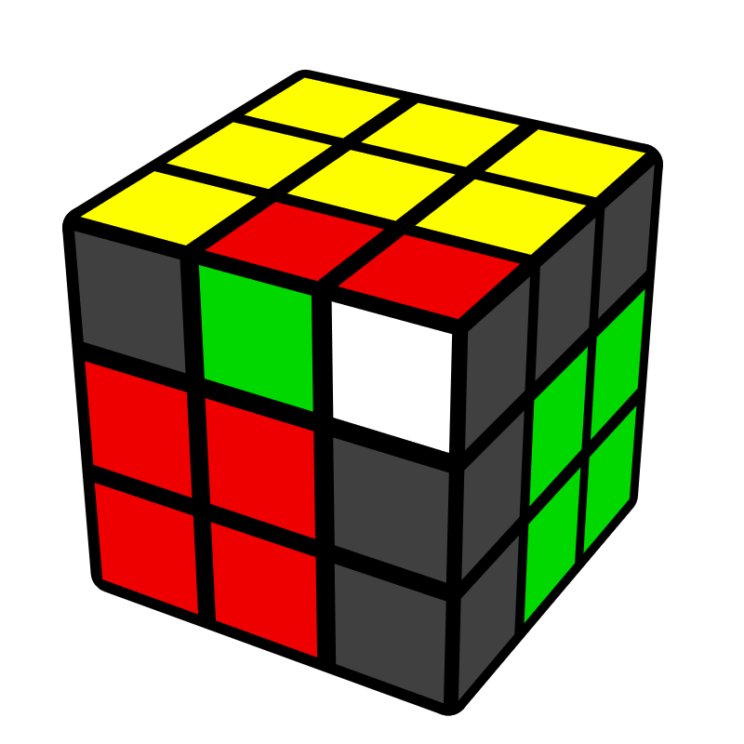 | 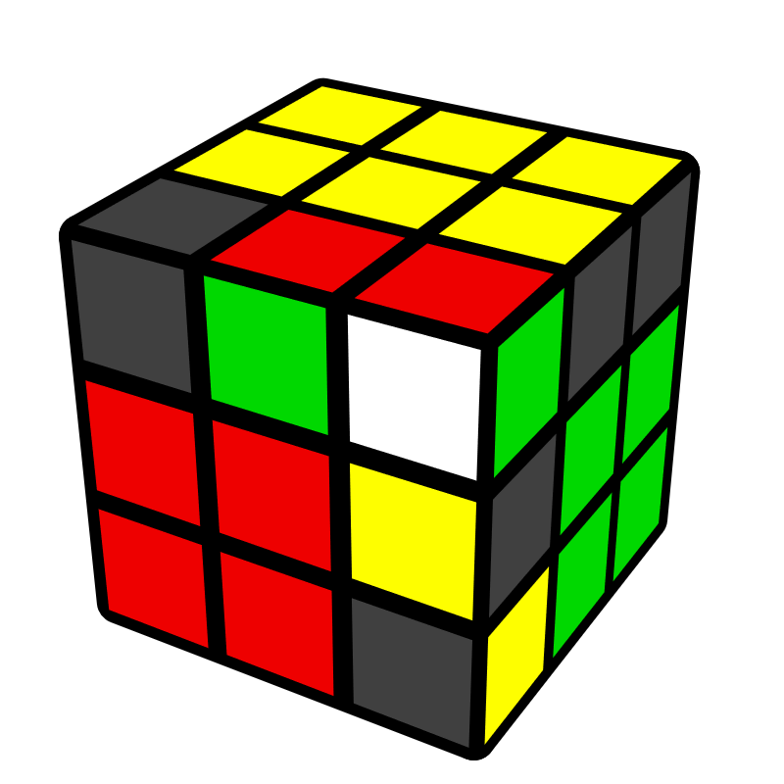 |  | 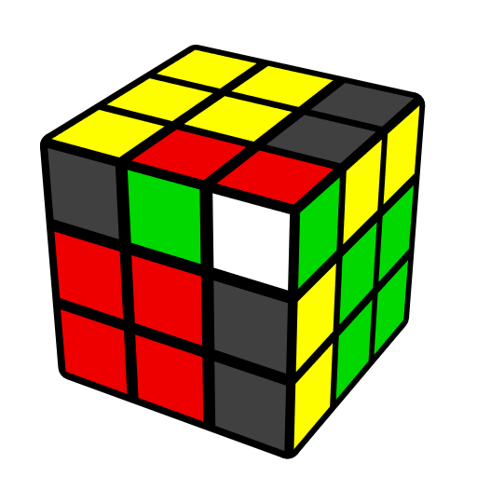 |  | 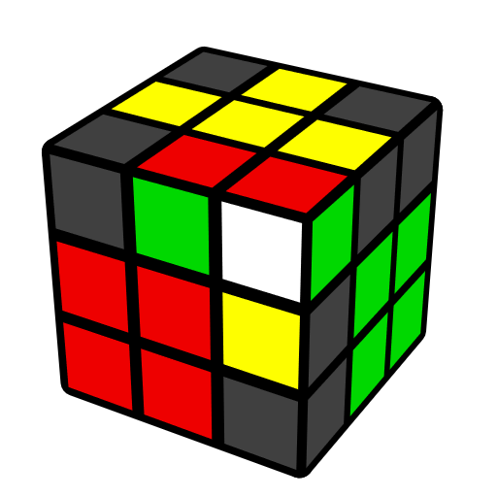
R' D' (R U' R' D)  (R U R U' R') | (R U' R U2') (R2' U' R2 U' R2') |  | y' (R' U R) U2'  y (R U R') |  | (R U R') U2 (R U' R' U)  (R U' R')
 | 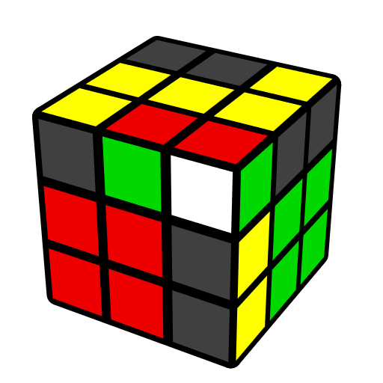 |  | 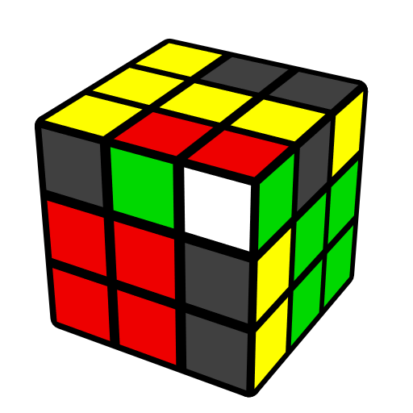
 | l U (r U' r' U') l' |  | M U (r U' r' U') M'
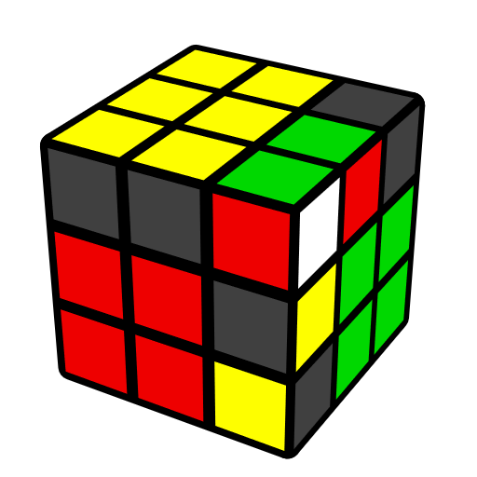 | 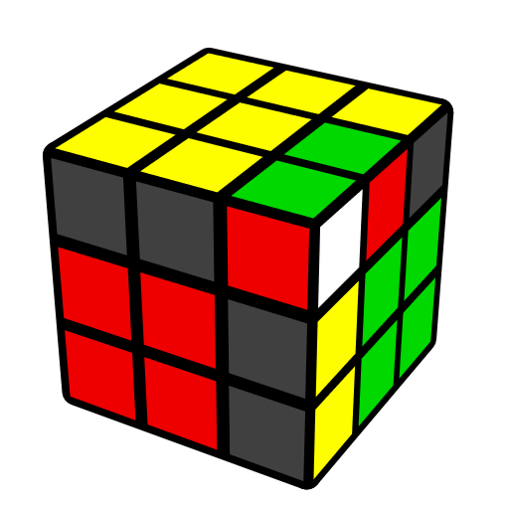 |  | 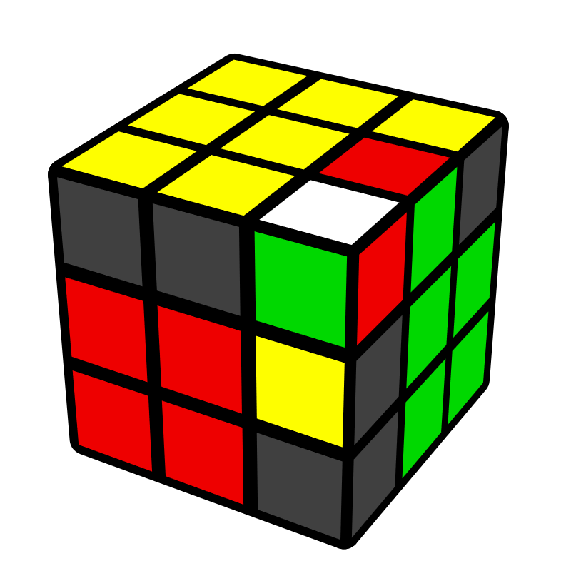 |  | 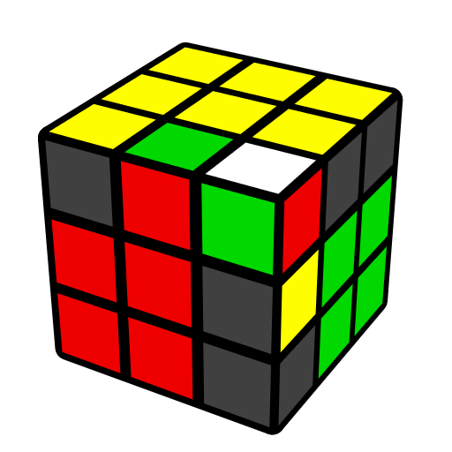
y' U (R U R2' U R2 U2') (R' U R' U' R) | y' U R' U' (R2 U R2' U R2 U2') (R' U R' U' R) |  | (R U2' R' U') (R U2' R' U) (R U2' R') |  | y' R' U2 (R U R' U2)  (R U' R' U2 R)
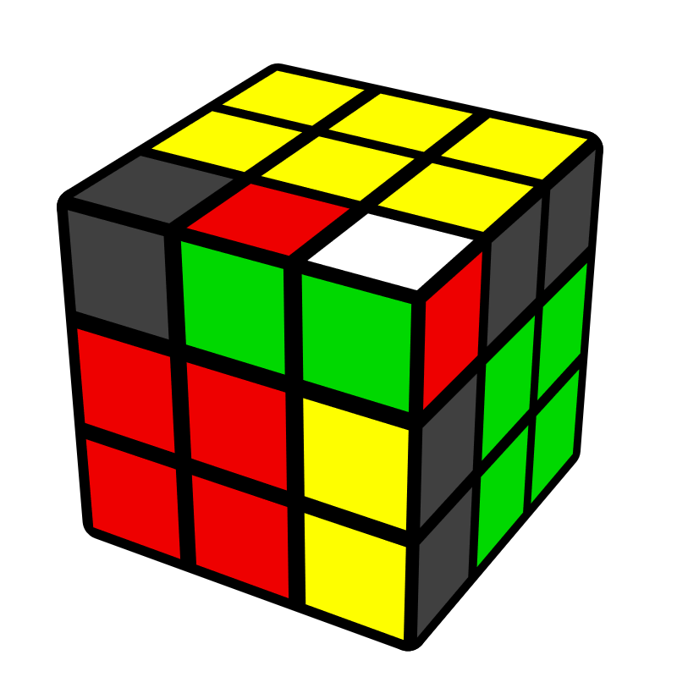 | 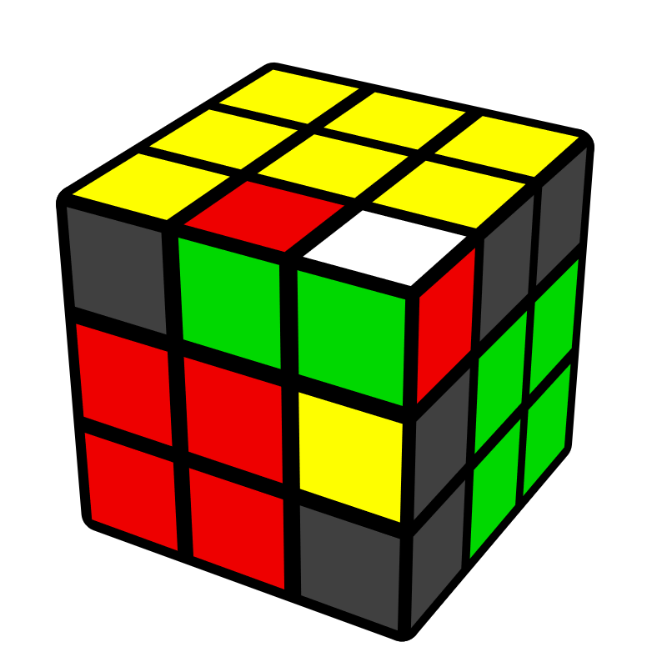 |  | 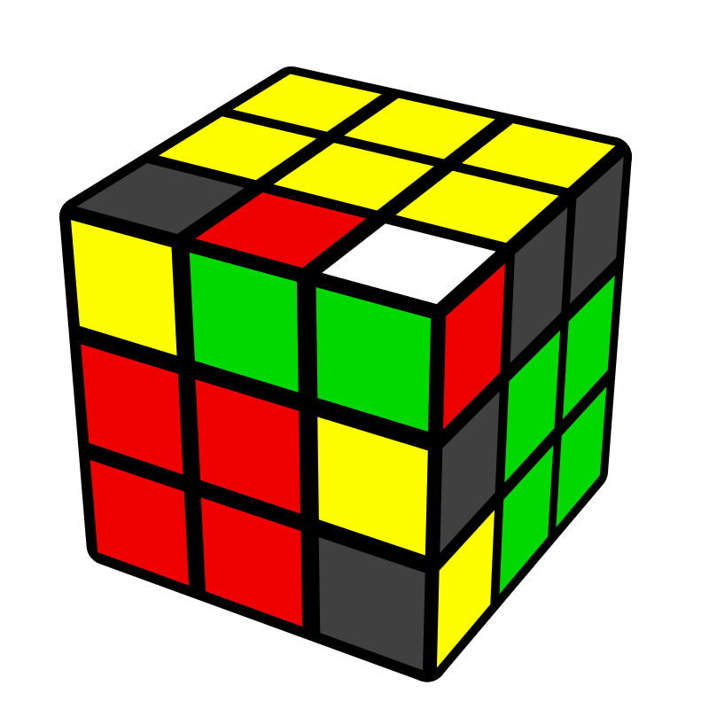 |  | 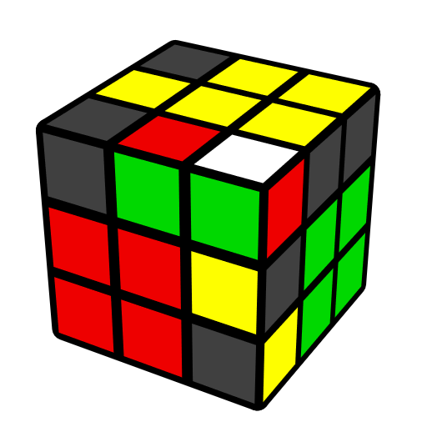
U (R U' R' U') (R U' R' U) (R U' R') | U (R U R U2') (R' U' R U' R2') |  | U (R U2' R' U') (R U' R' U2) (R U' R') |  | (R U R' U2') (R U R' U') (R U R')
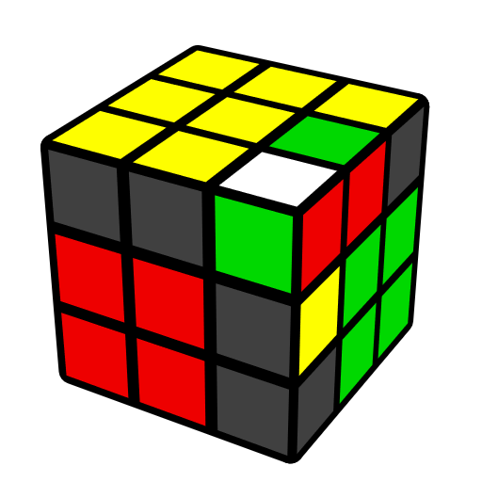 | 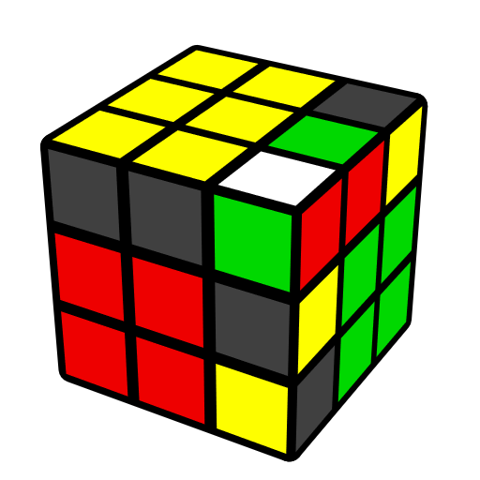 |  | 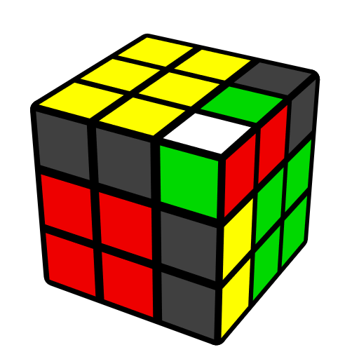 |  | 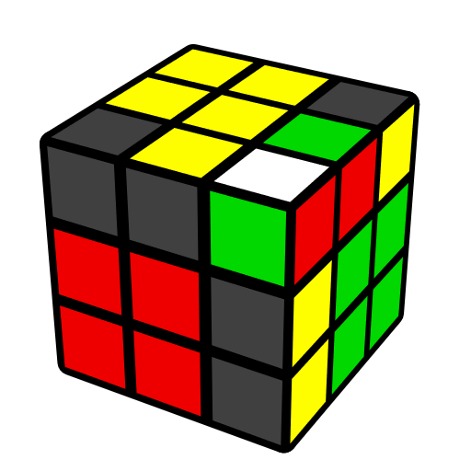
y' U' (R' U' R' U2)  (R U R' U R2) | y' U' (R' U2 R U) (R' U R U2) (R' U R) |  | y' U' (R' U R U) (R' U R U') (R' U R) |  | U' R U (R2' F R F')  (R U' R')
 | 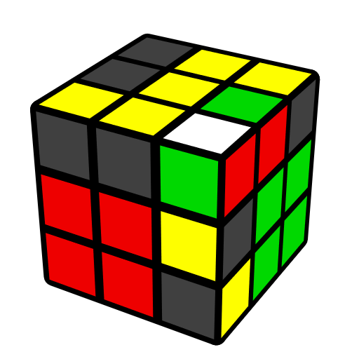 |  | 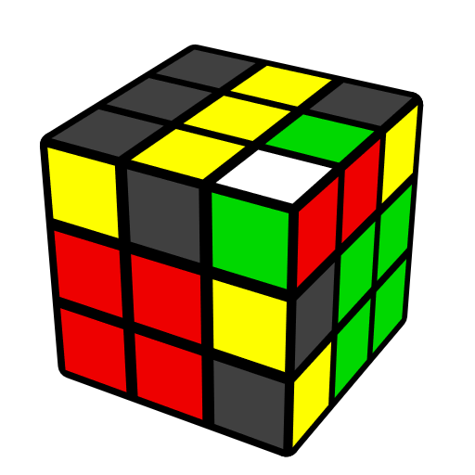
 | U' (R U' R' U') y' (R' U' R U' R' U R) |  | (R U' R' U) (r U' R' U)  (R U r')
角归位，棱顶层 [14]
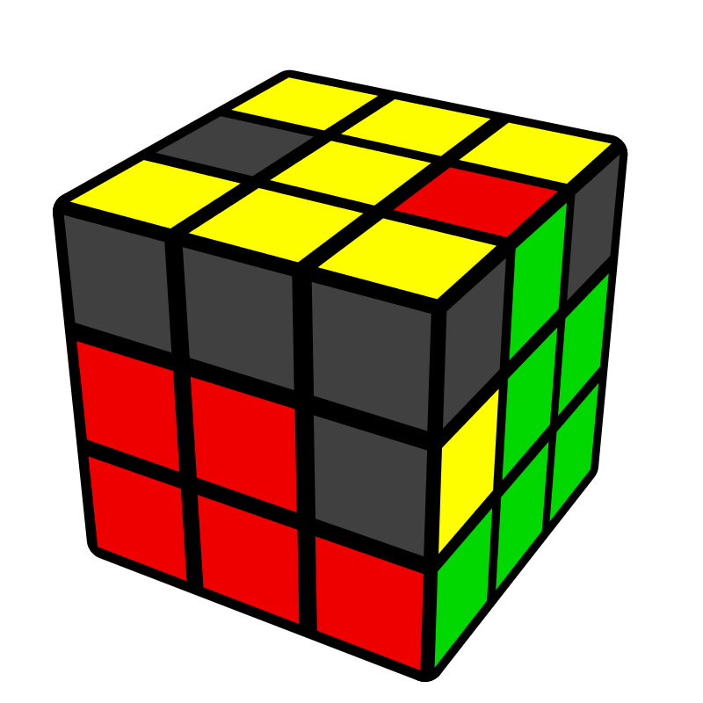 | 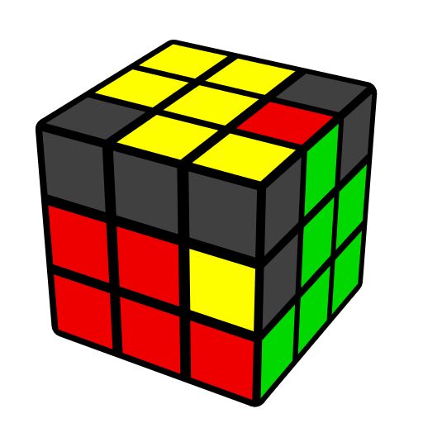 |  | 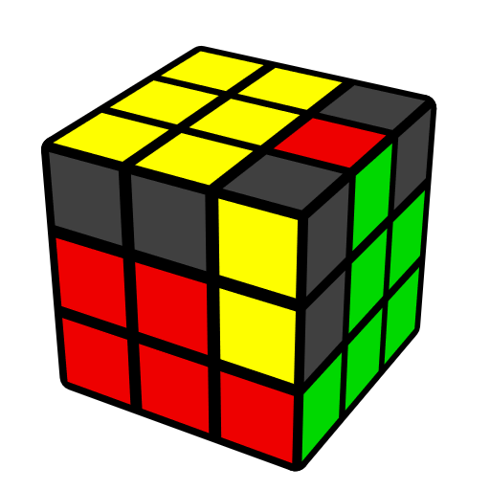 |  | 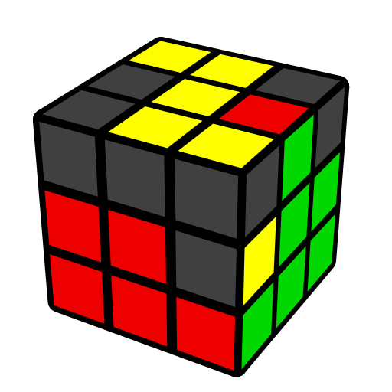
U' r (R' U R U')  r' (R U R') | U' F' (R U R' U') R' F R |  | (R' F' R U) (R U' R' F) |  | U F' U2' F U2' (R U R')
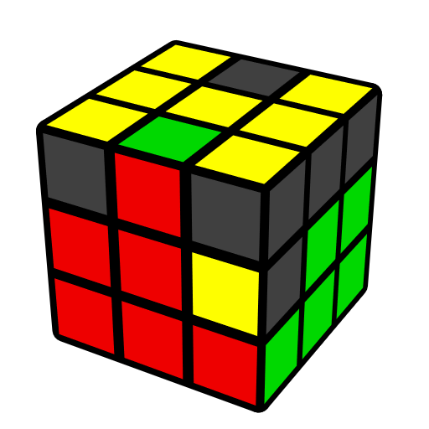 | 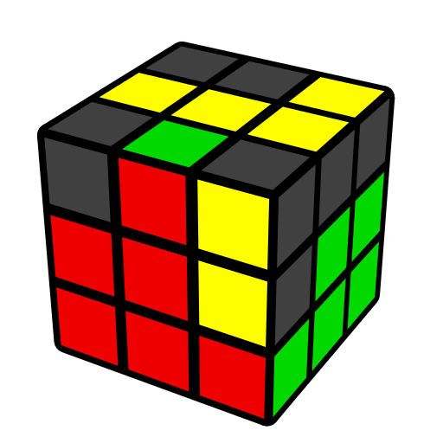 |  | 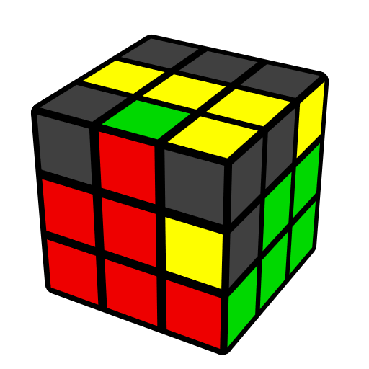 |  | 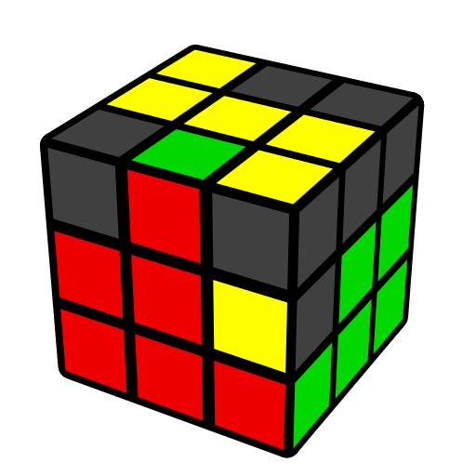
U (R U' R') (r U R' U') r' R | y' U x' (R U' R' U)  l' U' R |  | U (R U' R') (F R' F' R) |  | U' (R U2' R' U2)  (F' U' F)
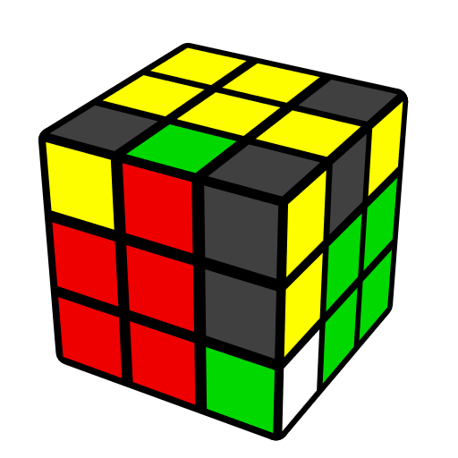 | 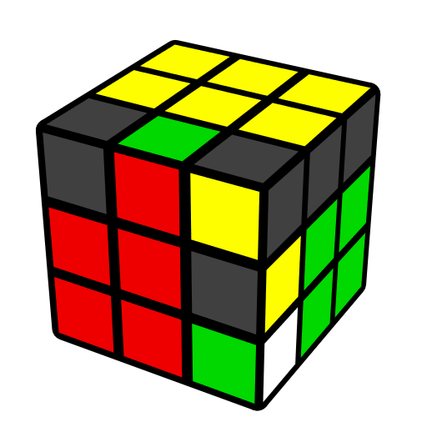 |  | 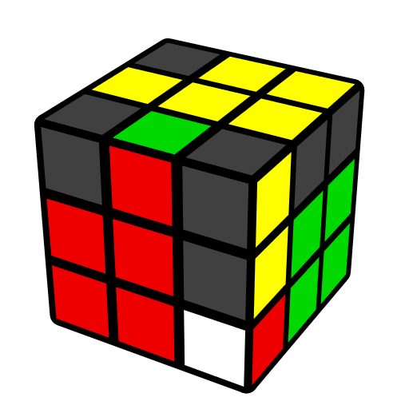 |  | 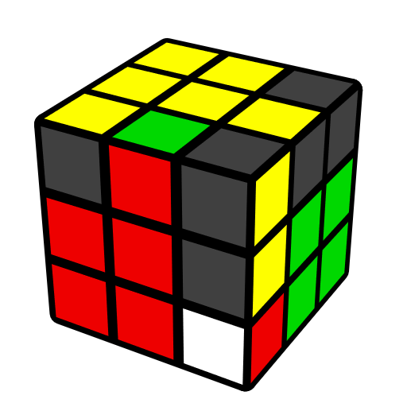
y' (R' U R U') (R' U R) | (R U R' U') (F R' F' R) |  | y' (R' U' R U) (R' U' R) |  | (R' F R F') (U R U' R')
 | 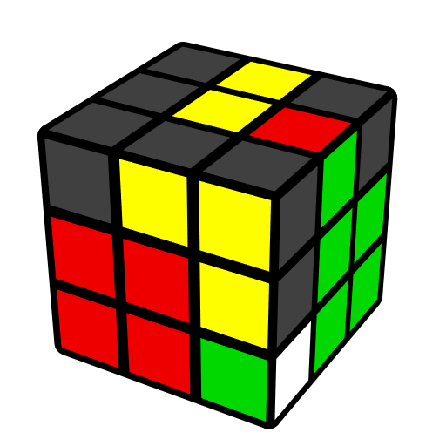 |  | 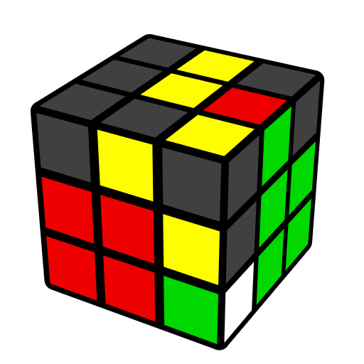
 | U' (F R' F' R2) U R' |  | U' R d' (R U' R' U') F'
棱归位，角顶层 [3]
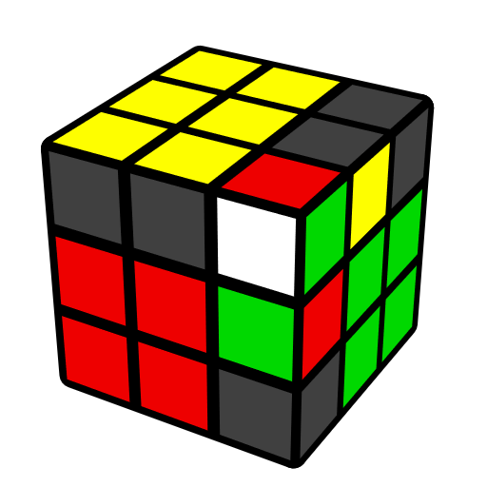 |  | 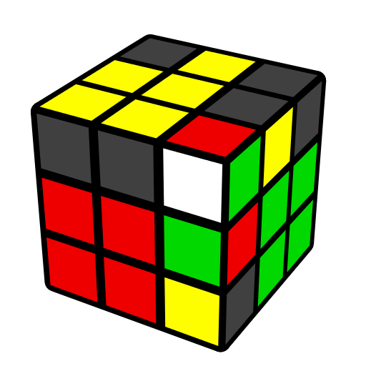 |  | 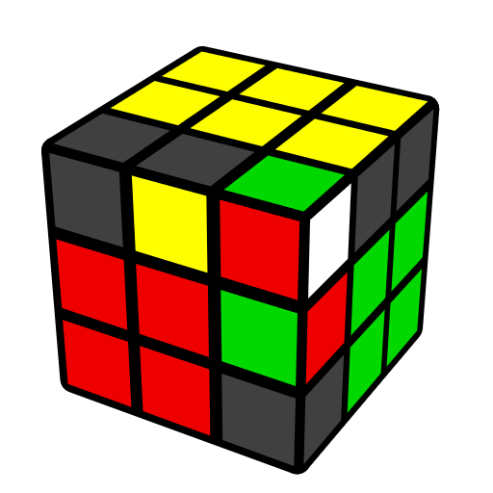
U' (R U R' d) (R' U' R) |  | U M' U R U' r' (R U' R') |  | U (R' U' R d') (R U R')
棱角归位 [11]
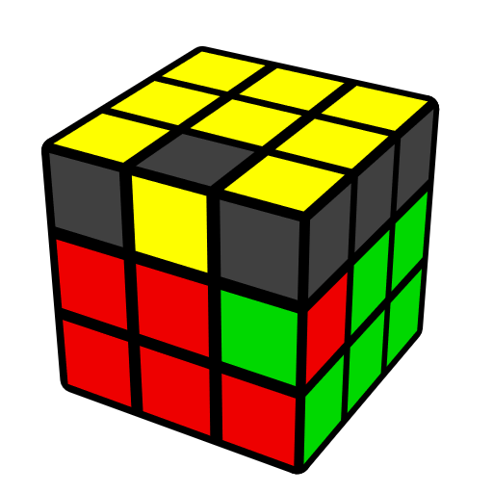 | 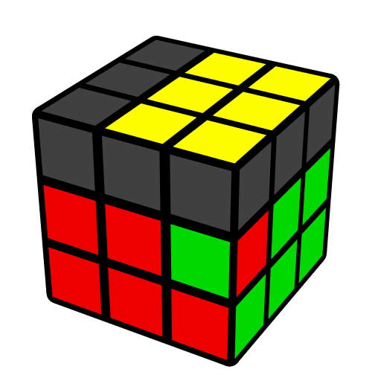 |  | 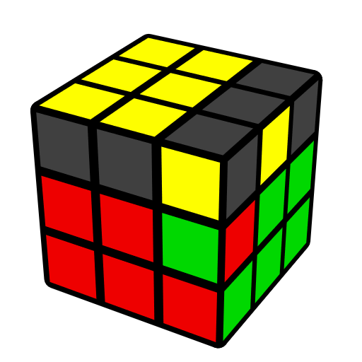 |  | 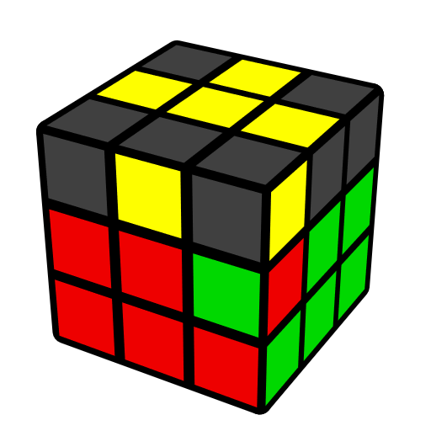
(R' F R F') (R' U2' R2 U R2' U R) | (R' F R F') (R' U2' R2 U R2') F' U F R |  | (R2 U2' R2' U') (R U R U2) R2' U' (F' U' F) |  | (R U' R' d) (R' U2 R U2') (R' U R)
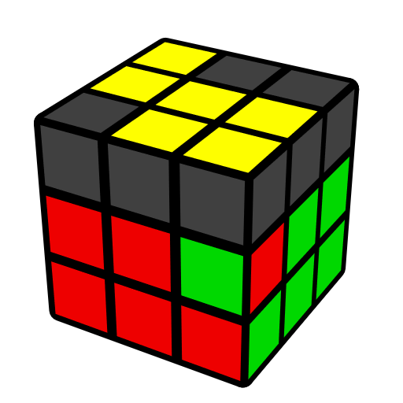 |  | 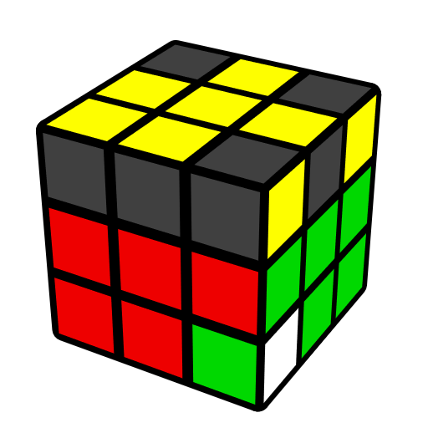 |  | 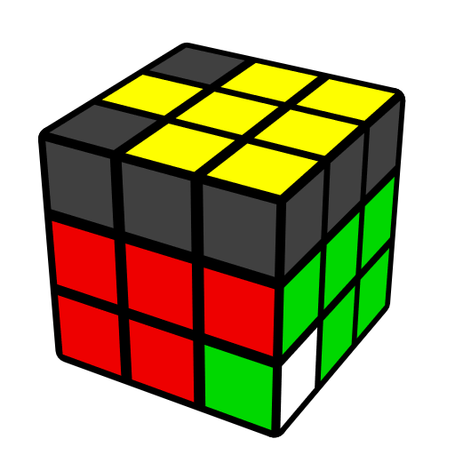
(R U2' R' U)2 y' (R' U' R) |  | (R U' R' U) (R U2' R' U)  (R U' R') |  | (R U R' U2') (R U' R' U)  (R U R')
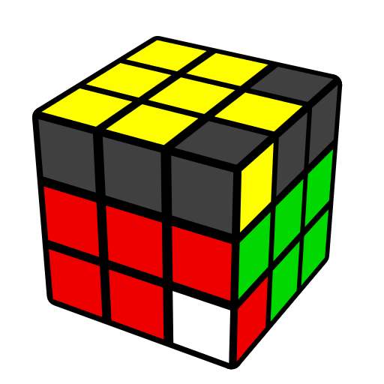 | 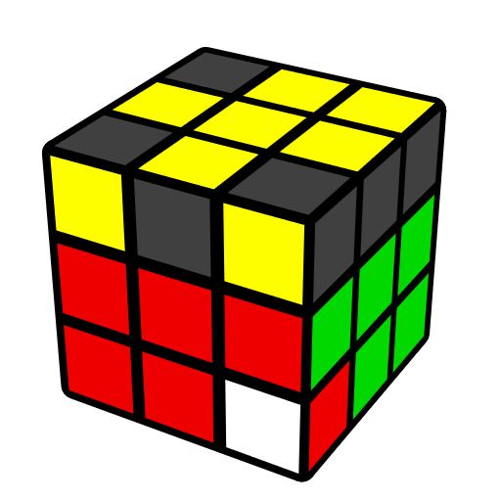 |  | 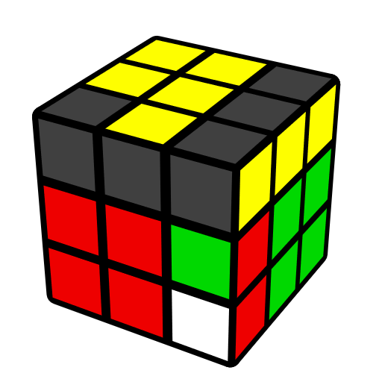 |  | 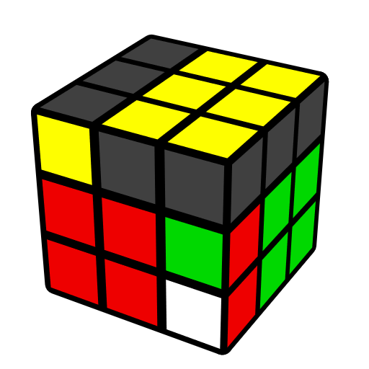
(R U' R' U') (R U R' U2) (R U' R') | (R U R' U') (R U2' R' U') (R U R') |  | (F' U F) U2 (R U R' U)  (R U' R') |  | (R U' R') F (R U R' U') F' (R U' R')

