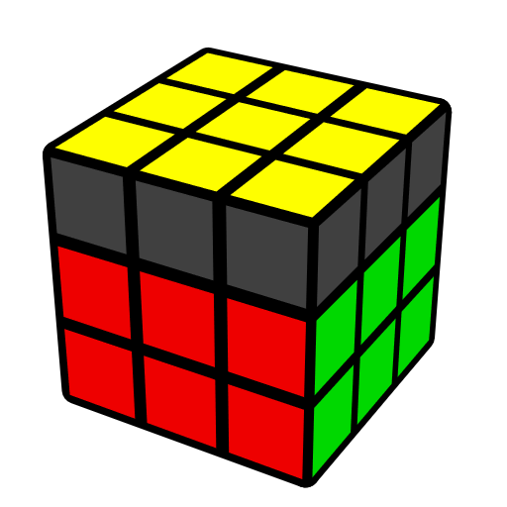
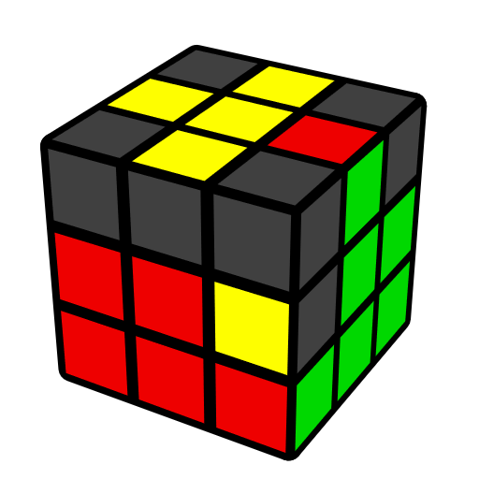
BLE Algorithms (Brooks' Last Edge)
Algorithms from Feliks Zemdegs, Anthony Brooks

BLE [27] insert last F2L edge into slot and orient LL corners, assuming LL edges are oriented. Prerequisite: COLL.
BLE = pure BLE; BLE = break F2L corner + solve F2L; BLE = insert F2L edge directly + OLL.

CO [1] |  | H [2]
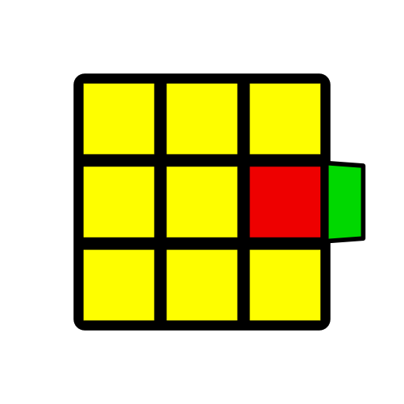 |  | 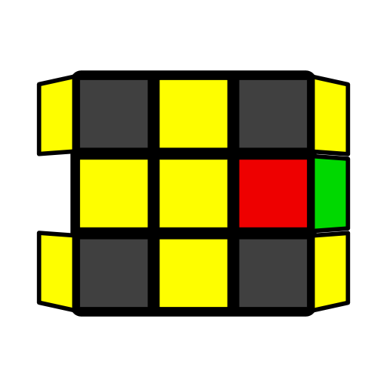 | 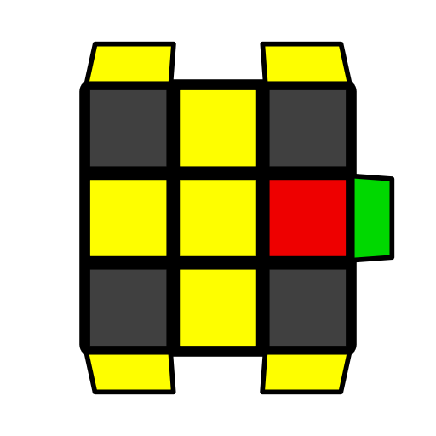
U (R U' R' U') (R U2' R' U R U R')  R' U' (R' U' R' U) (R U R) |  | U' (R U' R' U') (R U R' U R U R') | (R U' R' U') (R U' R' U R U R')
S [4]
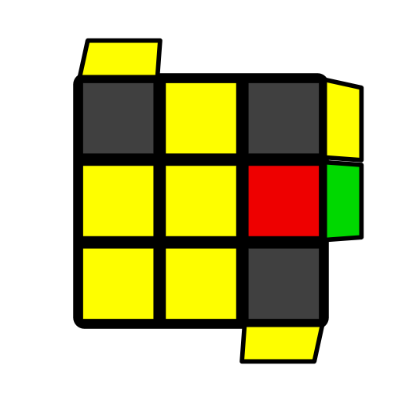 | 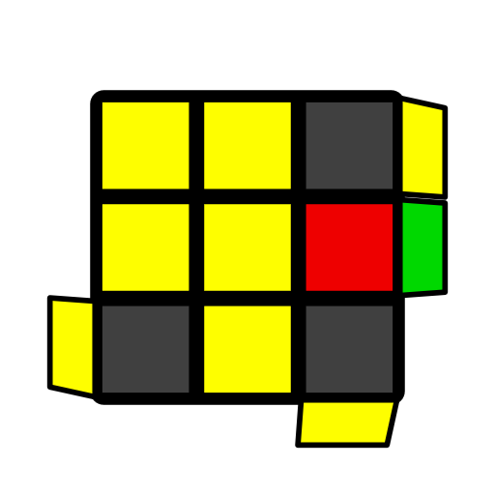 | 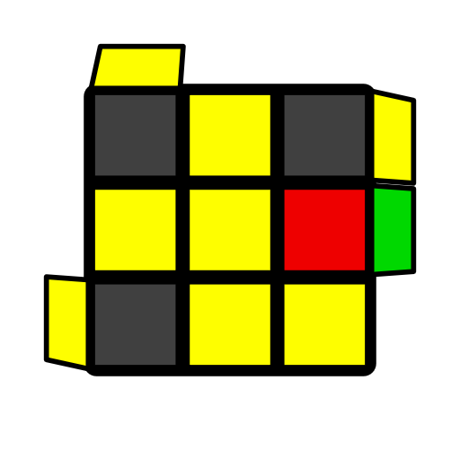 | 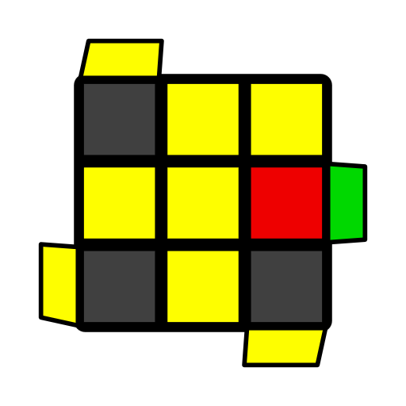
(R U R' U2') (R U R' U2' R U' R') | U' (R U' R' U R U R')  U (R U2' R' U R U R') | U (R U' R' U) (R U R' U2' R U R') | U' F' (R U R' U') (R' F R)  U R' U2' R U R' U R
AS [4]
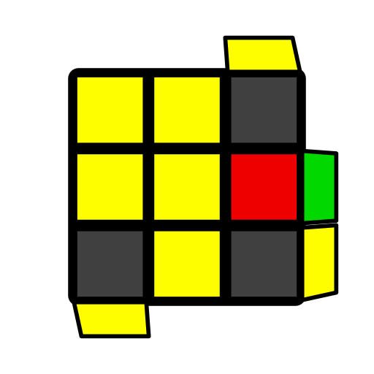 | 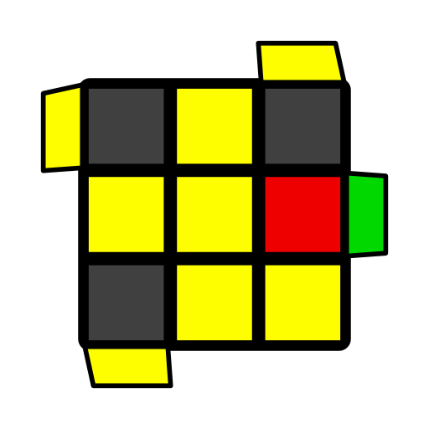 | 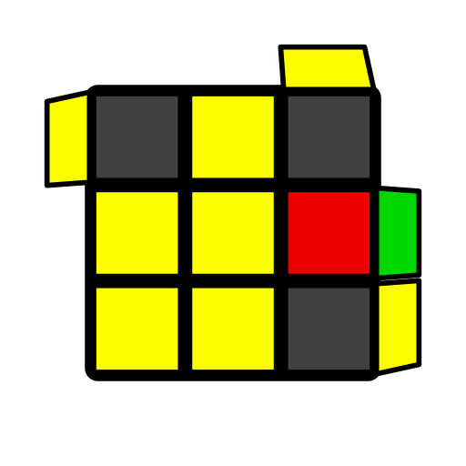 | 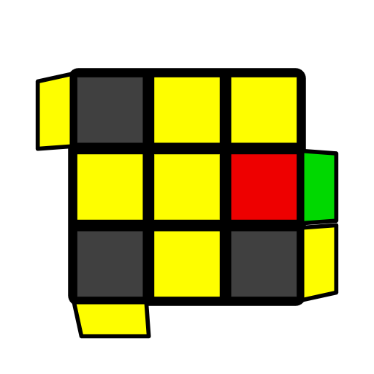
U' F' (R U R2' U') (R' F R U R) | U' (R U' R' U2) (R U' R' U' R U R') | U' (R U R' U2') (R U' R' U2 R U' R') | U' F' (R U R' U') (R' F R)  U R U2' R2' U' R2 U' R2' U2' R
L [4]
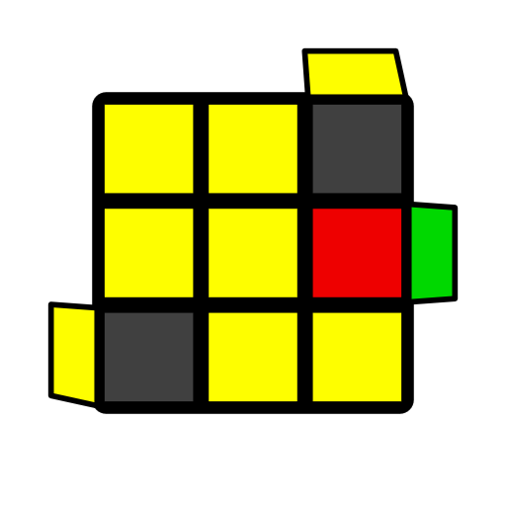 | 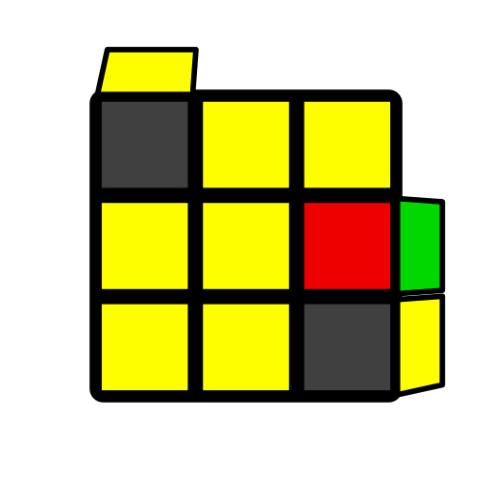 | 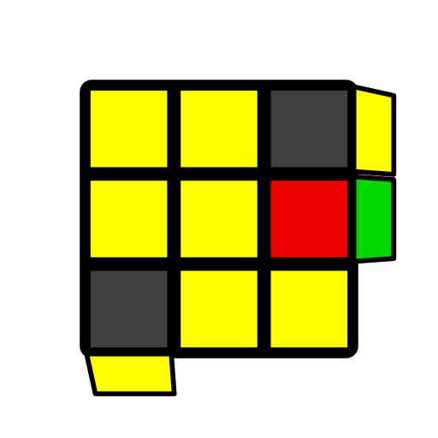 | 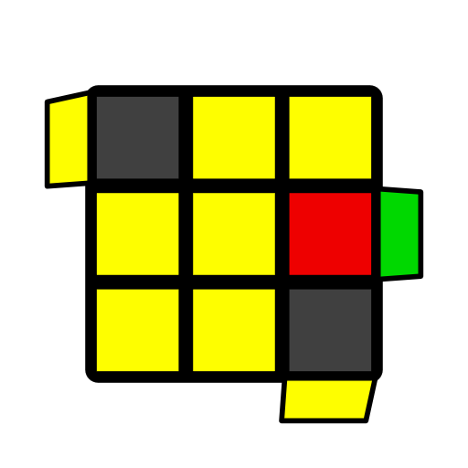
U' F' (R U R' U') (R' F R) | U2 (R U2' R' U') y' (R' U2 R U' R' U' R) | U (R U' R' U) y' (R' U R U R' U2' R) | (R' F' R U) (R U' R' F)  U2 (r U R' U') (r' F R F')
T [4]
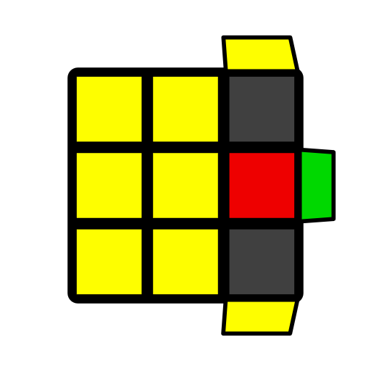 | 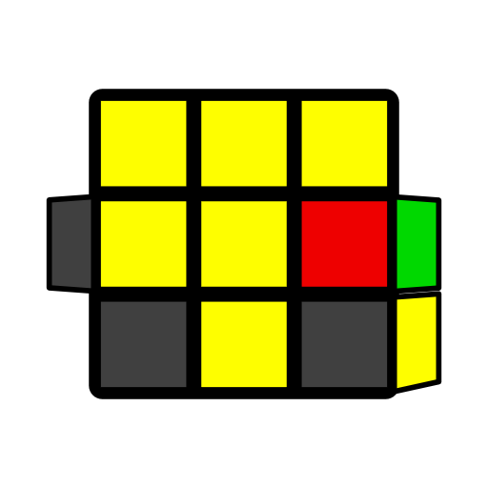 | 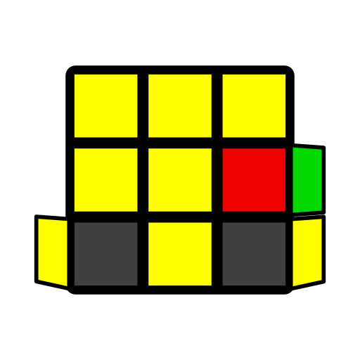 | 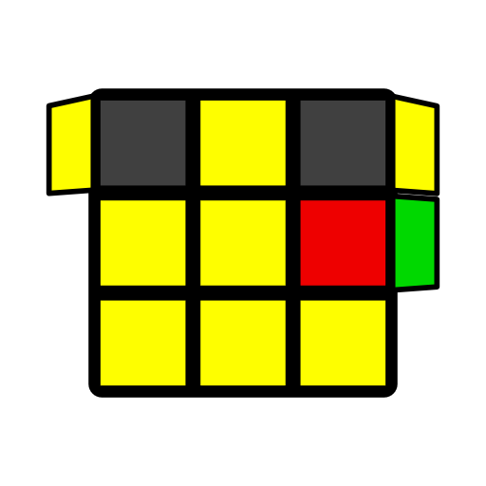
(R' F' R U) (R U' R' F) | (R' F' R U) (R U' R' F)  U R' U2' R U R' U R | U' F' (R U R' U') (R' F R)  R2' D' (R U2 R' D) (R U2 R) | U' F' (R U R' U') (R' F R)  R' U' R U' R' U2 R
U [4]
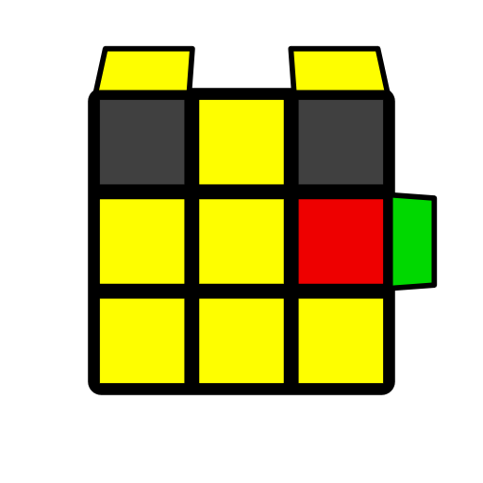 | 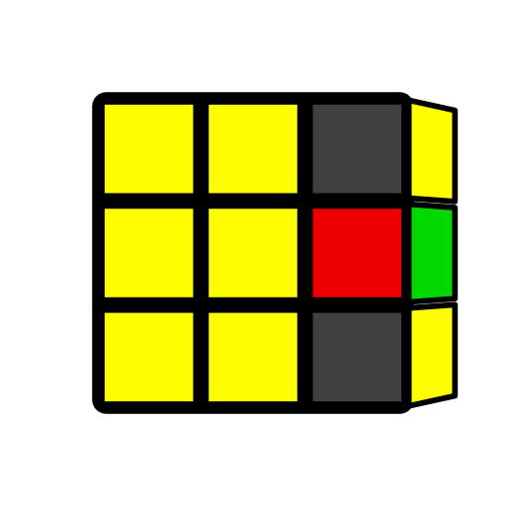 | 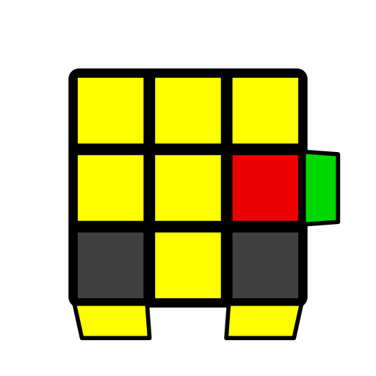 | 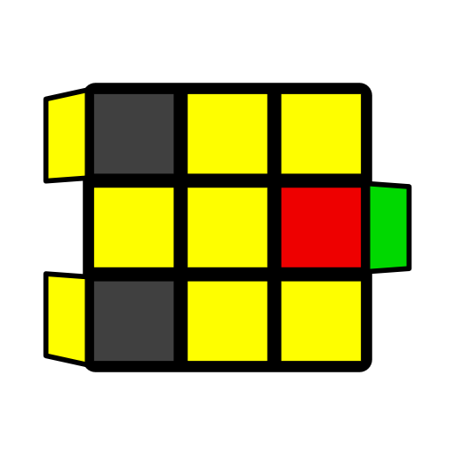
U' (R' D' R U') (R' D R U) (R U R') | U (R U' R') (U' R' D' R) (U R' D R) | U' F' (R U R' U') (R' F R)  R U R' U R U2' R' | U' (F' R U R') (U' R' F R)  R2 D (R' U2 R D') (R' U2 R')
Pi [4]
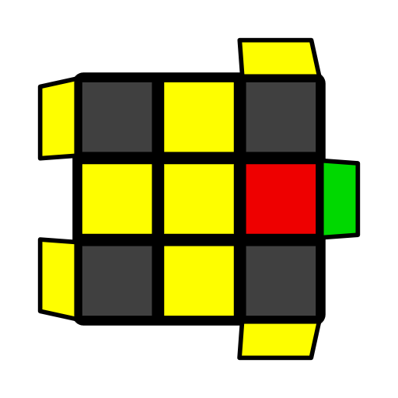 | 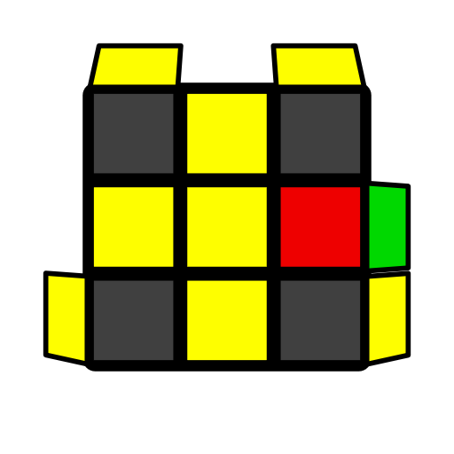 | 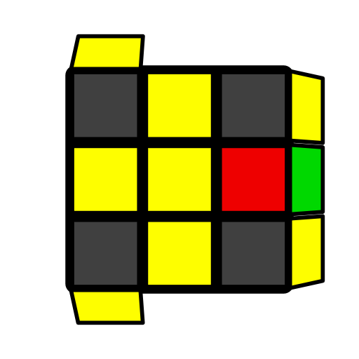 | 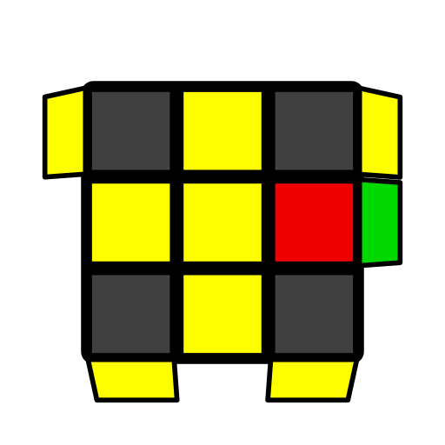
(R U2' R' U) (R U2 R' U') (R U2 R') | (R U R' U2') (R U R' U') (R U2 R') | U2 (R U2' R' U) (R U' R' U2 R U' R') | U2' (R U R' U2') (R U2' R' U2 R U' R')

