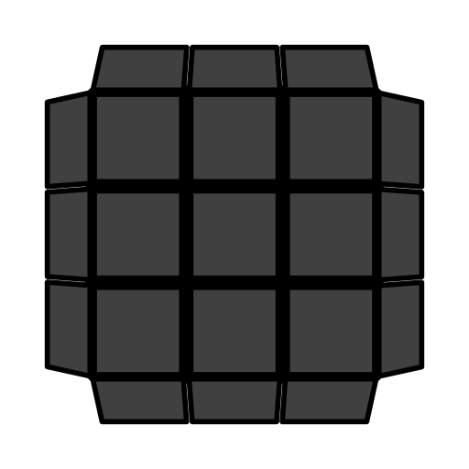
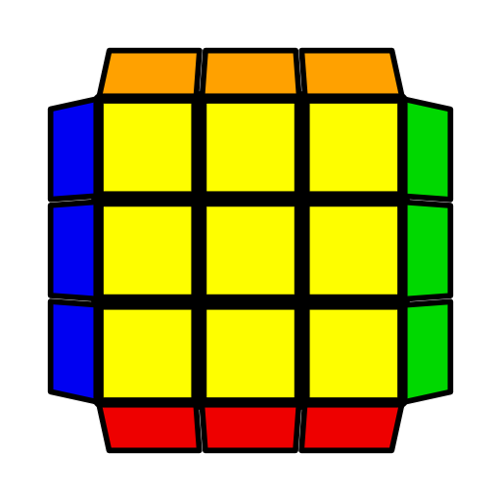
PLL Skip Prediction, Easy 1LLL Algorithms

This page does not include OCLL (see ZBLL page). All bold algorithms are from OLL page. Suggested OLL.

T-Shapes
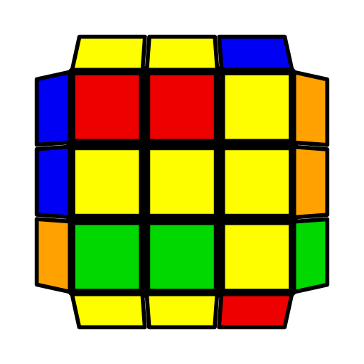 | 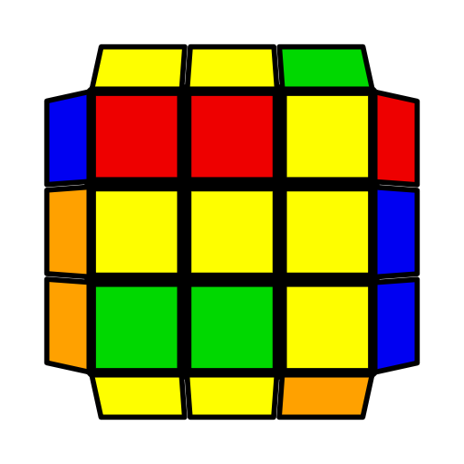 | 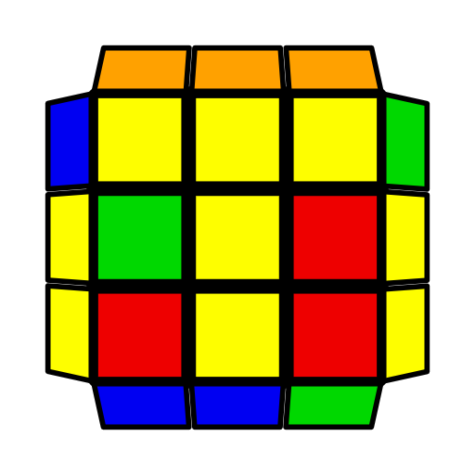 | 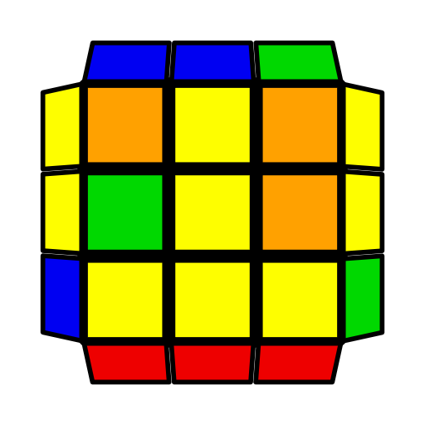 | 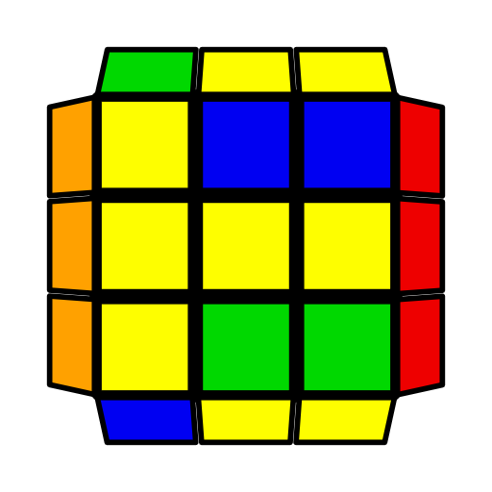
(R U R' U') (R' F R F') | F (R U' R' U) (R U R' F') | (R' U2' R U R' U R) (r U2' R' U' R U' r') | (R U2' R' U' R U' R') (r' U2' R U R' U r) | (r U' r' U') (r U r' U2) (r' D' r U') (r' D r)
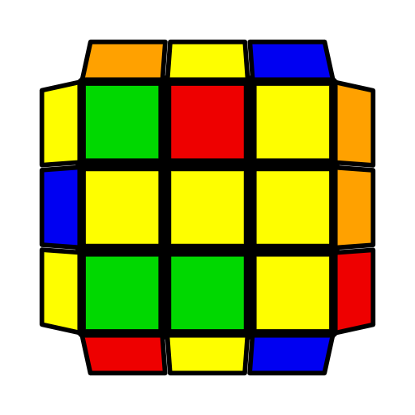 | 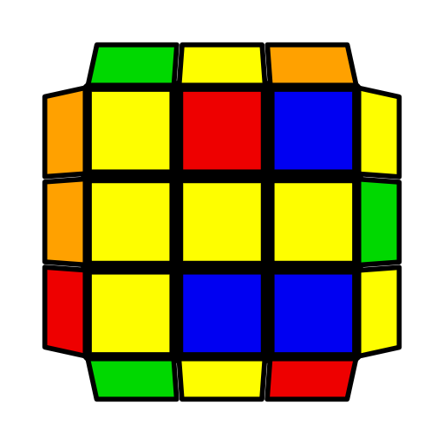 | 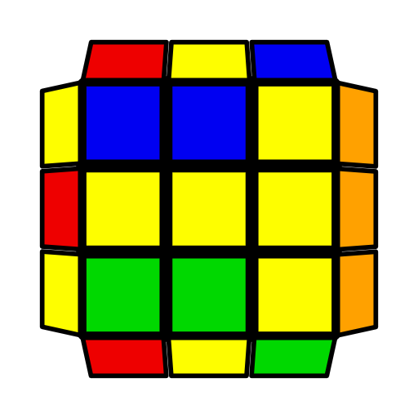
F (R U R' U') F' | F' (L' U' L U) F | F U (R U' R' U)2 y' (R' U R U') (R' U R U2' R')
Squares
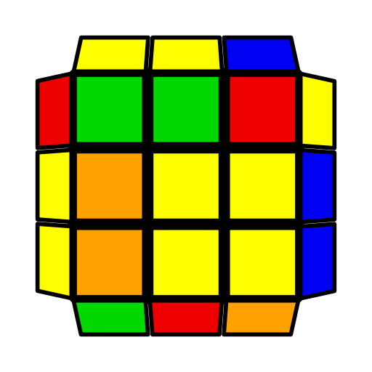 | 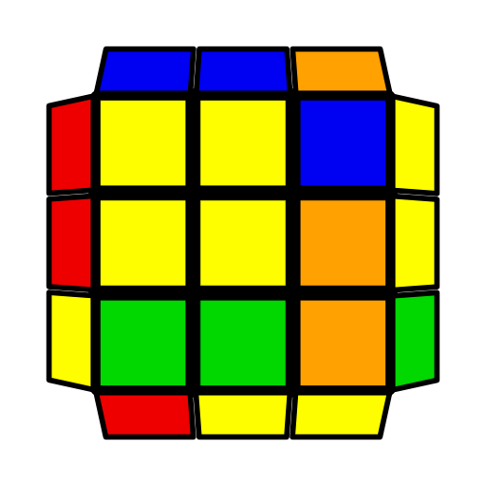 |  | 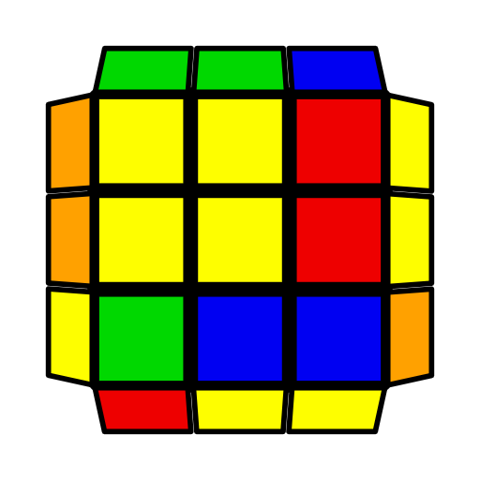
r' U2' R U R' U r | (R' U' R U') y x' R2 U' R' U l' | R' U' R U' y x' R2 U' R' U R' x | F U' R2 D (R' U R D') R2 U F'
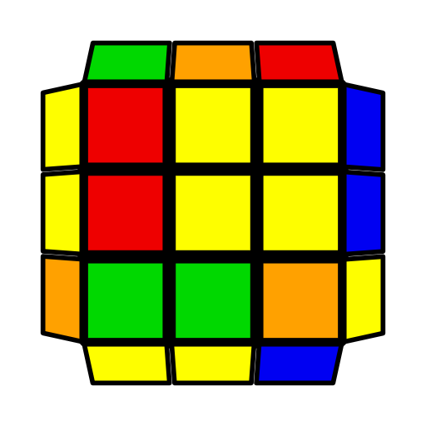 | 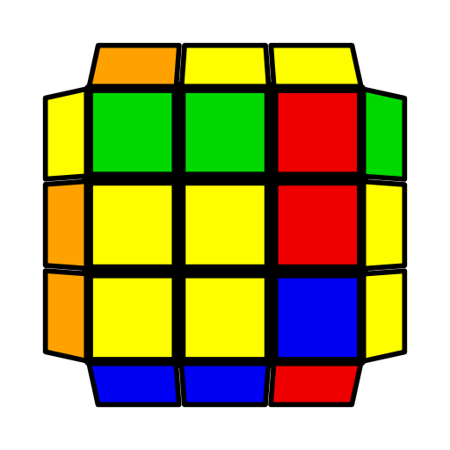 | 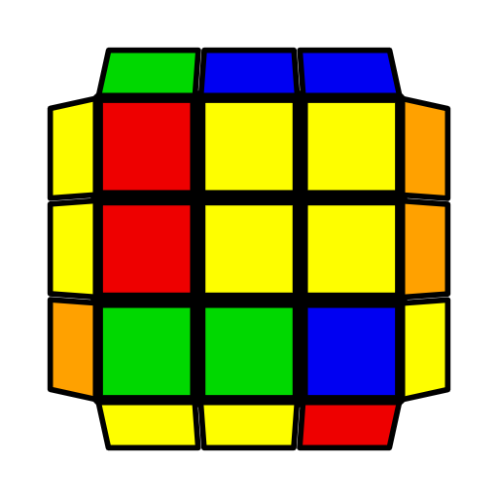
r U2' R' U' R U' r' | R U R' U y' R2' F R F' R | F U' R2 D (R' U' R D') R2 U F'
C-Shapes
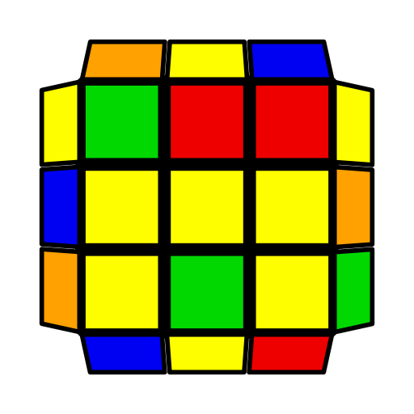 | 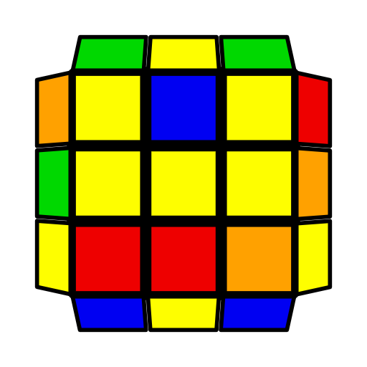 | 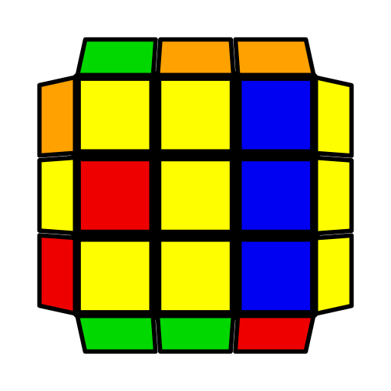 | 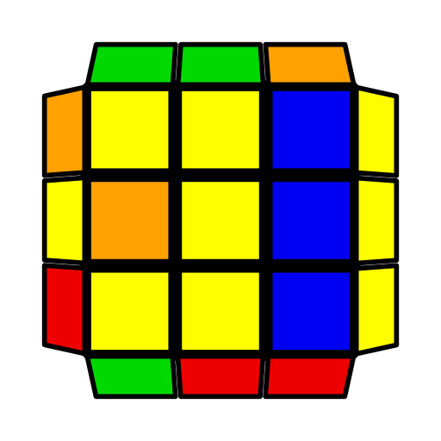 | 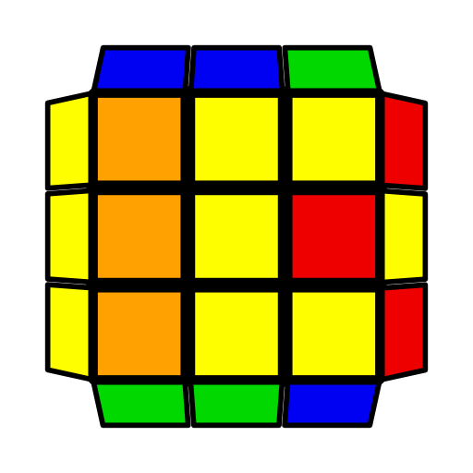
(R U R2' U') (R' F R U) R U' F' | (R U R' U') (R' F R F') (R' U' R U' R' U2 R) | R' U' (R' F R F') U R | R U l U' R' U x U' R' | R' D (R' U' R U D') R U' F (R2 U R' U') F'
W-Shapes
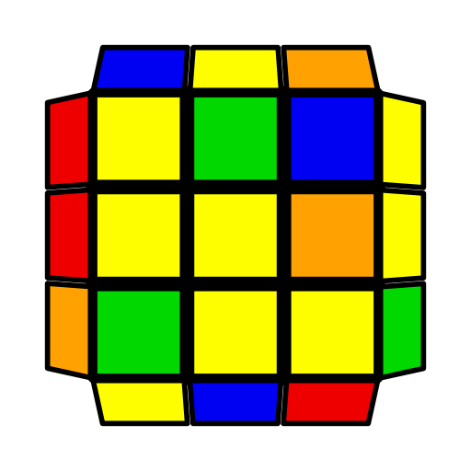 | 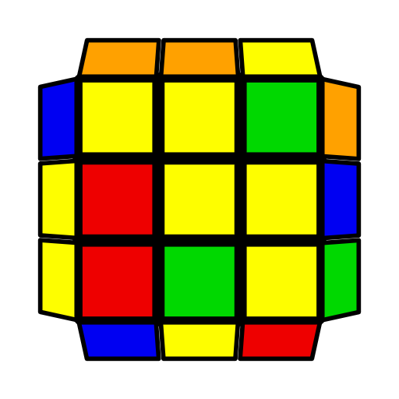 | 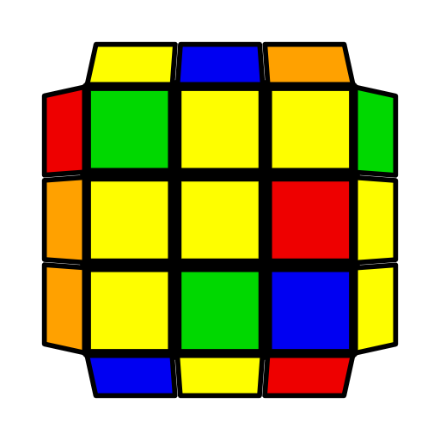
(R' U' R U') (R' U R U) x' (R U' R' U) x | (R U R' F') (R U R' U') (R' F R U') (R' F R F') | (R U R' U) (R U' R' U') (R' F R F')
OELL
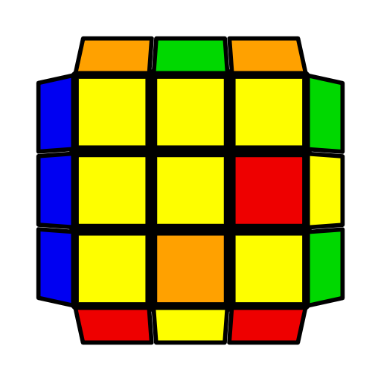 | 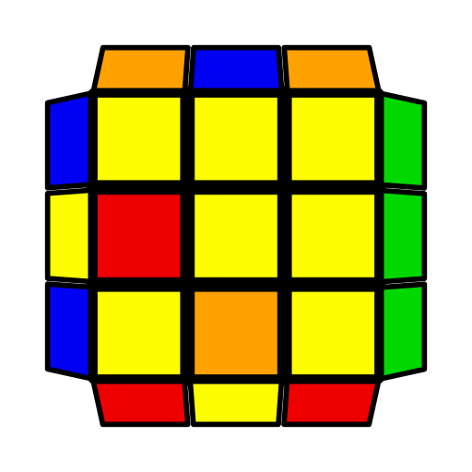 | 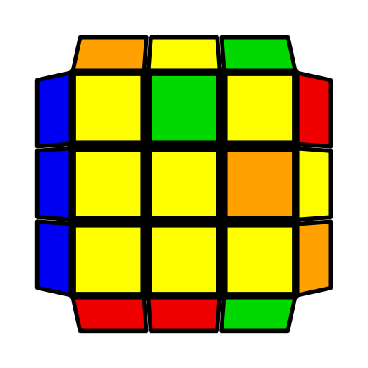 | 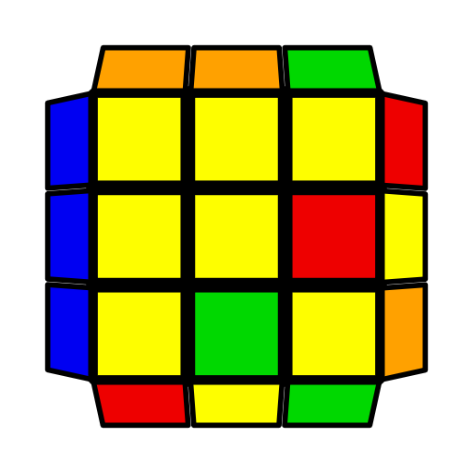 | 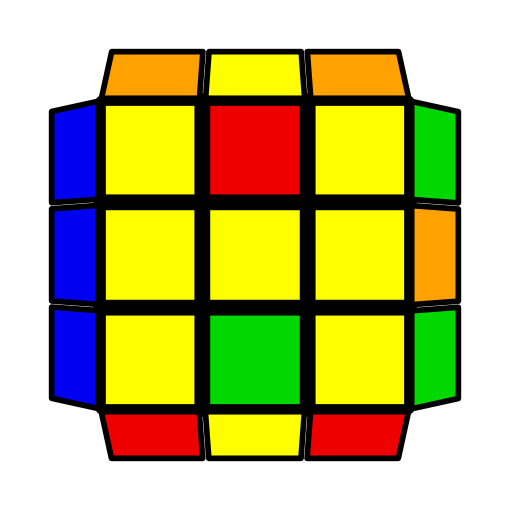 | 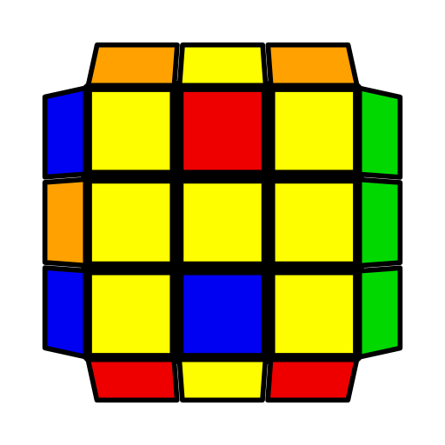
(r U R' U') r' (R U R U' R') | (l' U' L U) l L' (U' L' U L) | l (R U R' F') (R U R' U') R' F R2 U' R' U' l' | l' U' (R' U L' U2) (R U' R' U2 R) L l | (R U R' U') r (R' U R U' r') | (L' U' L U) l' L (U' L' U l)
P-Shapes
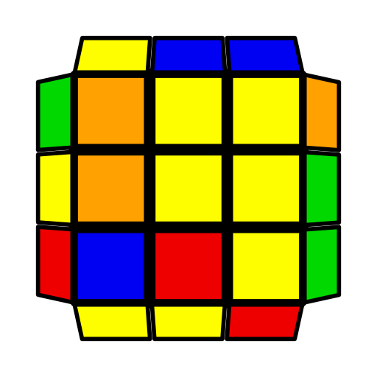 | 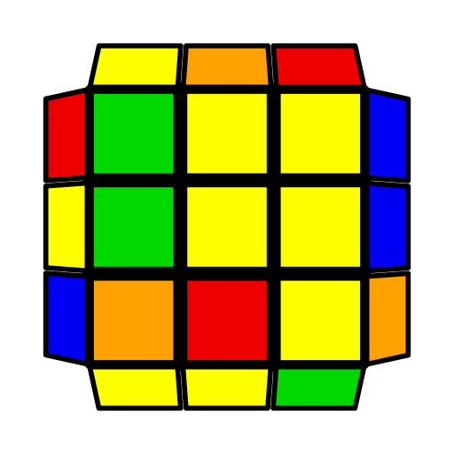 | 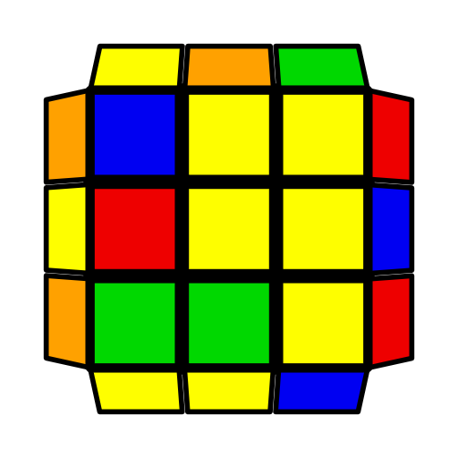 | 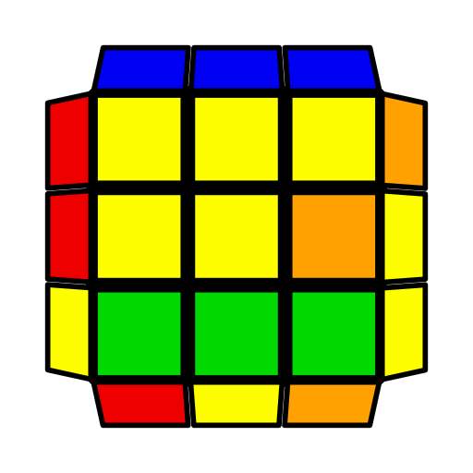
(R' U' F) (U R U' R') F' R | (r U' r') y' R U (R U R' U') (R U' R') | (r U2' R' U') (R2 U' L' U) R' U' x' | (r U' r' U') (r U' r' U2)2 (r U r' U') (r U r')
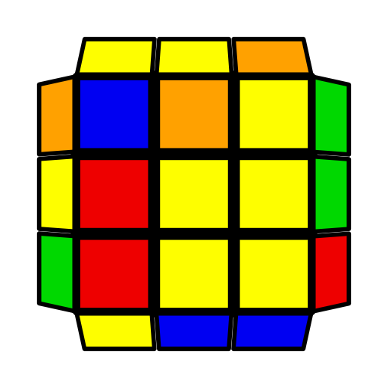 | 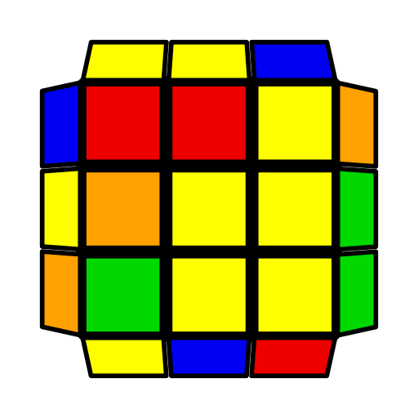 | 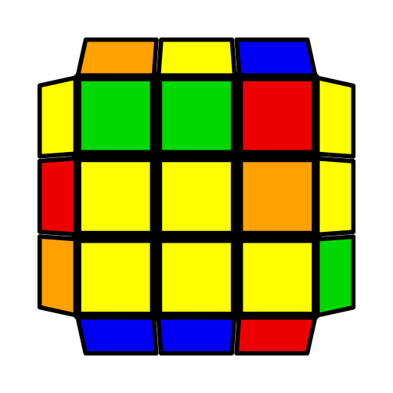 | 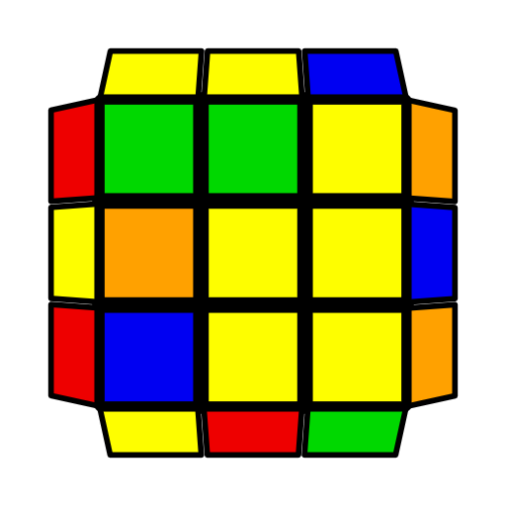 | 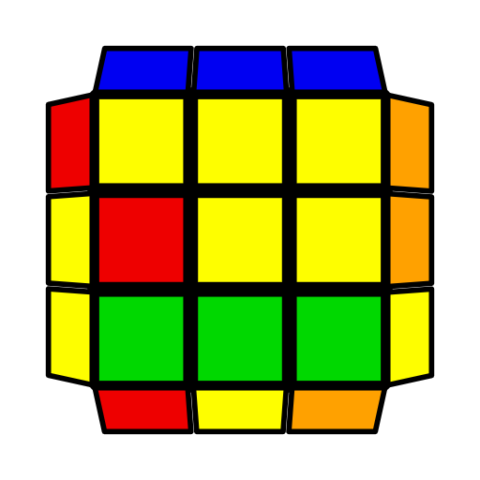
(R U B' U') (R' U R B) R' | S (R U R' U') (R' F R f') | x' (U' R U R') x U' (R' U' R U) (R' U R) | (r' U2' R U) (R2 U L U') R U x | (F R U' R' U' R U R' F') (R U R' U' R' F R2 U R' U' F')
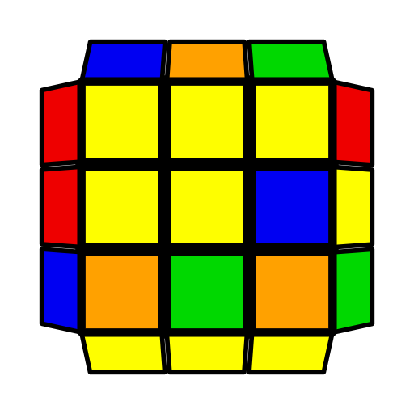 | 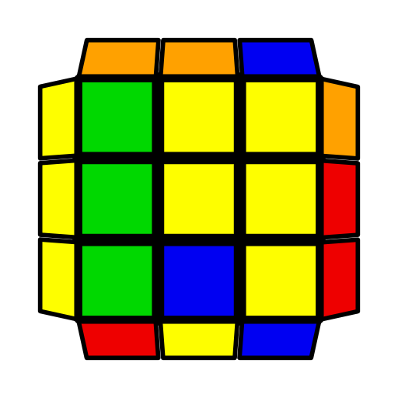 | 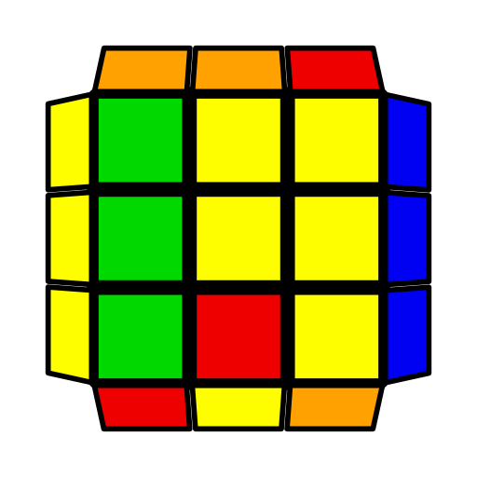 | 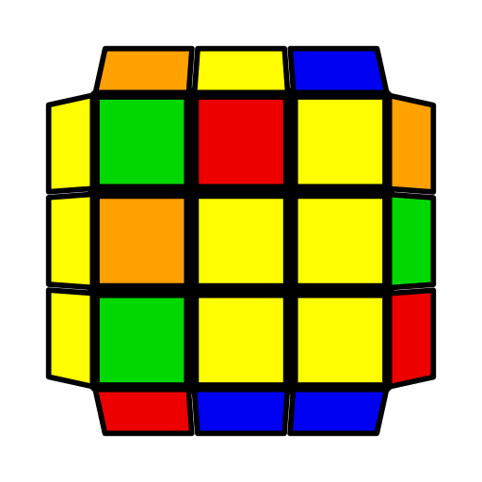 | 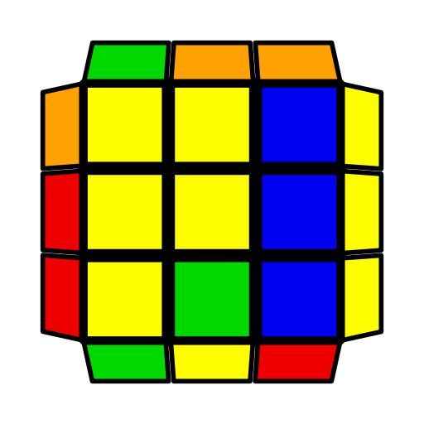 | 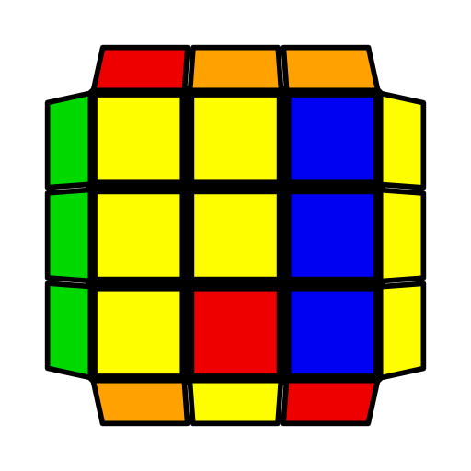
R' U' F' U F R | R' U' (F R' F' R) U R | (L' U R U' L) U2 R' F' (L' U' L F) | f (R U R' U') f' | L U (F' L F L') U' L' | (R U' L' U R') U2 L F (R U R' F')
I-Shapes
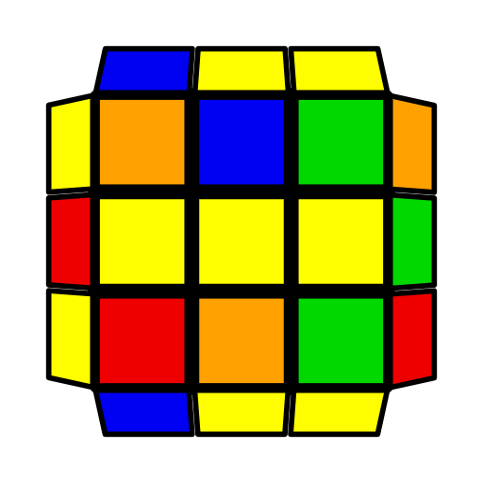 | 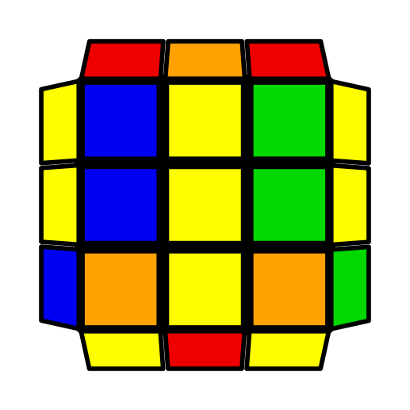 | 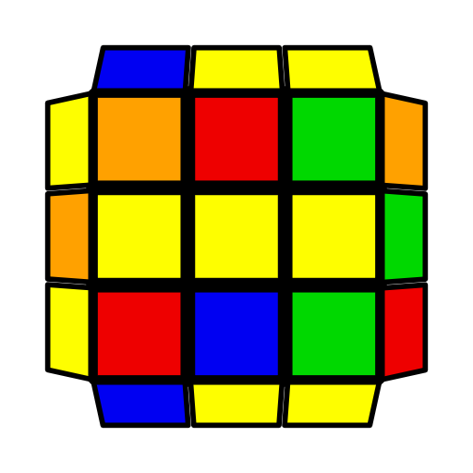 | 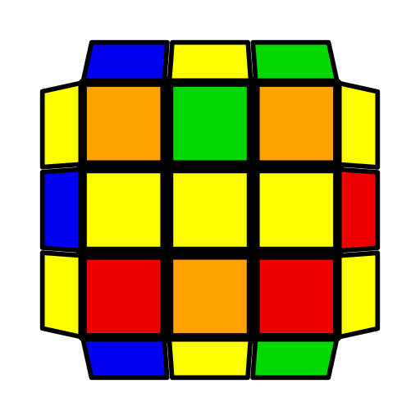 | 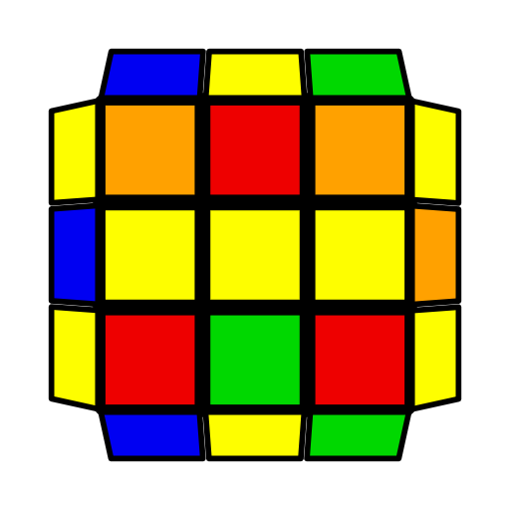 | 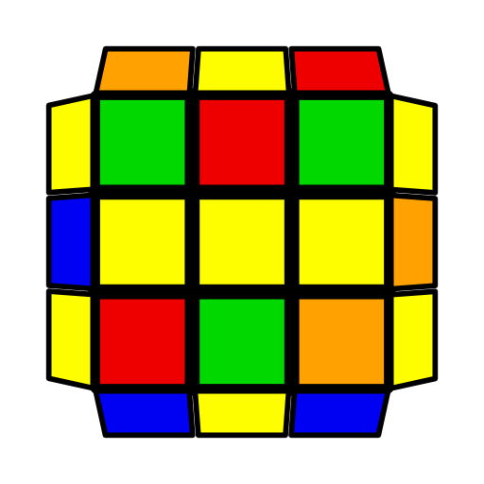
f (R U R' U')2 f' | R' U' (R' F R F') (R U' R' U2 R) | F' (U' L' U L)2 F | (r' U' r) (U' R' U R)2 (r' U r) | (r U r') (U R U' R')2 (r U' r') | F (R U R' U') R F' (r U R' U') r'
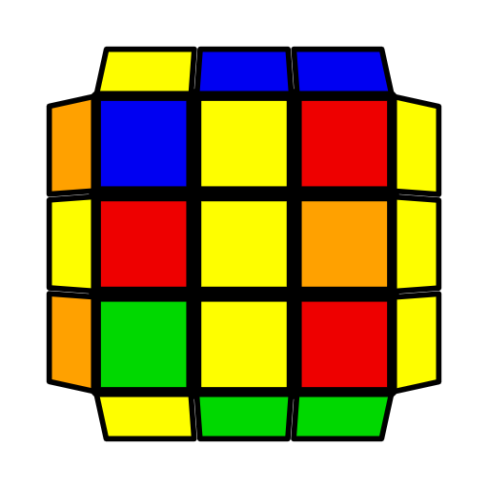 | 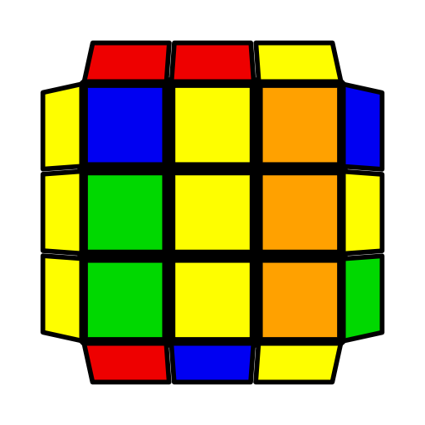 | 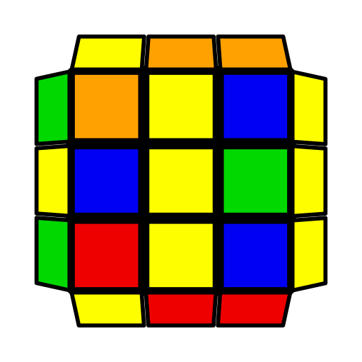 | 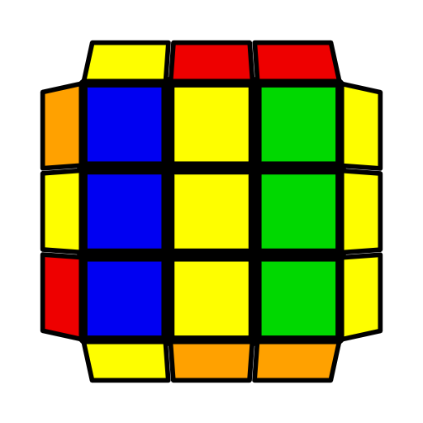 | 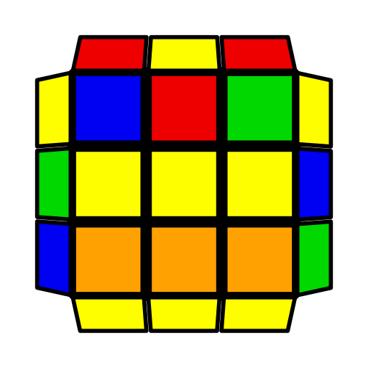
(R' U' R U' R' U) y' (R' U R B) | R' U2 (R2 u R' U) (R U' R u') R' | R' U' (R U' R' U) F' U F R | (r' U2' R U R' U r) U' (R U R' U') (R' F R F') | (r U2 R' U' R U' r') (F R U R' U' F')
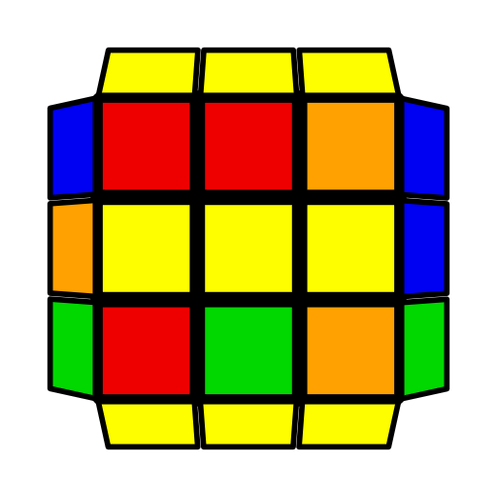 | 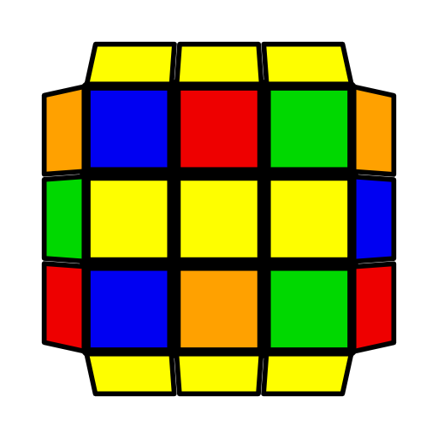 | 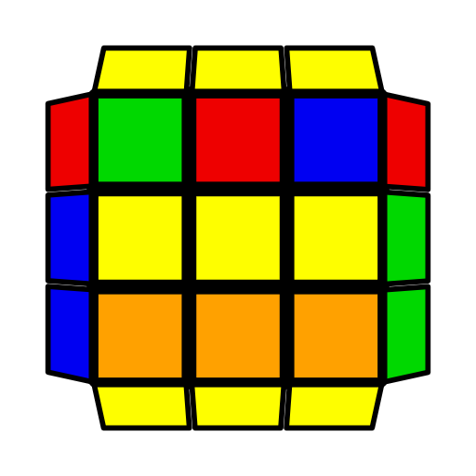 | 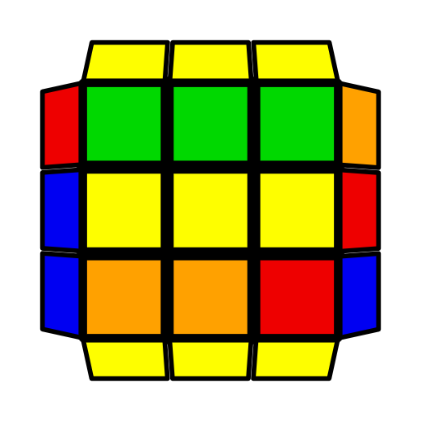 | 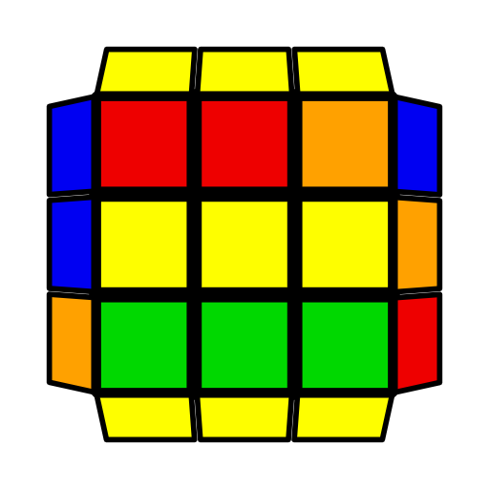 | 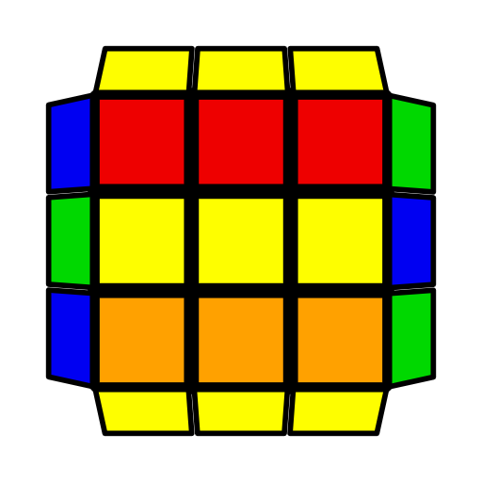
(R' F R U) (R U' R2' F') (R2 U' R' U) (R U R') | (r U2' R' U') R2 (r' U R' U') (r U' r') | F (R U' R' U') (R U R' U) (R U2 R' U2') (R U R' F') | R B' U' R' U (R2 B R2' U') (R U R') | R' F U (R U' R2' F') (R2 U R' U' R) | F U' R2 D (R' U2 R D') R2' U F'
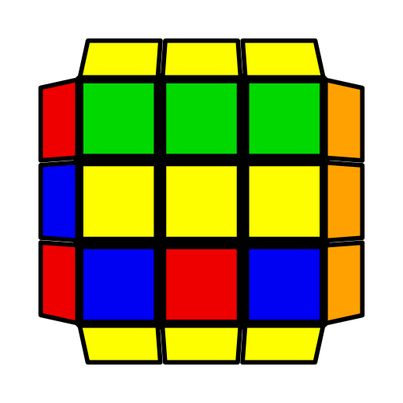 | 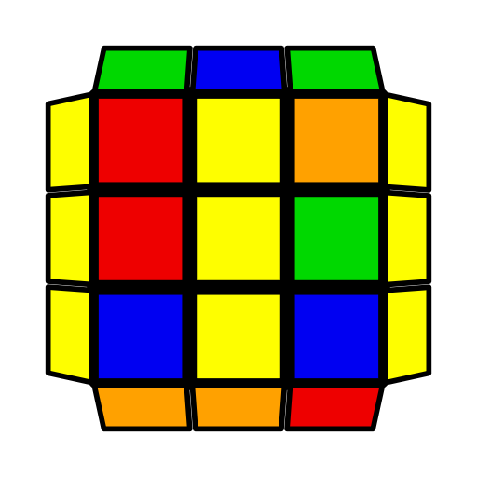
(r U' r' U') (r U r') y' R2' D' (R U R' D R2) | (R U2' R2' U') (R U' R' U2') (F R F')
Fish Shapes
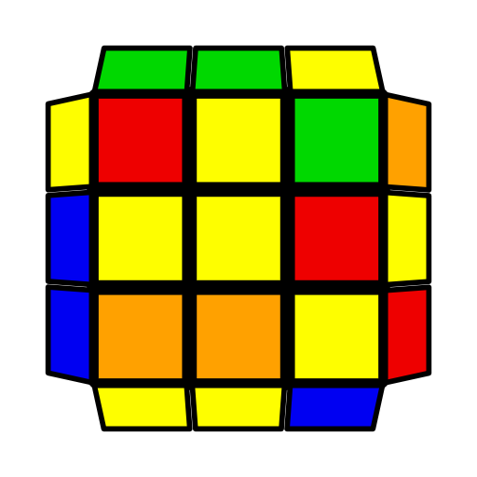 | 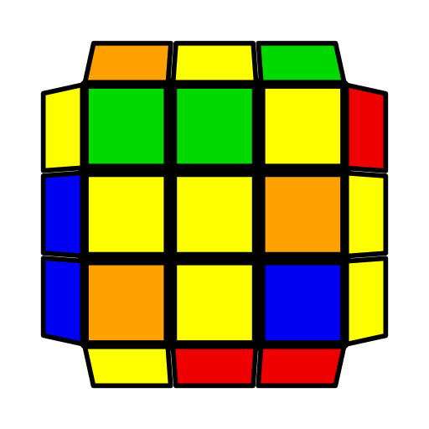 | 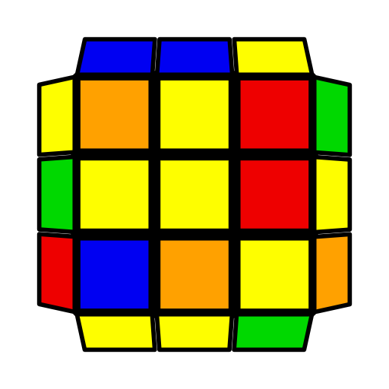 | 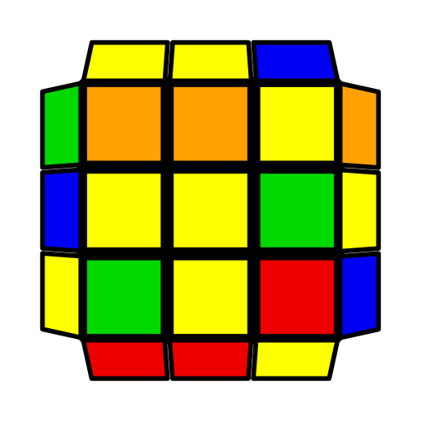 | 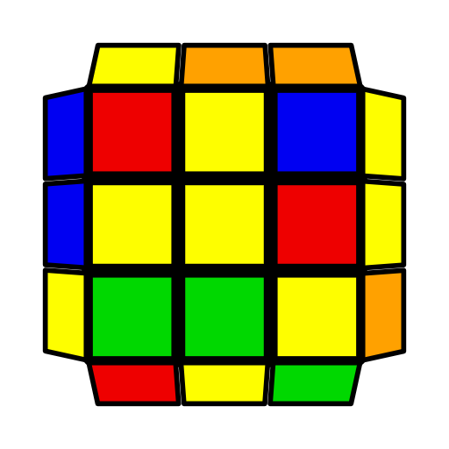 | 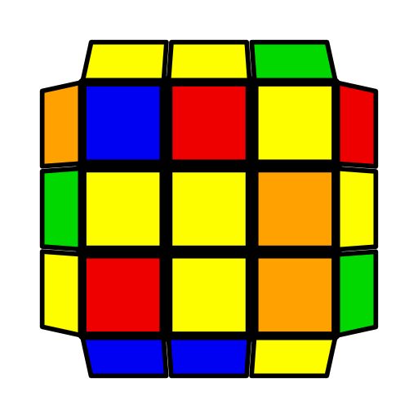
(R U R' U') R' F (R2 U R' U') F' | r' R2 U2' (R' U' R U') (R' U' r R') | (R' U' R) x' z' (R U' R' F) (R U l') | (R U R' U) (R' F R F') (R U2' R') | r R2' U2' (R U R' U) (R U r' R) | (R U R') y (R' F R U') (R' F' R)
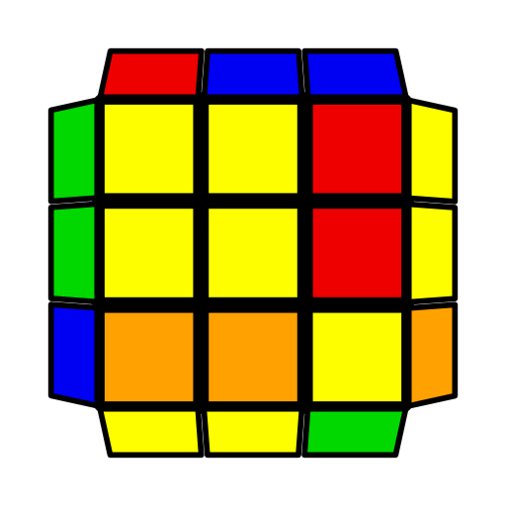 | 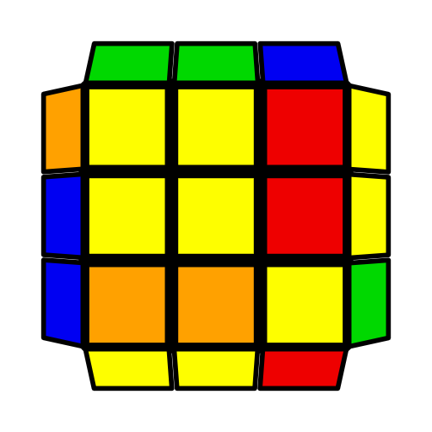 | 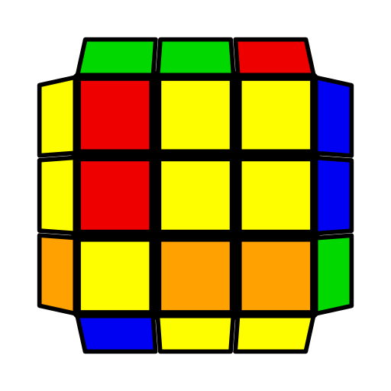 | 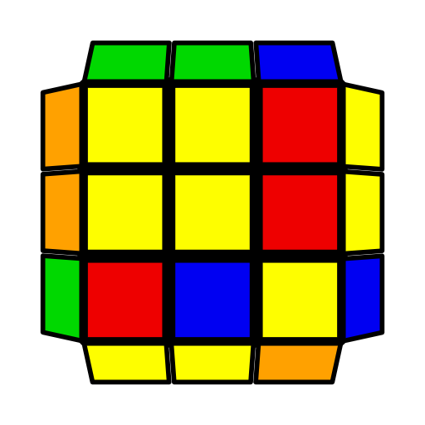 | 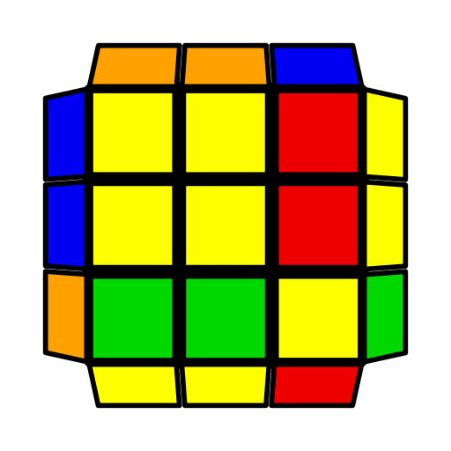 | 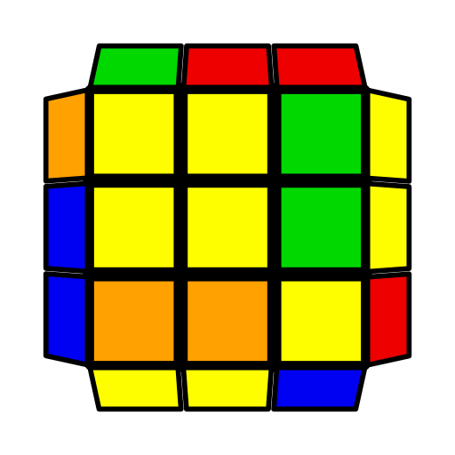
F (R U' R' U') (R U R' F') | (F R' F' R) (U R U' R') | F' (L' U L U) (L' U' L F) | (R U R' U') (R' F R2 U') (R' U R U R' F') | l' U (R U R' F') (R U R' U') (R' F R2 U') R' U2 l | (r U R' U R U2 r') U (R' U' R U' R' U2 R)
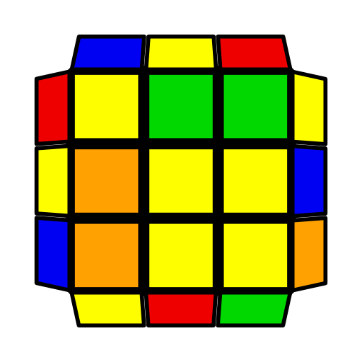
(R U2') (R2' F R F') (R U2' R')
Knight Move
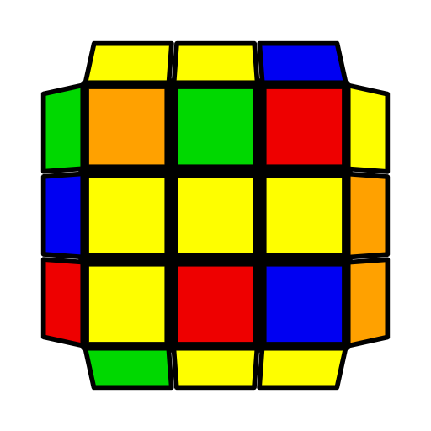 | 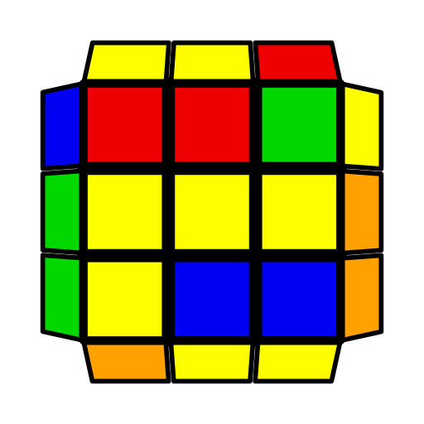 | 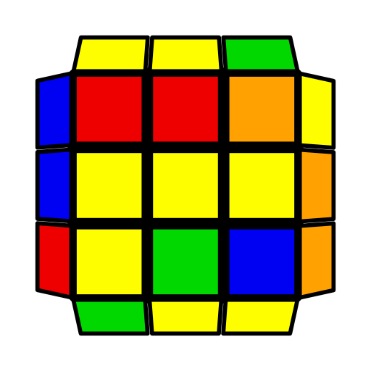 | 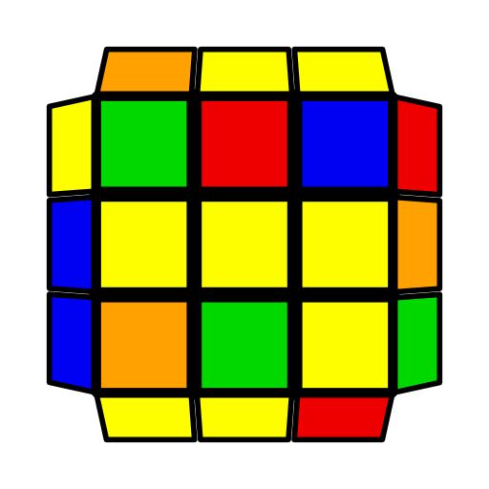 | 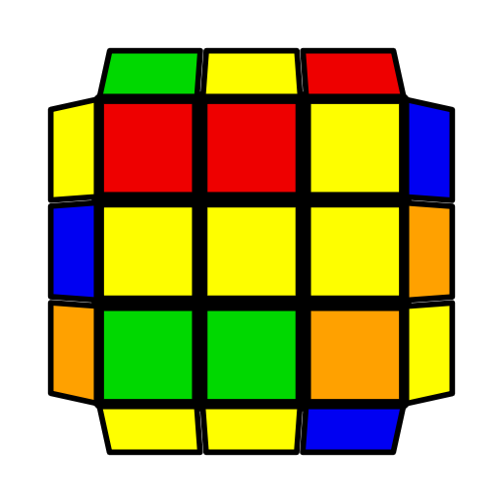 | 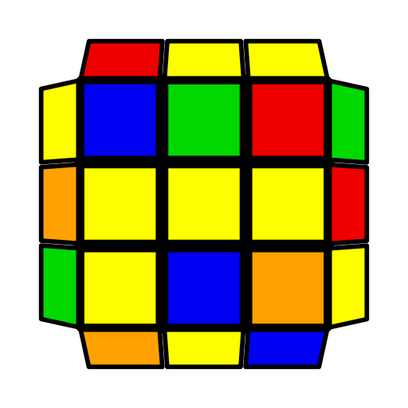
(r U' r' U') (r U r') y' (R' U R) | F U (R U2 R' U') (R U R' F') | F U (R U' R2' F') (R U R U' R') | (R' F R U) (R' F' R) (F U' F') | (r U r') (R U R' U') (r U' r') | R' F (R U R' U') F' R (U' R' U2 R)
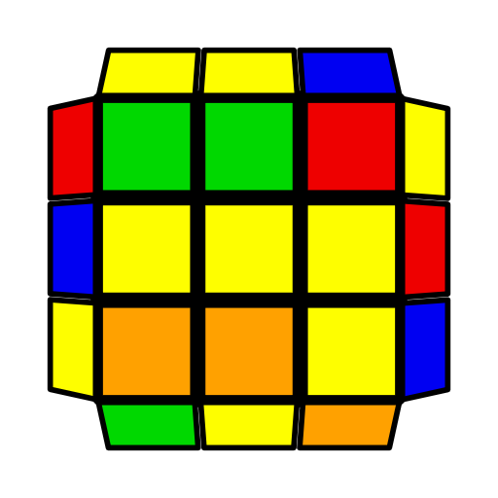 | 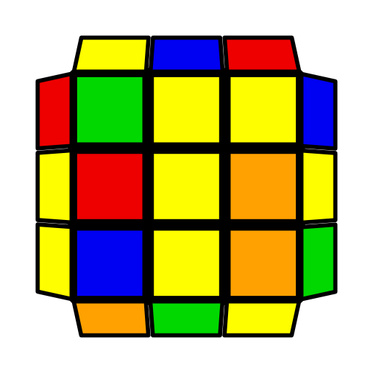
(r' U' r) (R' U' R U) (r' U r) | R' U2' (R U R' F) (U R U' R') F' R
Awkward Shapes
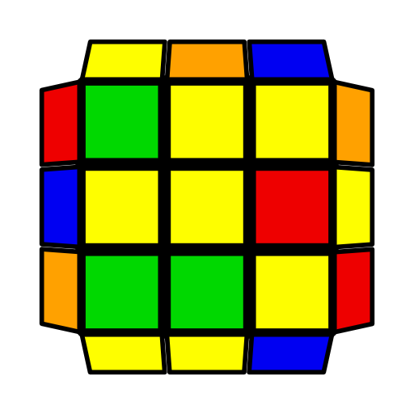 | 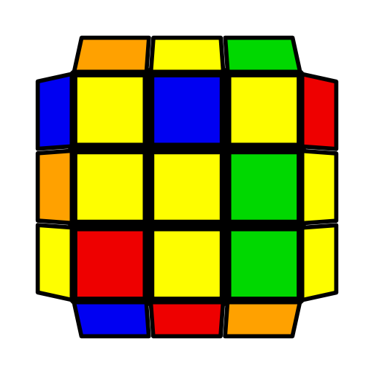 | 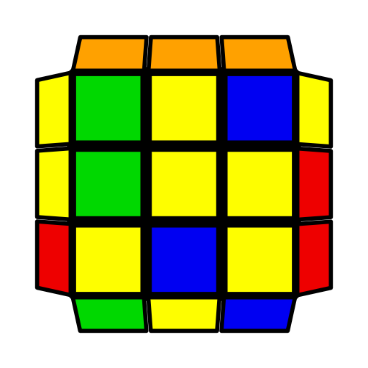 | 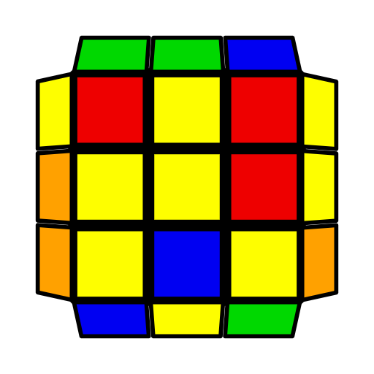 | 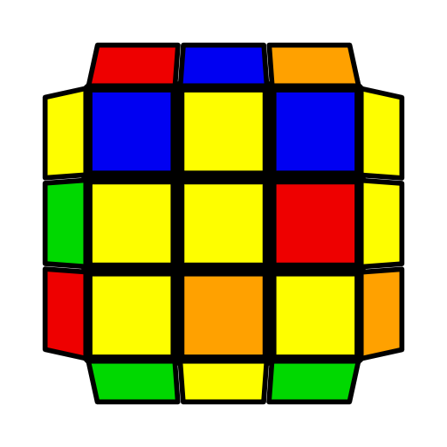 | 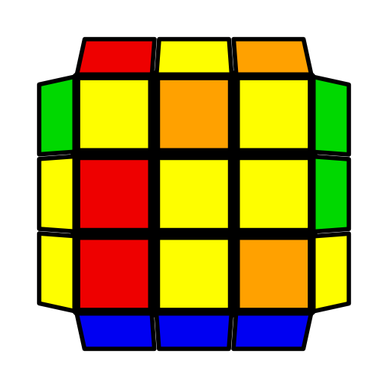
(R U R' U') (R U' R') (F' U' F) (R U R') | M U (R U R' U') (R' F R F') M' | (R' F R F') (R U2' R' U') (F' U' F) | F U (R U2 R' U')2 F' | (F R' F) (R2 U' R' U') (R U R') F2 | (R2' U R' B') (R U' R2' U) (R B R')
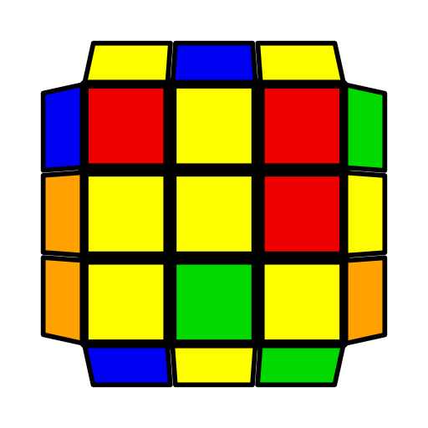 | 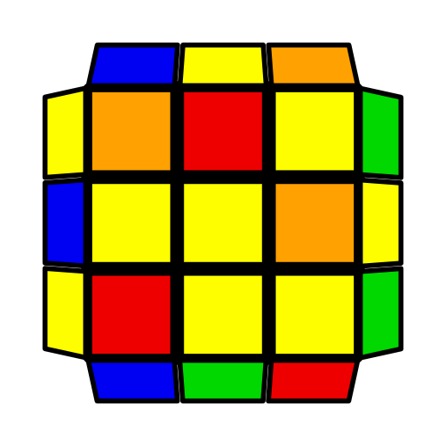 | 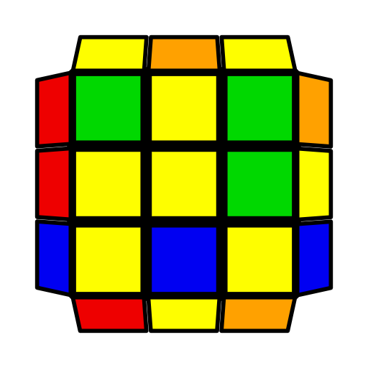 | 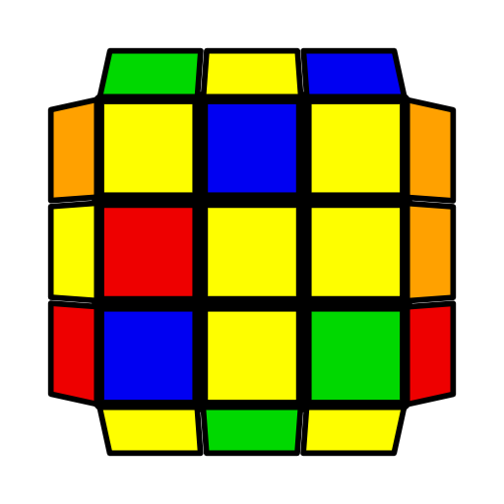
(R U R' U R U2' R') F (R U R' U') F' | x' (R U' R' U)2 x (R' U' R U)2 | r R2' (F' U' F) (U R U' r') R | (R U' R' U2 R U) y (R U' R' U') F'
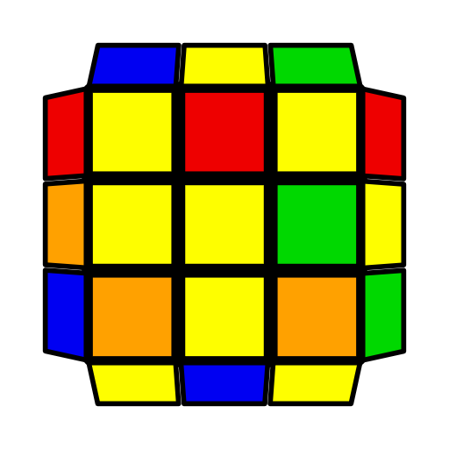 | 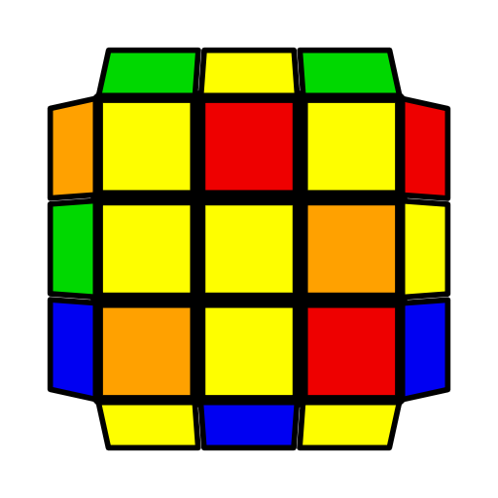 | 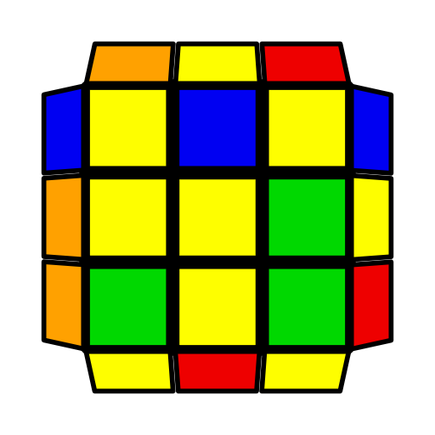 | 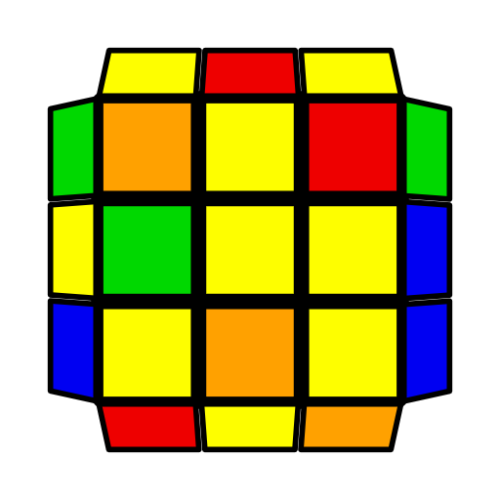
(R' U' R U' R' U2 R) F (R U R' U') F' | x' (U' R U R')2 x y (R U R' U')2 | r' R2 y (R U R' U') y' (R' U r R') | (R' U R U2' R' U') (F' U F) U R
L-Shapes
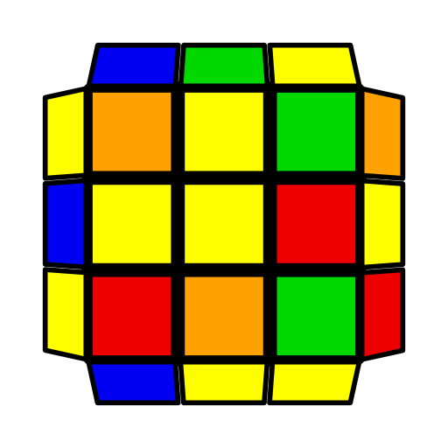 | 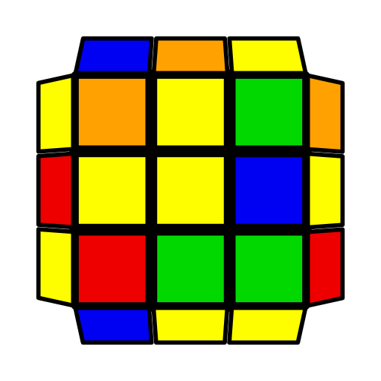 | 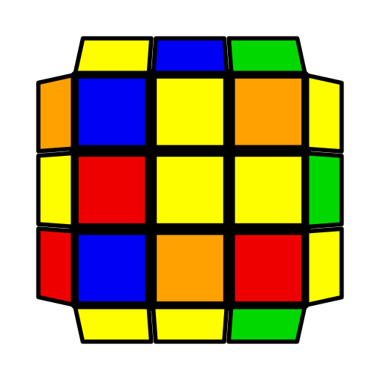 | 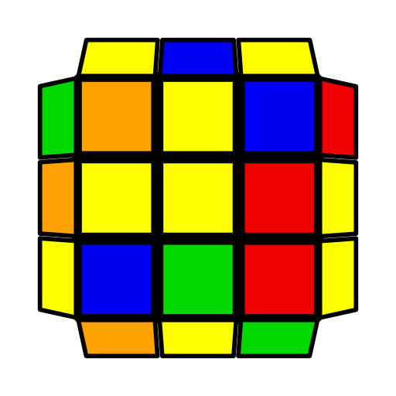 | 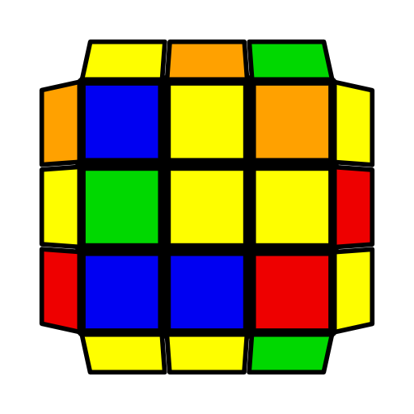
F (R U R' U')2 F' | L U (L F' L' F)2 U' L' | F' (L' U' L U)2 F | x (U R' U' R) x' U2' (R U' R' U) (R U2' R') | R' U' (R' F R F')2 U R | (F R' F' R) U2' (R U' R' U) (R U2' R')
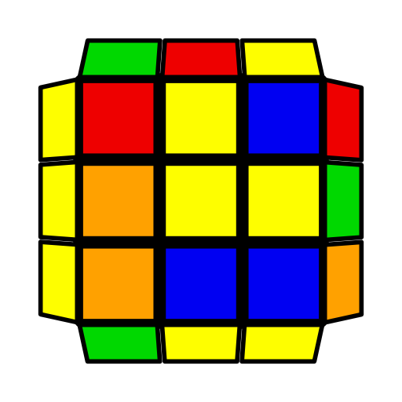 | 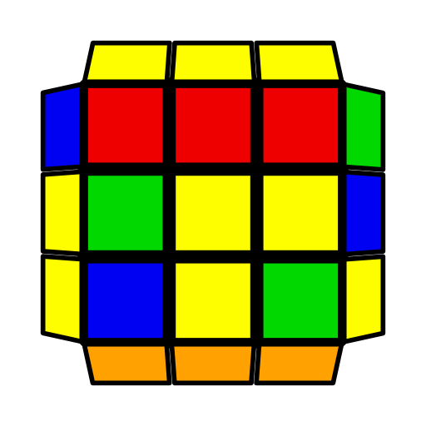 | 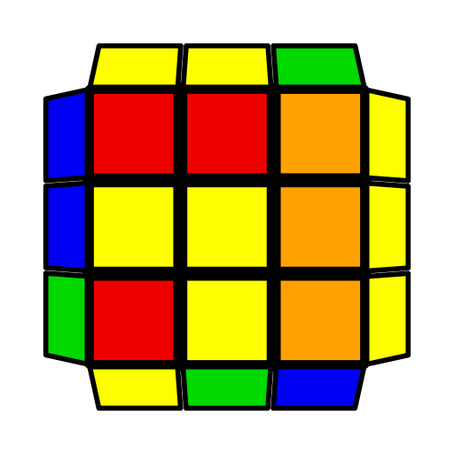 | 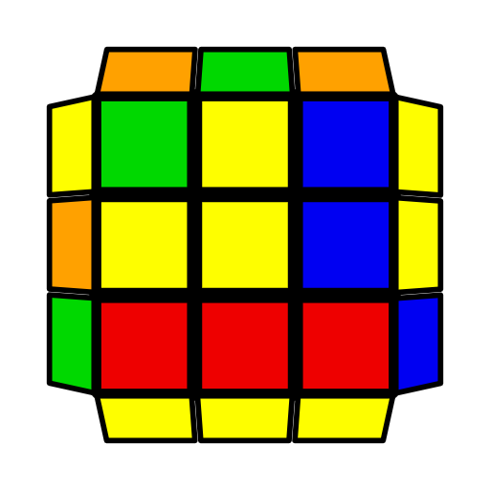 | 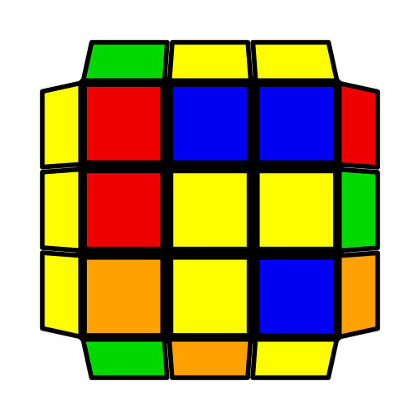 | 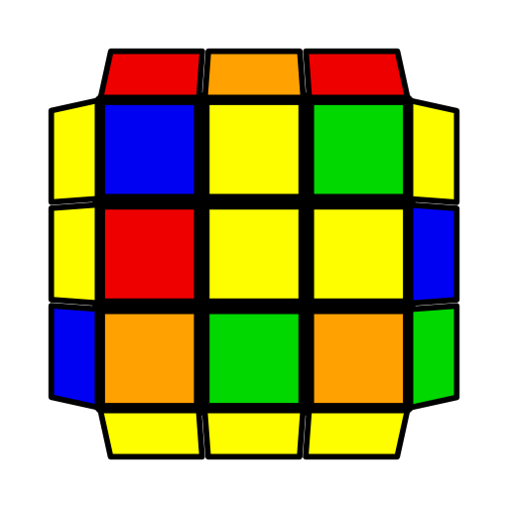
r U' r2' U r2 U r2' U' r | (R' U2 R U R' U R) F (R U R' U') F' | (R U' R' U) (R2 B' R2' U') R U B R' | (L' U2 L) (R U2' R' U' R U' R') U' (F R U R' F') | r' U r2 U' r2' U' r2 U r' | (R U2 R' U' R U' R') F (R U R' U') F'
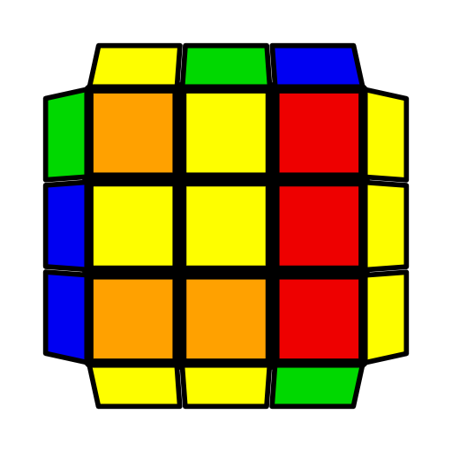 | 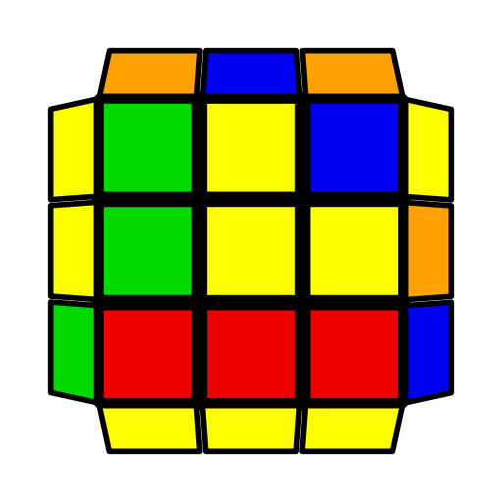 | 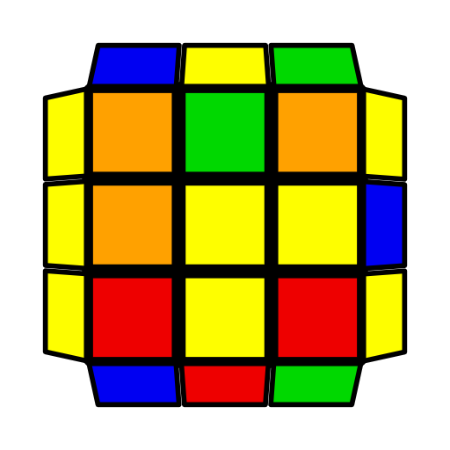 | 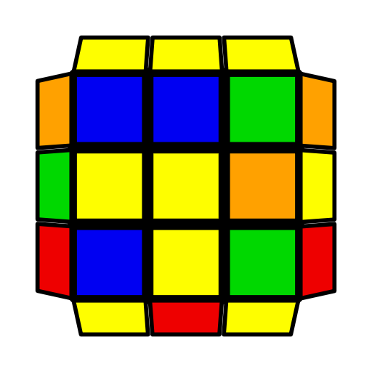 | 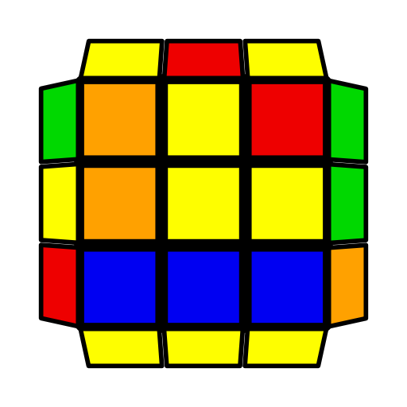 | 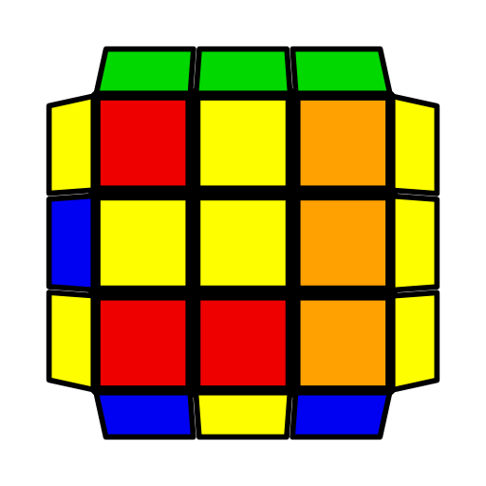
(R' U R U') (R2' F R2 U) R' U' F' R | (F R U' R' F') U (R U R' U R U2' R') (L' U2 L) | (r' U' R U') (R' U R U') R' U2 r | r' U2' (R U R' U') (R U R' U) r | (R' F R F') U2' x' R2 U' R' U l' | R2' D' (R U' R' D R2) y (r U' r' U) (r U r')
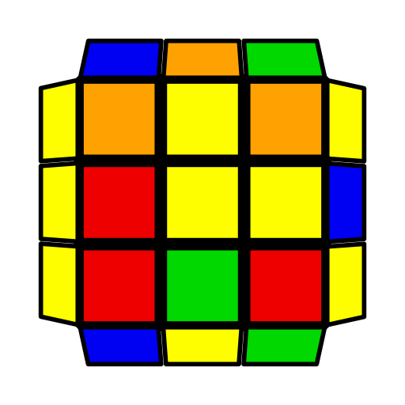 | 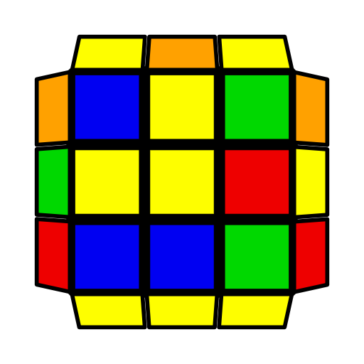 | 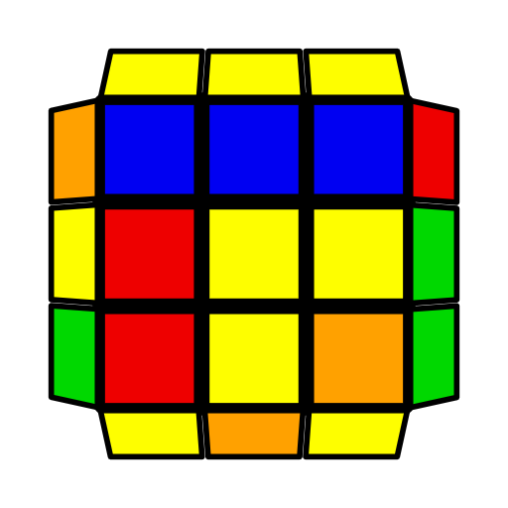 | 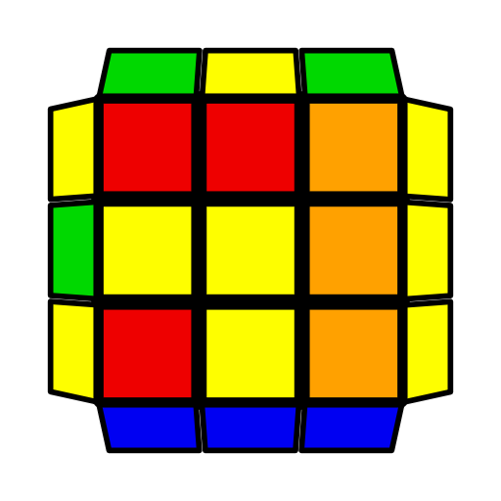
(r U R' U) (R U' R' U) R U2' r' | (r U2' R' U') (R U R' U') R U' r' | l U' R' U x U2 R2 F R F' R | R2 D (R' U R D' R2') y (R' F R U') R' F' R
Small Lightning Bolts
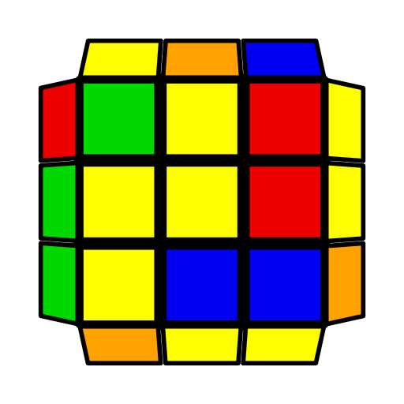 | 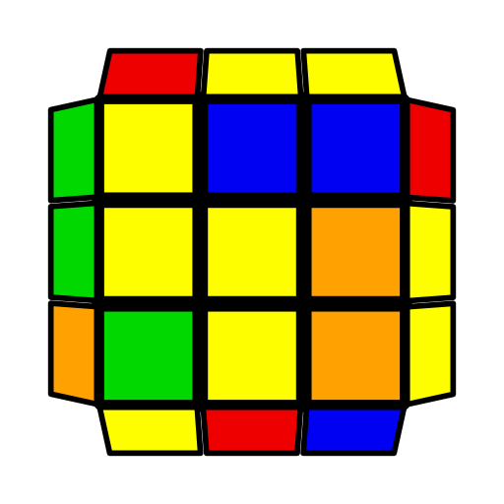 | 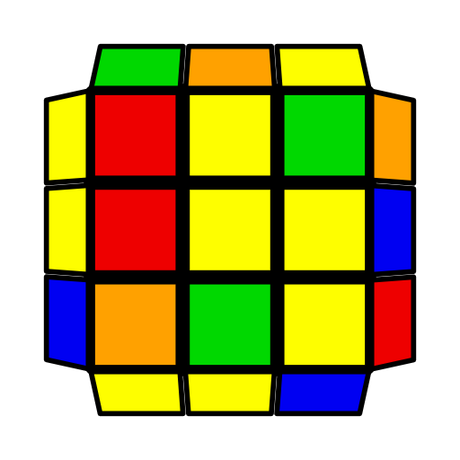 | 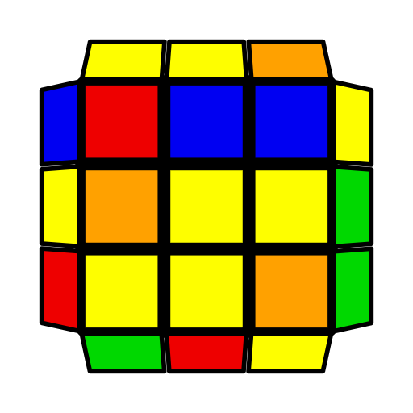 | 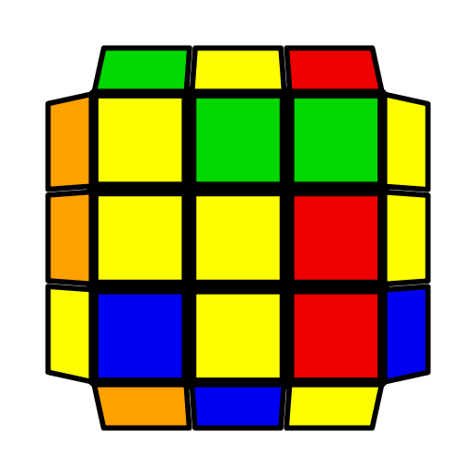 | 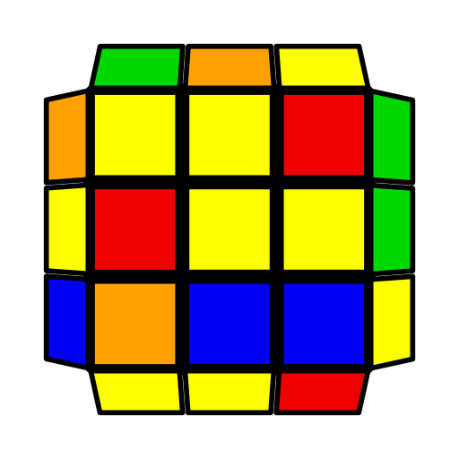
r U R' U R U2' r' | r' U' R U' R' U2 r | (R U2 R' U2') (R' F R F') | r' (R2 U R' U R U2' R') U M' | F' (L' U' L U) F U' F' (L' U' L U) F | r (R2' U' R U' R' U2 R) U' R r'
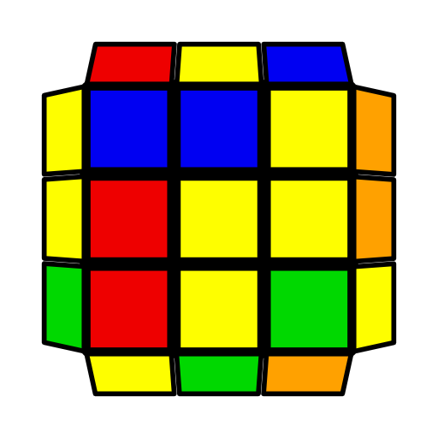
F (R U R' U') F' U F (R U R' U') F'
Big Lightning Bolts 大闪电
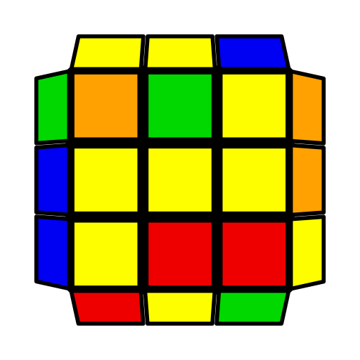 | 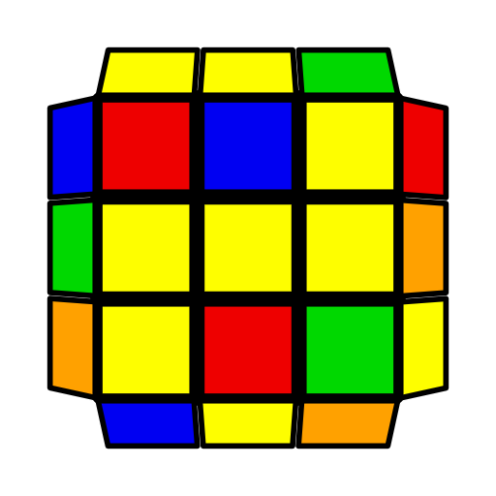 | 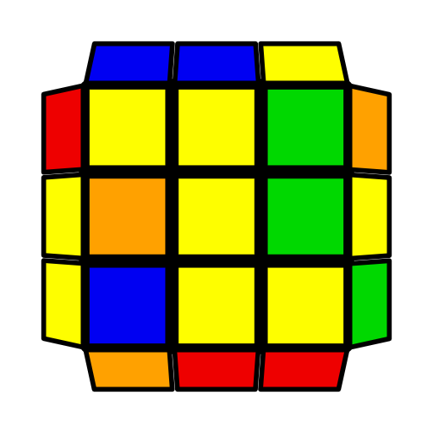 | 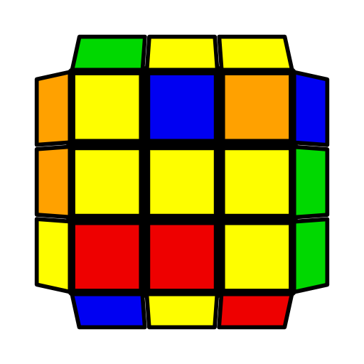 | 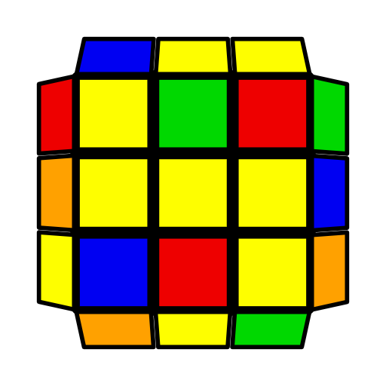
L F' (L' U' L d) R d' L' | F (R U R' U') F' (R' U' R U' R' U2 R) | (F R' F') U' F (U R U') F' | R' F (R U R' U') F' U R | F' (L' U' L U) F (L U L' U L U2 L')
Dot Cases
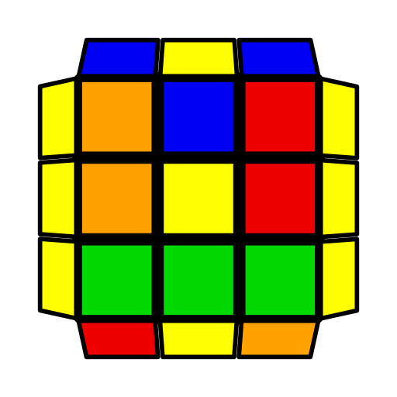 | 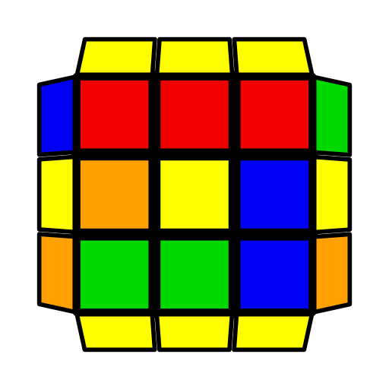 | 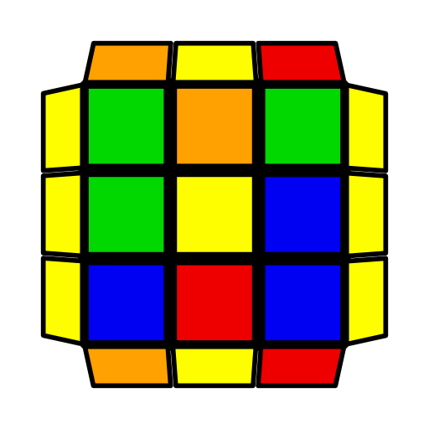 | 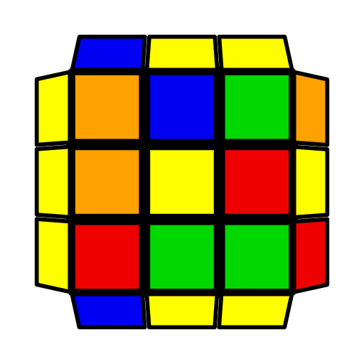 | 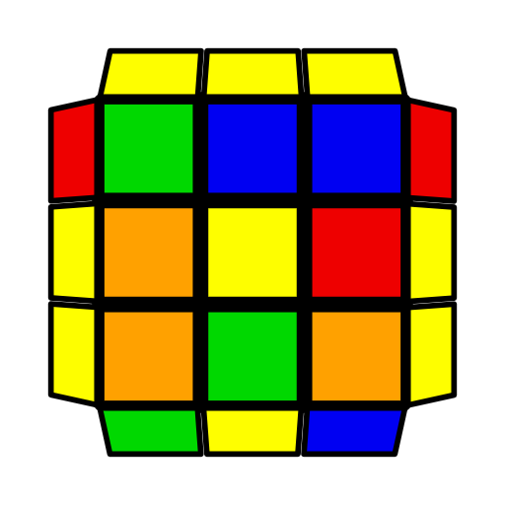 | 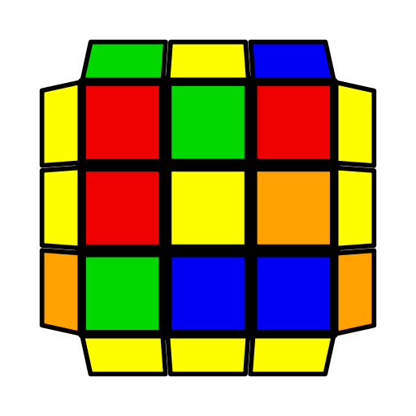
R U2' (R2' F R F') U2' (R' F R F') | (R U' R2' D') (r U' r' D) (R2 U R') | (r' U' R U' R' U2' r) U (r U2' R' U' R U' r') | F (R U R' U') F' f (R U R' U') f' | (r U r') U2 R U2' R' U2 (r U' r') | (r' U' r) U2' R' U2' R U2' (r' U r)
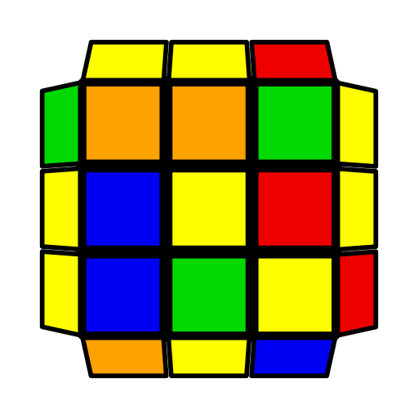 | 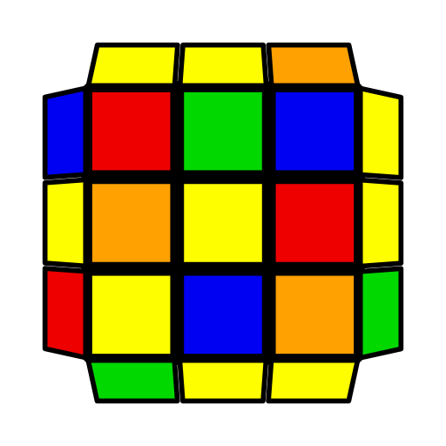 | 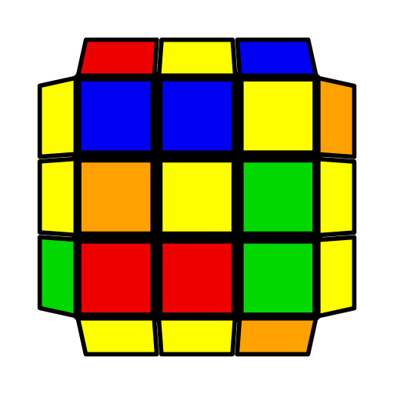 | 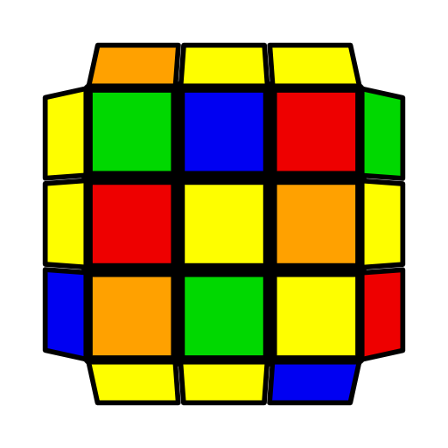 | 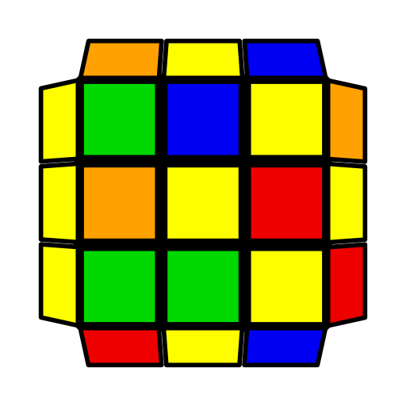 | 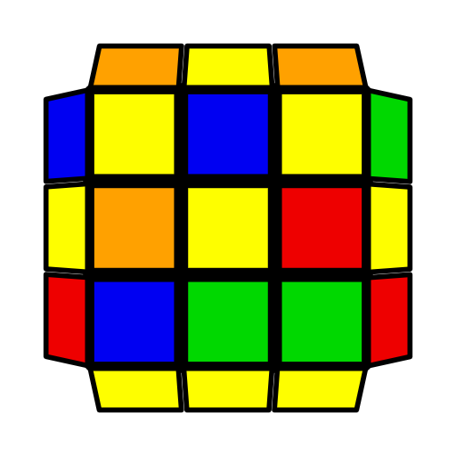
f (R U R' U') f' U' F (R U R' U') F' | r' (R2 U R' U) (r U2' r' U) r R' | f (R U R' U') f' U F (R U R' U') F' | r' R U' (r U2' r' U') (R U' R2' r) | R U2' (R2' F R F') U2' r (R' U R U' r') | (r U R' U R U2 r') (r' U' R U' R' U2 r)
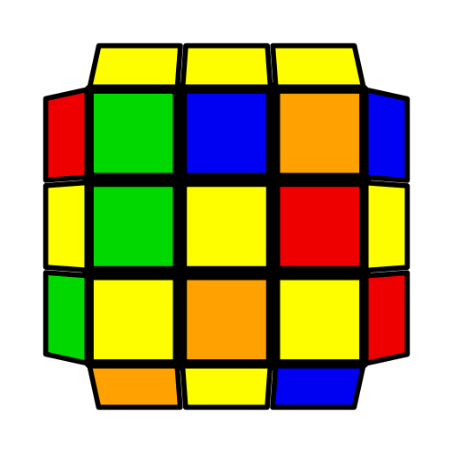 | 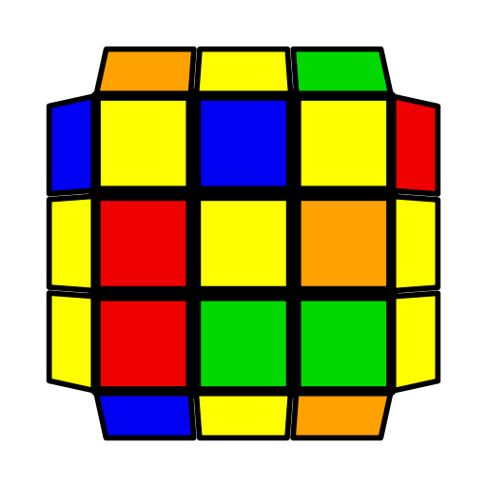 | 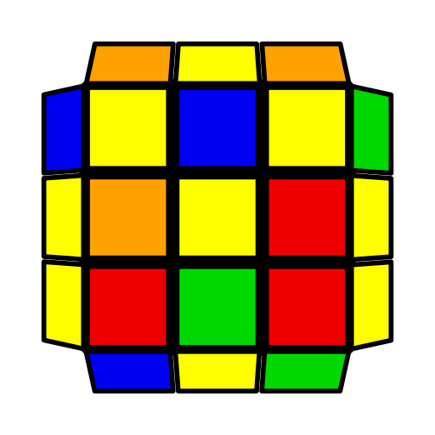 | 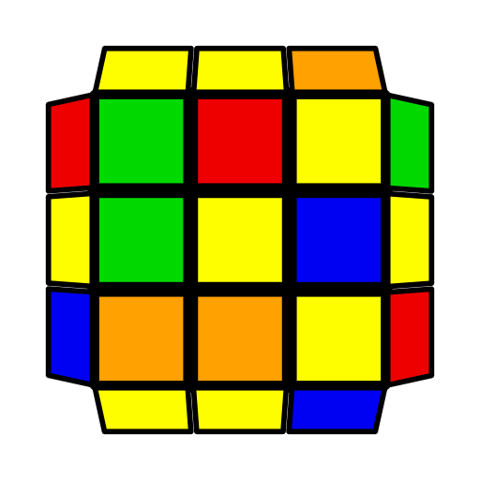 | 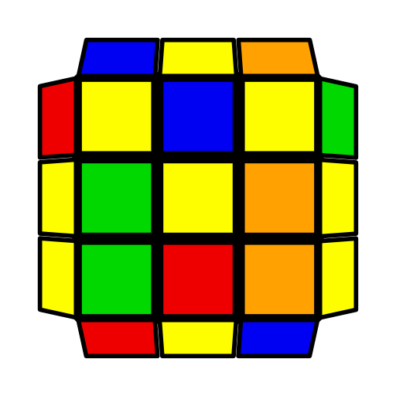 | 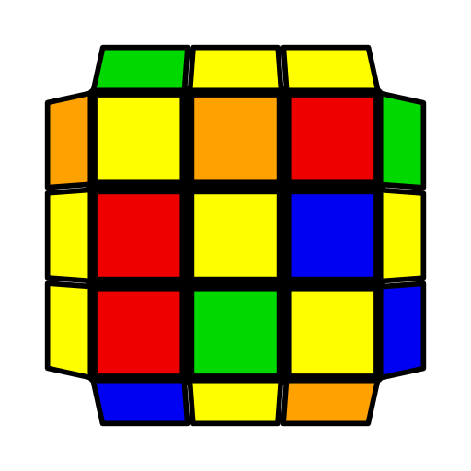
F (R U R' U) y' R' U2 (R' F R F') | r' R U (R U R' U') r (R2' F R F') | (r' U2' R U R' U) (r2 U2' R' U' R U' r') | F (R U' R' F) (R' F' R U) (R U R' U') F' | R' U2 F (R U R' U') F2 U2 F R | (R U R' U) (R' F R F') U2' (R' F R F')
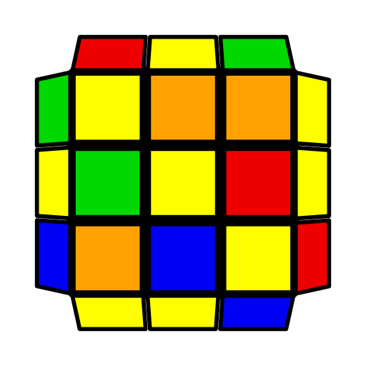 | 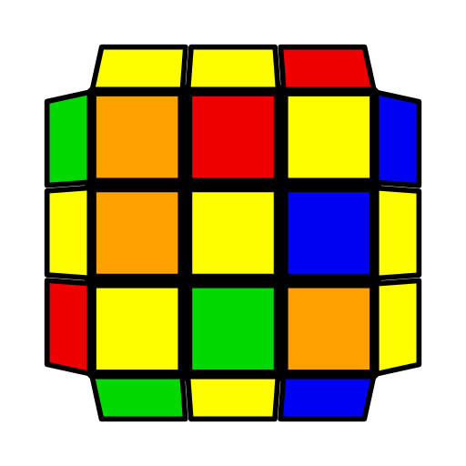 | 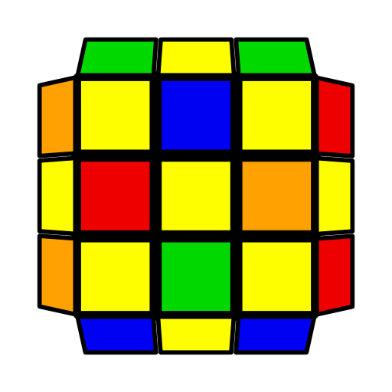
r U' z U' R x' U2' R U' y (R U' R' F') | (F R' F' R) U2' R U' y (R U' R' F') | r' R U (R U R' U') r2 (R2' U R U' r')

