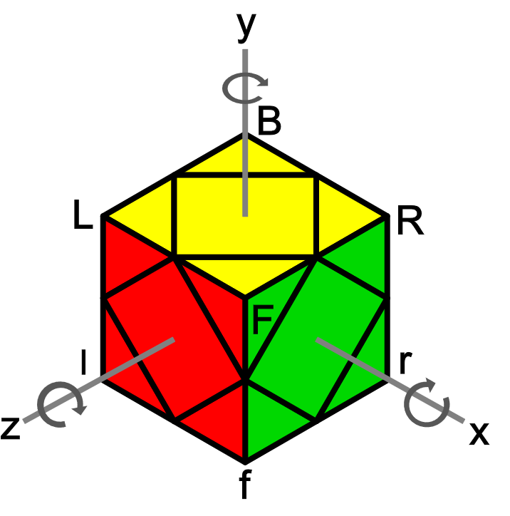
斜转L2L法 (二步法) (最后两层)
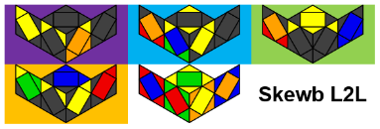
公式来源Sarah Advanced - http://sarah.cubing.net/skewb/advanced-variation-by-case.pdf
L2L - http://scribd.com/document/379738419/L2L-Skewb-1
NS2.0 - http://mofangshe.com/zb_users/upload/2016/4/NS%202.0.pdf

符号
Peanut | Pi | S = r' R r R', H = R r' R' r.  Cancellation: H z' H = R r' R' r' z' r' R' r,  S z S = r' R r R z R r R'.  态 (情况): 一叠 [2] + 二叠 [14] + 三叠 [62] + 四叠 [43] + 五叠 [13] = L2L [134].
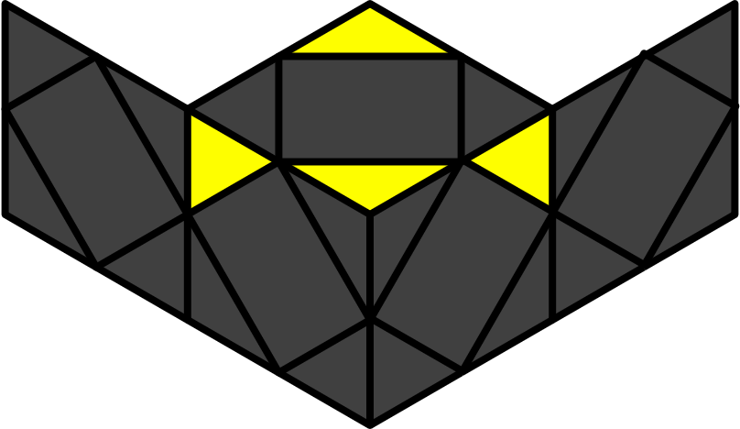 | 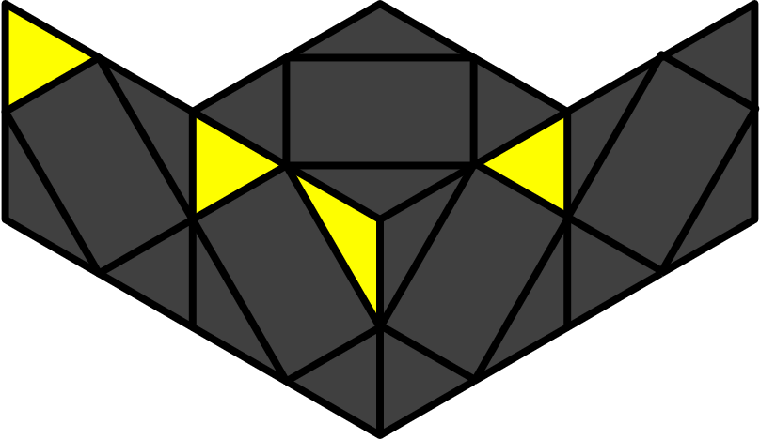

FL (底层)
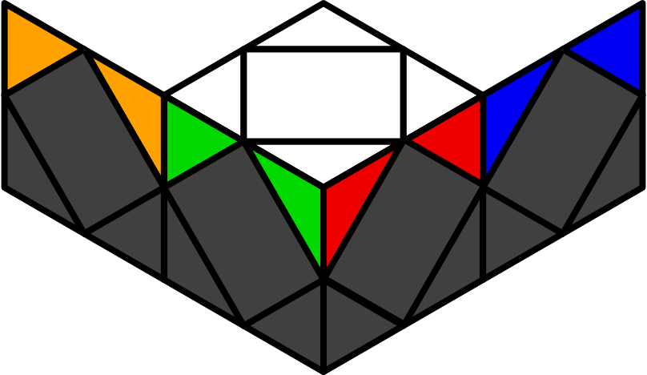

LL (顶层)
假设BL, FL, FR, BR面的底角分别为红, 绿, 橙, 蓝. 除了12个三叠外, 所有一二三叠都用SH叠加 (SH流); 所有四五叠都用纯公式 (即非SH叠加). 一般地, 观察顺序为:
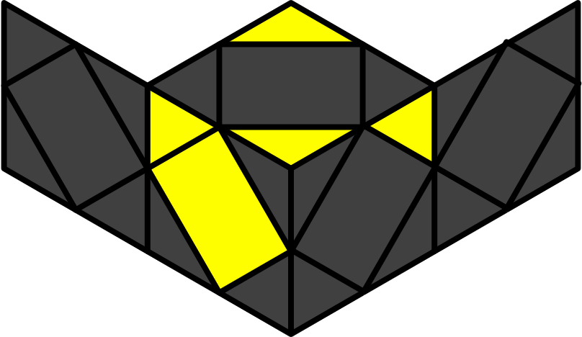 | 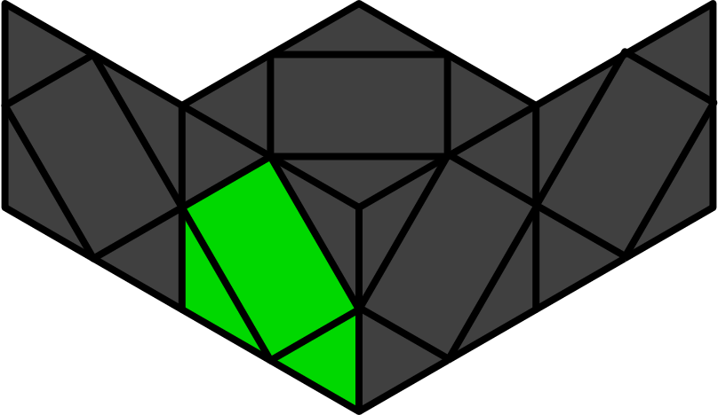 | 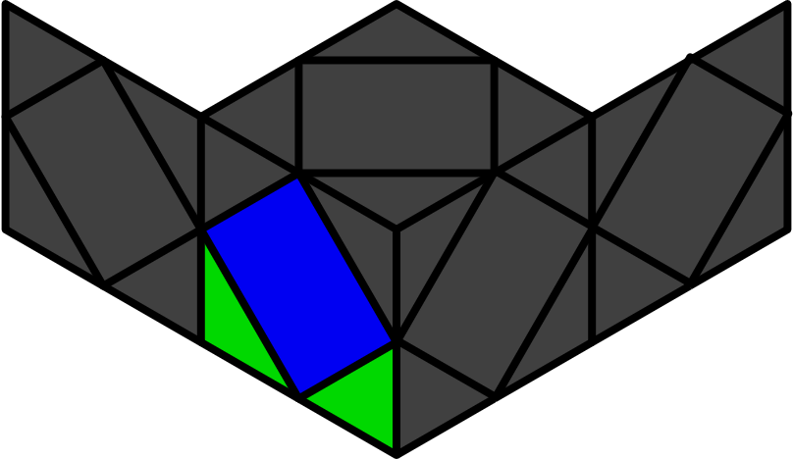 | 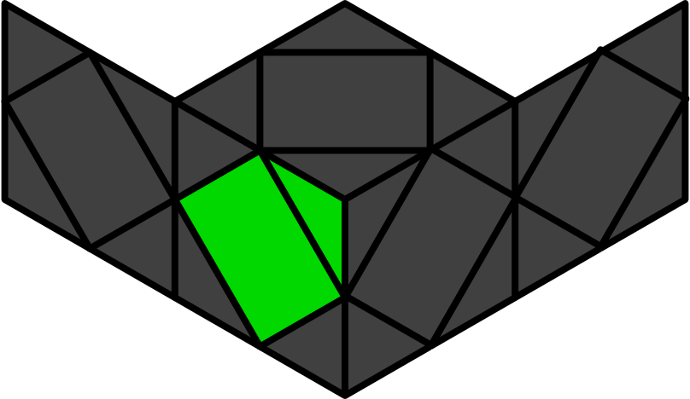
1. 范畴 | 2. 同心 | 3. 对心 | 4. 箭头

L5C (后五心) [14]
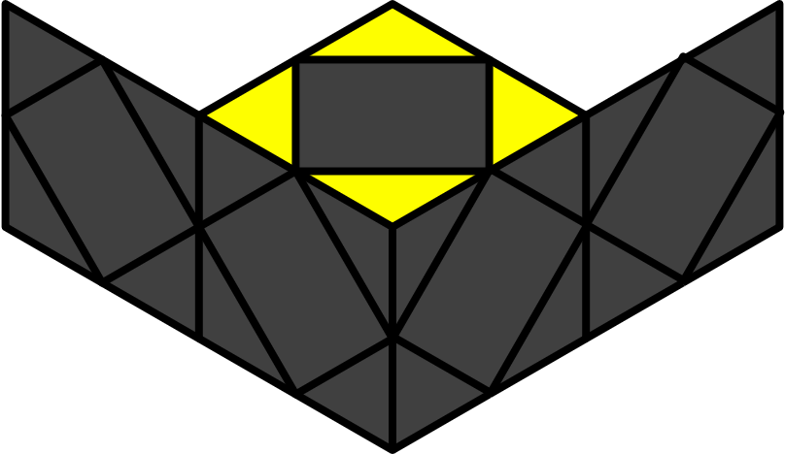
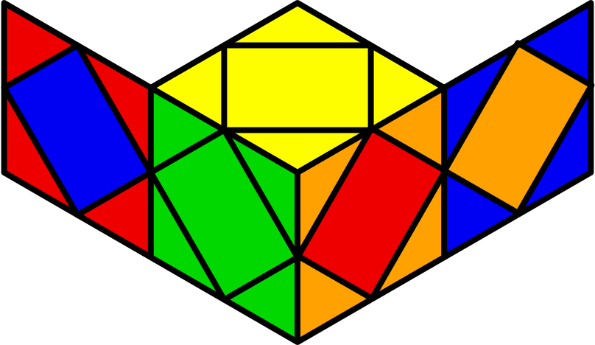U1 | 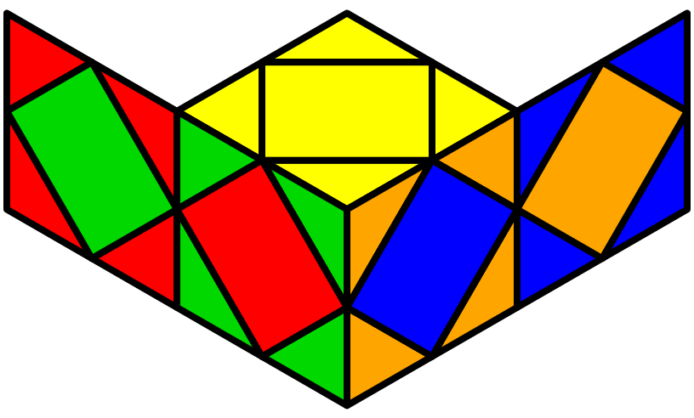Z1 | 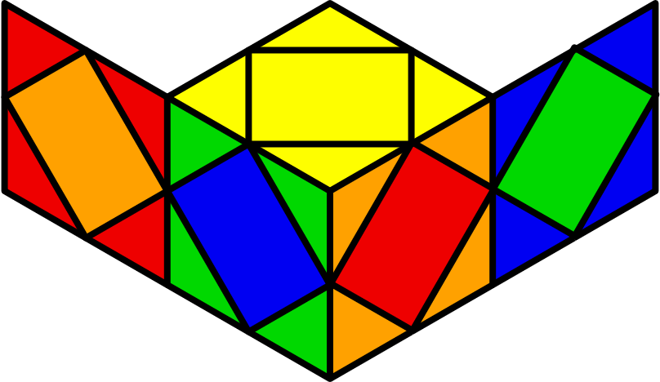H1 | 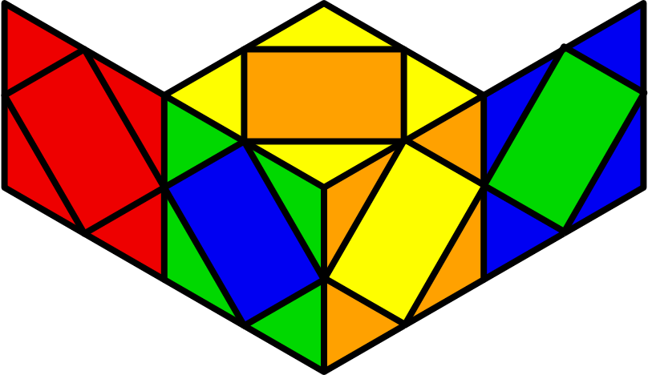H2
(S z2' S) | (r l' B' l) (B l r l' r) | r R' r R' y L' l L' l | x S S S
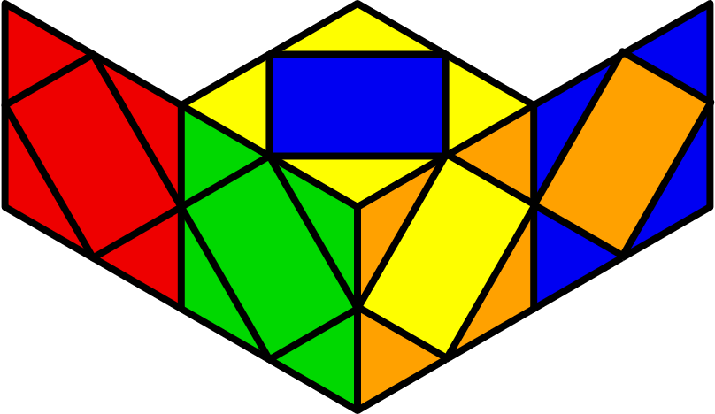U2 | 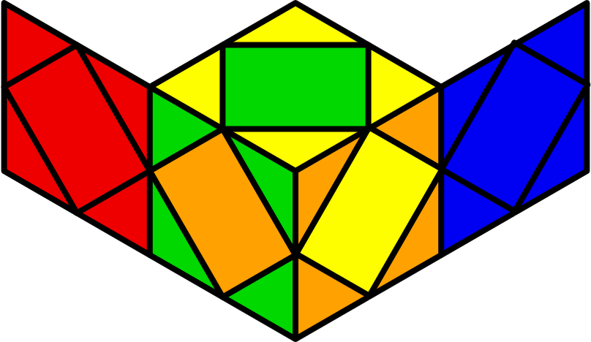U3 | 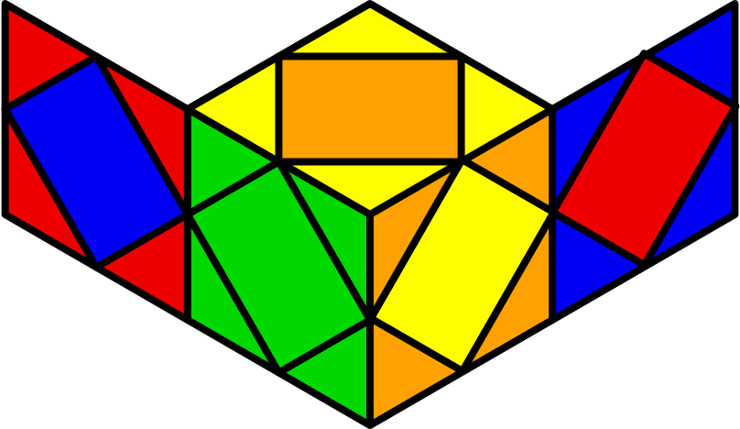Z2 | 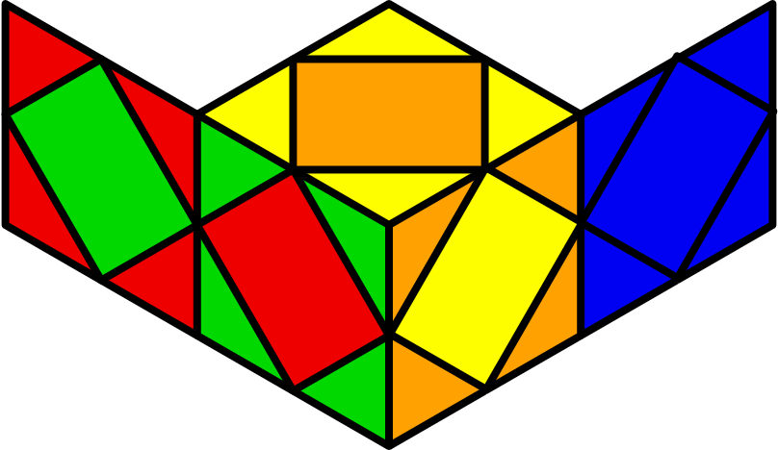Z3
y' F (S z2' r' R r R) | y' L (r R' r' R y' H) F' | x R' b' r' R r z' r B r' | y x R r R' y' r' R' x y' r' R r
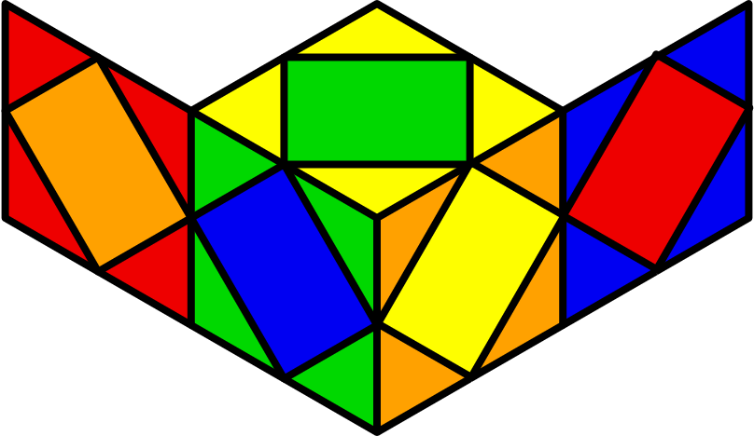X1 | 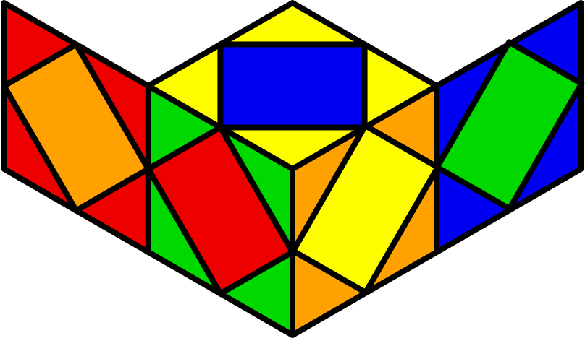X2 | 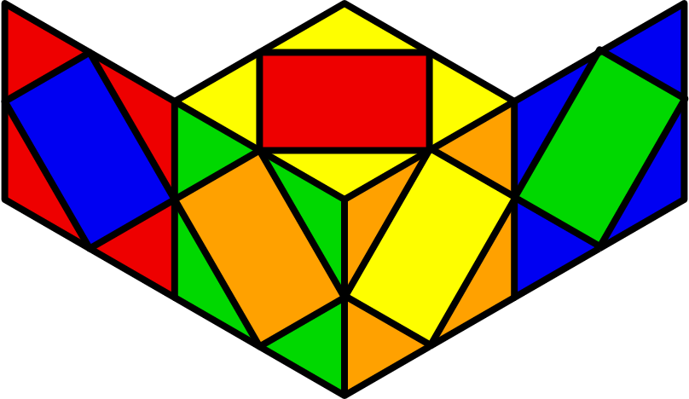W1 | 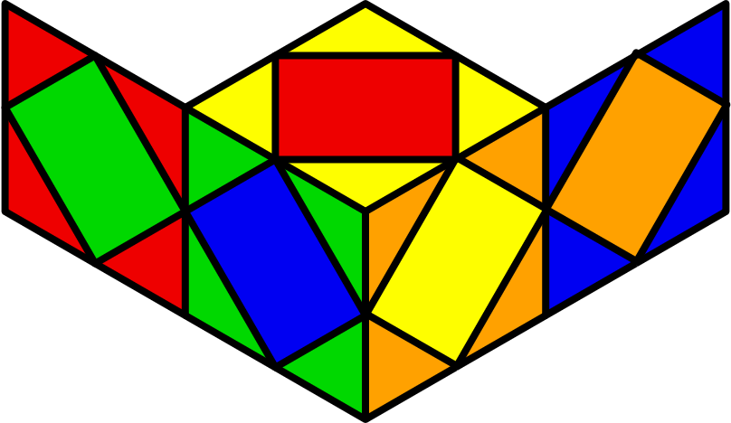W2
y2 x r' R' r B r' H B r' R | y' x B' r' R' r B r' R r z' r' R r R' | y2 x S r R y' r' R r B' r | x (H B r')2
 | 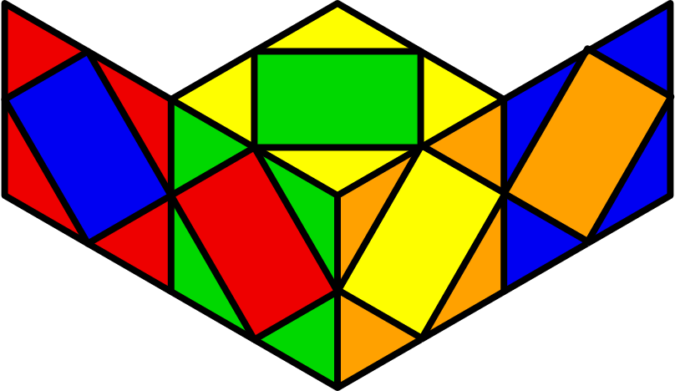S1 | 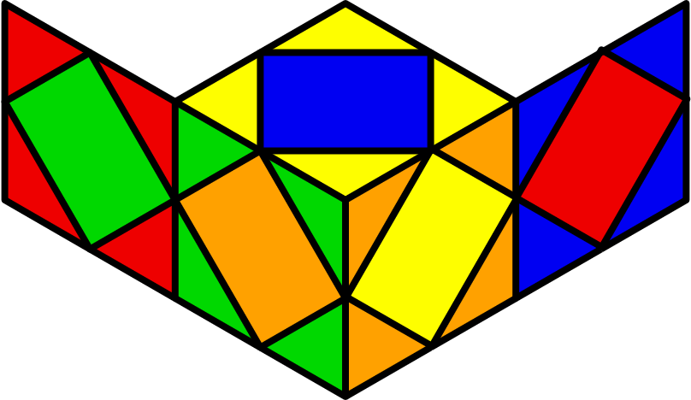S2
 | y2 x r' R' r B r' R r z' r' S b' | y2 x r' R r b z' B' R r' R' B' r
Peanut - U [12]
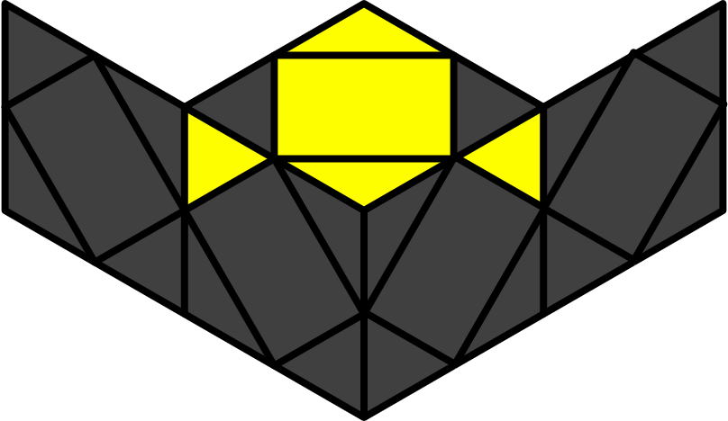
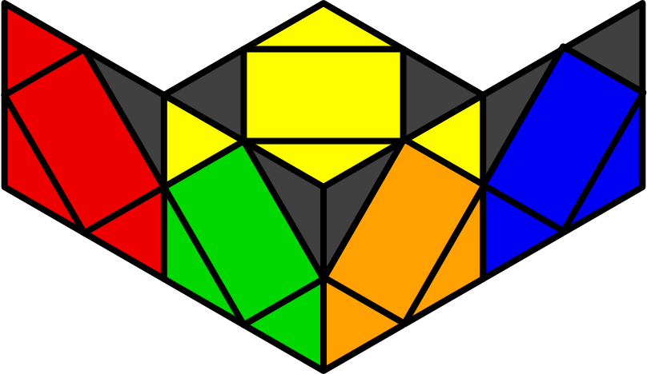- | 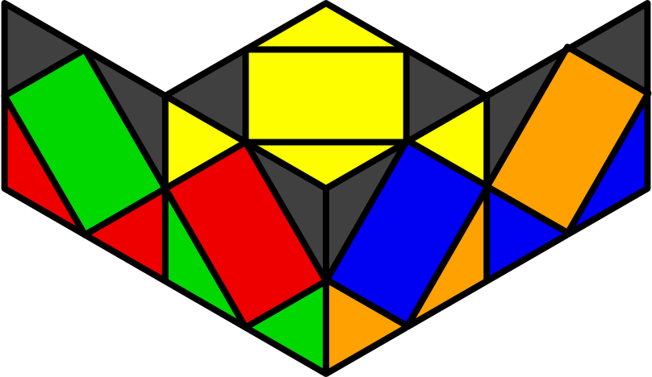Z1 | 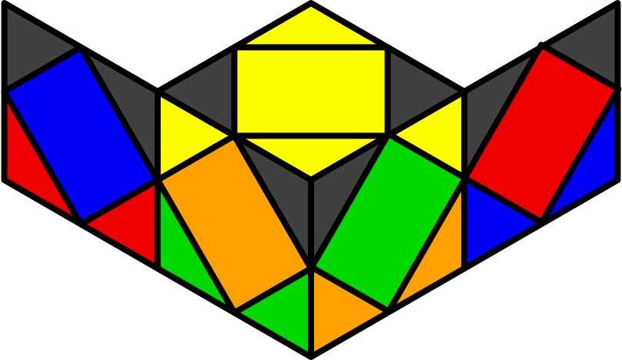Z2 | 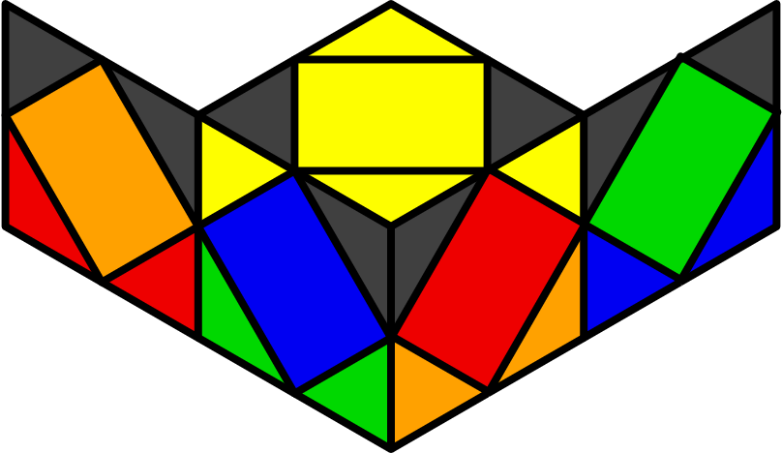H
y' x S (S z S) S | x R r' R r' R' z' r' R r B' R | y x r' R' r R r' R' r' z' r' R' r B | y x r' R' r R' B R B' H R
y2 x r' R' z' r B r' R r y' r' R' r
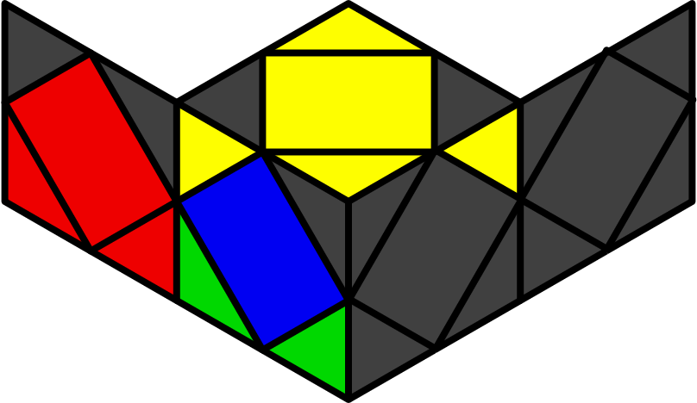U1 | 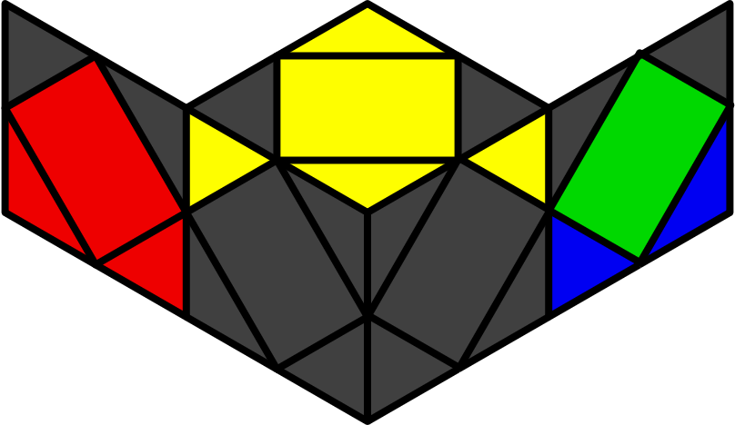U2 | 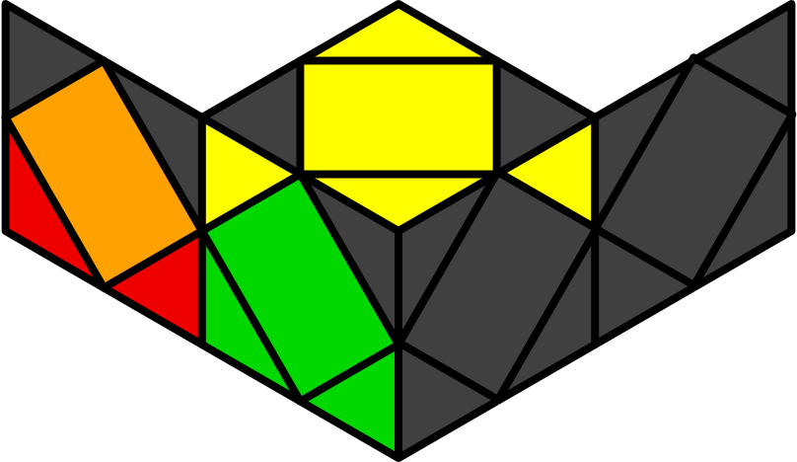U3 | 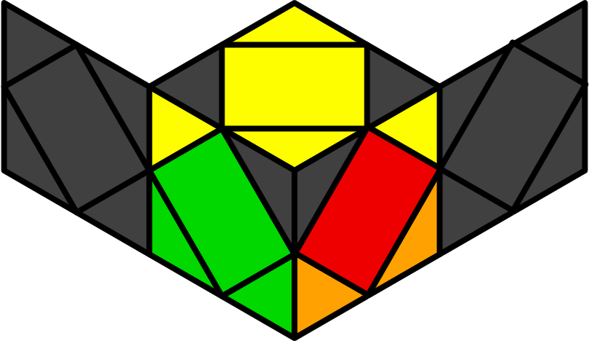U4
y x (H z' H) z' S | y' x S z H z H | x H z H z S | y2 x S z' (H z' H)
R r' l r R' r' l' r | y2 x R r R' B R B' r' R r R r' | x r' z r R r' R' r' z' r' R r' | y2 x r R' r' B' r R r' B
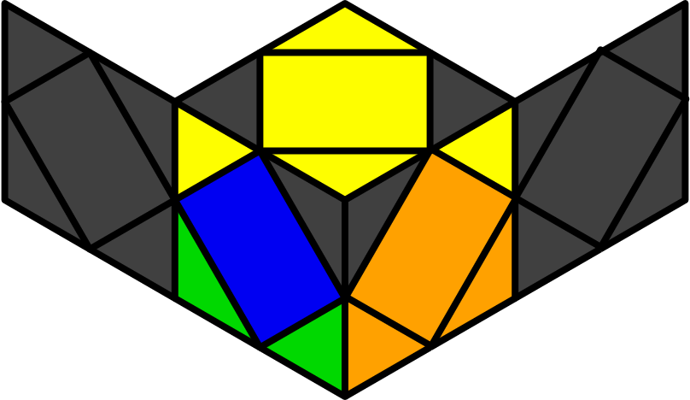U5 | 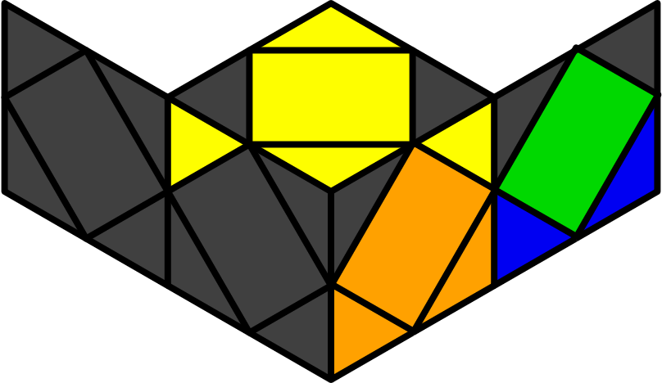U6 | 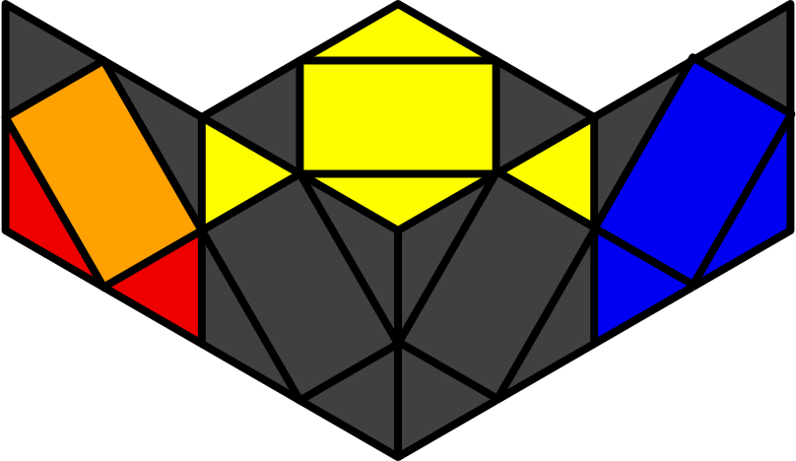U7 | 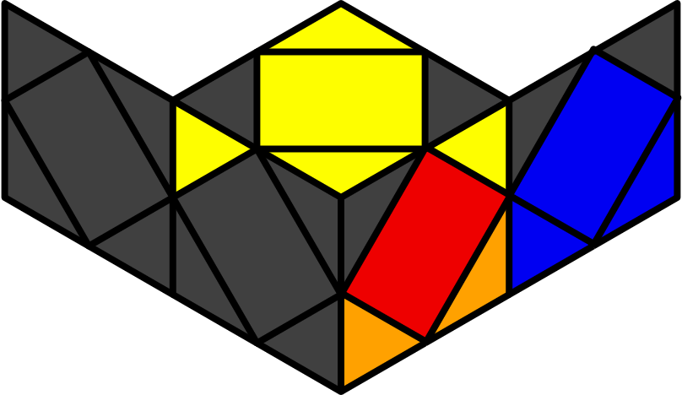U8
y x H z (S z S) | y' x S z' S z' H | x H z' S z' S | y2 x (S z S) z H
z r' R r y r R' B' R r' | x r' R' z' r' R r z R r R r' R' | x R' B' R r' y' r' R' z' R r R' | x B' r R' r' B r R r'
Pi - U [12]
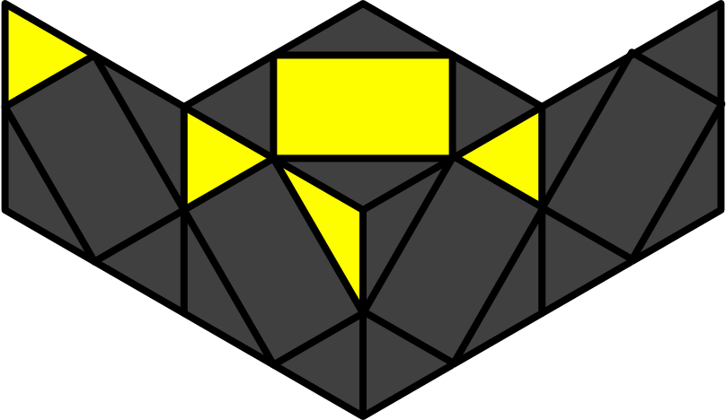
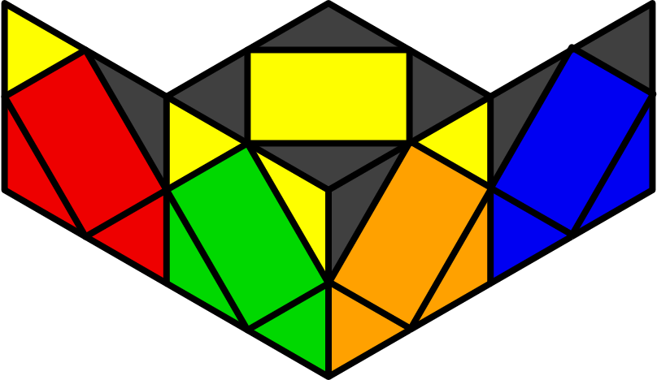- | 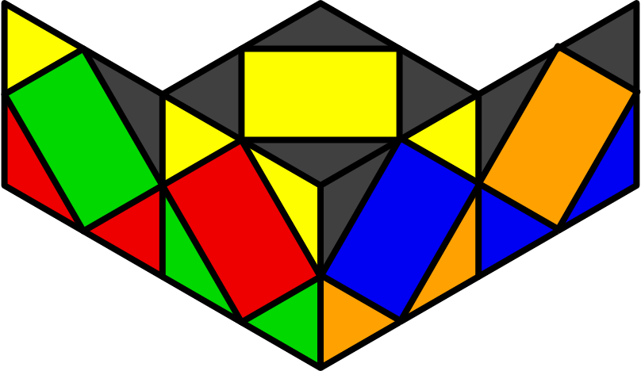Z1 | 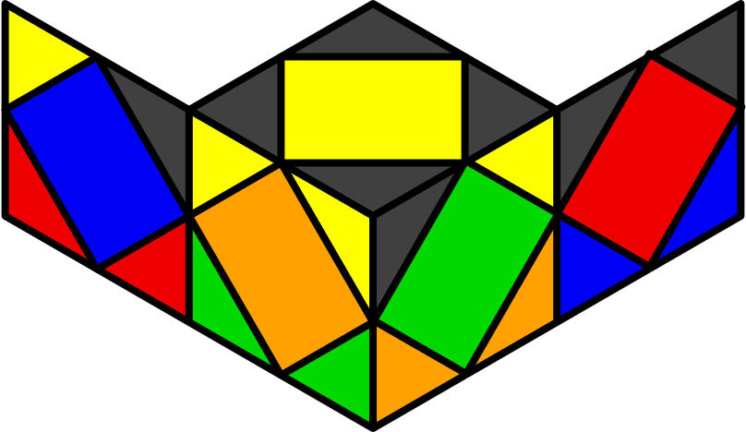Z2 | 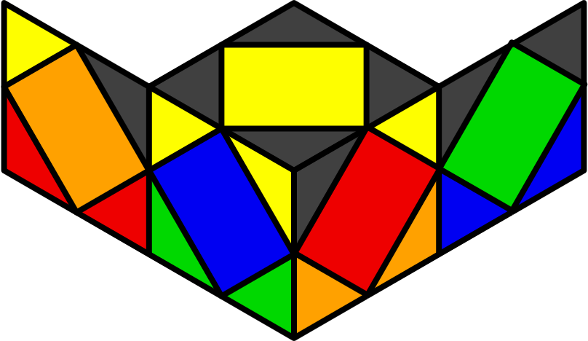H
x S S | y x R r R' r' z' r' R r z R r' R' | y' x r' R' r B R B' R' r' R r | y2 x (S z2' S) z2 H
 |  |  | y' x r B R B' r2' R r R
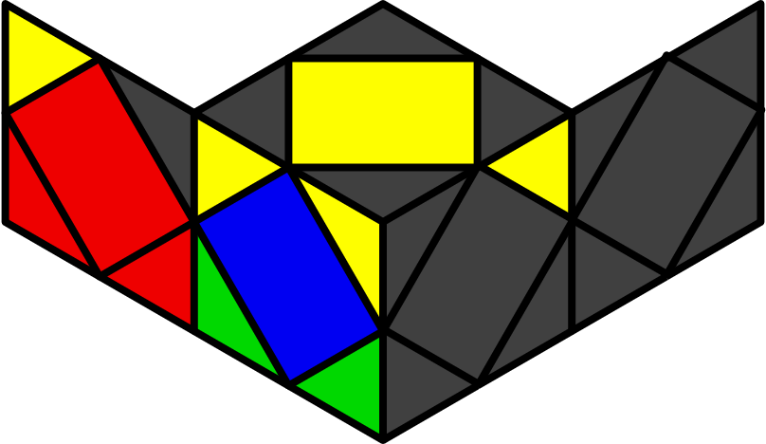U1 | 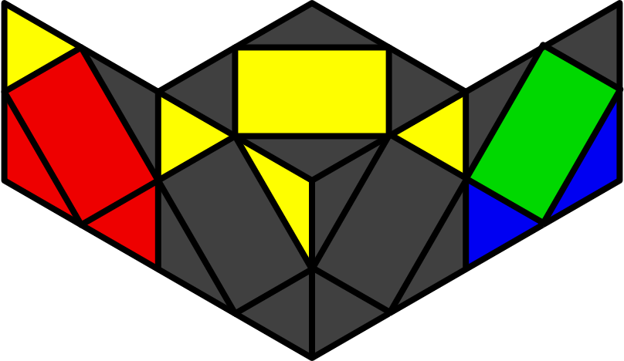U2 | 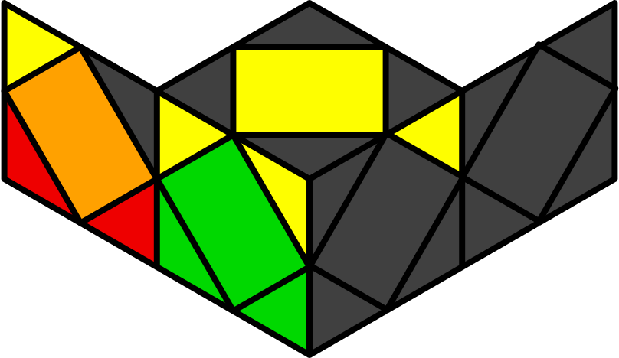U3 | 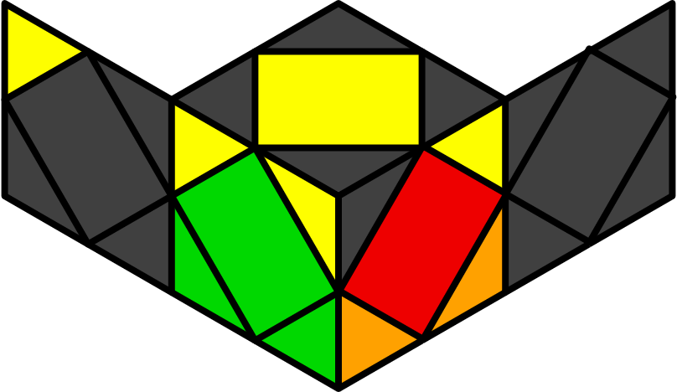U4
y x S z' S z' S | y' x (S z S) z S | x S S x' z2 (S z2' S) | x S S x' (S z2' S)
y2 x R B' r' R r z R' r R' | y' x R' r R' B b r' R r' | y' f r' H B r' | y2 x l' B b' r B r' R' r
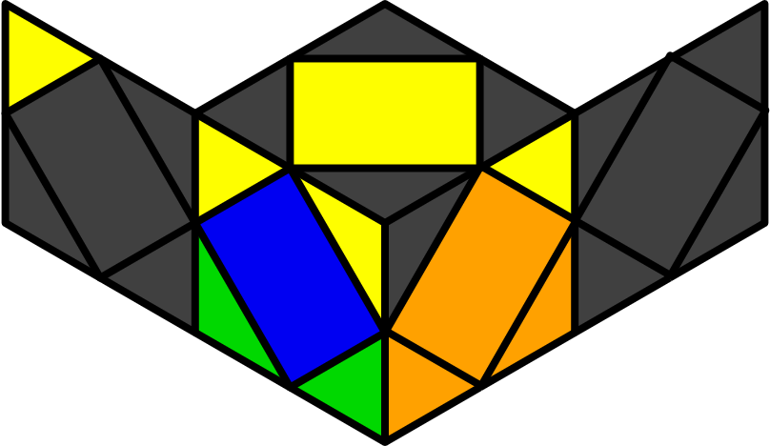U5 | 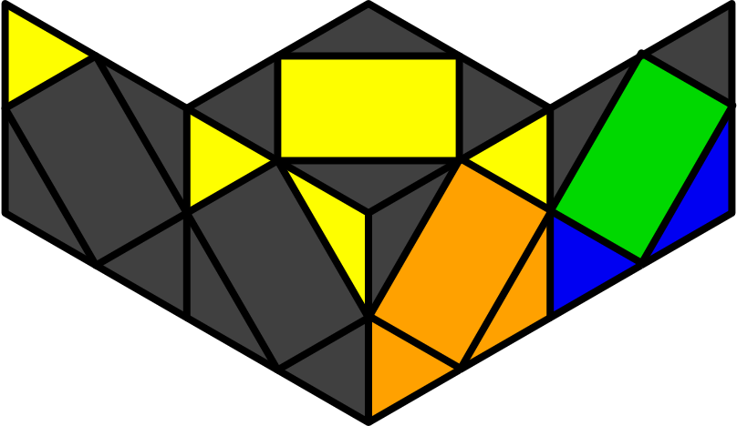U6 | 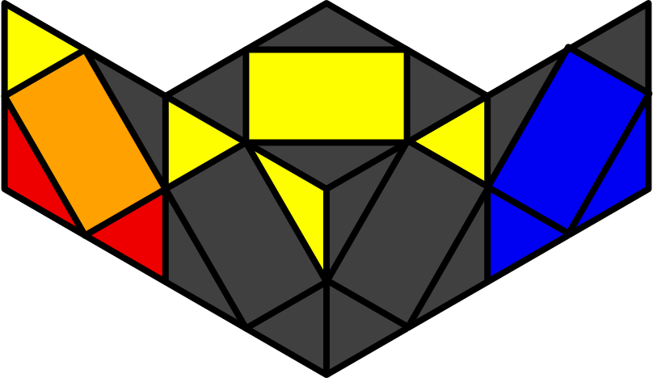U7 | 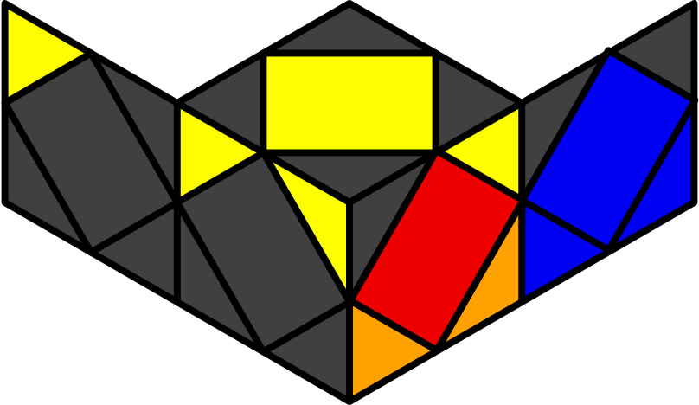U8
y x H z H z H | y' x (H z' H) z' H | x S S x z2 (S z2' S) | x S S x (S z2' S)
x B R' B r' R' r B R' | y' x z' R B' R r' z' r' y r R' r | x r B' S r B' | y2 z' r' R r B' r' b B' R
Peanut - FR [12]
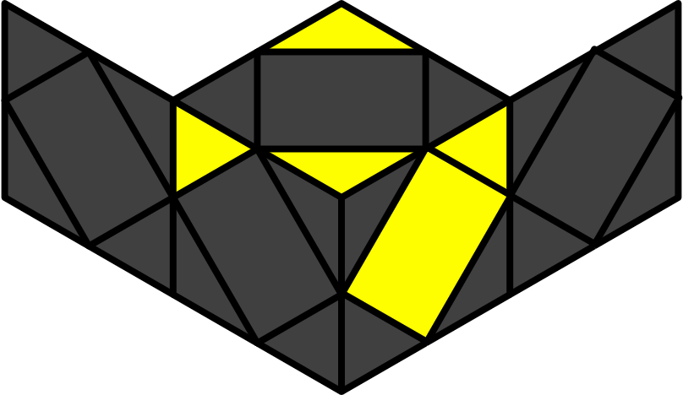
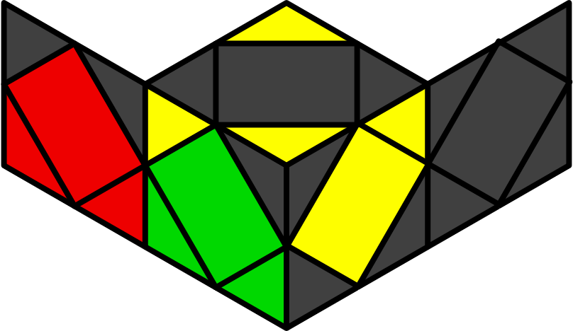O1 | 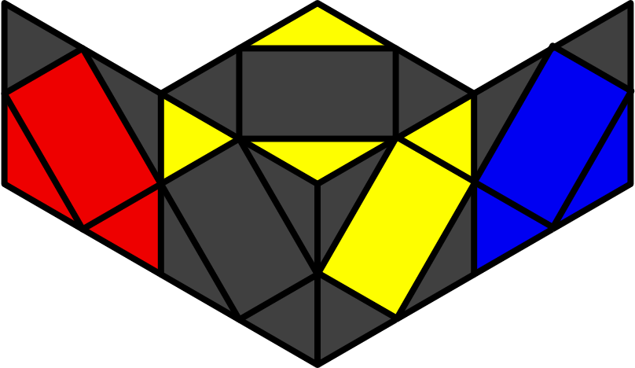O2 | 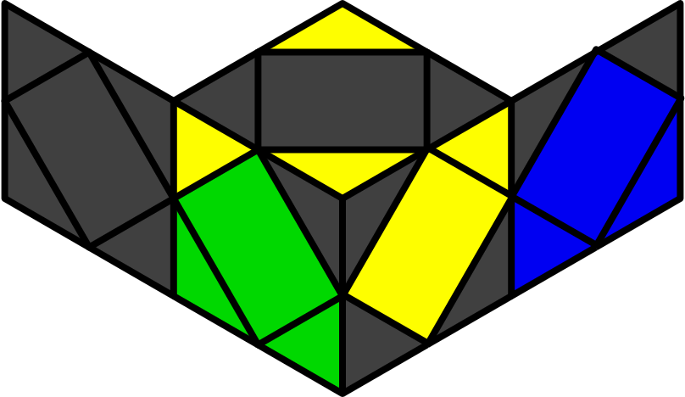O3 | 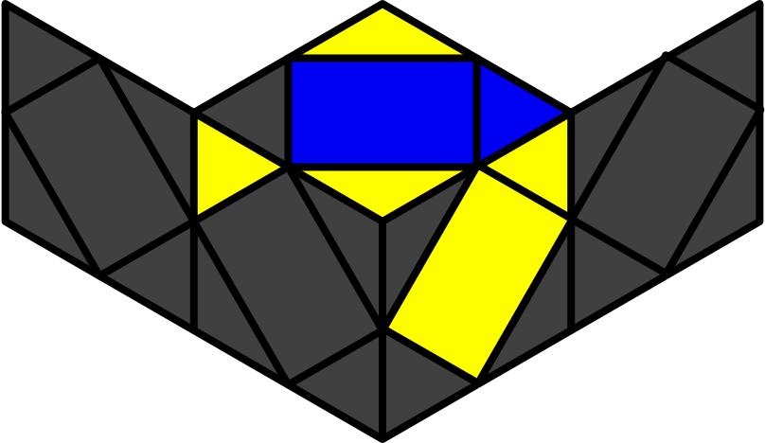S1
y x S z H z2 S | y' x (H z' H) z2 S | y2 x S z2 H z' S S | y x H z (H z' H) z H
y' r' R' r' R r z' r' R r | y2 x r' R' r R z R r R' r' | z' S z' R r R' r' | y2 x r' R' r R' z' H B'
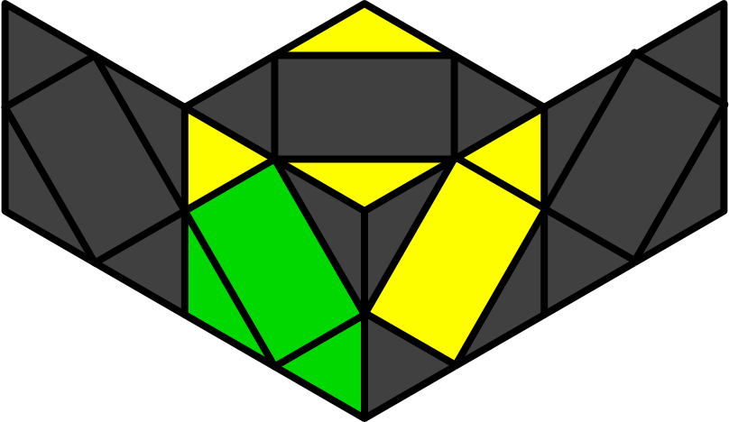U1 | 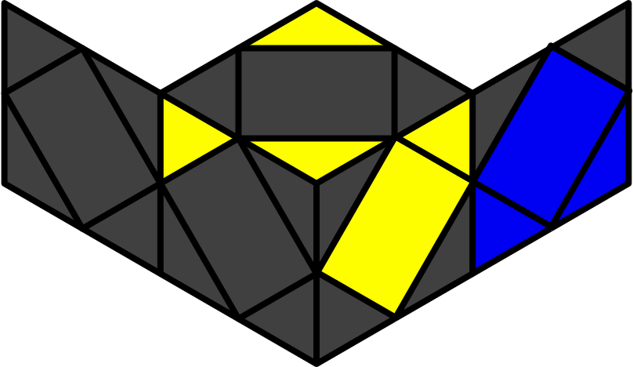U2 | 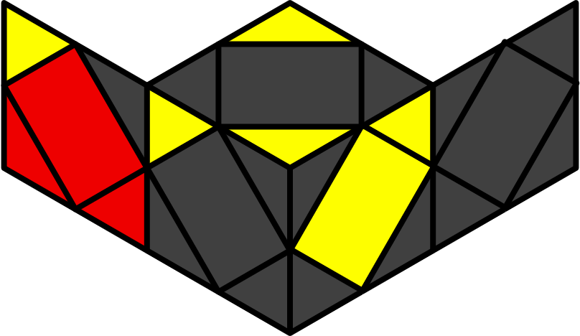U3 | 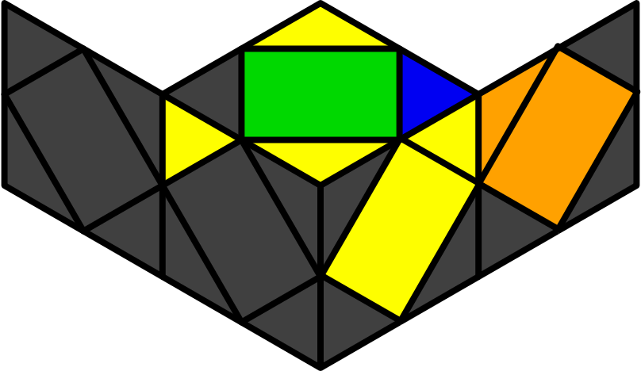S2
y2 x S z' H z S | y2 x (S z S) z' S | x (S z S) S | y' x S z' H z S z' H
y x R S z H R r' R' |  |  | y x r2' R r R' z' r' R' r R'
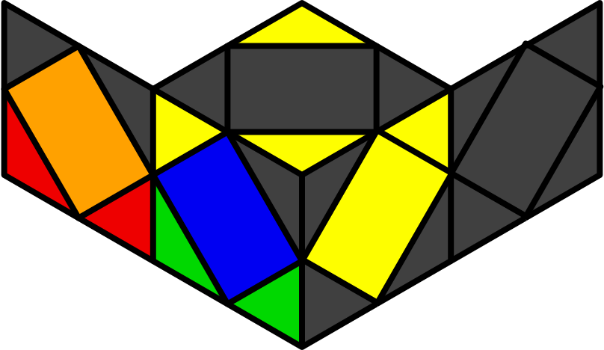X1 | 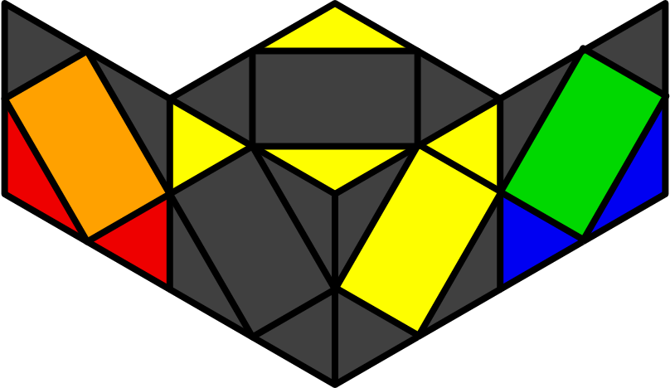X2 | 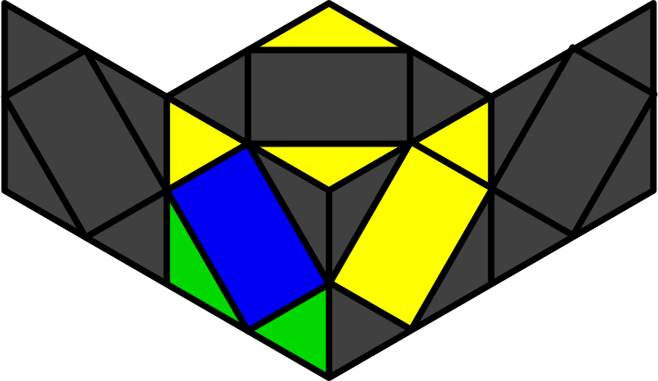W1 | 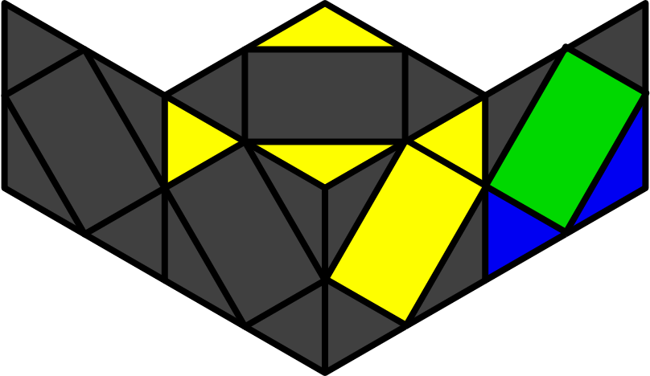W2
y x S z' H | y' x H z H | x S z2' (S z S) z S | x (S z2' S) z' H z' S
 |  | y' r R' r' y' r l' B l B' | y x R' r' R r R z R r2' R' r
Peanut - FL [12]
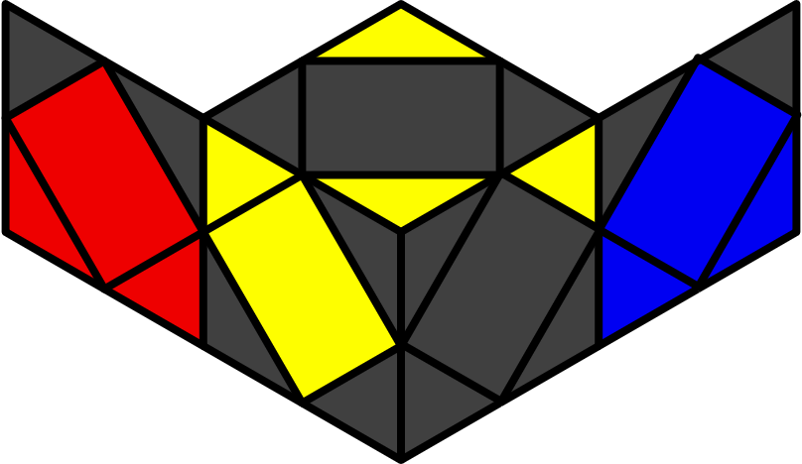O1 | 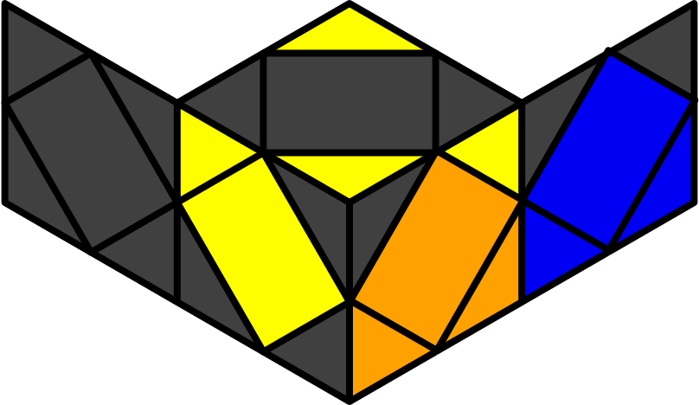O2 | 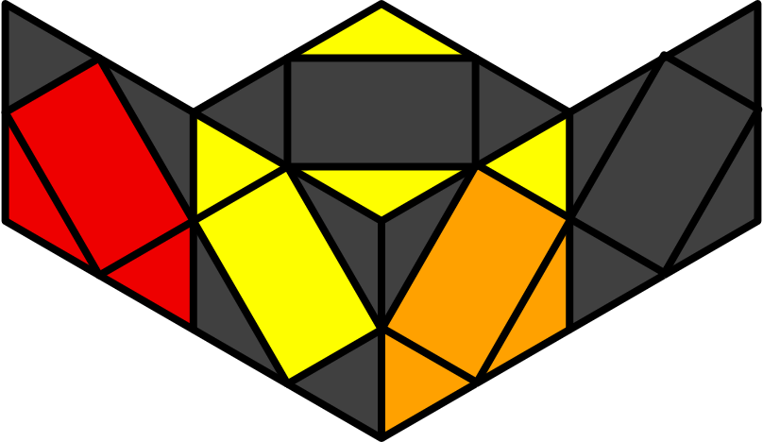O3 | 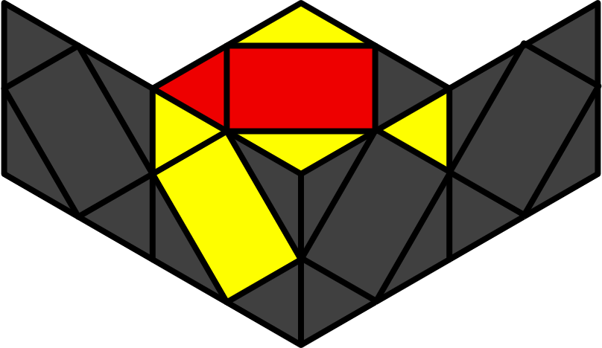S1
x S z' S z2 H | y2 x H z' S z2 H | y x H z2 (S z S) S | y2 x S z' (S z S) z' S
y2 x B R B' R' r' R' r R | y z' r' R' r l' r' R r R | y' R' r' R r z' S | y2 f S z R r' R r
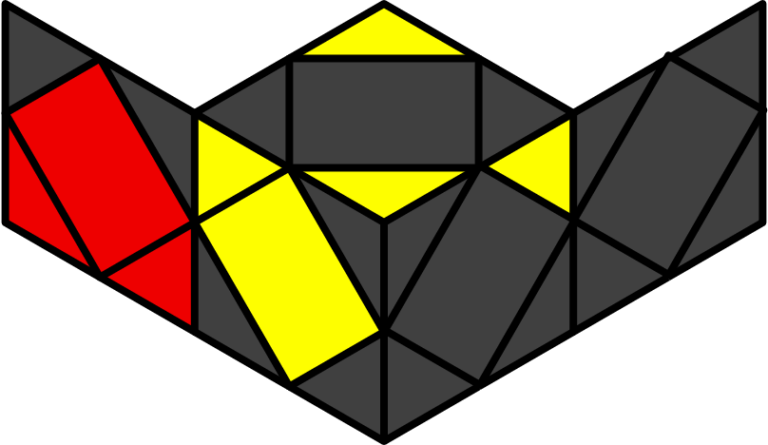U1 | 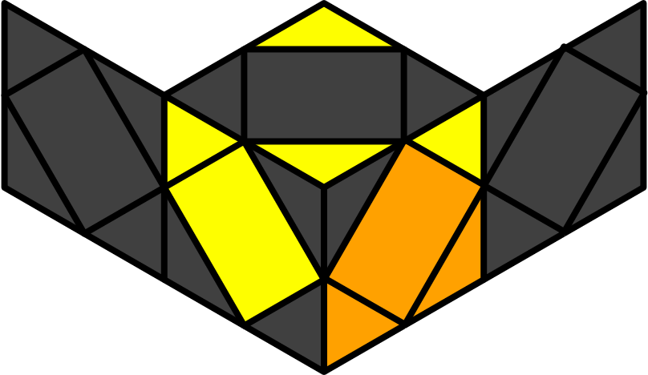U2 | 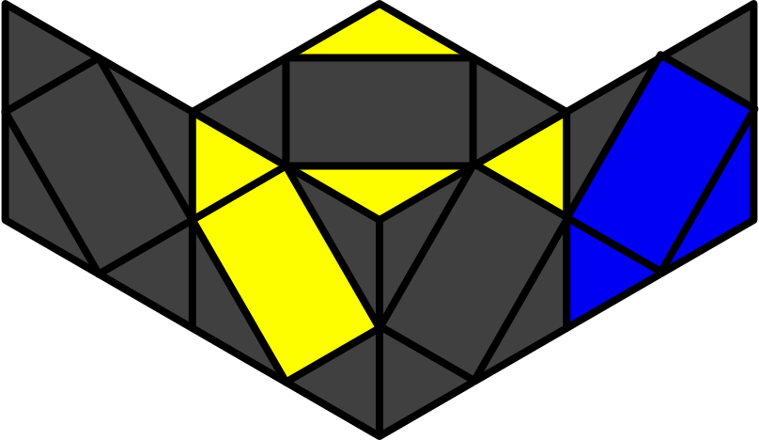U3 | 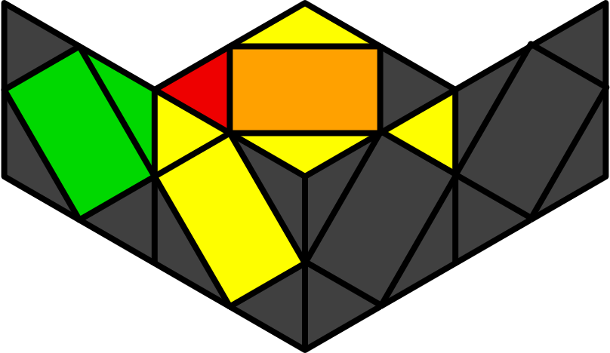S2
y x (H z' H) z H | y x H z S z' H | y' x H z S S | x H z S z' H z S
 | y2 x r' R' r R' B R' B' R z R r' R' |  | y2 x R' r' R' r B R B' R
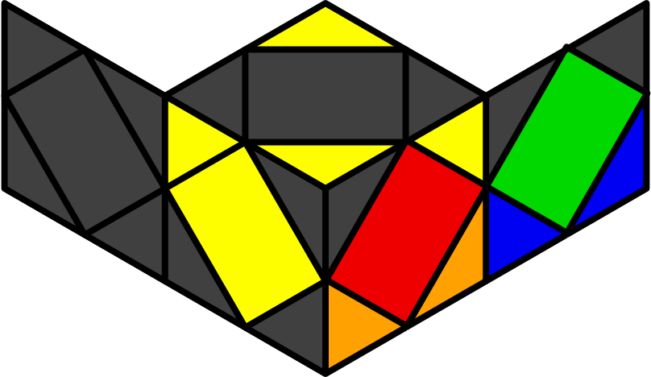X1 | 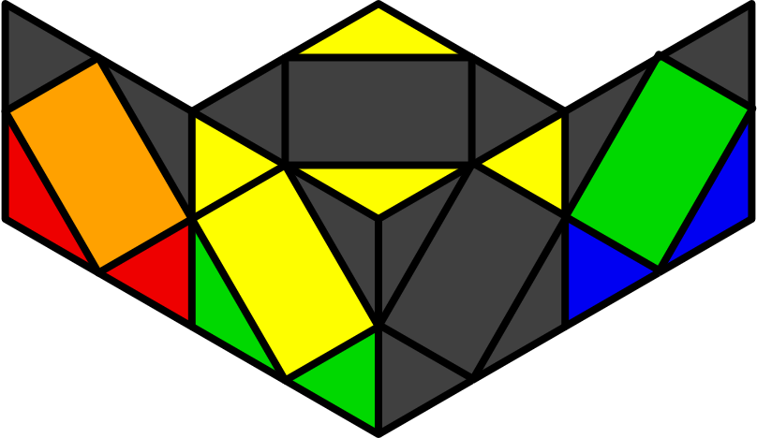X2 | 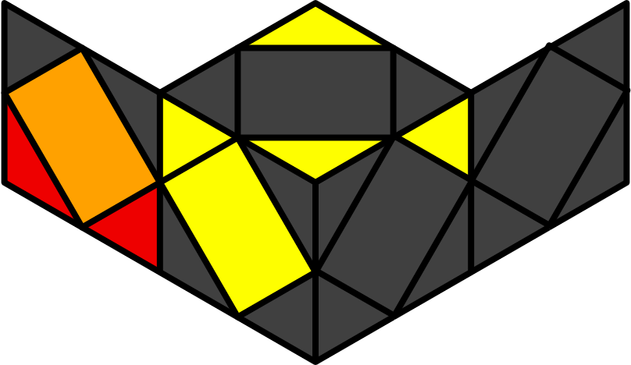W1 | 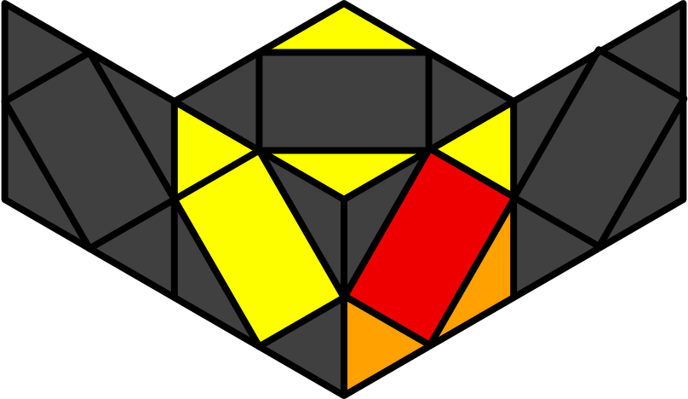W1
y2 x H z S | x S z' S | y' x S z2' (S z S) z H | y' x (S z2' S) z' (H z' H)
 |  | y2 x r R r' R' r' z' r' R' r R' | y' r' R r b' B r' z' r' R
Peanut - BR [12]
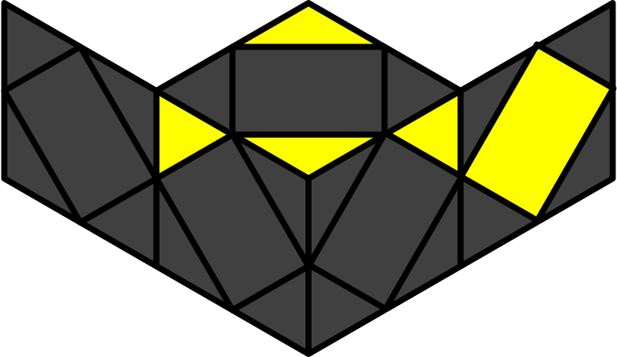
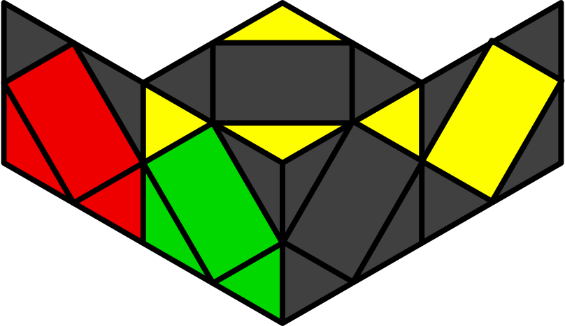O1 | 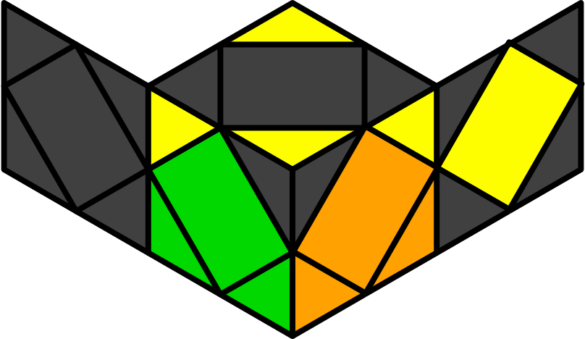O2 | 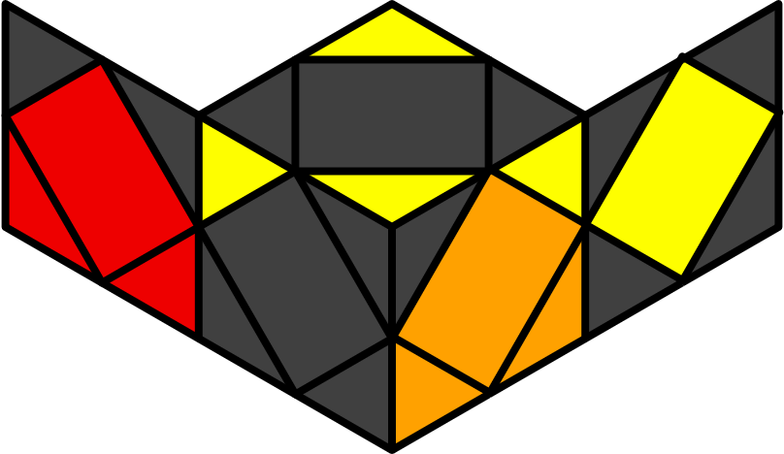O3 | 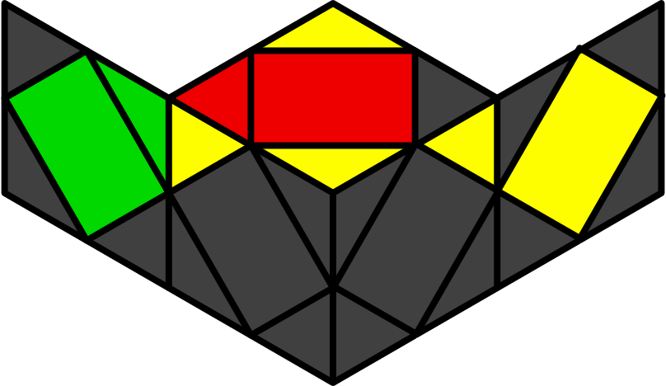S1
x S z' H z2 S | y2 x H z H z2 S | y' x S z2 H z S S | y2 x S z H z' S z H
y' R r R B R' B' R' r' | x z r R r' R' r' z' r' R r | y r' R' r R z' R r' R' r | x R r' R r z R r' R' r'
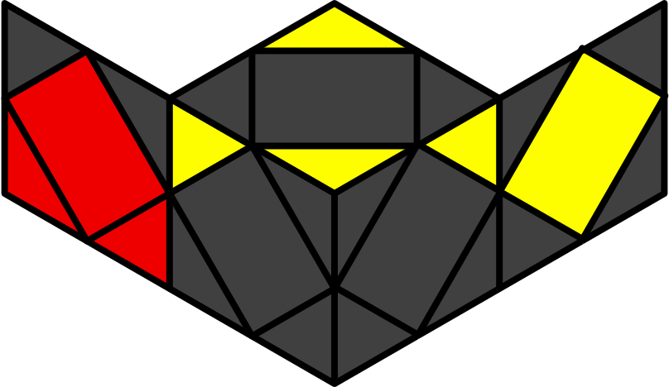U1 | 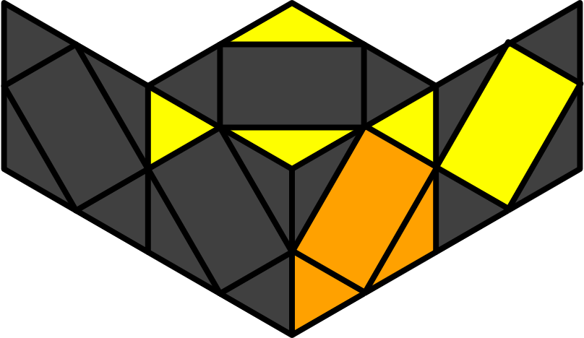U2 | 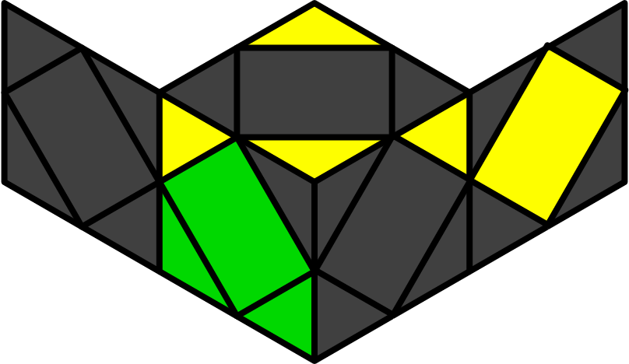U3 | 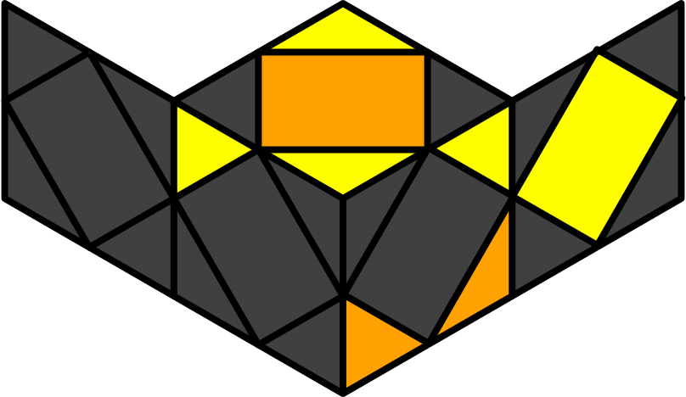S2
y' x S z H z' S | y' x S z' (S z S) | y x S z' S S | x (H z' H) z (H z' H)
y' x R r R' S r z' r' R r |  |  | y2 x r' z S z' R r' R' r'
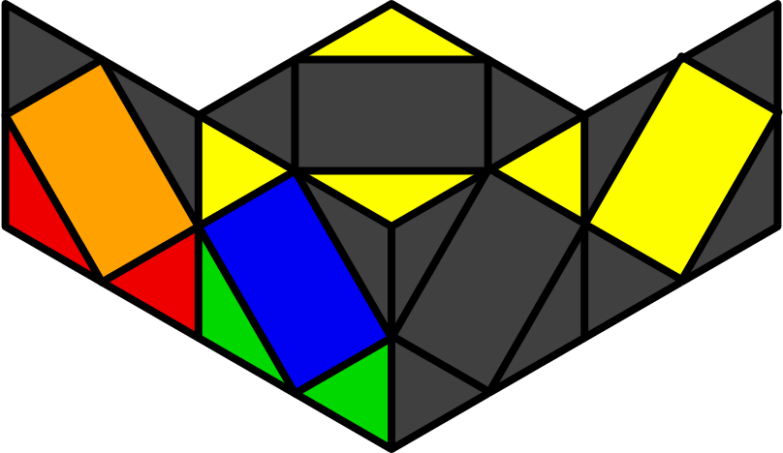 X1 | 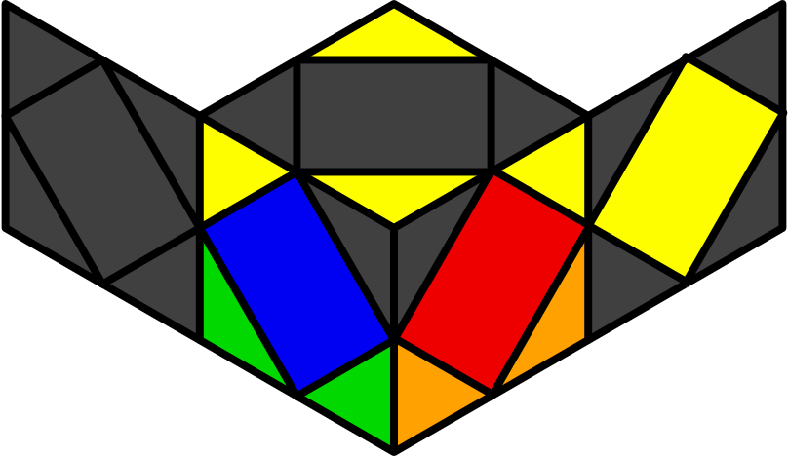X2 | 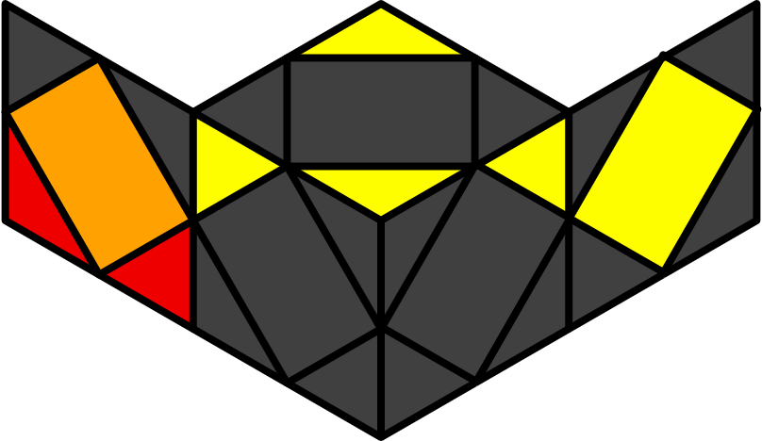W1 | 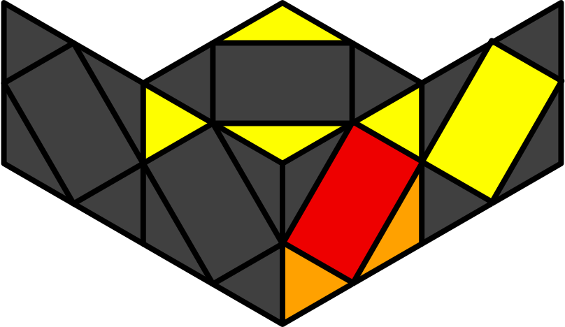W2
x S z H | y2 x (H z' H) | y x (S z2' S) z' S z' S | y x (S z2' S) z H z S
 |  | x R' r' R' r z' r' R r z r R' r | x R r R' z' r' R r R
Peanut - BL [12]
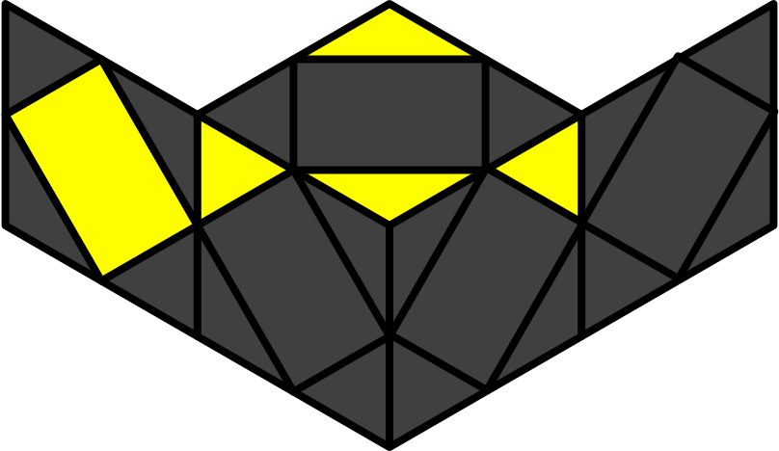
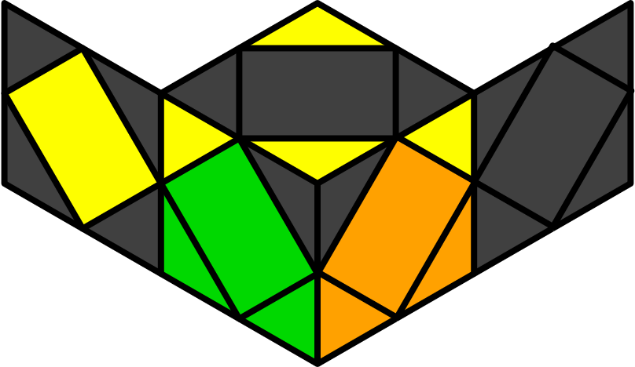O1 | 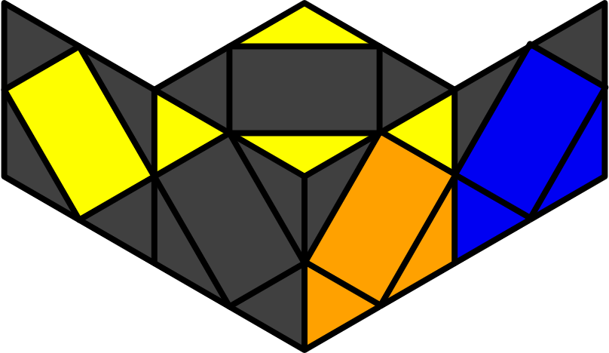O2 | 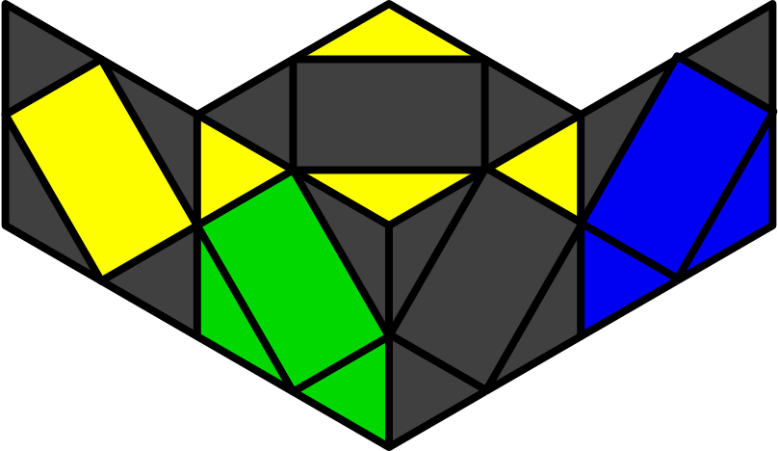O3 | 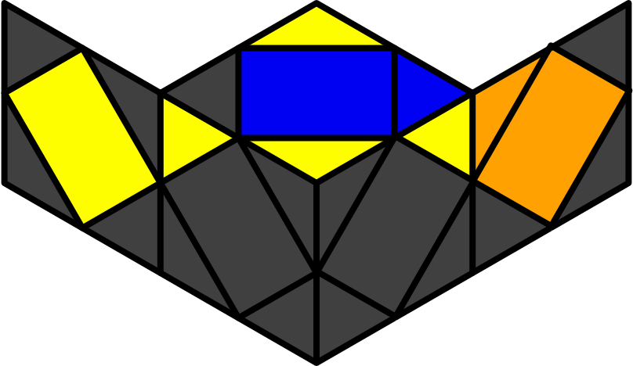S1
y x (S z S) z2 H | y' x H z Sz 2 H | x H z2 S z' S S | y x H z' S z H z' S
x R' r' R r R z R r' R' | y r R B R B' R' r' R' | y r R r' R' r' y' z' R r R' | x z r' R r' R' z' r' R r R
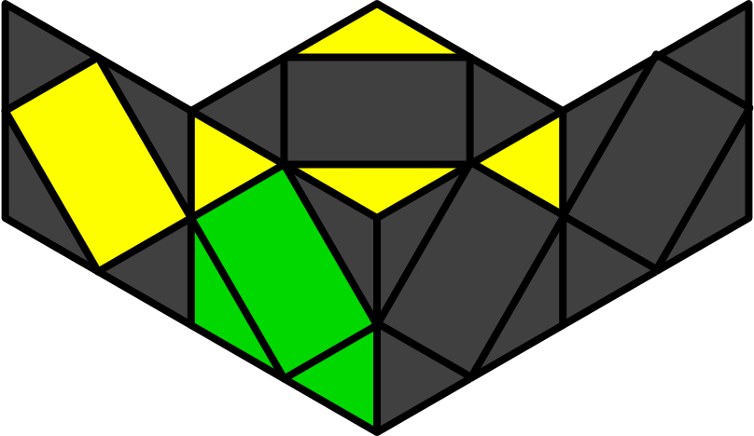U1 | 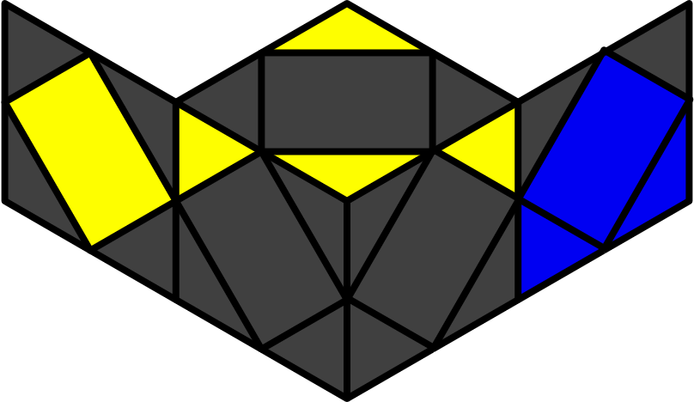U2 | 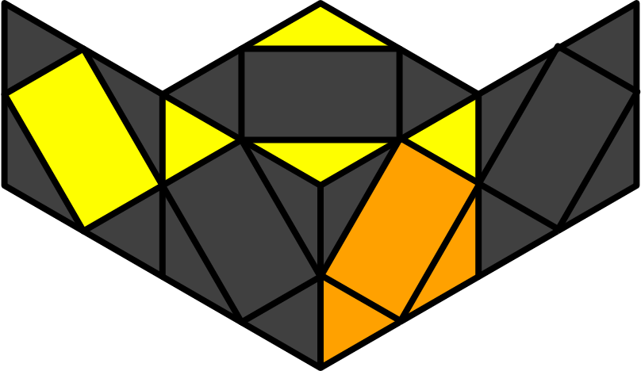U3 | 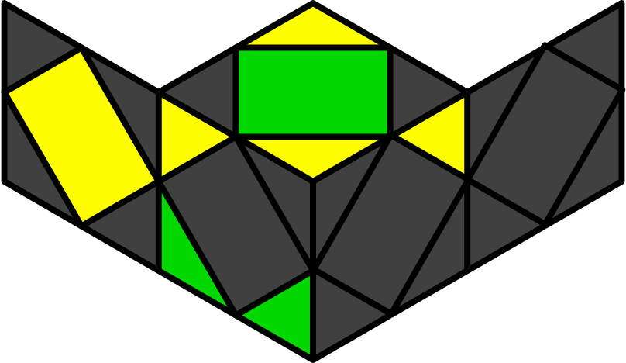S2
x H z (H z' H) | x H z' S z H | y2 x H z' S S | y' x (S z S) z' (S z S)
 |  |  | x r' S z H z' r
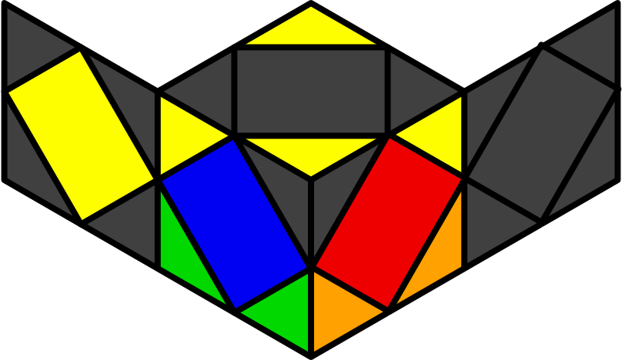X1 | 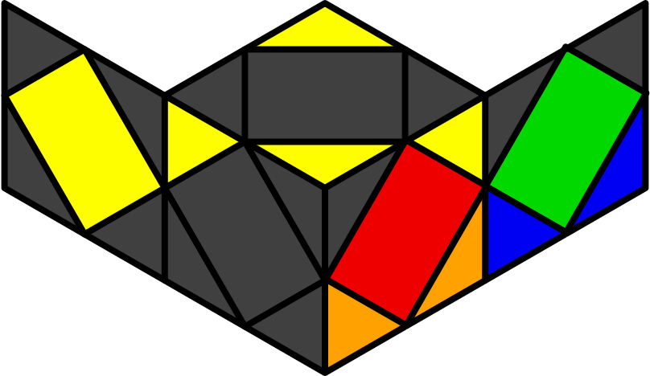X2 | 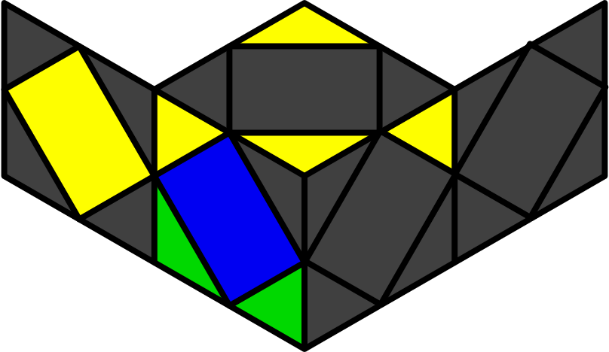W1 | 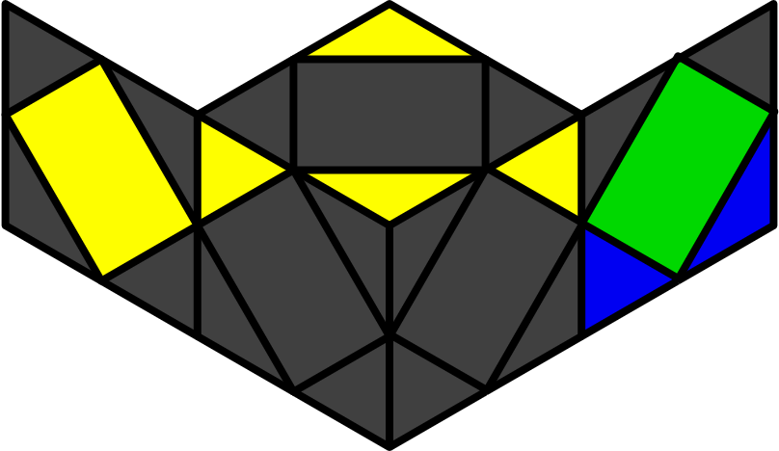W2
y x (S z S) | y' x H z' S | y2 x (S z2' S) z' S z' H | y2 x (S z2' S) z (H z' H)
 |  | x z r2' R r R' z' r' R r | y x R r' R' z S z' R r' R' r'
Pi - FL [12]
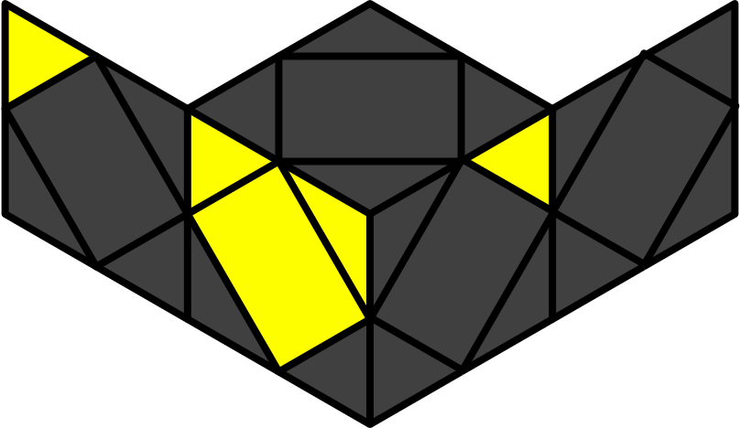
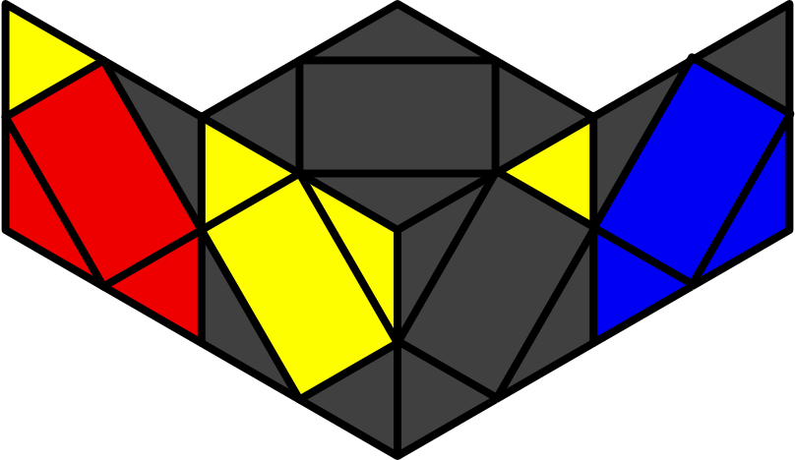O1 | 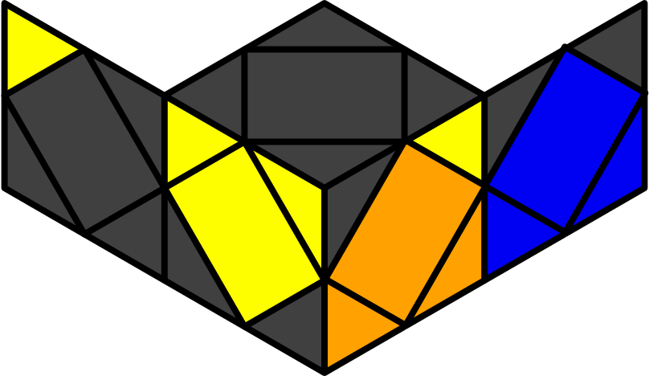O2 | 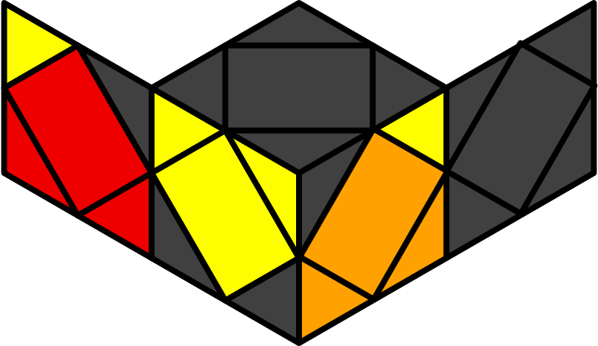O3 | 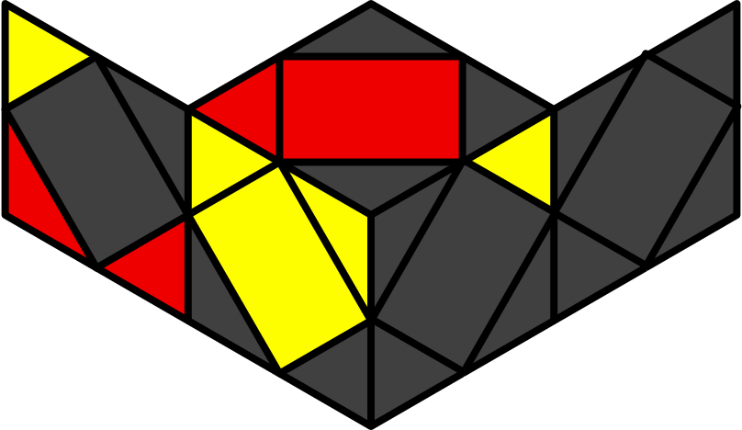S1
x H z (S z2' S) | y2 x S z' (S z2' S) | x S S z' (S z2' S) | y2 x (H z' H) z H z' S
y x R r' R' S z' r' R r | y x r' R r H z R r' R' | y2 (r' l r l') r' R' F r' R r | y2 R r' z' r' z r' R r' R r
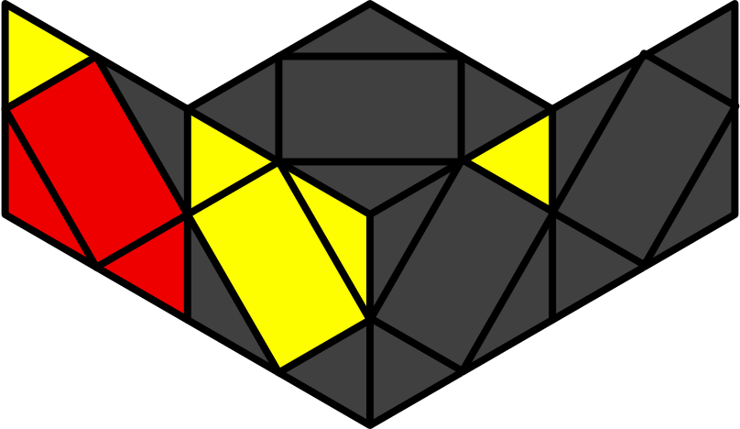U1 | 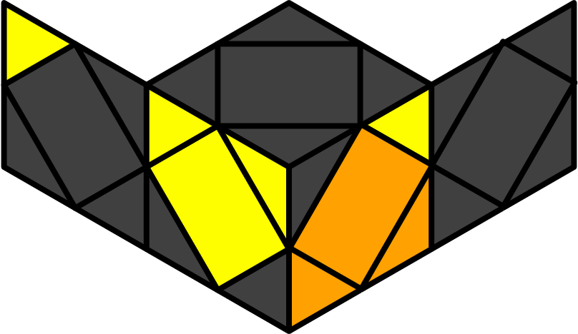U2 | 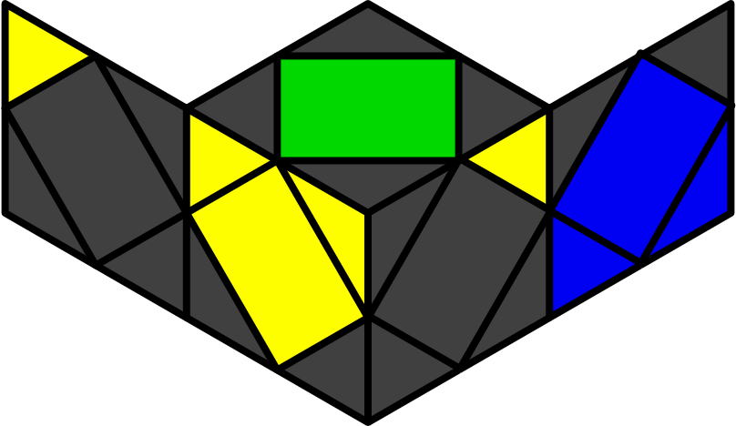U3 | 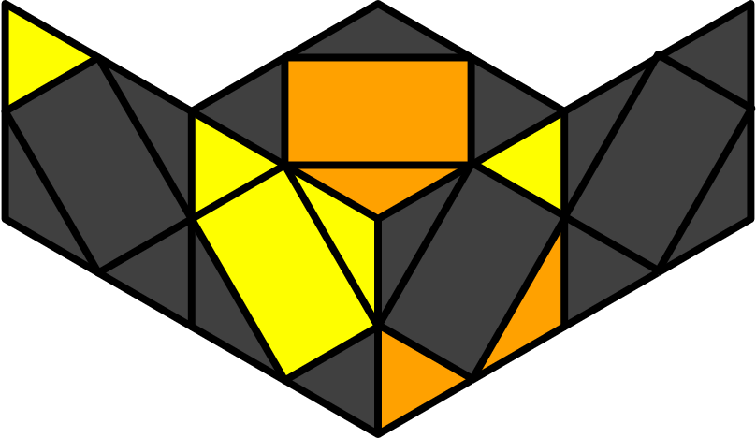S2
y x (S z S) z H | y x S z (H z' H) | y x r' R r R r' z' r' R r z r R r' | x (S z S) z' S z H
 | x r' R r R r' z' r' R r z r R r' |  | x' r' R r x R' r' R B' R' r'
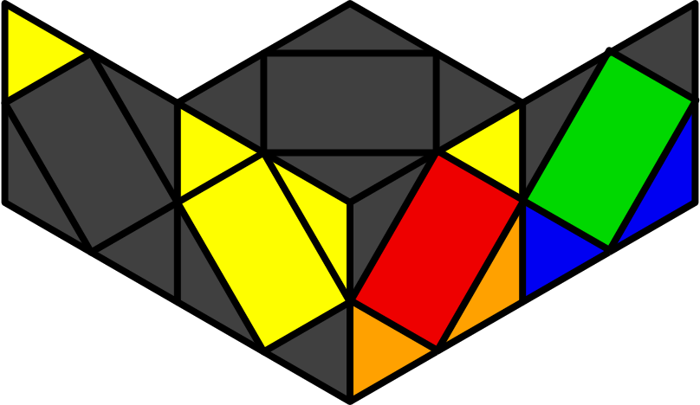X1 | 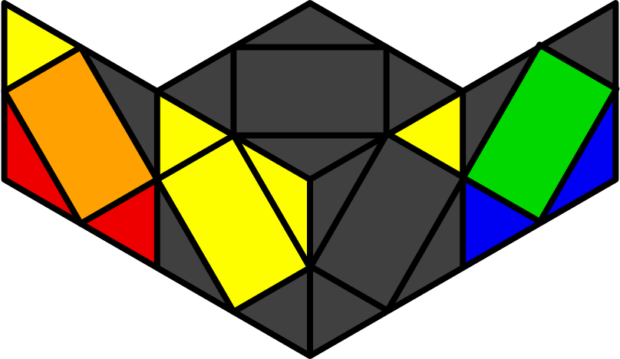X2 | 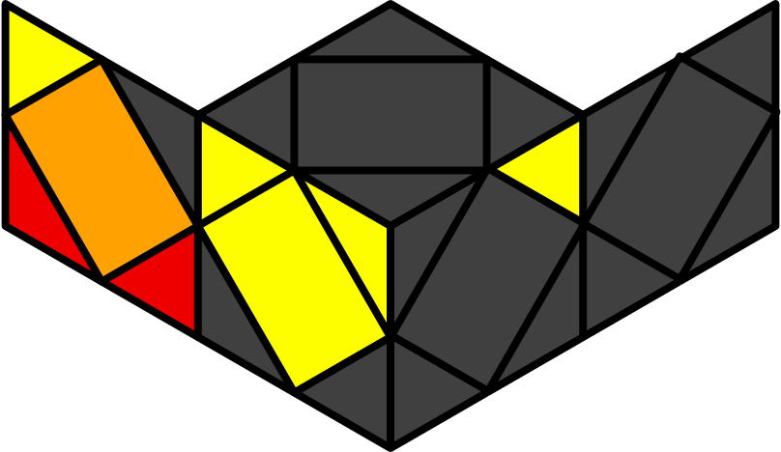W1 | 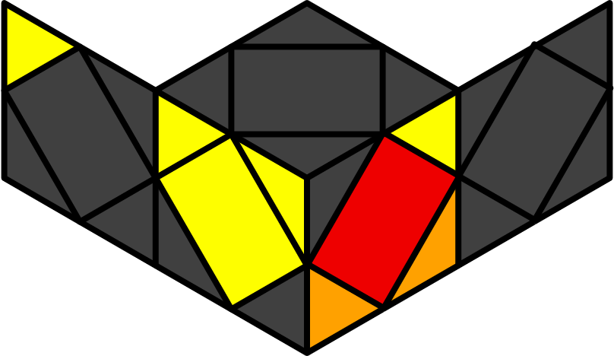W2
y2 x (S z S) S S | x H z' S S S | y' x H z2 S z H z H | y' x S z2 H z' S z' S
x R r R' z' R r z' r' R' r B | y2 x r' R' r l' y' z' S b' | y2 x r' R' r R' z' r R' r B r' R | y x S r R r' R' r' z' r' R r
Pi - BR [12]
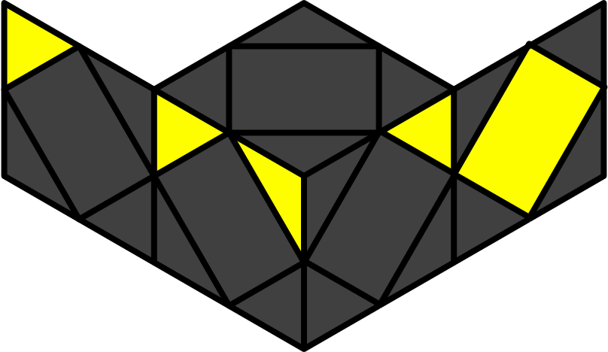
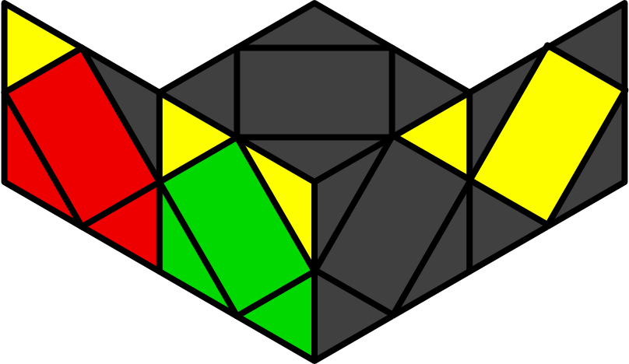O1 | 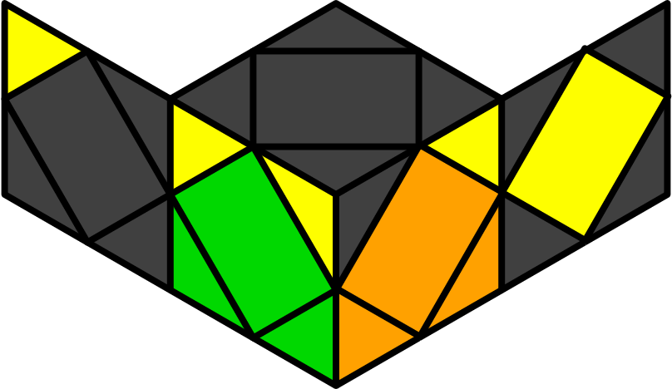O2 | 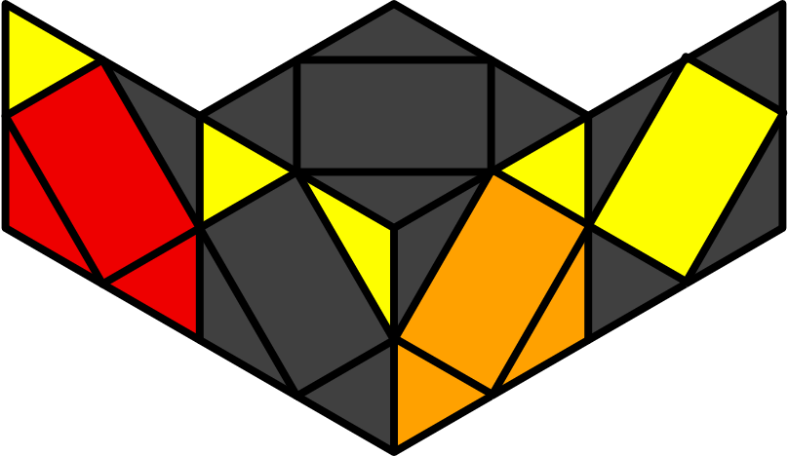O3 | 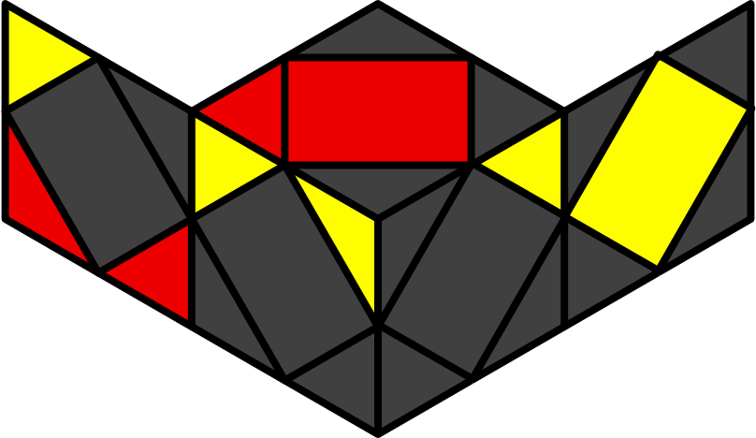S1
x H z' (S z2' S) | y2 x (S z S) z2' S | x S (S z S) z2' S | y2 x H z (H z' H) z S
y2 z' l' r y r' R' r B' b' | y x r R' r B r' R f | y2 x r B R' B' z' r' R' r B | y' x r' R r z R r R' z' r' R' r R'
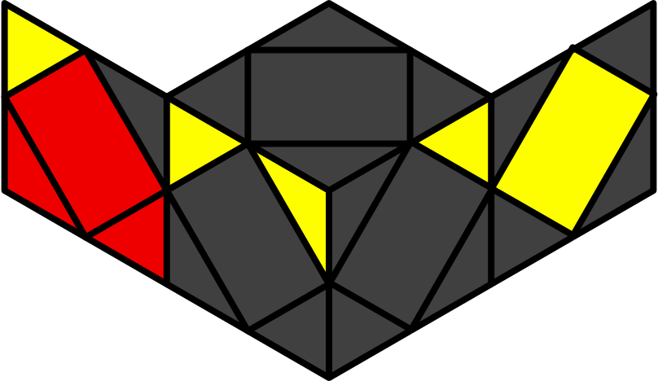U1 | 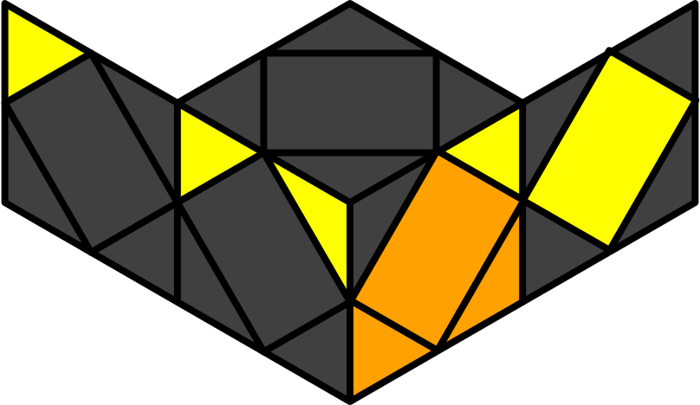U2 | 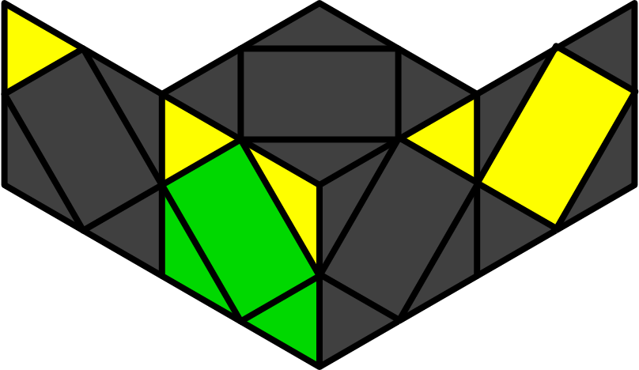U3 | 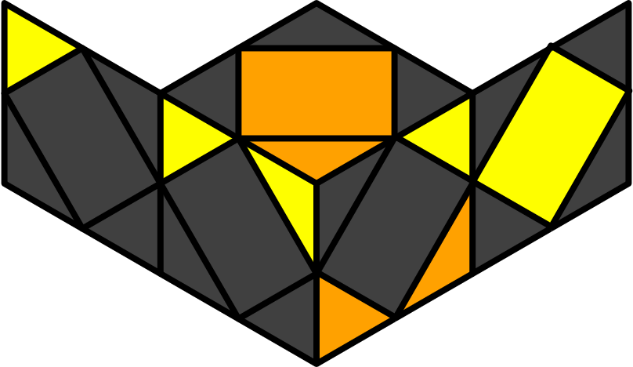S2
y' x (S z S) z' H | y' x S z' H z H | y' x r R' r' z' r' R' r z r R' r' R' r | x S z' (S z S) z' H
 |  |  | y' x R r' R' z' r' R' r B R B' R
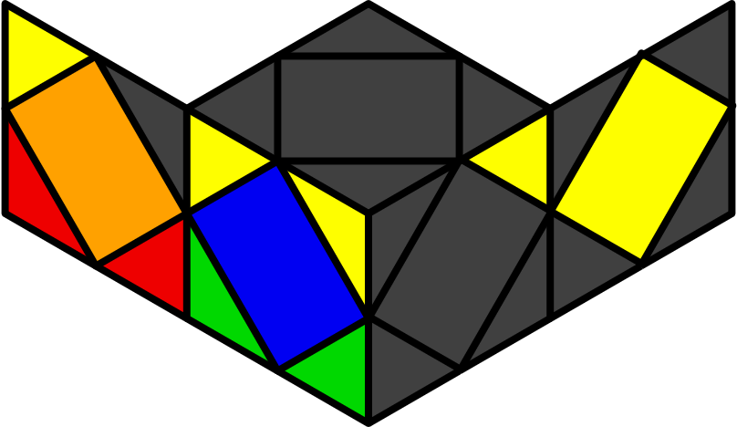X1 | 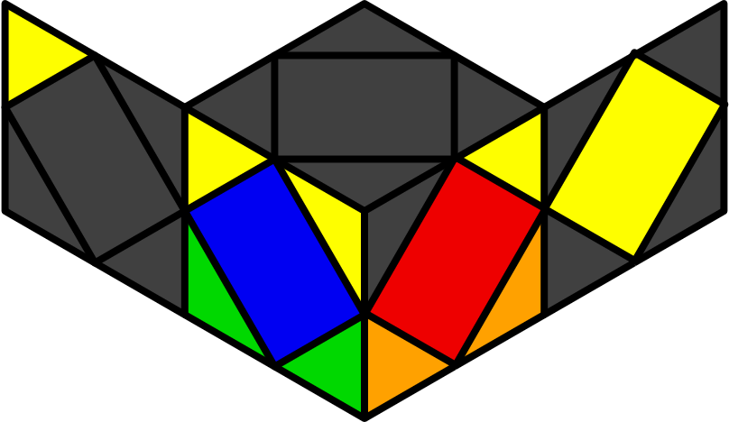X2 | 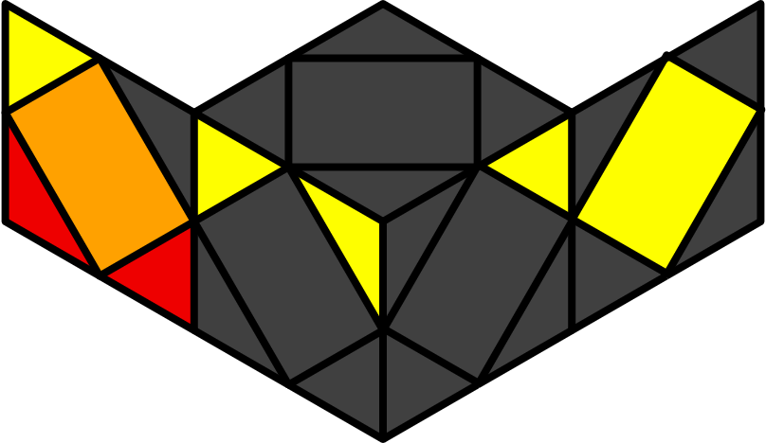W1 | 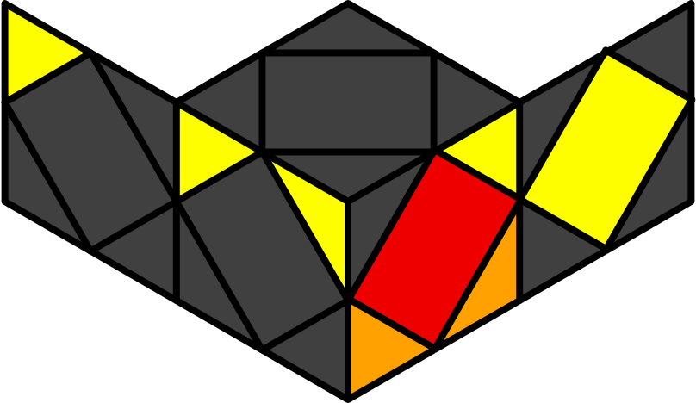W2
x H z S S S | y2 x S z' S S S | y x H z2 S z' (H z' H) | y x S z2 H z (S z S)
x b' S z2 r' R' r R' | y x r' R z' r' R r z r R r' R | y2 x R' r' R' z' r' R' B R' r' | x r2' R r B R r' R B
Pi - FR [12]
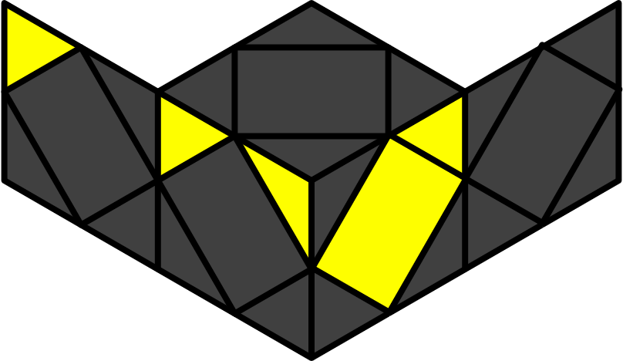
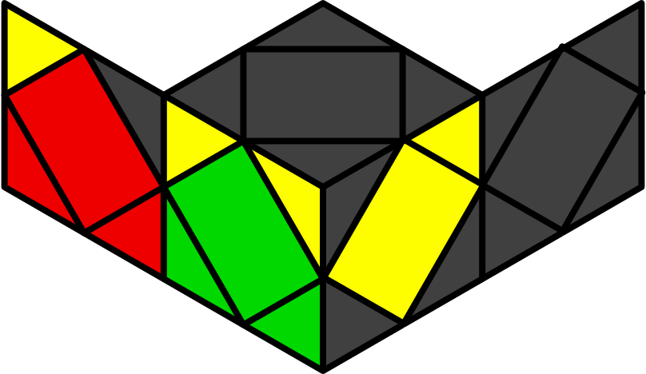O1 | 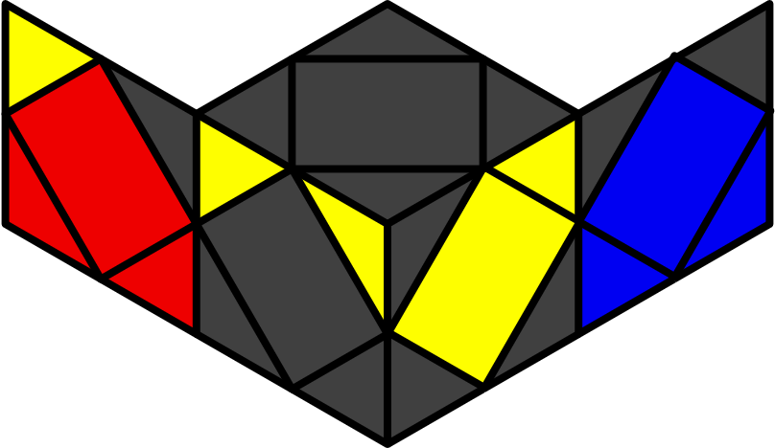O2 | 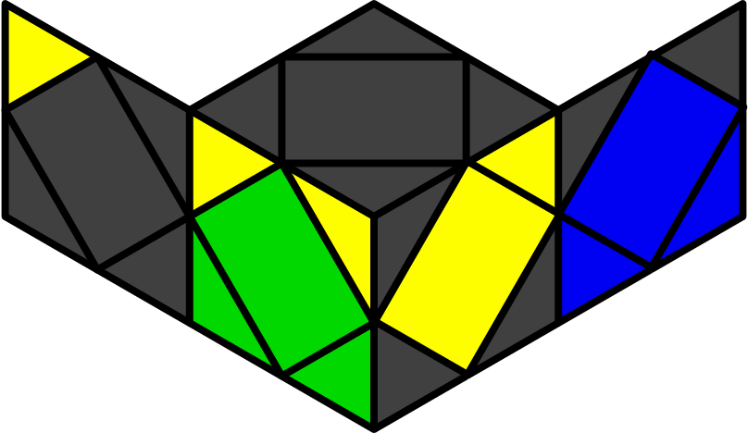O3 | 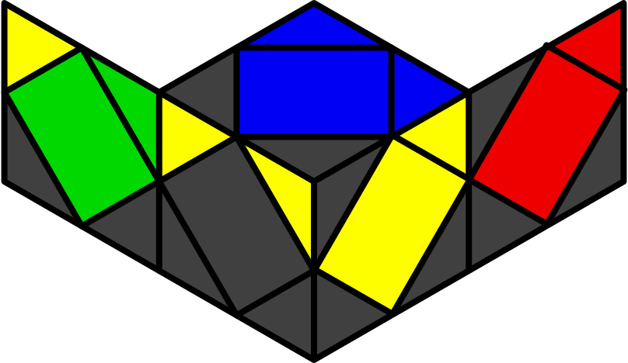S1
x H y' z' (S z2' S) | x H y' z (S z2' S) | y2 x H z2 S | y x (S z S) z' H z S
y' x B R B' S r' R' r | y' x B' R' r B' r' R r' |  | y' z' r' R' r R' r b r R'
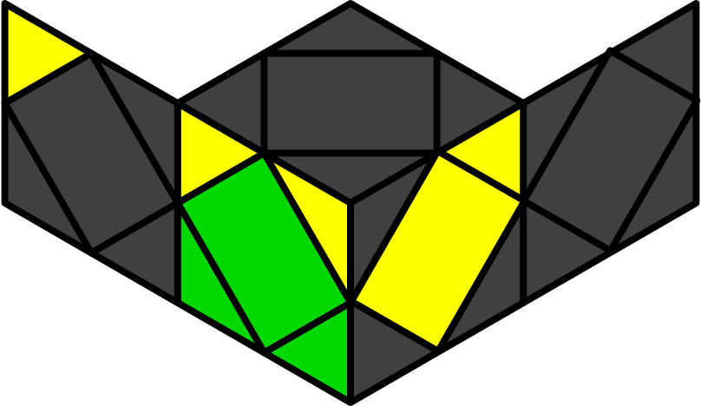U2 | 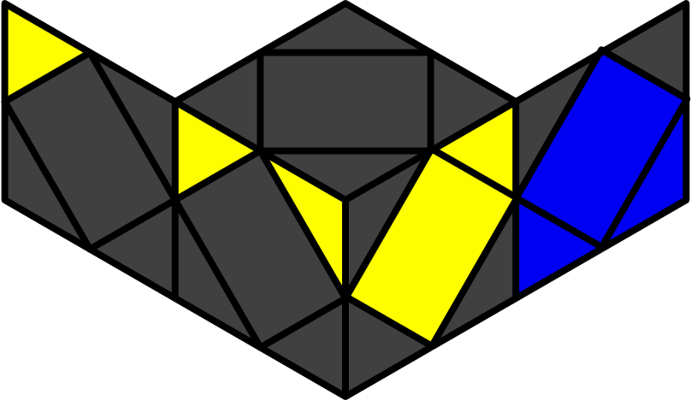U3 | 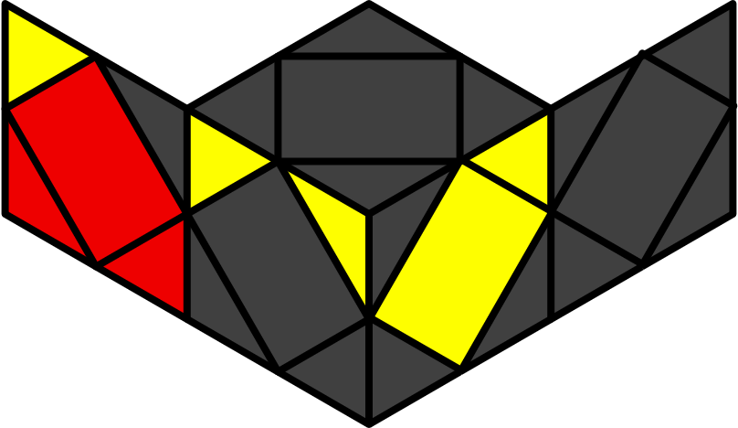U1 | 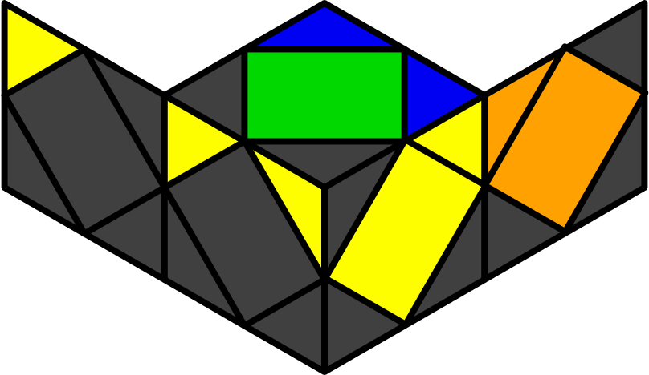S2
x H y z' (S z2' S) | x H y z (S z2' S) | x H | y' x S z' S z H z' S
x r B R B' r' B R' B' | y x r' R' r B' r' R r B |  | y x R r' R r B R' B' r' R' r
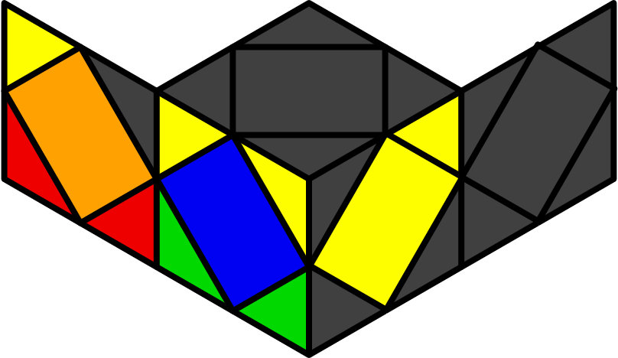X1 | 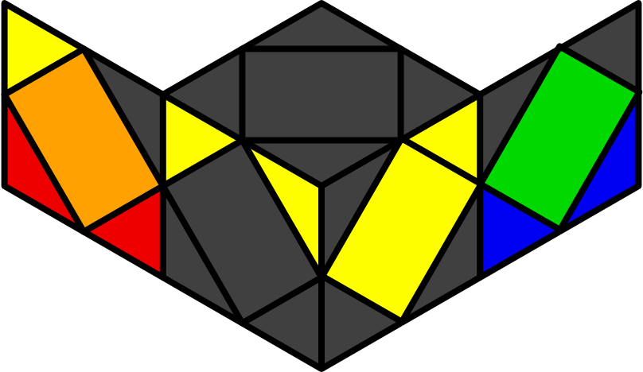X2 | 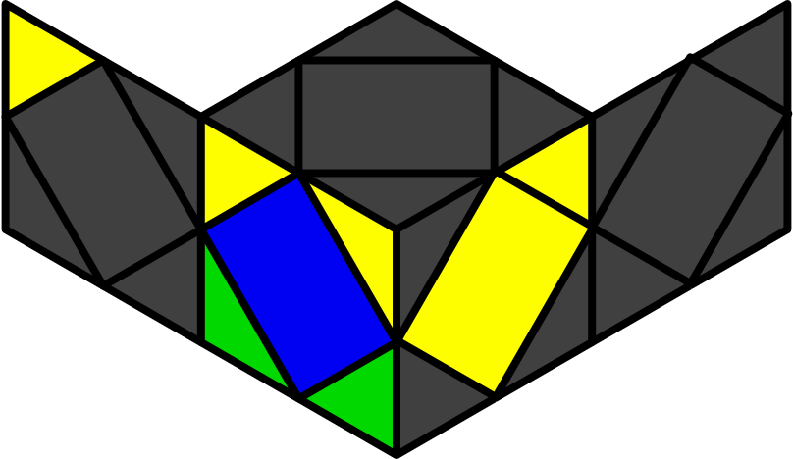W1 | 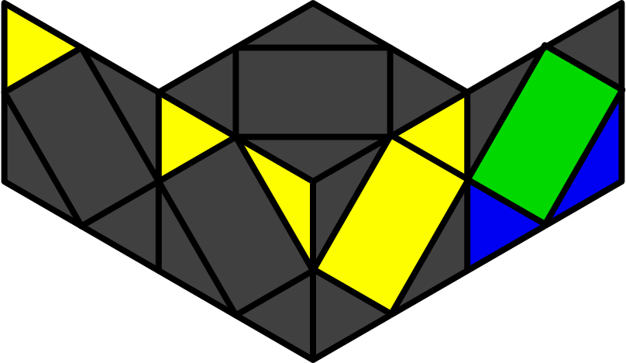W2
y2 x S y' z (S z2' S) | y2 x S y z (S z2' S) | x H x (S z2' S) | x H x' (S z2' S)
x R r' R r z B R' B' R r | y' x r B R' B' R r z' r' R r
Pi - BL [12]
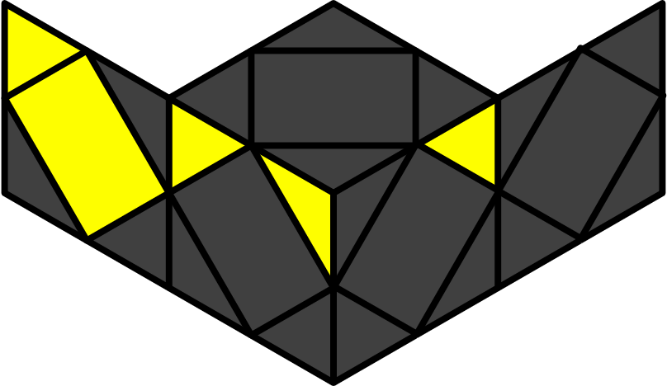
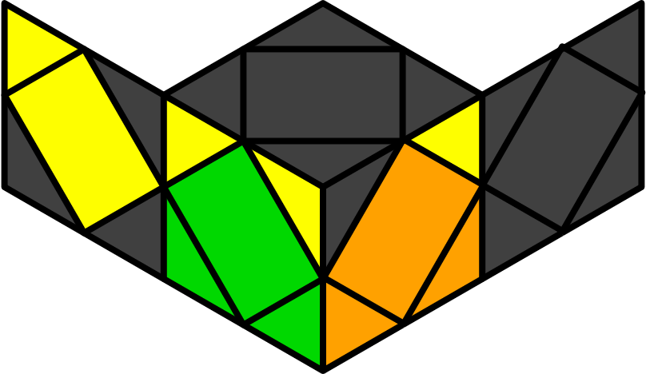O1 | 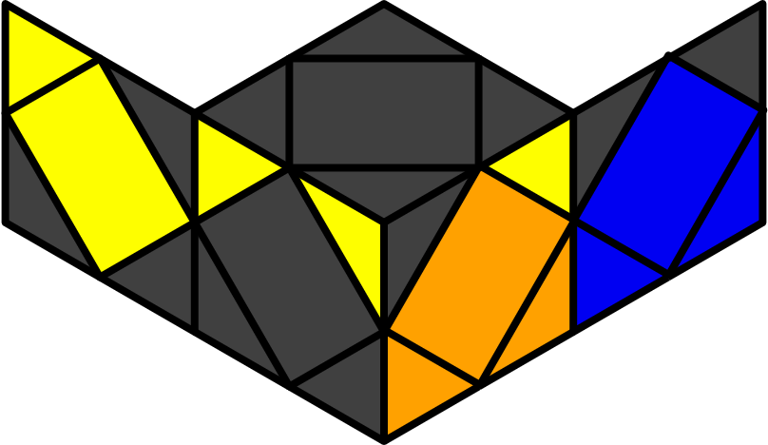O2 | 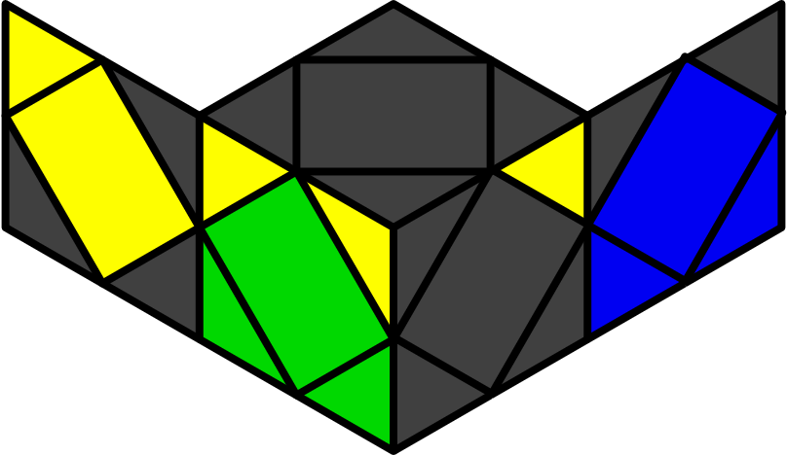O3 | 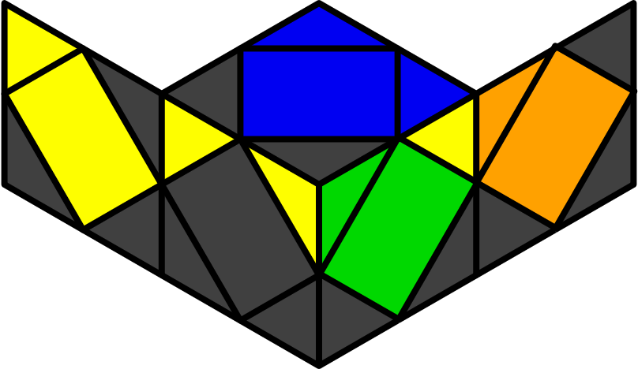S1
x H x z2 (S z2' S) | y2 x S y' z' (S z2' S) | x S z2 H | y x (H z' H) z S z' H
 | x r R B' r z R r' R |  | x R b R' z' R r' R' B' r
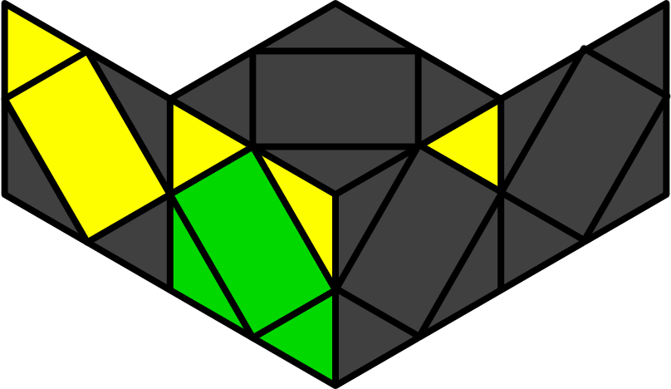U1 | 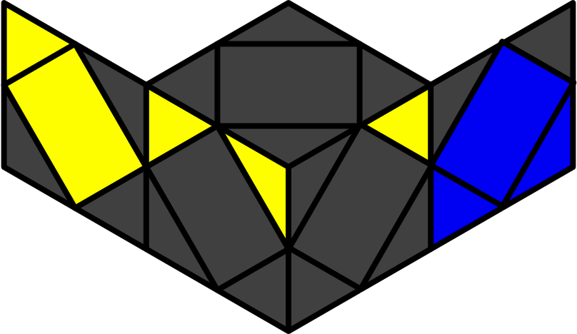U2 | 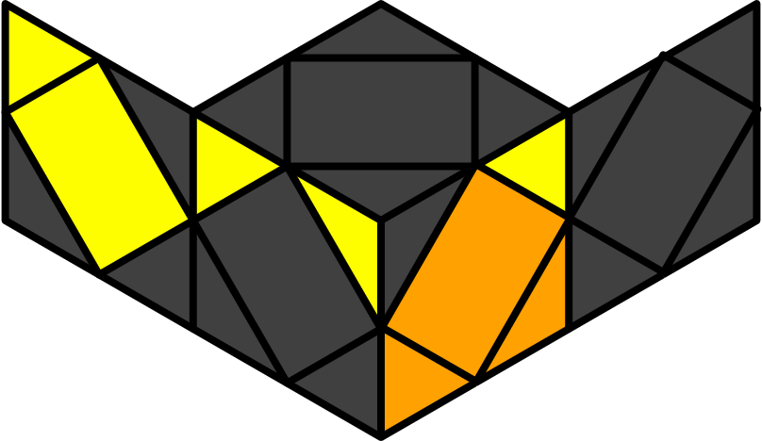U3 | 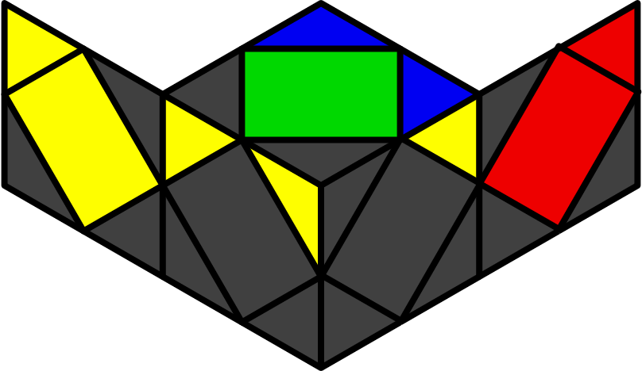S2
x H x' z2 (S z2' S) | y2 x S y z' (S z2' S) | y2 x S | y' x H z H z' S z H
y' x B' r' R' r B r' R r | y2 x B R B' r B R' B' r' |  | y' b R r' b R' r' R' r
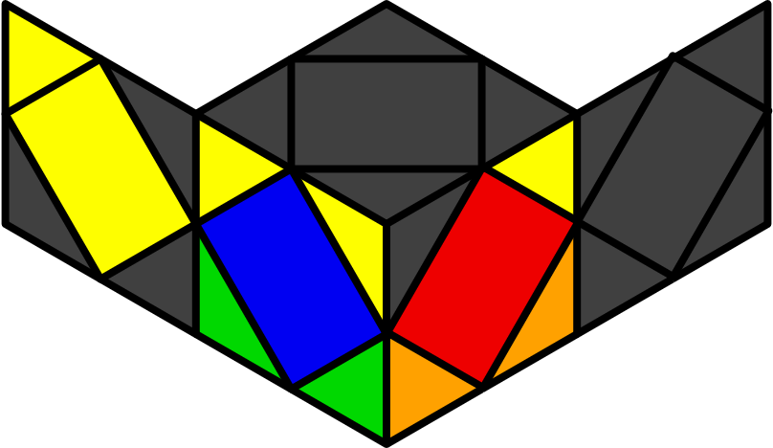X1 | 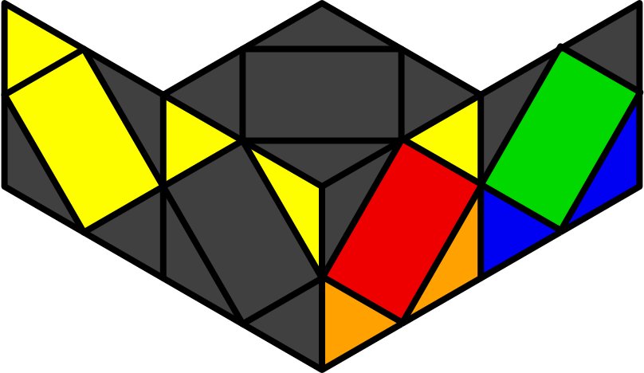X2 | 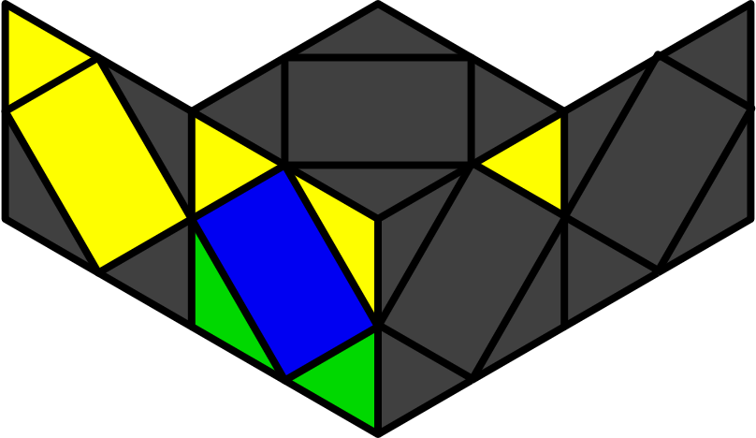W1 | 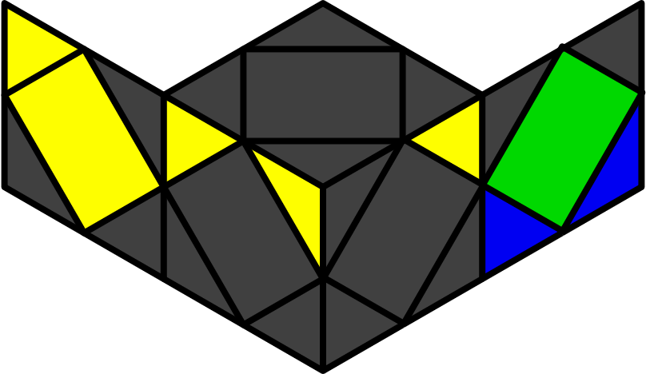W2
y2 x S x' z2 (S z2' S) | y2 x S x z2 (S z2' S) | y2 x S x' (S z2' S) | y2 x S x (S z2' S)
y' x R' r R' r' z' r' R' r z R' r | x B' S z2' r' R r' R'

