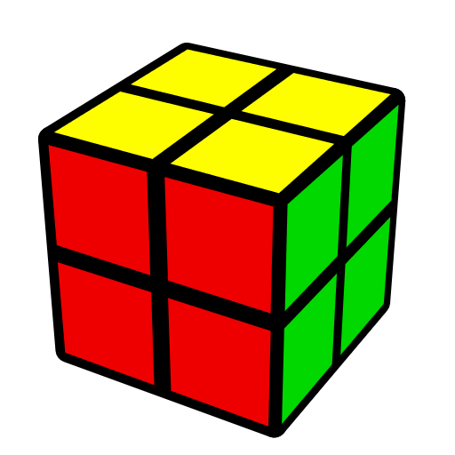
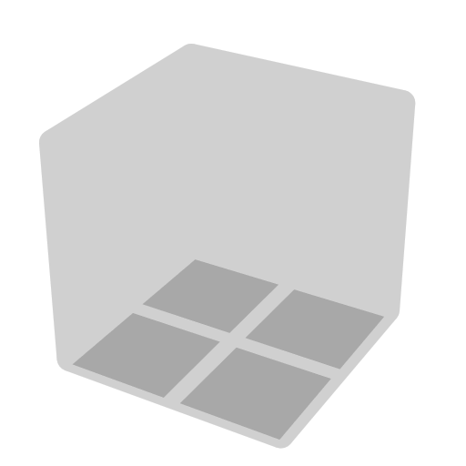
2x2 EG Methods (Erik-Gunnar)
Algs from Chris Olson http://cyotheking.com, Will Callan http://bit.ly/2lQXlxe, Jack Pan http://bit.ly/2nCwwyc

Face | EG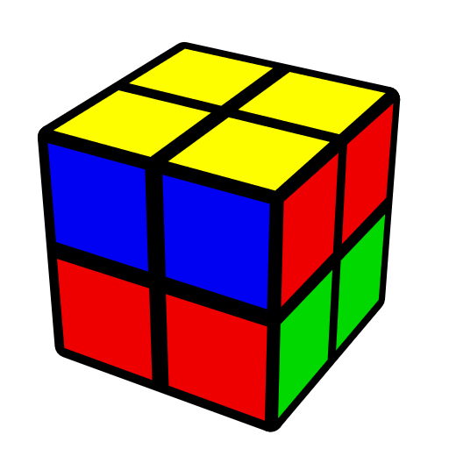 | AUF

Intermediate
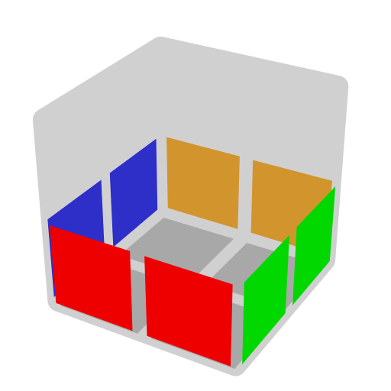CLL |  | 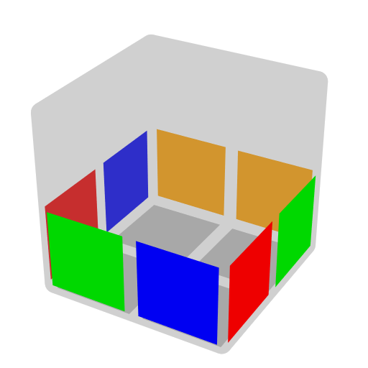EG1 |  |  | 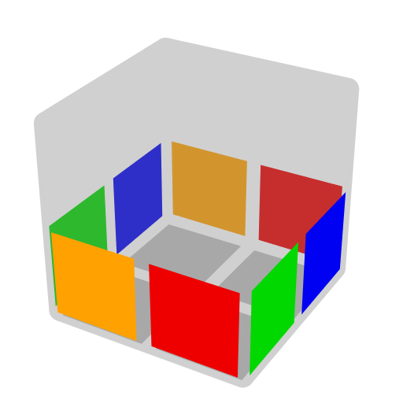EG2
Advanced
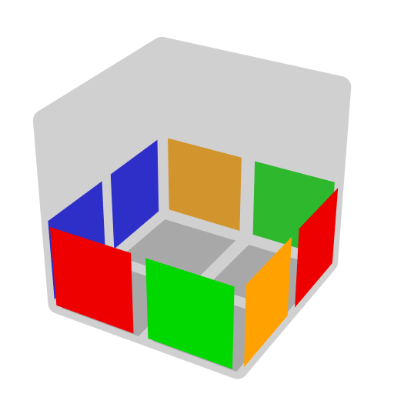LEG |  | 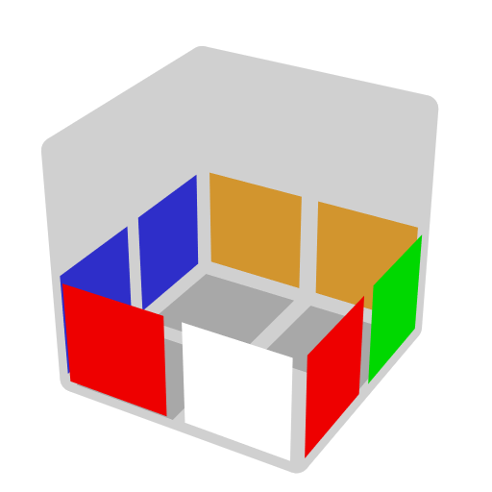TCLL+ |  |  | 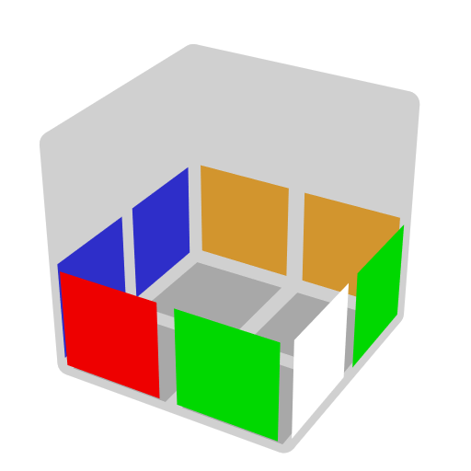TCLL-
Supplement
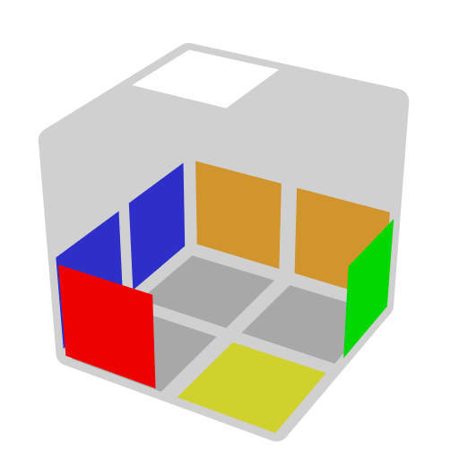LS1 | 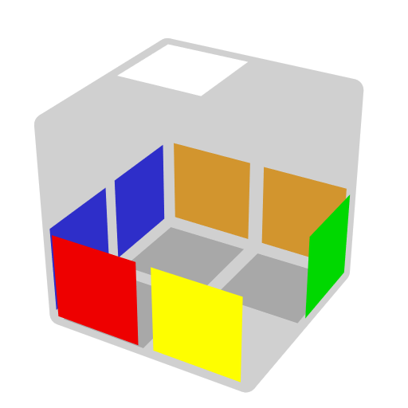LS2 |  | 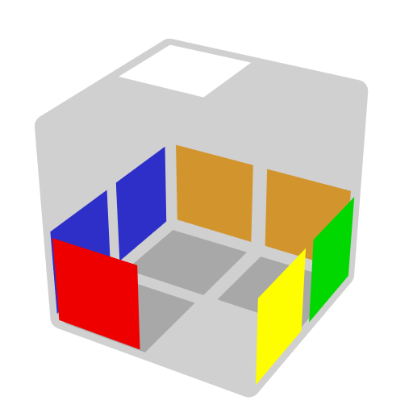LS3 | 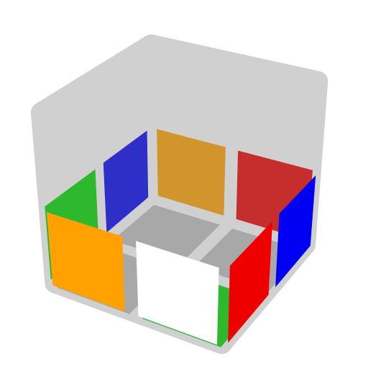TEG2+ |  | 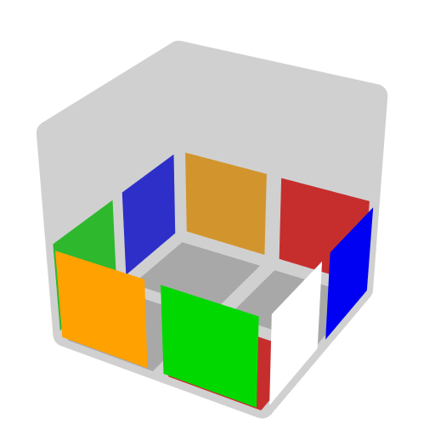TEG2-

Special finger trick: In F' U', use right index to execute F'.

Predict D Layer
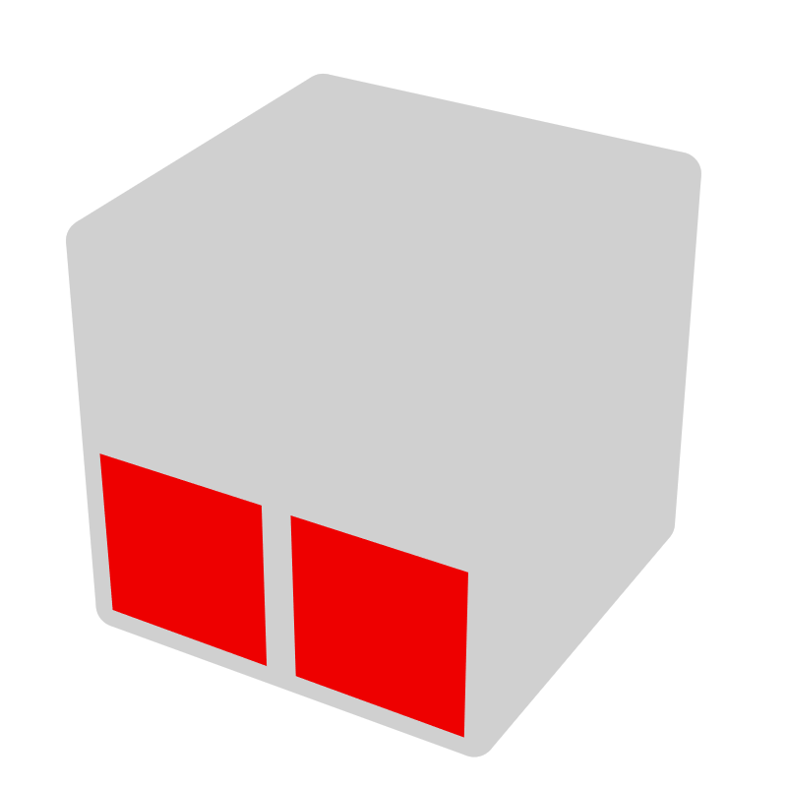 | 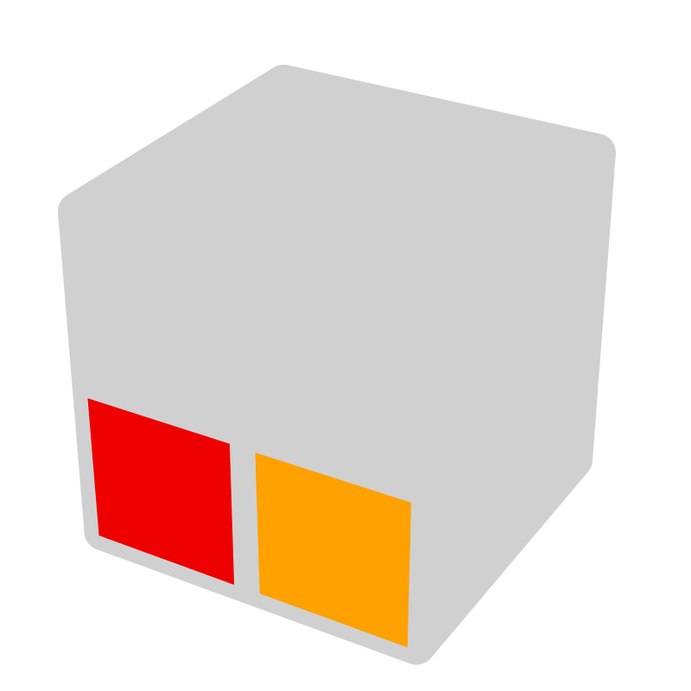
Matched Color Side | Opposite Color Side

2 matched color side => CLL; 2 opposite color side => EG2; Other cases => EG1, and the opposite side of opposite color side is matched color side.

Predict AUF (Adjust U Face)
After doing alg, U layer will follow the image below (exceptions exist), then AUF can be recognized by comparing U layer to D layer.
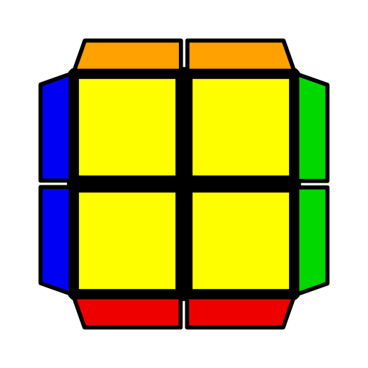
Examples
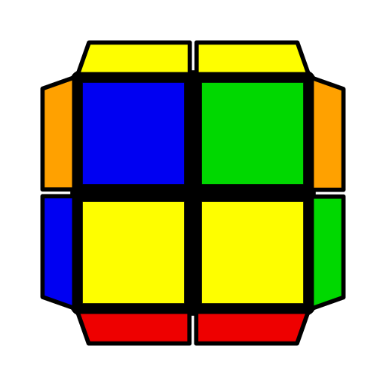 | 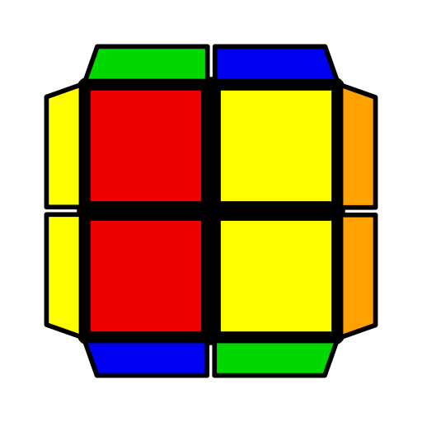 | 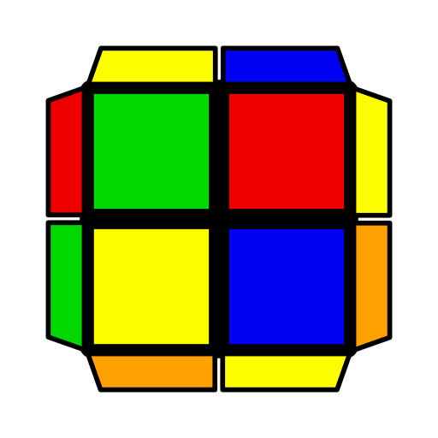
R' U' R2 U R' U2 R U2' R' U R'  Pick FUR sticker as AUF sticker. After doing alg, it will be front. | R U2 R U' R' F R' F2 U' F  Pick UFL sticker as AUF sticker. After doing alg, it will be front. | R U R' U R U2' R'  Pick FUL sticker as AUF sticker. After doing alg, it will be back.
2x2 CLL Algorithms
1 | 2 | 3 | 4 | 5 | 6
H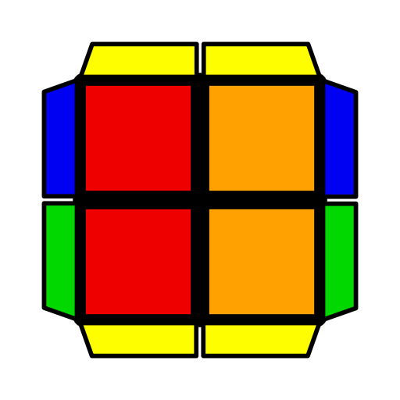 | 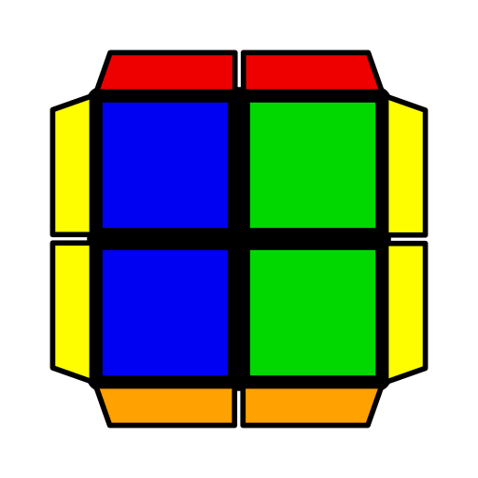 | 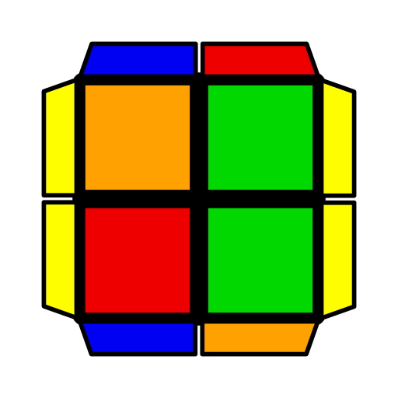 | 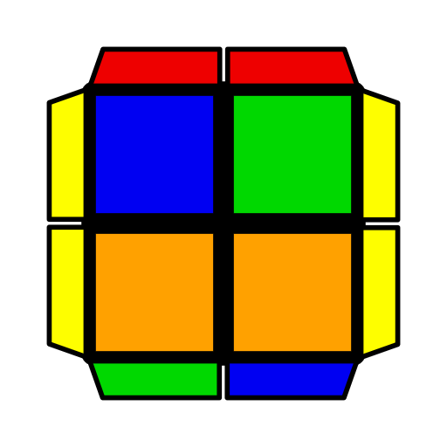
R2 U2 R U2' R2'  R2 U2' R' U2 R2 | R U' R' (F R' F' R2 U' R') (F R' F' R)  (R' F R F') (R U R2' F R F') R U R' | (R U R' U R U R')  (F R' F' R)  U2 (L' U' L U' L' U' L) (F' R U R') | F (R2 U' R2' U')  (R2 U R2') F'  U2 (F R' F' R) U' (R U' R' U) (R' F R F') | Mirror. Start thumb from back, right (left) thumb and midfinger always pinch the initial DR (DL) piece *.
Pi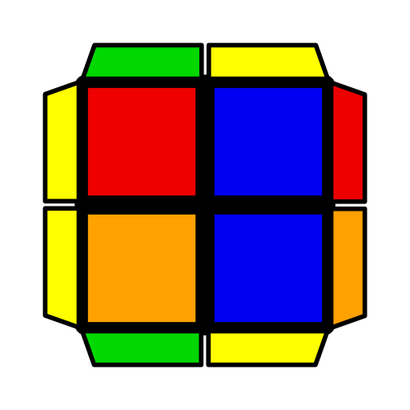 | 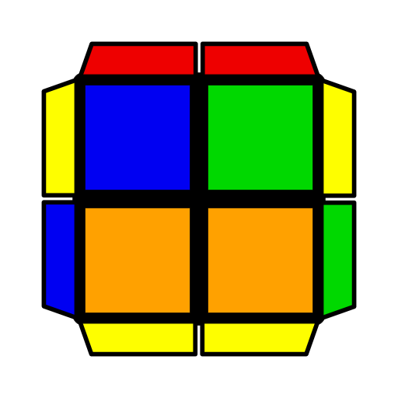 | 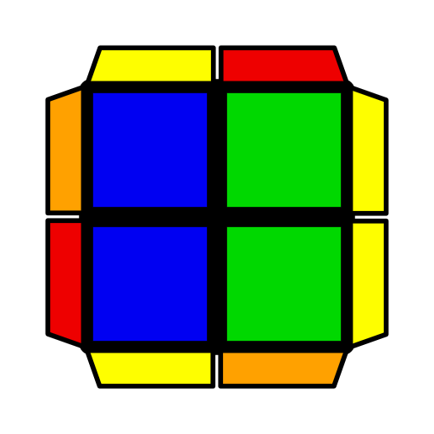 | 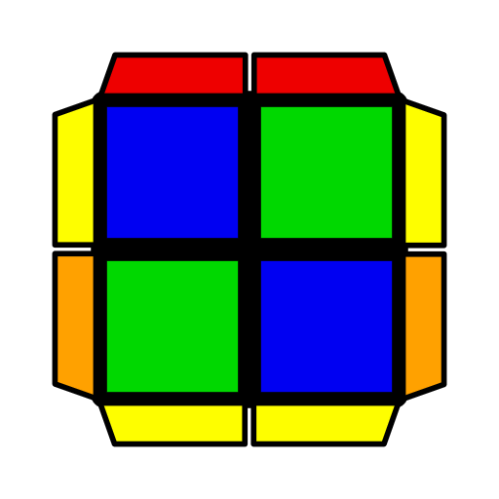 | 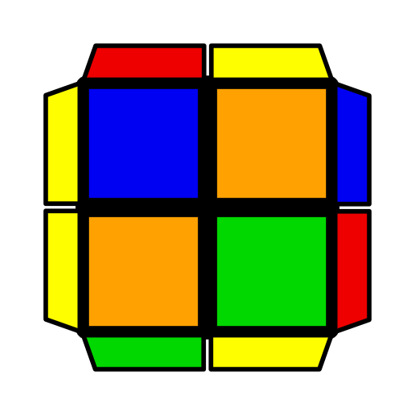 | 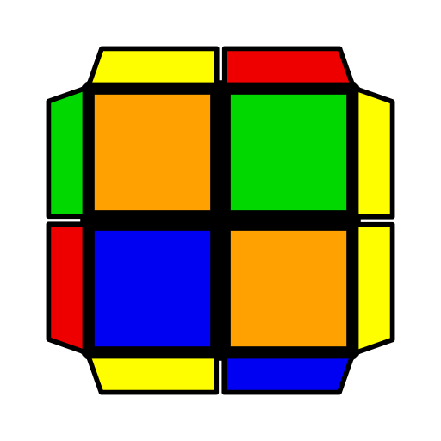
R U' R2' U R2 U R2' U' R  R' U R2 U' R2' U' R2 U R'  F (R U R' U')2 F' | R' U' (R' F R F')  (R U' R' U2 R) | (R' F R F') (R U' R' U') R U' R'  U2 (R U' R' F) (L' U L U) L' U L | (R U' R U') (R' U R' F) R2 F'  (F R' F' R) U' (R U R' U) (R' F R F')  U2 F (R2 U' R2' U)  (R2 U R2' F') | (R U2' R' U') (R U R' U2') (R' F R F')  U F' (R U R' U2') (R' F R F') R' F2 R | (L' U2 L U) (L' U' L U2) (R U' R' F)  U' (F R' F' R) U2 (R U' R' U) R U2' R'
U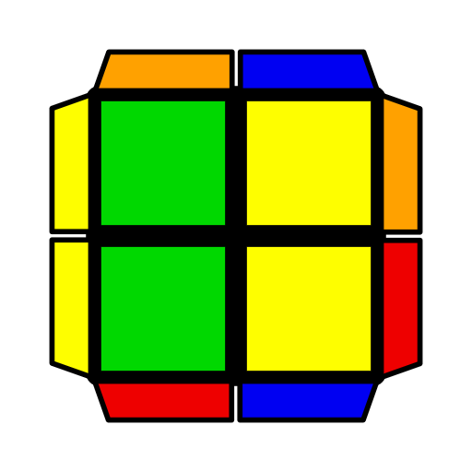 |  |  | 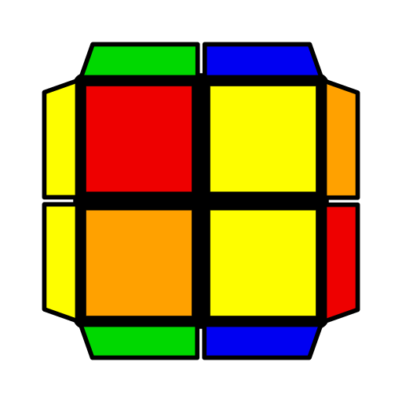 | 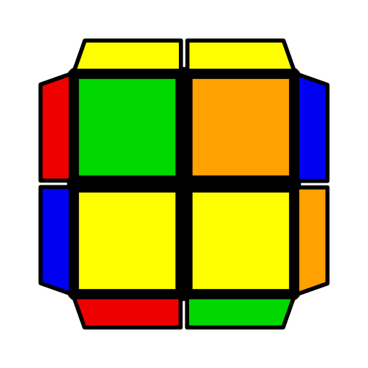 | 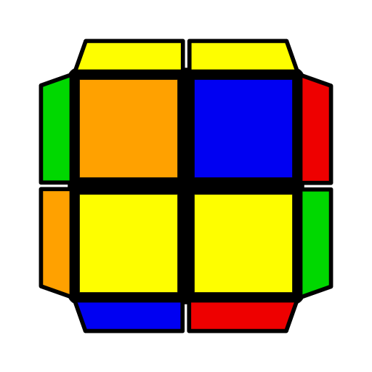
F (R U R' U') F'  R' U' (F R' F' R) U R  U2 F (U R U' R') F'  U2 R' U' (R' F R F')  U R | (R' U' R2 U) (R' U2 R U2') R' U R'  U' (R' F R F')2 (R U R' U') R U R'  U2 R2' F2 (R U R' F)  (U' R U R2) | (R U2 R U' R' F)  R' F2 U' F  U' (F R U R' U2 F')  (R U' R' F)  z' U2 R' U' (R2 U' R' U') R U' R' | (F R' F' R) U' (R U' R' U2) R U' R'  U2 (F' R U R') U (L' U L U2) L' U L  U2 (R U R' U) (R U' R U') (R' F R' F') | (R U' R2' F R F')  (R U R' U') R U R' | (R' F R2 U' R' F)  (R' F' R U) R' F' R
T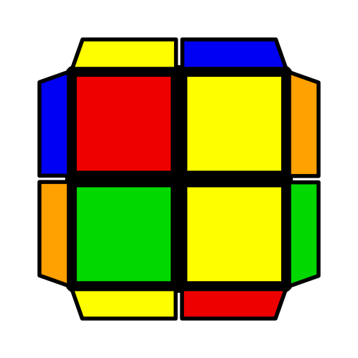 | 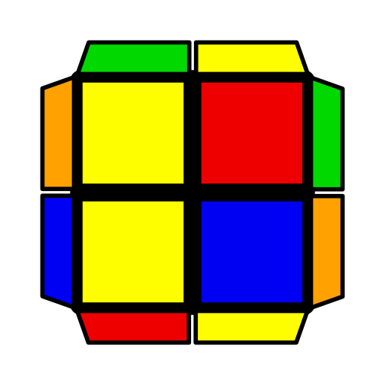 | 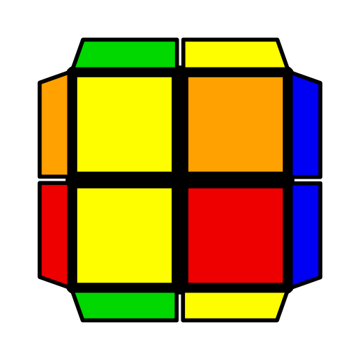 | 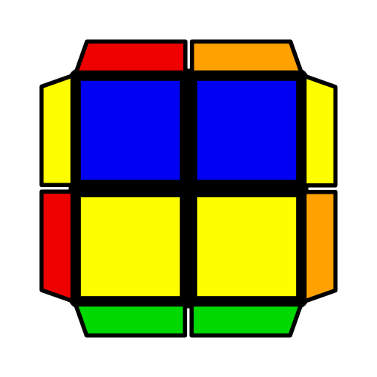 | 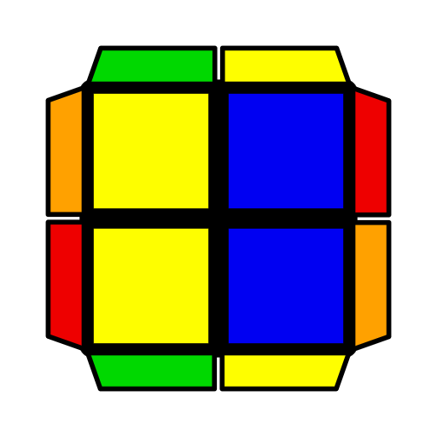 | 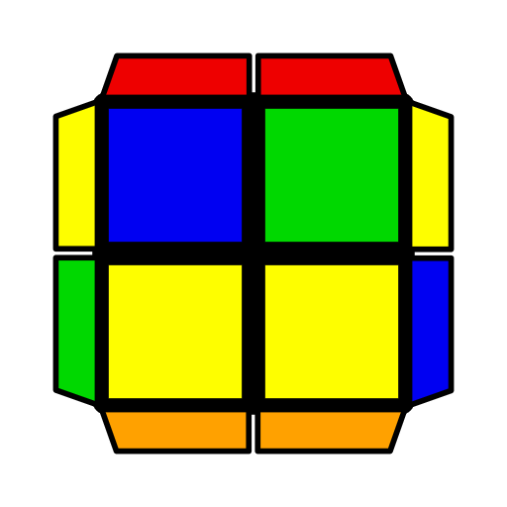
(R U R' U') (R' F R F')  U2 (F' L' F L')  (U' L U L) | (L' U' L U) (R U' R' F)  U2 (F R F' R)  (U R' U' R')  U2 F R F' (U' R' U' R) | (R U2' R2' F R F')  (R U' R' U) R U2' R'  U2 (L' U2 L2 F' L' F) (L' U L U') L' U2 L  U' F U' (R U2 R' U')  (F2 R U R') | (R U' R' U) (R U' R')  (F R' F' R)2  U2 (R' U R' U2') (R U2 R' U) R2 U' R'  (R' U R U2') (R2' F' R U') R' F2 R2 | (R U R' U2') (R U R' U) (R' F R F')  U2 (L' U' L U2) (L' U' L U') (R U' R' F)  U F (R U R' U') (R U' R' U') (R U R' F')  U' (R U2' R' U)2  (R' F R F') | (R' U R U2')  (R2' F R F' R)  (L U' L' U2)  (L2 F' L' F L')  U' (R U2 R' U') R2 U' R' F R' F'
L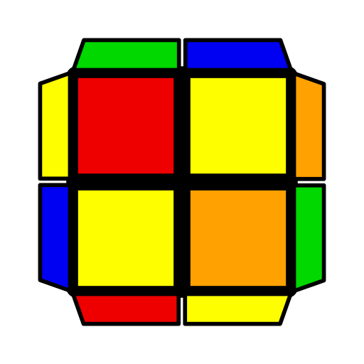 | 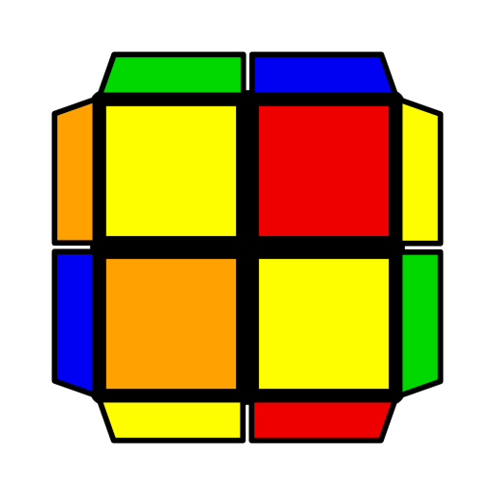 | 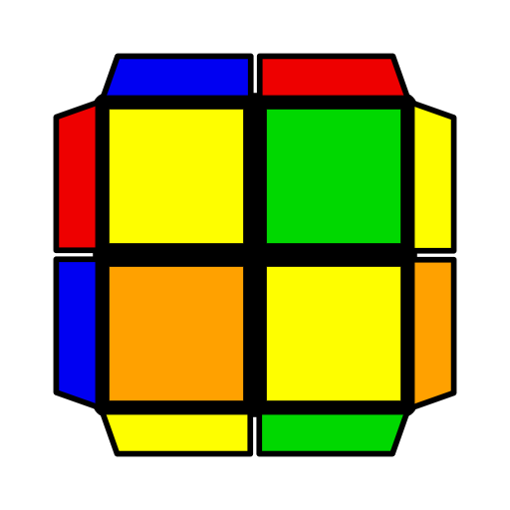 | 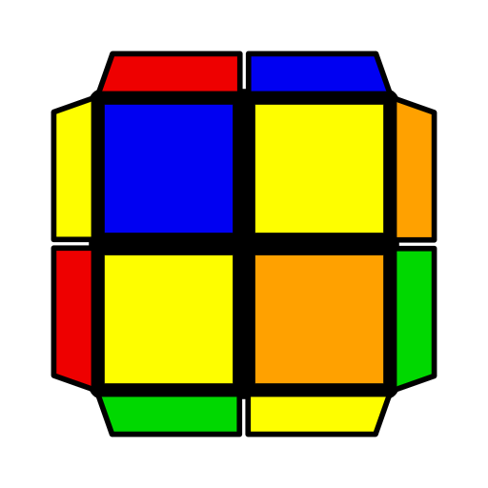 | 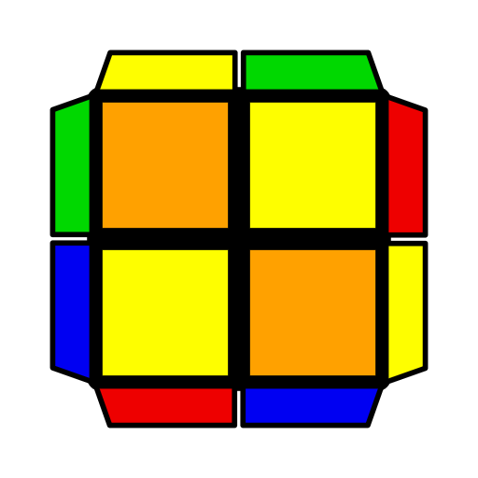 | 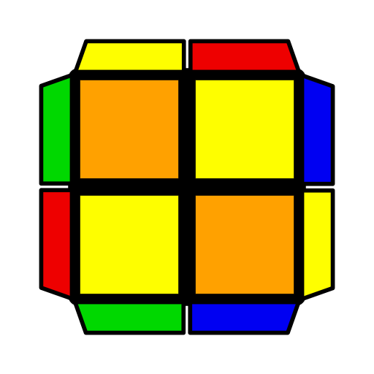
F' (R U R' U') R' F R  U' F (R U' R' U')  (R U R' F')  U2 (R U R U')  (R' F R' F') | (F R' F' R) (U R U' R')  U2 (L' U' L' U)  (L F' L F) | (R U2' R2' F R F')  R U2' R'  U2 (L' U2 L2 F' L' F)  L' U2 L  U' R U2' R' (F R' F' R2 U2' R') | R2' U' (R U2' R' U2)  R U' R2'  (R' U R' U2') (R U' R' U) R U' R2  U (R2 U R' U2)  (R U2' R' U R2) | (R U' R' U) (R U' R')  (F R' F' R2 U R')  U (R U R' U') (R' F R2 F') (U' R' U' R)  U' L F (L' U' L U) (L F' L2 U L U2 L') | R' F' (R U R' U') (R' F R2 U' R' U2 R)  U (R U R2' F') (R U R U') (R2 F' R F)  U' (L' U L U') (L' U L) (F' L F L2' U' L)
S | 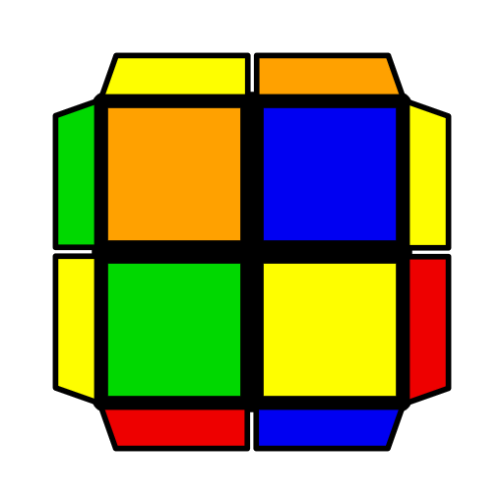 | 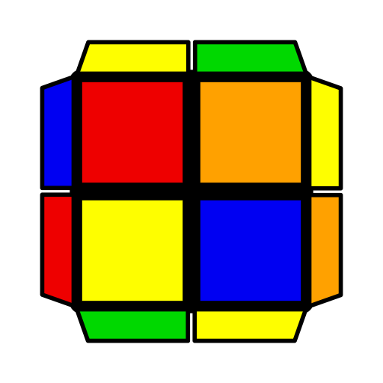 | 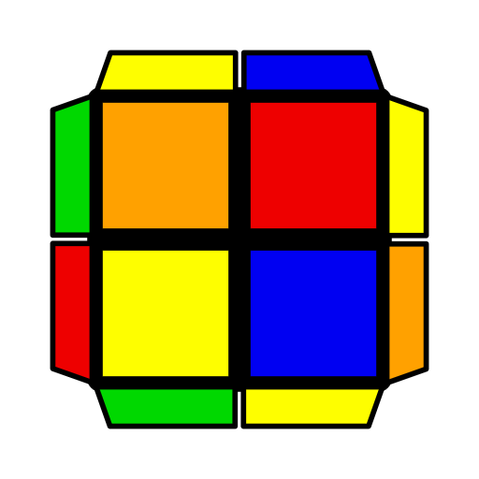 | 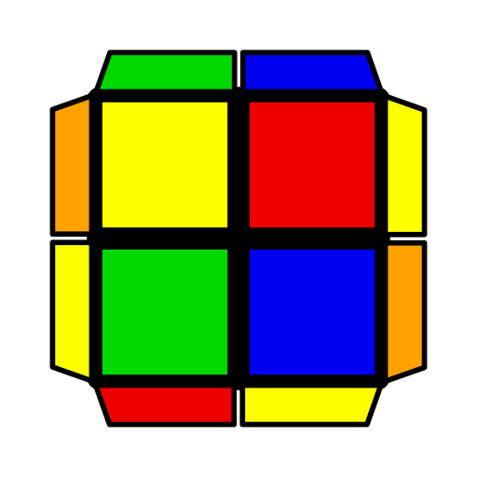 | 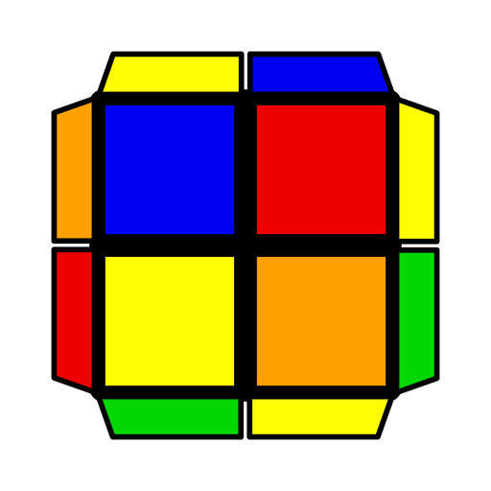
R U R' U R U2' R'  U' R' U2' R U R' U R | R' F R2 F' U' R' U'  R2 U R' * | (F R' F' R)  (U2 R U2' R') | R U' R' (F R' F' R) | (R' F' R2 U R' F')  (R' F R2 U' R') | (L' U2 L U2)  (R U' R' F)
AS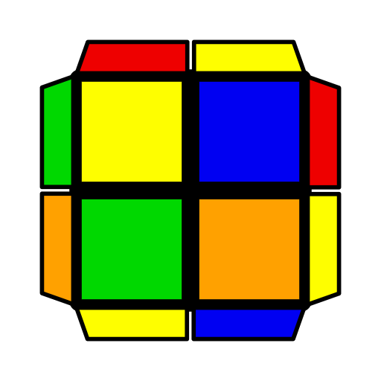 | 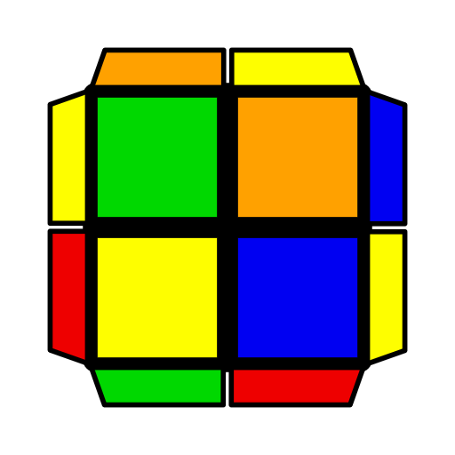 | 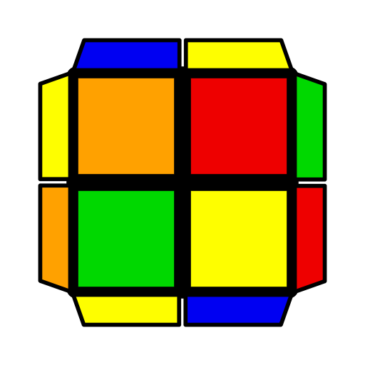 | 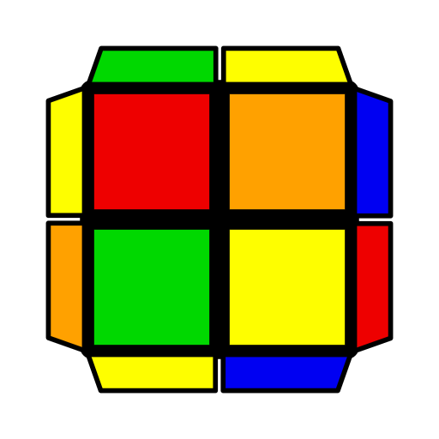 | 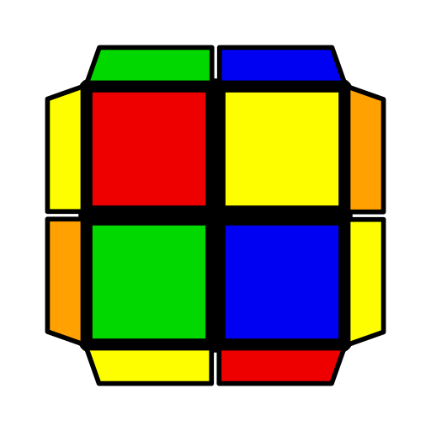 | 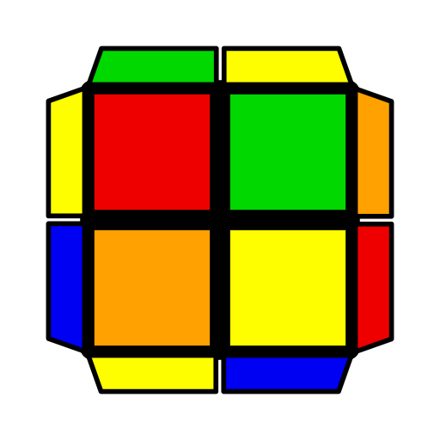
R' U' R U' R' U2 R  U R U2' R' U' R U' R' | L F' L2 F U L U  L2 U' L * | (F' R U R')  (U2' L' U2 L) | (R' F R F') R U R' | (R U R2' F' R F)  (R U' R2' F R) | (R U2' R' U2)  (R' F R F')
2x2 EG1 Algorithms
1 | 2 | 3 | 4 | 5 | 6
H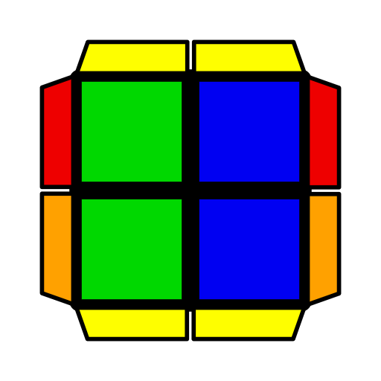 | 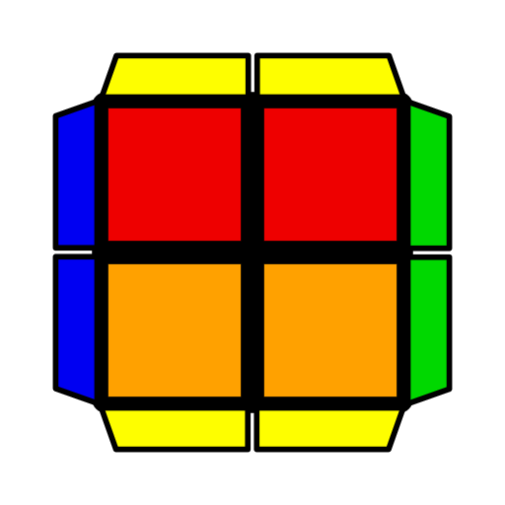 | 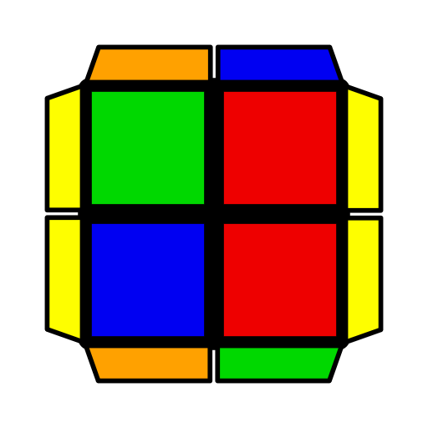 | 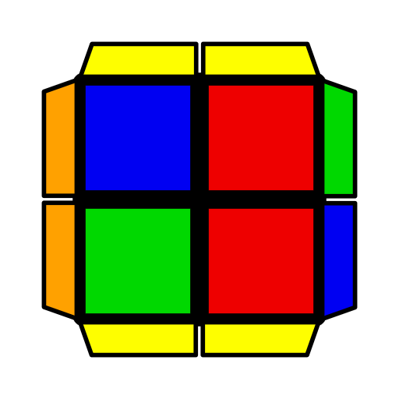
R' F (R2 U' R2' U')  F U R | F' U (R U' R2' F2)  R U' F | (R' U' R' F2) U F' R F'  U2 (L U L F2)  U' F L' F  U (R' F R F') U2  (F R U2' R' F) | (R U R' F') (R U R' U') R U R' | [R] denotes putting D-bar in DR. Mirror.
Pi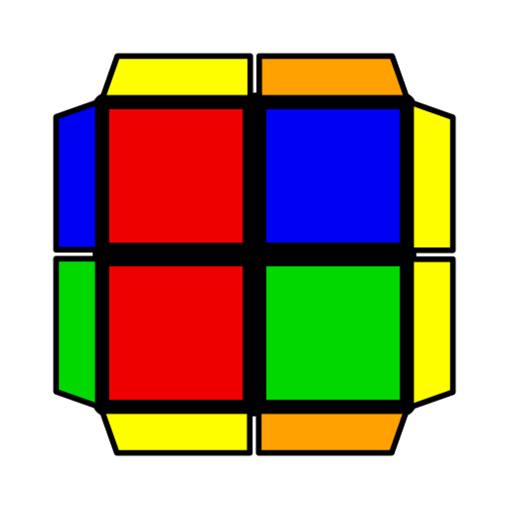 | 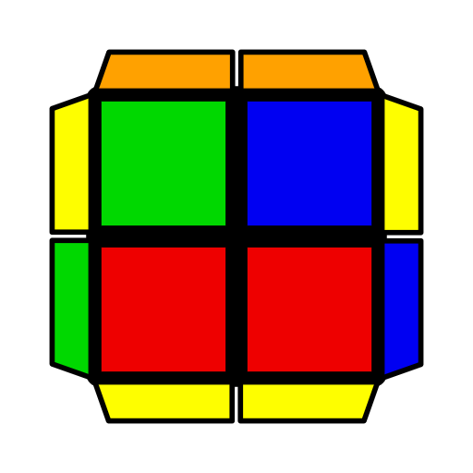 | 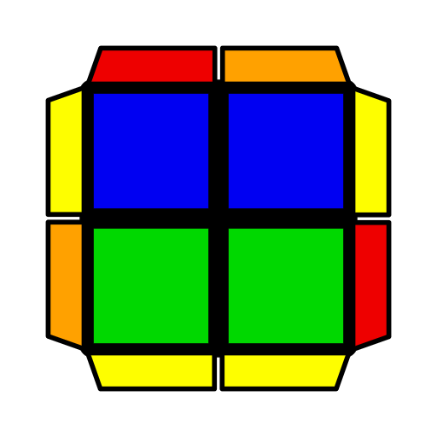 | 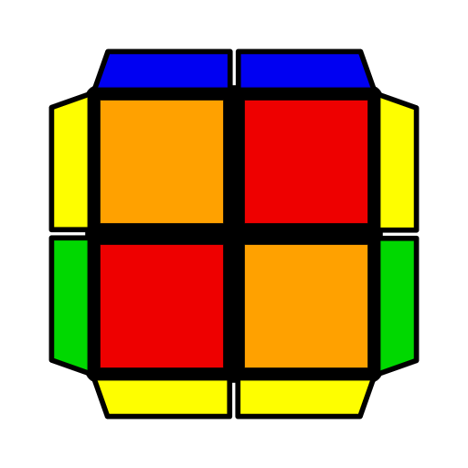 | 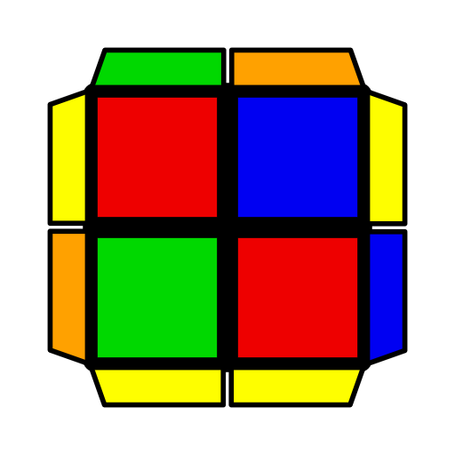 | 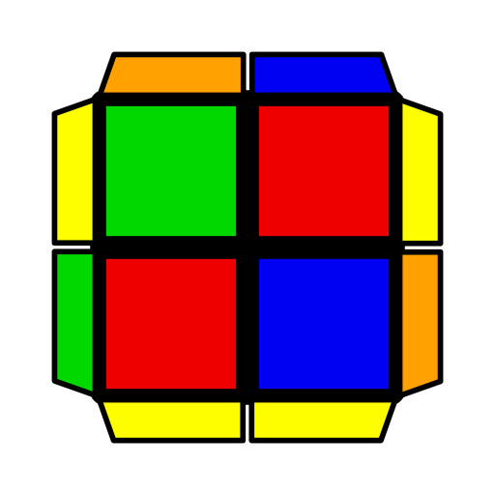
R2 B2 (R' U R' U')  (R U2 R U' R2')  F2 (R U R' U2')  (R U R' U' F) | R' F R2 U' R2' F R  R U R2' F' R2 U R' | F R' F U' (F2 R U R) | (R U' R' U) (R U' R' F)  R U' R'  (R' F R U') (R' F R F') R' F R  F' (R U R' U') (R U R' F') R U R' | (R U R' U) (R U' R2' F' R) (F R' F' R)  U2 F U' (R U2 R' F')  (R U R' F')  U (R U' R2' F R U) (R U' R' U') (R' F R F') | (R' F R F') (R' F R2 U R' U') R U' R'  U F (R U' R' F)  (R U2' R' U) F'
U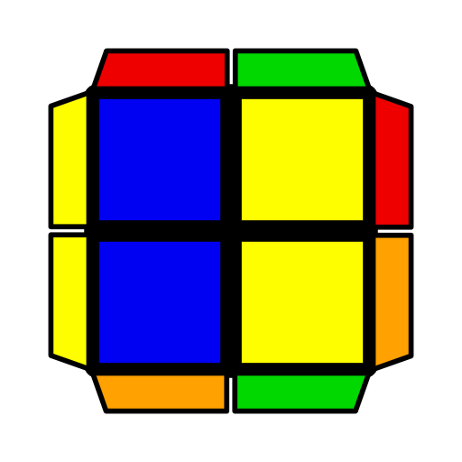 | 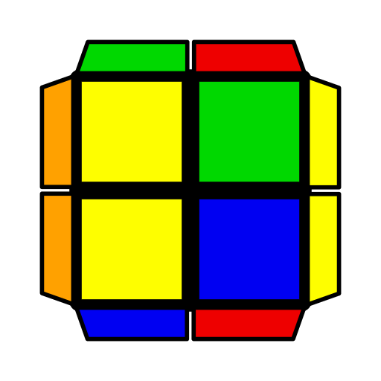 | 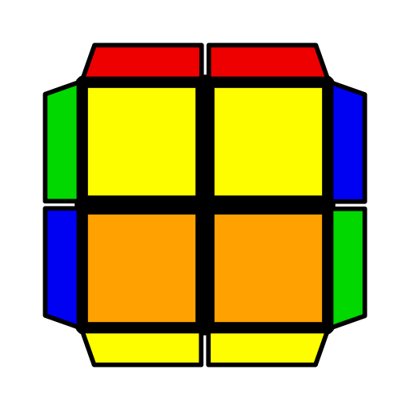 | 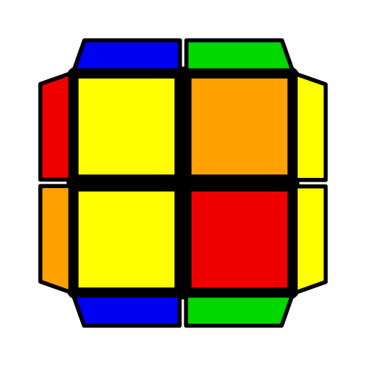 | 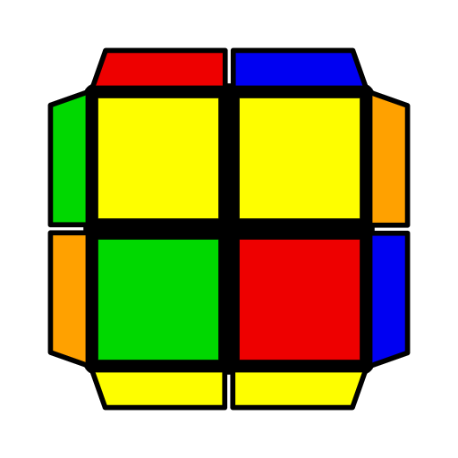 | 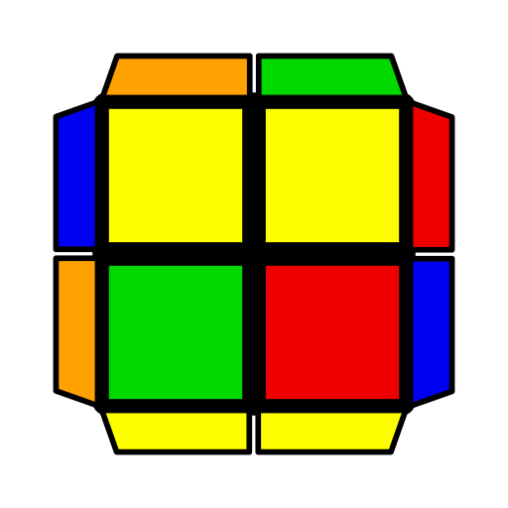
(R U' R2' F) (R2 U R' U') R U' R'  (L' U L2 F') (L2' U' L U) L' U L  (R U R' U) (R U R2' F R2 U' R') | (R U' R' U) (R U' R' F) (R U2' R') (F R' F' R)  U2 (R' F R U') (R' F R F') (R' F2 R F') R U R'  [R] U2 (R' U R' U')  (R U' R' U') F2 R2 | (R U' R2' F2 R F')  (U R U R')  U2 F' U2 (R U2' R' U2) F | (R' F R F') (R' F R2 U' R')  U2 (R U' R' F)  (R U' R2 F R) | (R U' R' U) (R U' R' U') (F R U' R')  (L F' L2 U L)  (D' L' U' L) | (R' F R2 U' R')  (D R U R')  (L' U L U') (L' U L U) (F' L' U L)
T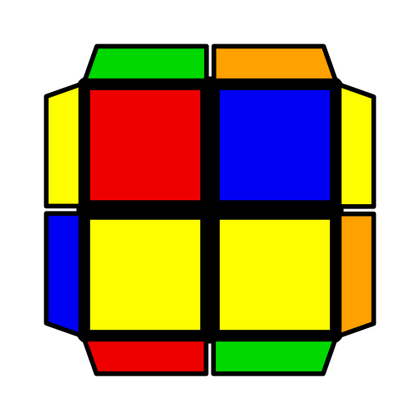 | 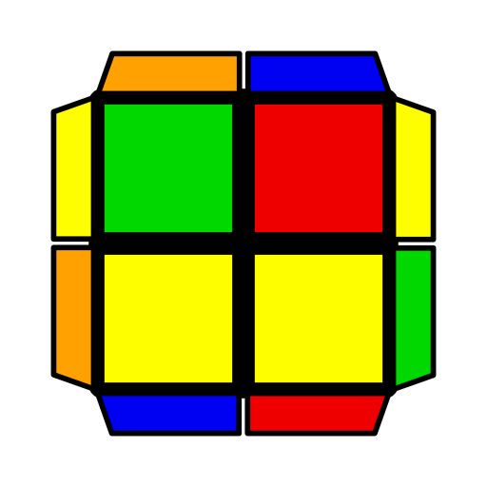 | 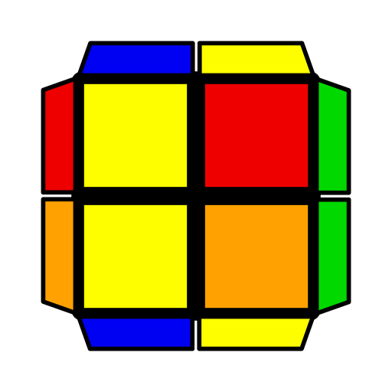 | 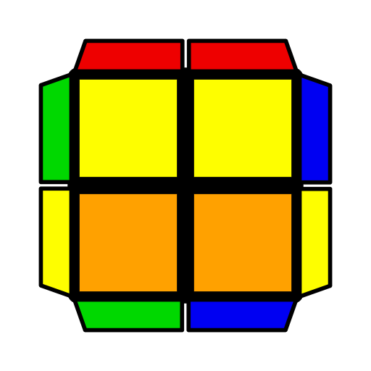 | 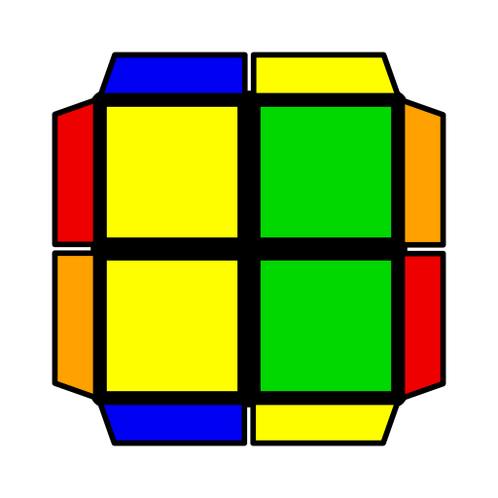 | 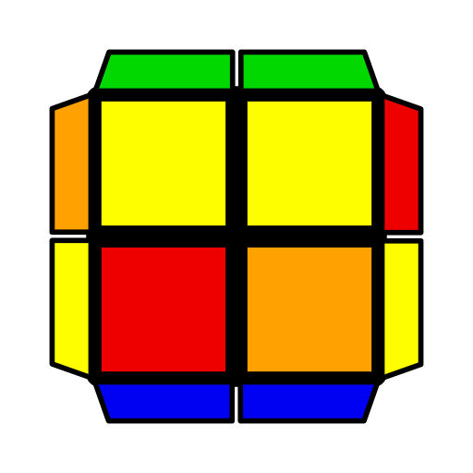
F (R U' R2' F' R U) R' F' R  U' (R U' R2' F) (R2 U R' U2) (R' F R F') | F' (R' F R2 U R' U')  R U R'  U (R U' R' U2) (R U2' R' F) R U' R' | (R U' R2' F) (R U R U2' R')  U2 (R' F R2 U' R' U') R' F2 R | (R U R2' F' R F R' F') (R2 U' R' F R' F' R)  U R2 B2 U' (R' U' R U') R' U R' | (R U R2' F' R)  (F R' F' R)  U2 (R' F' R2 U R')  (F' R U R') | (R U' R' U2)  (F R U2' R' F)  U (R U R' F)2  (U' R U' R')
L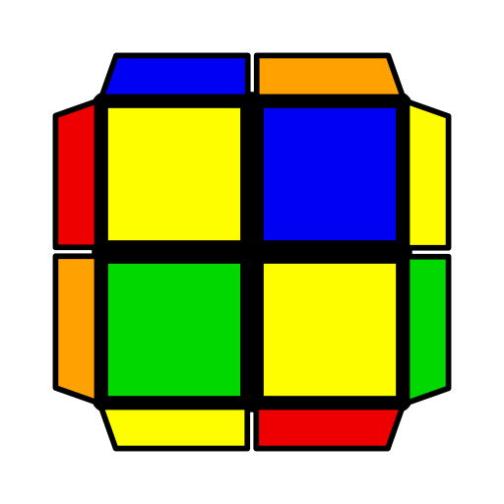 | 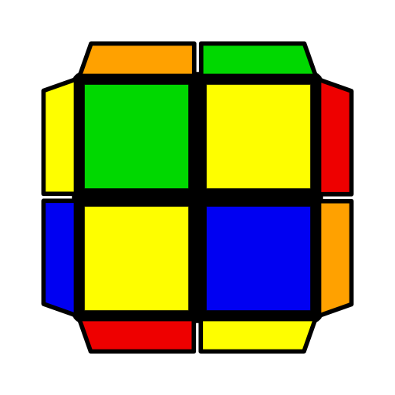 |  | 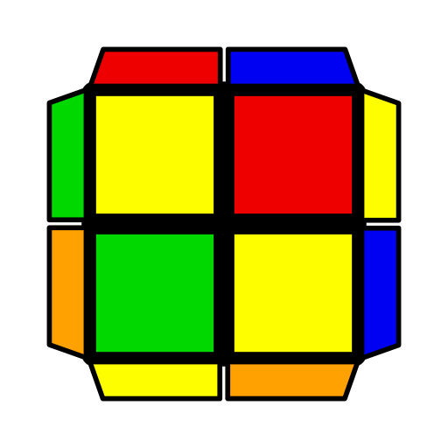 | 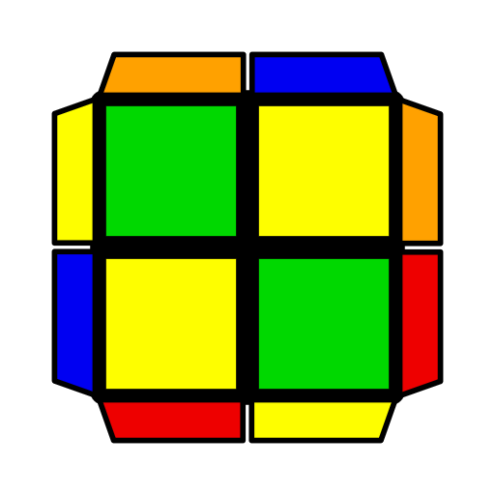 | 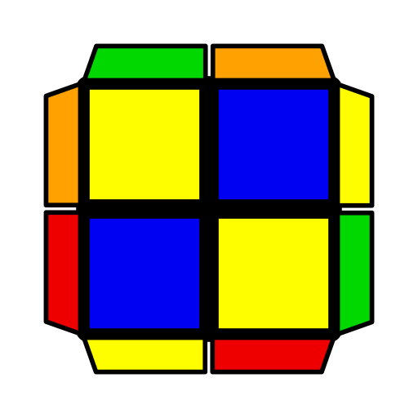
(R U' R' U) (R U' R2' F' R F)  U (R U R' F') (R U2' R' U2) R U R' | (R' F R U') (R' F R2 U R' F')  U (R' F R F') (R' F R U) R U2' R' | R' U (R2 U' R2' U')  (F R2 U' R') | (R' F R2 U R')  (F' R U2' R')  U (R' F2 R F')  (R' F R2 U R') | (R U R' F') (R U R' U') (F R' F' R)  U F' (R' F R U') (R U R' U' R U R') | (R' F' R F) (R' F' R U) (F' R U R')  U R' U2' F (R U2 R U' R2' F)
S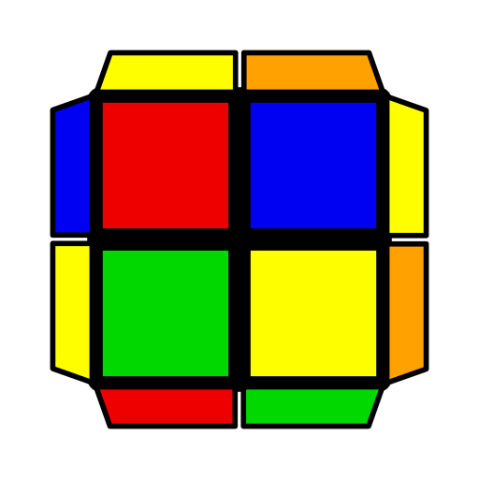 | 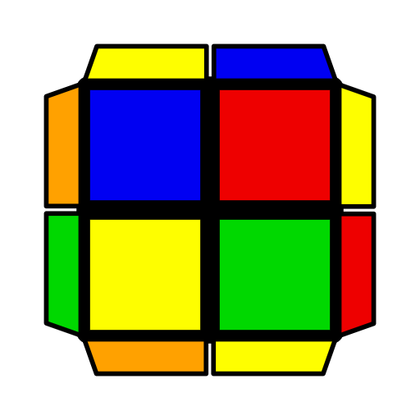 | 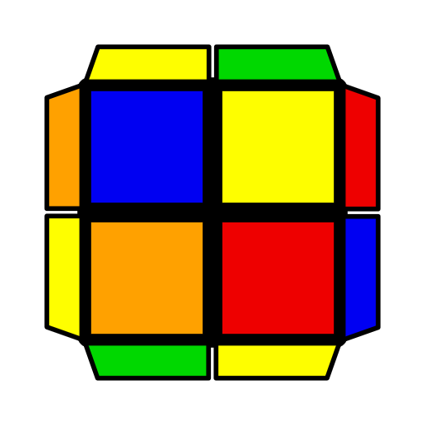 | 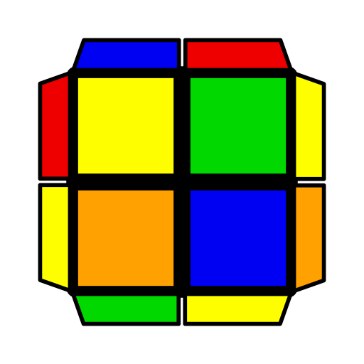 | 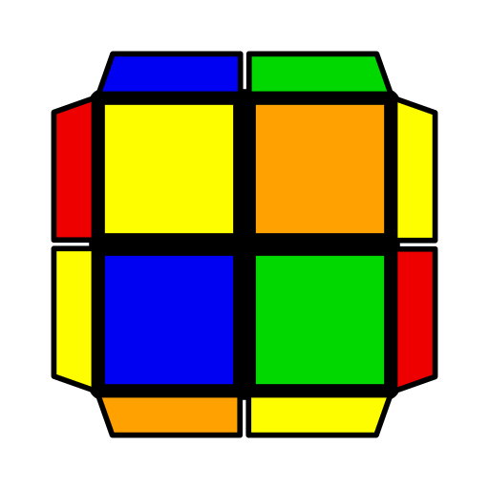 | 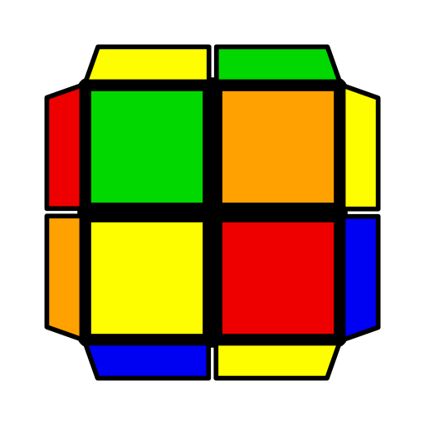
B' U L2 F2' U F'  U' (R U R' U) F R U' R2' F' R | (R U R') (F2 U F)  (R U R')  U2 F (R2 U' R2' F)  U' F2 U' R | (F R' F' R) U  (R' F' R2 U R')  U (R' F R U2 R U') (R2' F2 R F') | F' (R' F R2 U R' U')  (F R' F' R)  U' F' U (R U' R' U)  (F R U R') | (R U' R' U) (R U' R' U') (R' F' R F) | (R' F R2 U' R' U)  (R U' R' F)
AS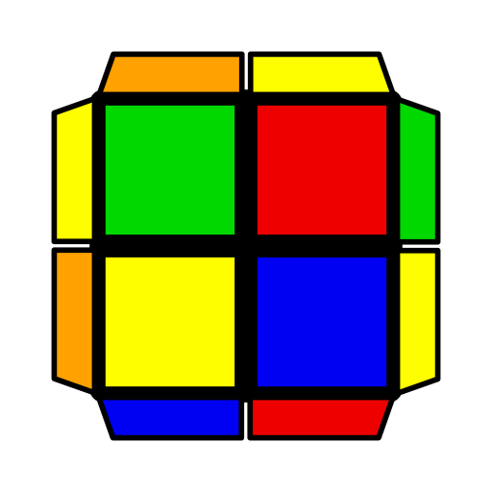 | 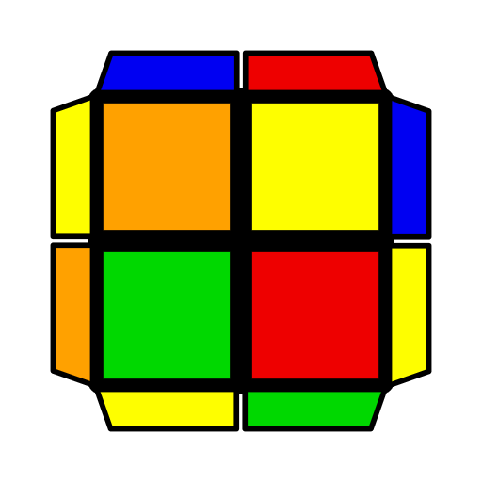 | 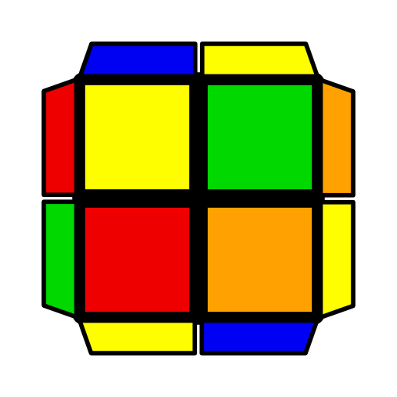 | 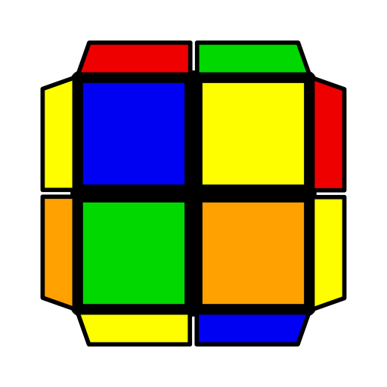 |  | 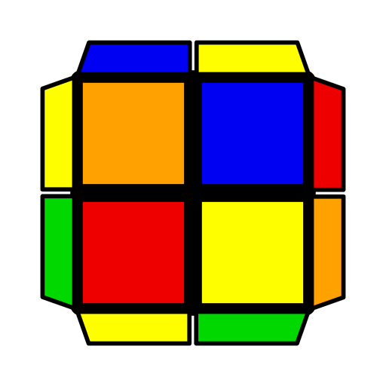
B U' R2' F2 U' F  U2 R' F (R2 U R' F')  (U' R U' R') | (R U' R' F' U')  (F2 R U' R')  U' R U' (F2 R U2 R U' B) | F' (R U R' U')  (R U R2' F' R) | F (R U' R2' F' R U)  (F' R U R')  U' (R U' R' F' U')  (R U R' U' F) | F' (R' F R U) (R U R' U') R U R'  U2 (R U R' F' U') (R U R' U') R U R' | (R U' R2' F R U')  (R' F R F')

2x2 EG2 Algorithms
1 | 2 | 3 | 4 | 5 | 6
H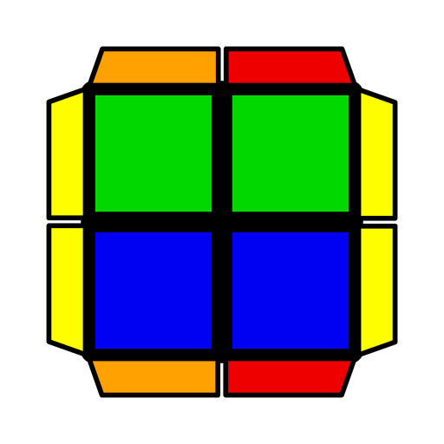
(R2' F U2' F2)  R2 F' R2' | R2 U2 R U2' B2 R2' | (R' U' R U2' R2' F' R) U' F R | R U2' B2 (R' U R U') B R' | Anti-CLL [12] (cancelling into R2 B2 R2', etc.), R2 B2 R2', etc. [6] (cancelling into CLL). Start thumb from back.
Pi | 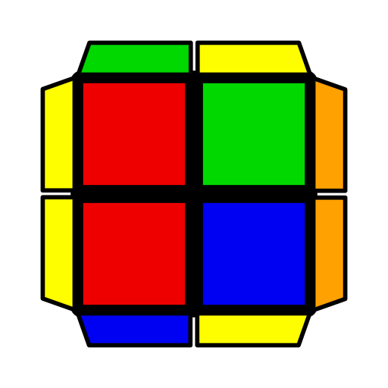 |  | 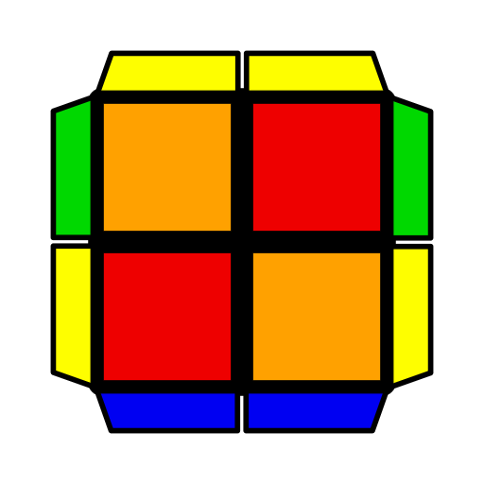 | 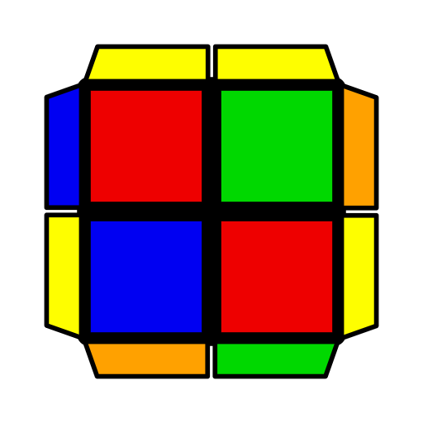 | 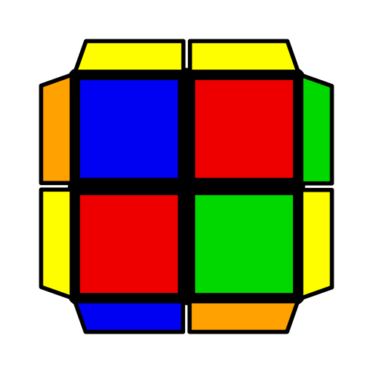
F U' (R U2 R U')  (R' U R' F') | (R' U2' R2 U' R')  F2 R2 F' | R' F' U (R' F R2 U2' R' U R) | (R' F U' R U R')  F2 U2' R | (L U2' L' U)  (L2 F2' L' F' L')  (R' U' R' F2 R2 U) R') F2 R | (R' U2 R U')  (R2' F2 R F R)
U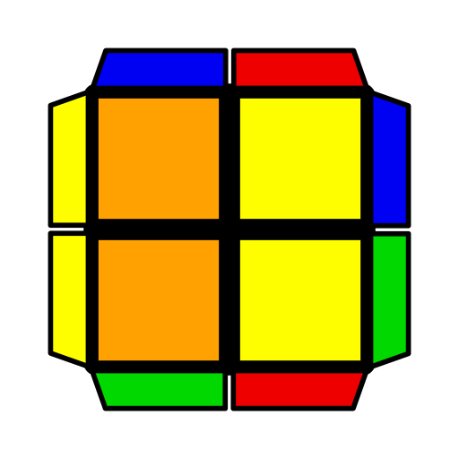 | 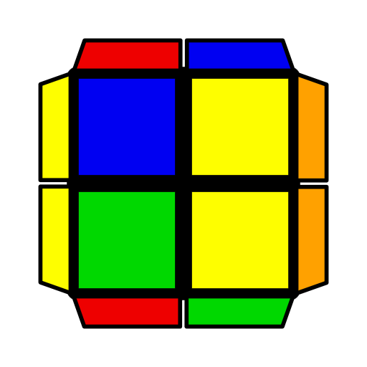 | 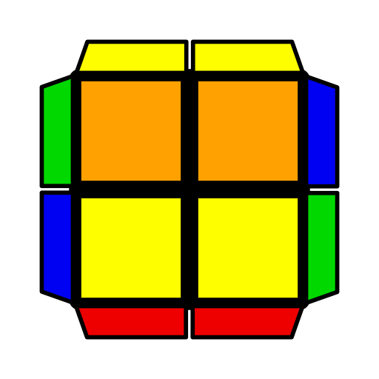 | 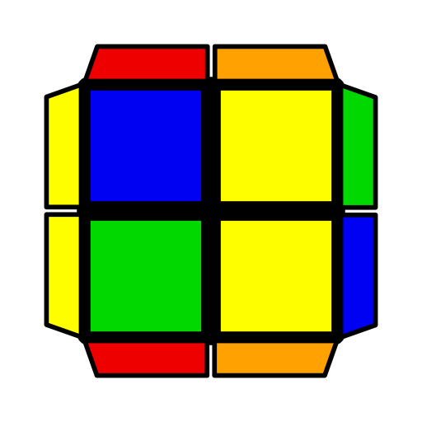 | 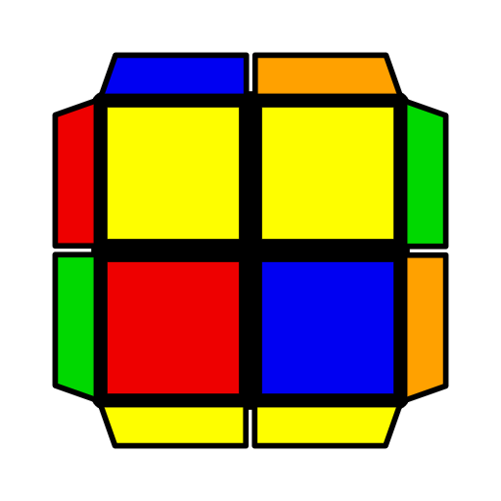
(R' U R' F U')  (R U' R' U2' R2) | (F R U R' U' F)  R2 B2 | (R U R' U' R) B2  (R' U R U' R') | (R2' F2 R U R U2')  (R2' F R F' R) | (R U' R' U2) (L U L' U2') R U' R' | (L' U L U2') (R' U' R U2) L' U L
T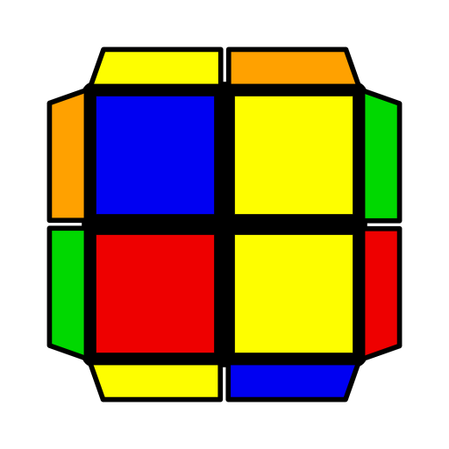 | 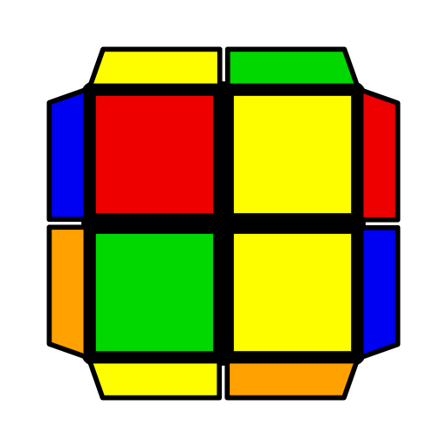 |  | 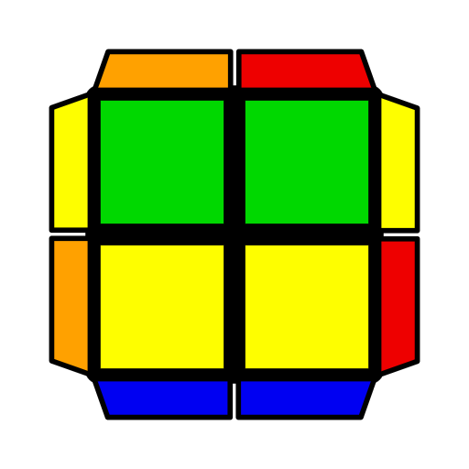 | 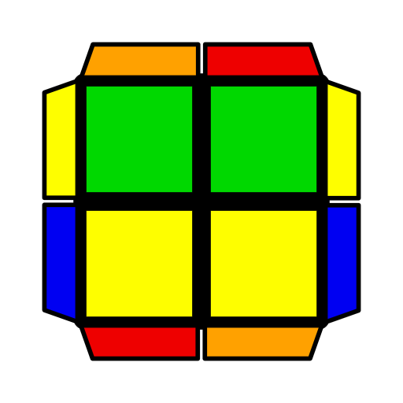 | 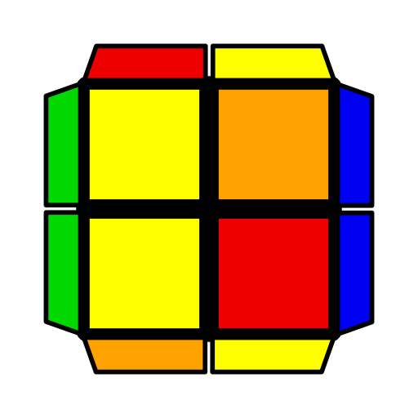
(F R F' R U R' U')  R B2 R2' | (R U R' U' R' F R F') R2 B2 R2' | (R' U R' F)  (U' R U R2)  U' (R' U R' F) (R2 U2' R' U' R) | R2' F2 (R U' F R' F' R U R)  U2 R2 B2 R2' (F R U R' U' F') | (R' U R U2' R2' F R F') R' F2 R2  U (R' F2 R U') (R' U  R' F R U' R) | (R' U2 R' F2 R)  F2 R
L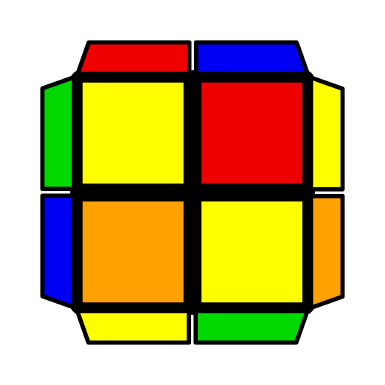 | 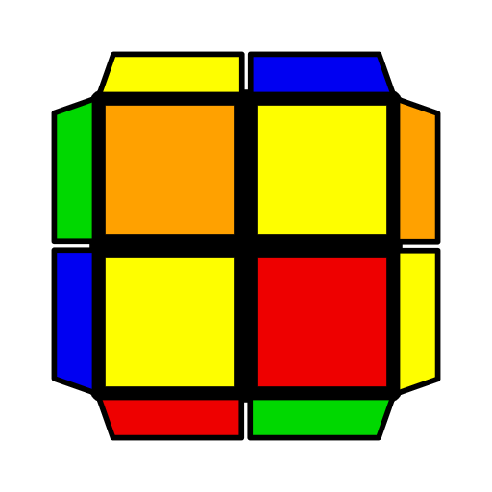 | 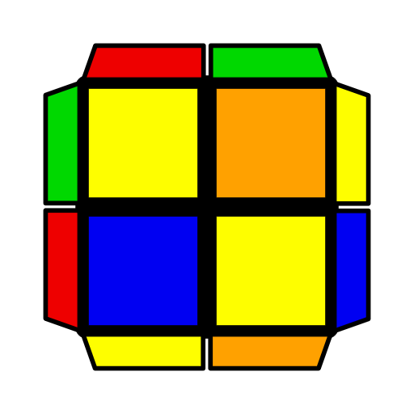 | 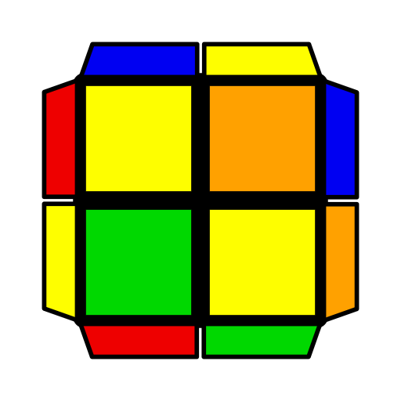 | 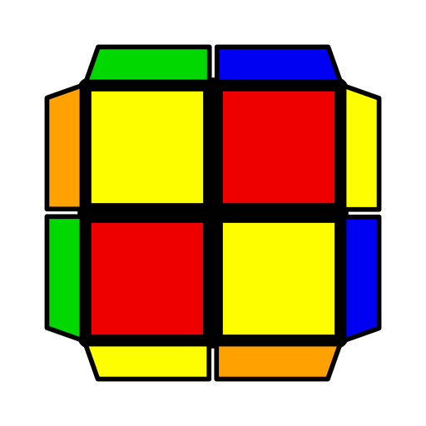 | 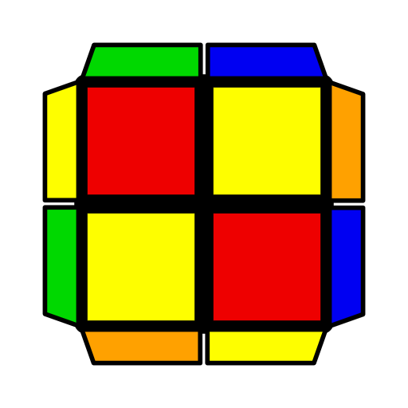
R2 B2 R2' F (R' F'  R U R U' R') | R2 B2 R2' (F' R U R' U' R' F R) | R' U' F2 (R U2 R' U2') F R | R' U' (R U R' F') (R U R' U') R' F' R2 | (F R' F' R U R U')  R B2 R2' | (F' R U R' U' R' F)  R' F2 R2
S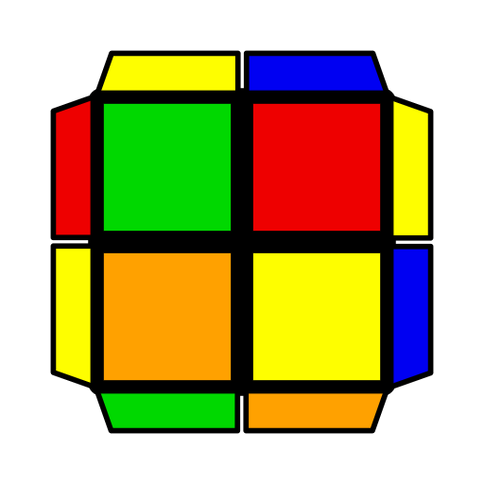 |  |  |  | 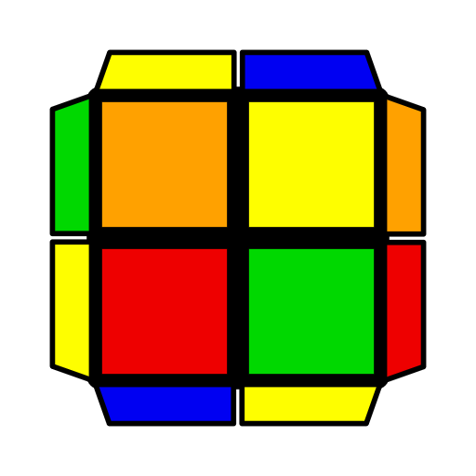
F U' (R2 U' R' U2)  (R U' R2' F') | R U R' U R U2 R B2 R2'  U' R' U2 R U R' U R' F2 R2 | (R U' R' F R' F')  R' F2 R2 | F (R2 F' R2' F')  R U' R | (L U L' U L U)  (L F2' L' F L')  (R' F R' F2) (R U R U R' U R) | R2 B2 (R' U' R' F) R' F' R
AS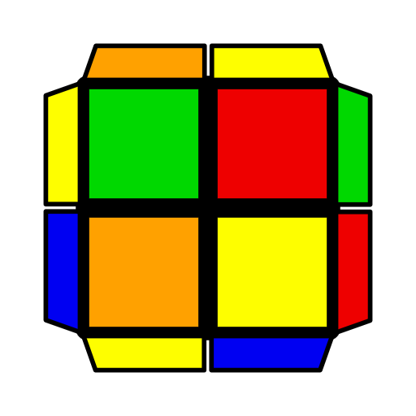 | 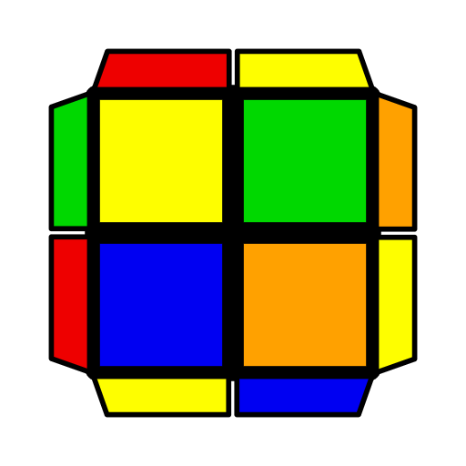 |  | 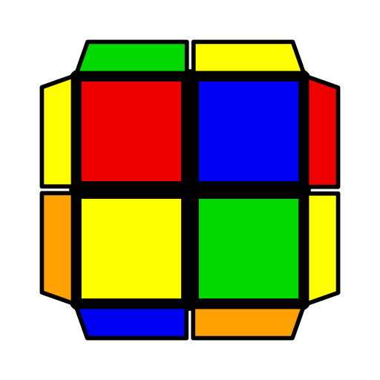 | 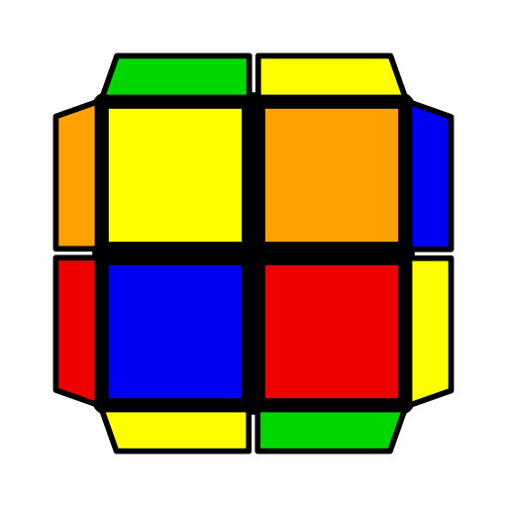
(R' U R U') (R2' F R F') (R U R' U')  R' F2 R2 | R' U' R U' R' U2 R' F2 R2  U' R U2 R' U' R U' R B2 R2 | (R' F R F') (R U R B2 R2') | (R' U R' F) (R2 F R2' F') | (R' U' R U' R' U') (R' F2 R F' R) | R2' F2 R (F R F'  R U R')

