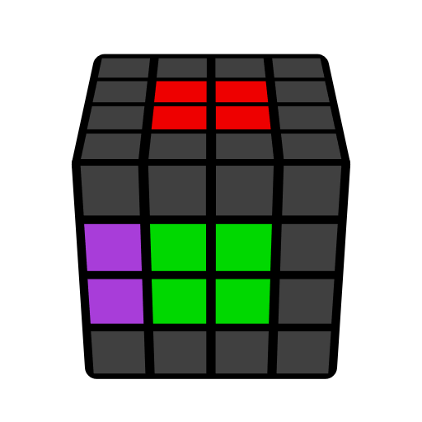
4x4 L2C Algorithms (Last Two Centers)

r, 3r, 2L-gen. Learn intuitively. Immovable, basic.

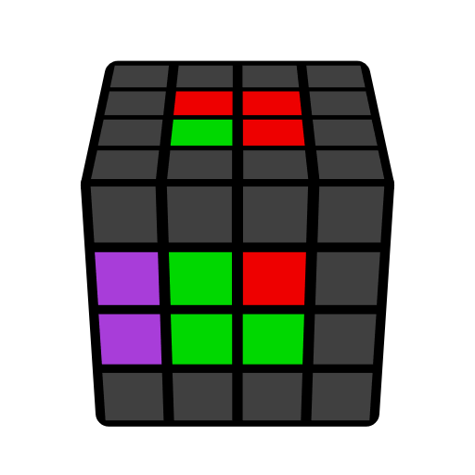 | 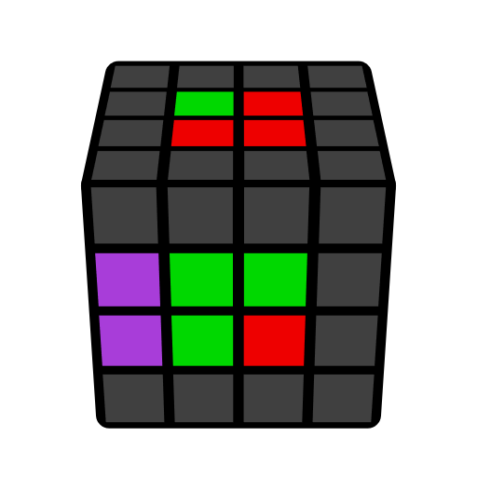 | 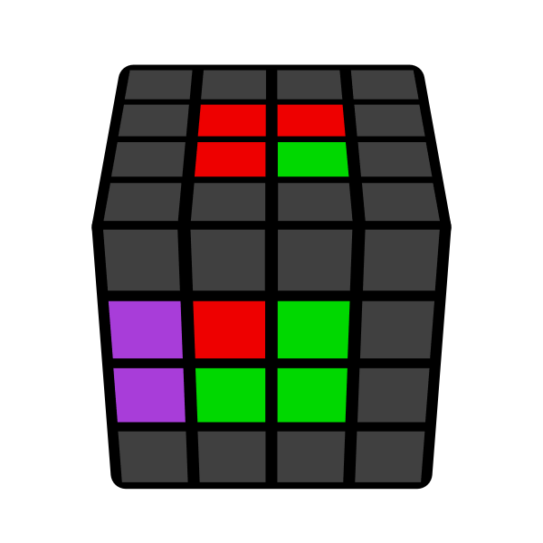 | 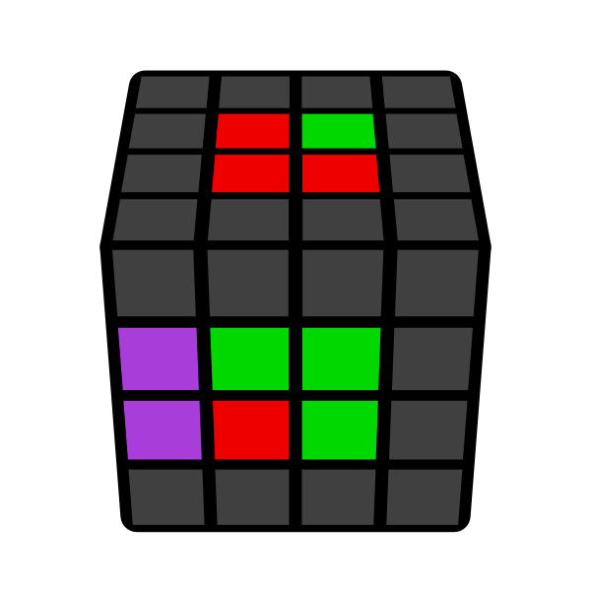
r U' r' | r U r' | 2L' U r | 2L' U' r
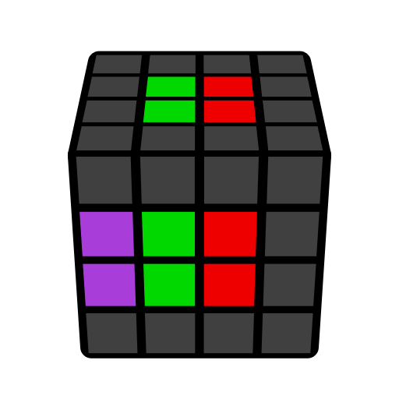 | 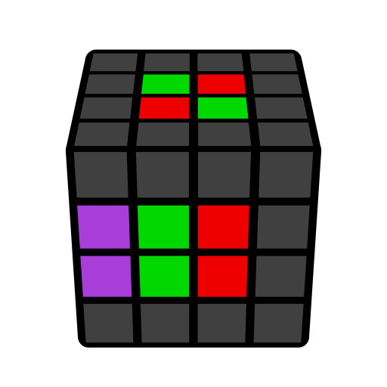 | 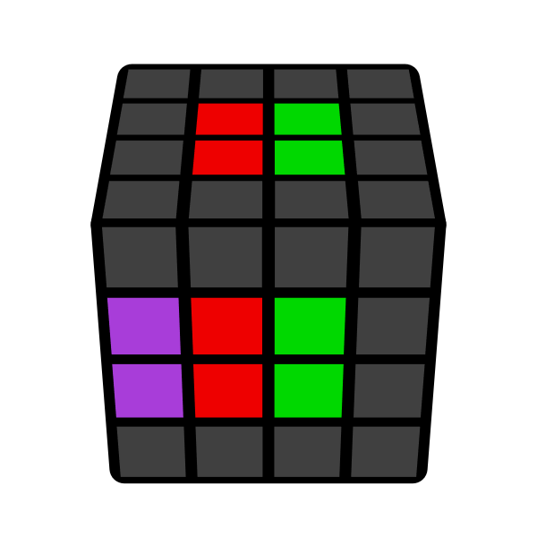 | 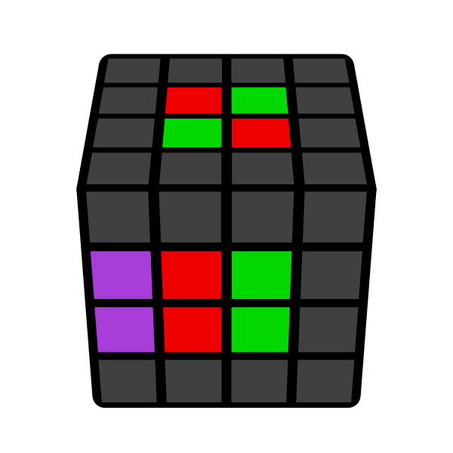
r U2' r' | (r U' r' U) r U2' r' | 3r r' U2 r | (r U' r' U) 2L' U2 r
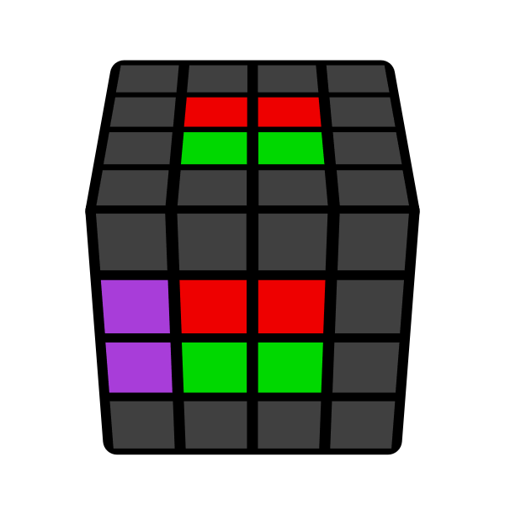 | 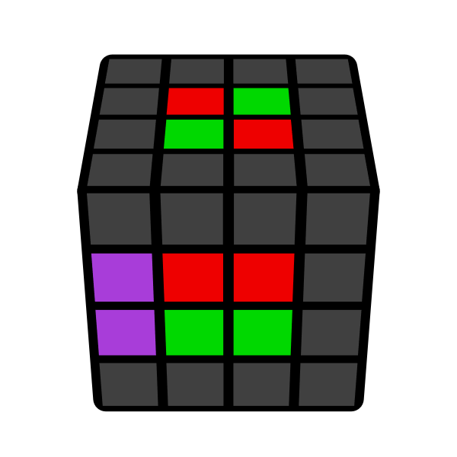 | 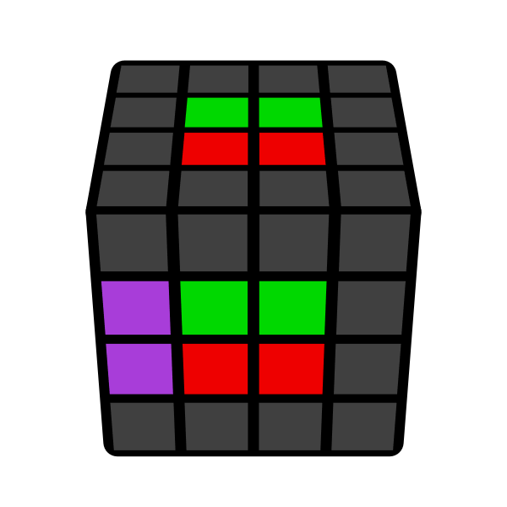 | 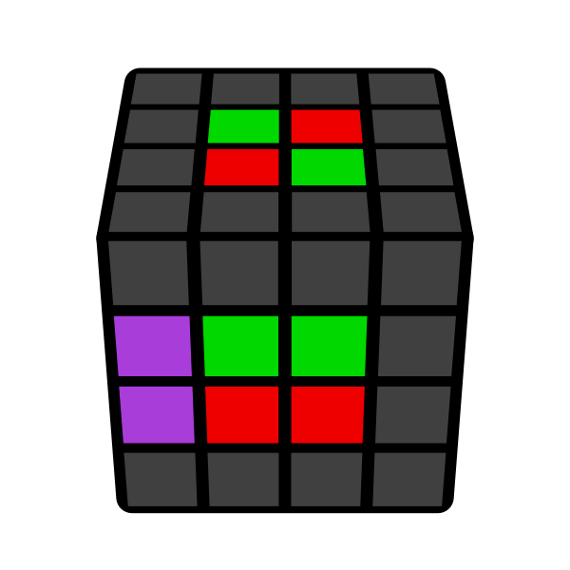
r U' r2' 3r U r | (r U' r' U) 2L' U r | r U r2' 3r U' r | (r U r' U') 2L' U' r
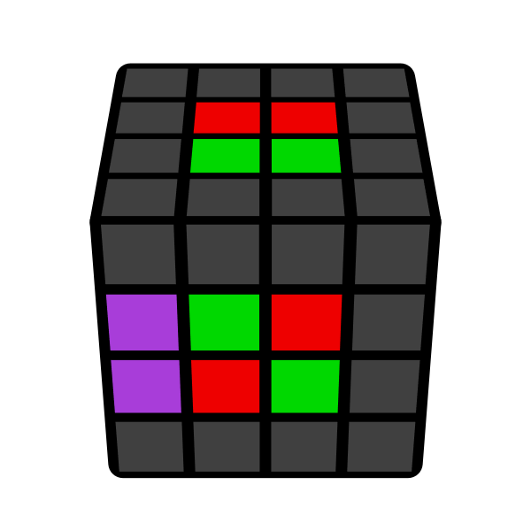 | 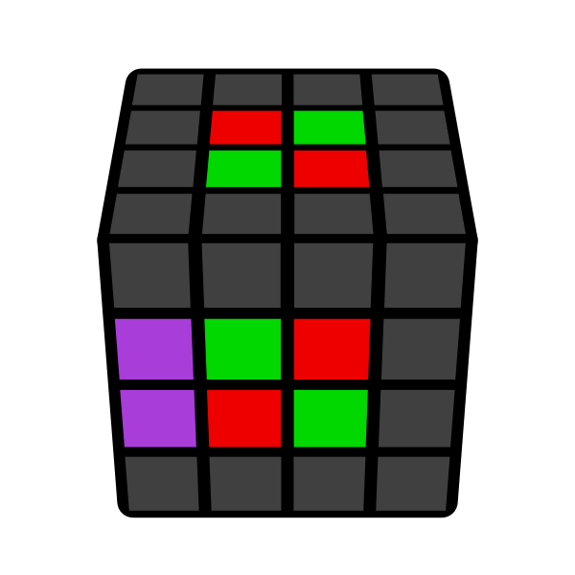 | 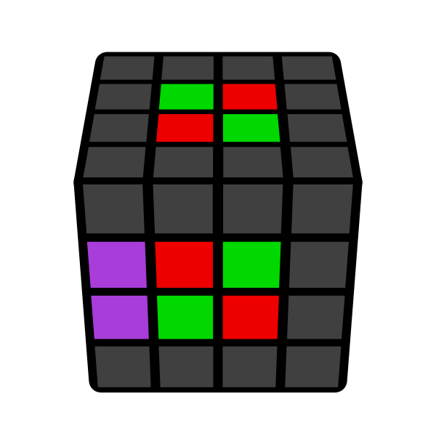 | 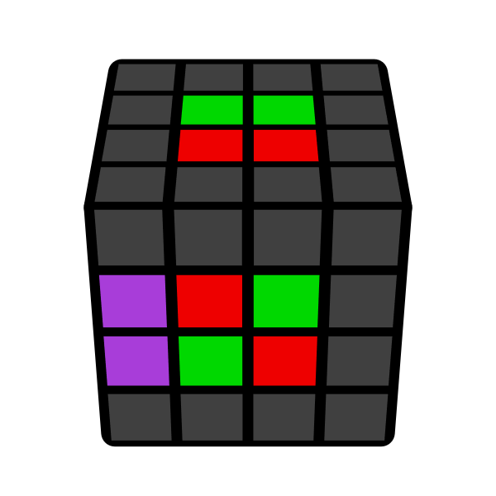
(r U' r' U') 2L' U' r | r U' r2') 3r U' r | r U r2' 3r U r | (r U r' U) 2L' U r
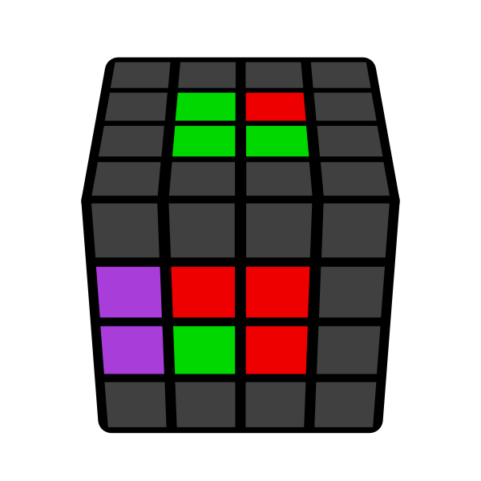 | 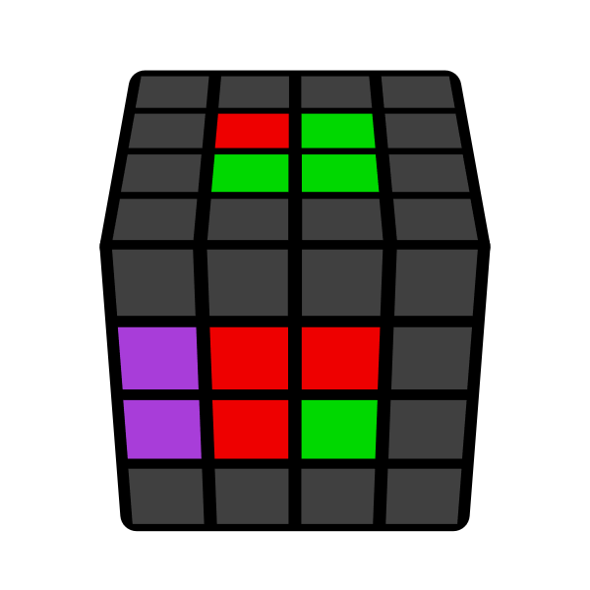 | 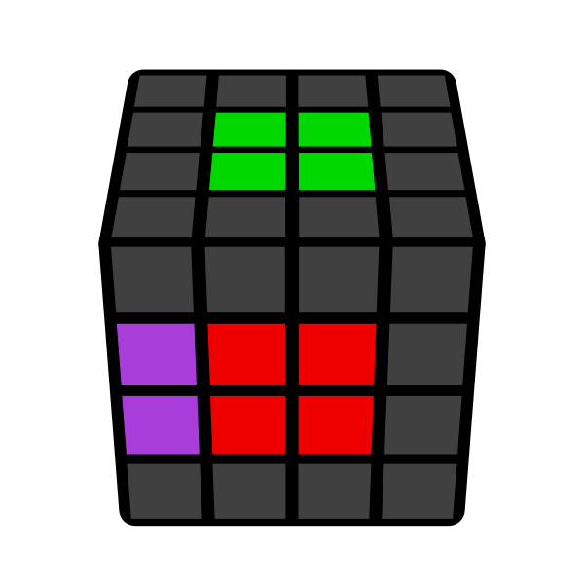
r U2' r2' 3r U r | r U' r2' 3r U2 r | r U2' r2' 3r U2 r | Solved

