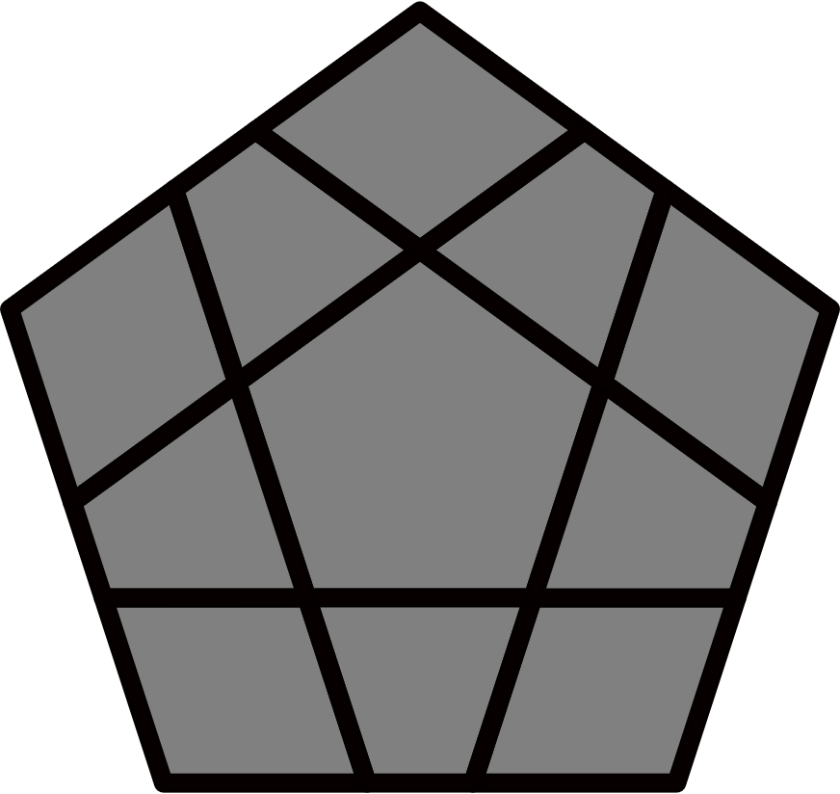
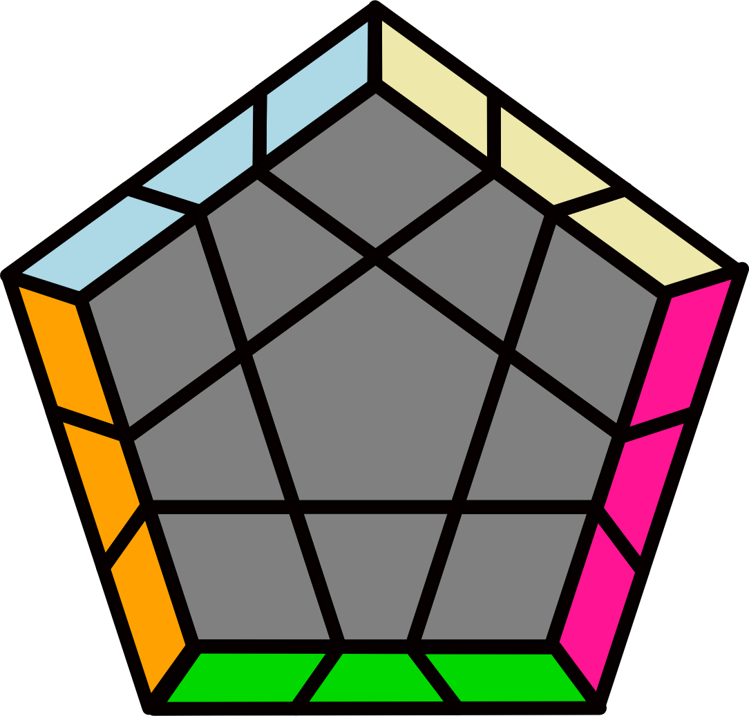
Megaminx PLL Algorithms
Algorithms from James Macdiarmid http://bit.ly/2BfW2w6

CPLL are not included. B=BR, D=DR. 3x3 PLL or PLL inverse.
Mushroom |  |  | Horseface |  |  |  |  | Bunny |  |  | Sunny |  |  | Checker
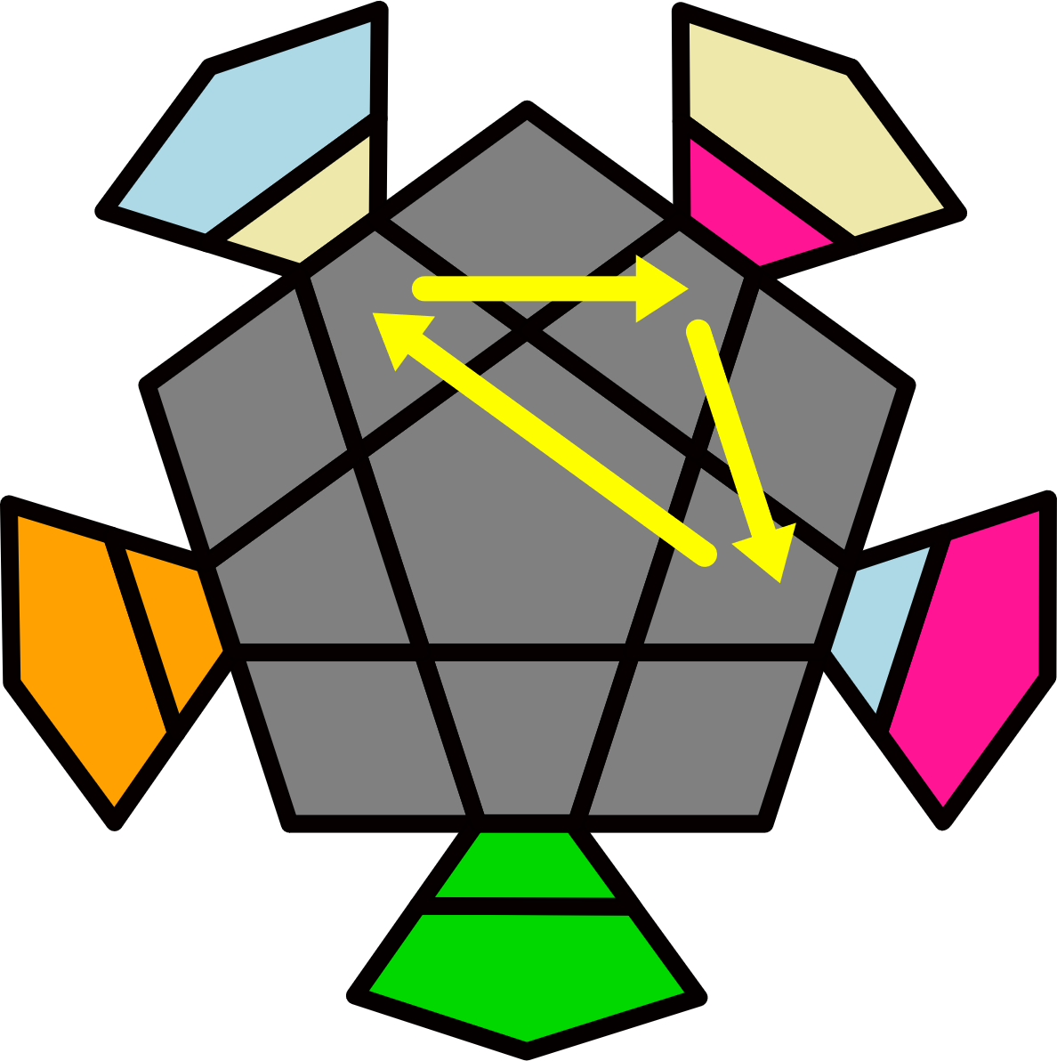M+ | 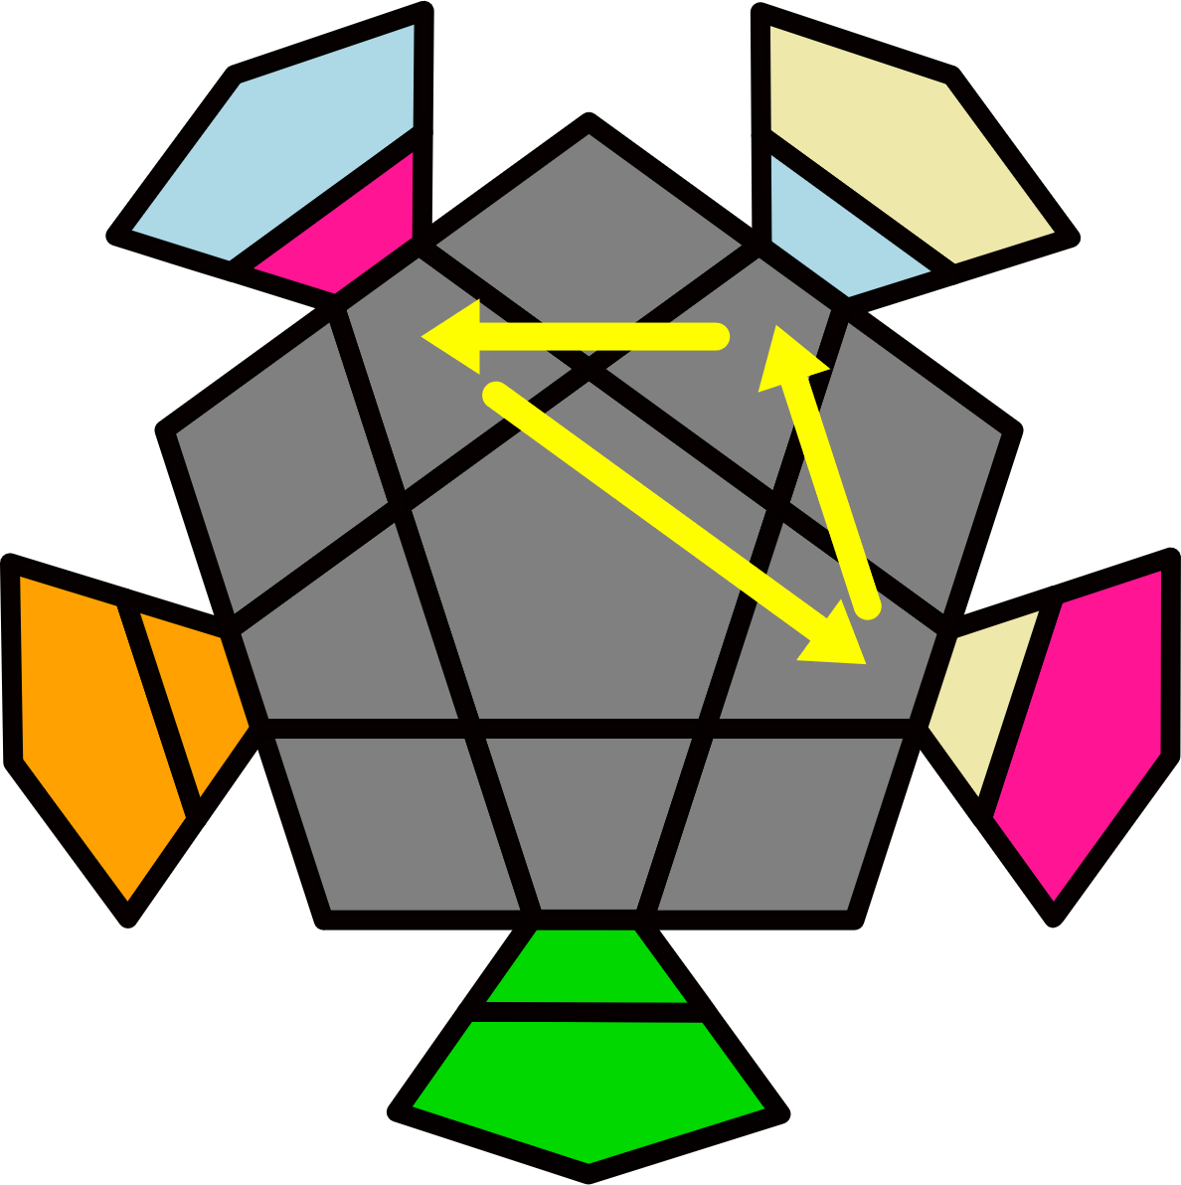M- |  |  | 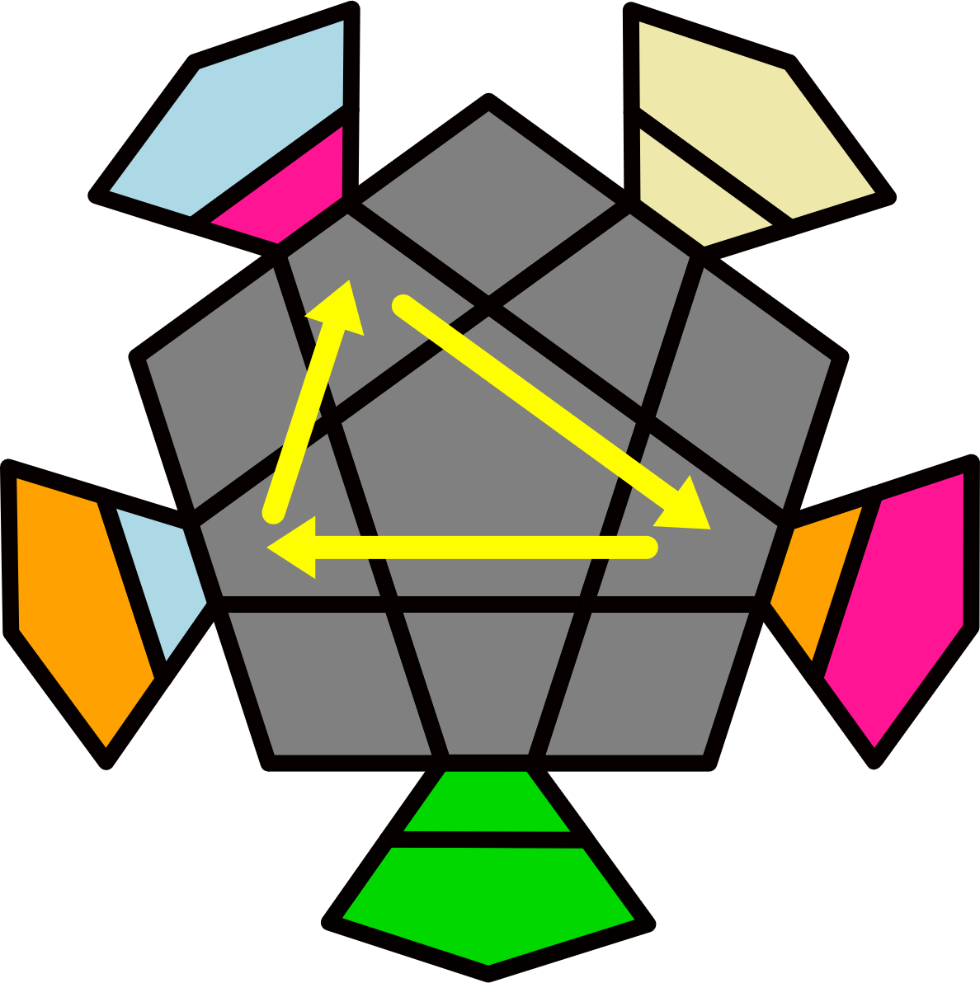H+ |  | 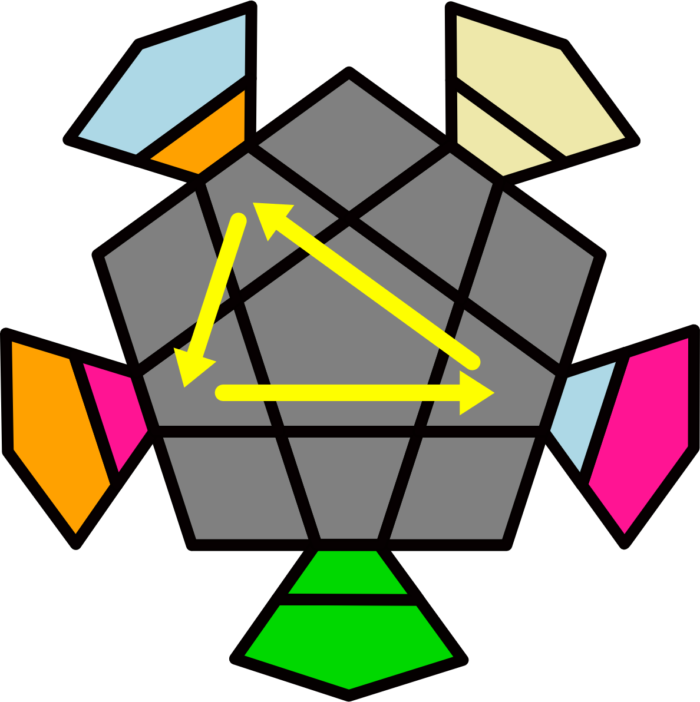H- |  |  | 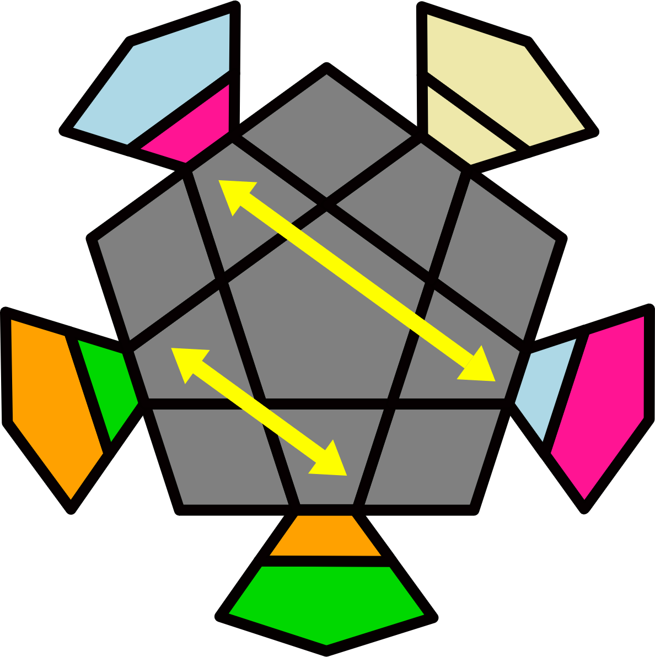B |  | 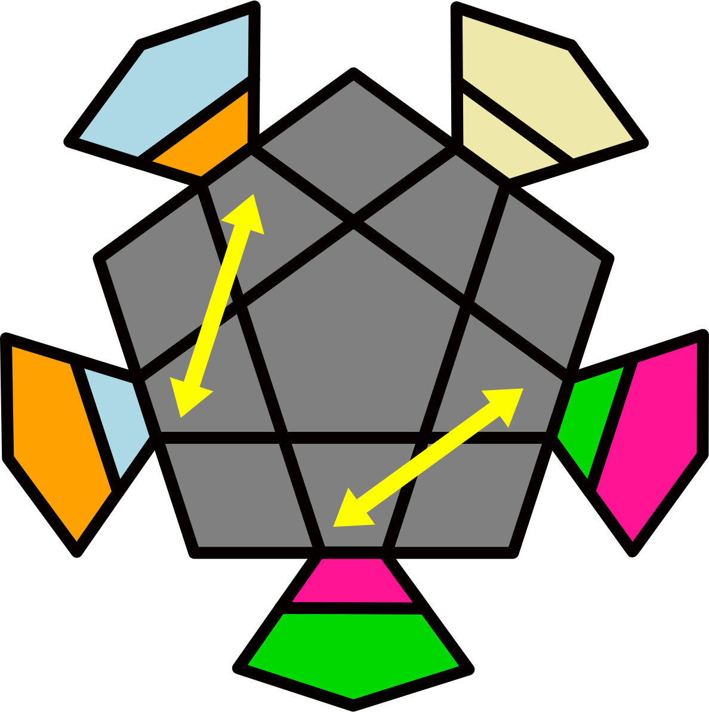S |  | 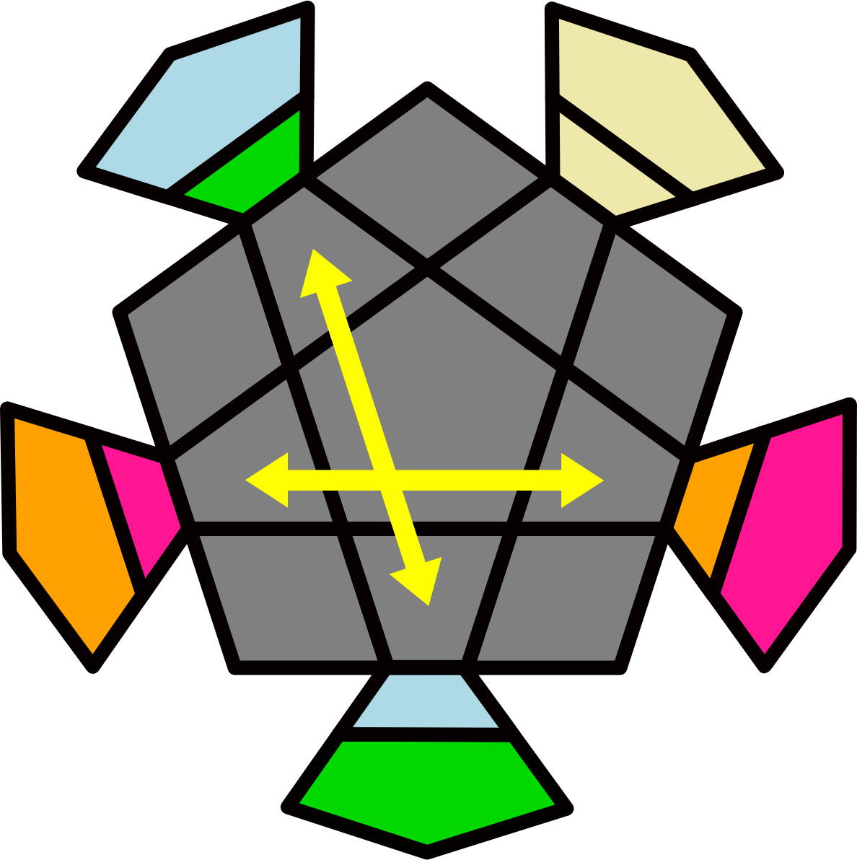X
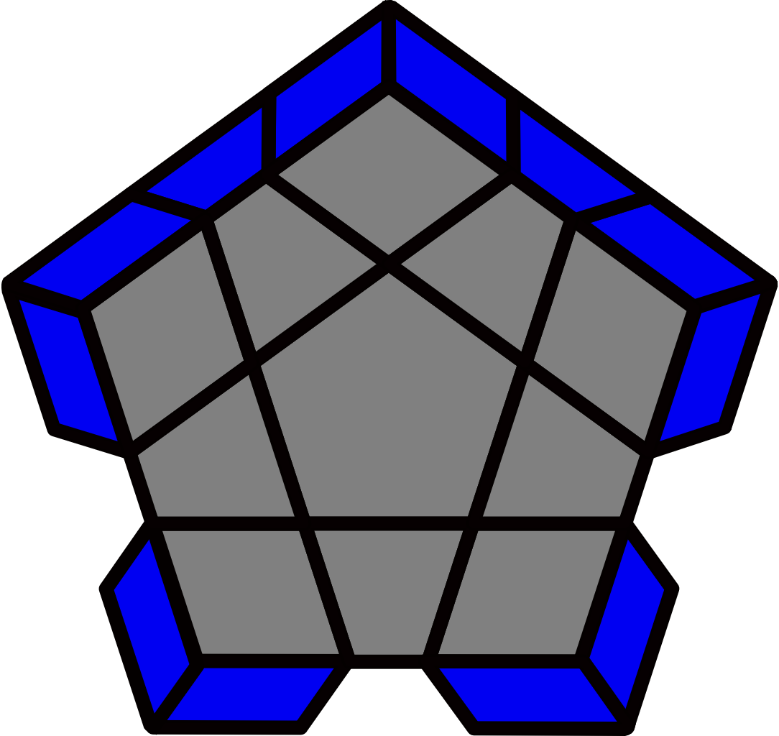 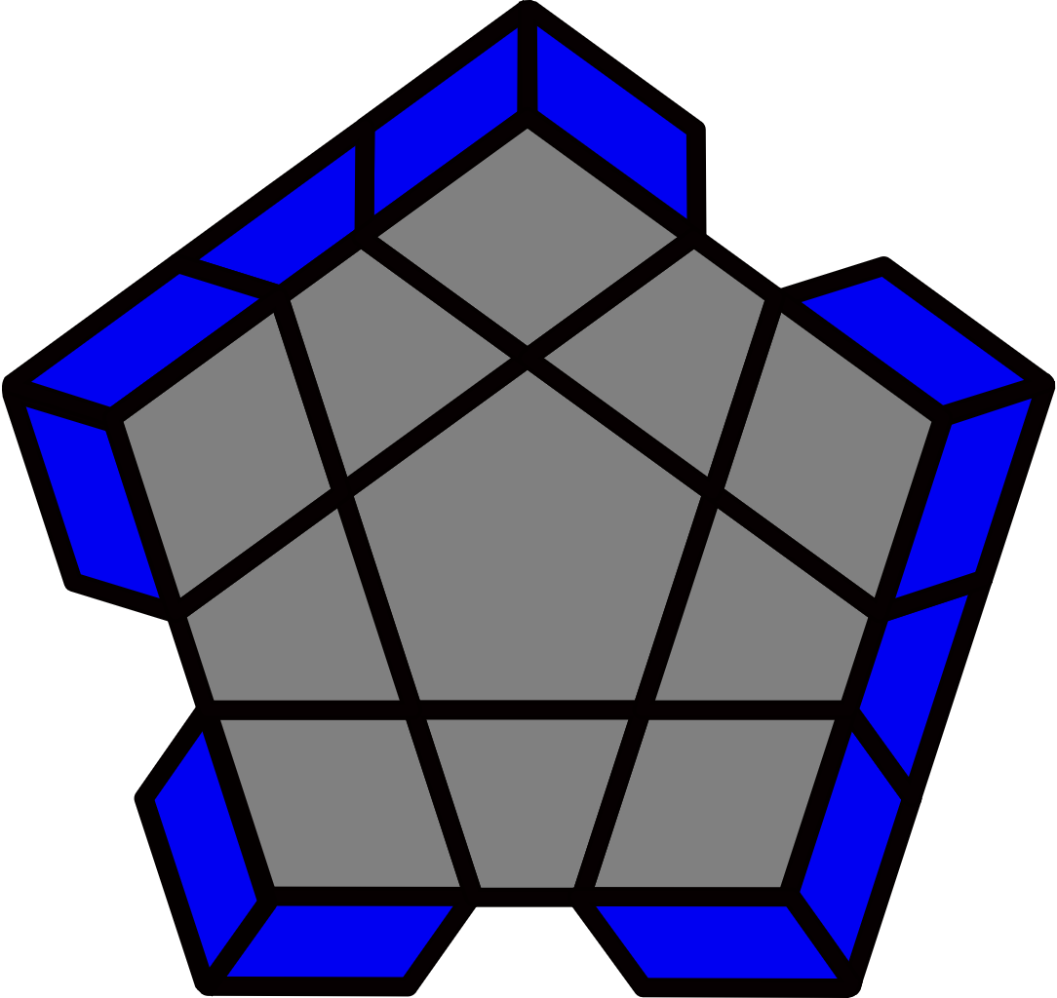 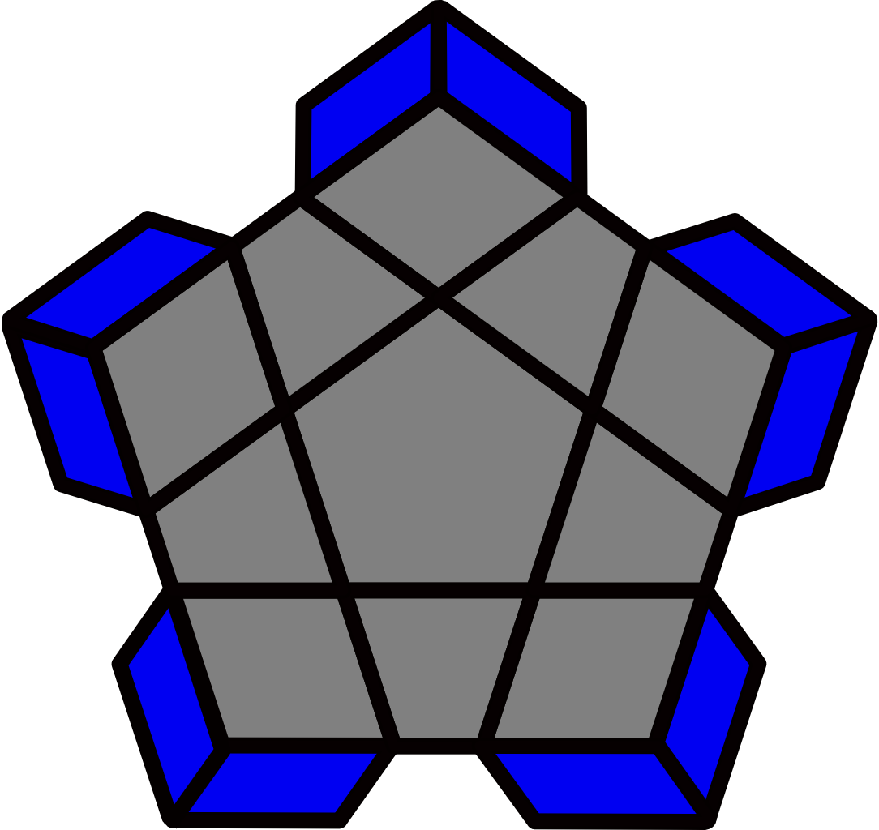3/4/5EP [11]
M+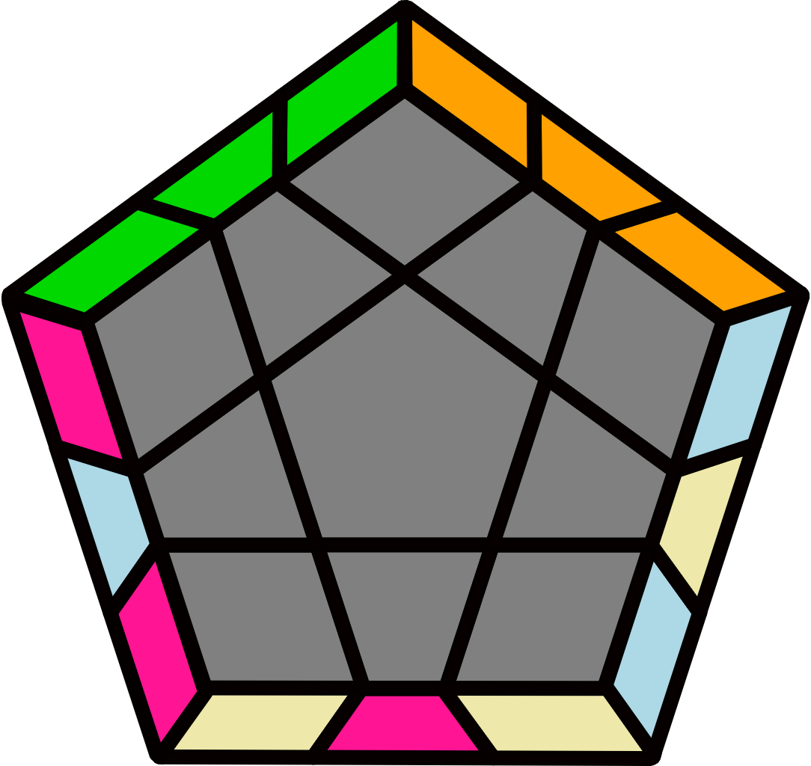 |  | M-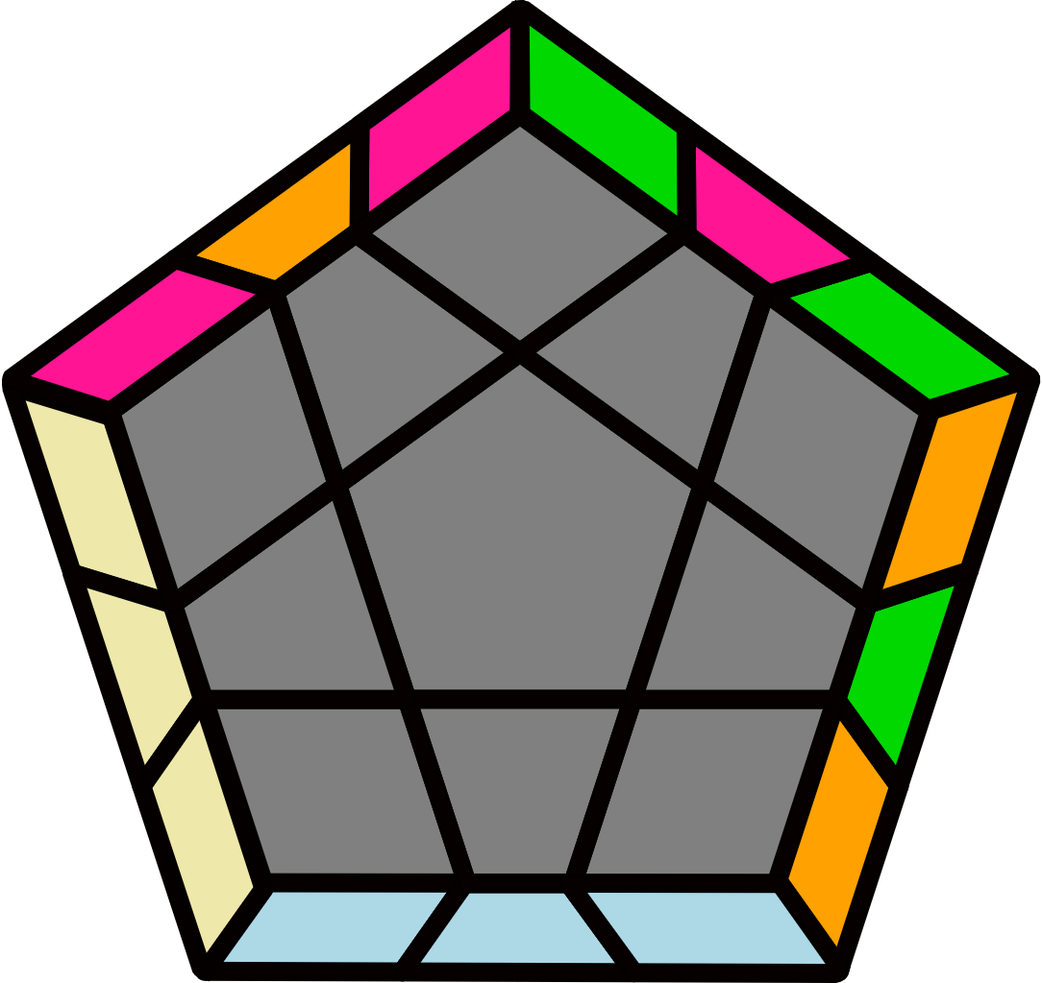 |  |  |  |  | H+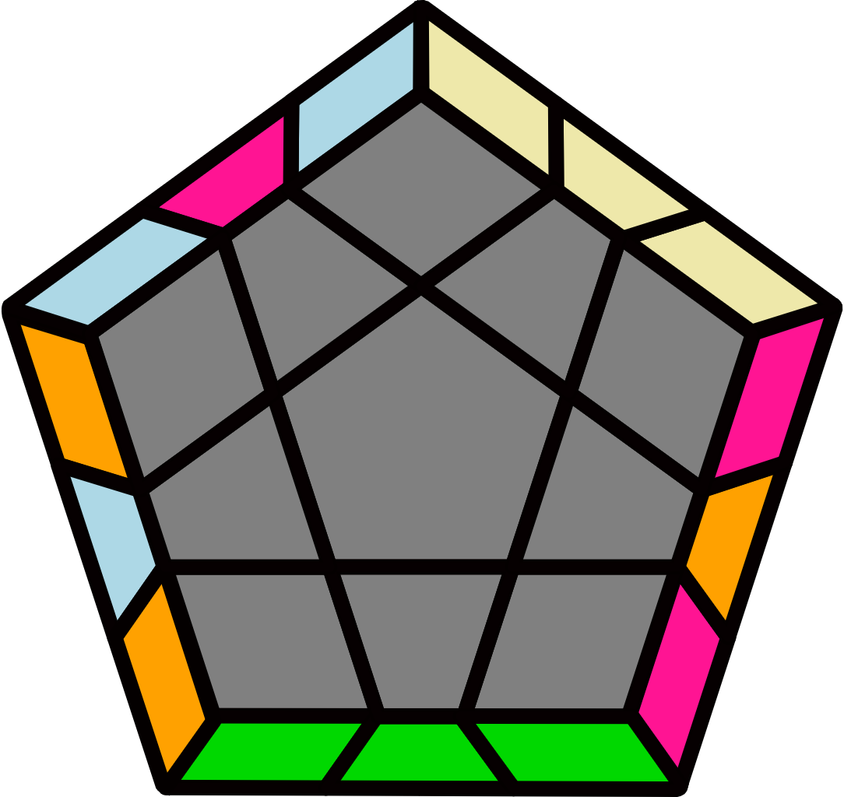 |  |  |  |  | H-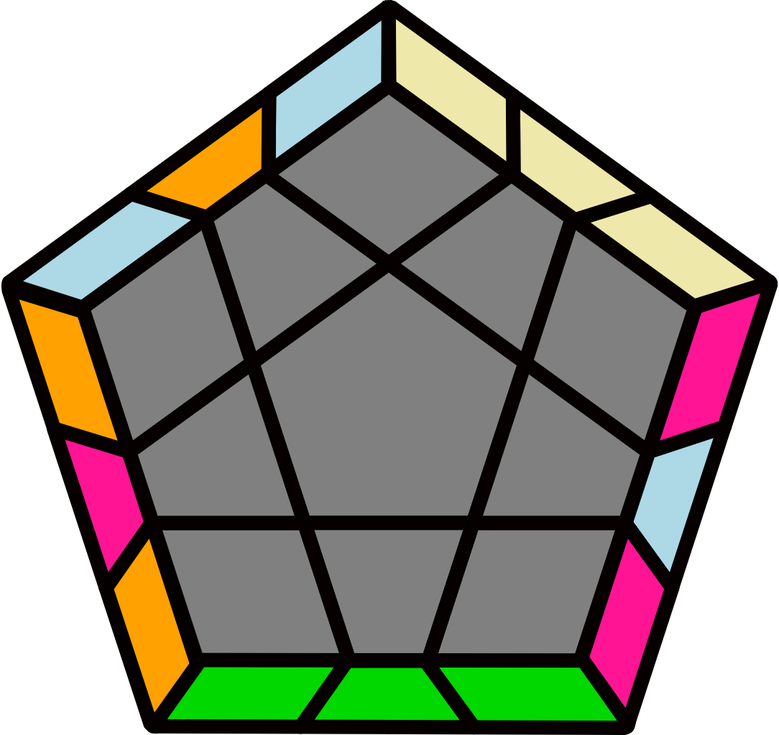
(R' U' R U') (R U R2' U)  R U' R U' R' |  | (R U R' U R' U' R2 U' R' U R' U R) |  |  |  |  | (R' U2' R U') (R U R2' U)  (R U' R U') R' U2 R' U R |  |  |  |  | (R U2 R' U) (R' U' R2 U') (R' U R' U) R U2' R U' R'
B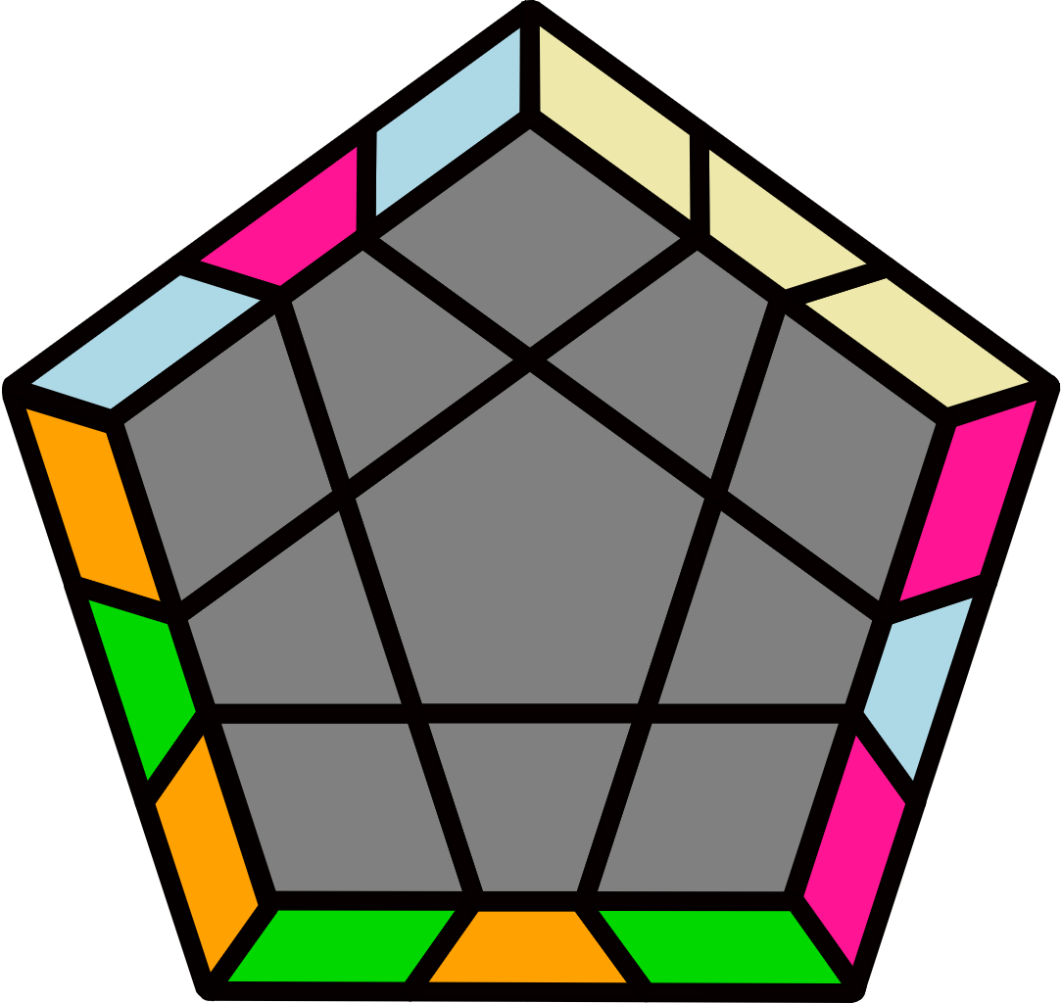 |  |  |  |  | S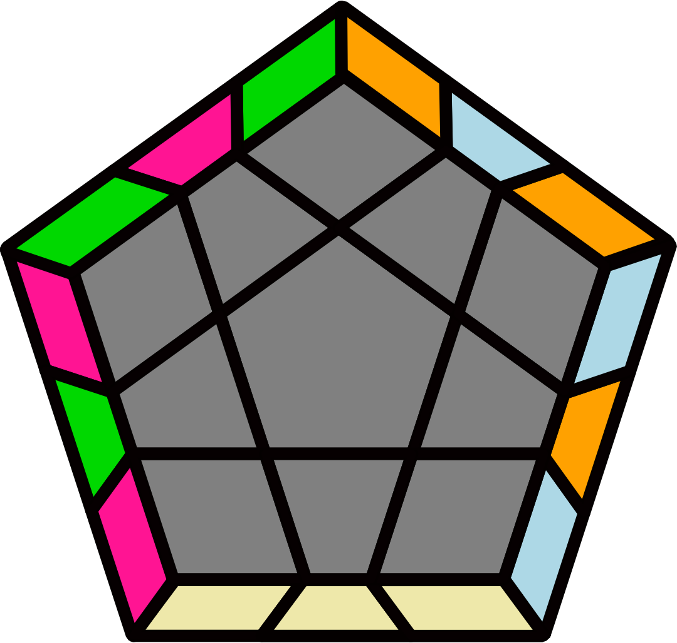 |  |  |  |  | X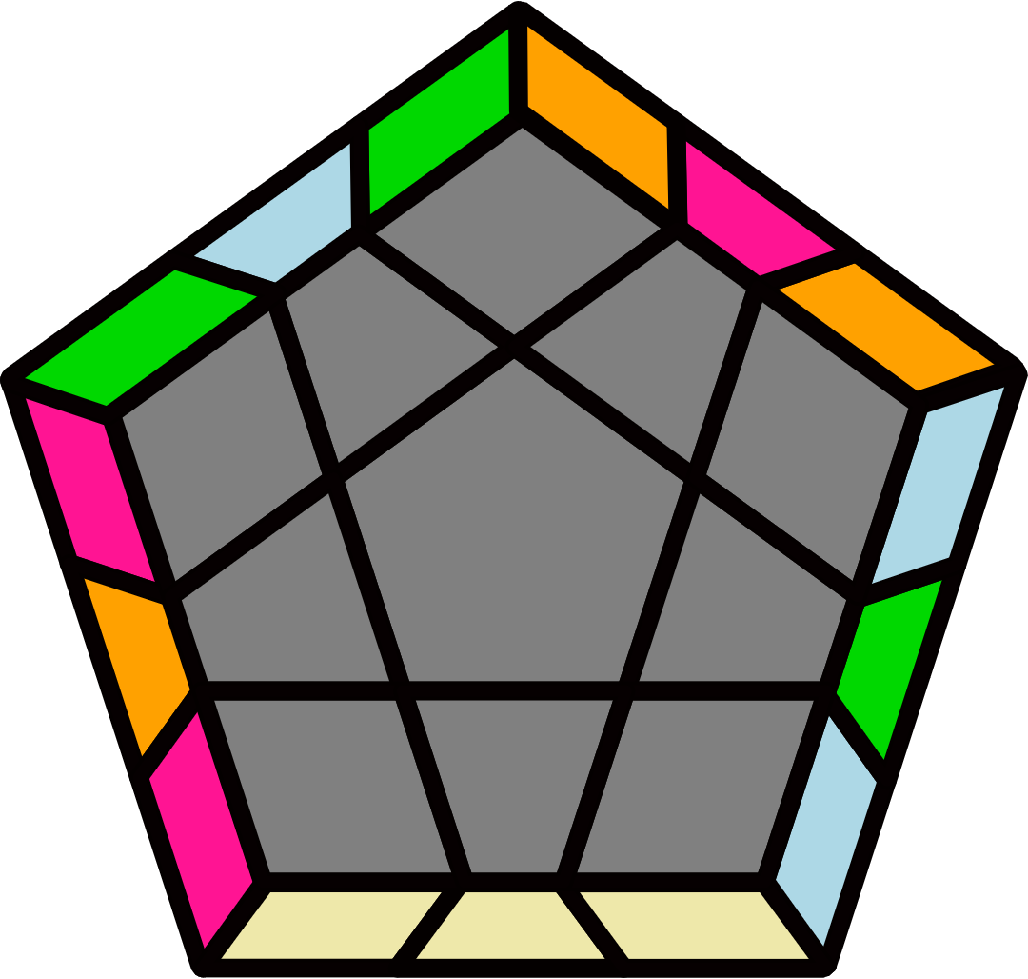
L U2' L' y' R' L' U2 L U R  y R L U2' R' U L' |  |  |  |  | (R U2 R2' F R F' R U2')  y (R U' R' U' R U R' F') |  |  |  |  | (R U R' U R' U' R2 U' R' U R' U R) U' (R U R' U R' U' R2 U' R' U R' U R)
M+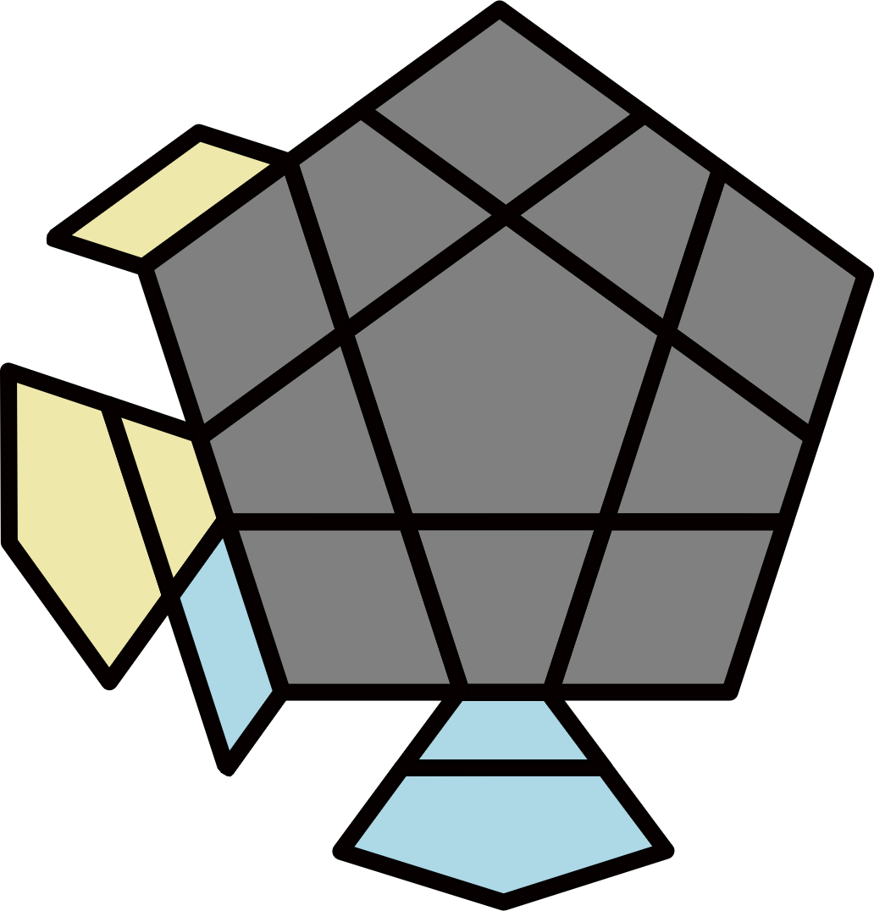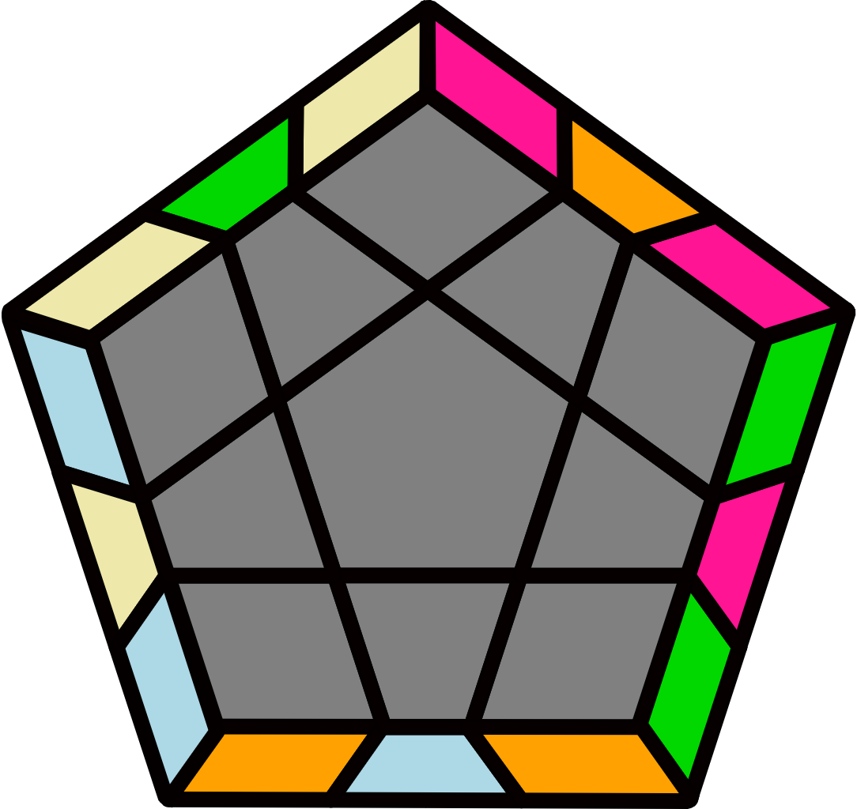 |  | M-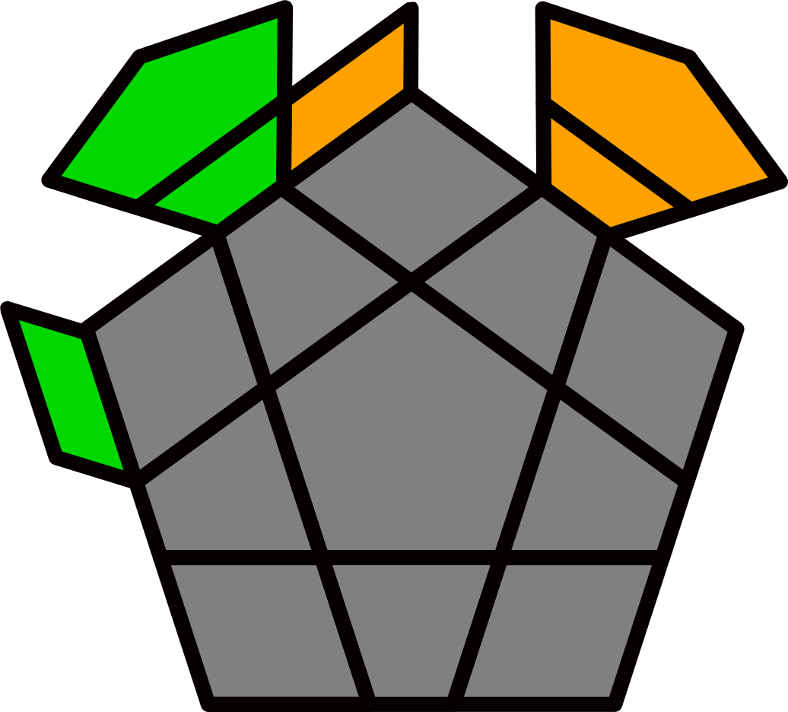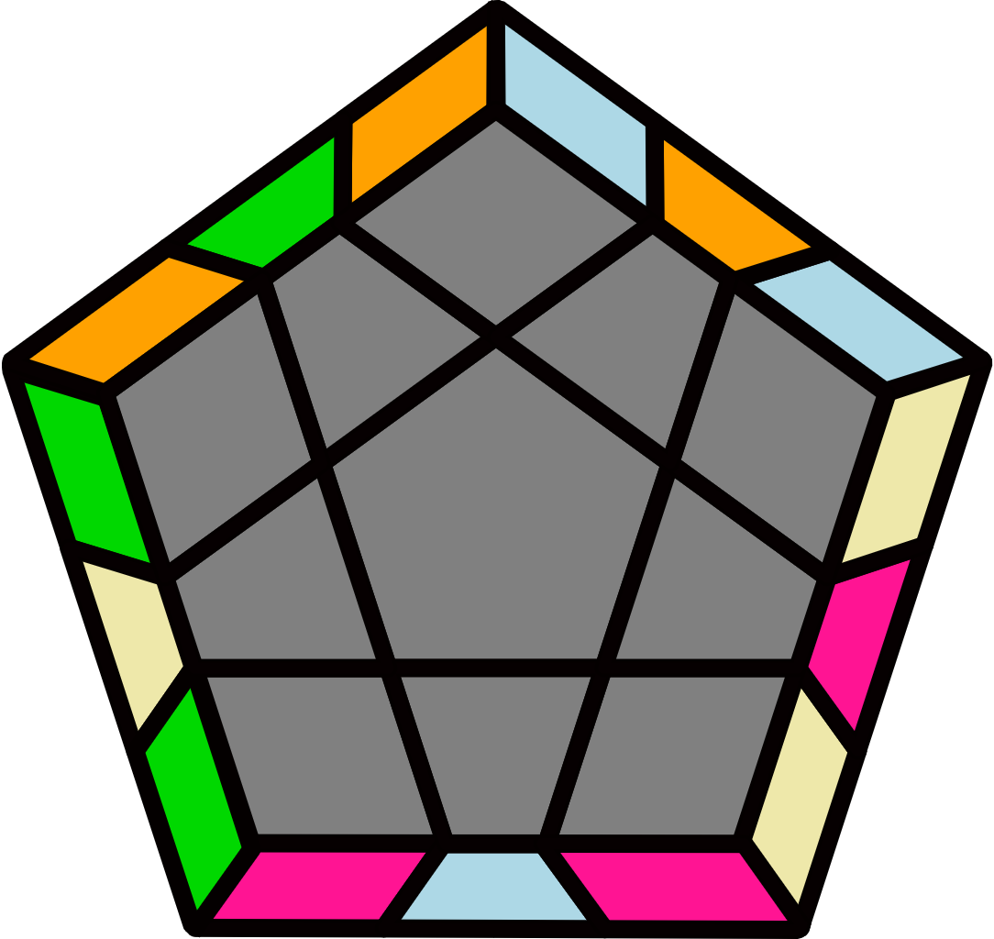 |  |  |  |  | H+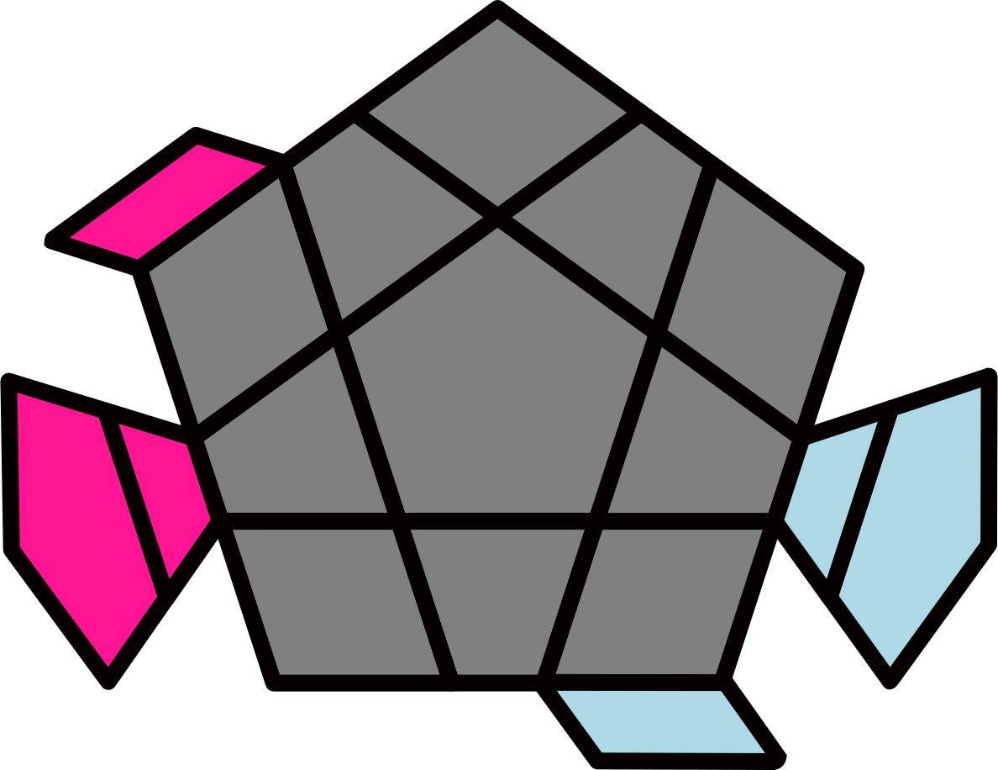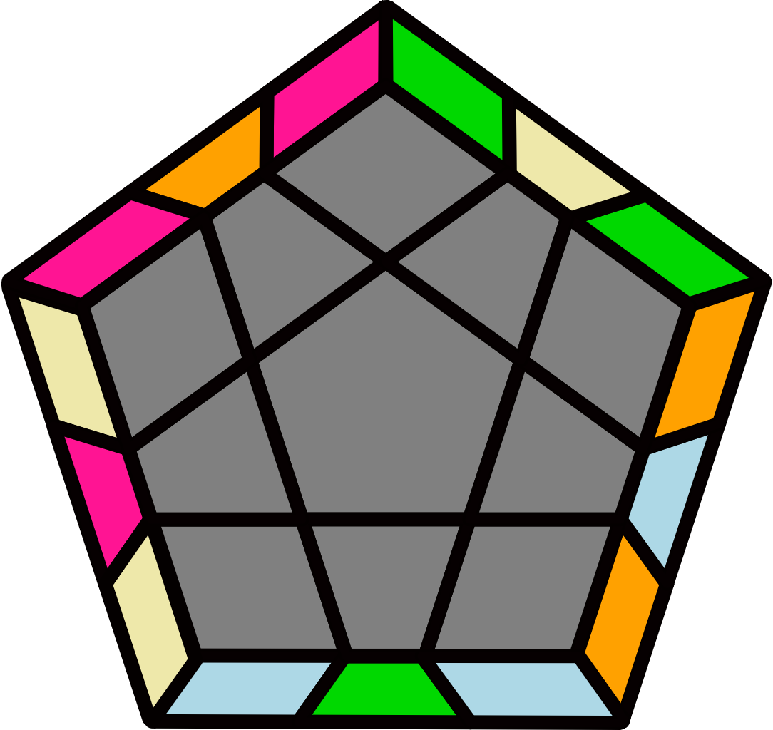 |  |  |  |  | H-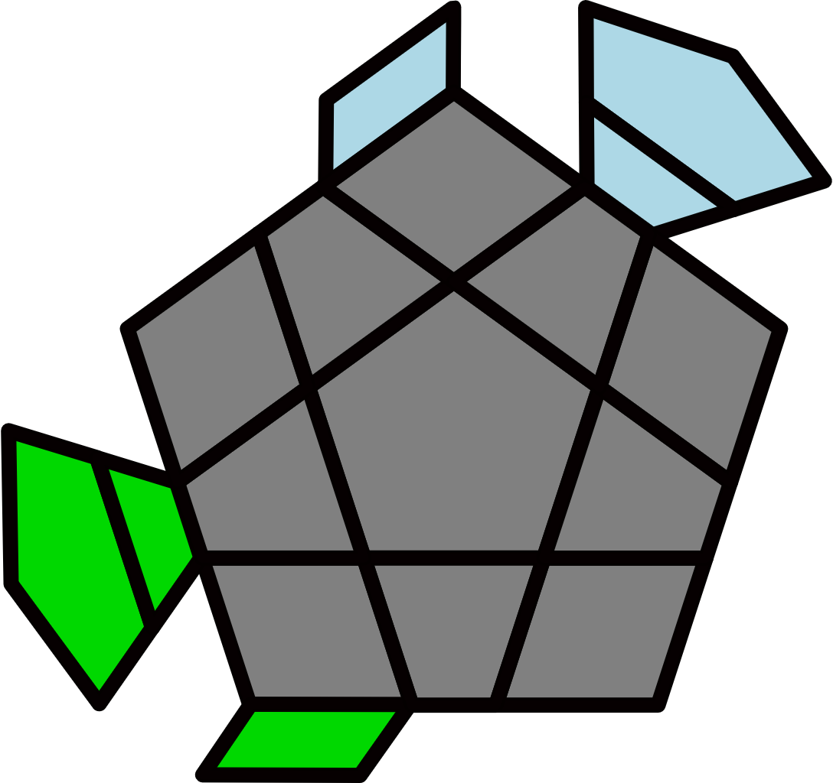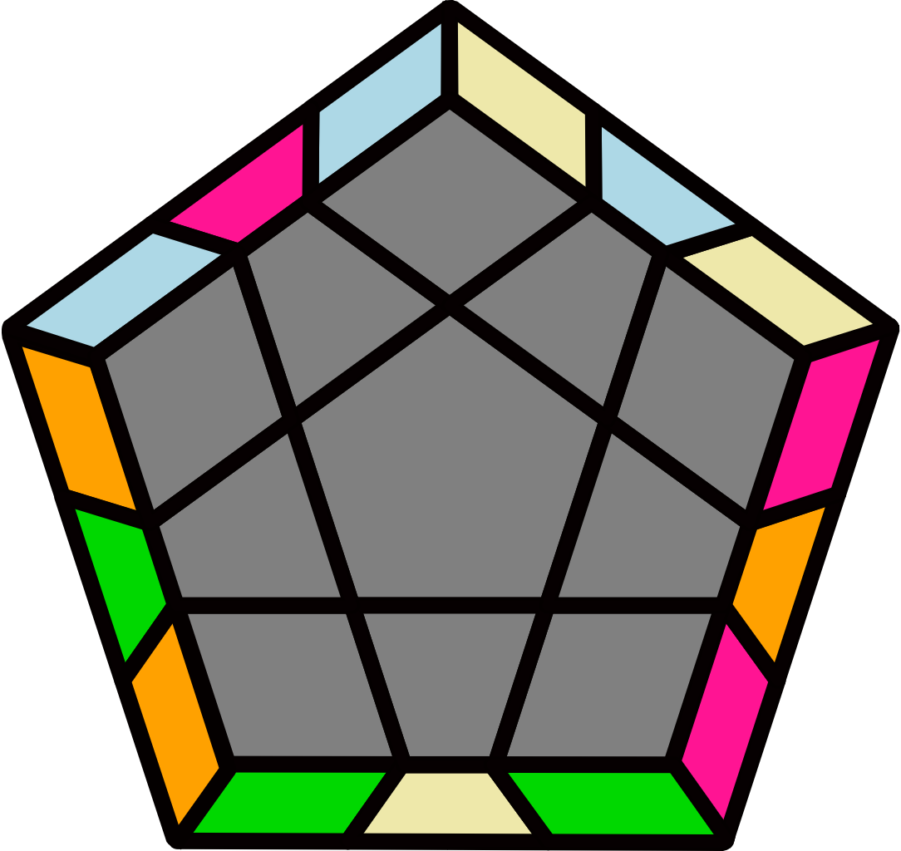
(R2 U2 R2' U R2 U2 R2') U' (R2 U2 R2' U R2 U2 R2') |  | (R2' U2' R2 U' R2' U2' R2) U (R2' U2' R2 U' R2' U2' R2) |  |  |  |  | (R' U2' R U' R' U2' R2)  (U2' R' U' R U2' R') |  |  |  |  | (R U2' R' U' R U2' R') U2' (R' U2' R U' R' U2' R)
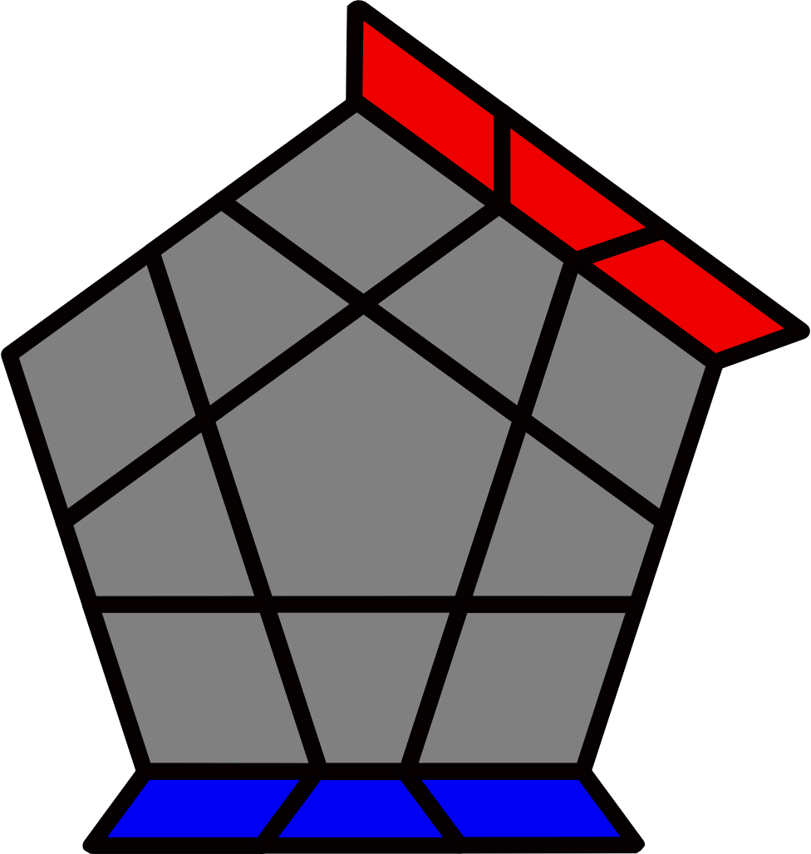 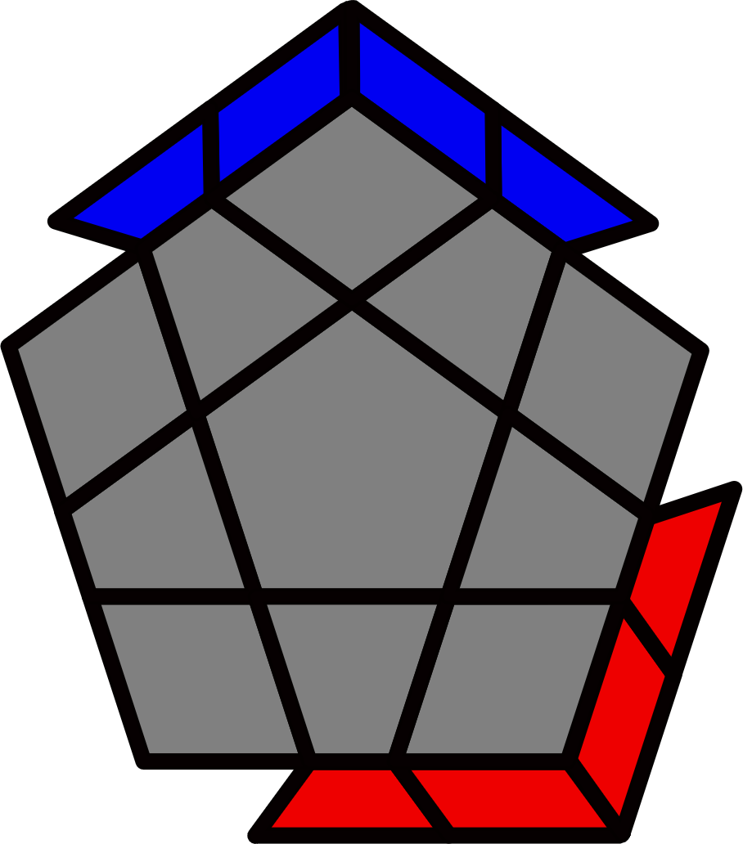 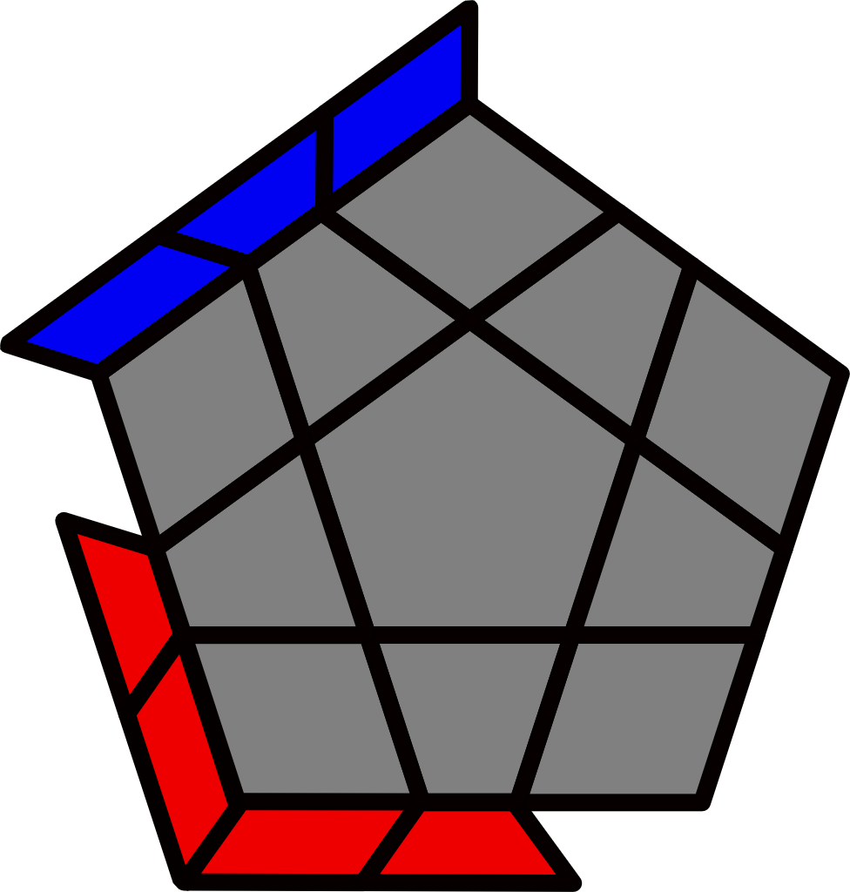2 Lines, 2 Blocks, Line + Block [4]
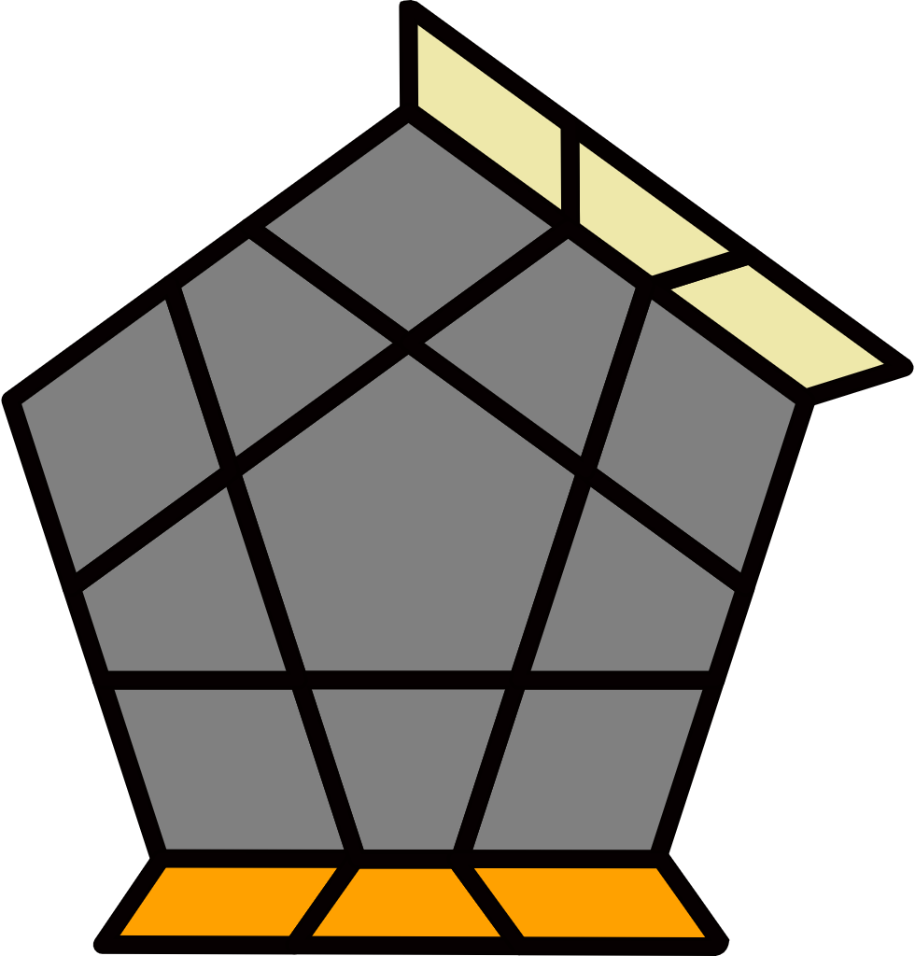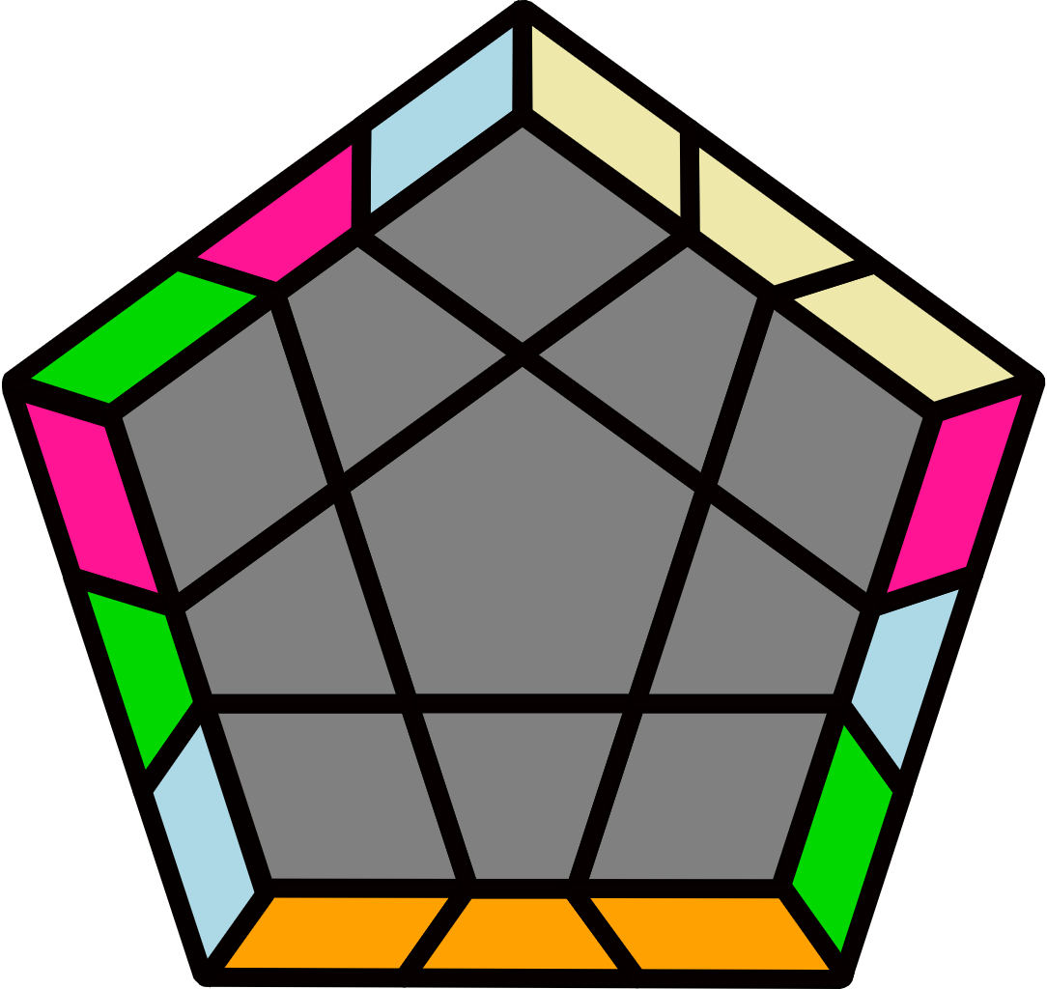 |  | 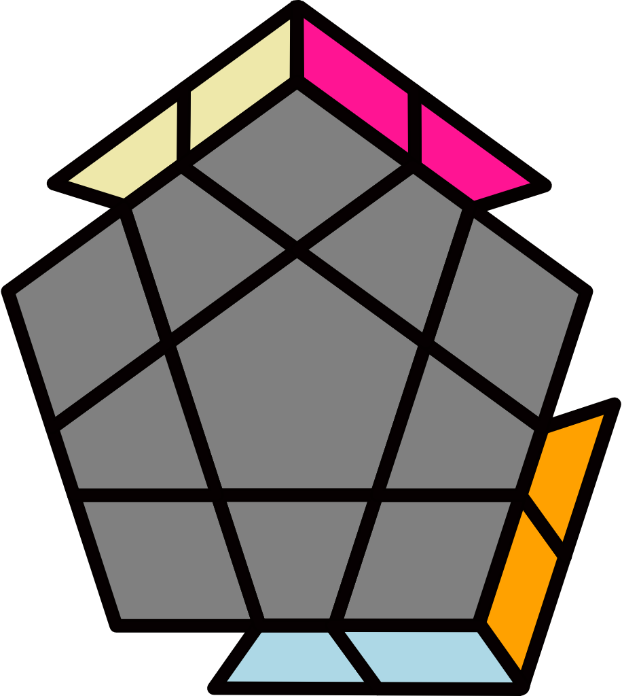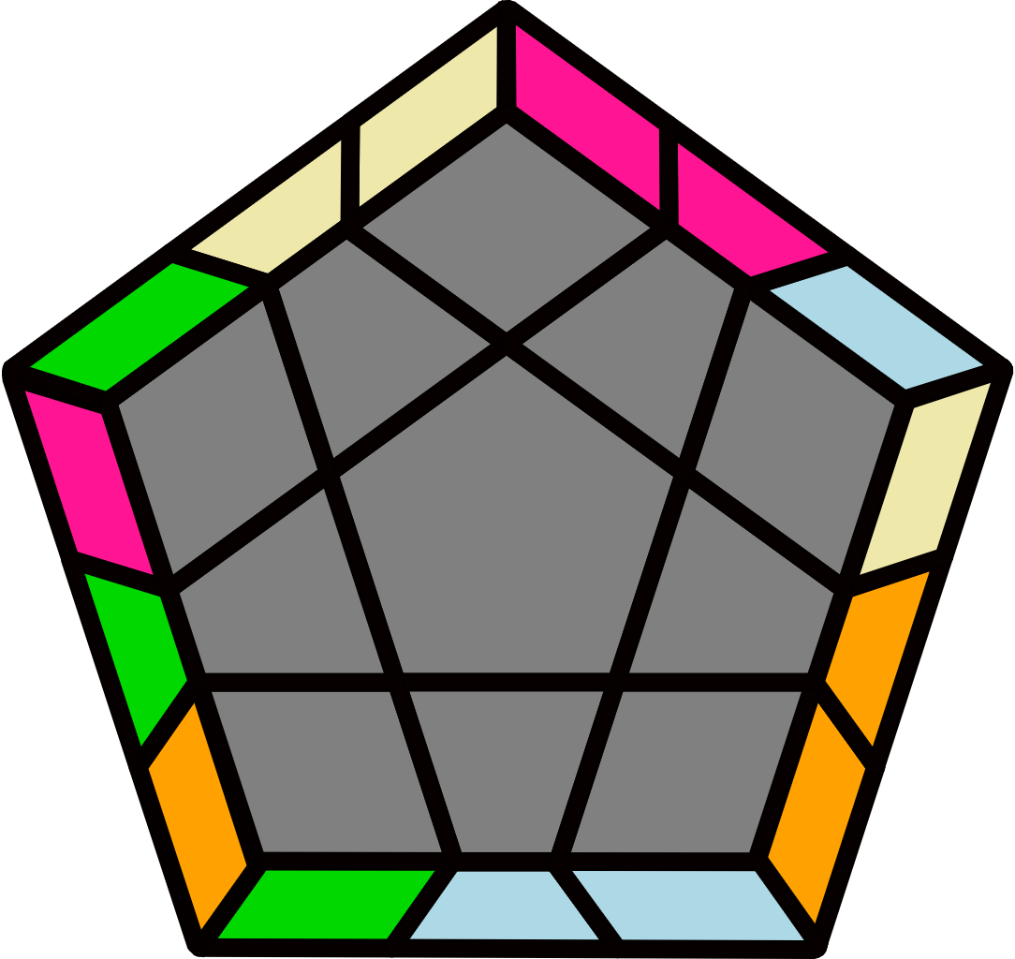 |  |  |  |  | 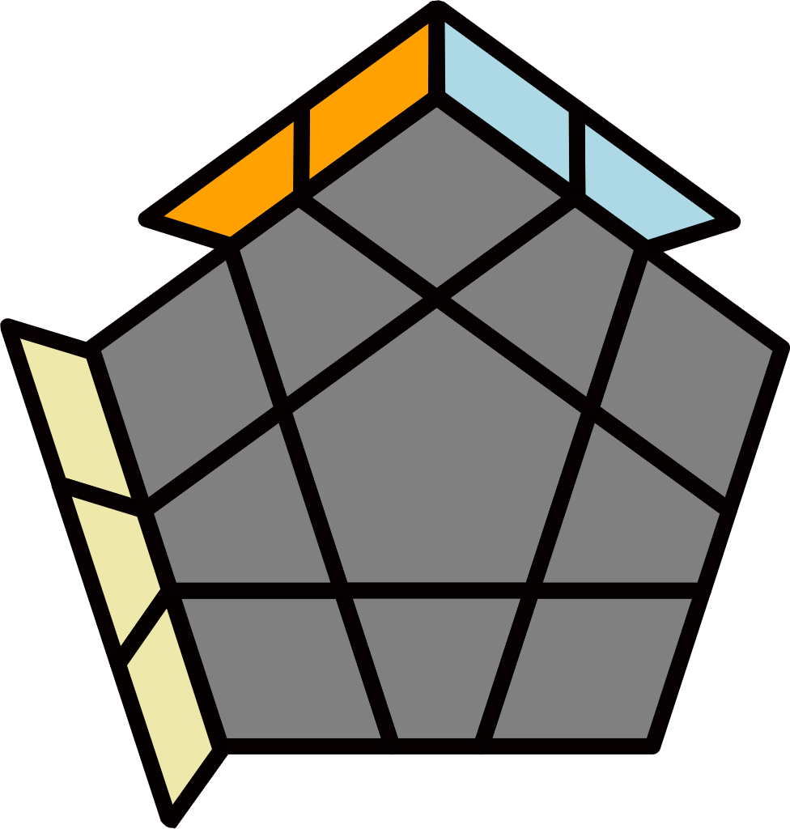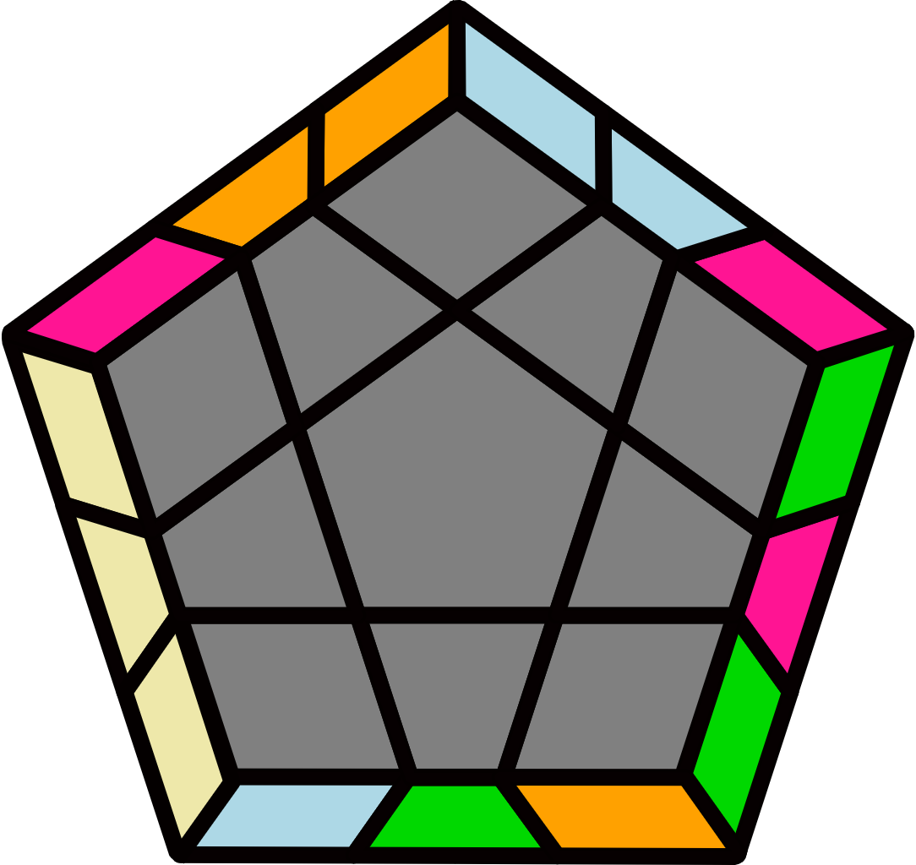 |  |  |  |  | 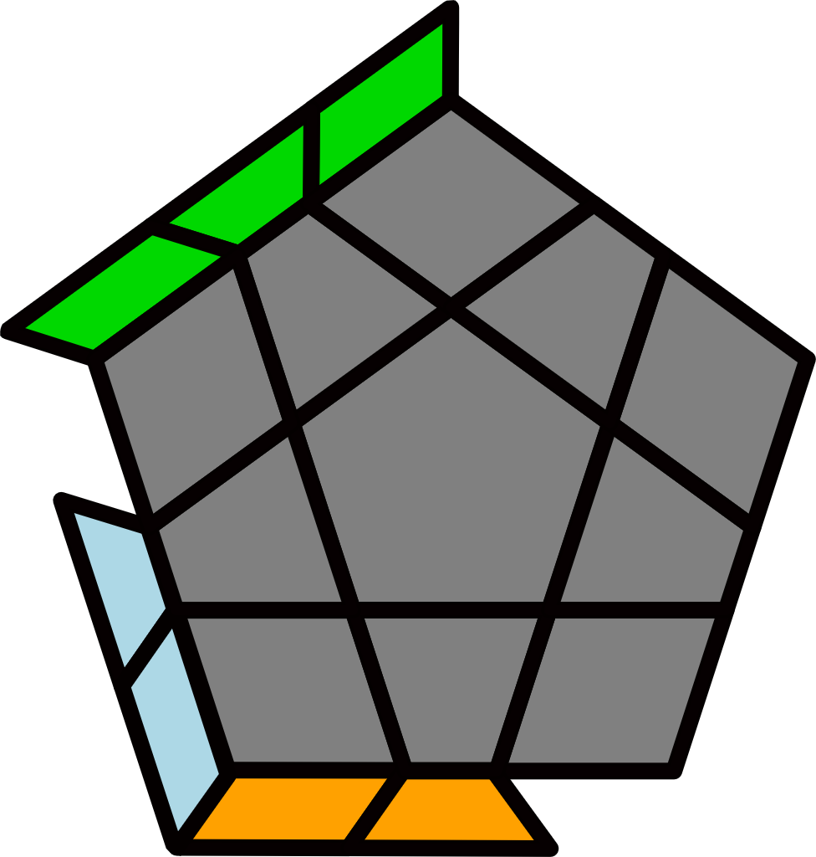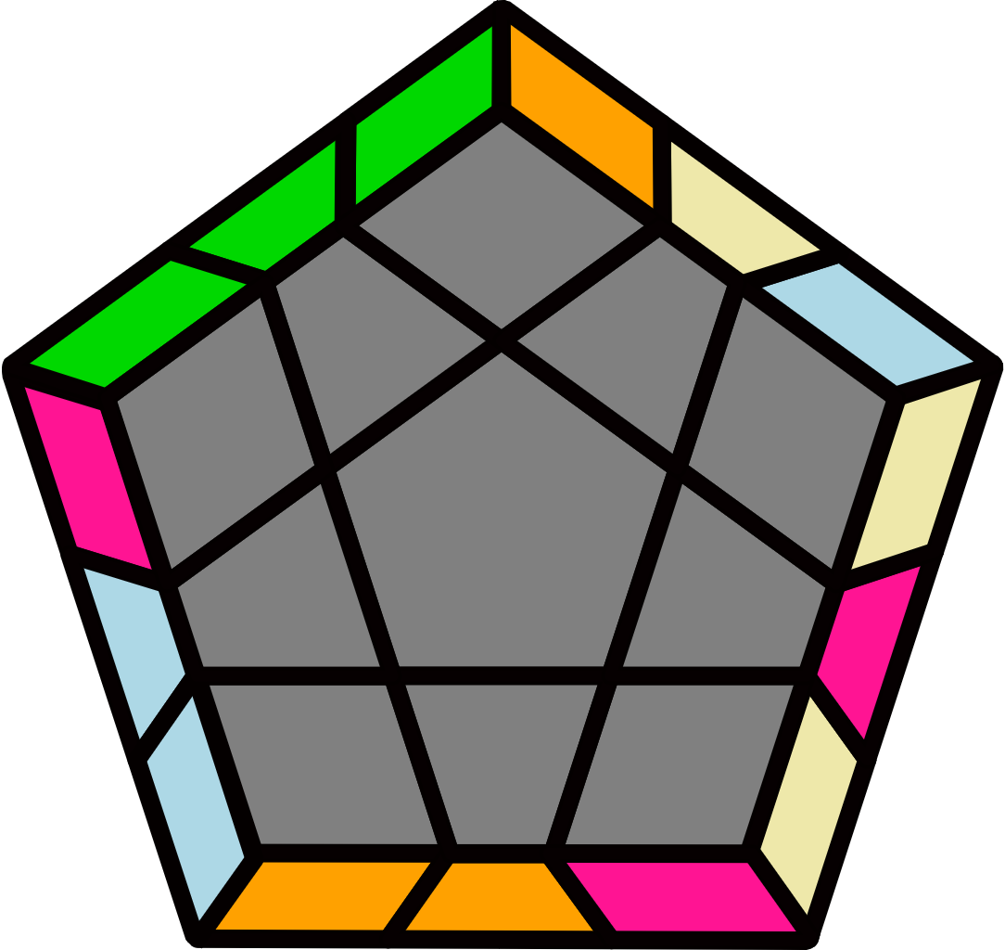
(R U R' U2') R' U2' (R U R' U) (R2 U' R' U2) (R U' R' U) R U' R' |  | (R' U' R U2') (R2' U2' R2 U) (R' U2' R' U2') R U2 R |  |  |  |  | (R U2 R' U') (R U R' U)  (R U2' R' U2) R U2 R' |  |  |  |  | R' U2' (R U R' U') (R U' R' U2) (R U2' R' U2' R)
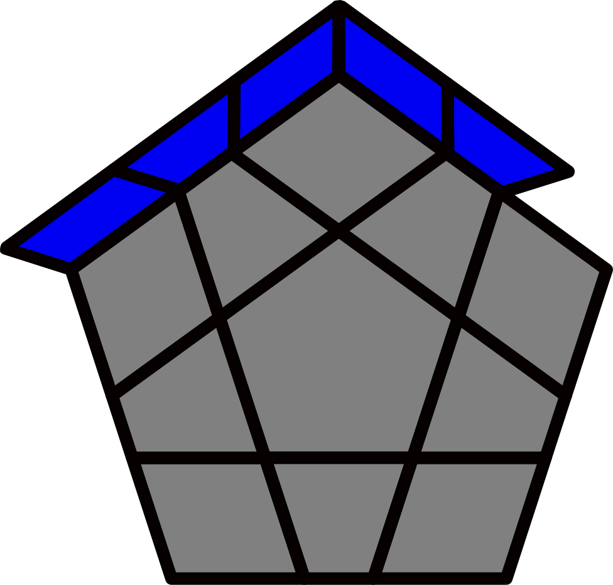 |  |  |  |  |  |  | 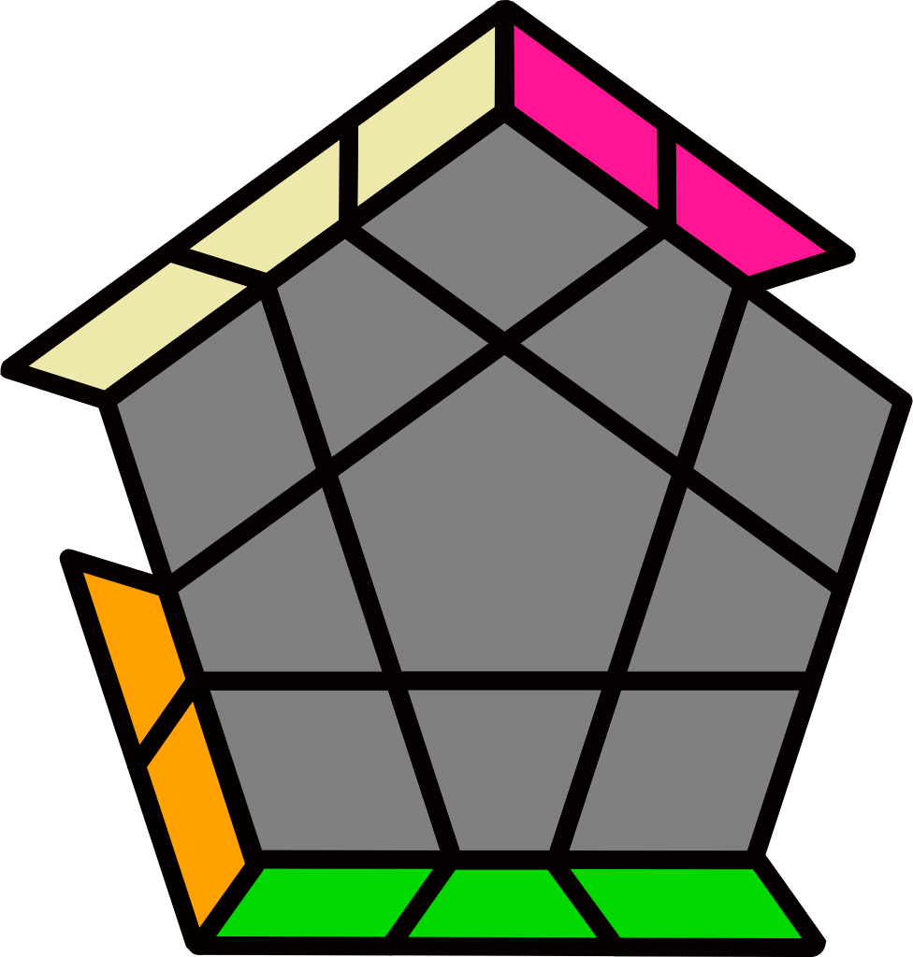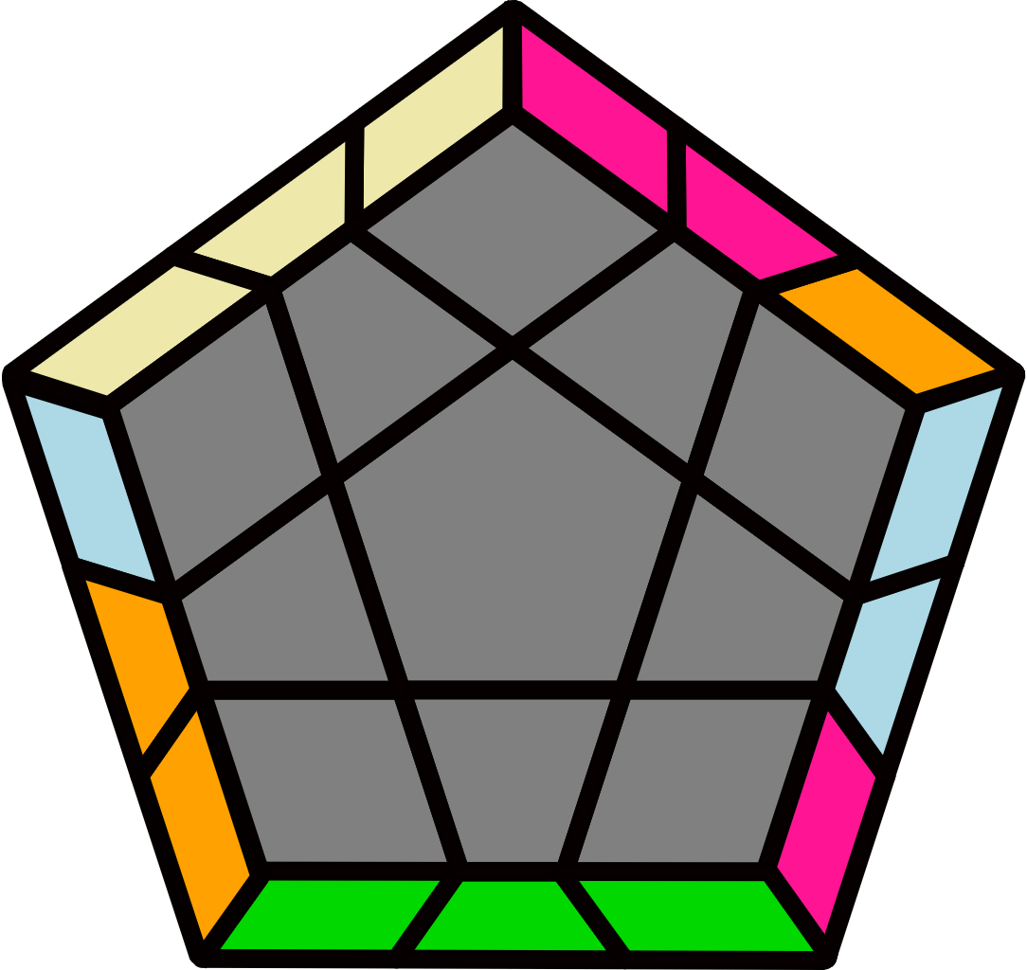 |  |  |  |  | 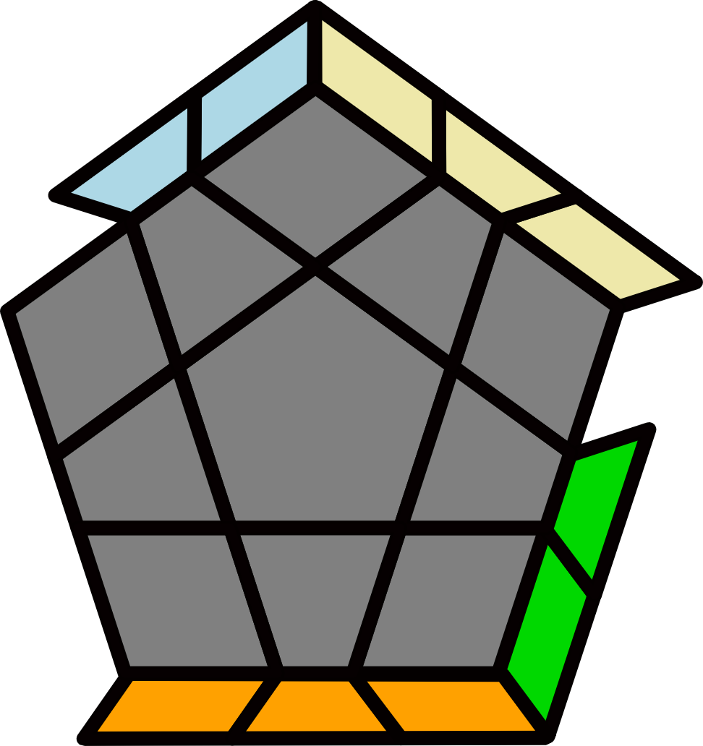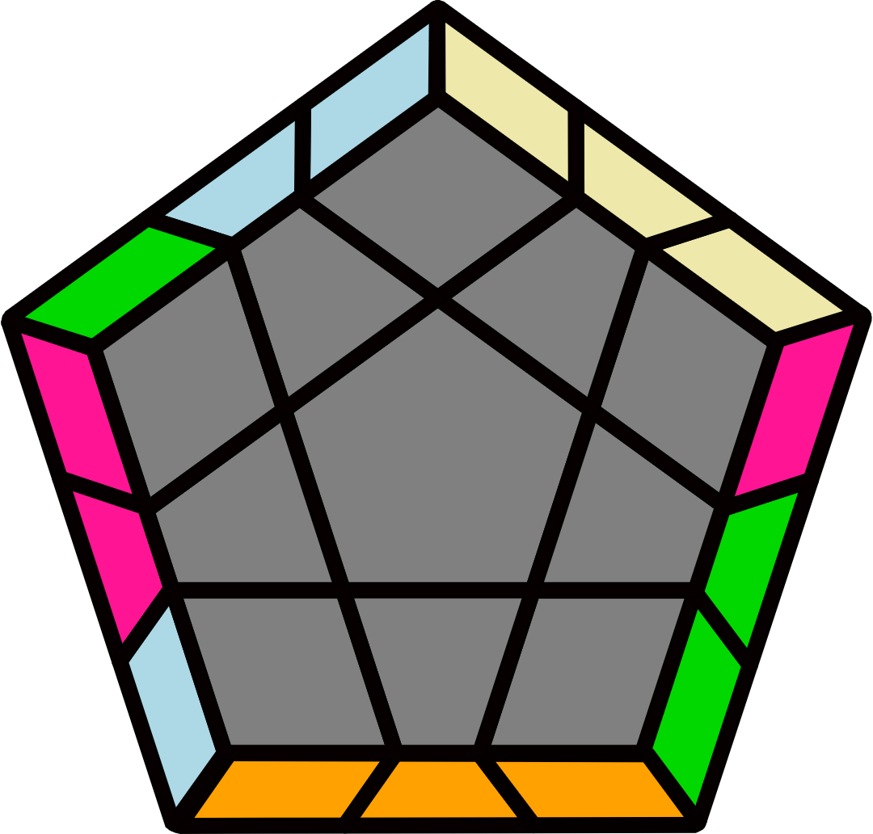
J Perm [6] |  |  |  |  |  |  | (R U R' F' R U R' U' R' F R2 U' R') |  |  |  |  | (R' U L' U2' R U' R' U2 R L)
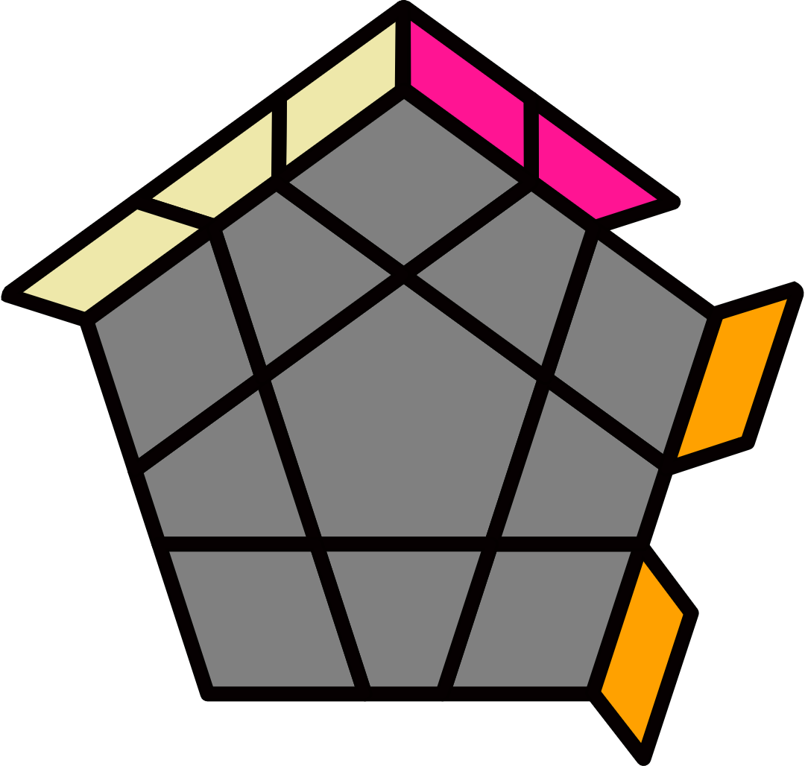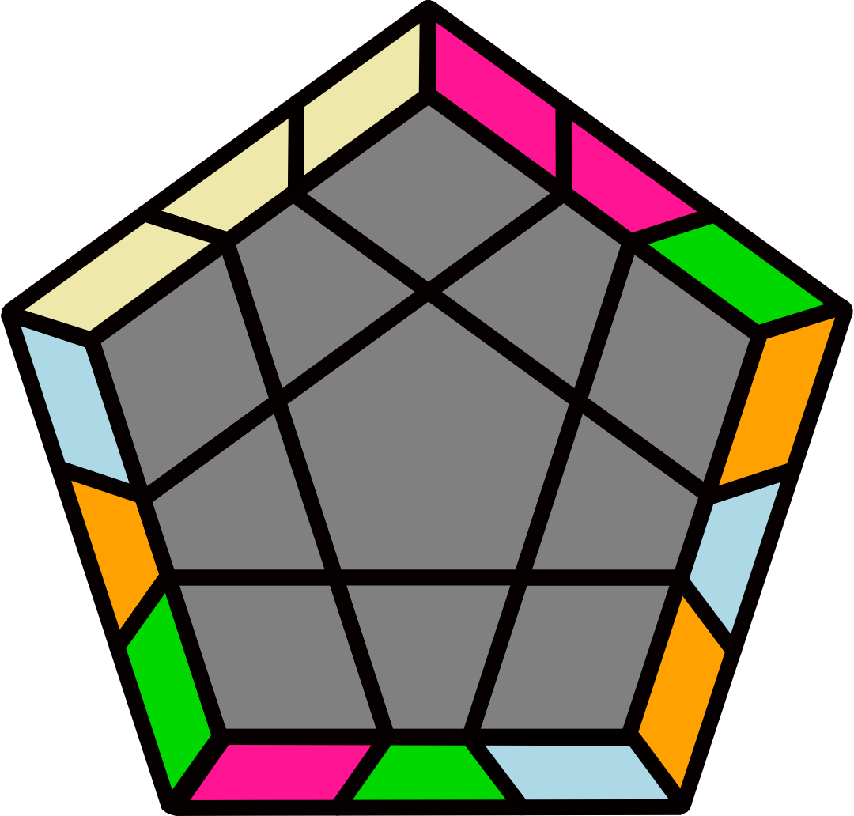 |  | 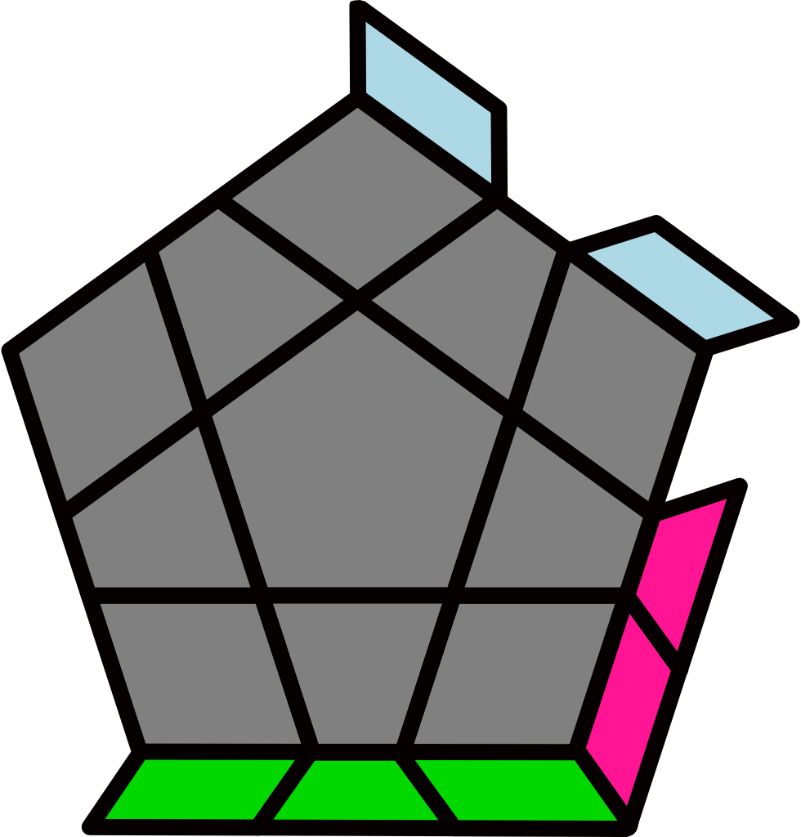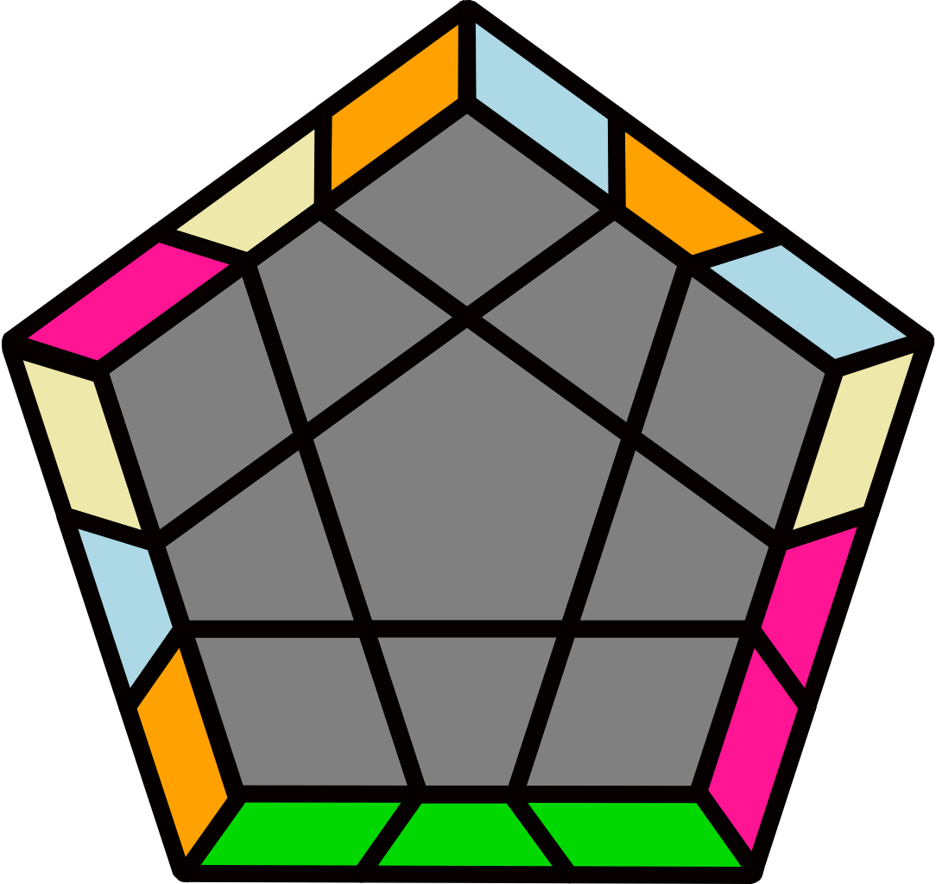 |  |  |  |  | 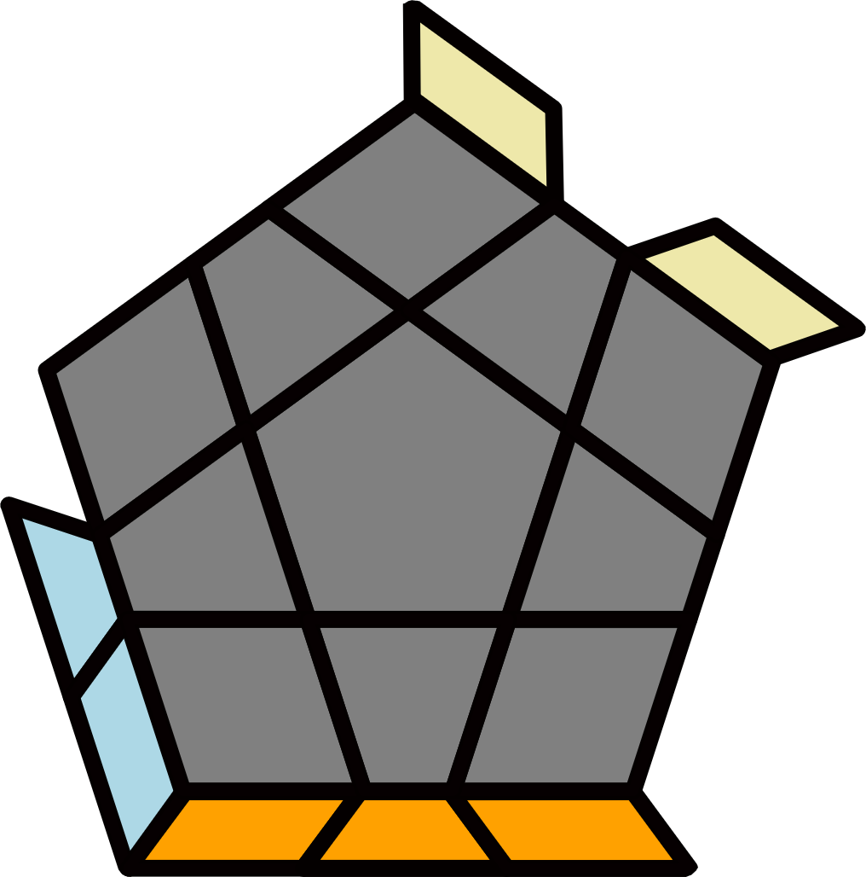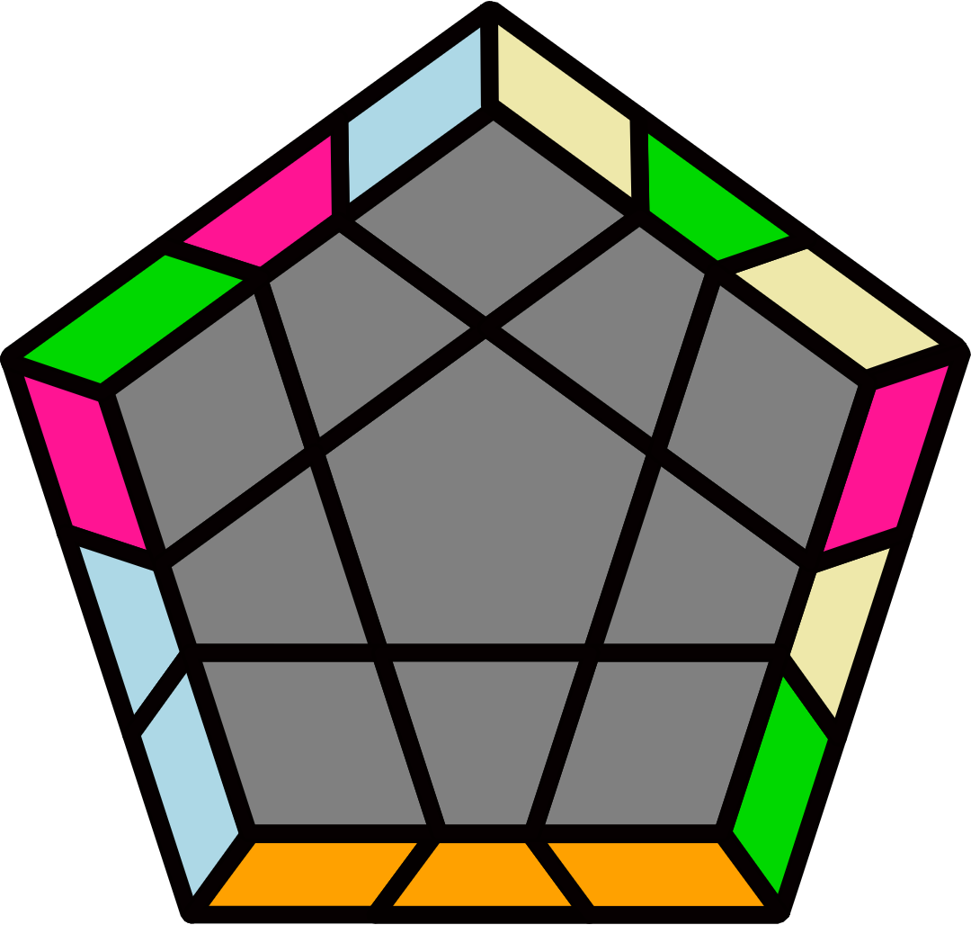 |  |  |  |  | 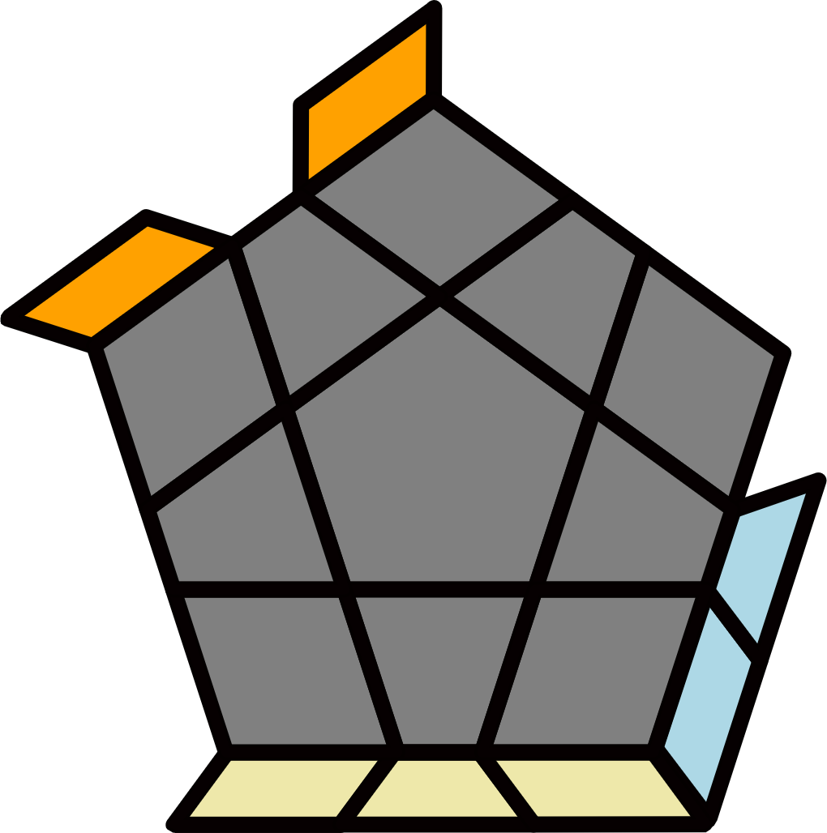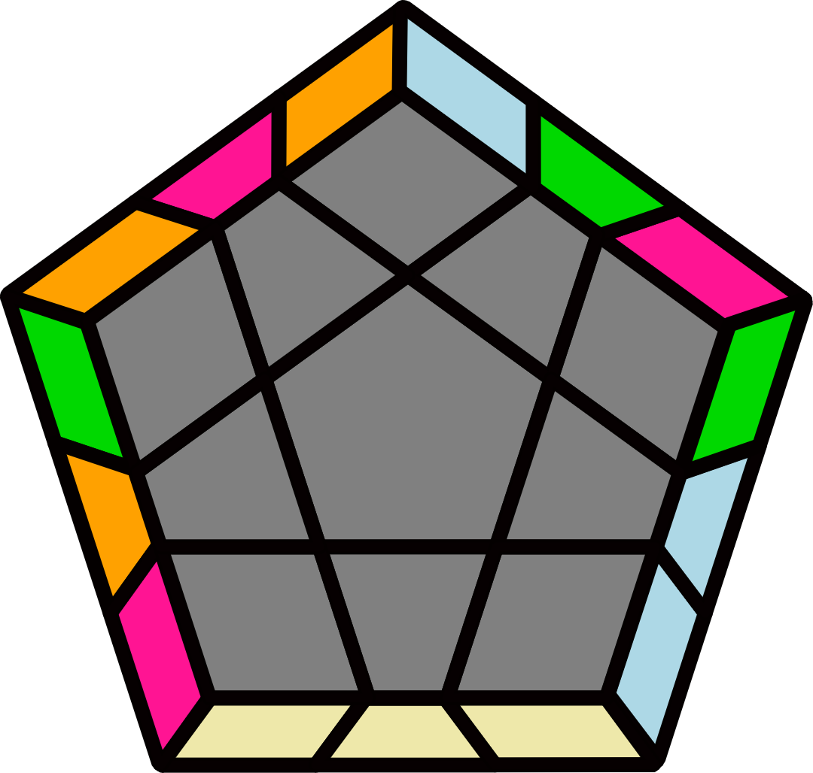
(R' U' R U' R U R2' U R U') F' (R U R' U' R' F R2 U' R') |  | (R U2 R' U2') (R U' R' U') R' U2' (R U R' U) R2 U R' |  |  |  |  | (R U R2' F' R U R U' R' F) (U R' U' R2 U' R' U R' U R) |  |  |  |  | (R U' R2' U') (R U' R' U2) (R U R U) (R' U2 R U2' R')
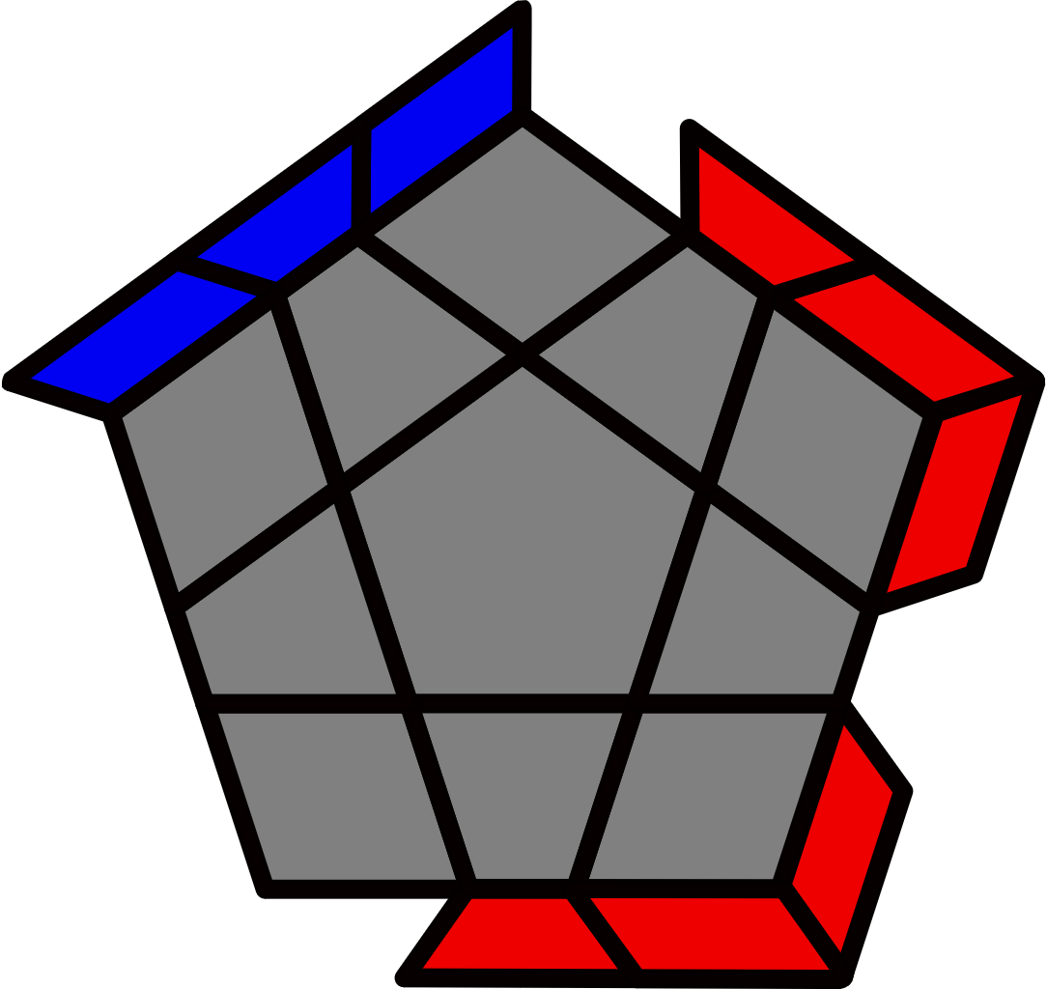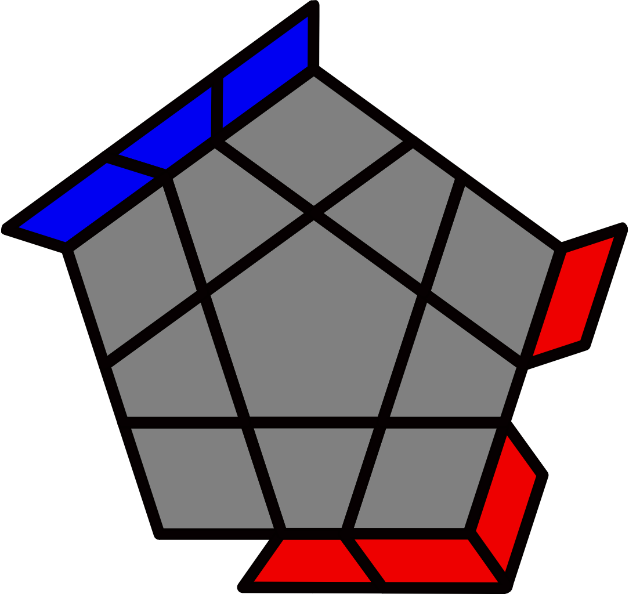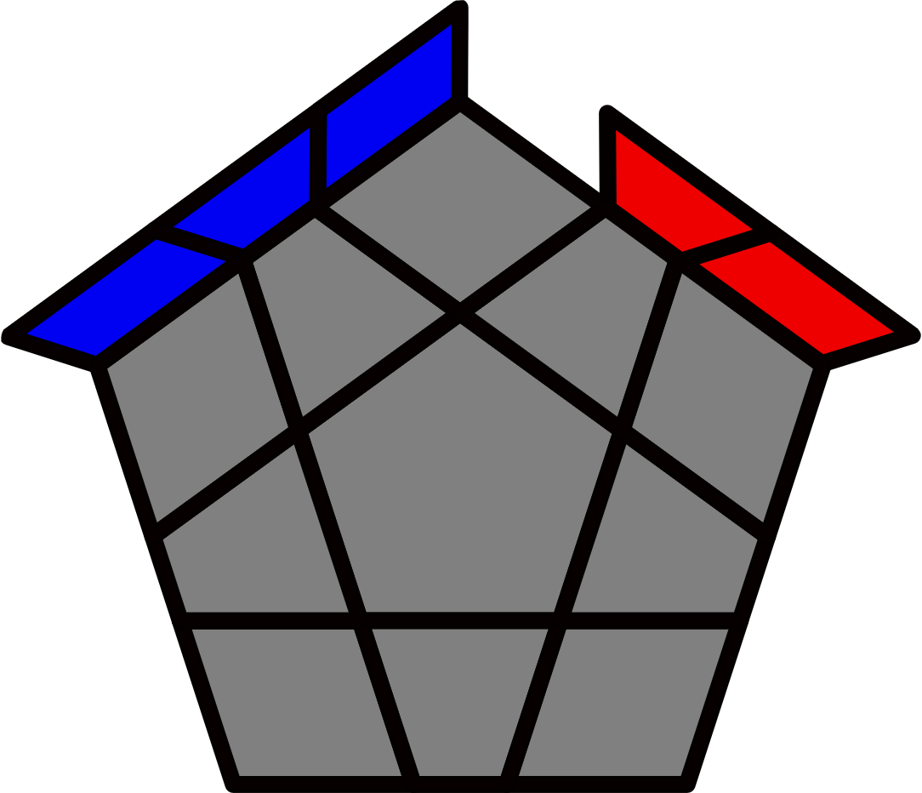 |  |  |  |  |  |  | 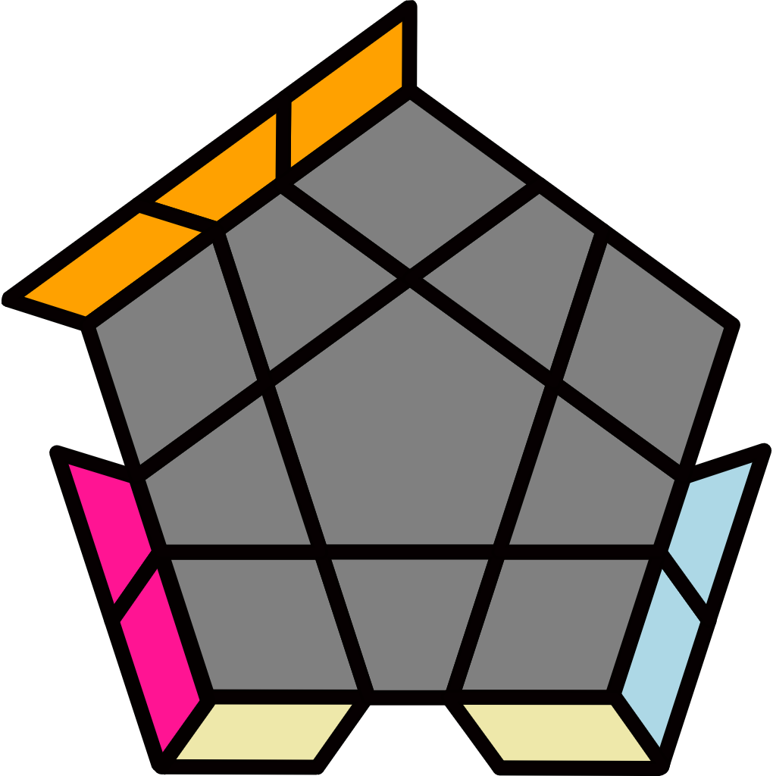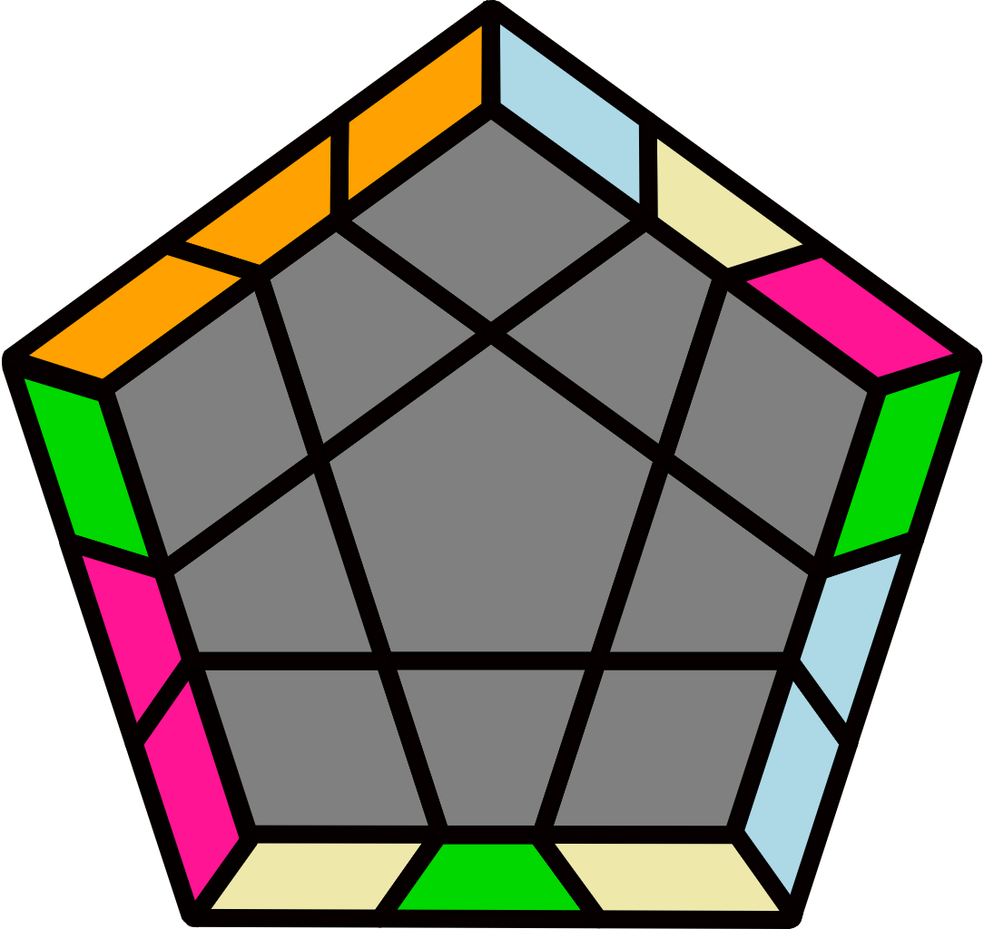 |  |  |  |  | 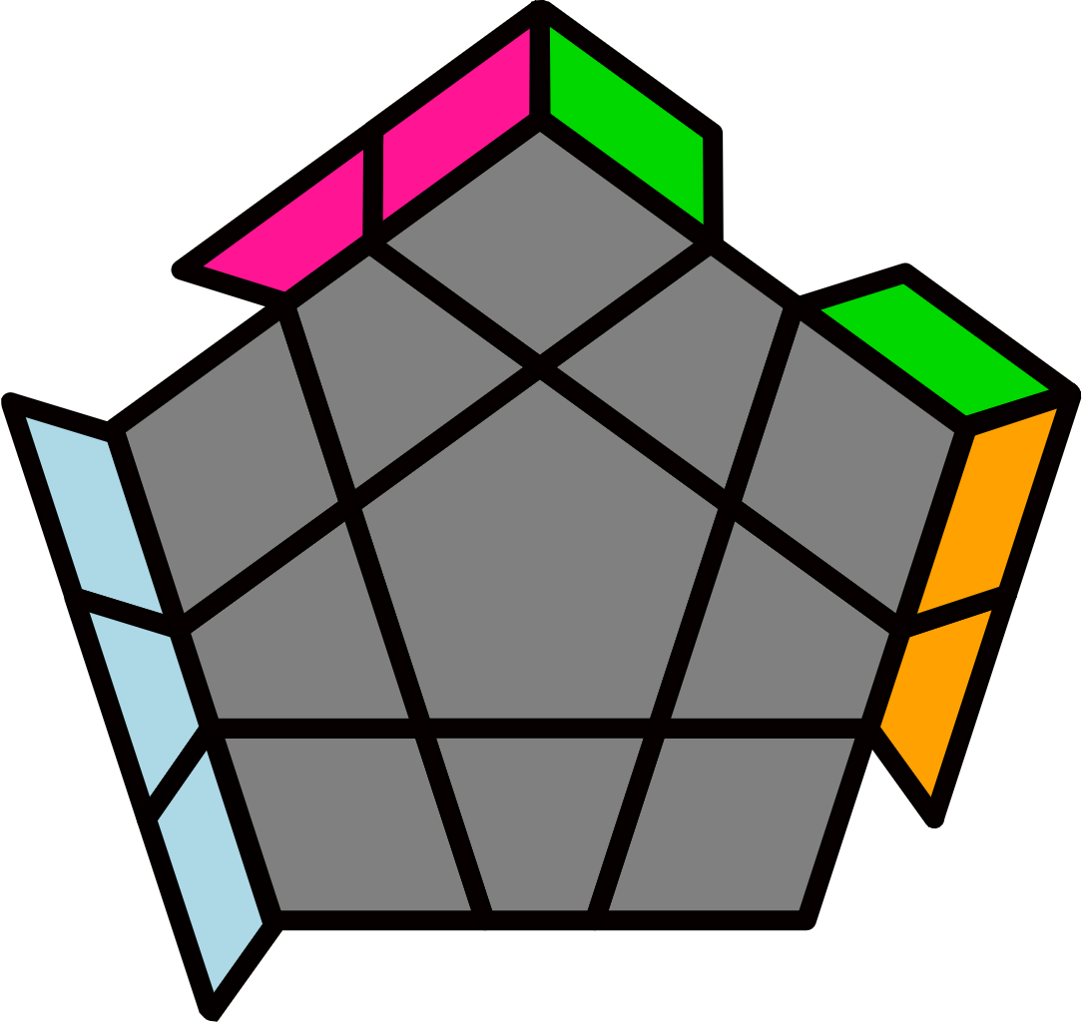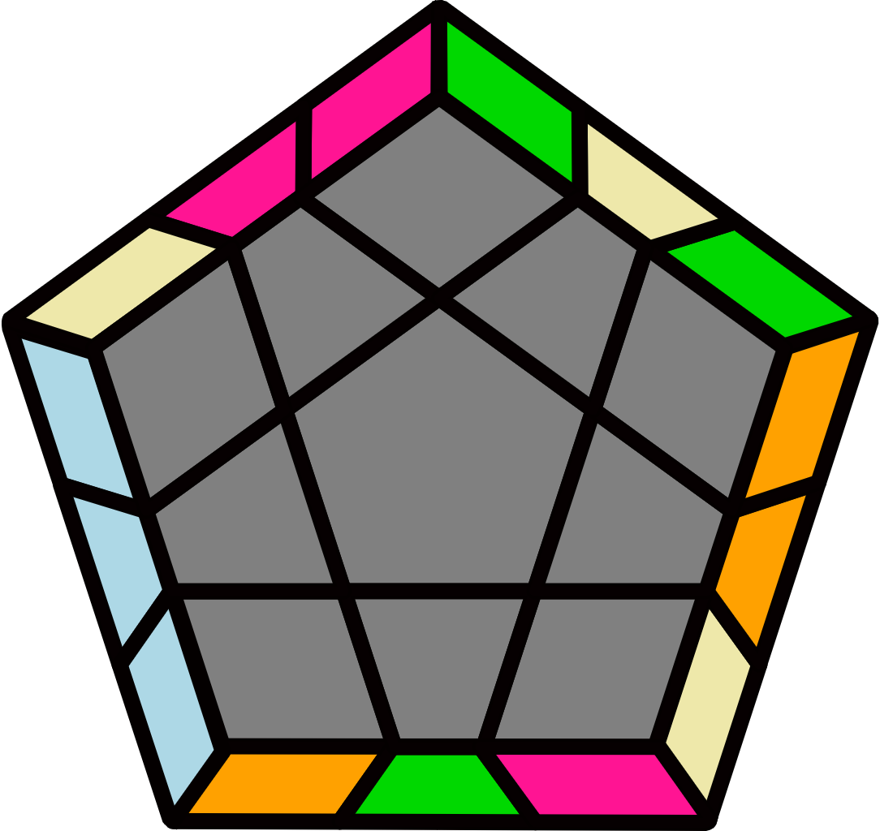
Line + T/R Perm or Bar [10] |  |  |  |  |  |  | R2 U2 R2' U R2 U2 R2' |  |  |  |  | R2' U2' R2 U' R2' U2' R2
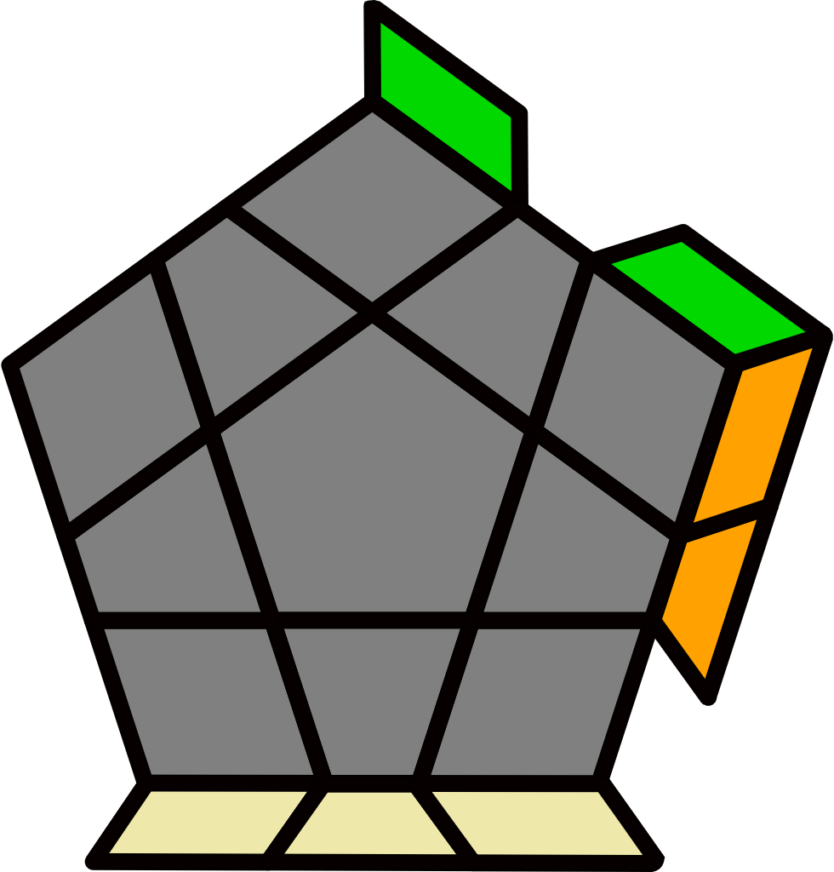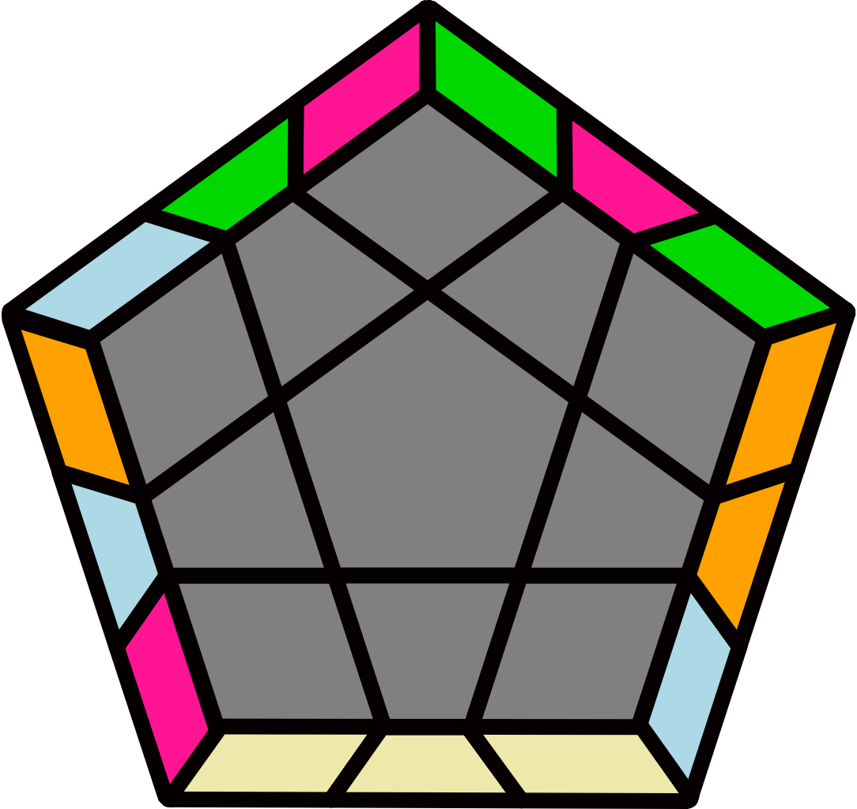 |  | 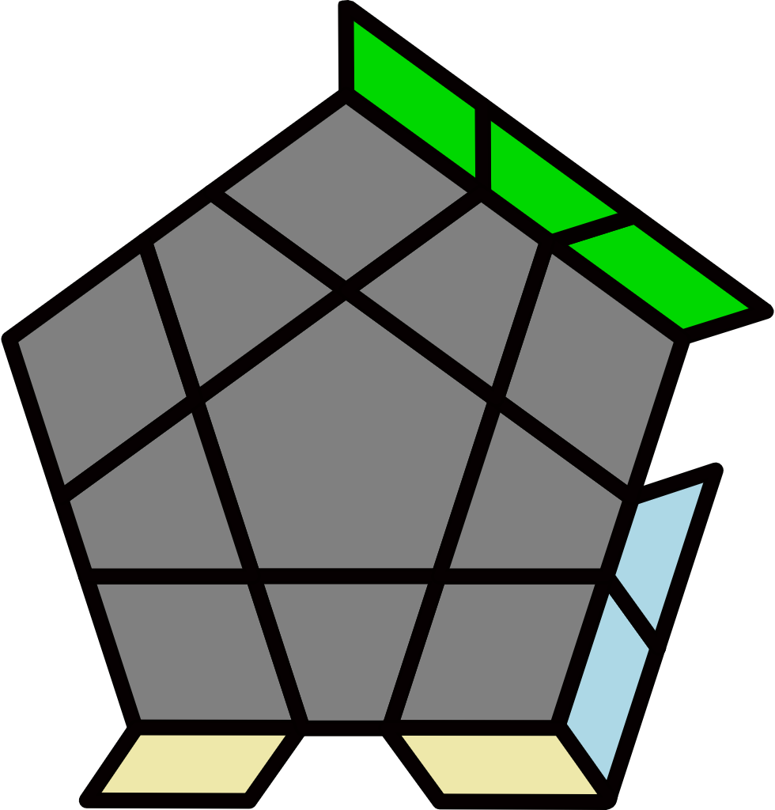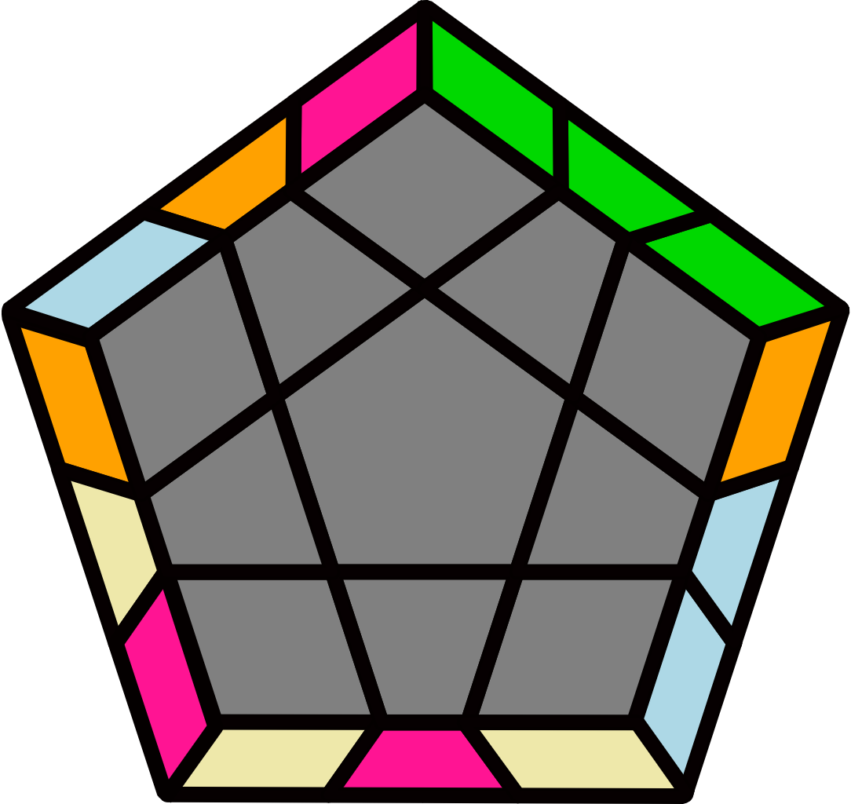 |  |  |  |  | 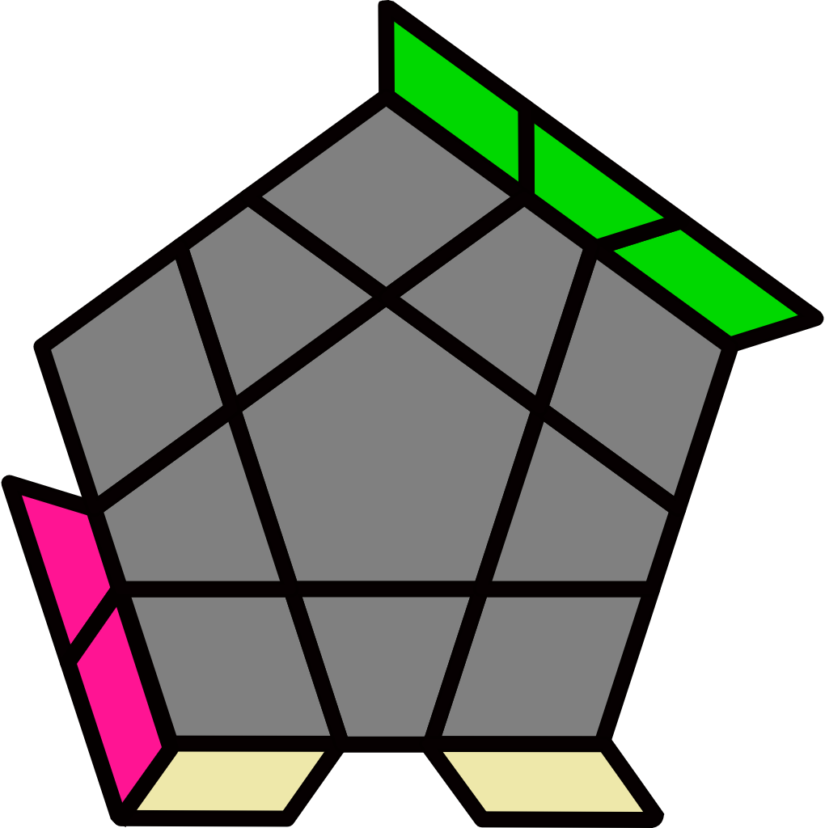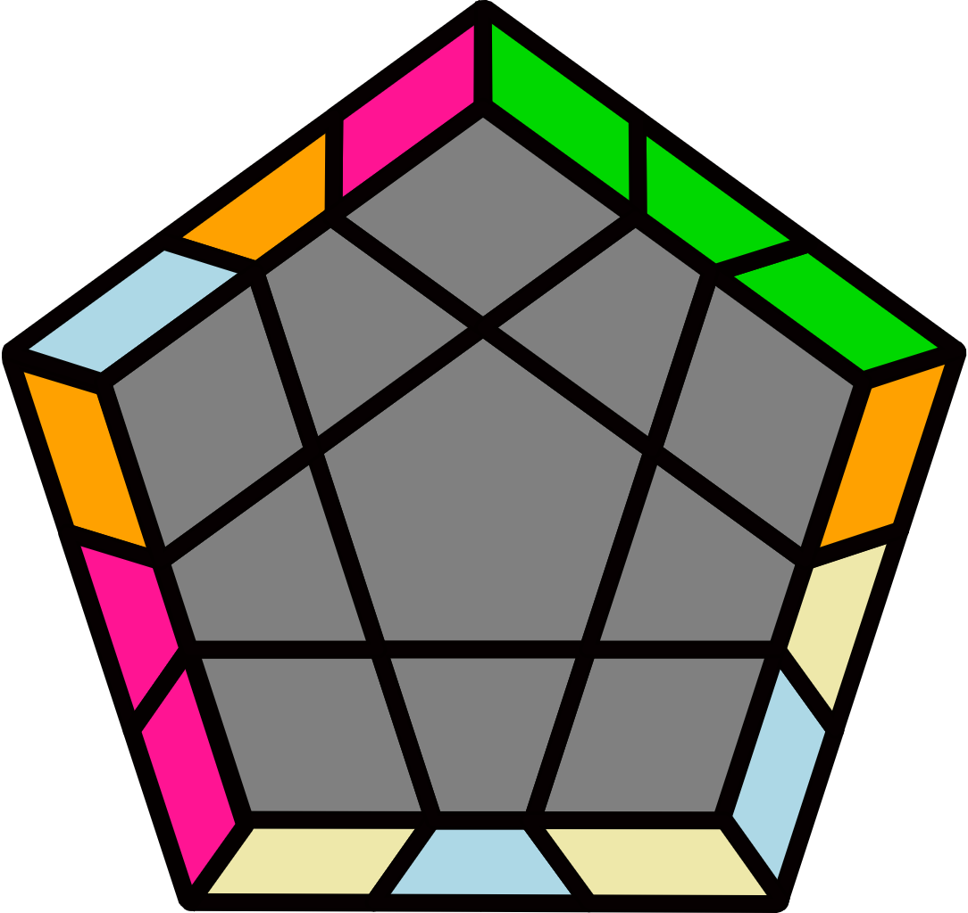 |  |  |  |  | 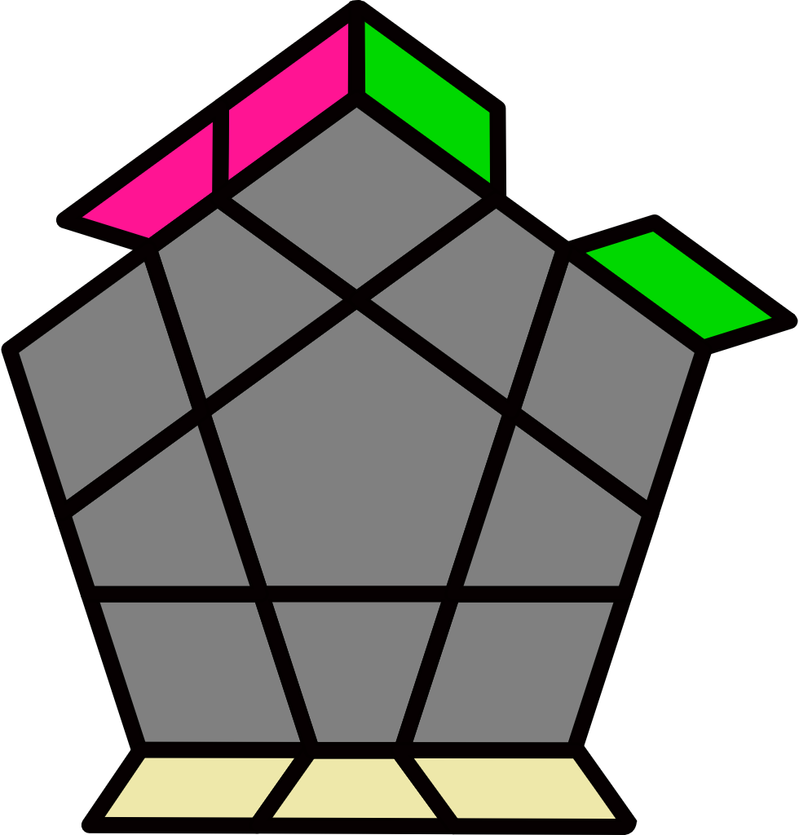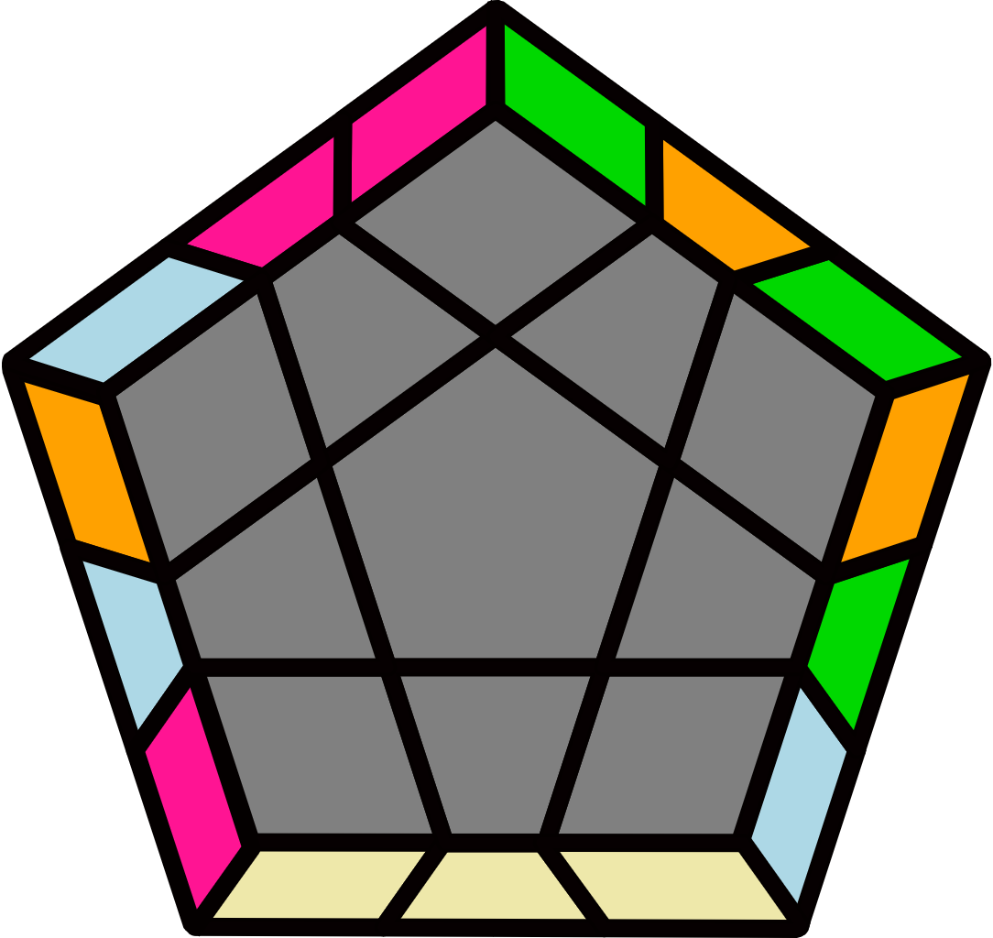
(R U R' U2) (R' U2' R2 U') R' U R' U2 R |  | (R' U' R U2') (R U2 R2' U) R U' R U2' R' |  |  |  |  | (R' U2' R U') (R U R2' U2) R U2' R U' R' |  |  |  |  | (R U2 R' U) (R' U' R2 U2') R' U2 R' U R
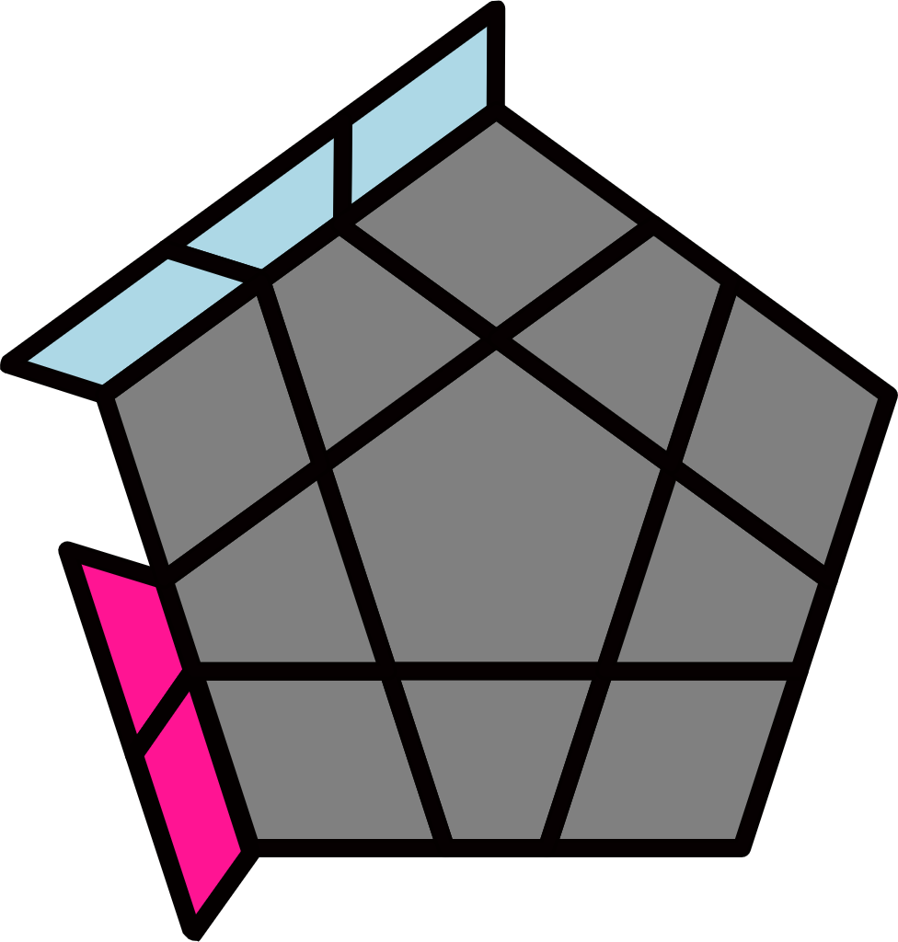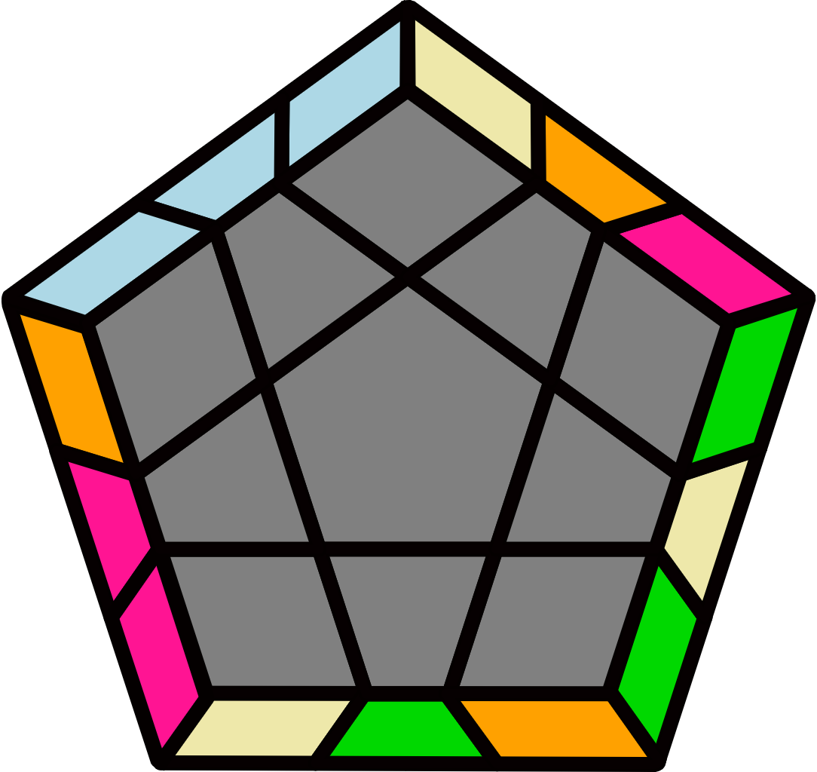 |  | 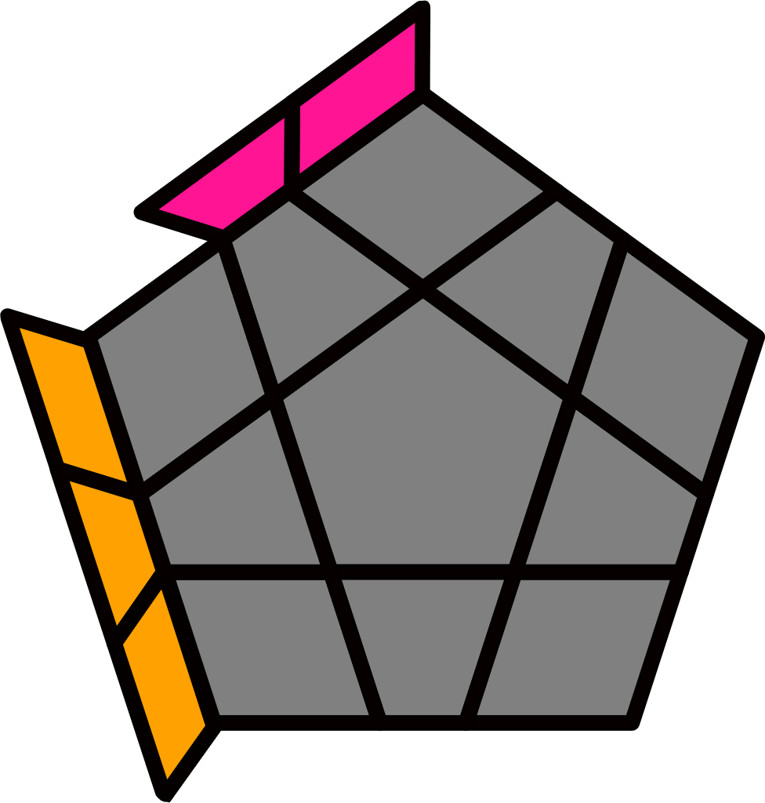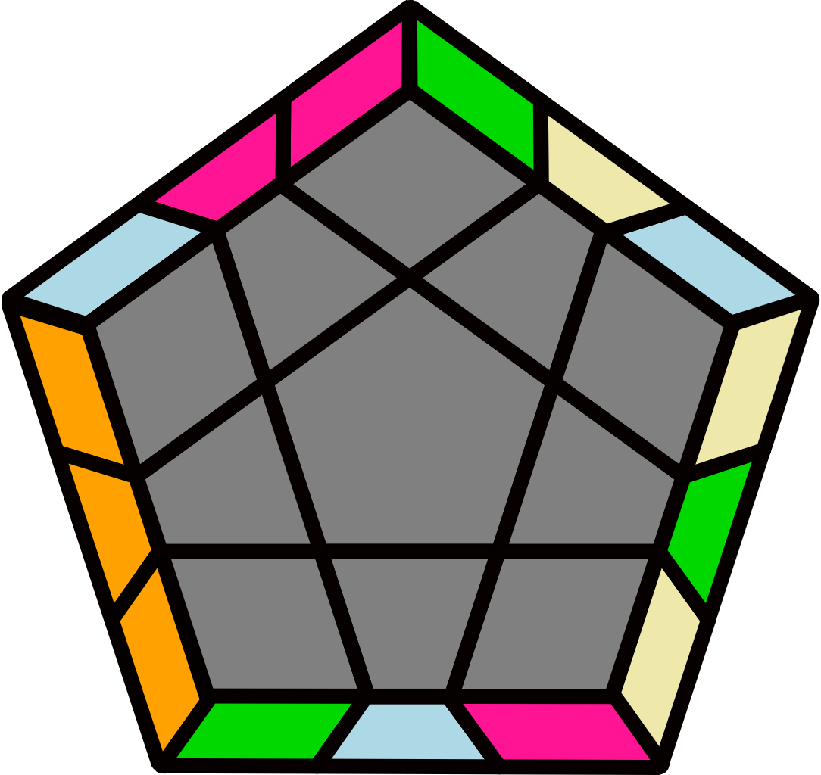 |  |  |  |  | 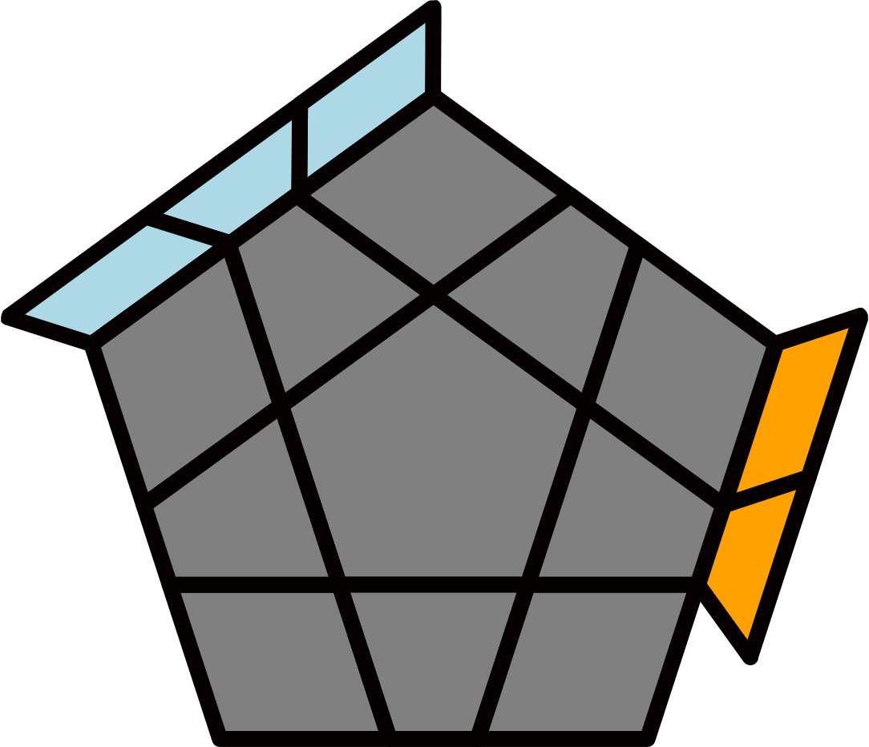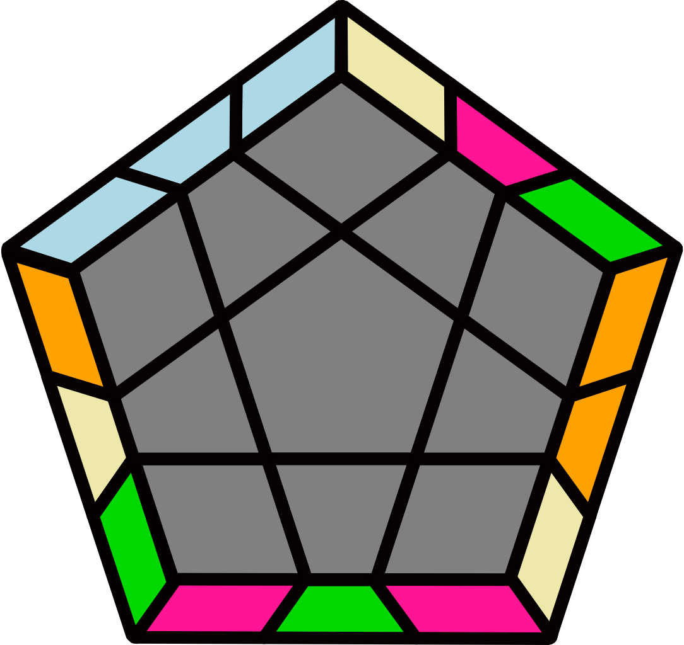 |  |  |  |  | 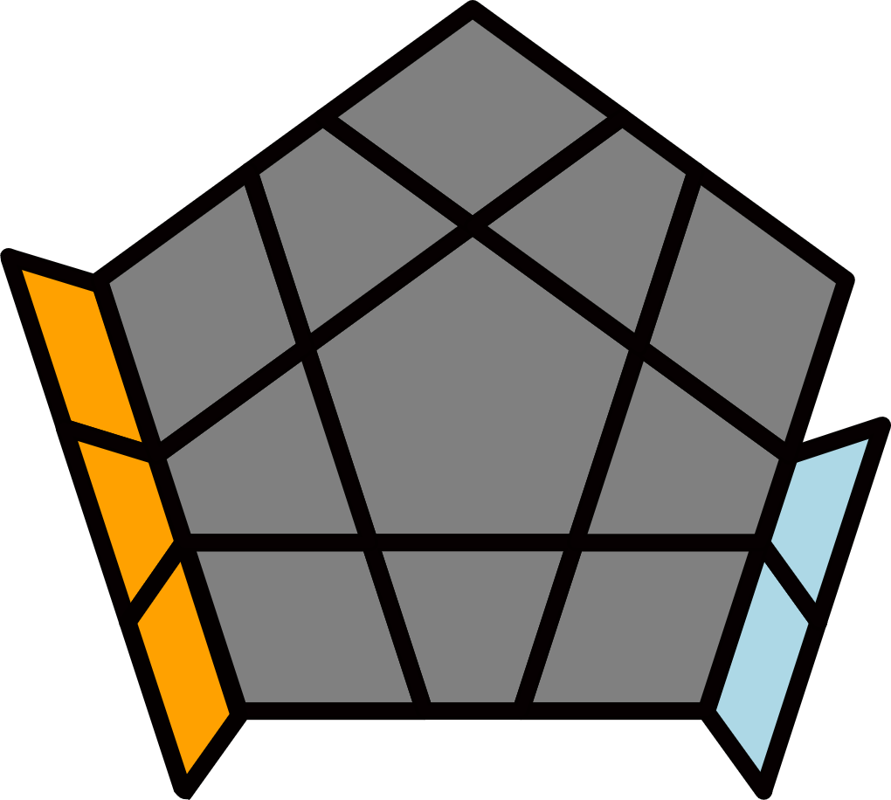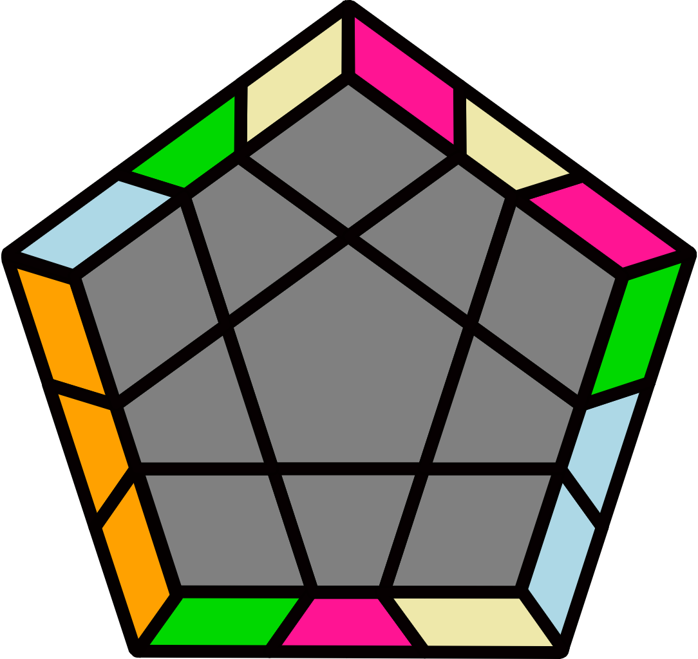
(R U R' U) (R2 U2' R2' U2') (R U2 R U2) R' U2' R' |  | (R' U' R U') (R2' U2 R2 U2) (R' U2' R' U2') R U2 R |  |  |  |  | (R U2 R U2') (R' U2' R' U2) (R2 U2 R2' U') R U' R' |  |  |  |  | (R' U2' R' U2) (R U2 R U2') (R2' U2' R2 U) R' U R
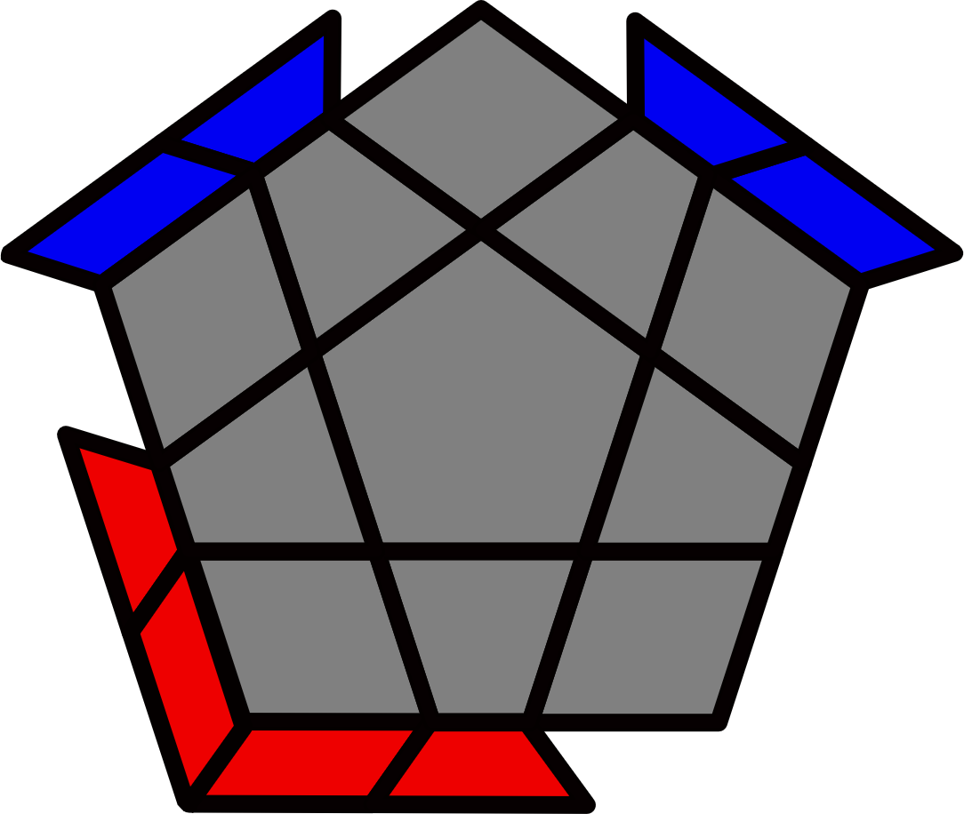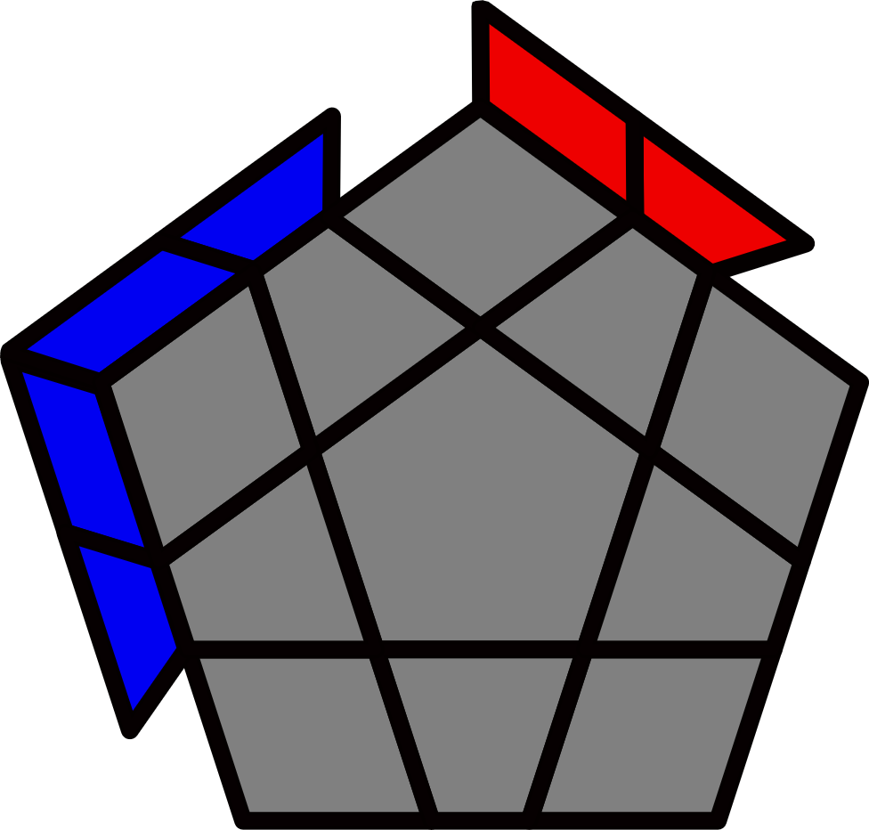 |  |  |  |  |  |  | 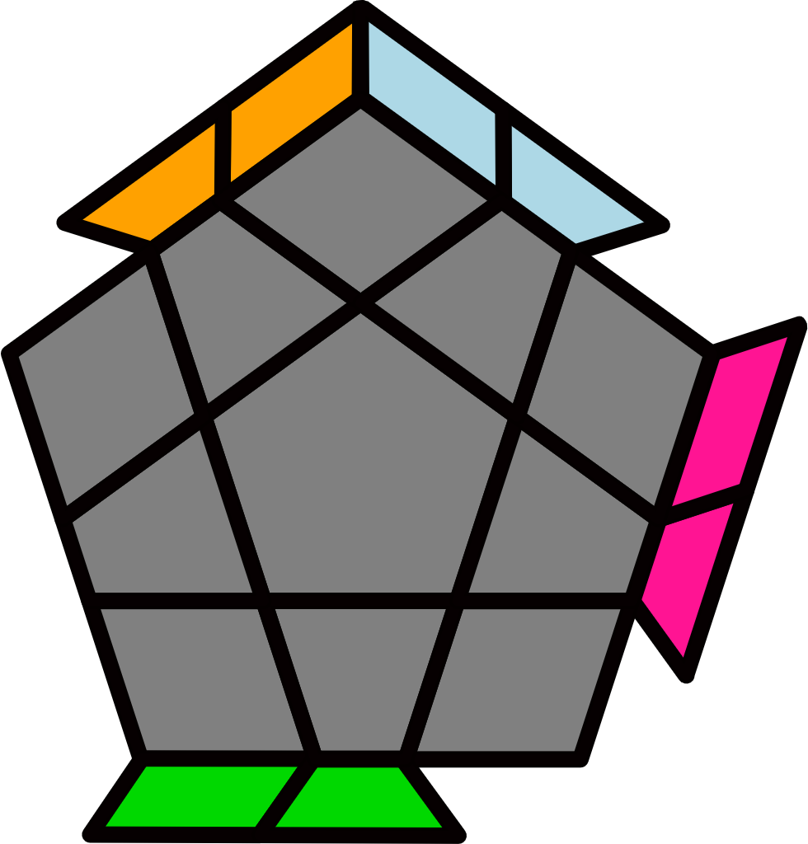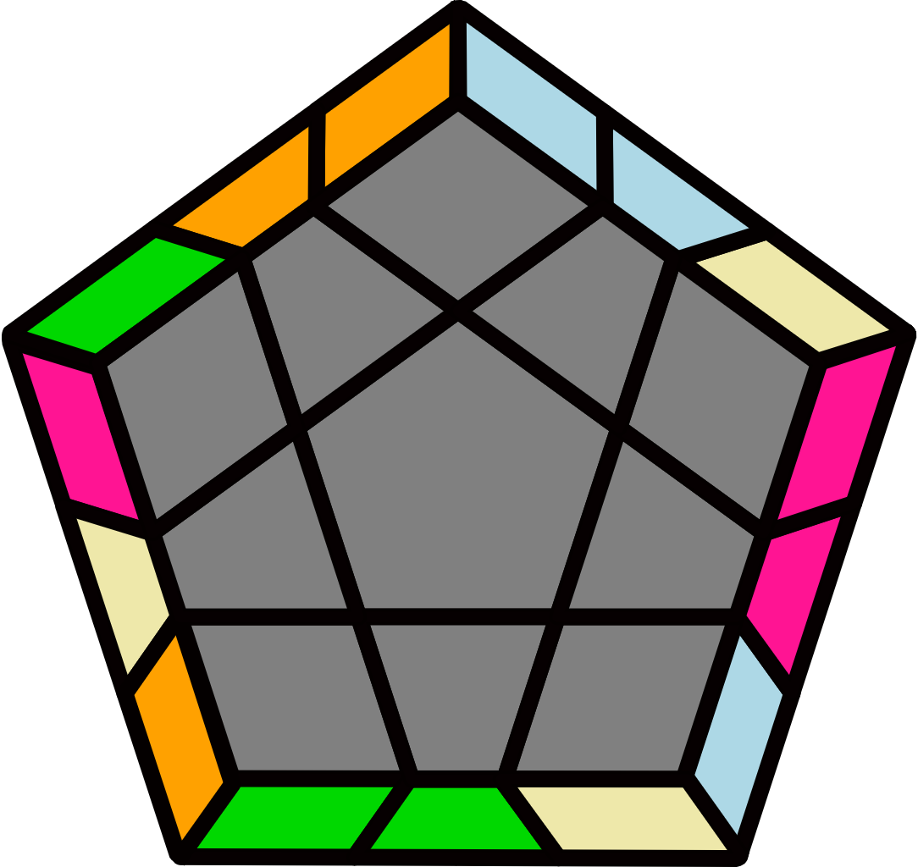 |  |  |  |  | 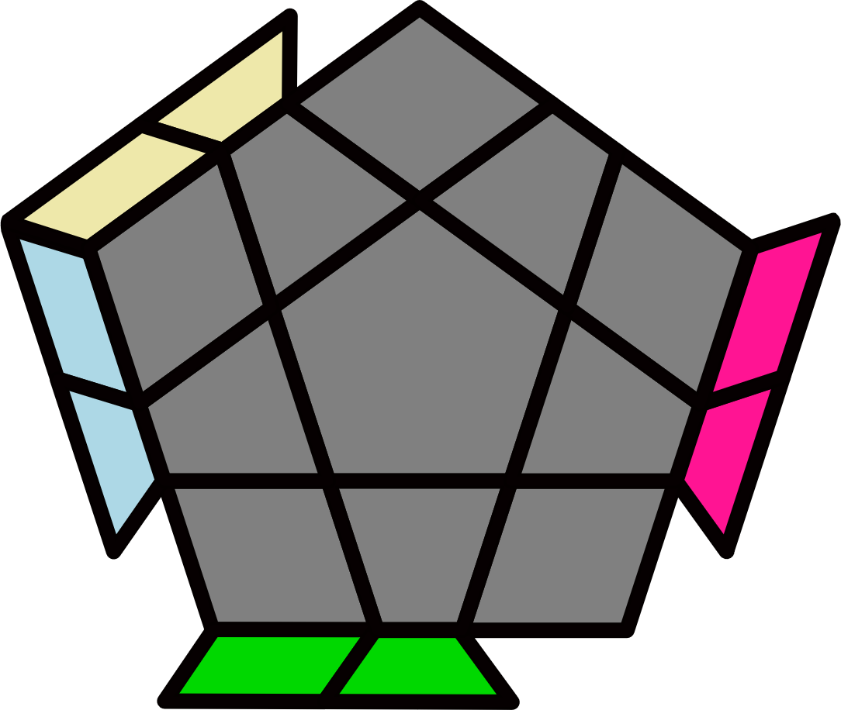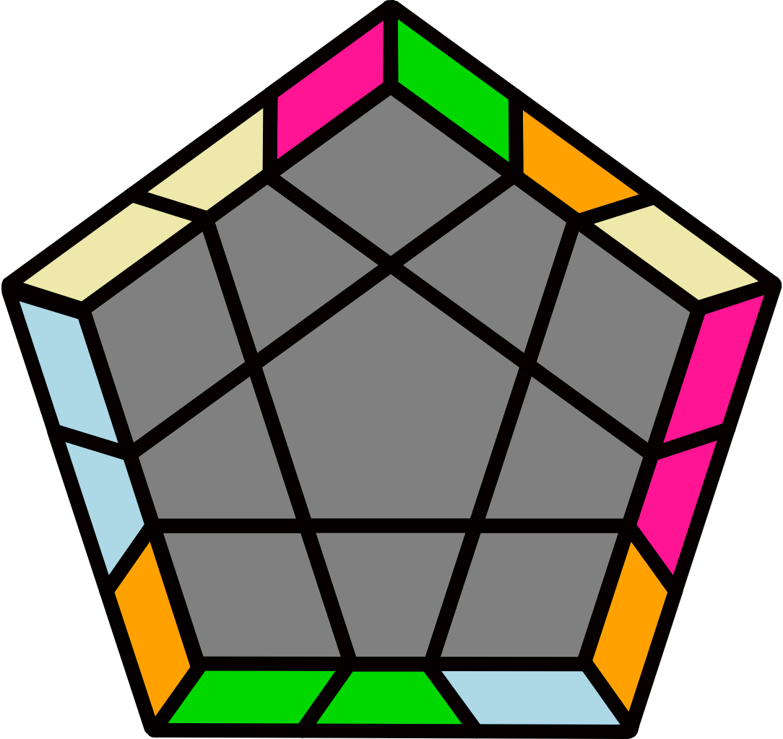
Block + 2/1 Bars [10] |  |  |  |  |  |  | (F R U' R' U' R U R' F' R U R' U' R' F R F') |  |  |  |  | (F R' F' R) (U R U' R') F (R U' R' U) (R U R' F')
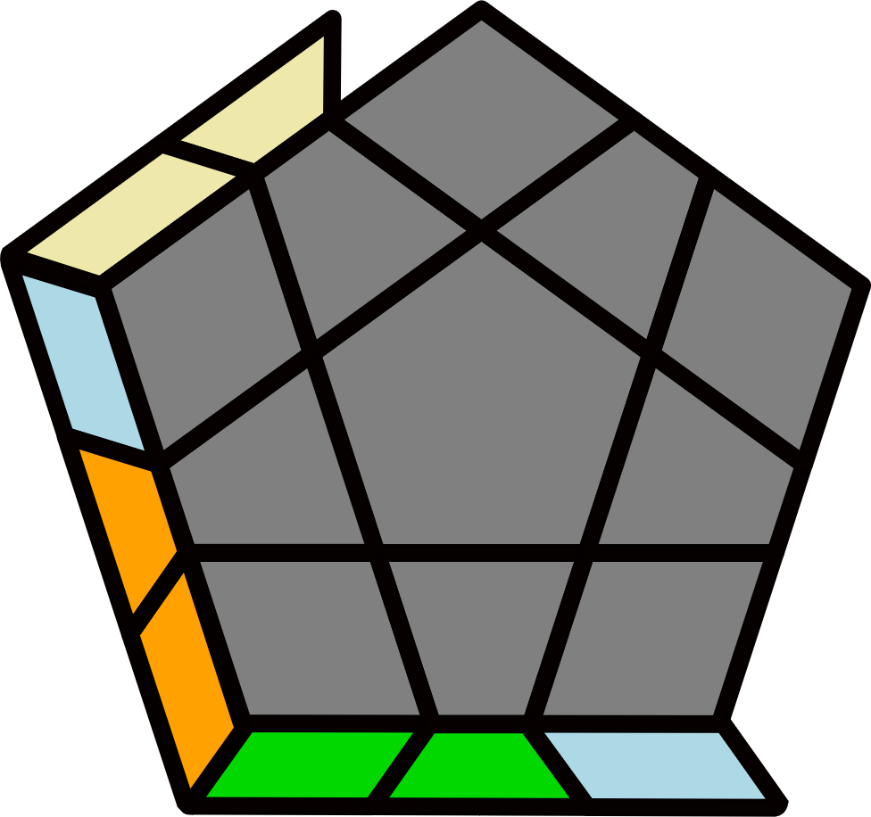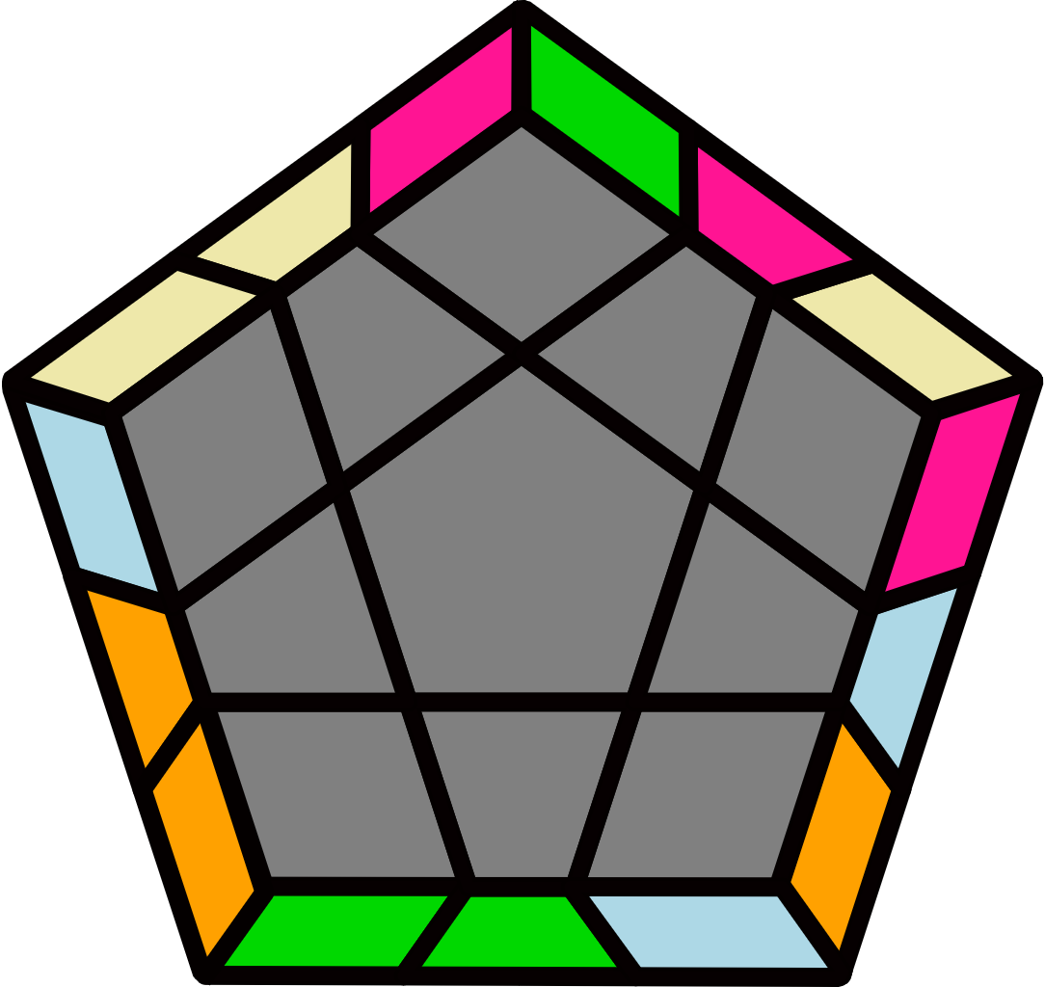 |  | 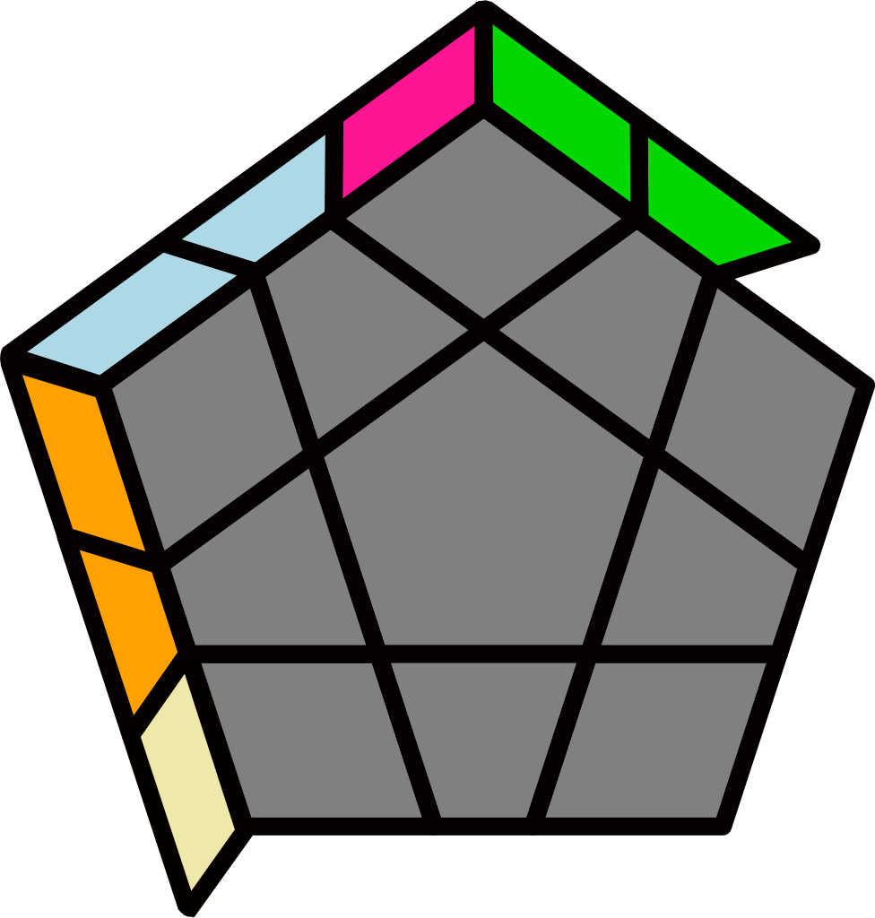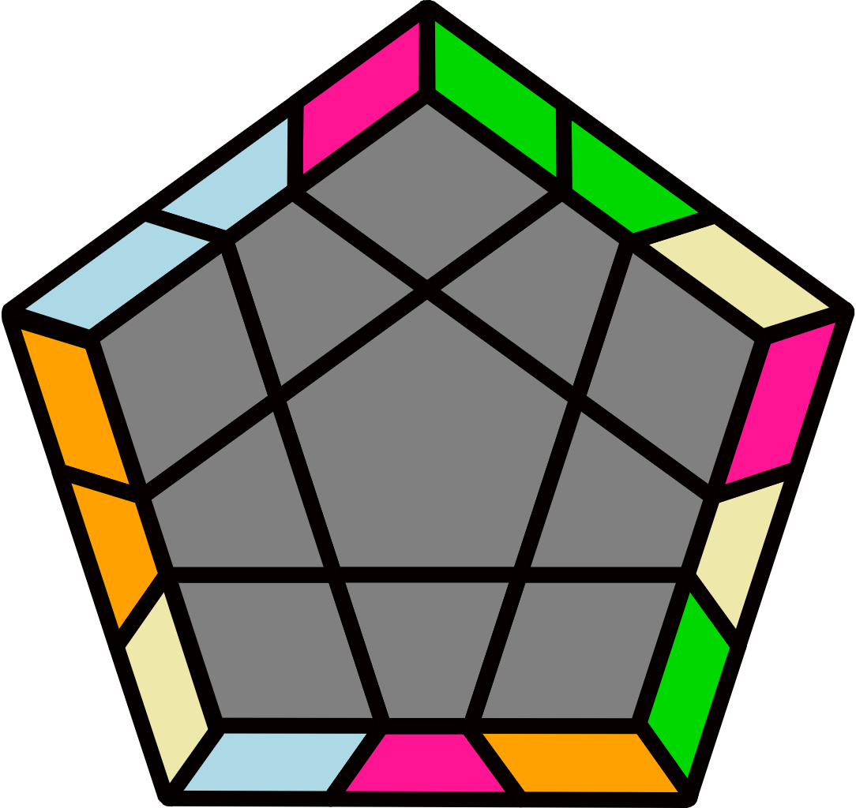 |  |  |  |  | 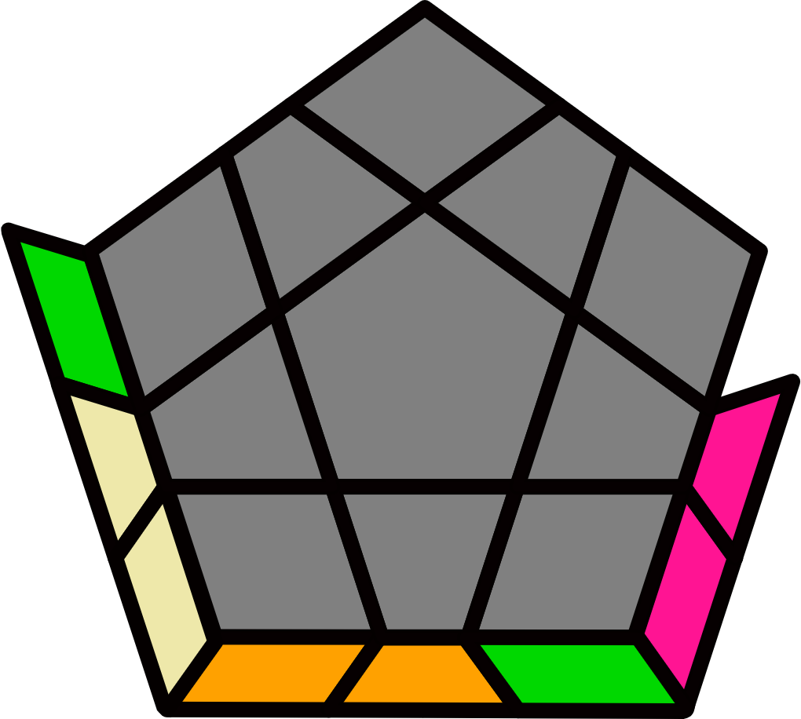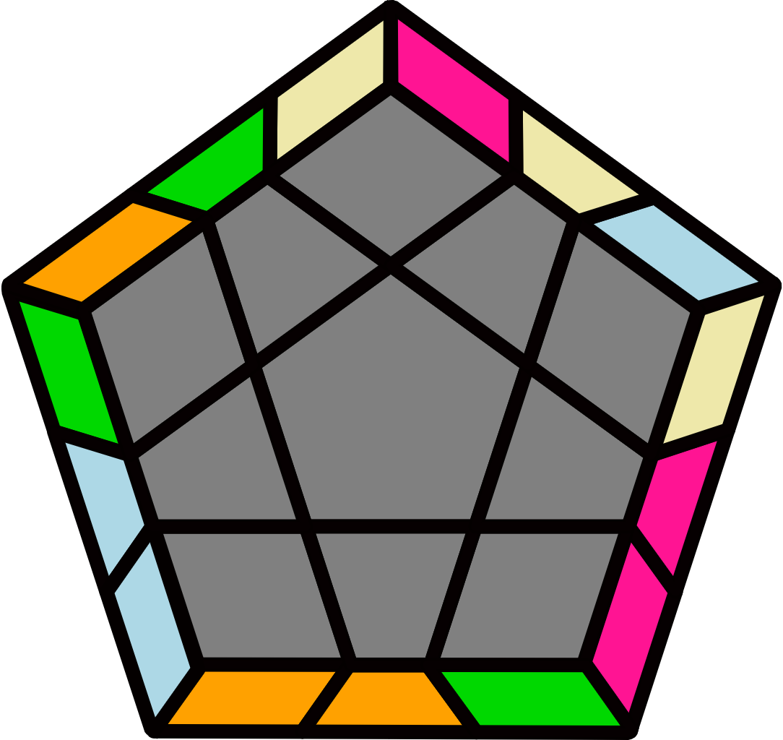 |  |  |  |  | 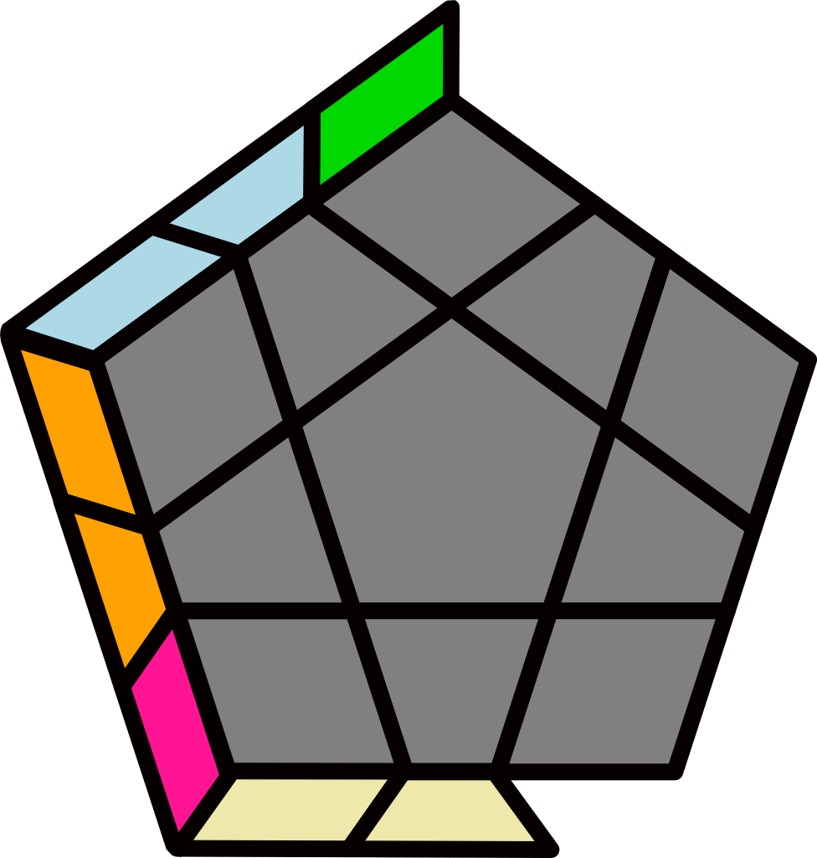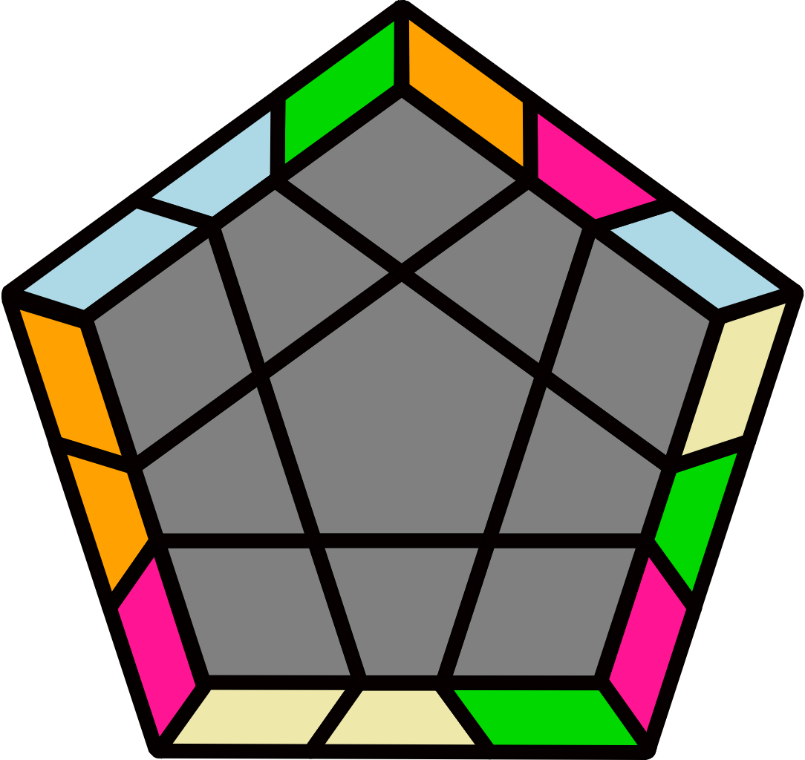
(R' U2 R' D') (R U' R' D)  R U R U' R' U' R |  | R U (R2 U' R' U') (R U R' U') R' U (R2' U R U' R) |  |  |  |  | R U2 (R2' F R F') (R U' R' F') U F R U' R' |  |  |  |  | R' U' (R2' U R U) (R' U' R U) R U' (R2 U' R' U R')
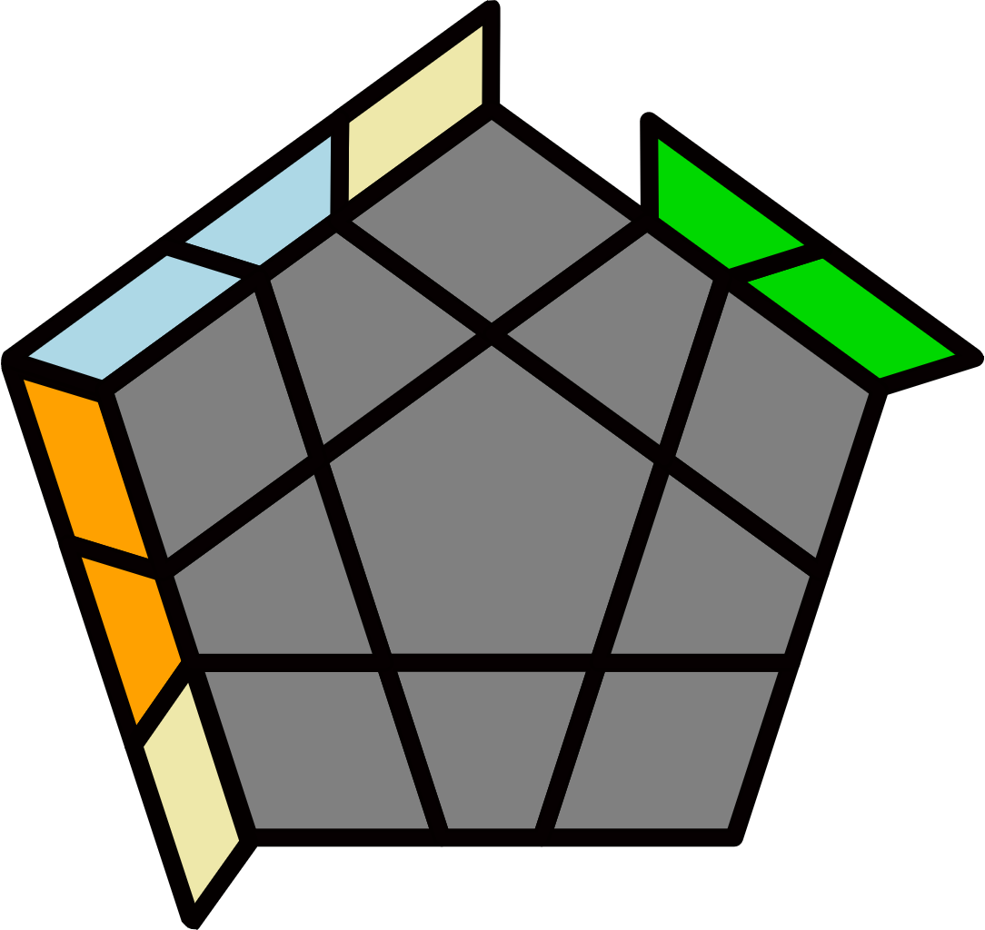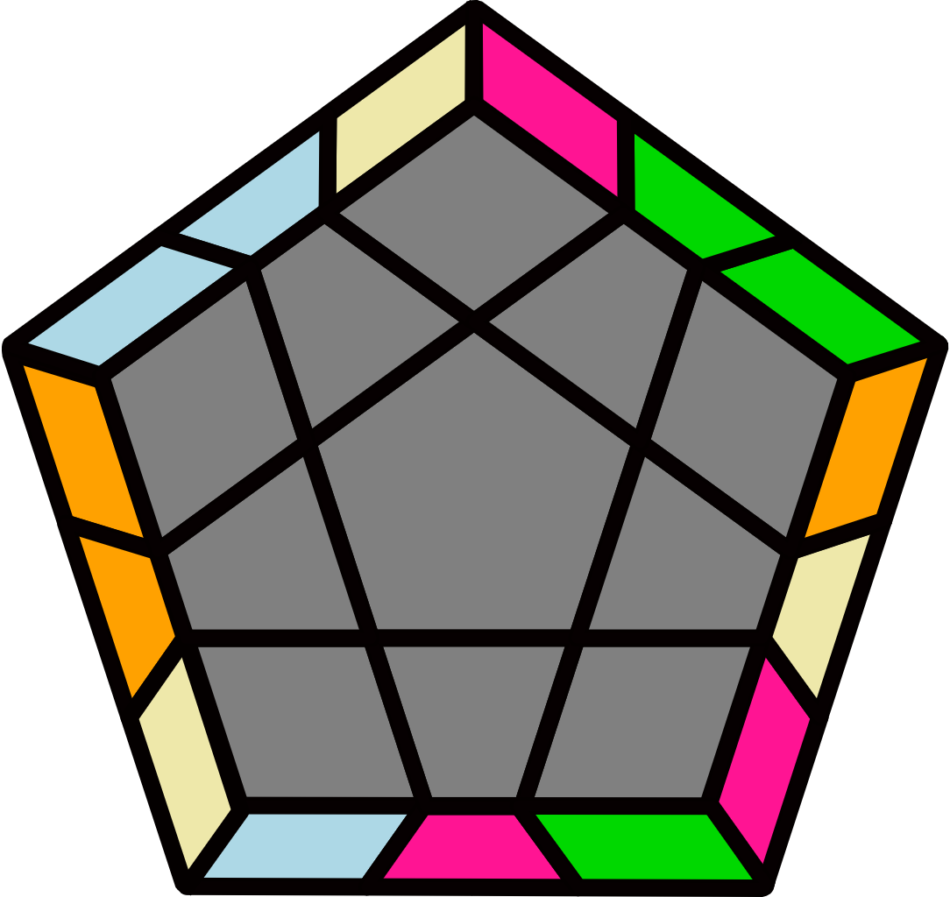 |  | 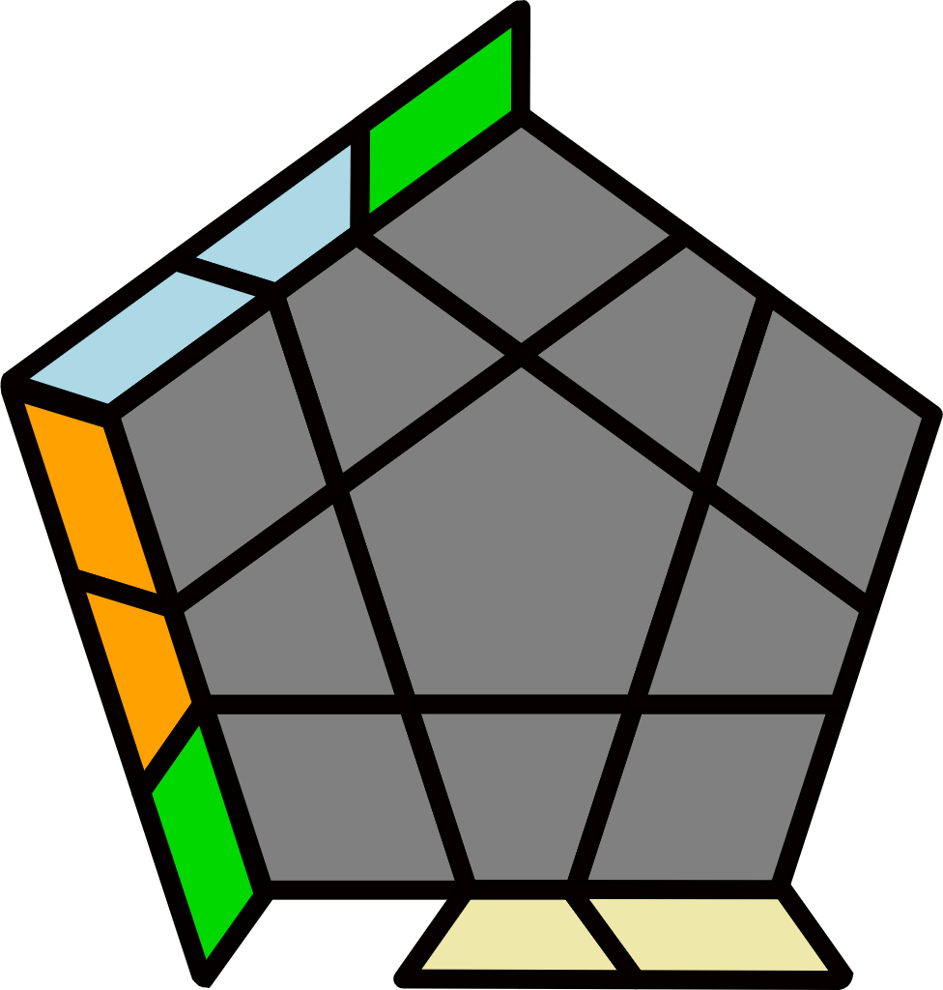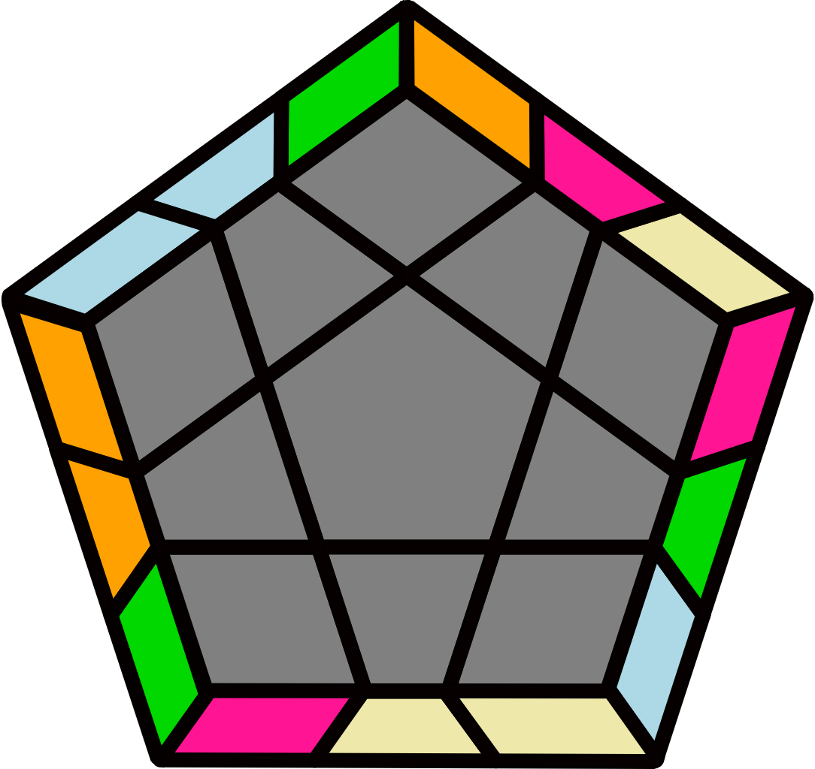 |  |  |  |  | 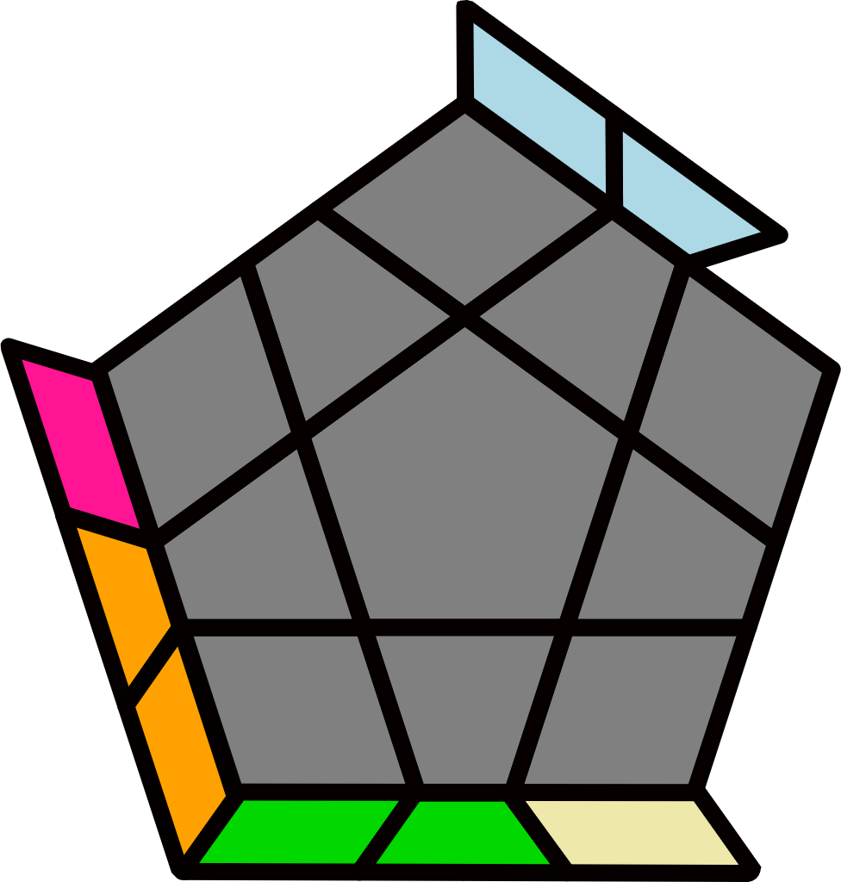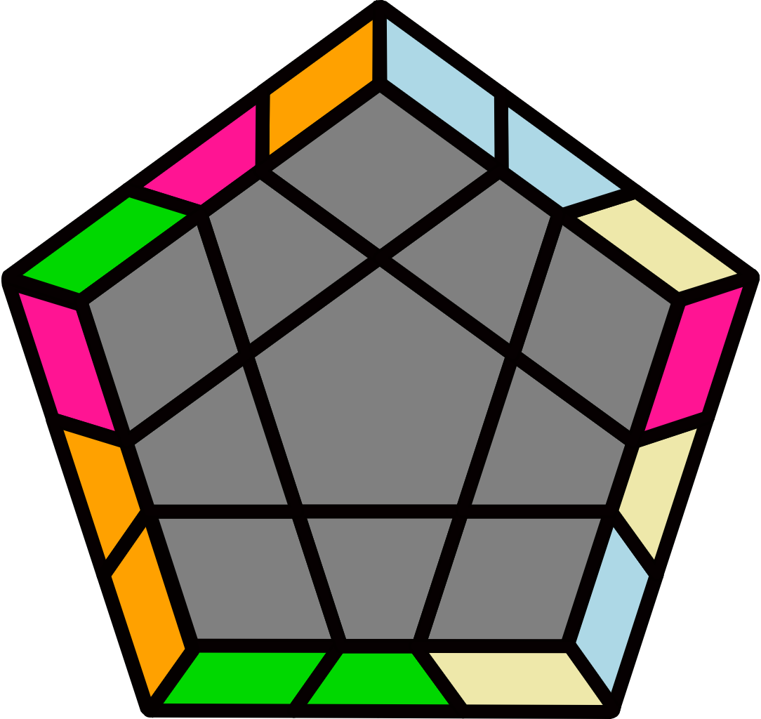 |  |  |  |  | 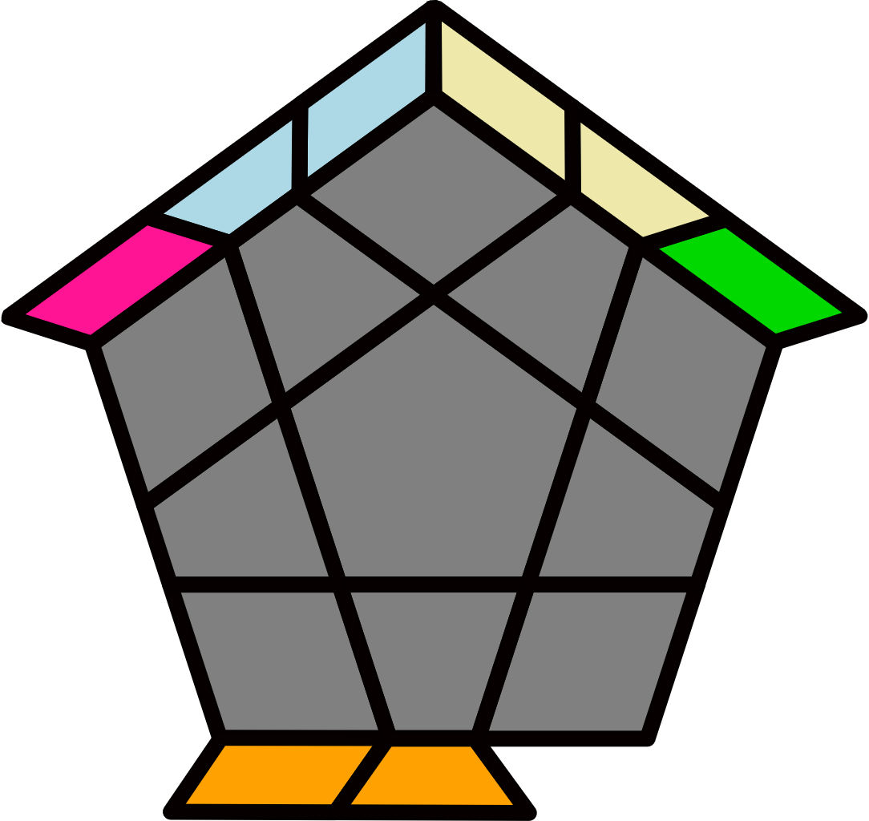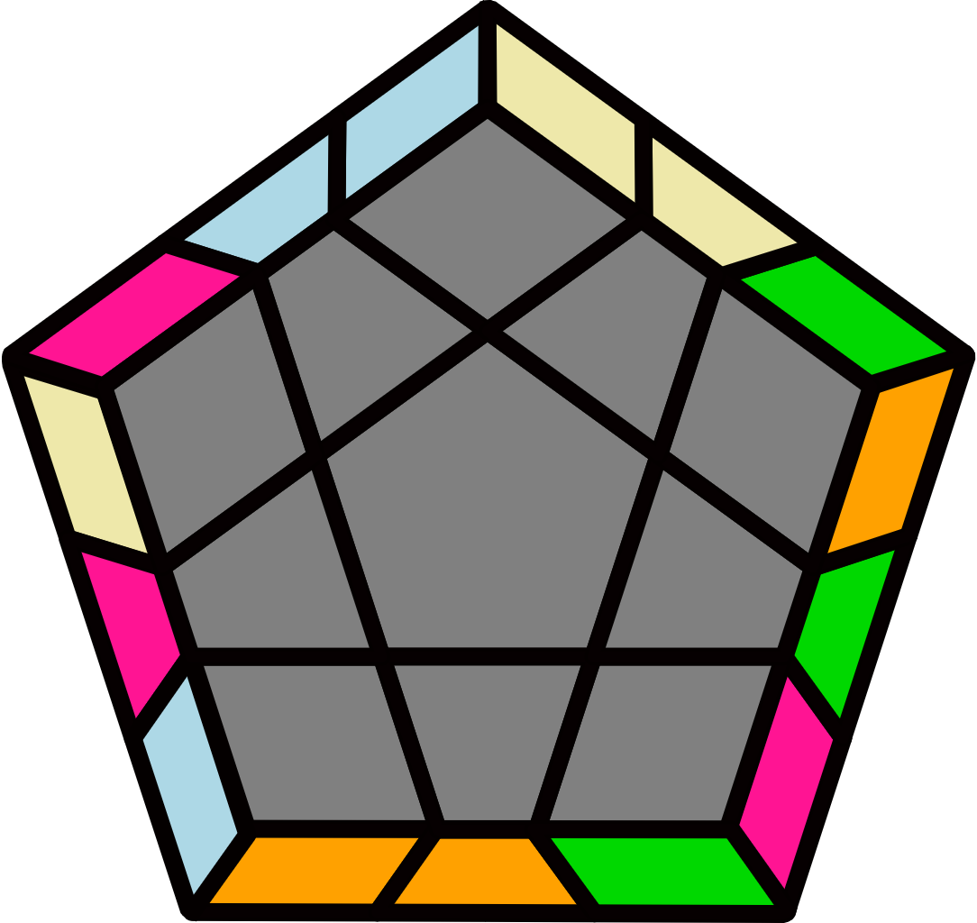
(R U' R U) (R2' U R' U')  (R' U R U') (R' U' R2 U R) |  | (R' U R' U') (R2 U' R U)  (R U' R' U) (R U R2' U' R') |  |  |  |  | R' U (R U R' U') R' D'  (R U R' D) R U2' R |  |  |  |  | (R U' R' F) U (R U' R' F')  (R U R') (F' U' F) (R U R')
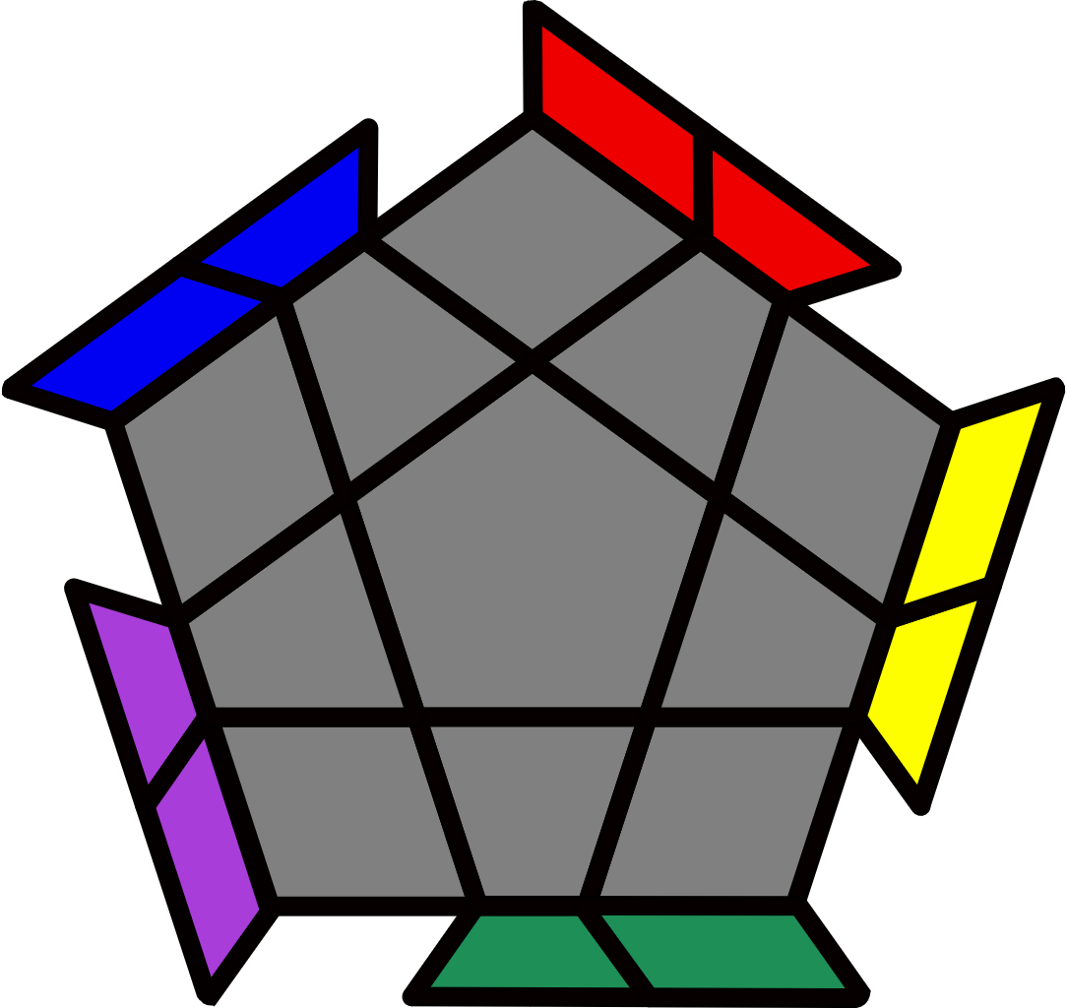5 Bars [4]
H+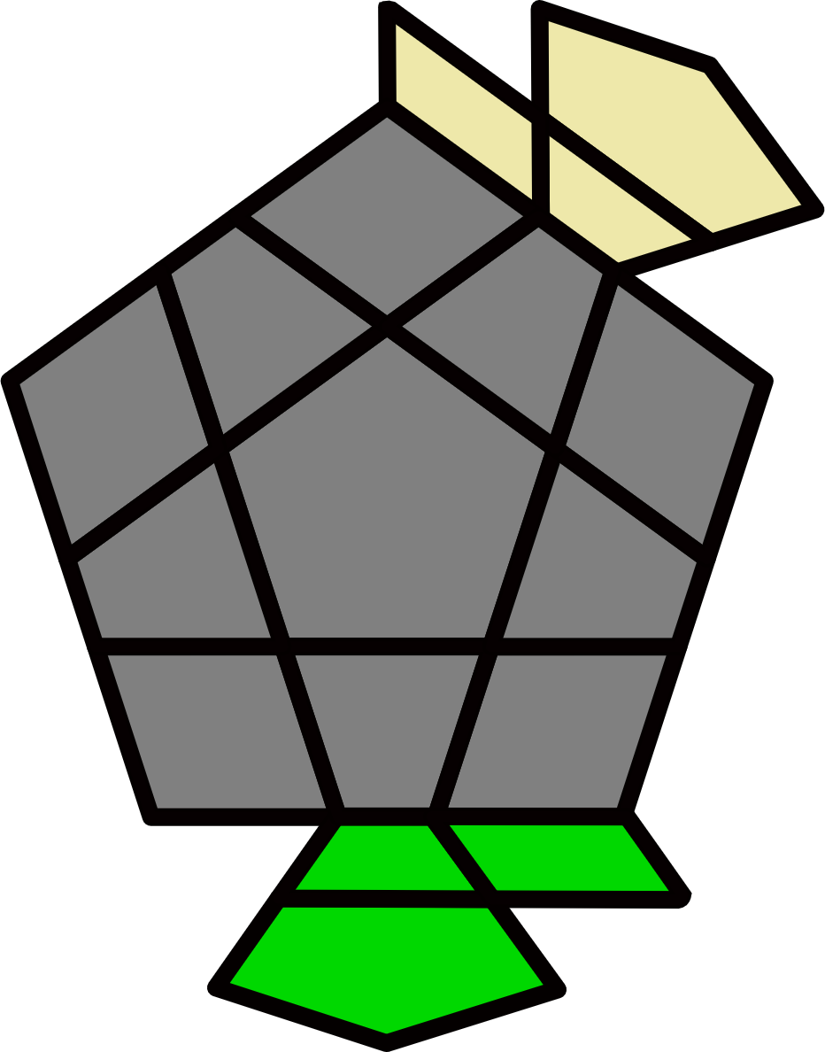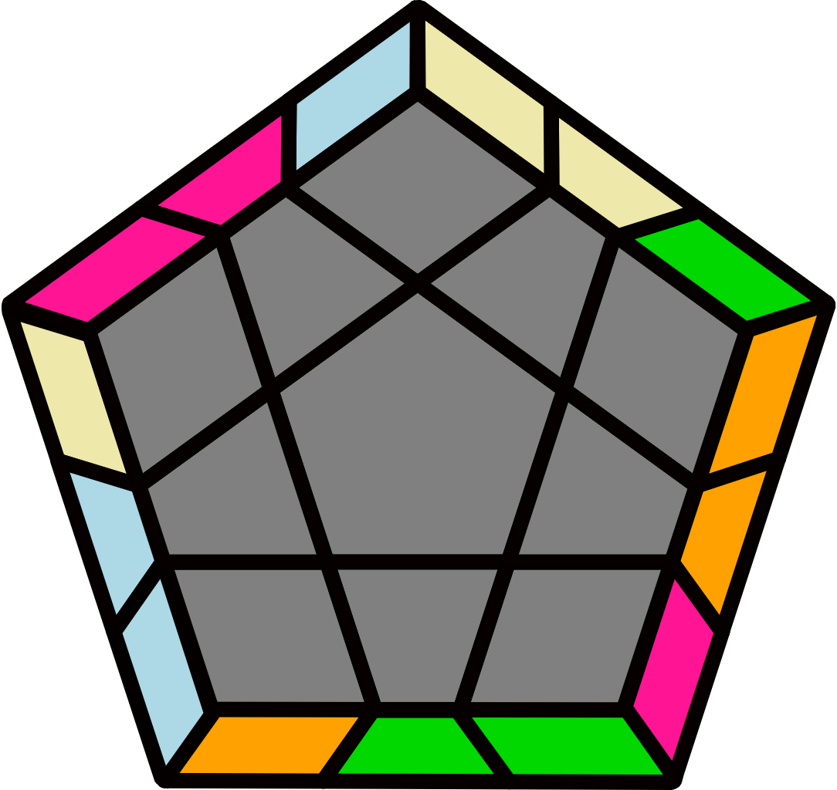 |  | B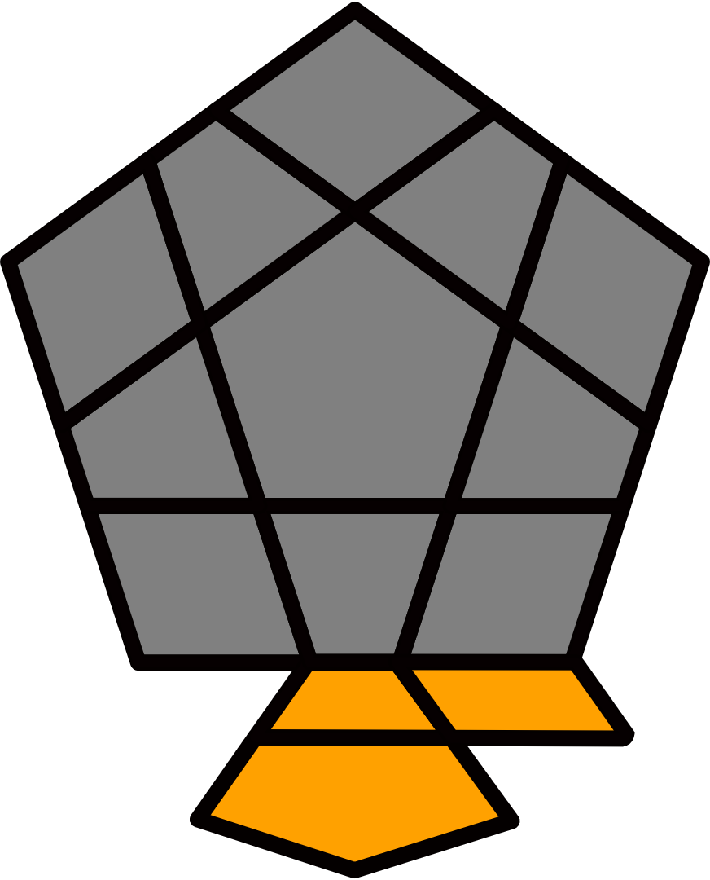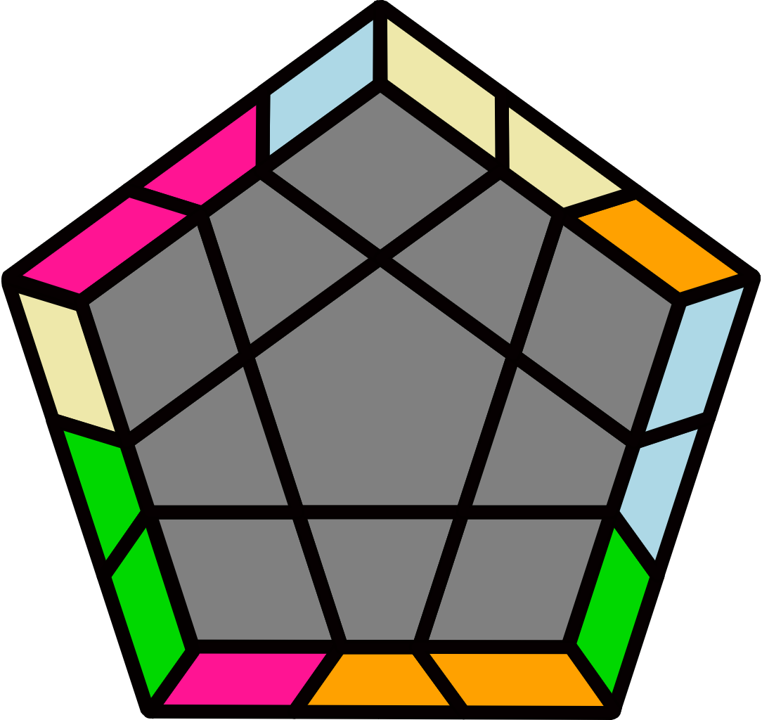 |  |  |  |  | H-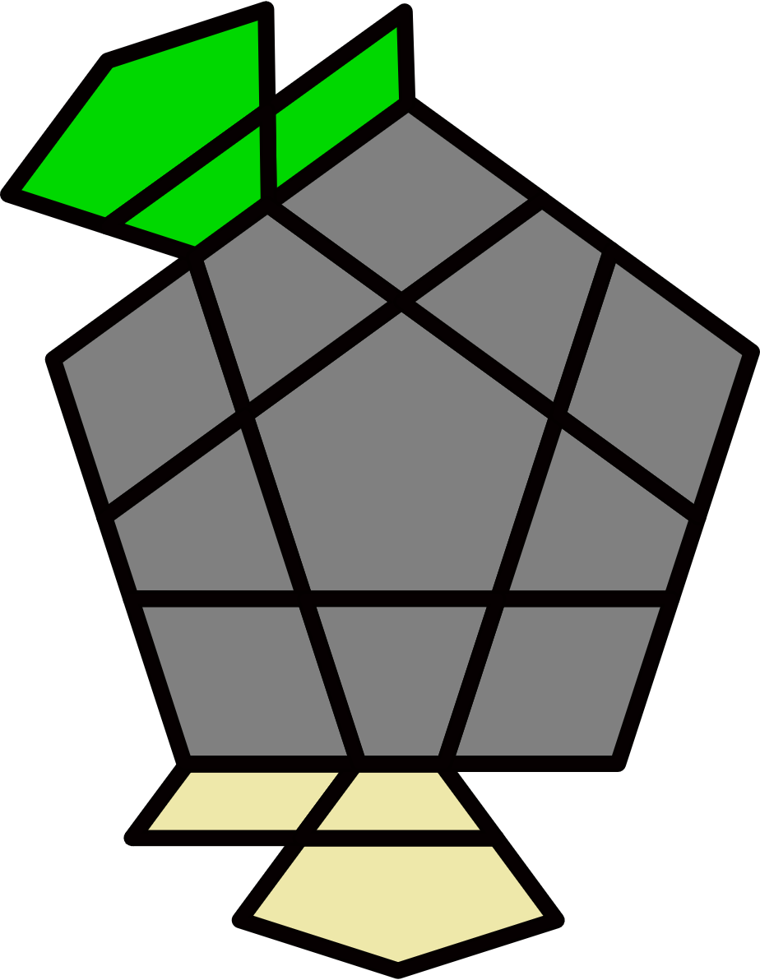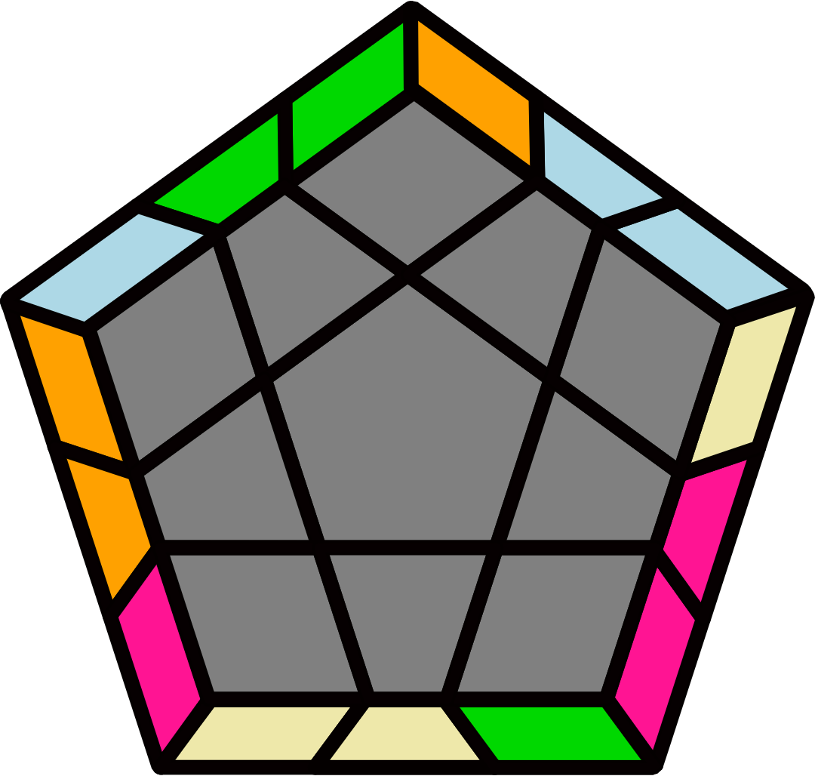 |  |  |  |  | B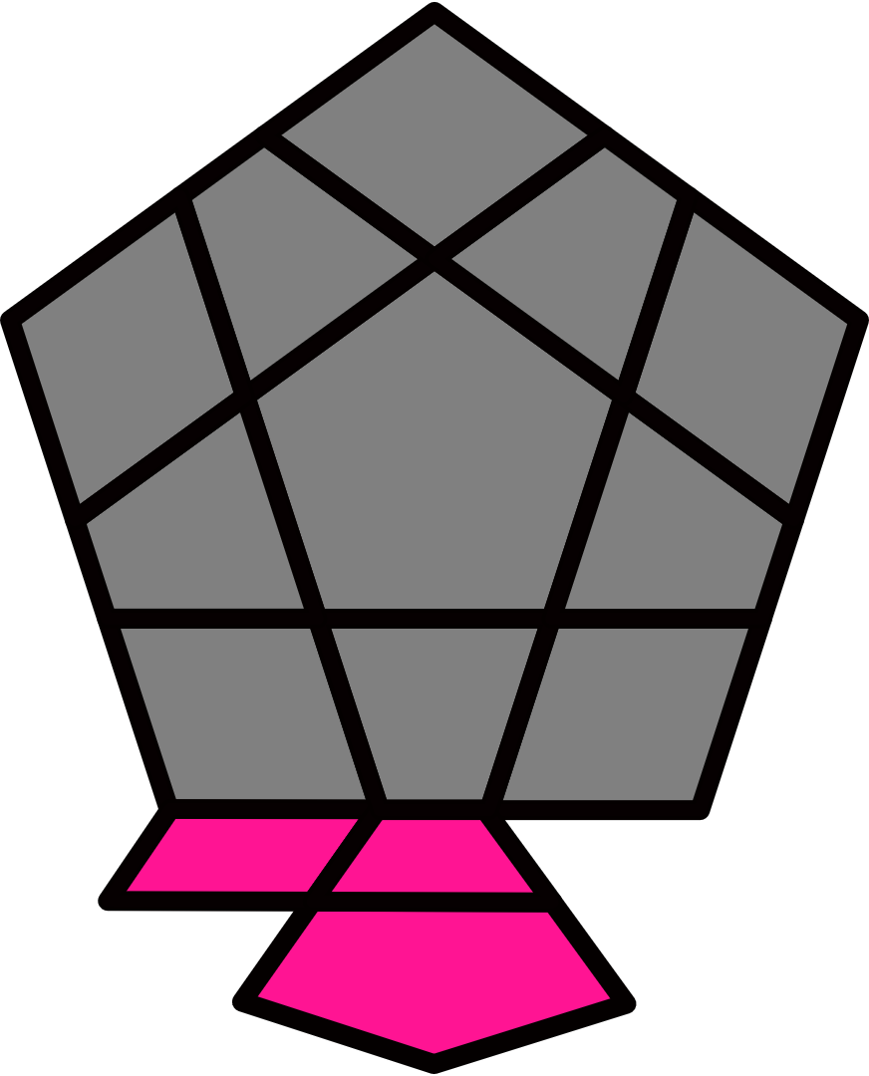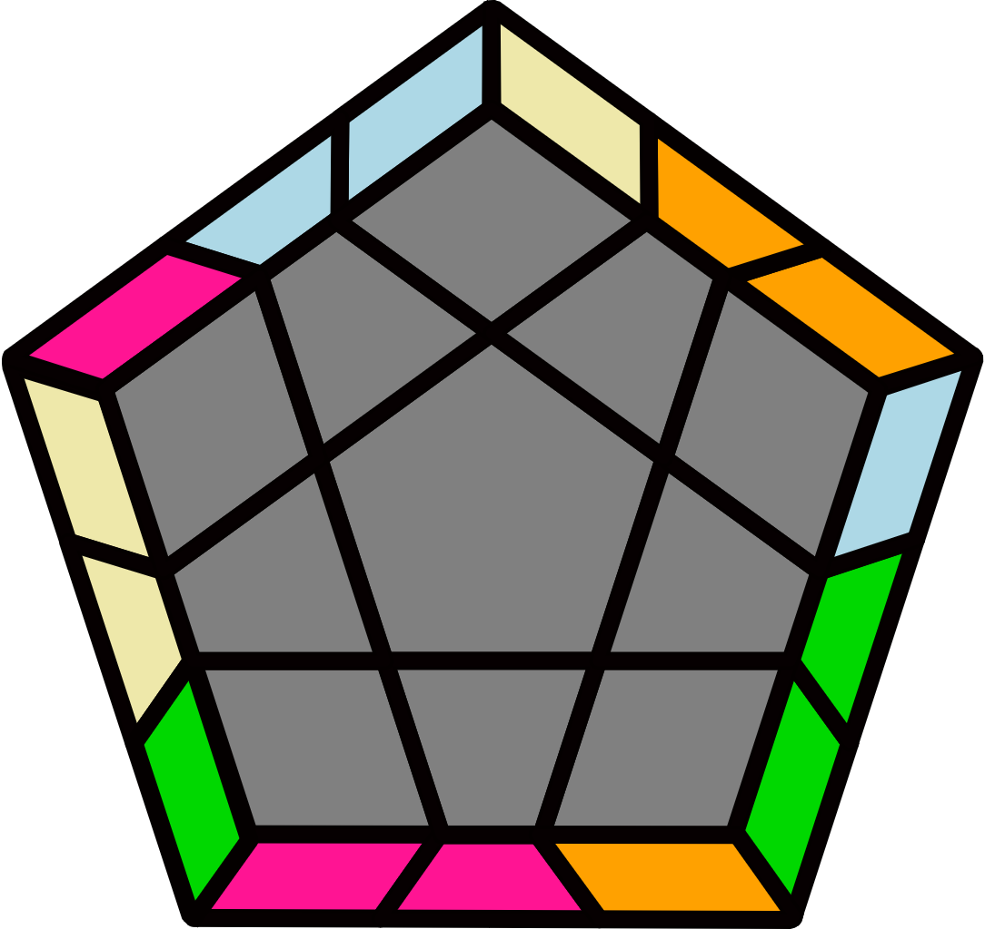
(R U2 R' F') (R U R' U') (R' F R2 U2' R') [H-: U' alg] |  | (R L U2 L' U R' L U' R U2 L' U2 R') |  |  |  |  | (R' U2 R' U2') (R U' R' U2') R U2 R [H+: U alg] |  |  |  |  | (R' L' U2' R U' L R' U L' U2' R U2' L)
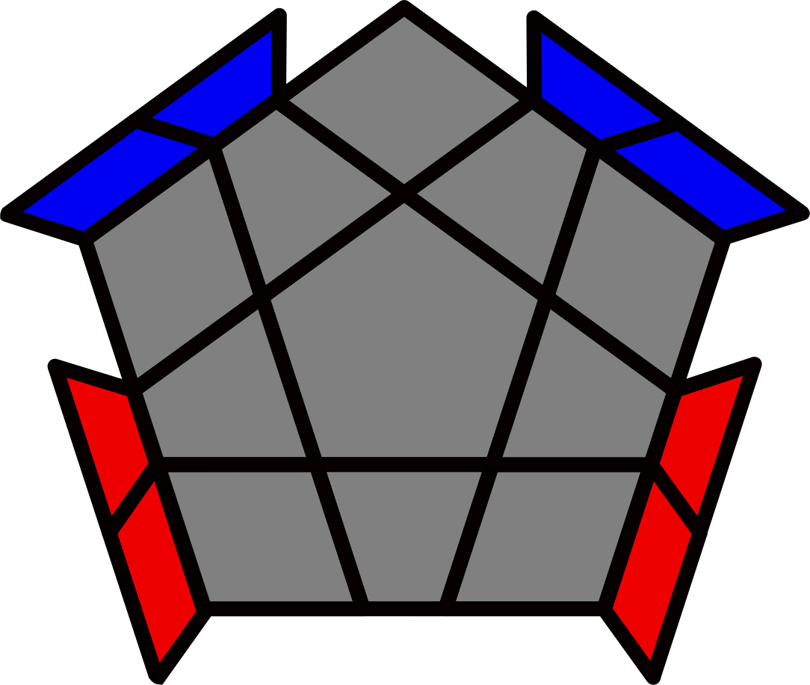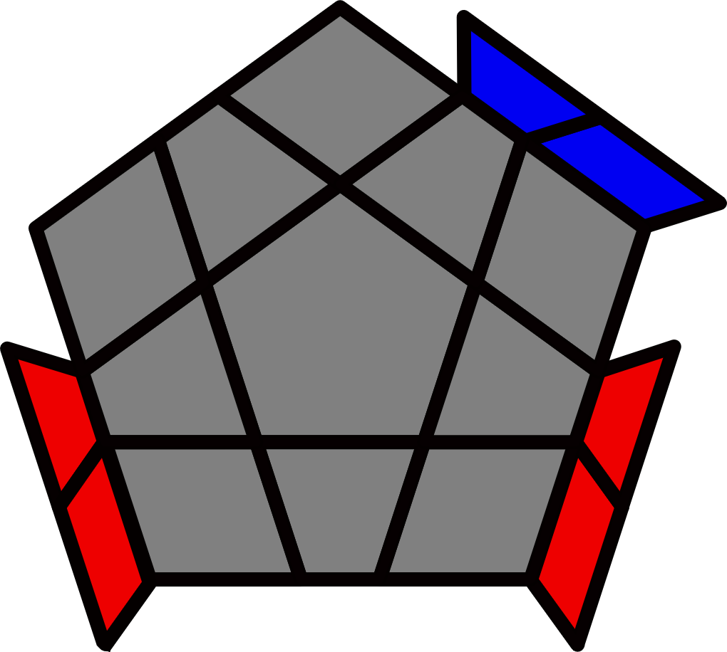 |  |  |  |  |  |  | 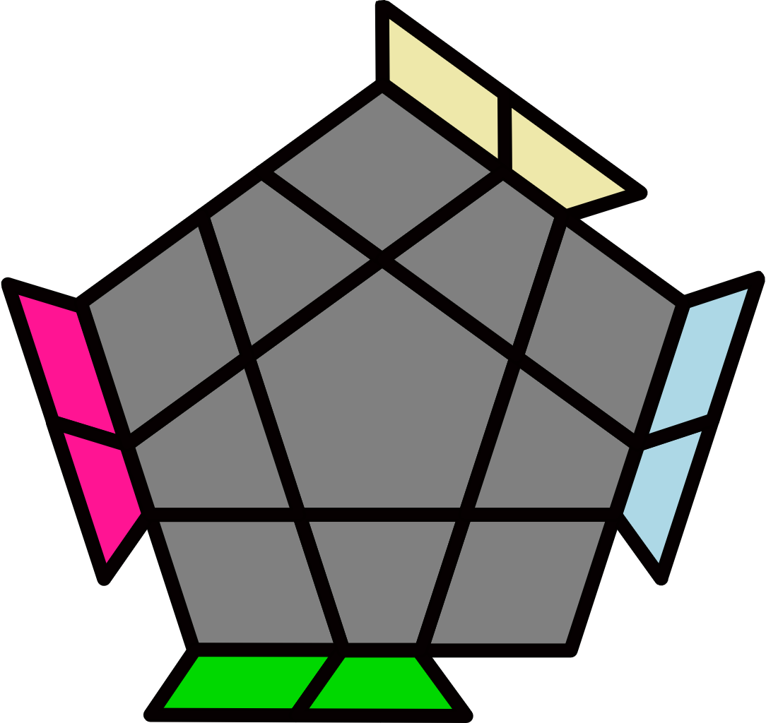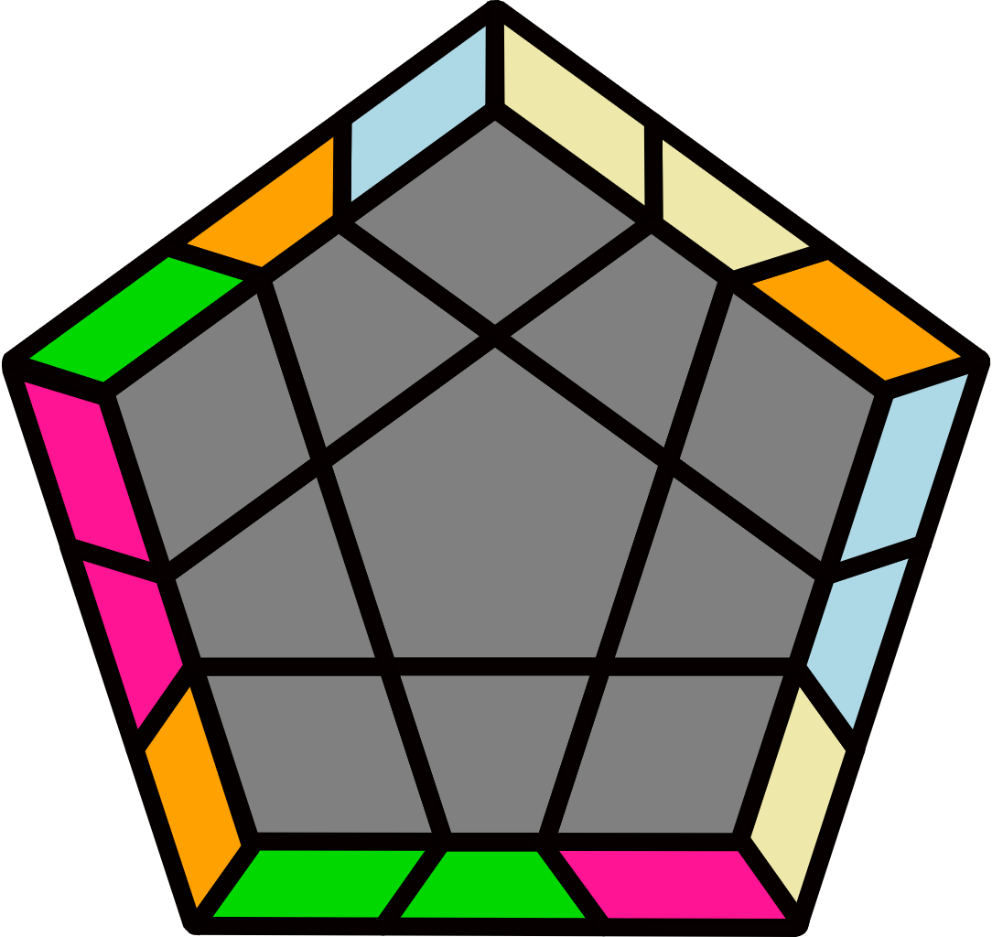
4/3 Bars [5] |  |  |  |  |  |  | (R U R' U' R' F R2 U' R' U' R U R' F')
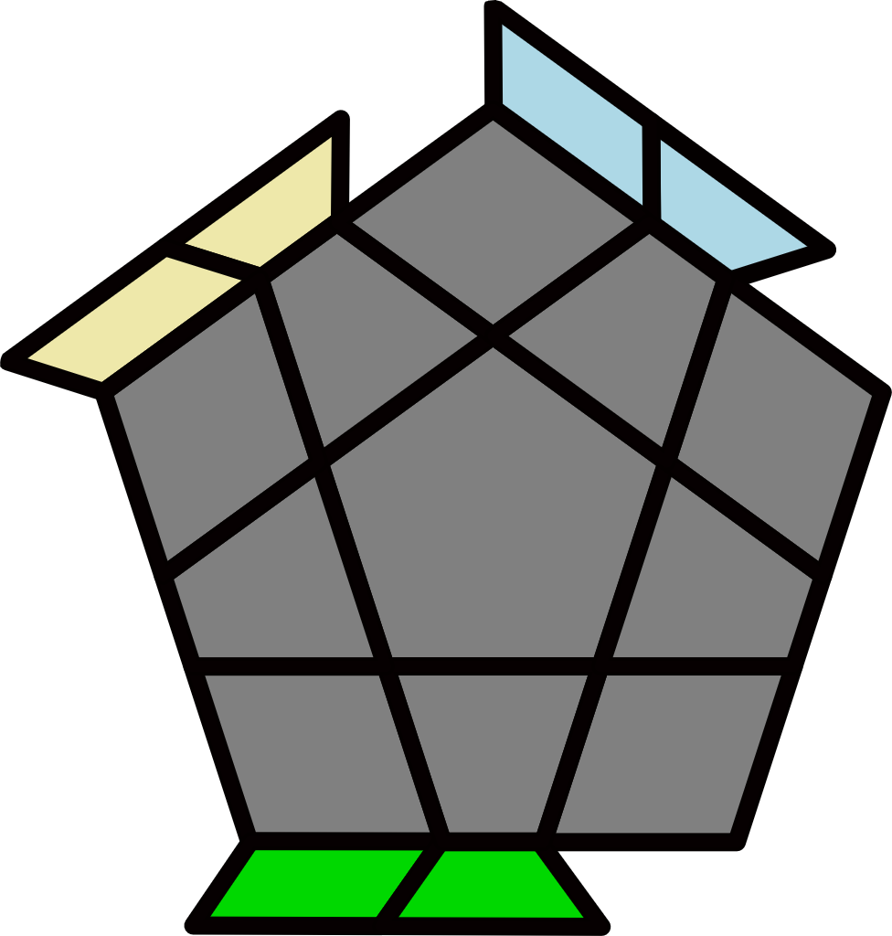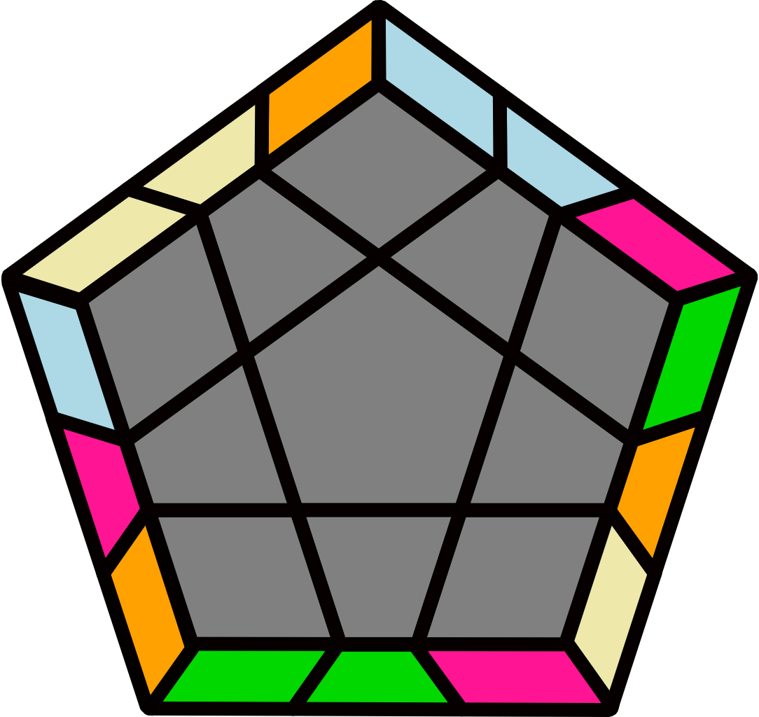 |  | 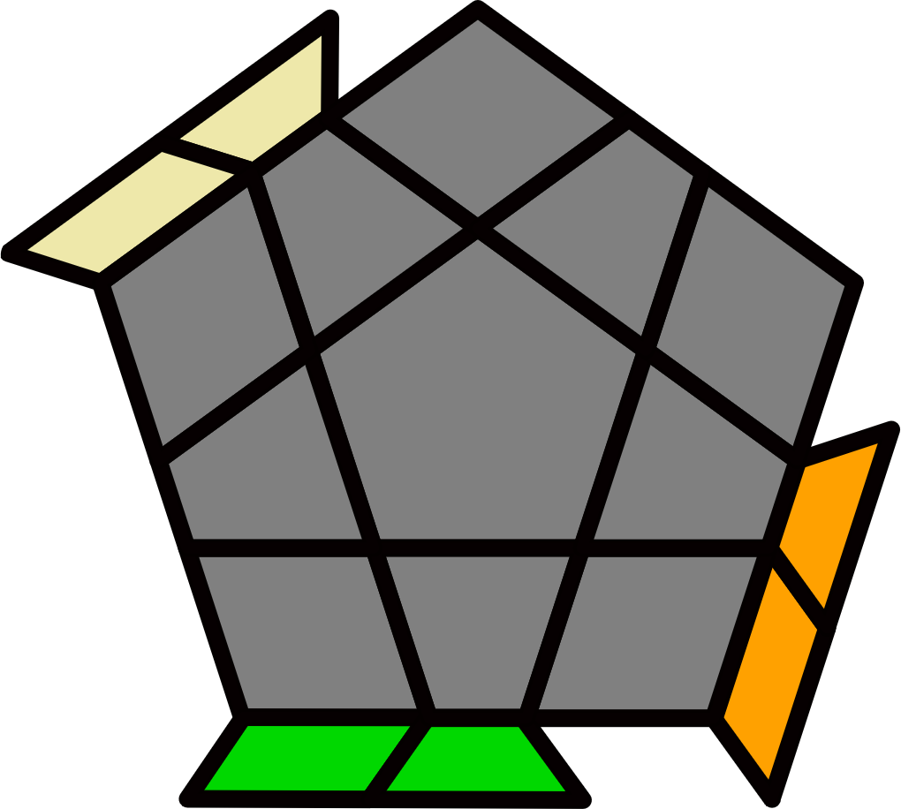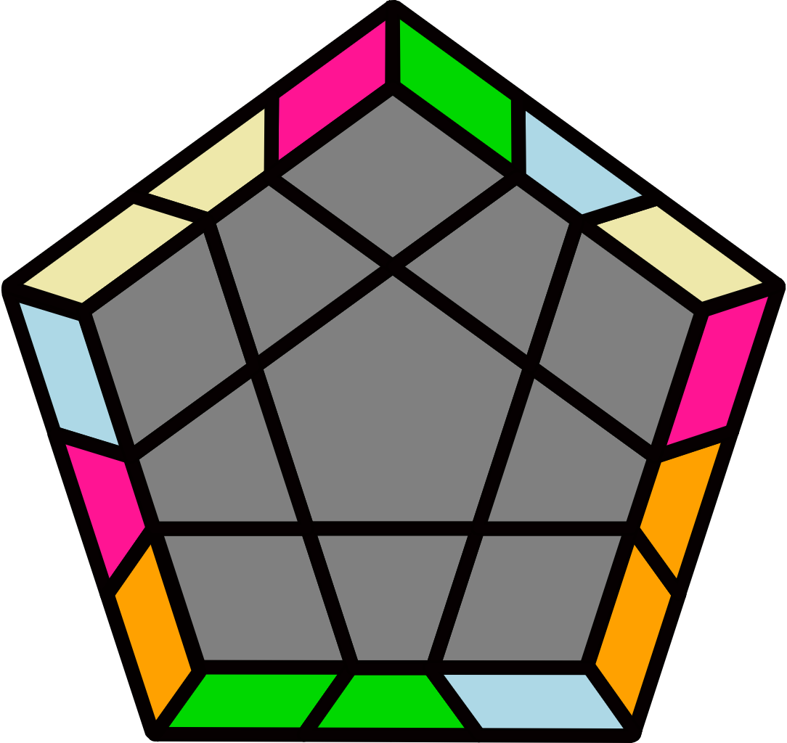 |  |  |  |  | 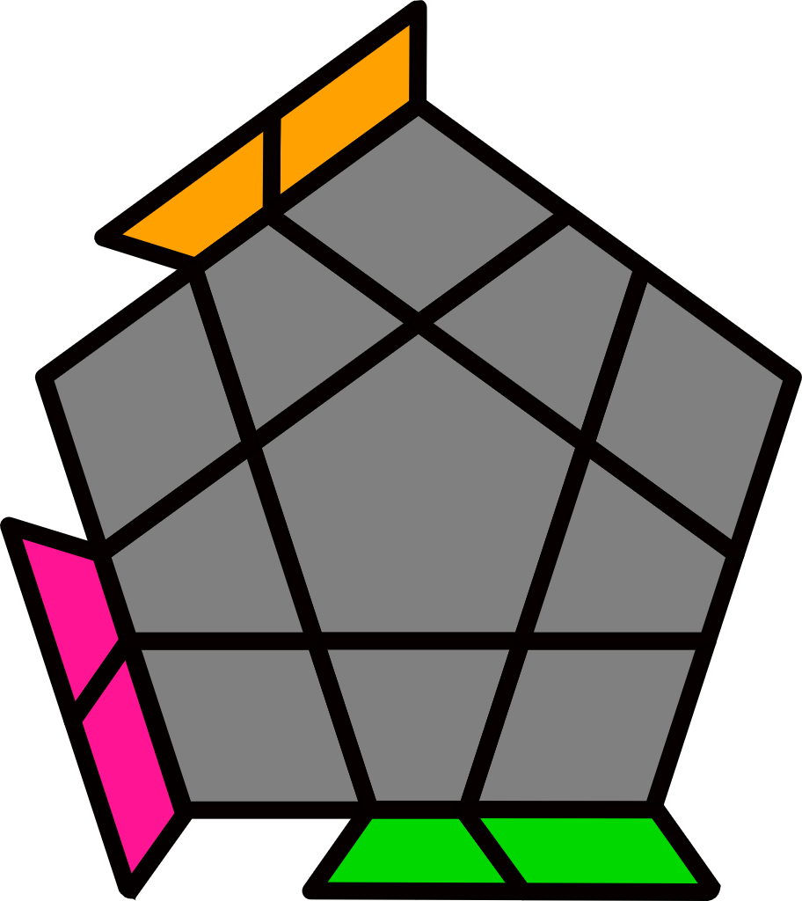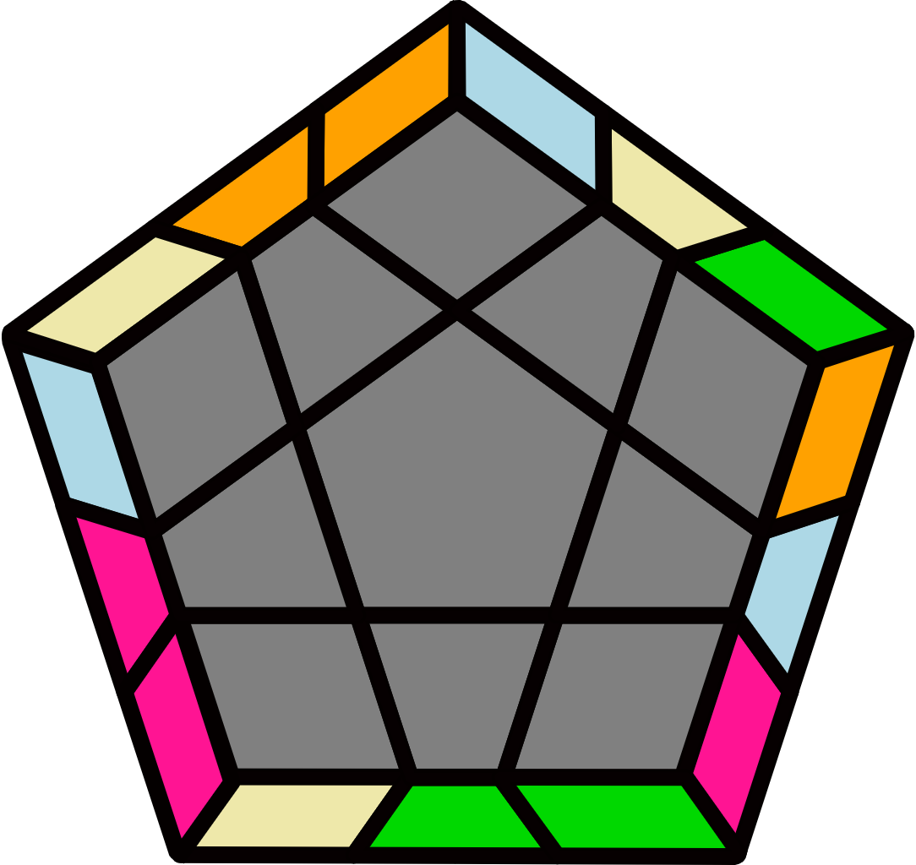 |  |  |  |  | 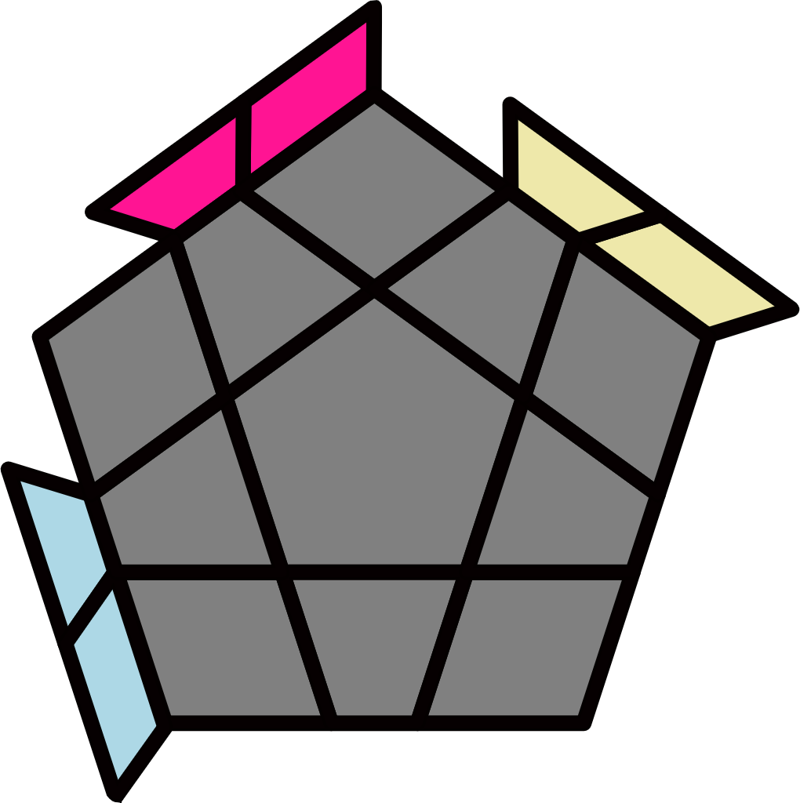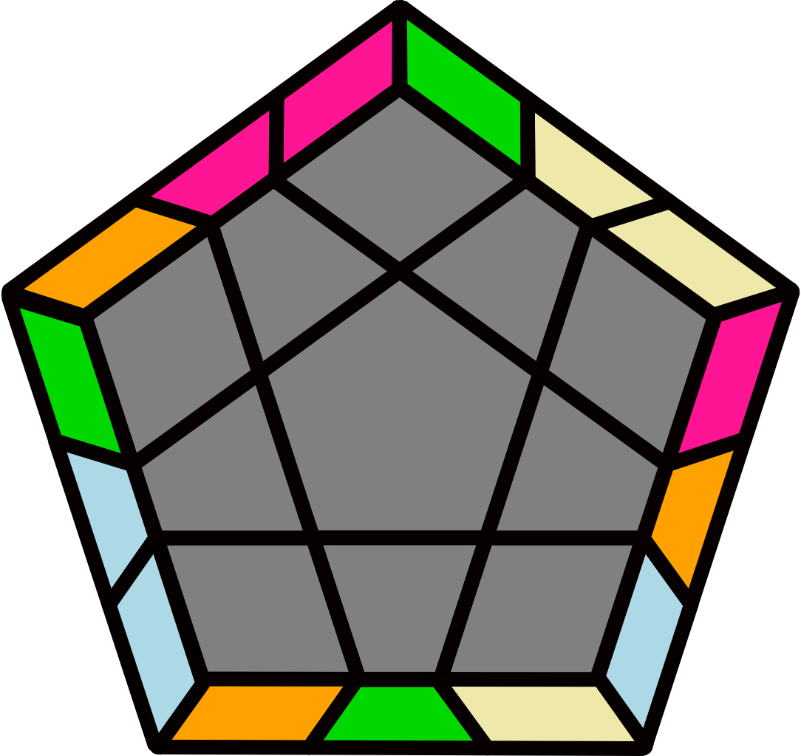
(R U R' F' R U R' U' R' F R U' R' F R2 U' R' U' R U R' F') |  | (R' U' R U2') (R2' U2' R2 U') (R2' U2' R2 U) R' U R |  |  |  |  | R2 U B2' U (R2' U R2 U') B2 U2' R2' |  |  |  |  | R2' U' F2 U' (R2 U' R2' U) F2' U2 R2
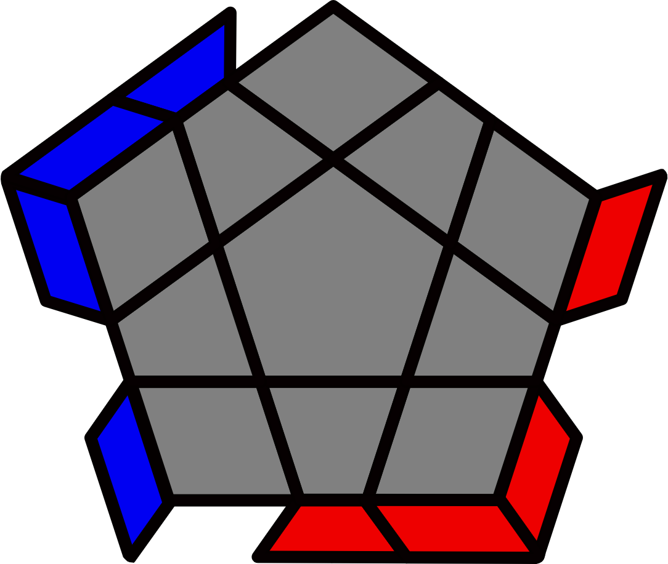R Perms [4]
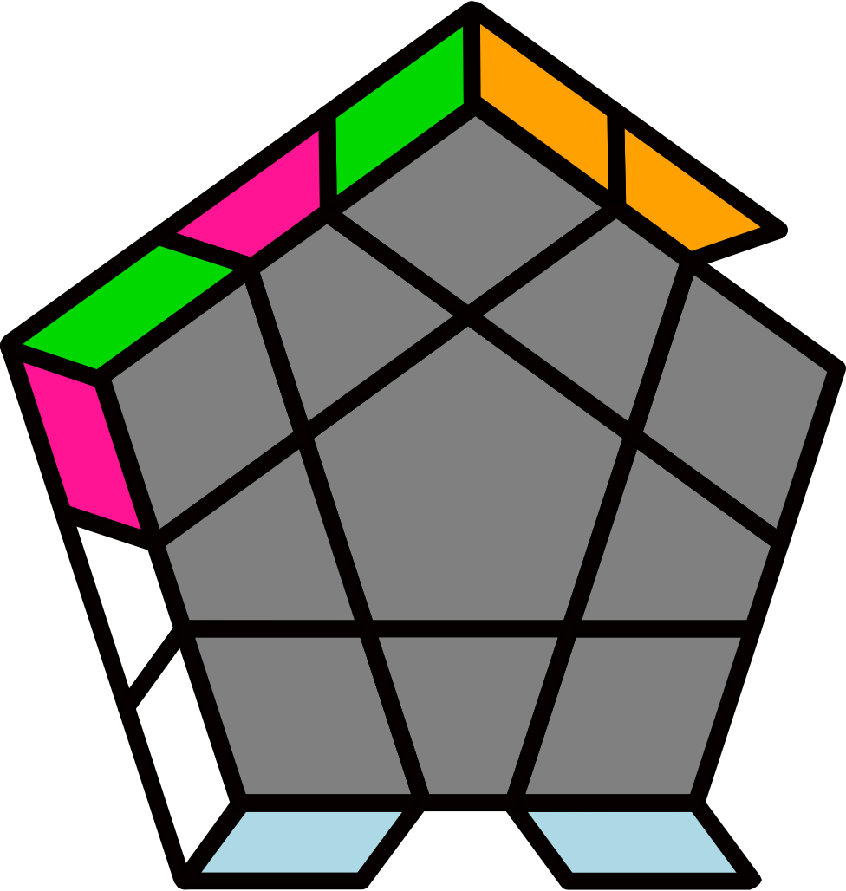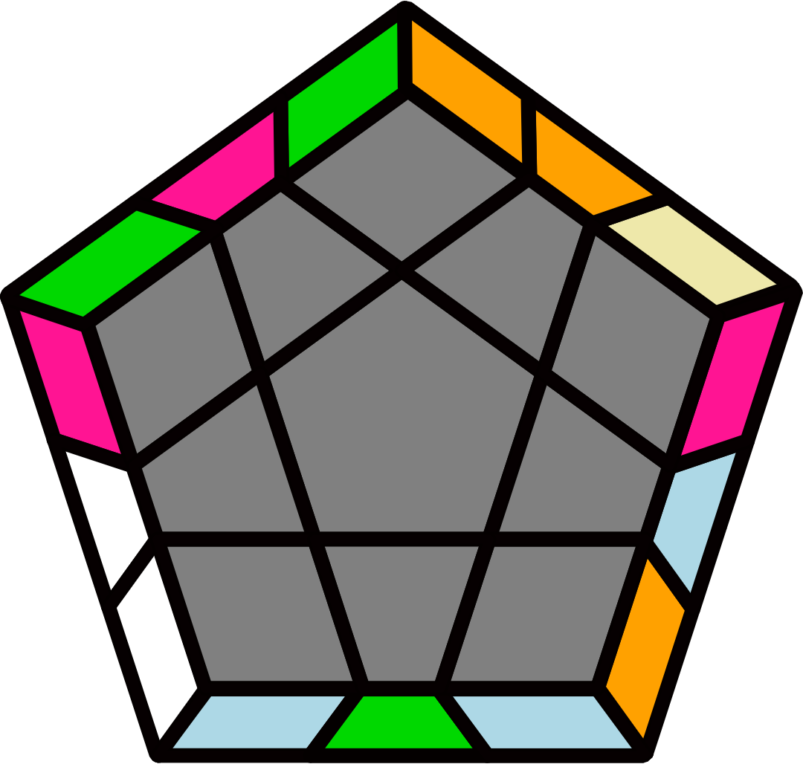 |  | B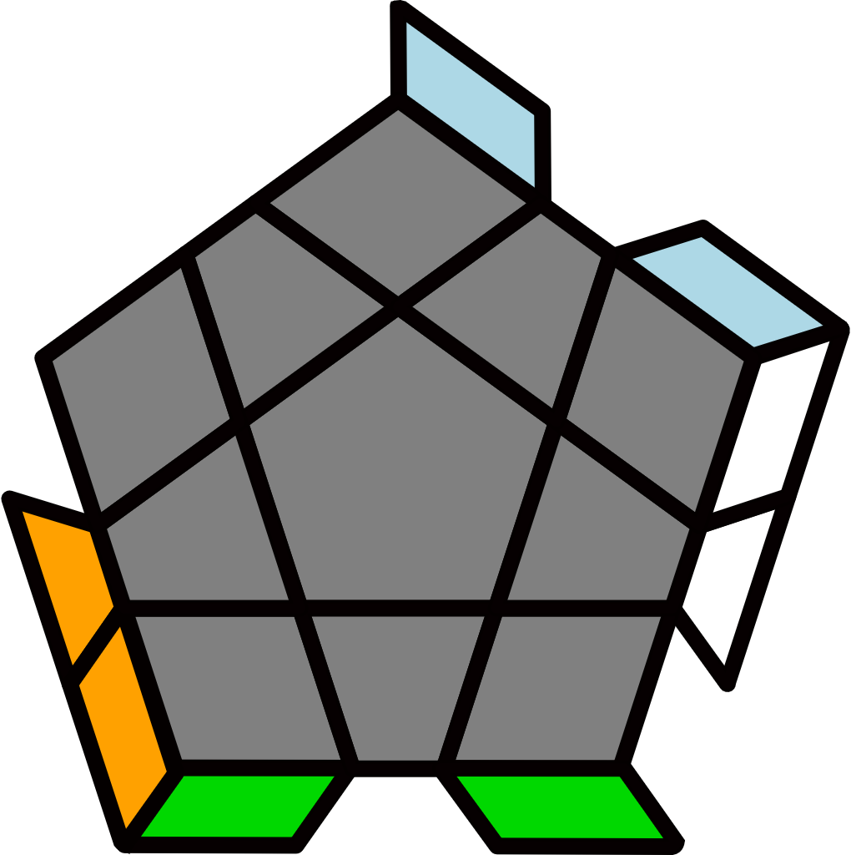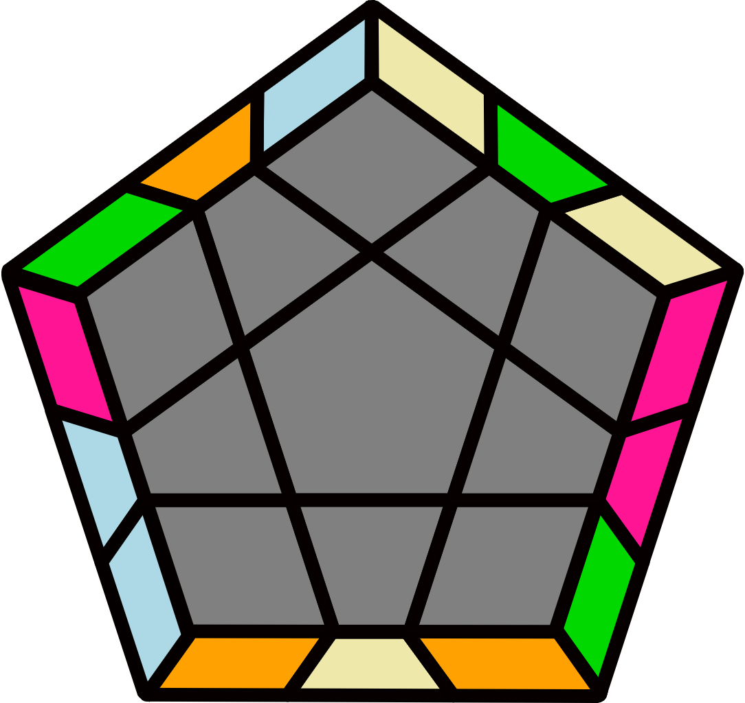 |  |  |  |  | 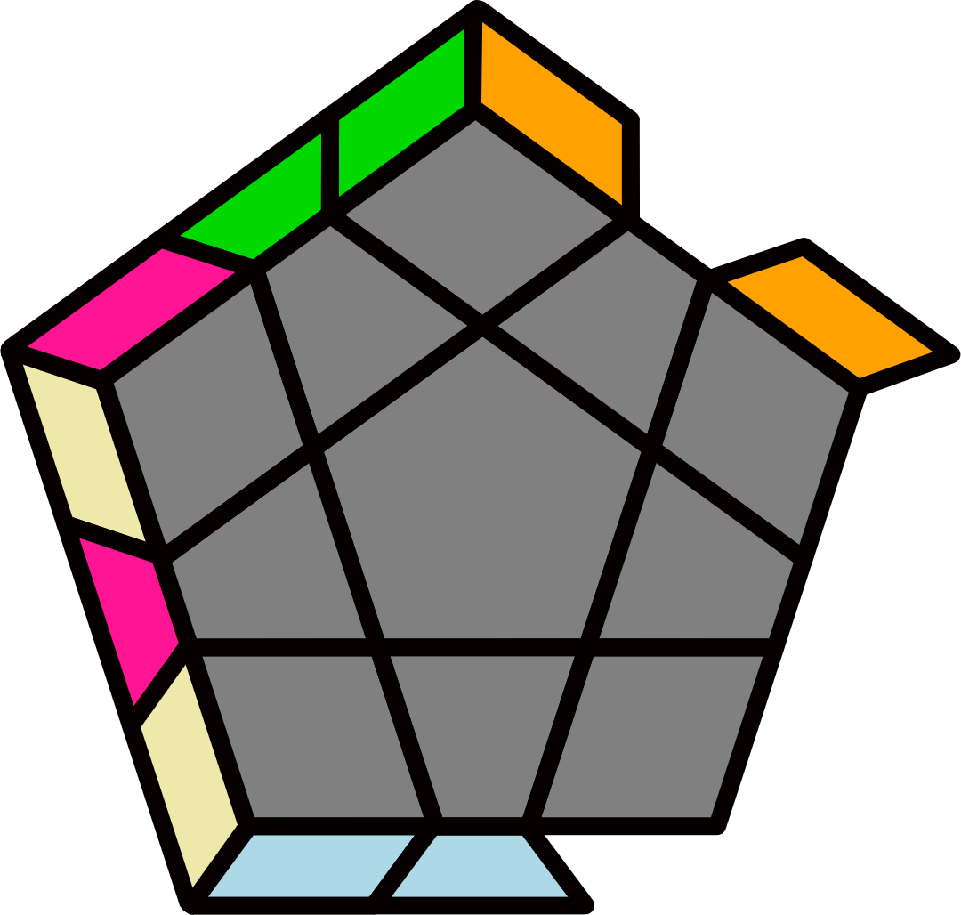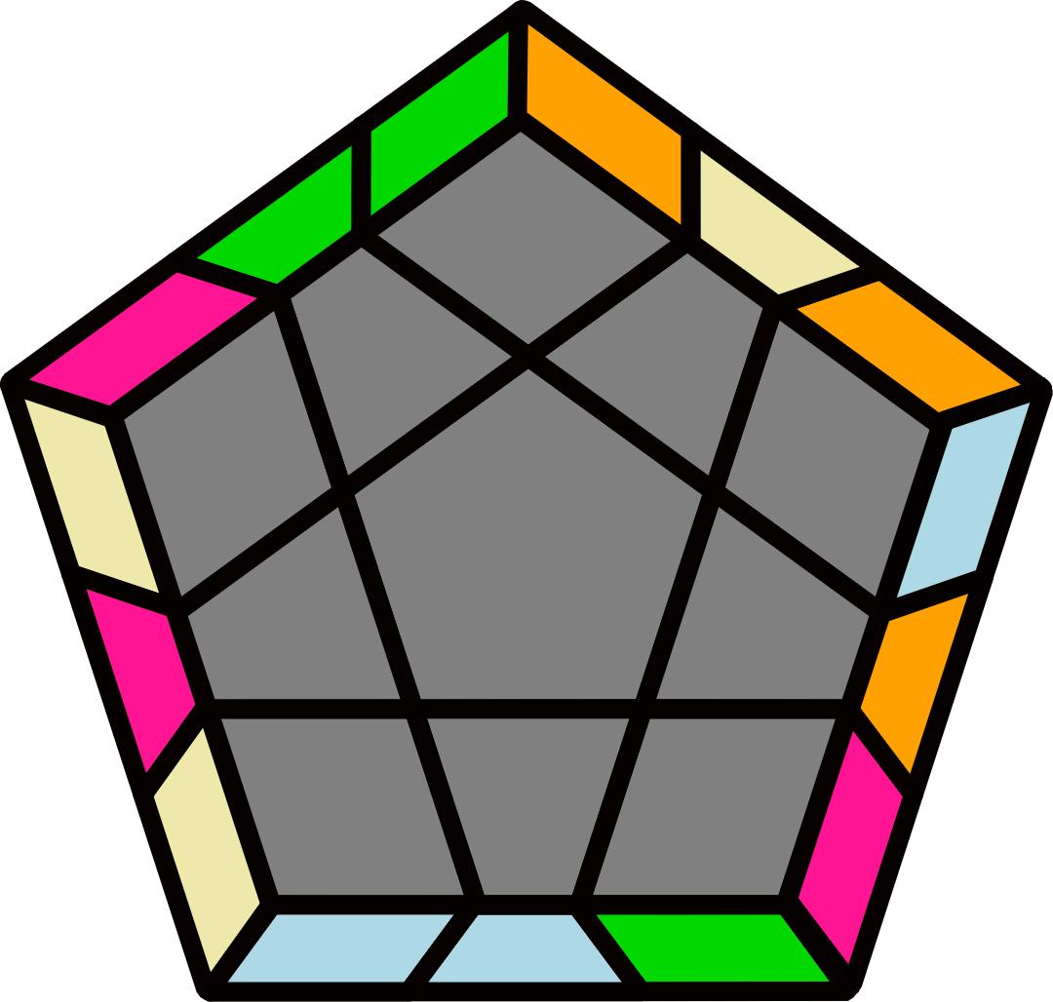 |  |  |  |  | B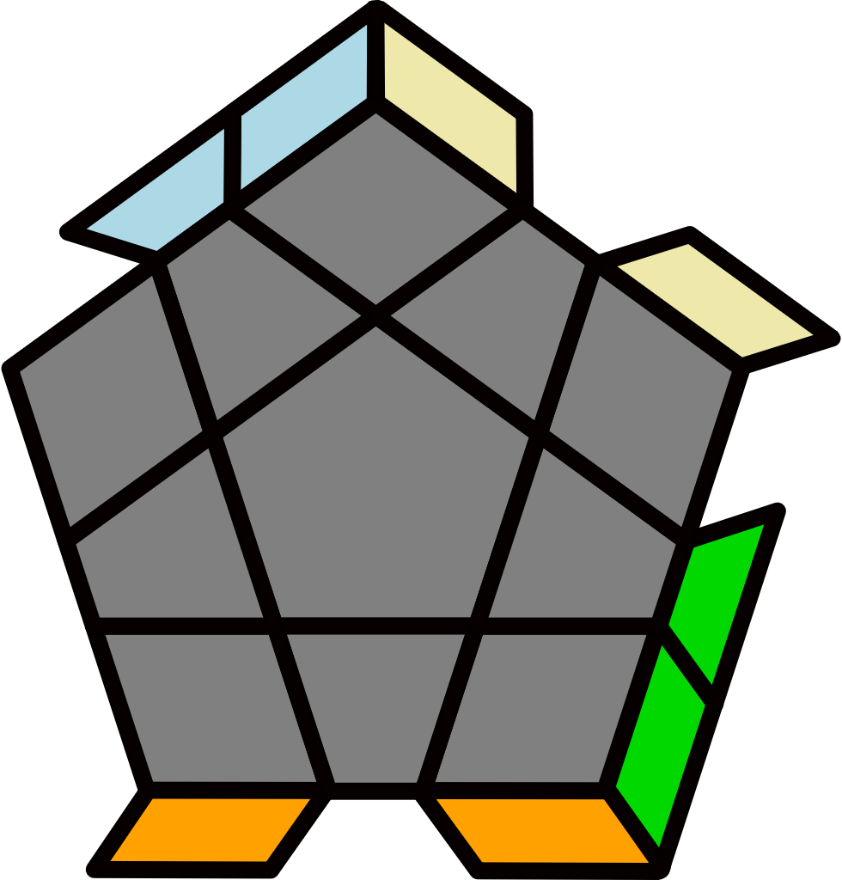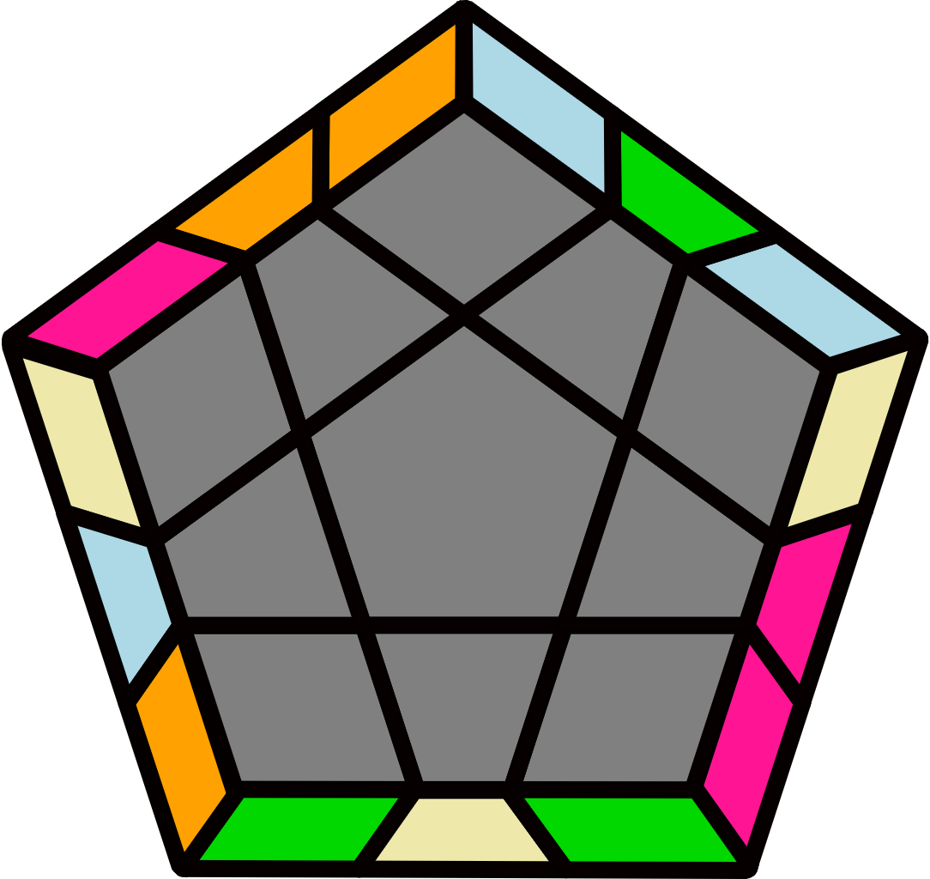
R' U2' (R2 U R' U')  (R' U2 R U R U' R') |  | R2 U R2' U2 R U2' (R U R' U') (R U' R2' U2) R U R' |  |  |  |  | R U2 (R2' U' R U)  (R U2' R' U' R' U R) |  |  |  |  | R2' U' R2 U2' R' U2 (R' U' R U) (R' U R2 U2') R' U' R
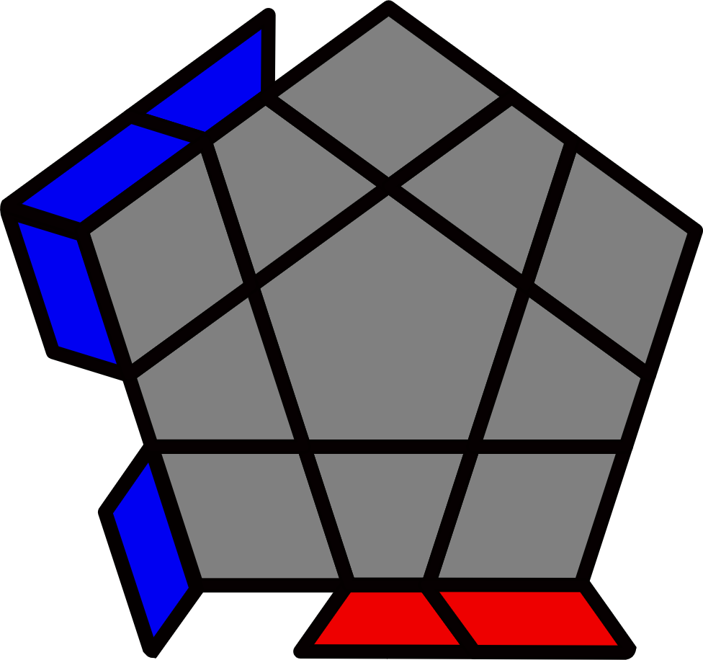 R Perm + Bar [8]
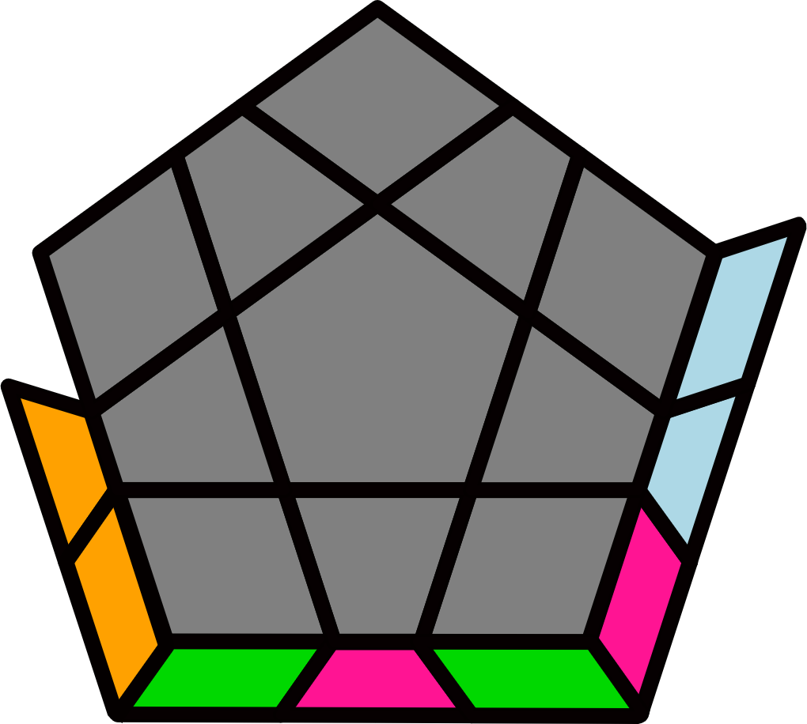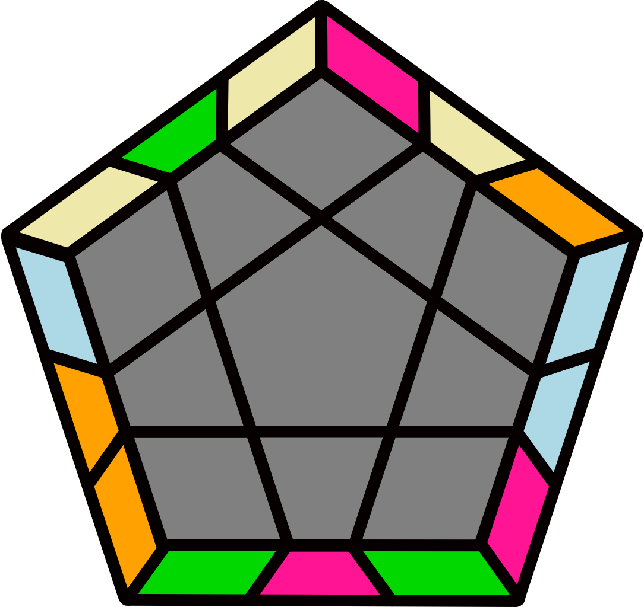 |  | 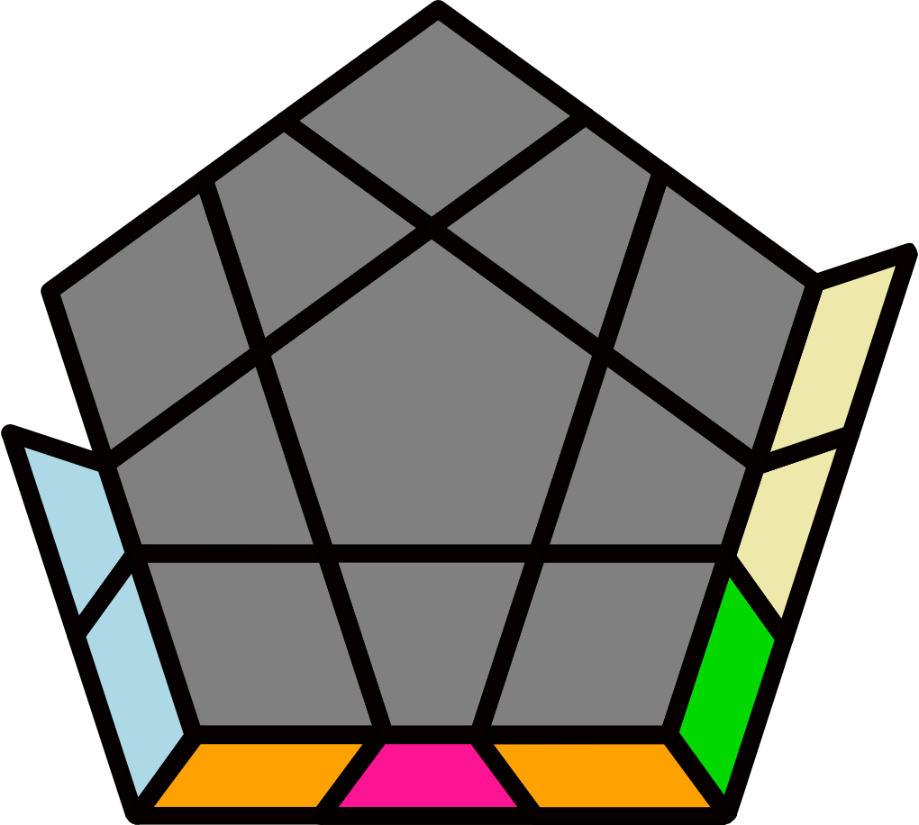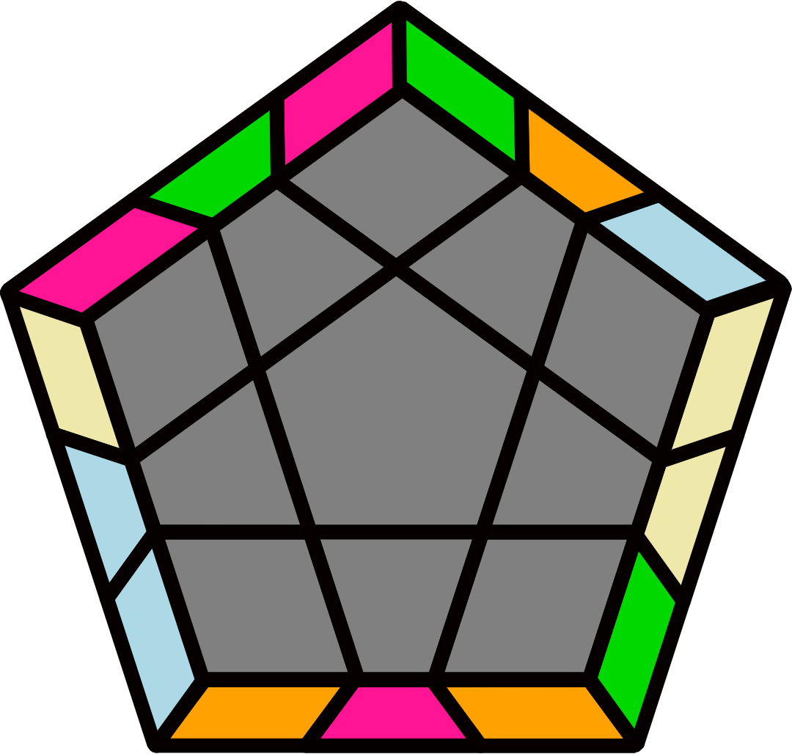 |  |  |  |  | 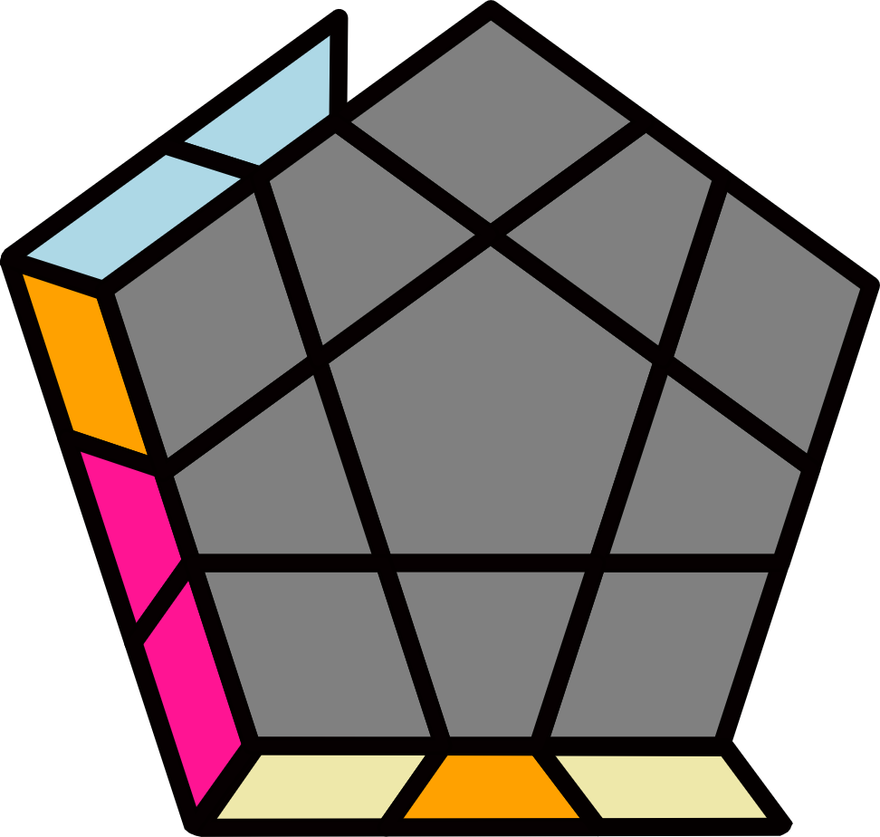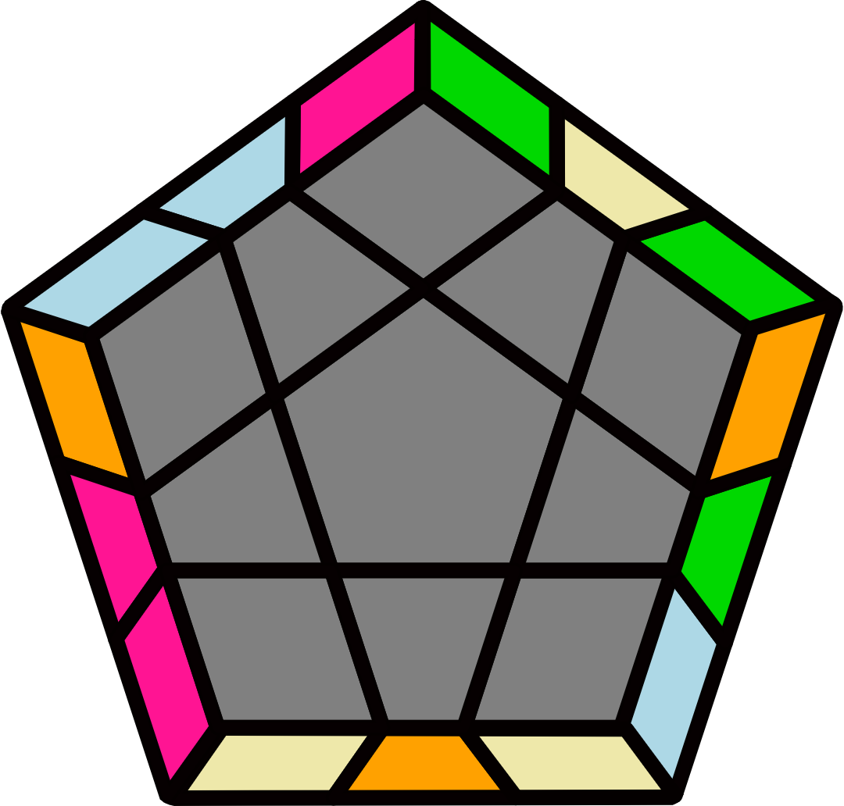 |  |  |  |  | 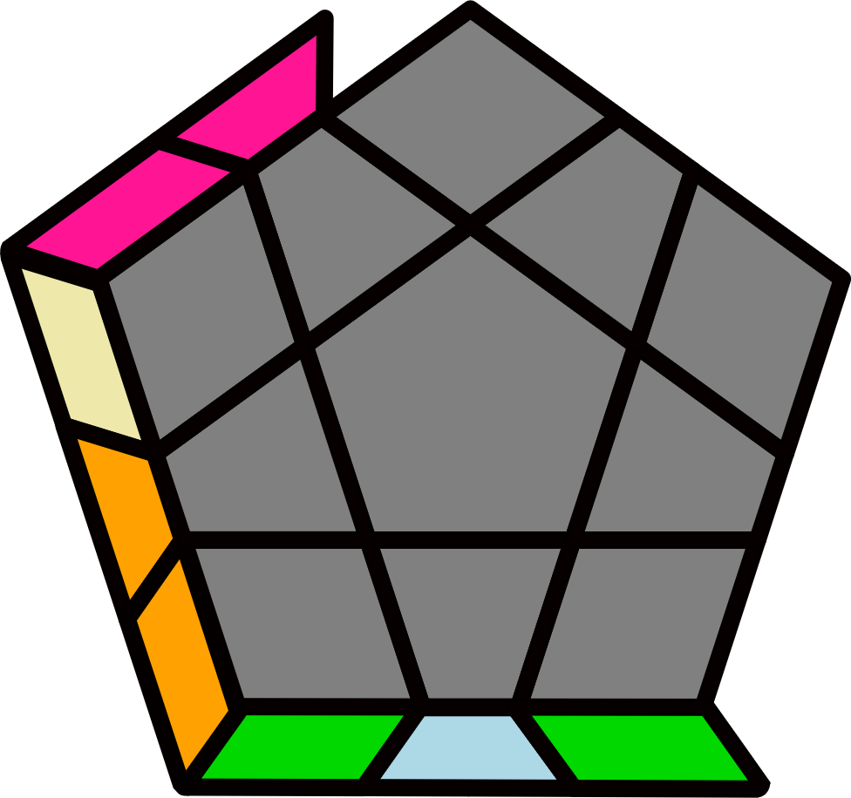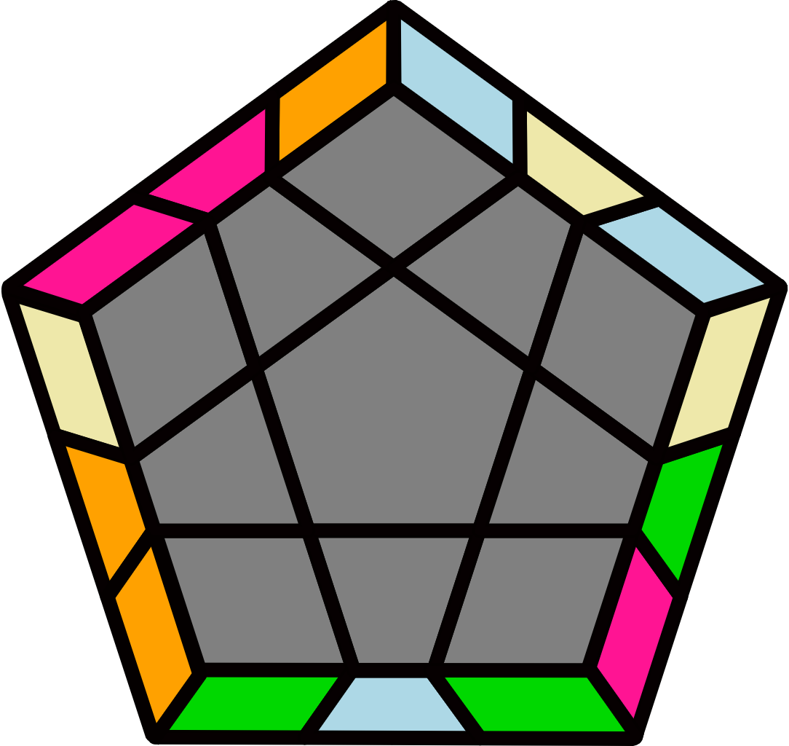
(R' U2 R U') (R2' U2 R2 U) (R' U' R' U2') R U' R |  | y2 (R2 U2 R2' U R2 U2 R2') U2' (R2 U2' R2' U' R2 U2' R2') |  |  |  |  | y' (R' U' R U) (R' U R2 U) (R' U R U) (R' U' R' U') R2 U' R' |  |  |  |  | (R' U R' U2) (R U R U')  (R2' U2' R2 U) R' U2' R
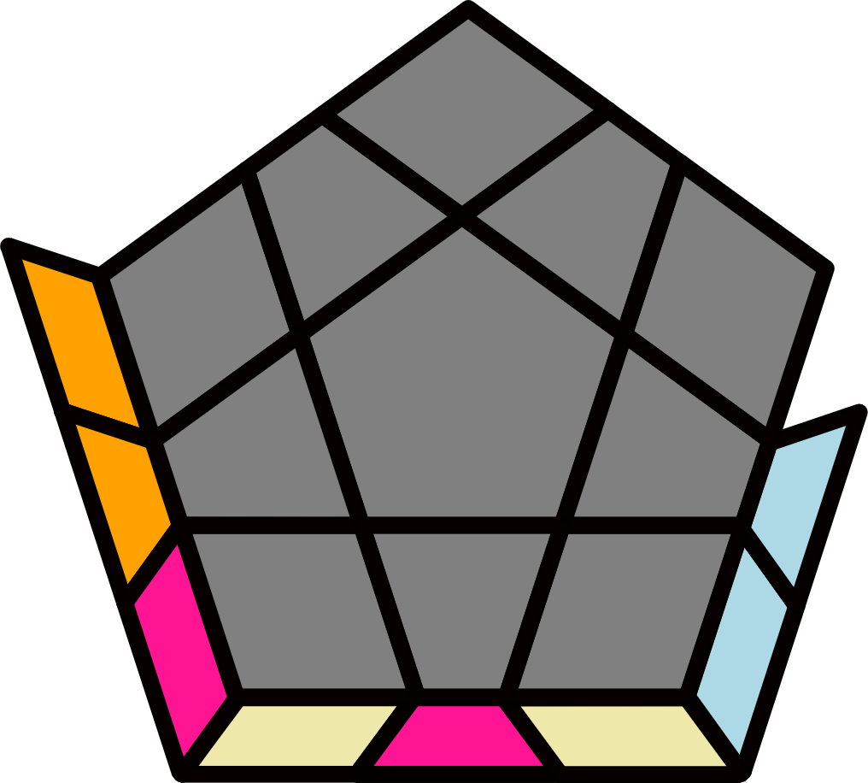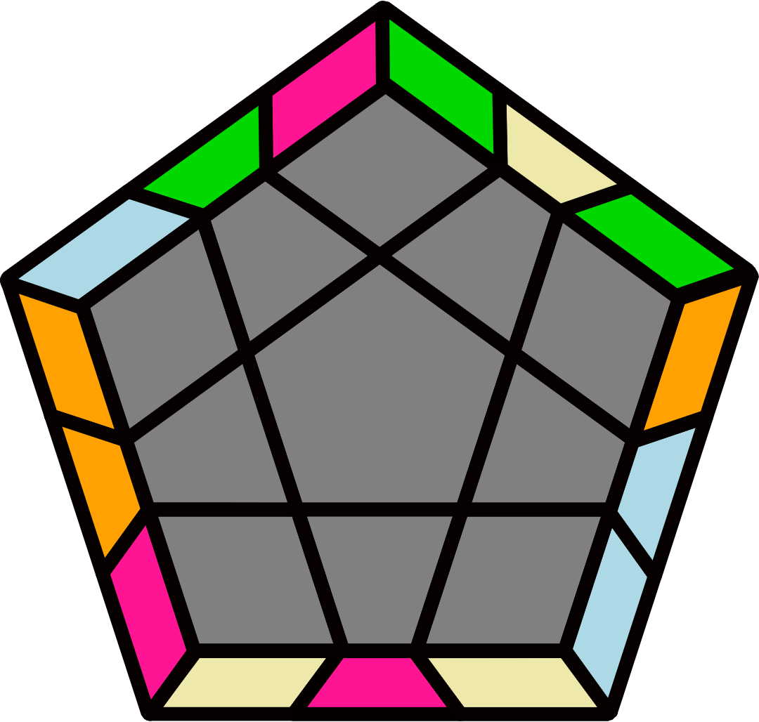 |  | 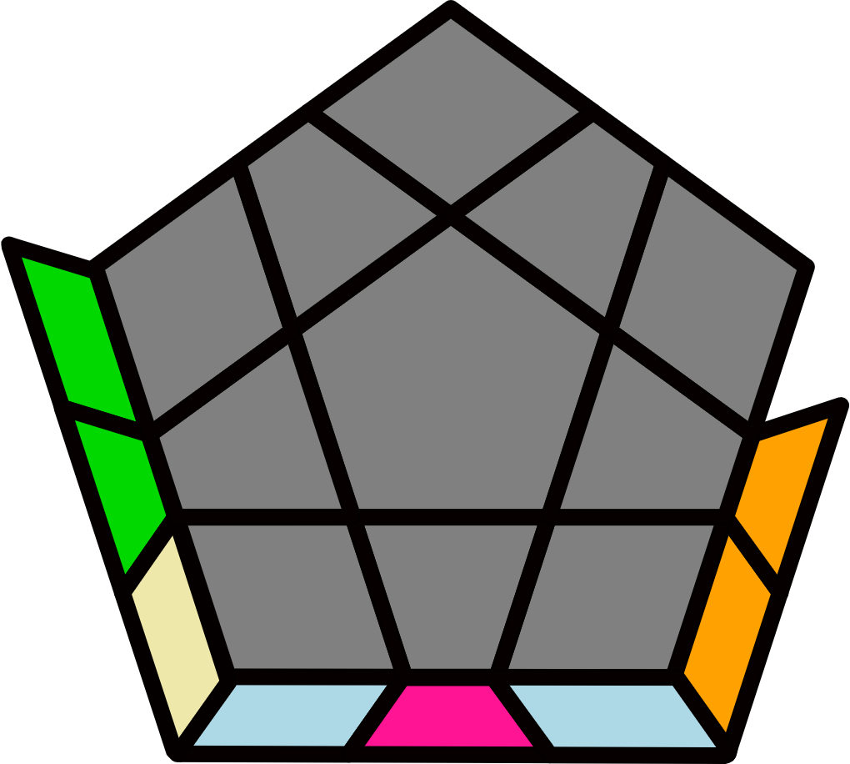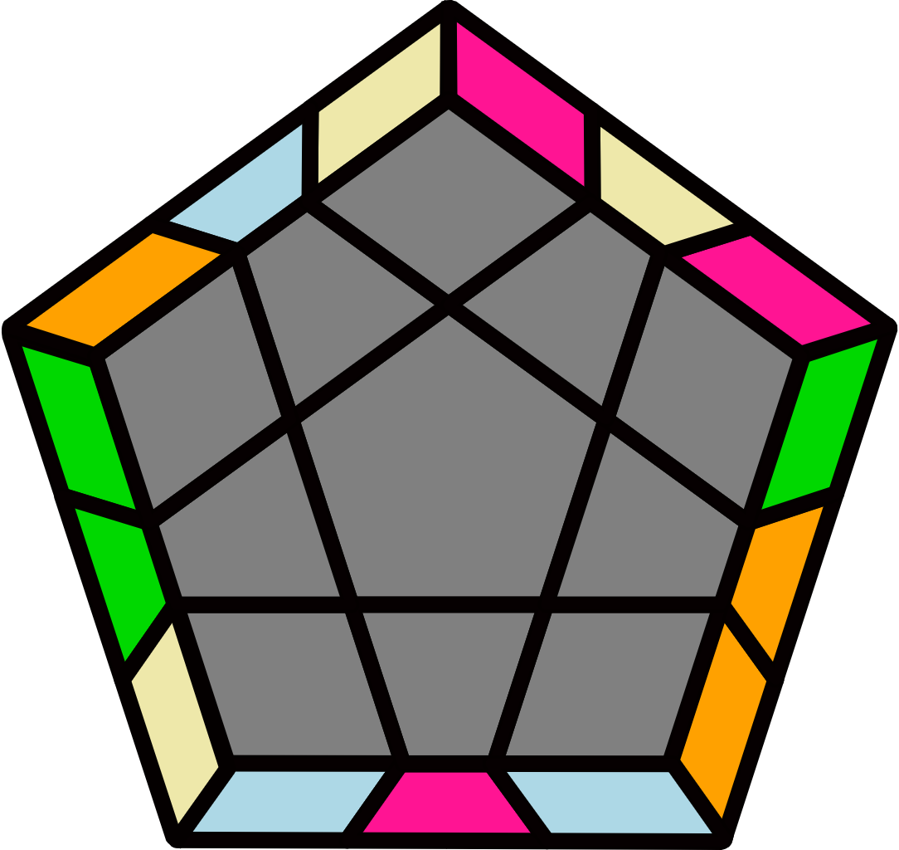 |  |  |  |  | 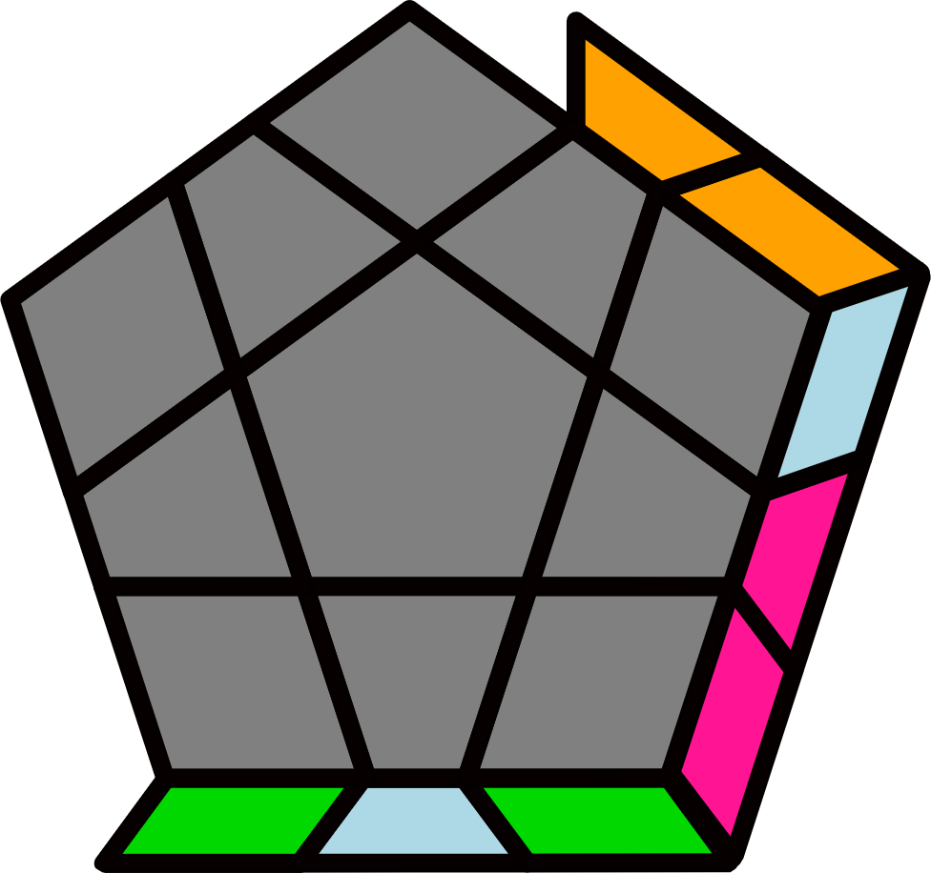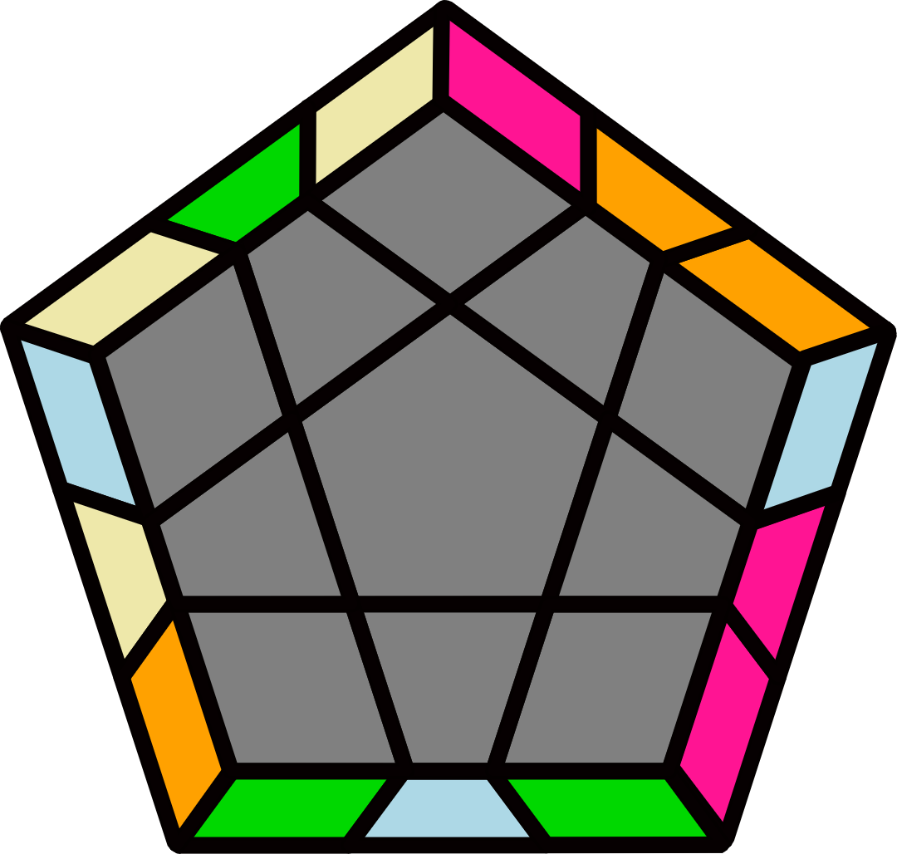 |  |  |  |  | 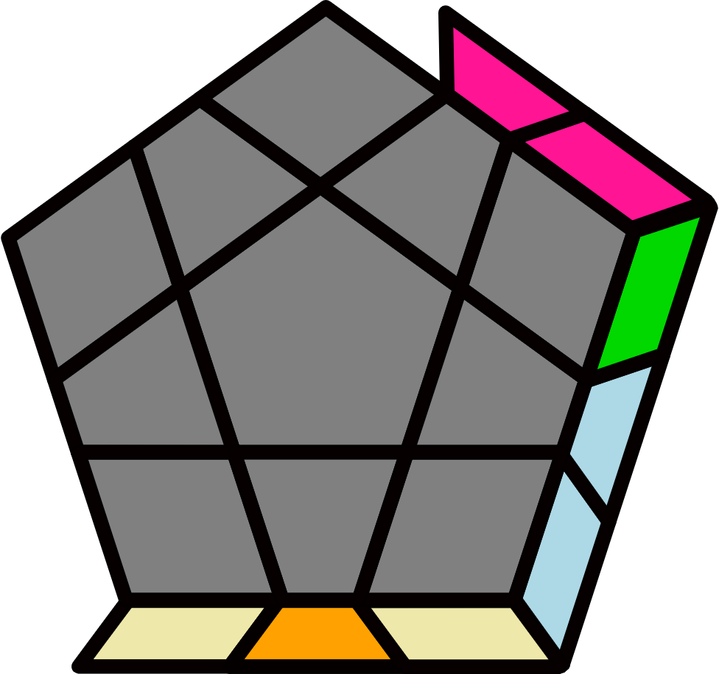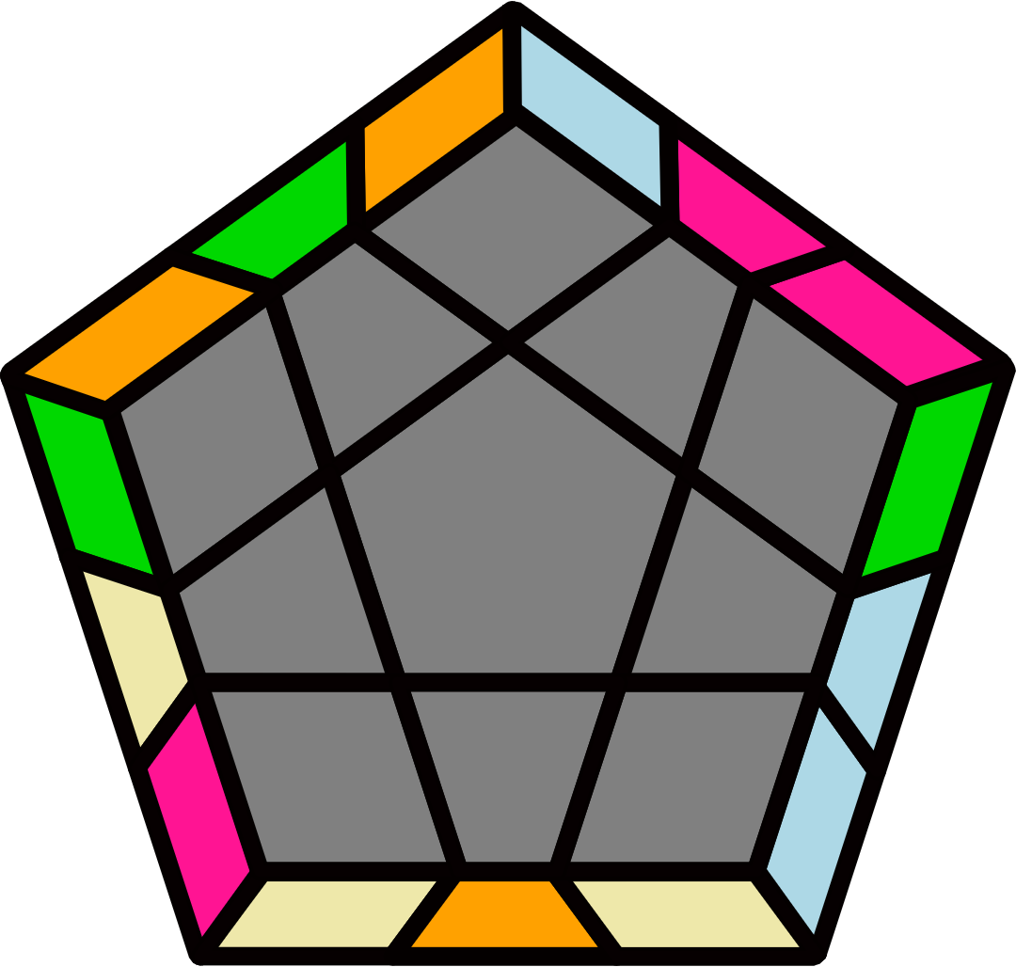
y2' (R U2' R' U) (R2 U2' R2' U') (R U R U2) R' U R' |  | (R2 U2' R2' U' R2 U2' R2') U2 (R2 U2 R2' U R2 U2 R2') |  |  |  |  | y2' (R U R' U') (R U' R2' U') (R U' R' U') (R U R U) R2' U R |  |  |  |  | y2 (R U' R U2') (R' U' R' U) (R2 U2 R2' U') R U2 R'
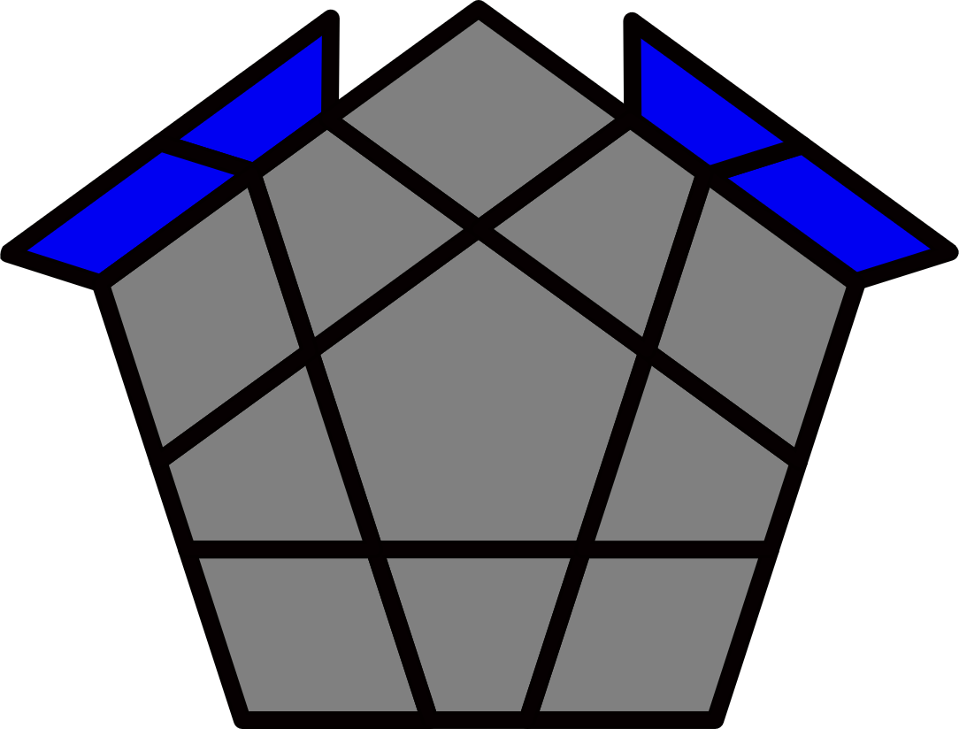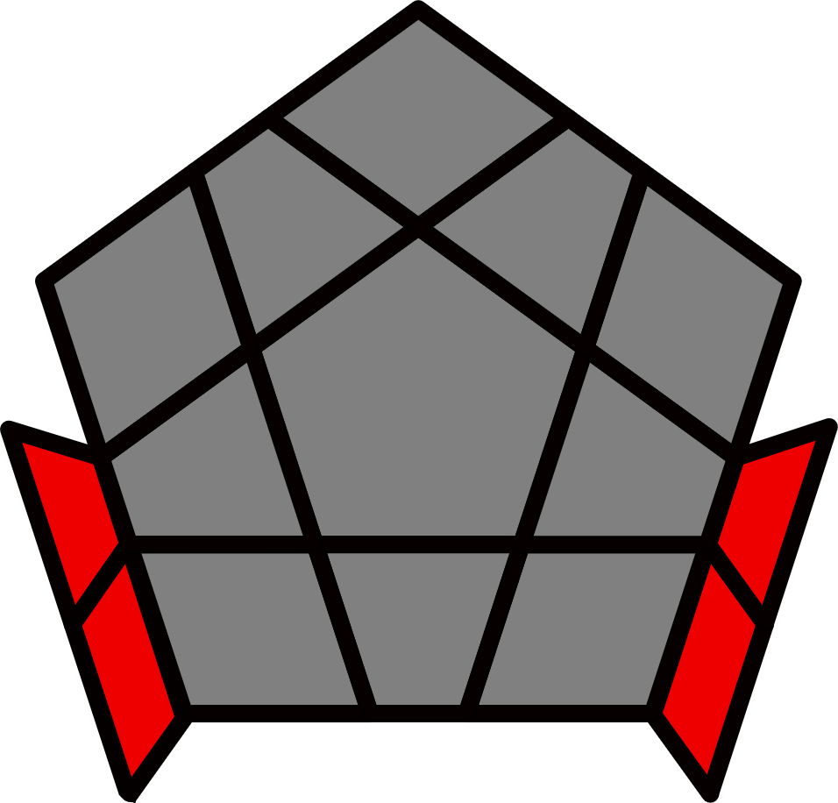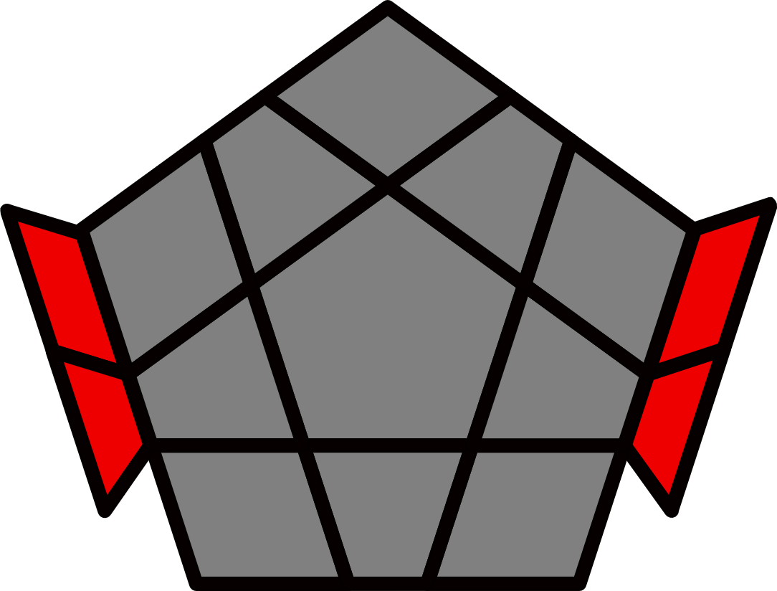 |  |  |  |  |  |  | 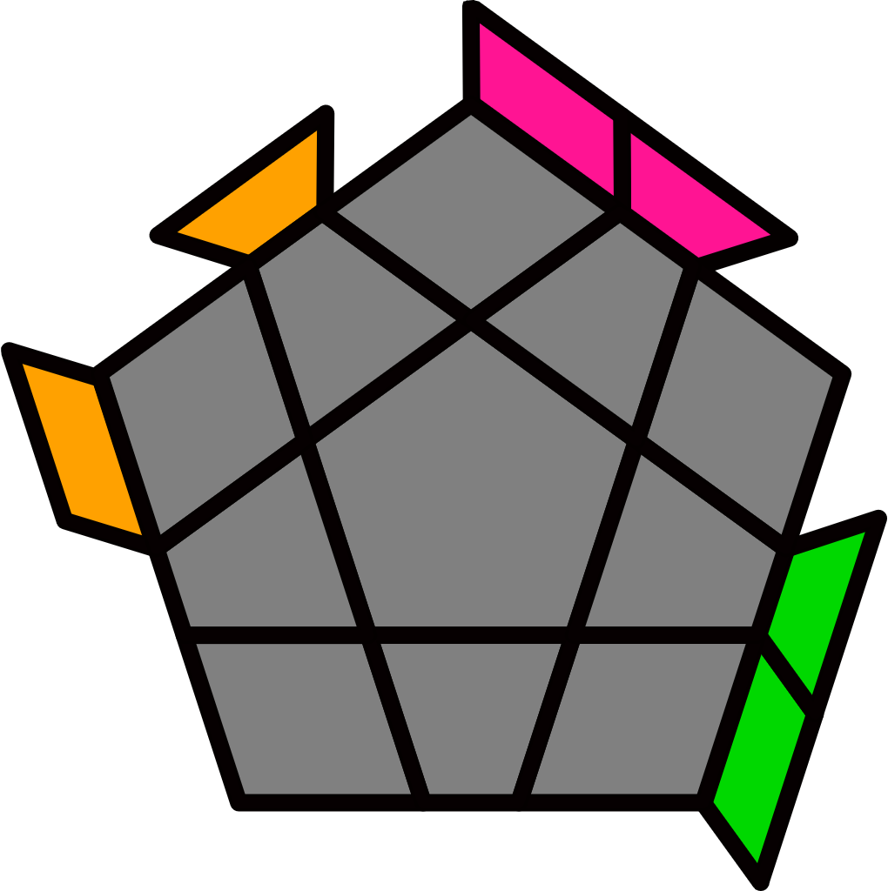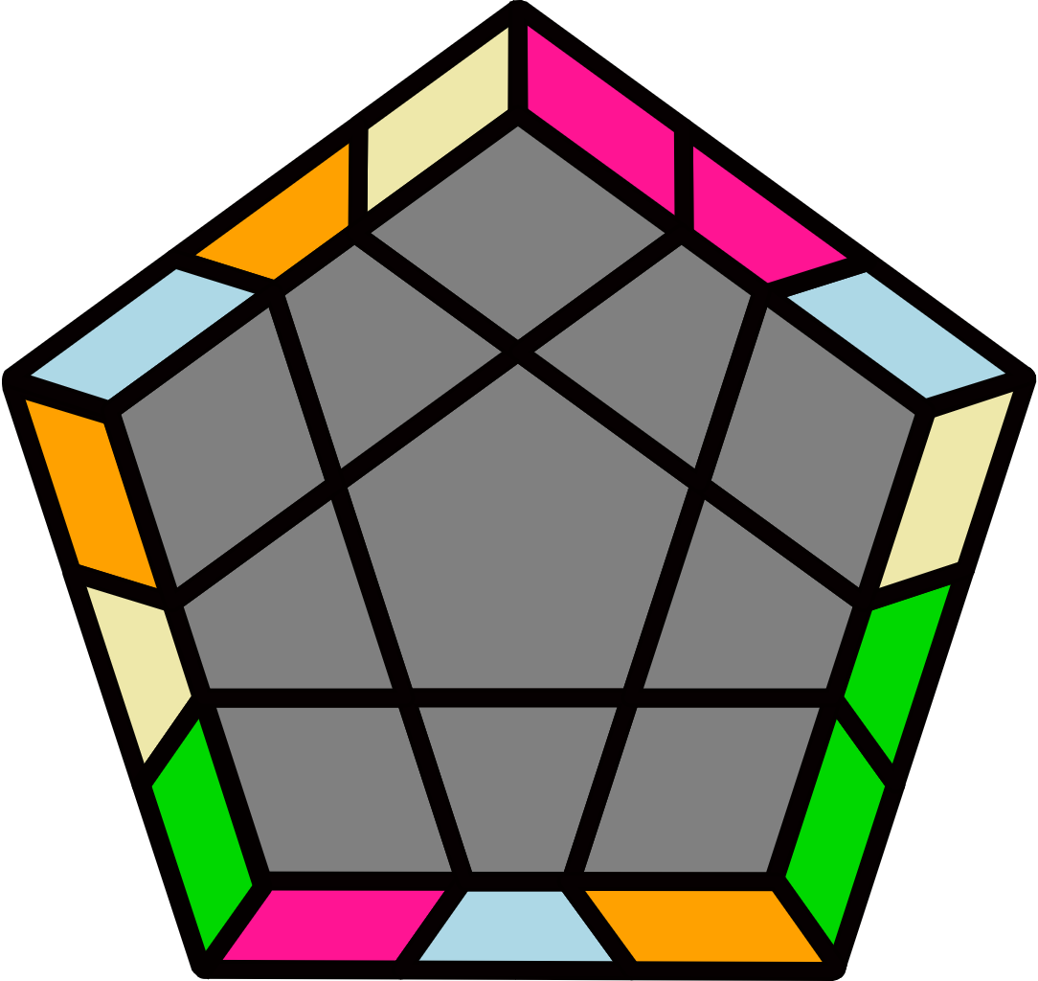 |  |  |  |  | 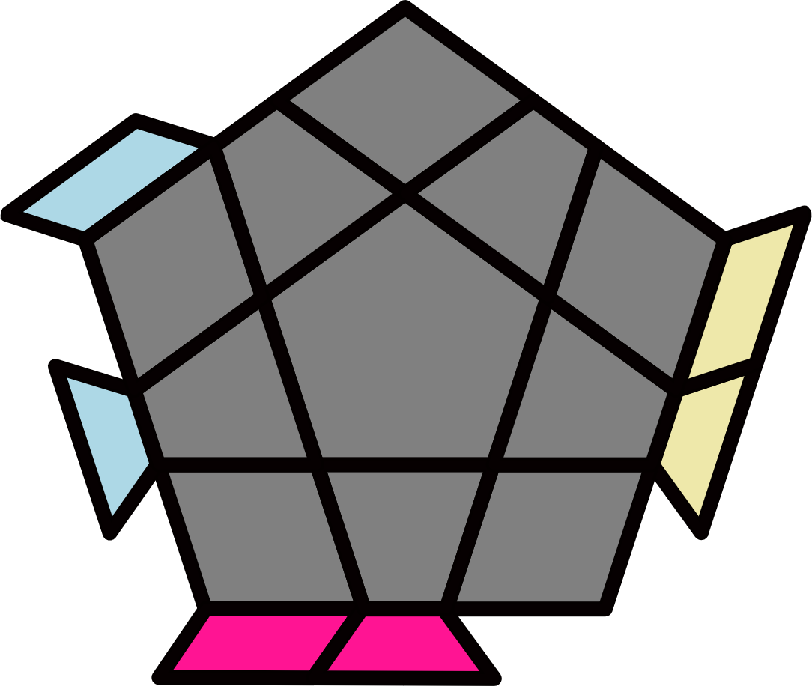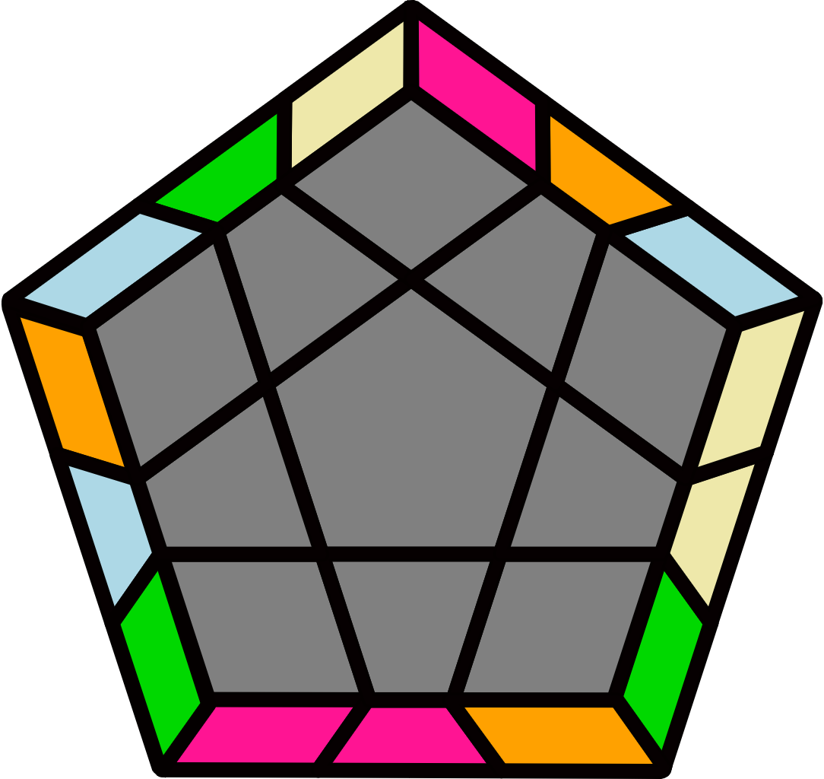
Y/T Perm [6] |  |  |  |  |  |  | R2' U2' R2 U2 R2' U' R2 U2 R2' U2' R2 |  |  |  |  | R2 U2 R2' U2' R2 U R2' U2' R2 U2 R2'
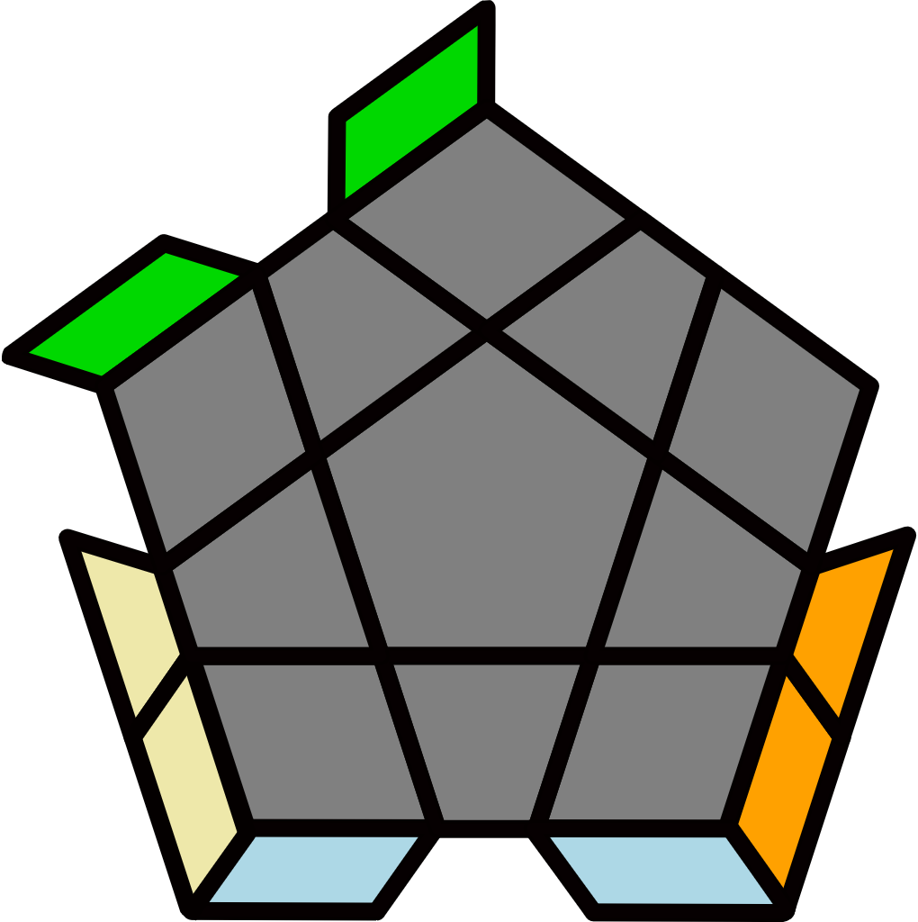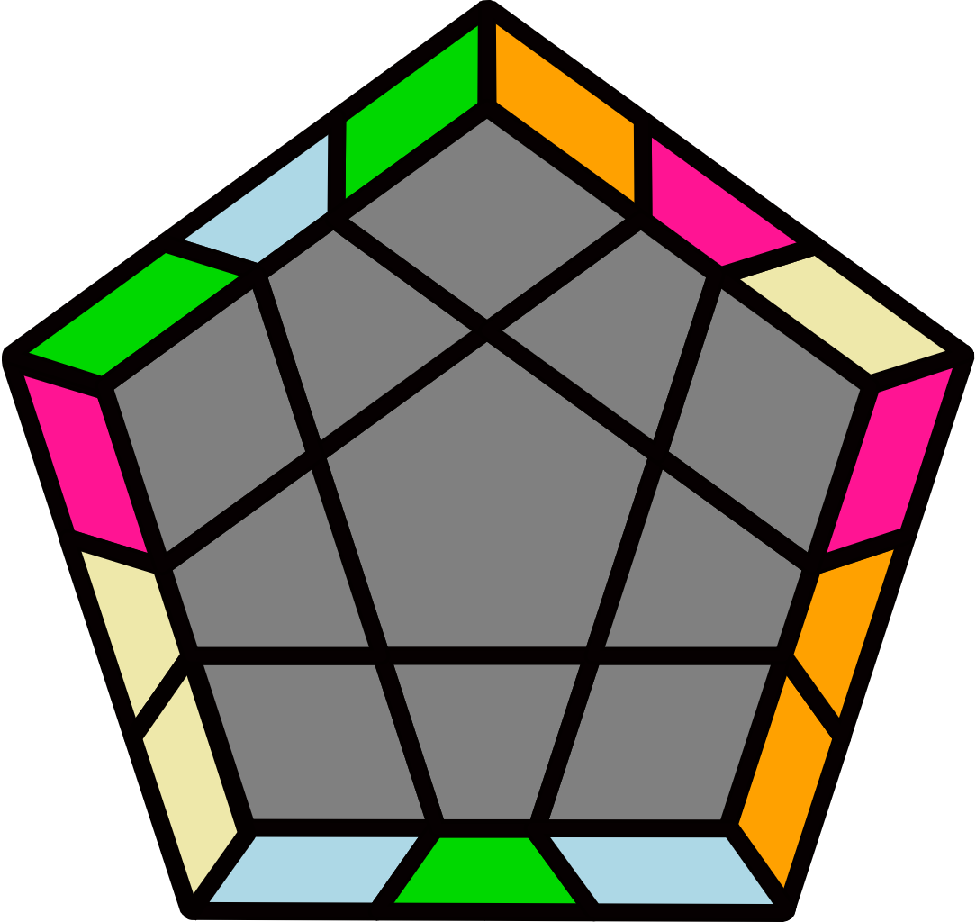 |  | 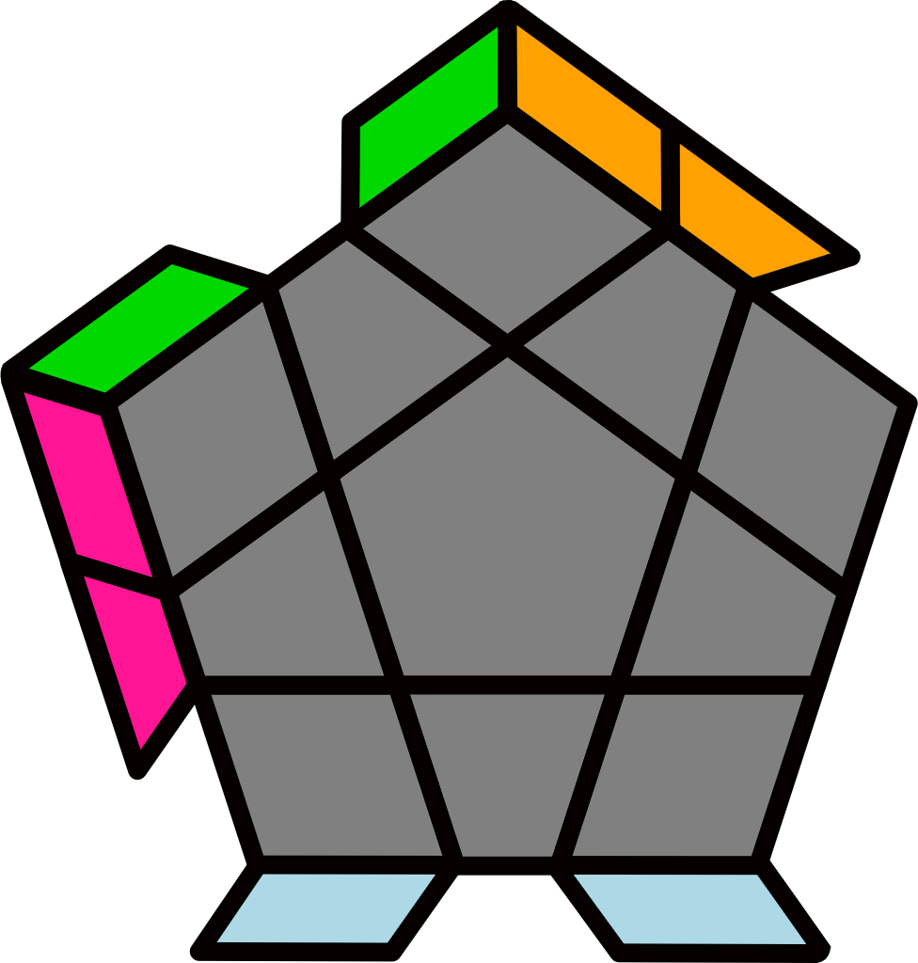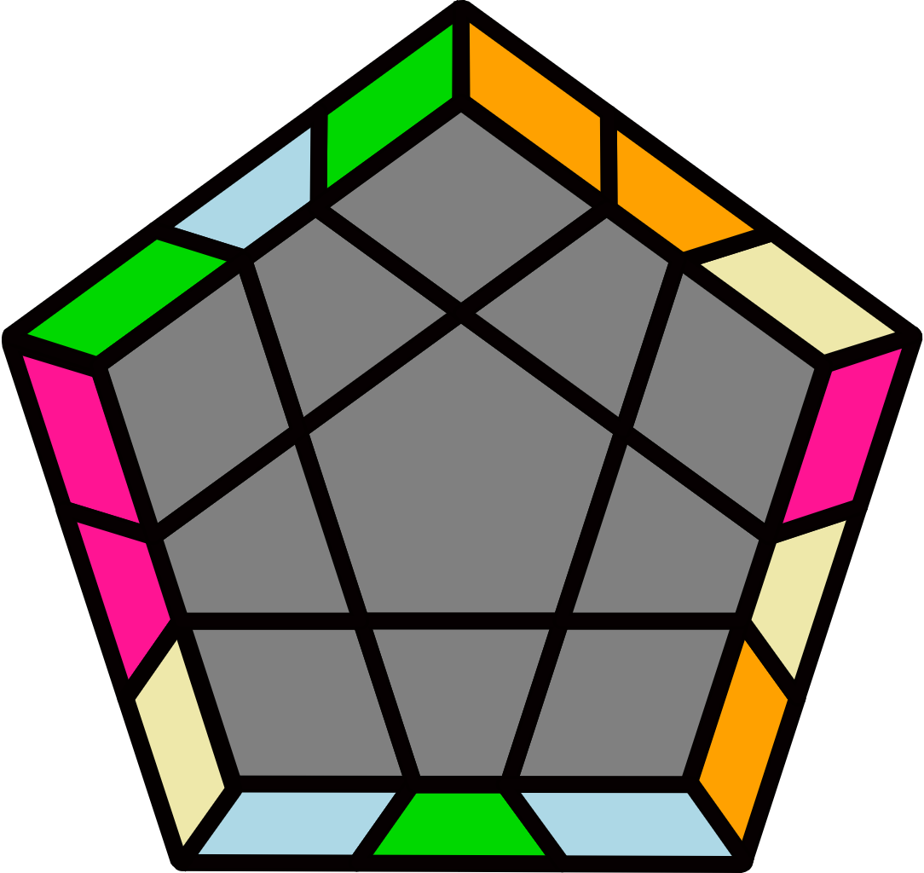 |  |  |  |  | 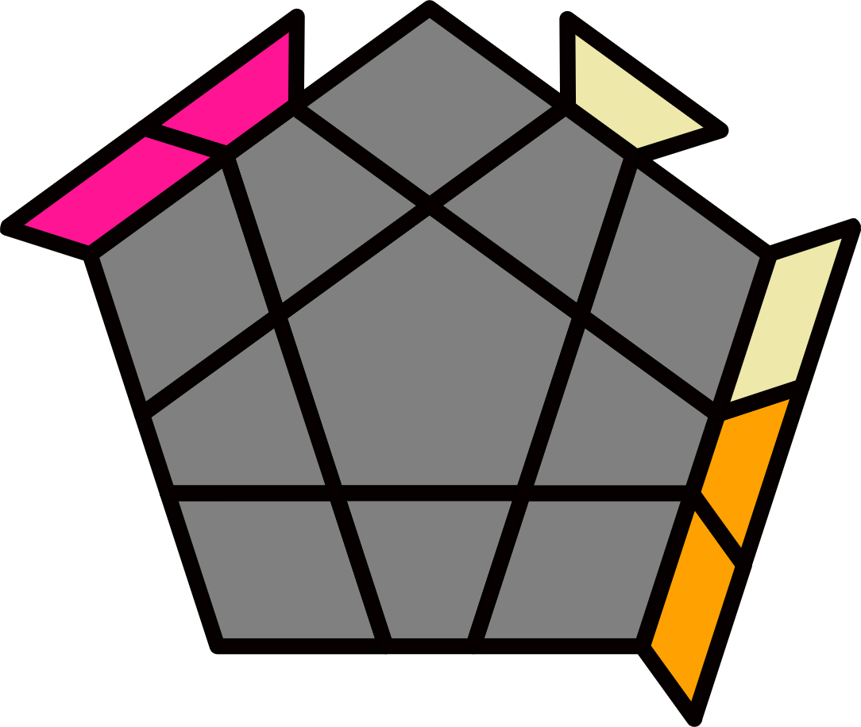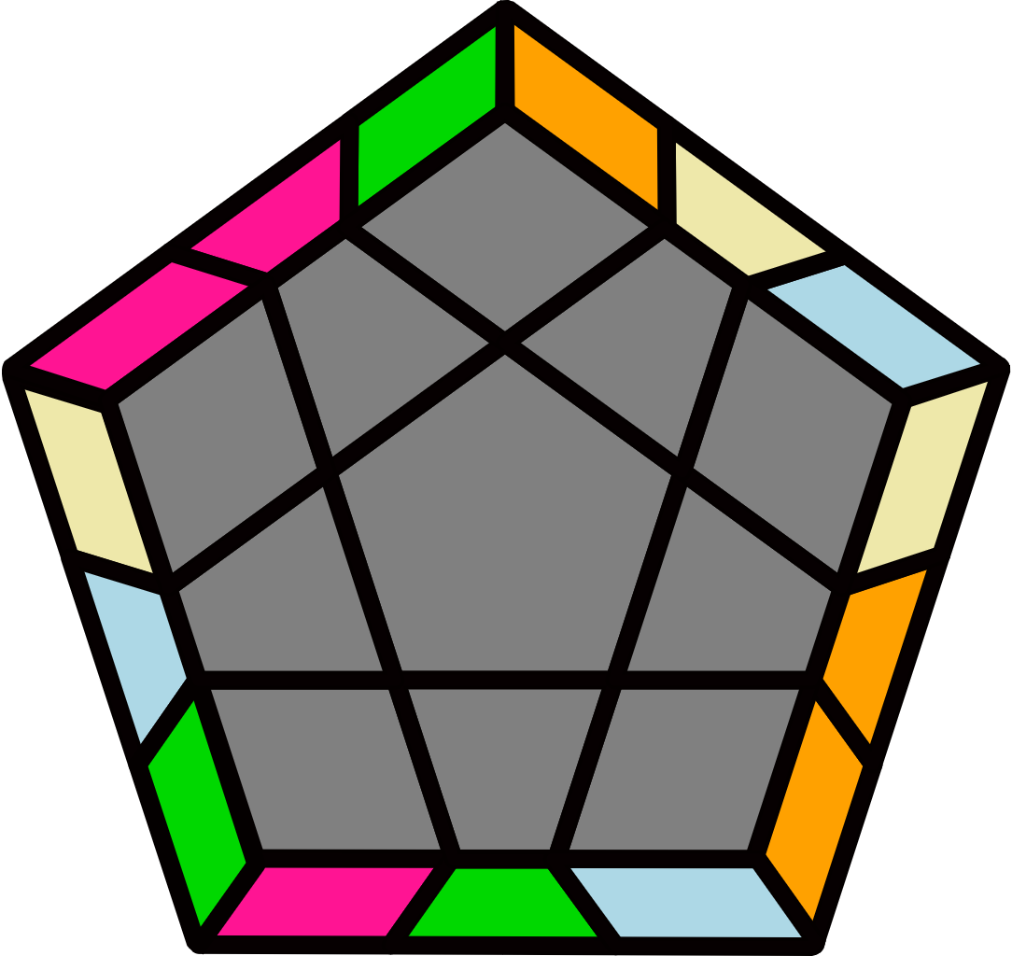 |  |  |  |  | 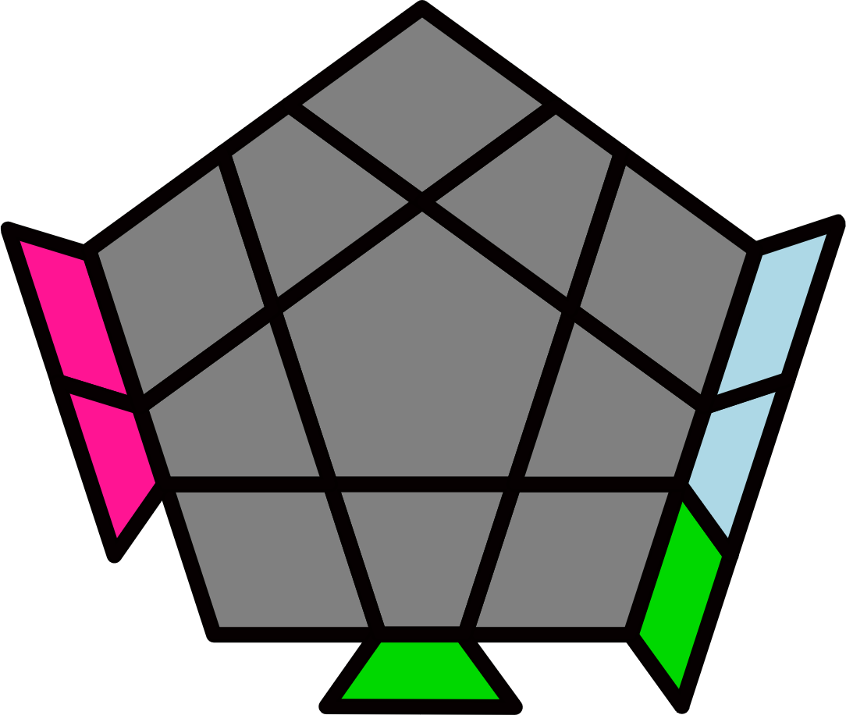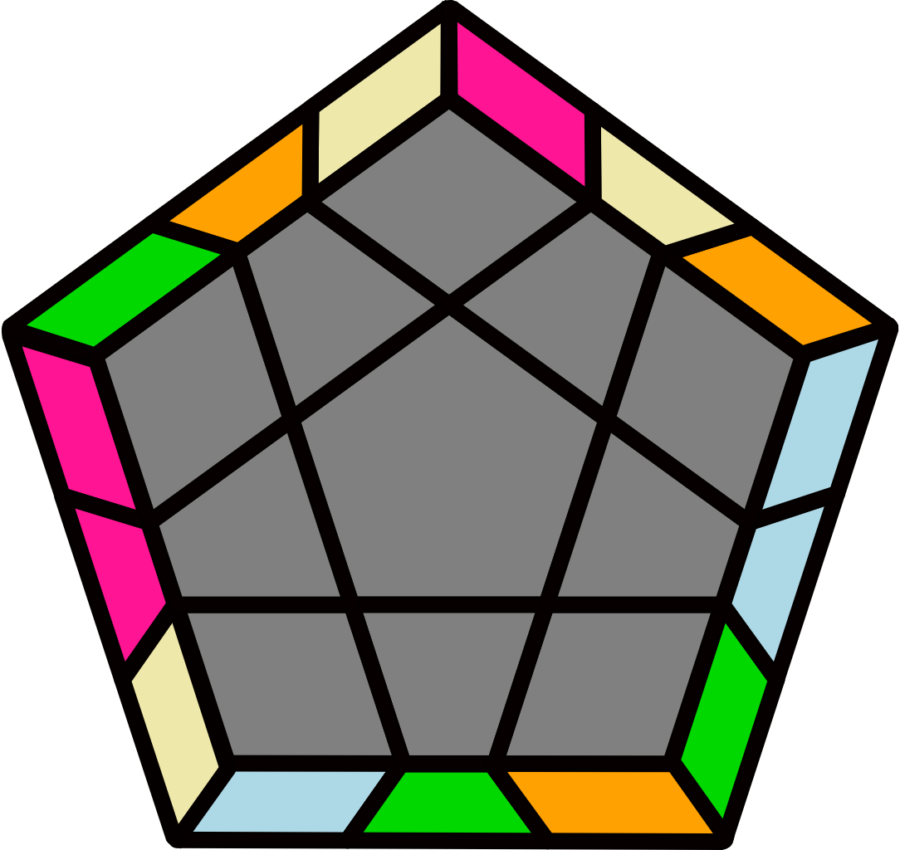
(R' U2' R U2 R' F R U R' U' R' F' R2) |  | (R2' F R U) (R U' R' F')  (R U2' R' U2 R) |  |  |  |  | (R2 U2 R2' U) (R2 U' R2' U) R2 U2 R2' |  |  |  |  | (R2 U2' R2' U') (R2 U R2' U') R2 U2' R2'
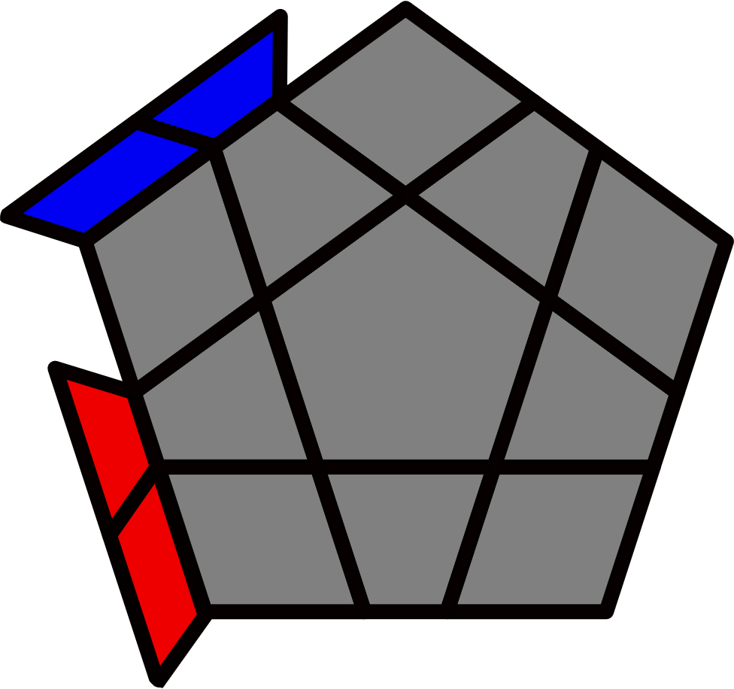Adj Bars [12]
H+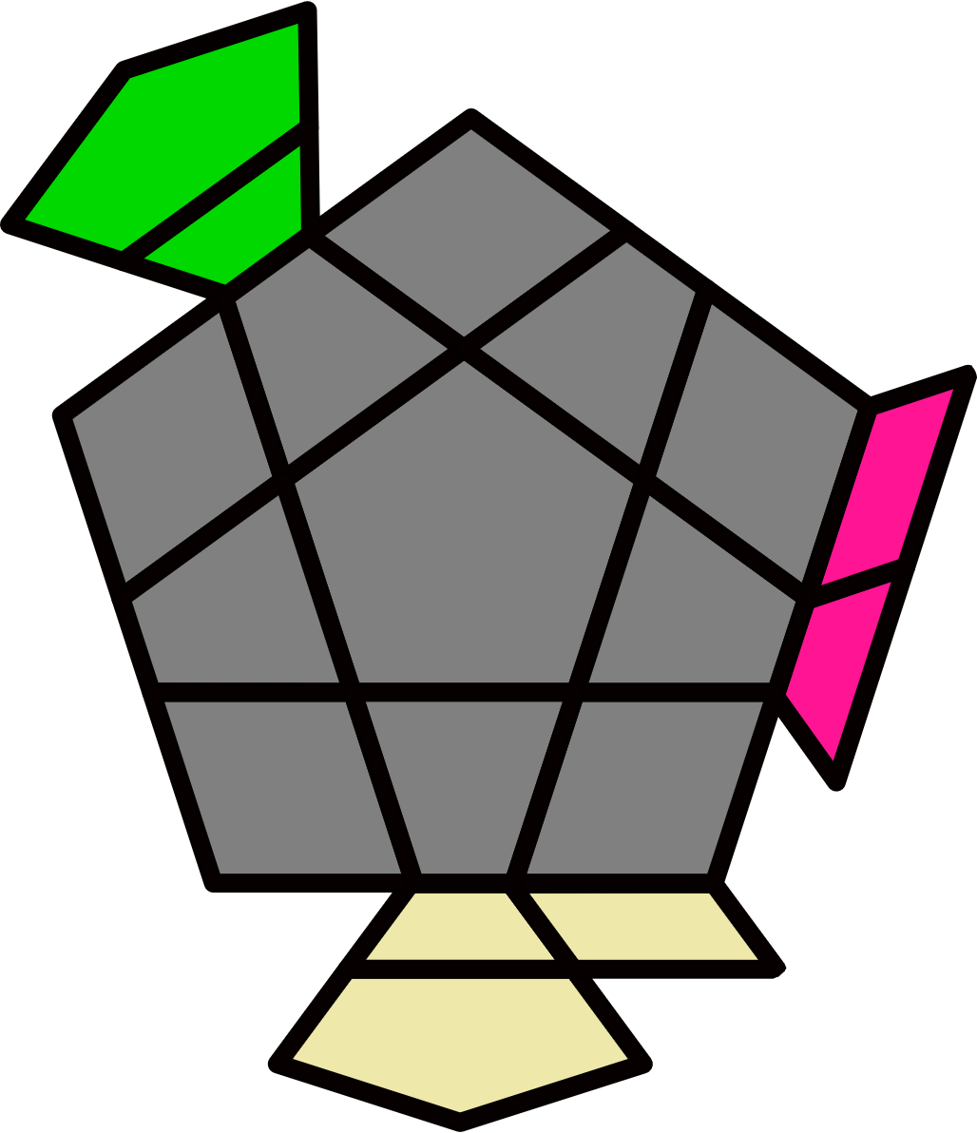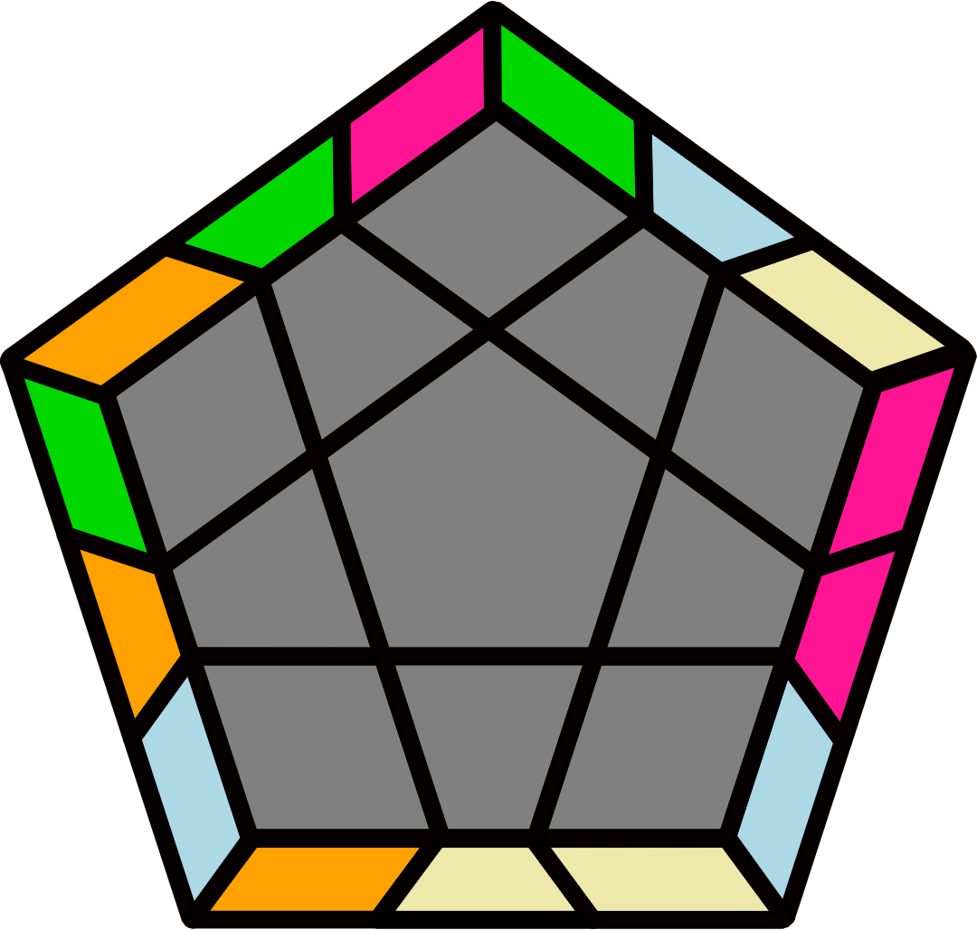 |  | H-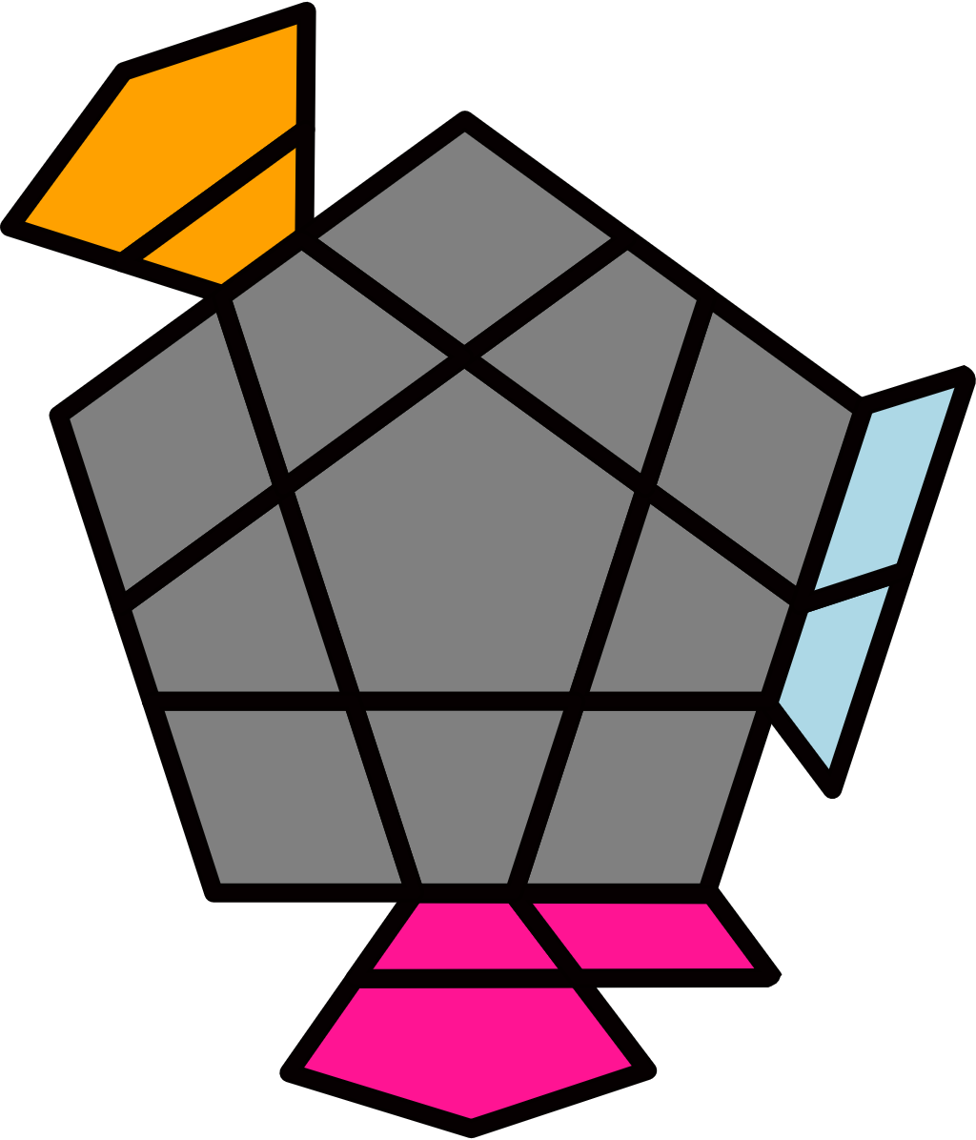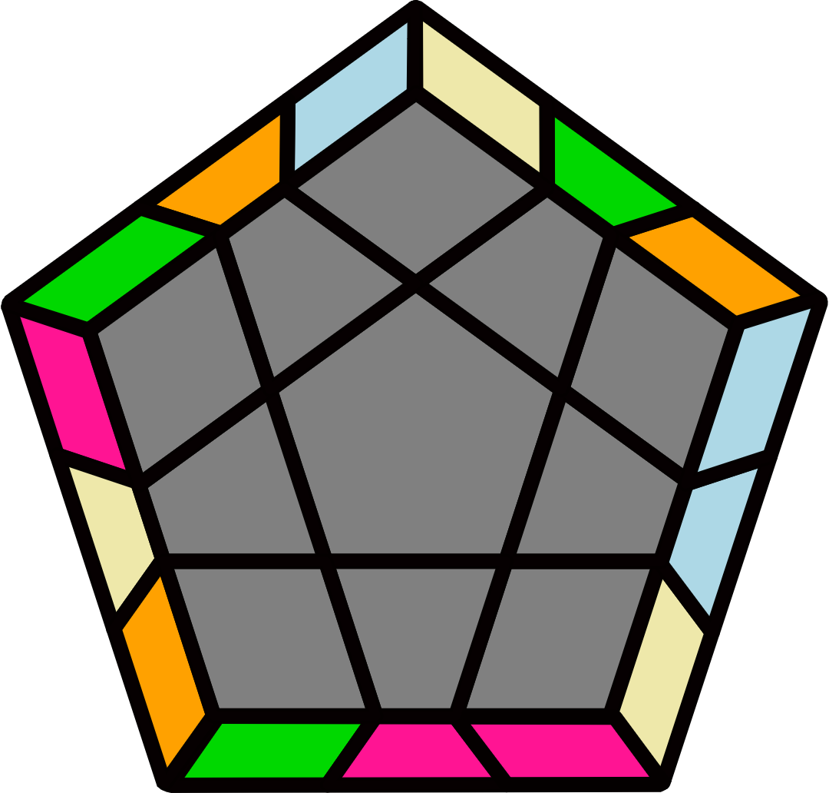 |  |  |  |  | H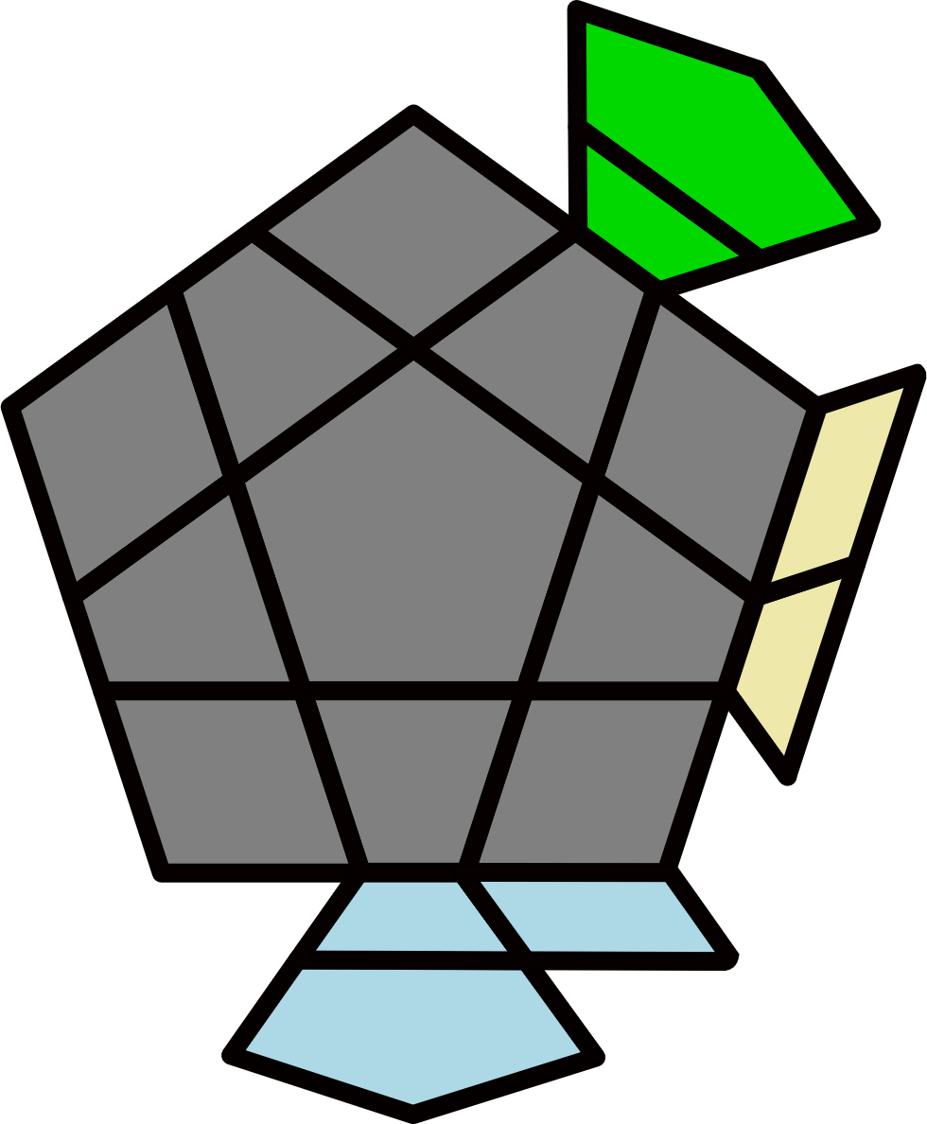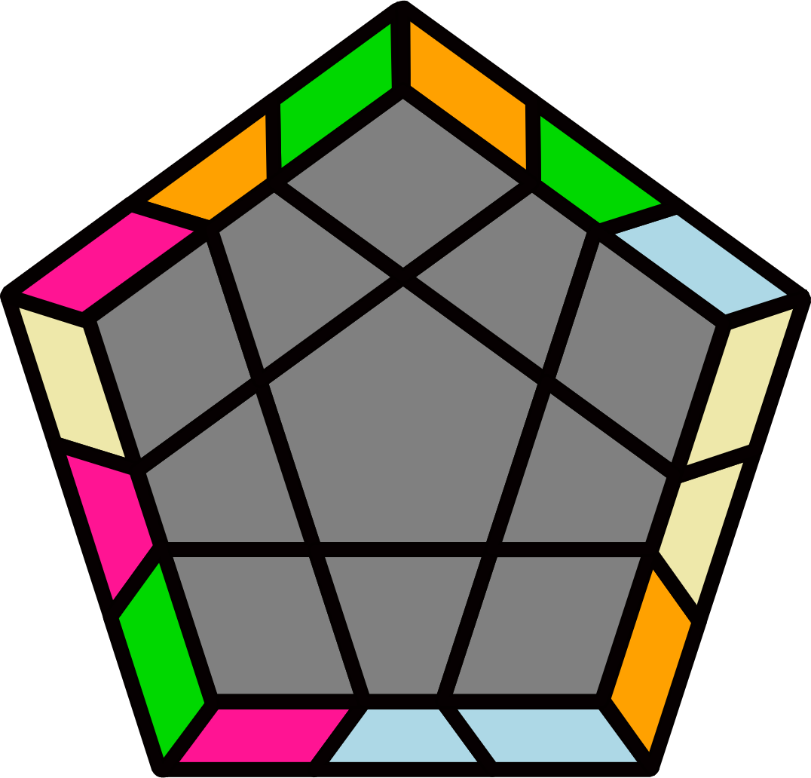 |  |  |  |  | S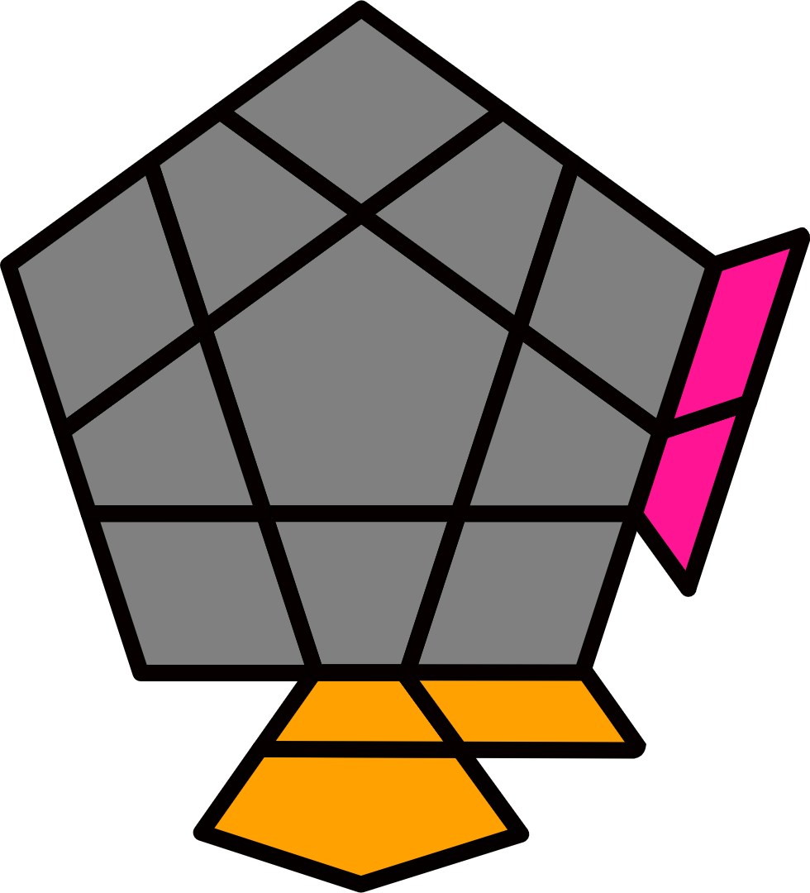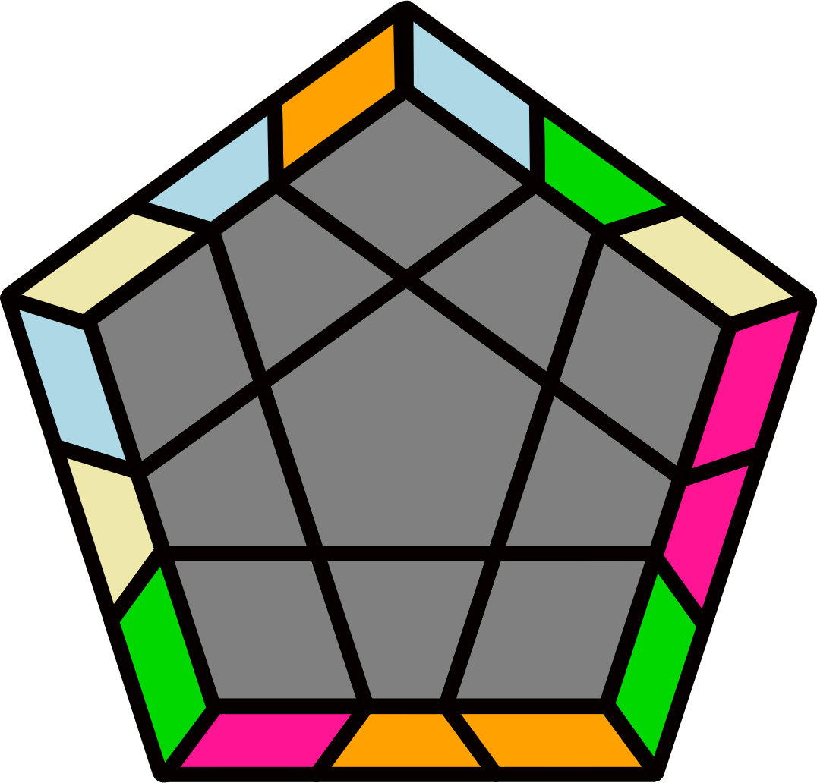
y2' B (R U R' U) (R U R' U') (R U' R' U') B' (U2' R U2 R') |  | y (R2' U2' R2 U' R2' U2' R2) U' (R2 U2 R2' U R2 U2 R2') |  |  |  |  | y' (R U2 R' U2) (R' U2' R2 U') (R' U R' U2) (R U2 R U' R') |  |  |  |  | y' (R U' R' U2) (R2 U R' U2) (R U' R' U') (R U' R' U' R')
B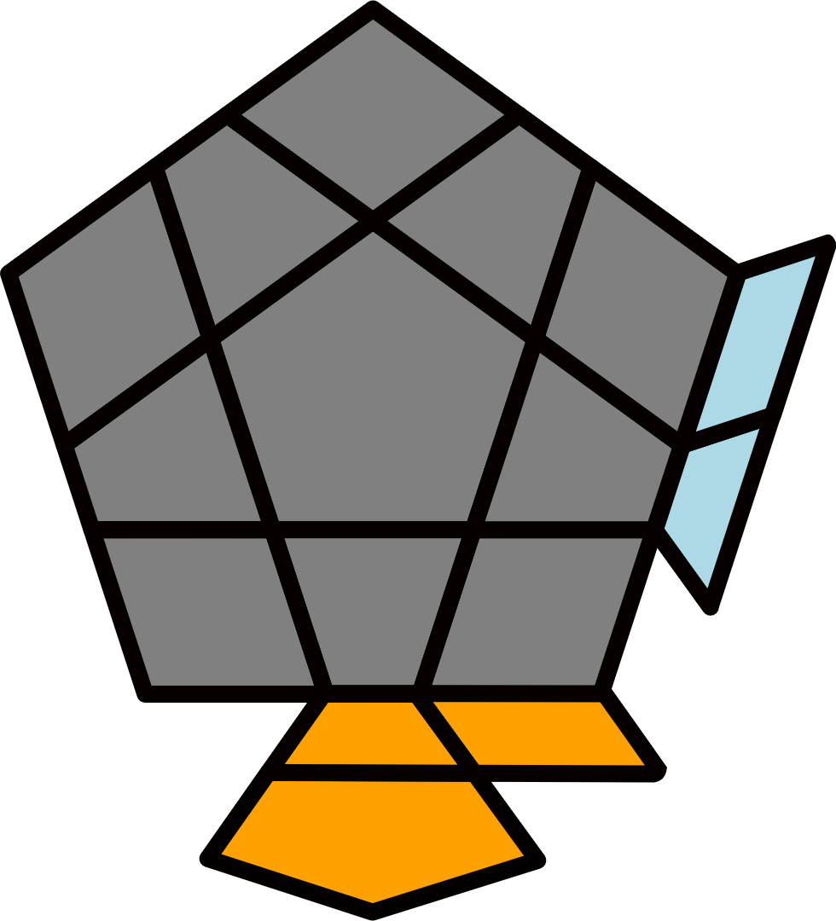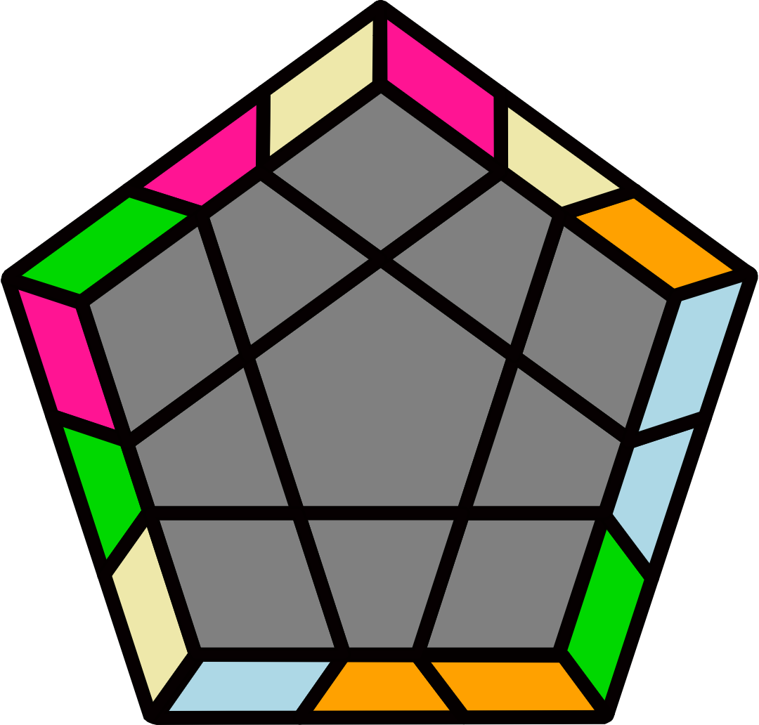 |  | M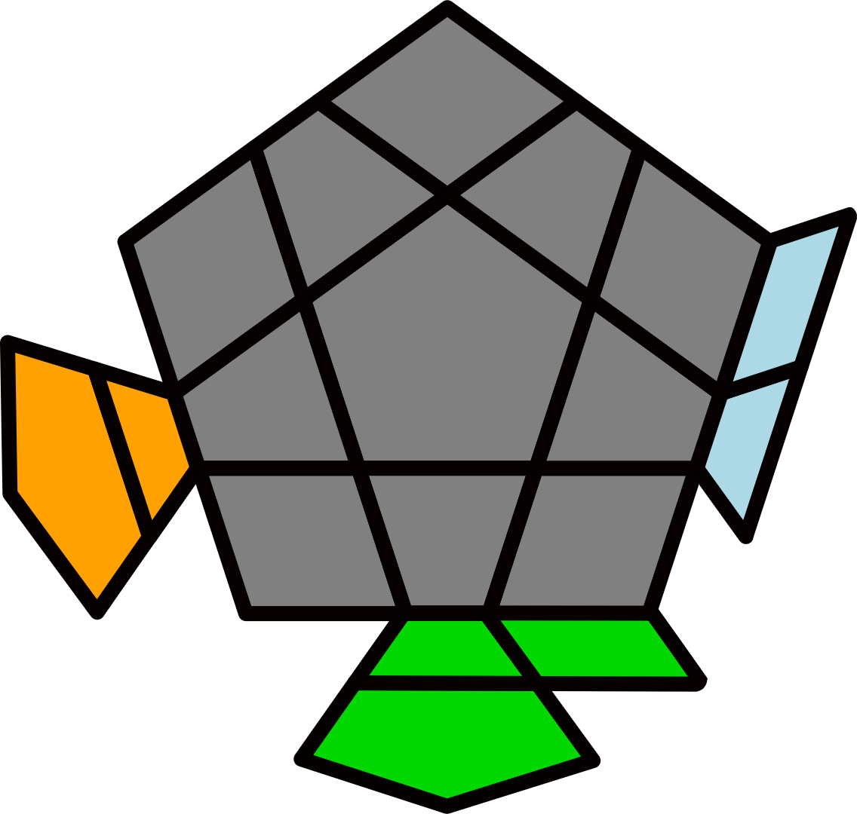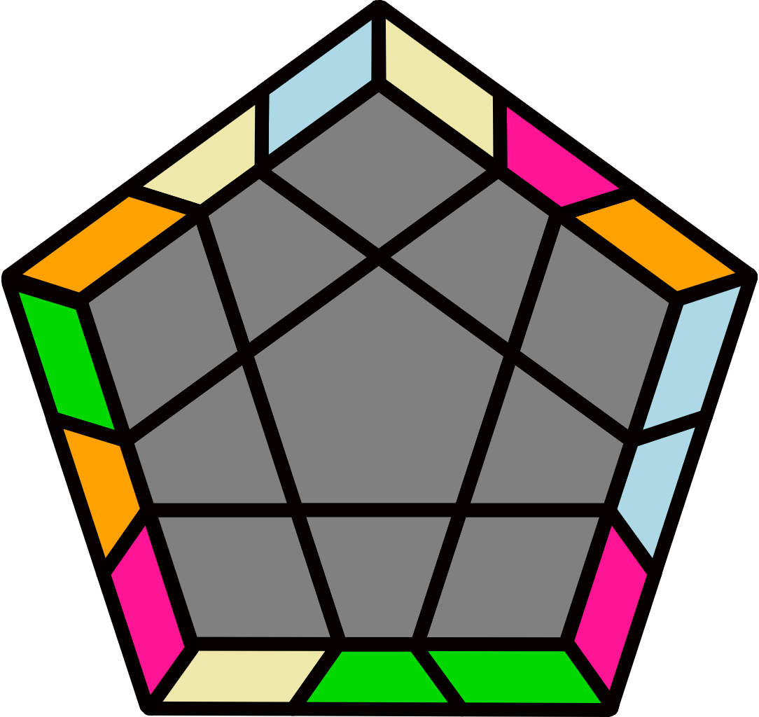 |  |  |  |  | H+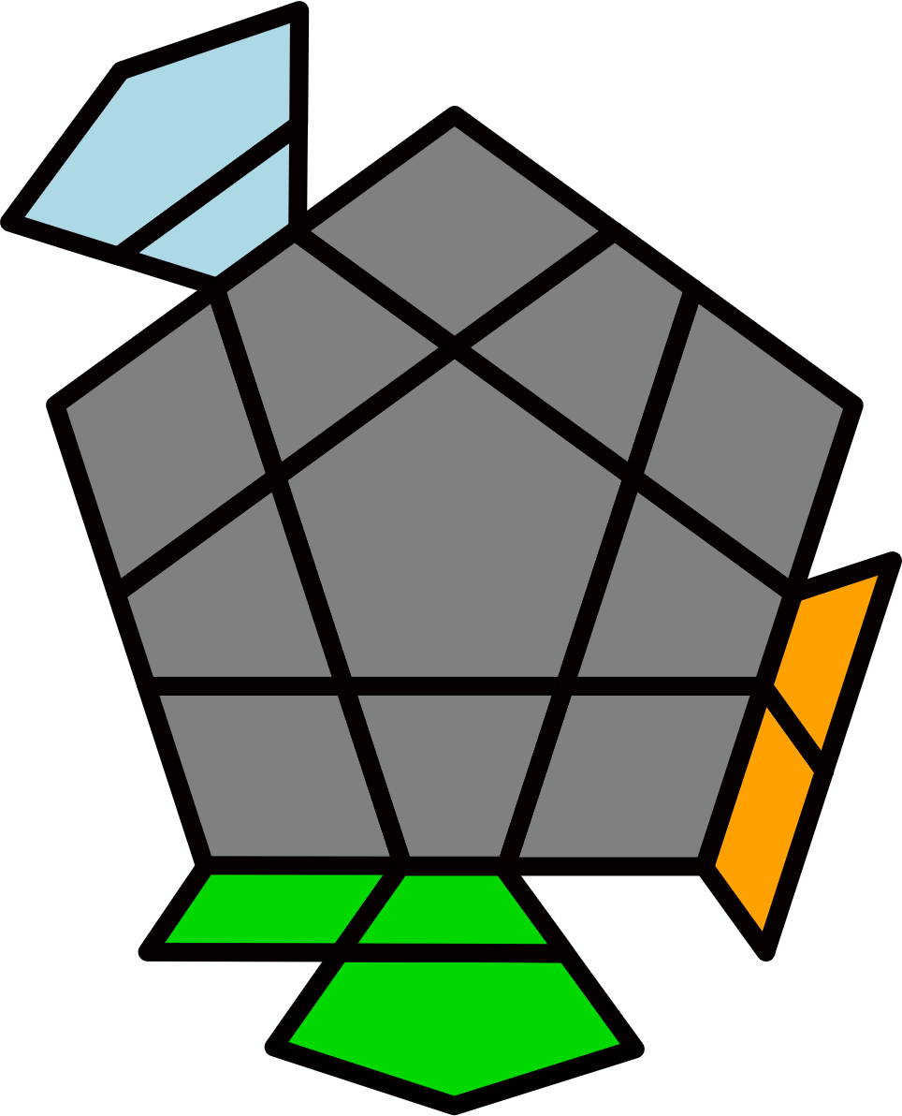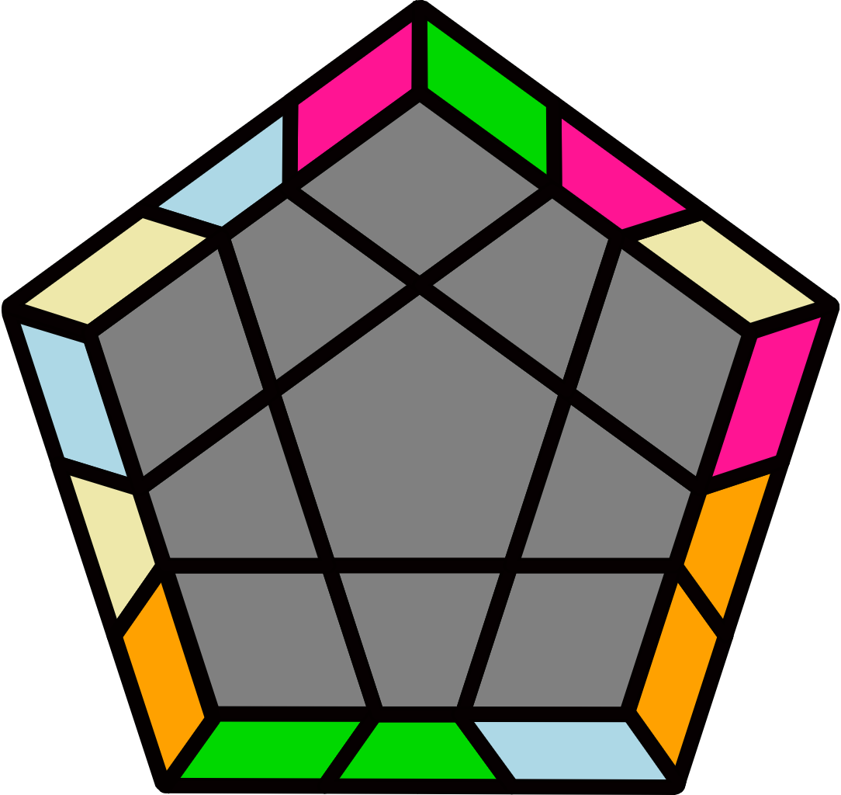 |  |  |  |  | H-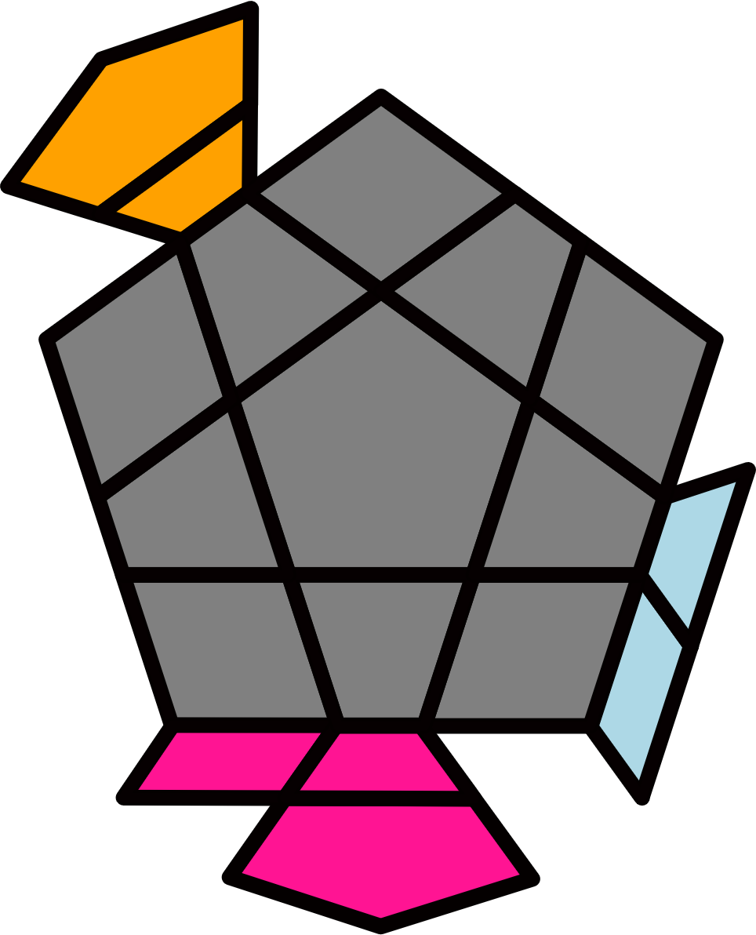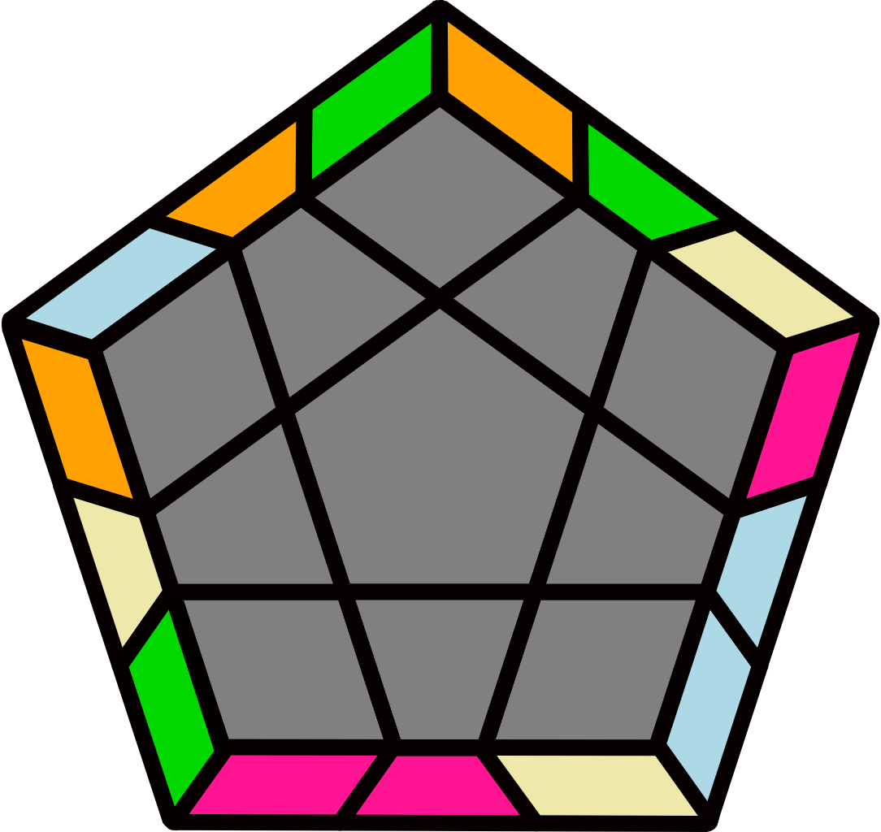
y (R2' U2 R2 U) (R2' U' R2 U2') (R2' U' R2 U2) R2' U2' R2 |  | (R U2 R' U2) (R U2 R U2) (R' U R' U') (R2 U2' R' U' R') |  |  |  |  | (R' U2' R U2') (R U2 R2' U) (R U' R U2') (R' U2' R' U R) |  |  |  |  | (R' U R U2') (R2' U' R U2') (R' U R U) (R' U R U R)
H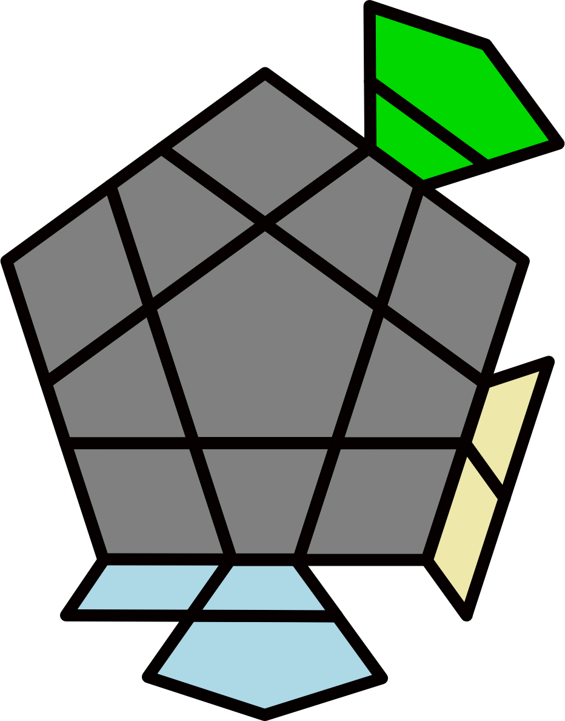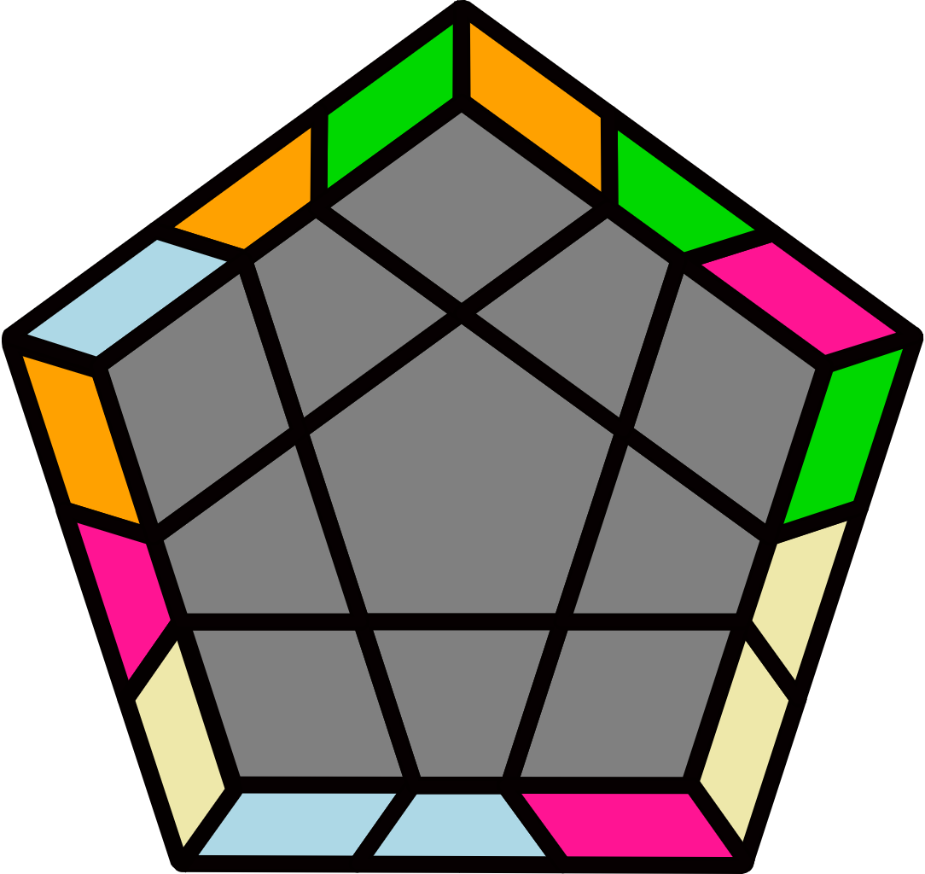 |  | S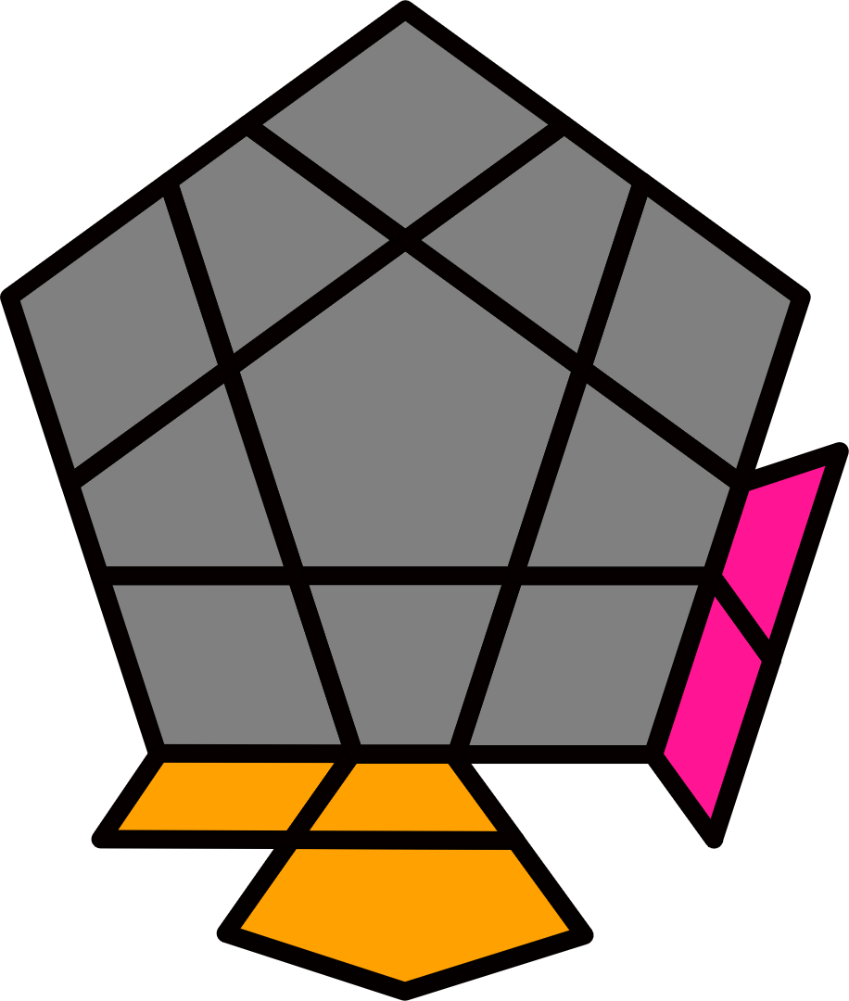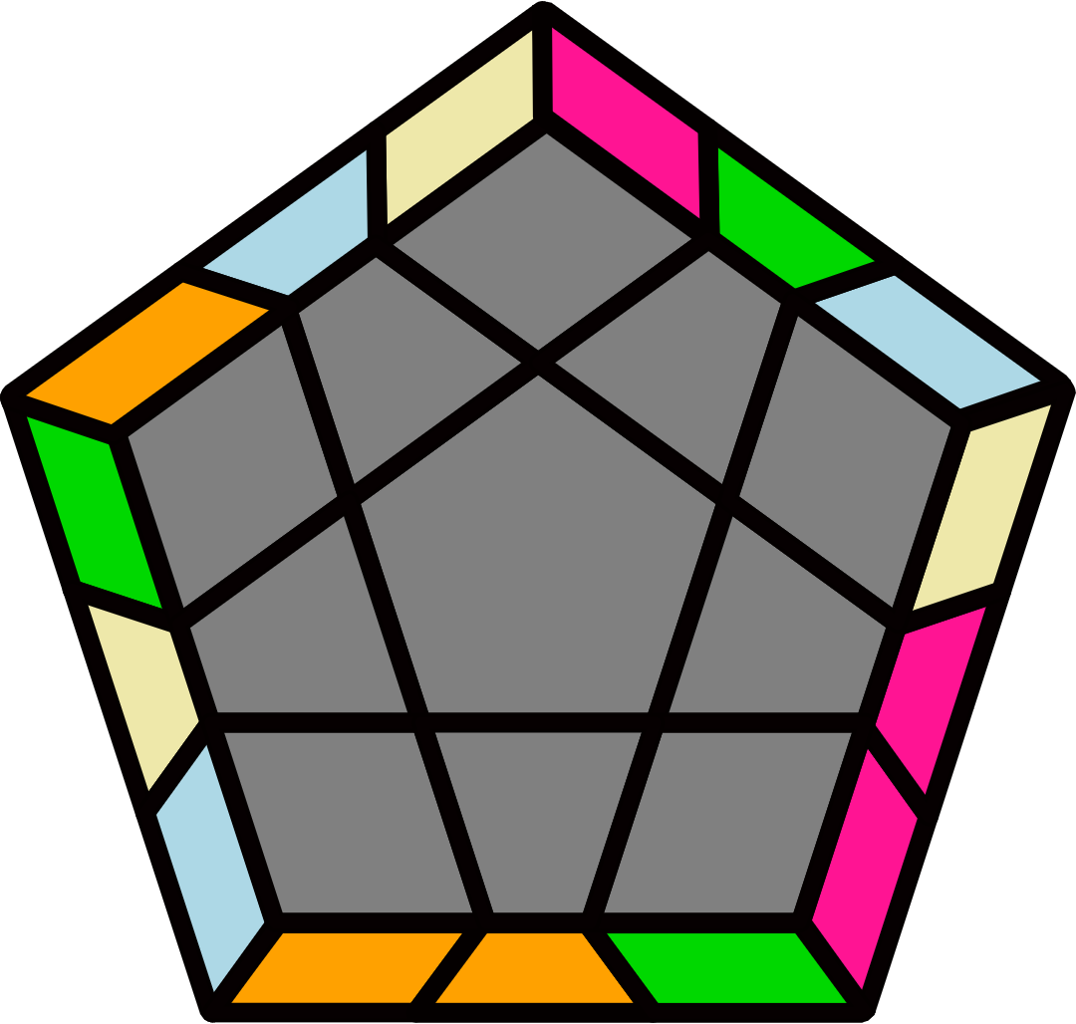 |  |  |  |  | B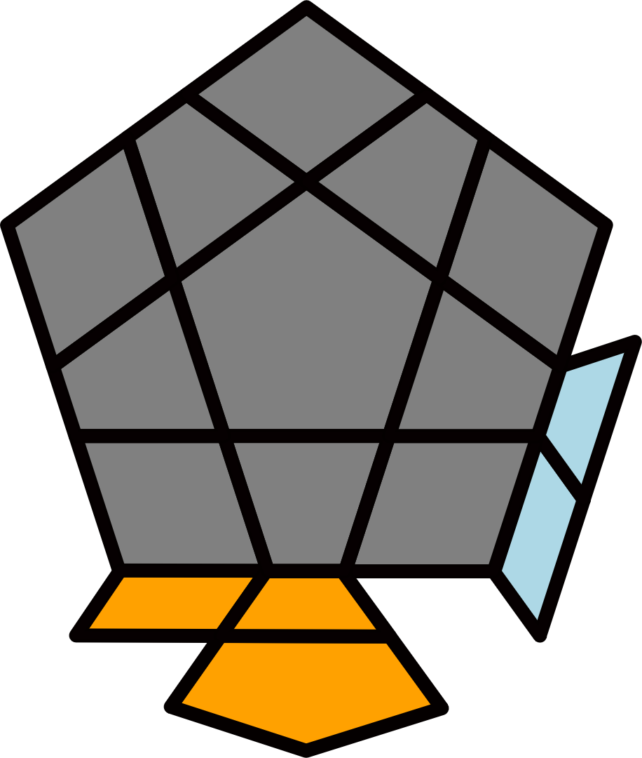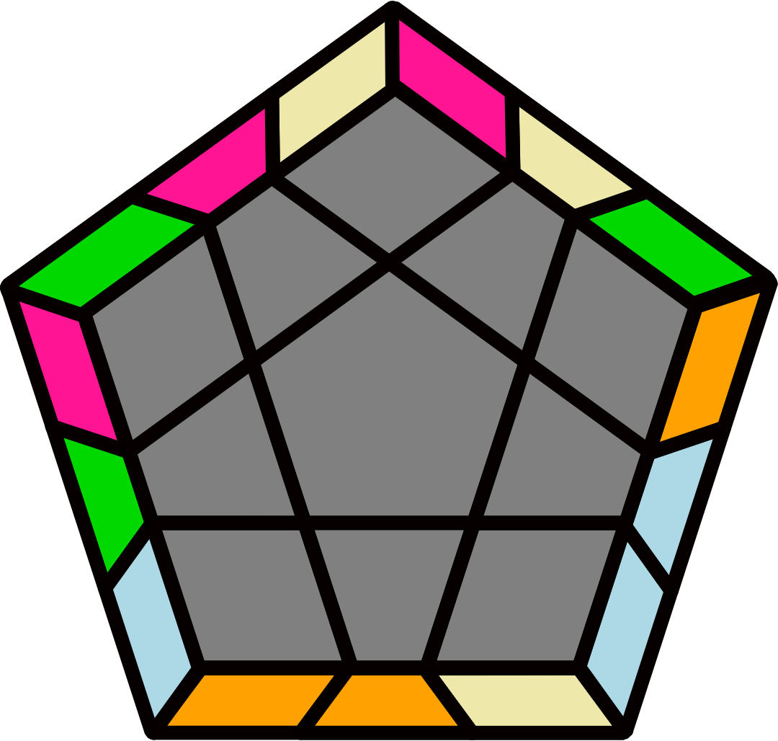 |  |  |  |  | X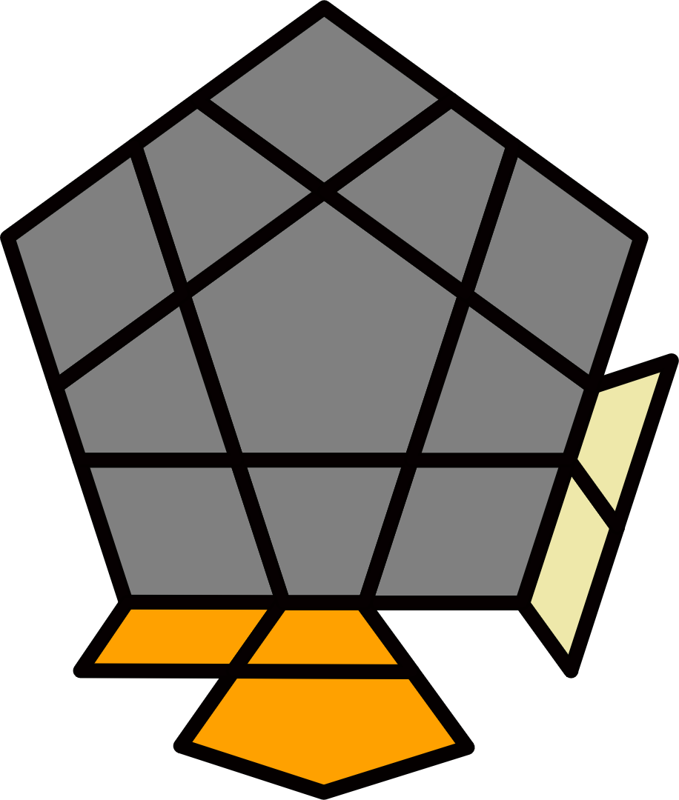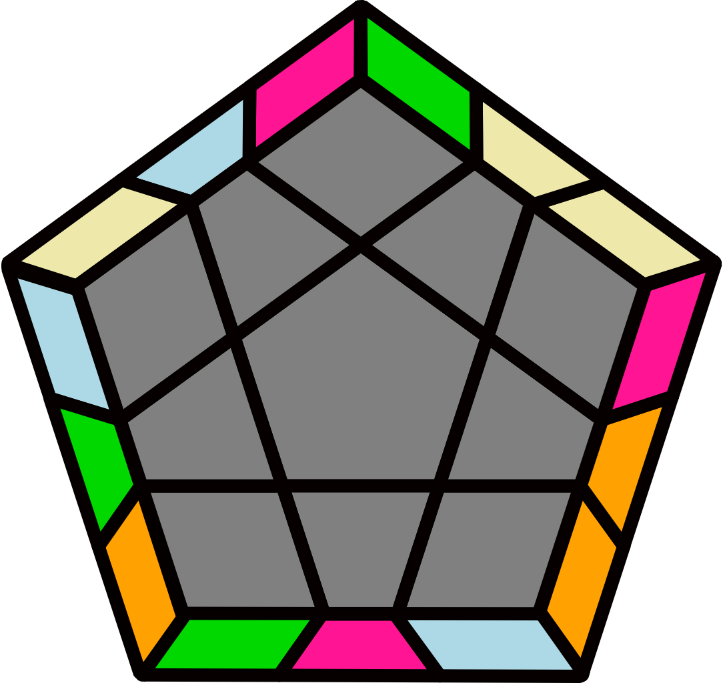
(R U R' U) (R' U2' R2 U) (R2' U R2 U2) (R' U' R U2' R') |  | y2' (R2 U2 R2' U R2 U2 R2') U (R2' U2' R2 U' R2' U2' R2) |  |  |  |  | y2' (R2 U2' R2' U') (R2 U R2' U2) (R2 U R2' U2') R2 U2 R2' |  |  |  |  | y' (R' U2' R U2') (R' U2' R' U2') (R U' R U) (R2' U2 R U R)
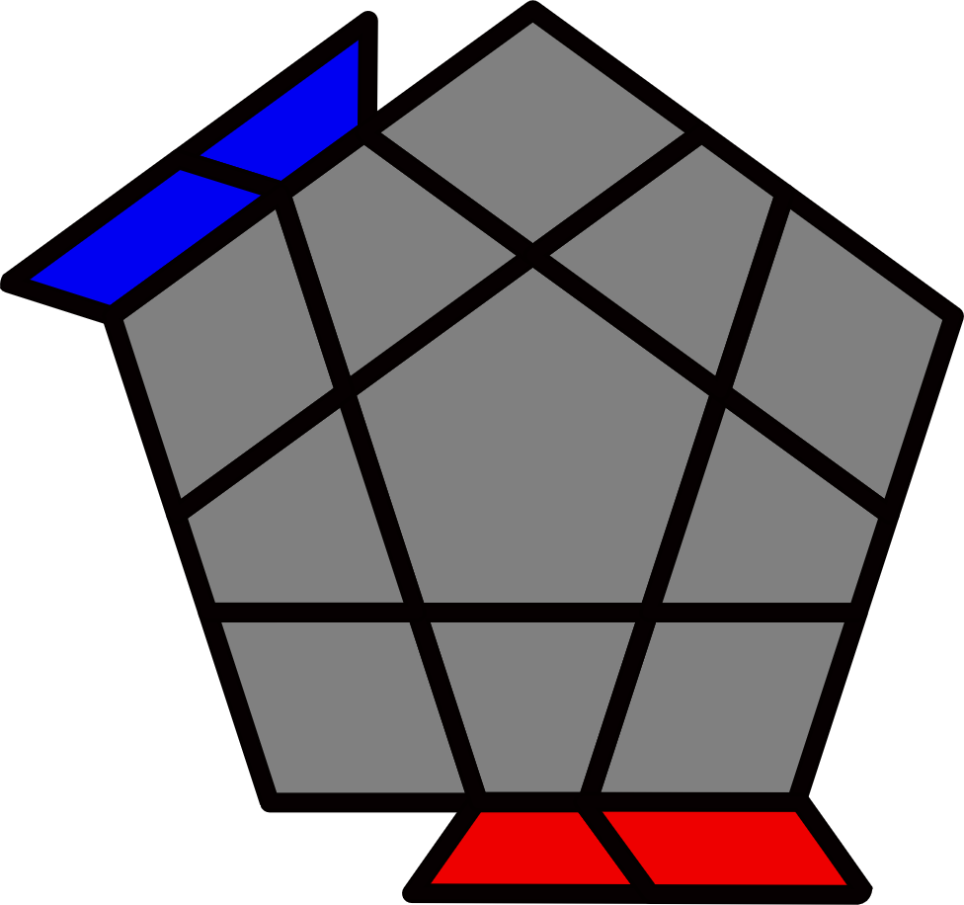Opp Bars [12]
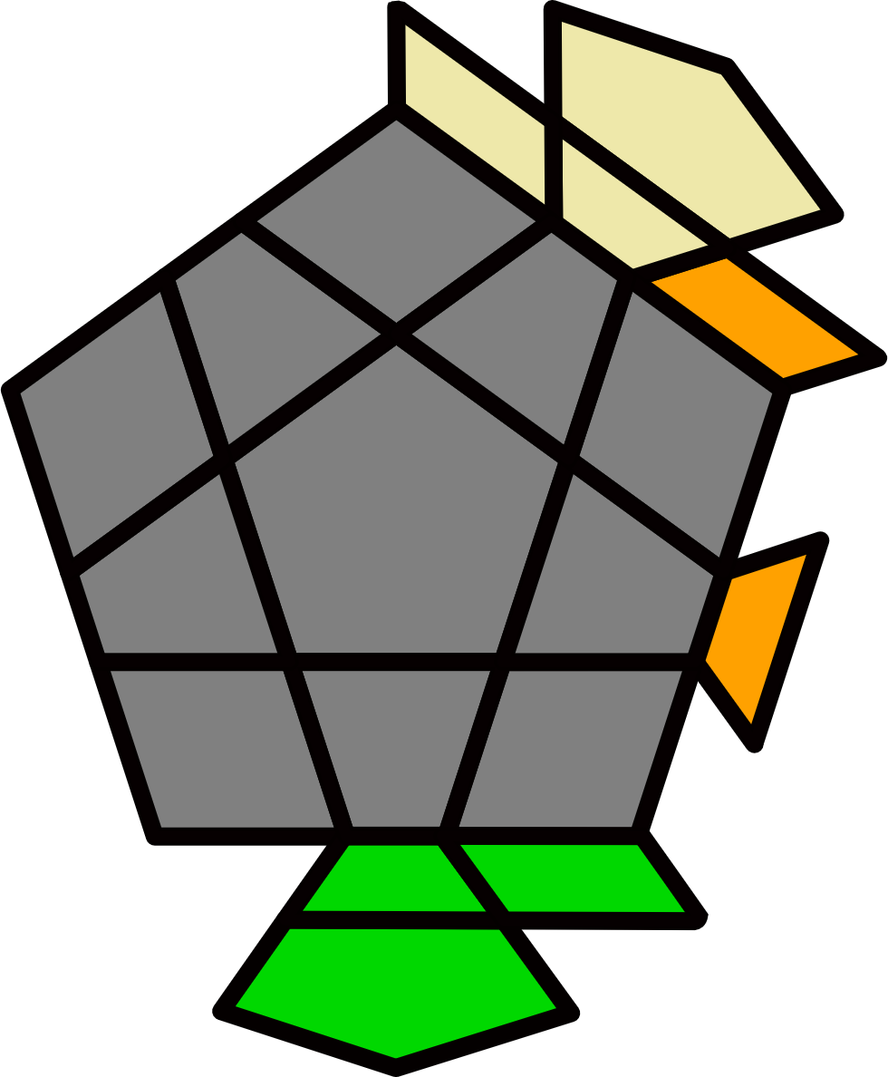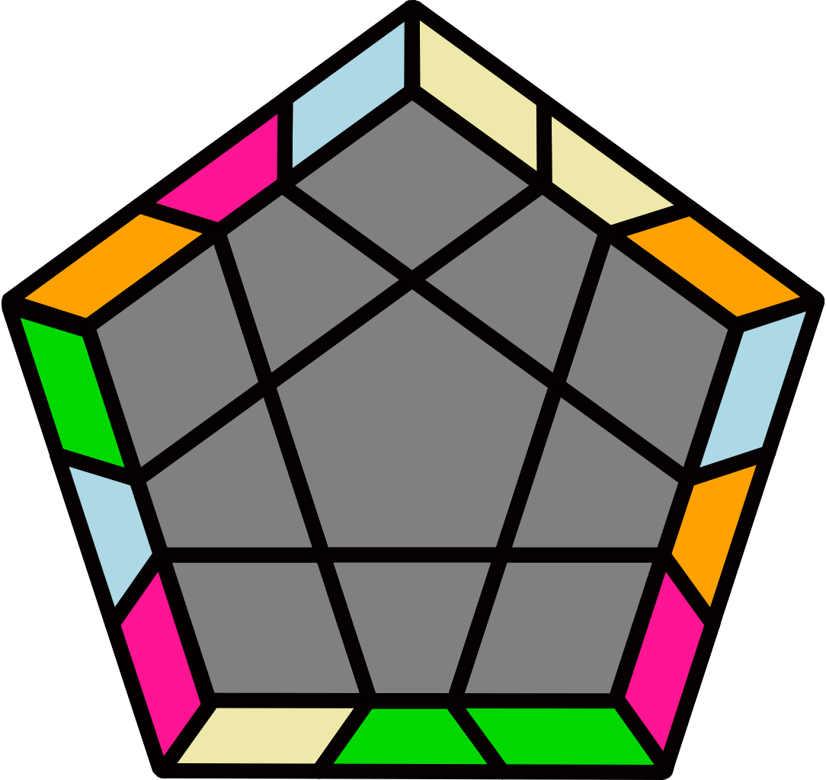 |  | 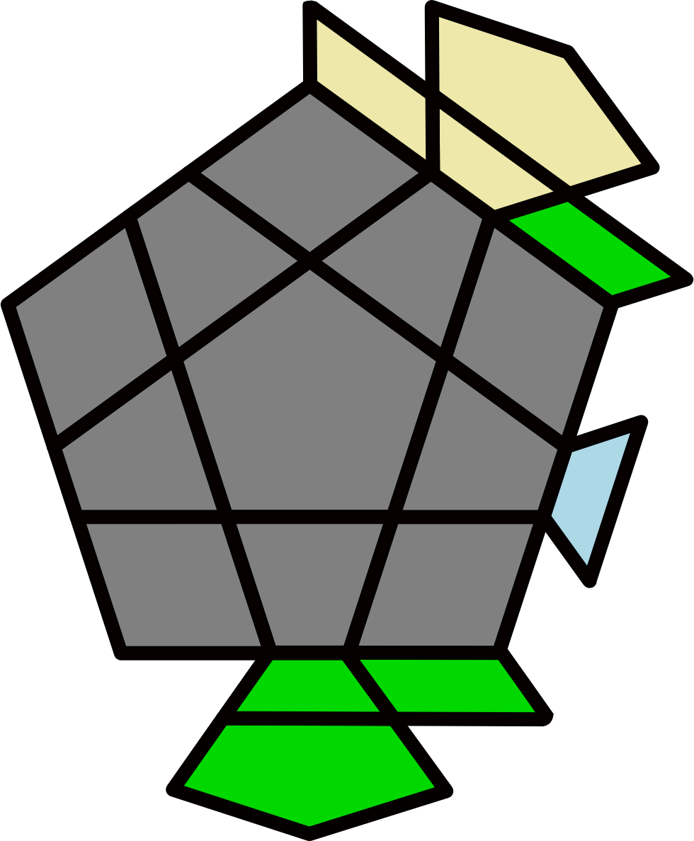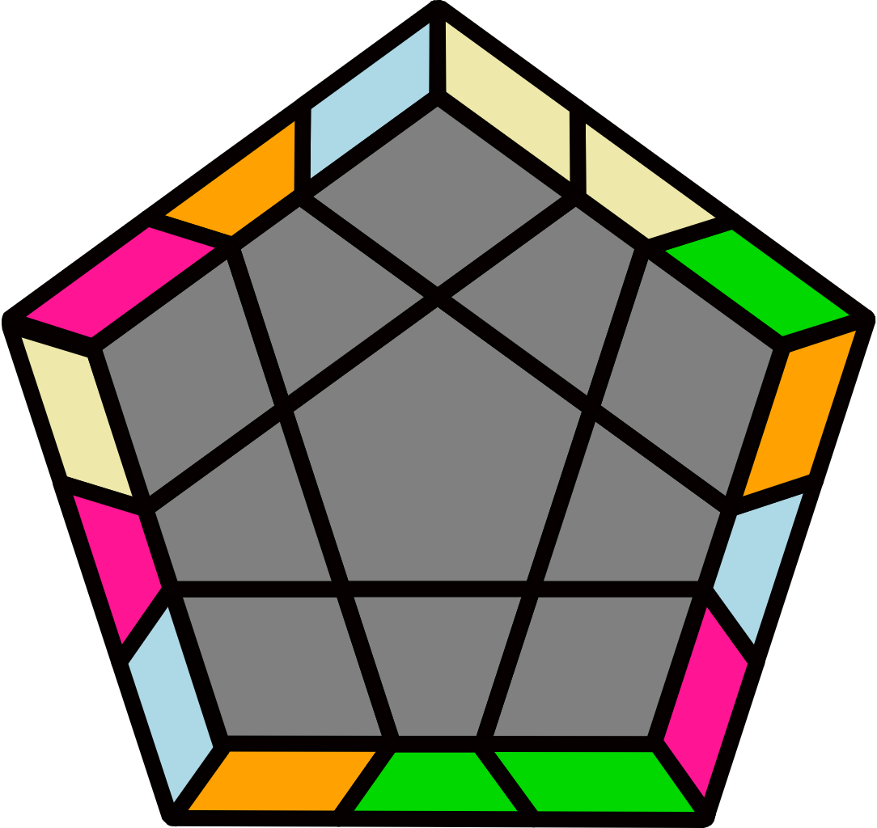 |  |  |  |  | 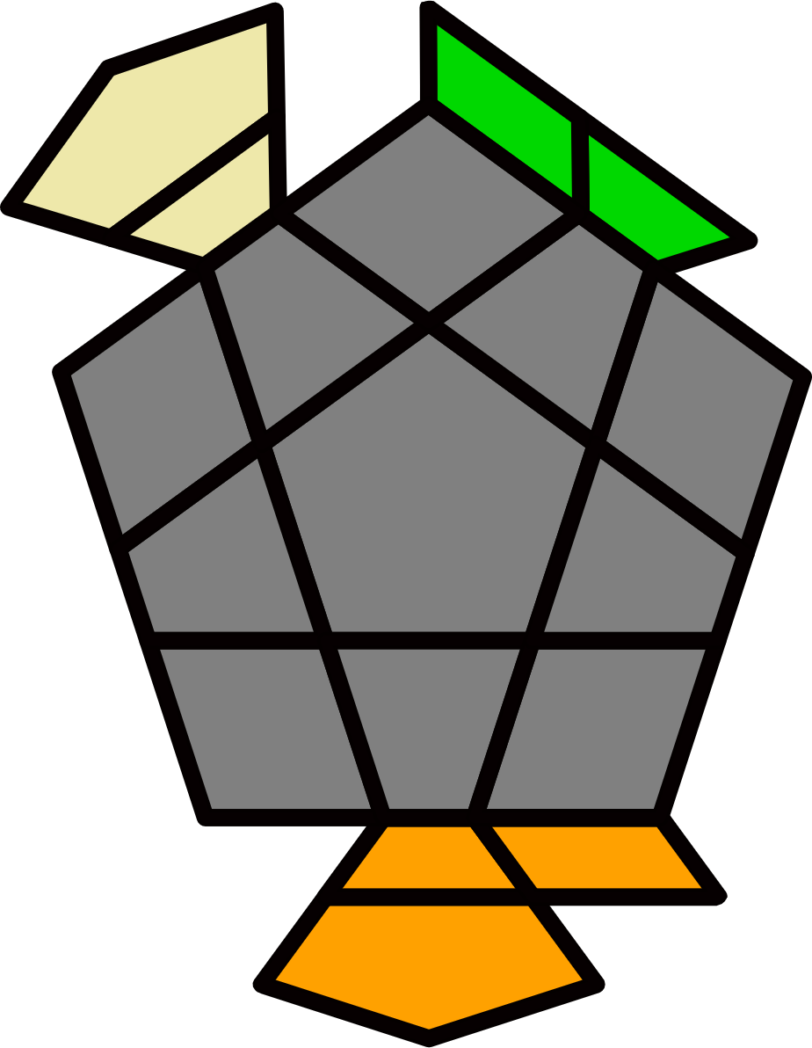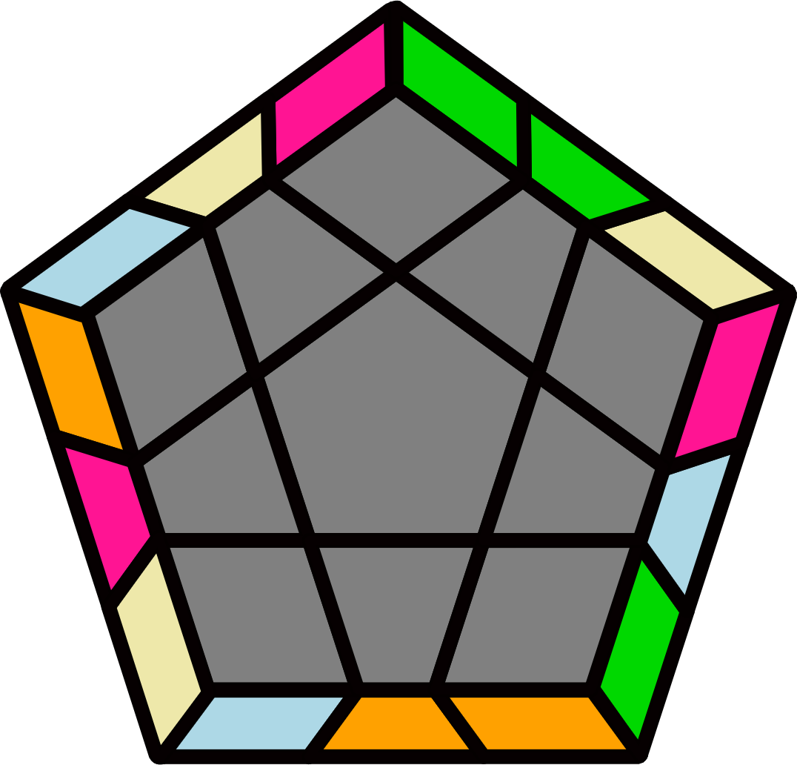 |  |  |  |  | 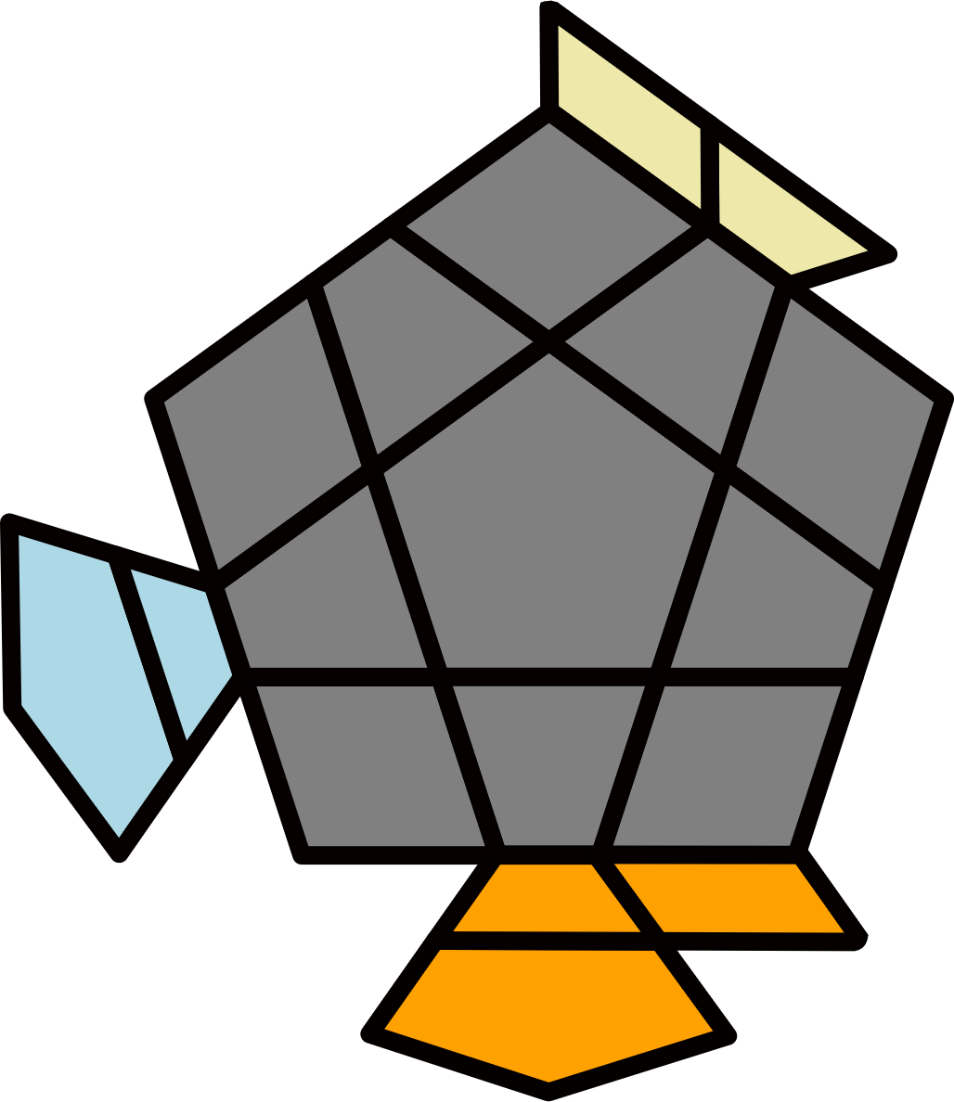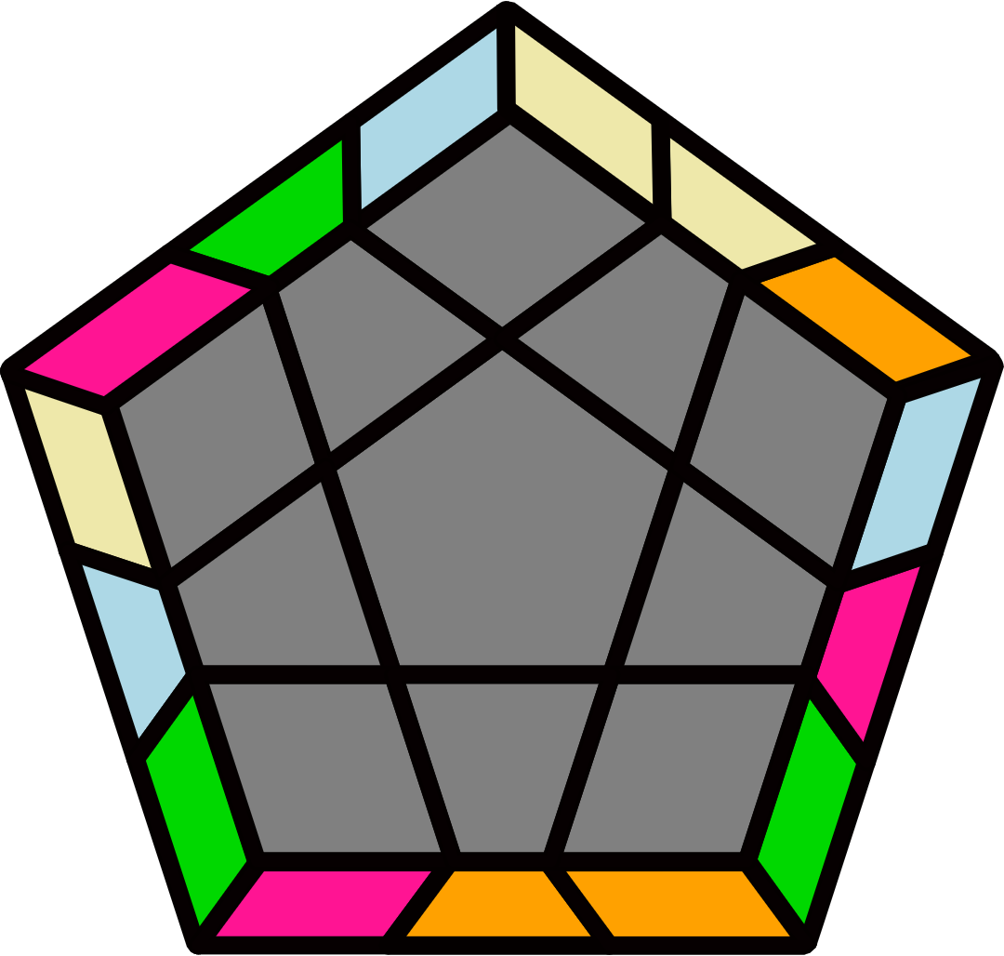
(R' U' R2 U') (R2' U2 R U) (R U2' R U) (R2' U2 R2 U2 R2') |  | (R2 U2' R2' U2') (R2 U' R' U2) (R' U' R' U2') (R2 U R2' U R) |  |  |  |  | y' (R2' U2' R2 U' R2' U2' R2) U (R2 U2 R2' U R2 U2 R2') |  |  |  |  | y2' (R U R' U2 R U2 R') U'  (R' U' R U' R' U2 R)
S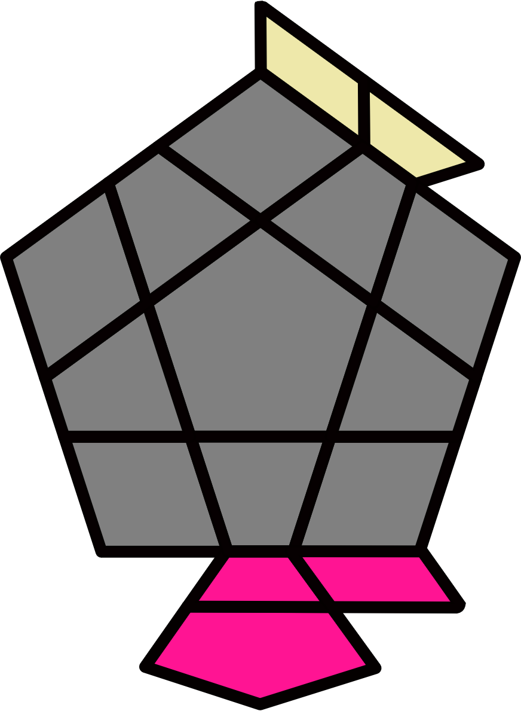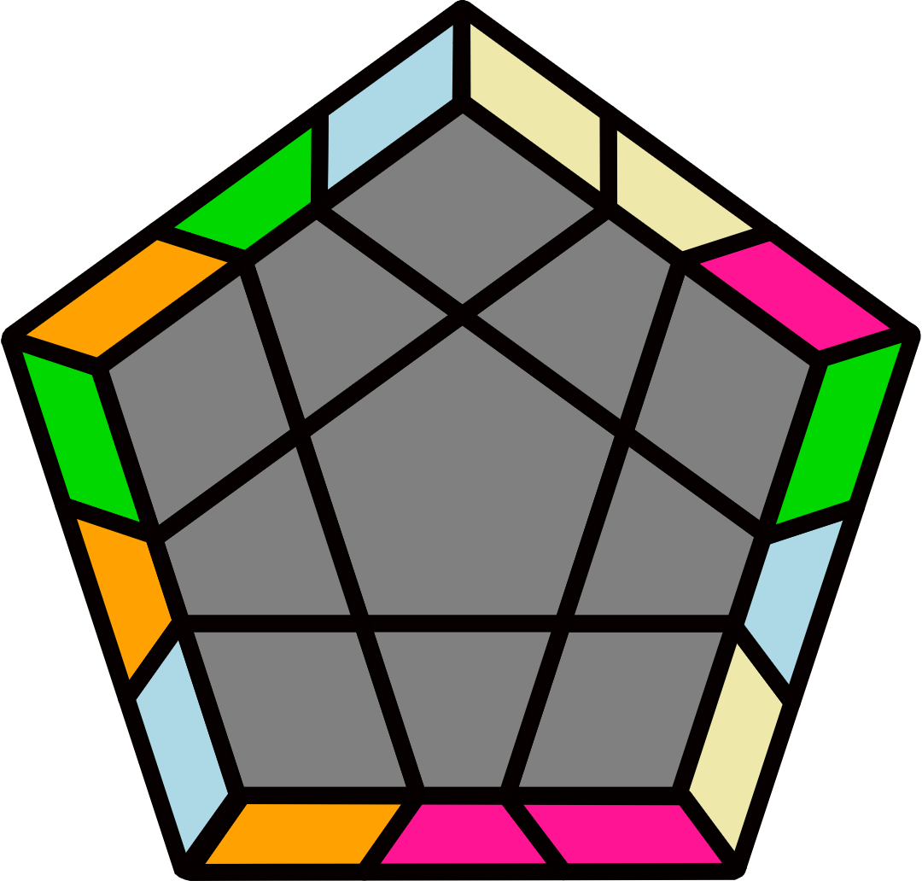 |  | X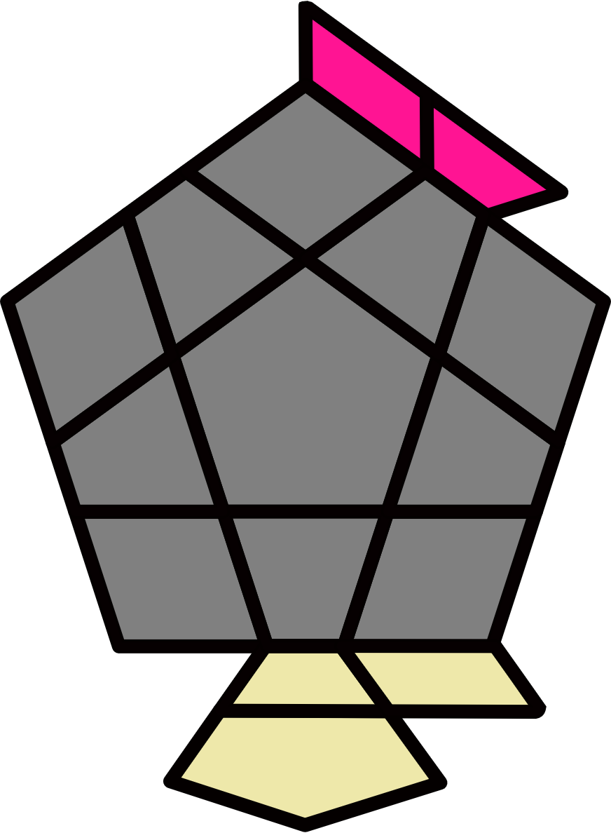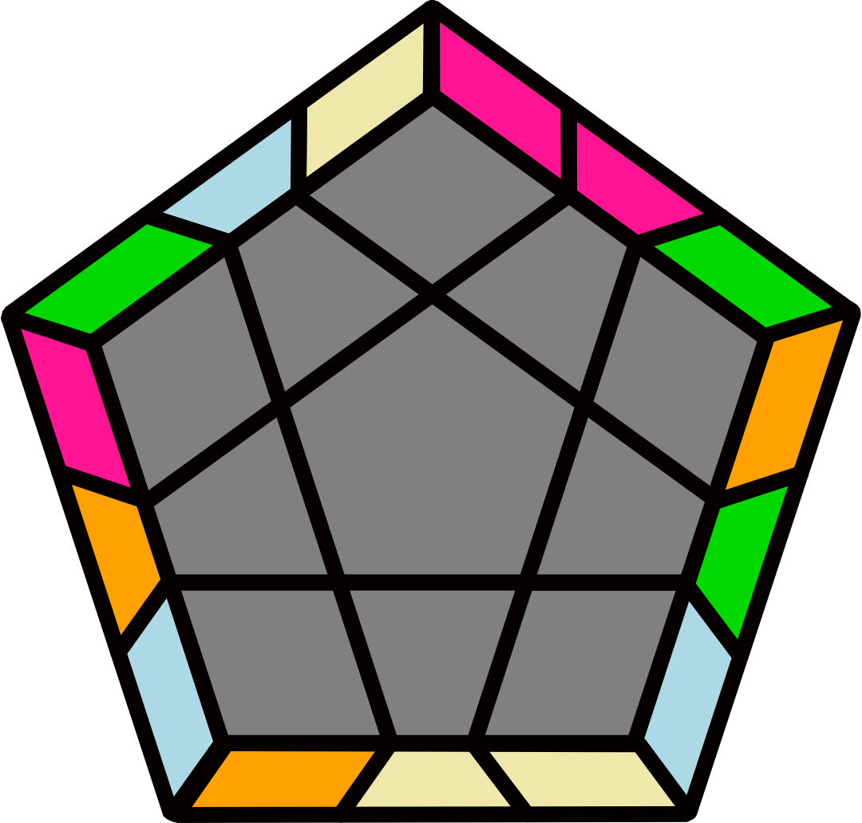 |  |  |  |  | 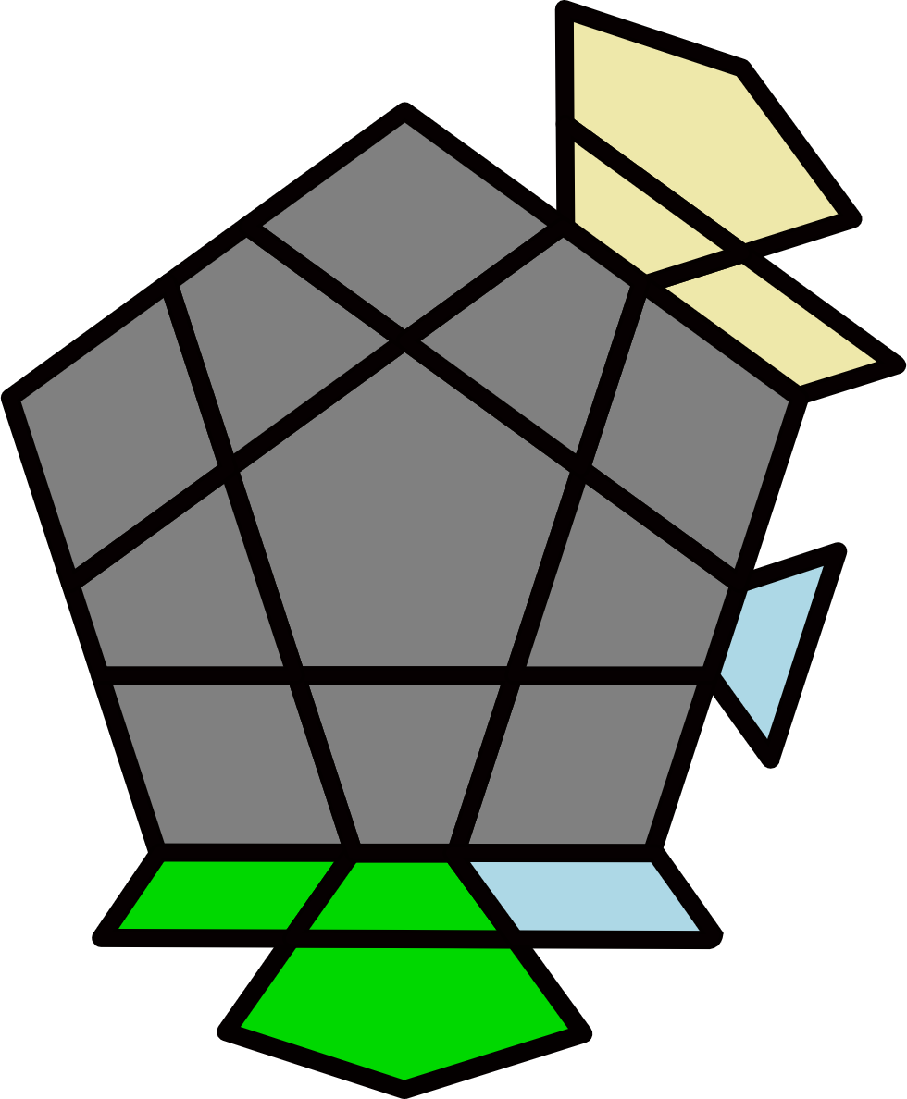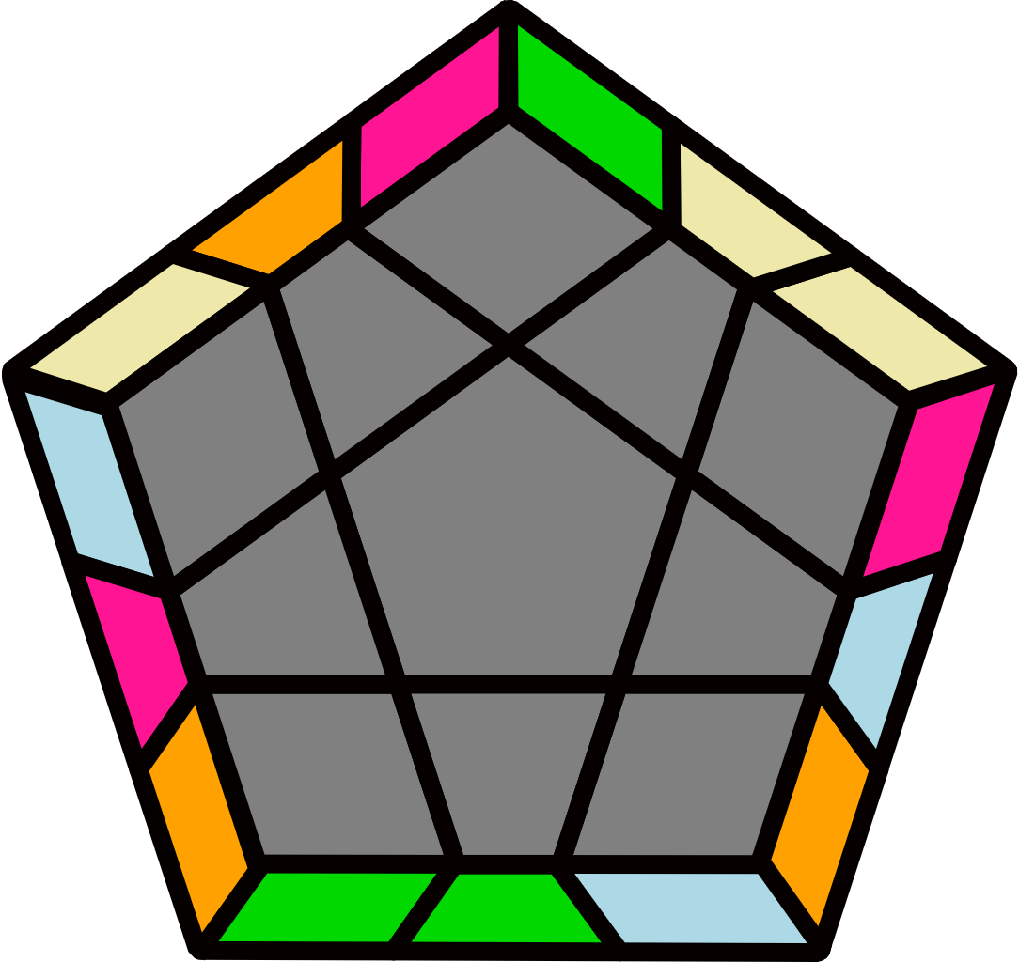 |  |  |  |  | 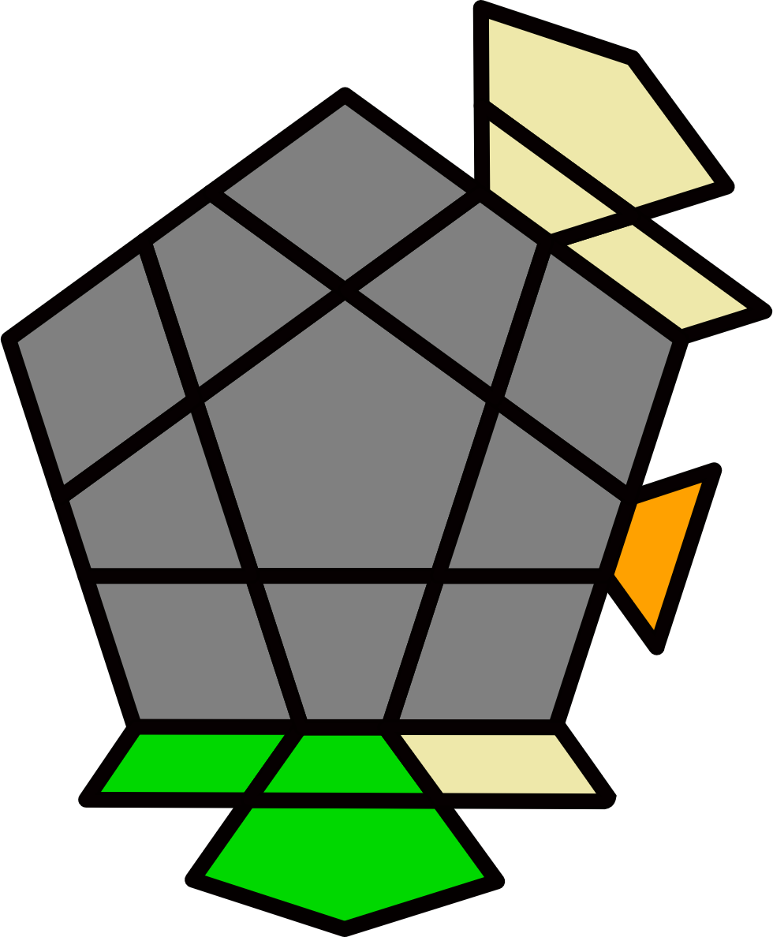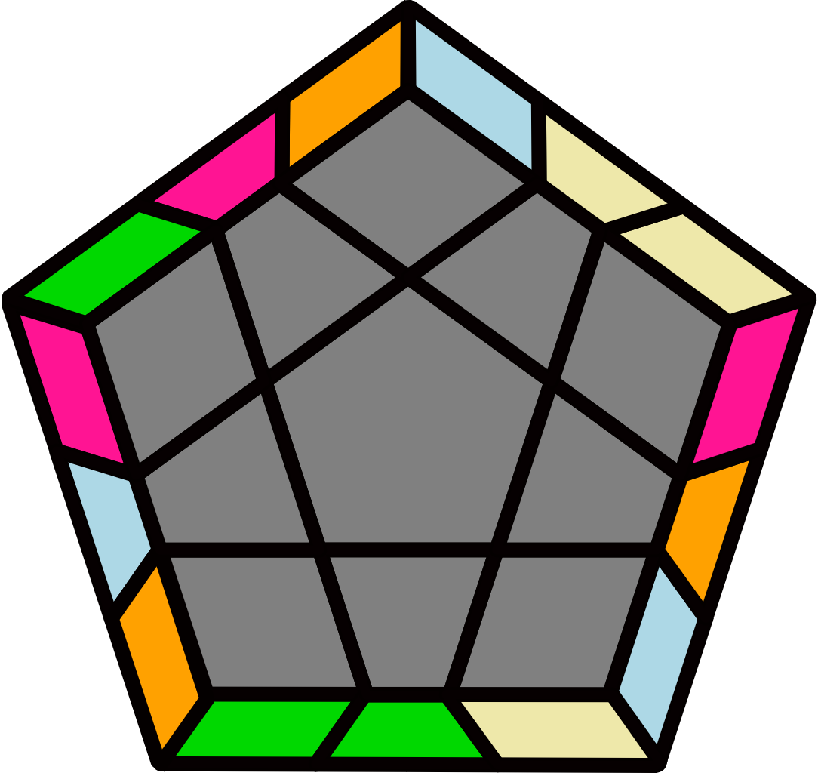
y (R U R U) (R' U R U) (R' U2' R U') (R2' U2' R U R') |  | y2 (R U R U2) (R2' U R U') (R U2' R' U2') (R' U2' R U2' R') |  |  |  |  | (R U R2' U) (R2 U2' R' U') (R' U2 R' U') (R2 U2' R2' U2' R2) |  |  |  |  | (R2' U2 R2 U2) (R2' U R U2') (R U R U2) (R2' U' R2 U' R')
M-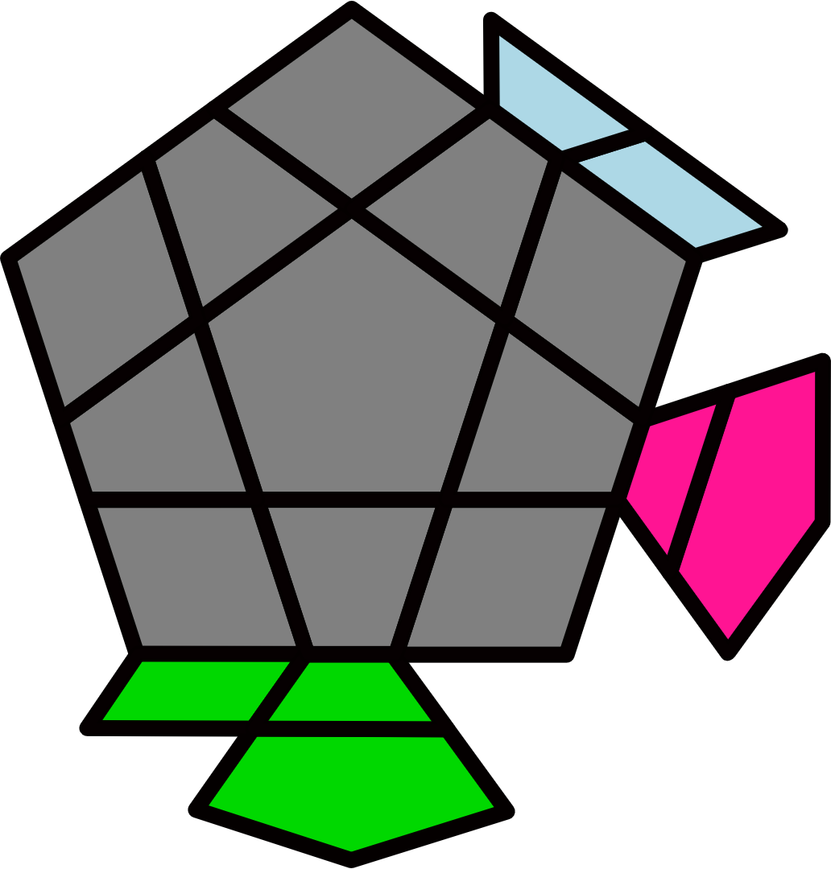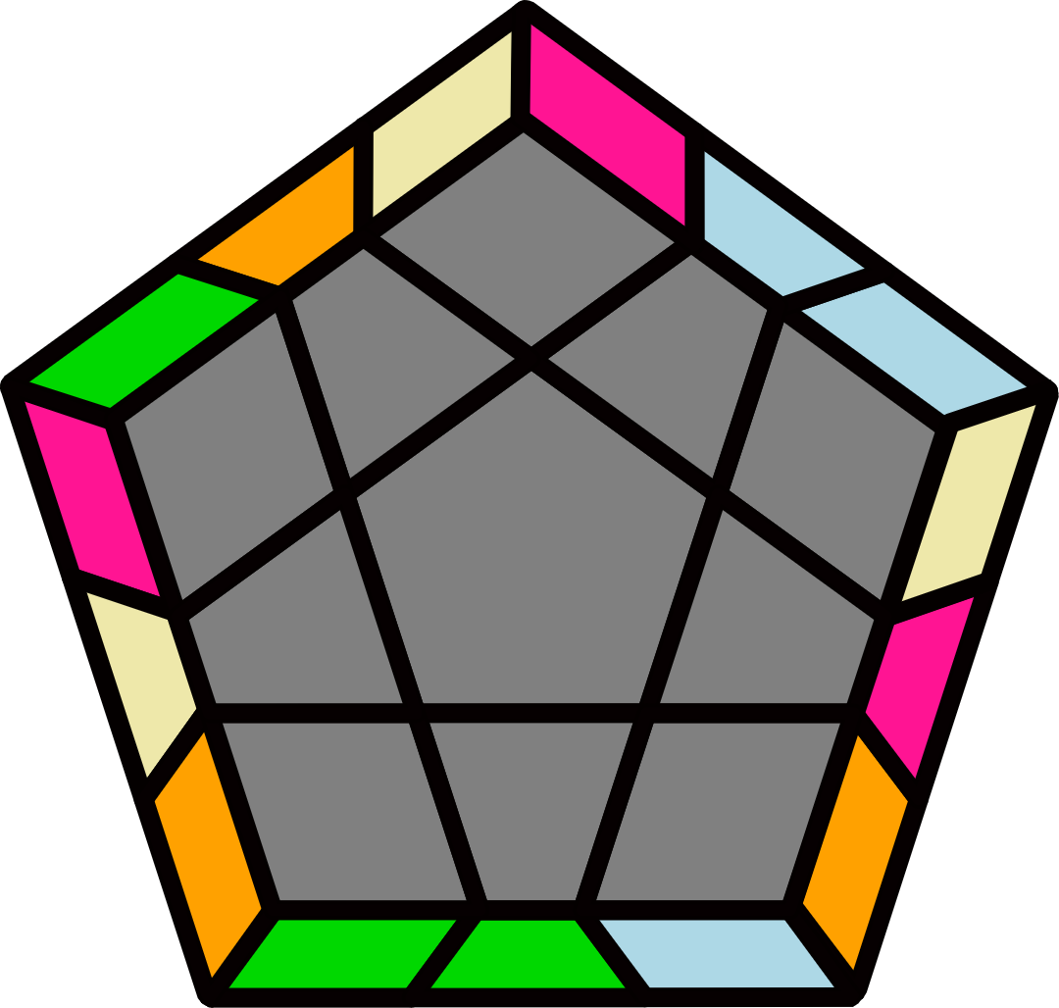 |  | M+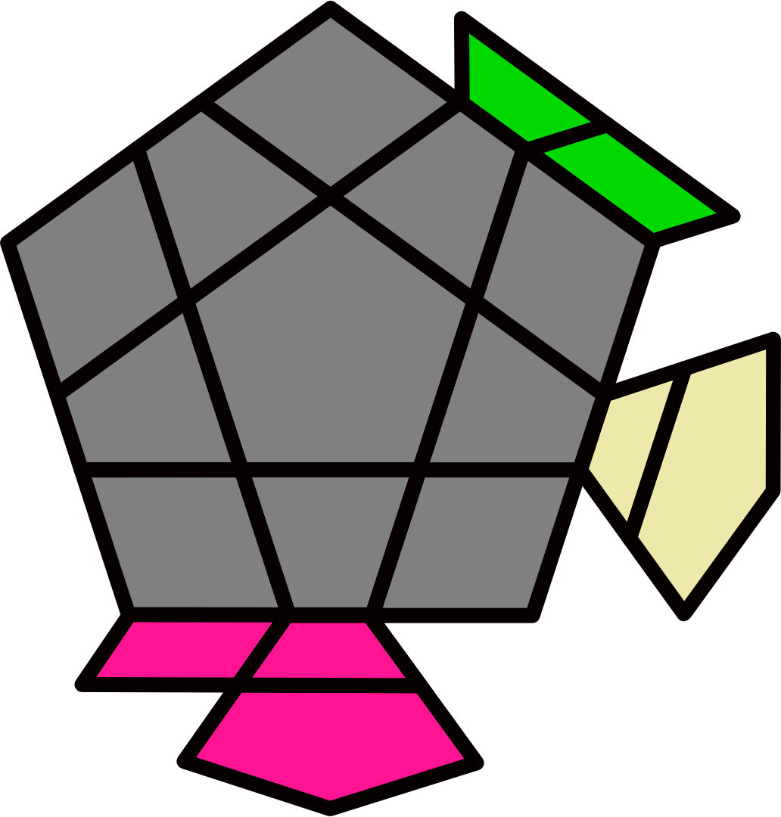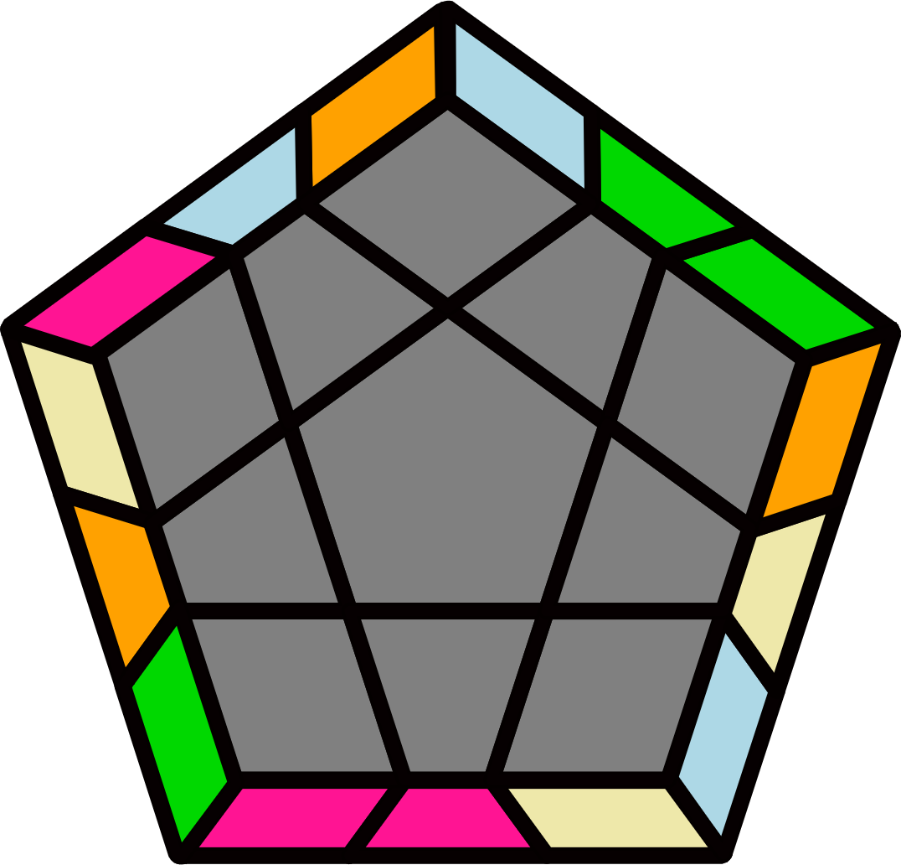 |  |  |  |  | 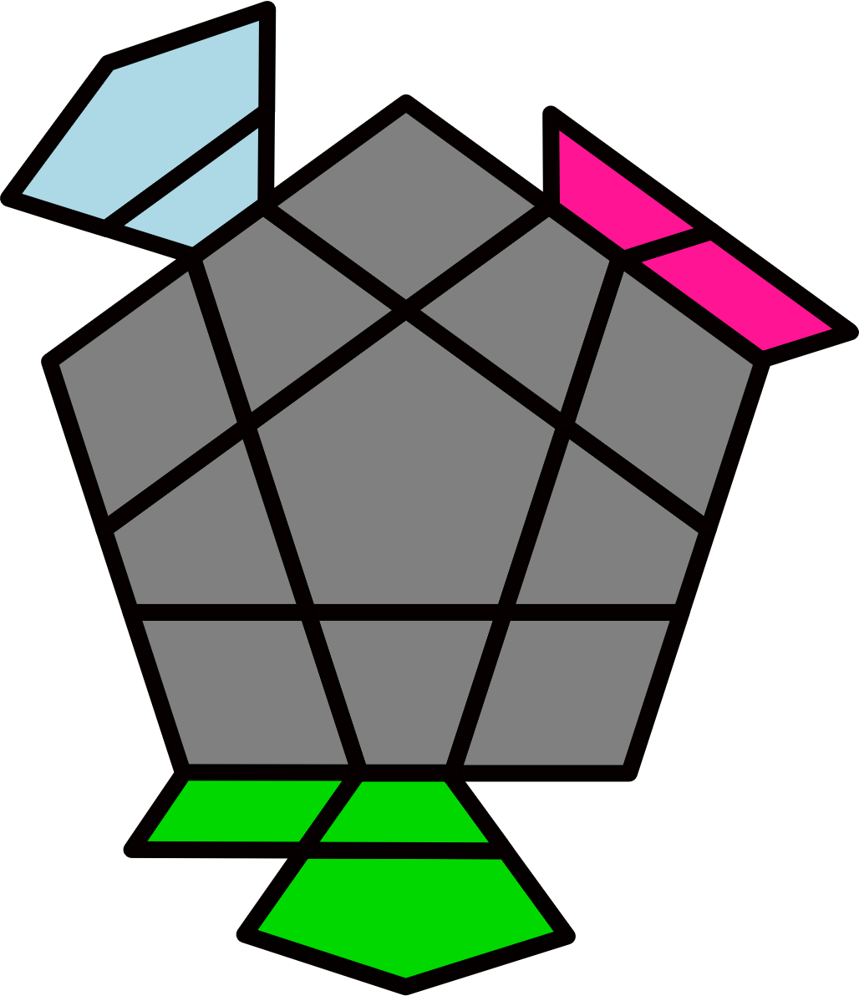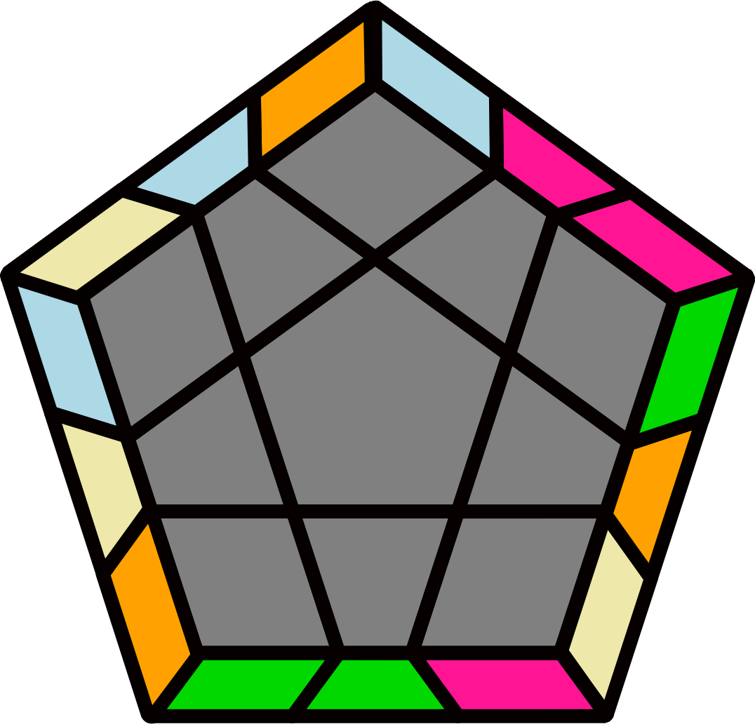 |  |  |  |  | 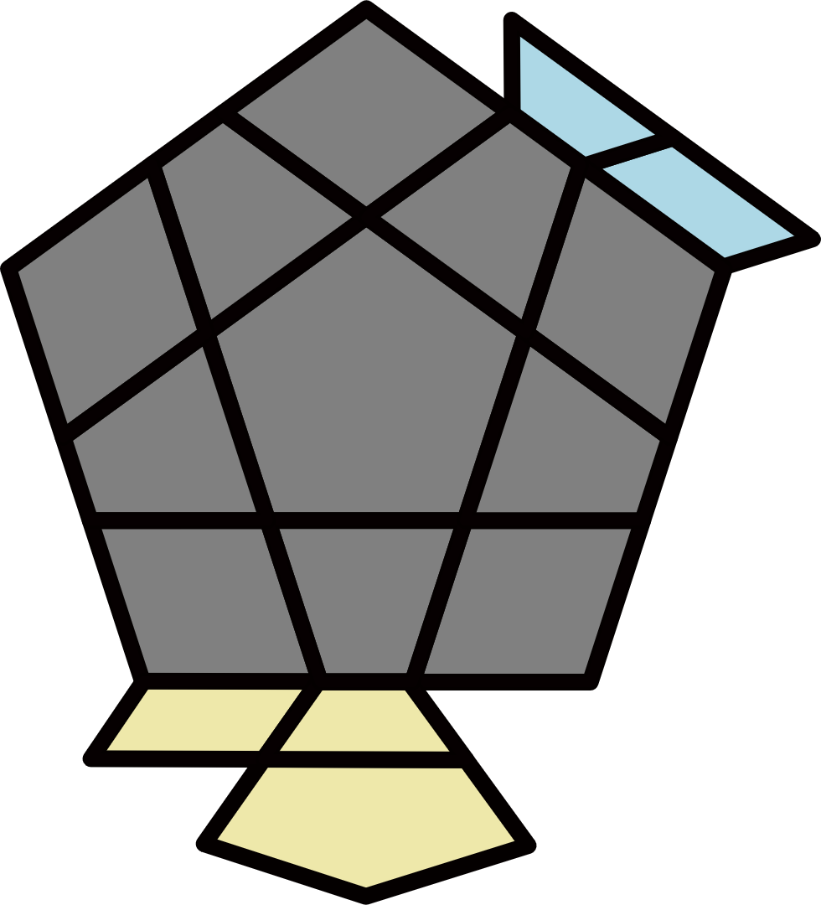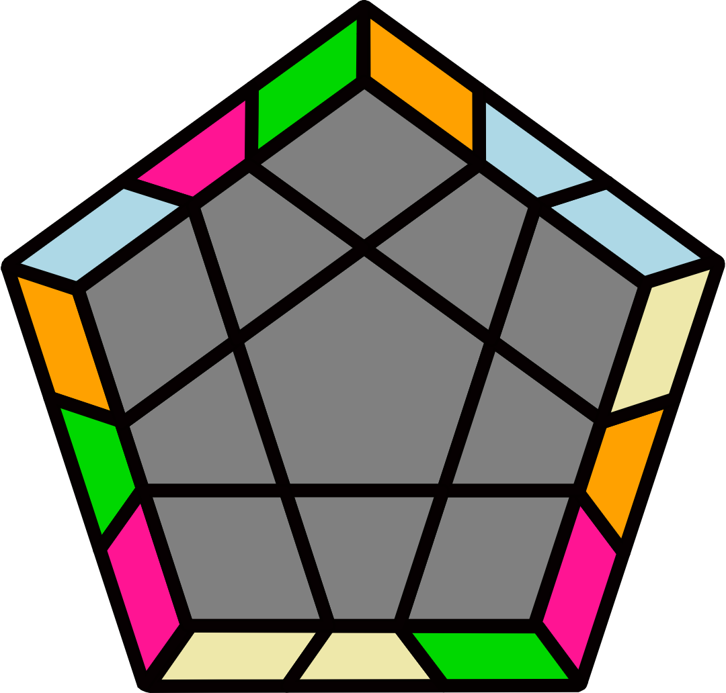
y2 (R' U' R U2' R' U2' R) U  (R U R' U R U2' R') |  | y' (R U2 R' U) B' (U R U' R' U') B (R U2' R') |  |  |  |  | y' (R' U' R' U') (R U' R' U') (R U2 R' U) (R2 U2 R' U' R) |  |  |  |  | y (R2 U2 R2' U R2 U2 R2') U' (R2 U2' R2' U' R2 U2' R2')
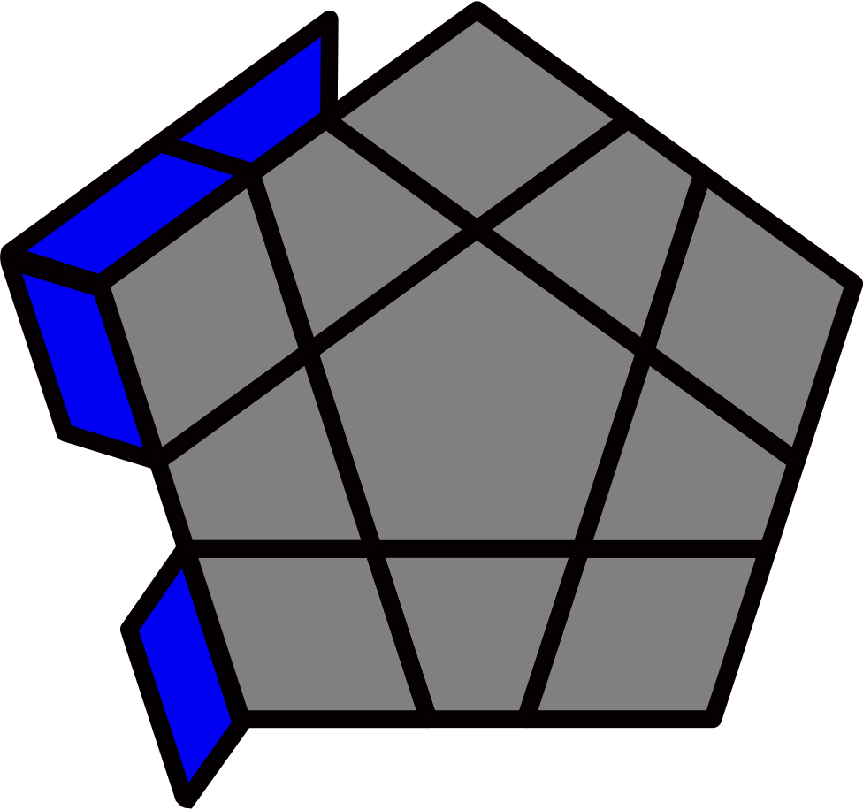R Perm [8]
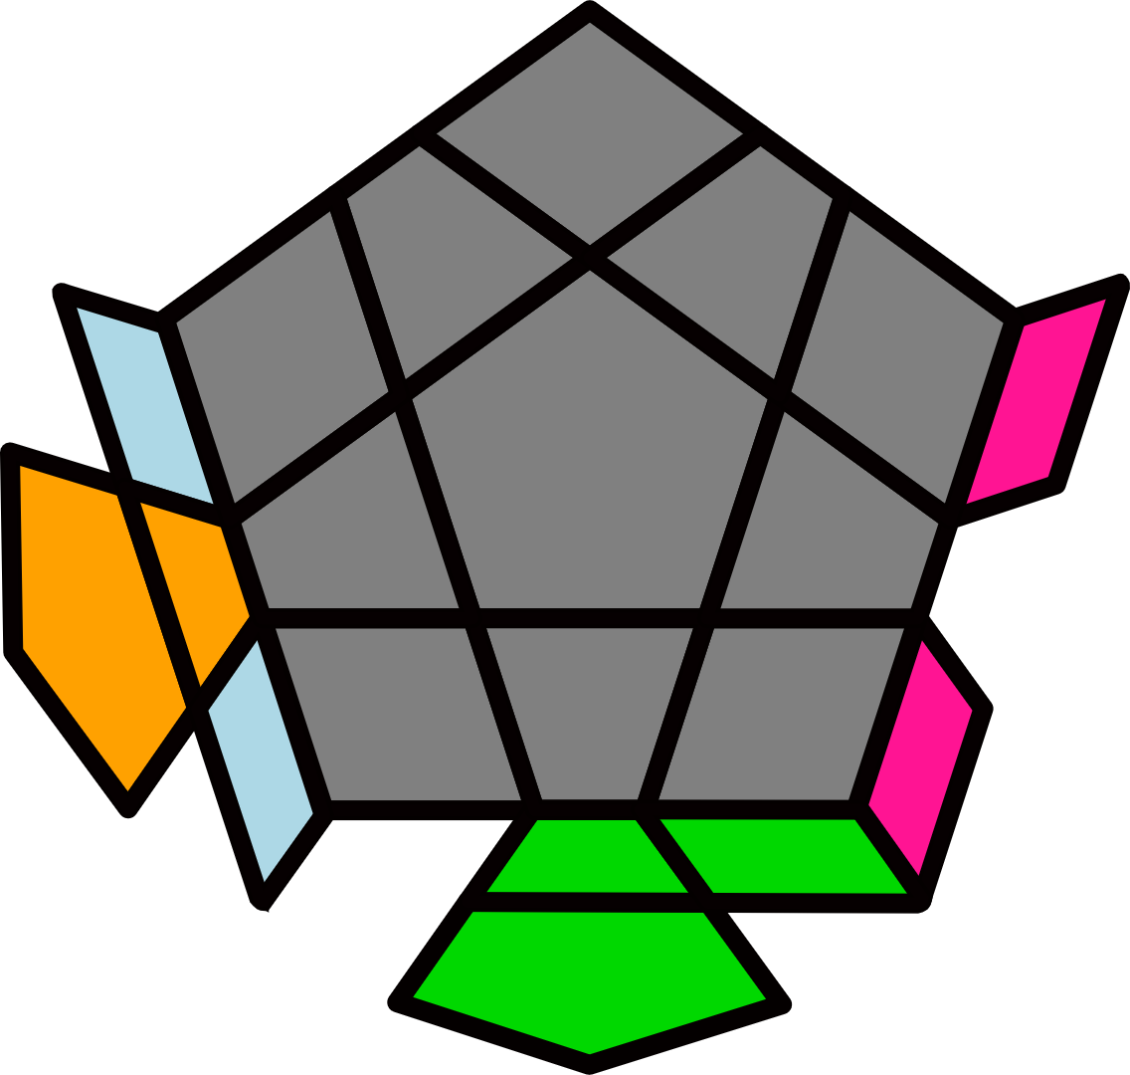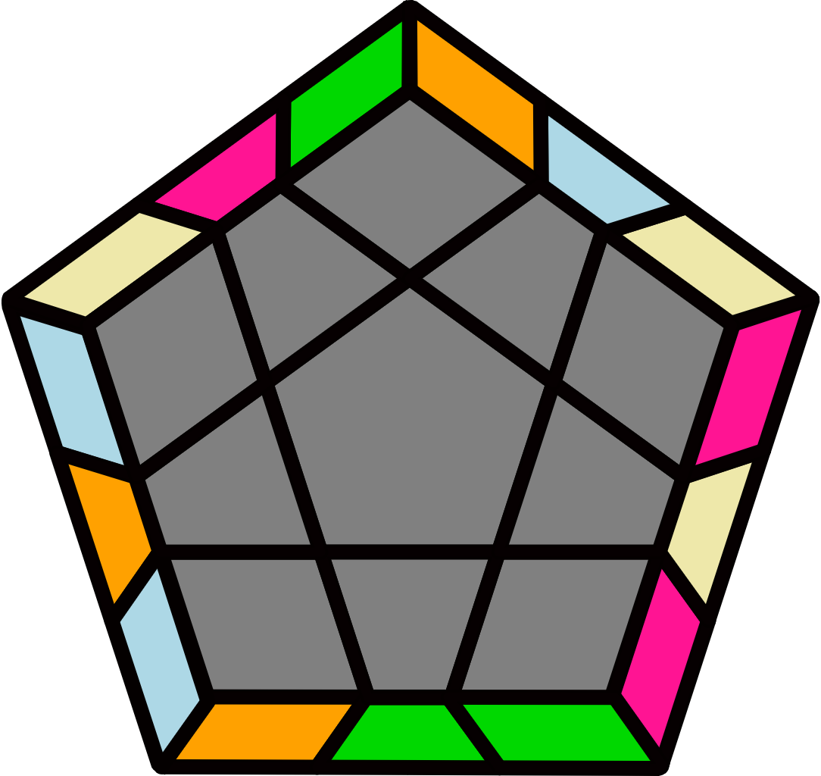 |  | 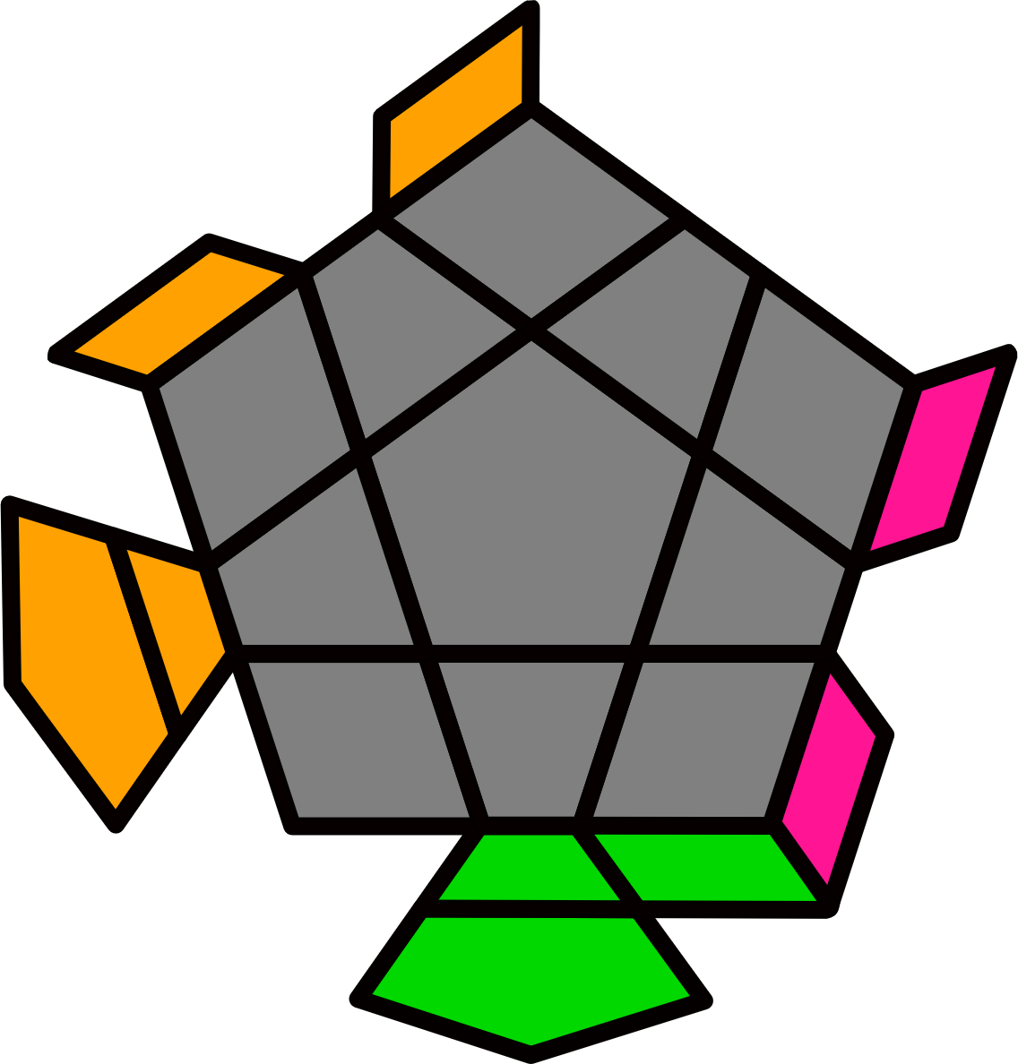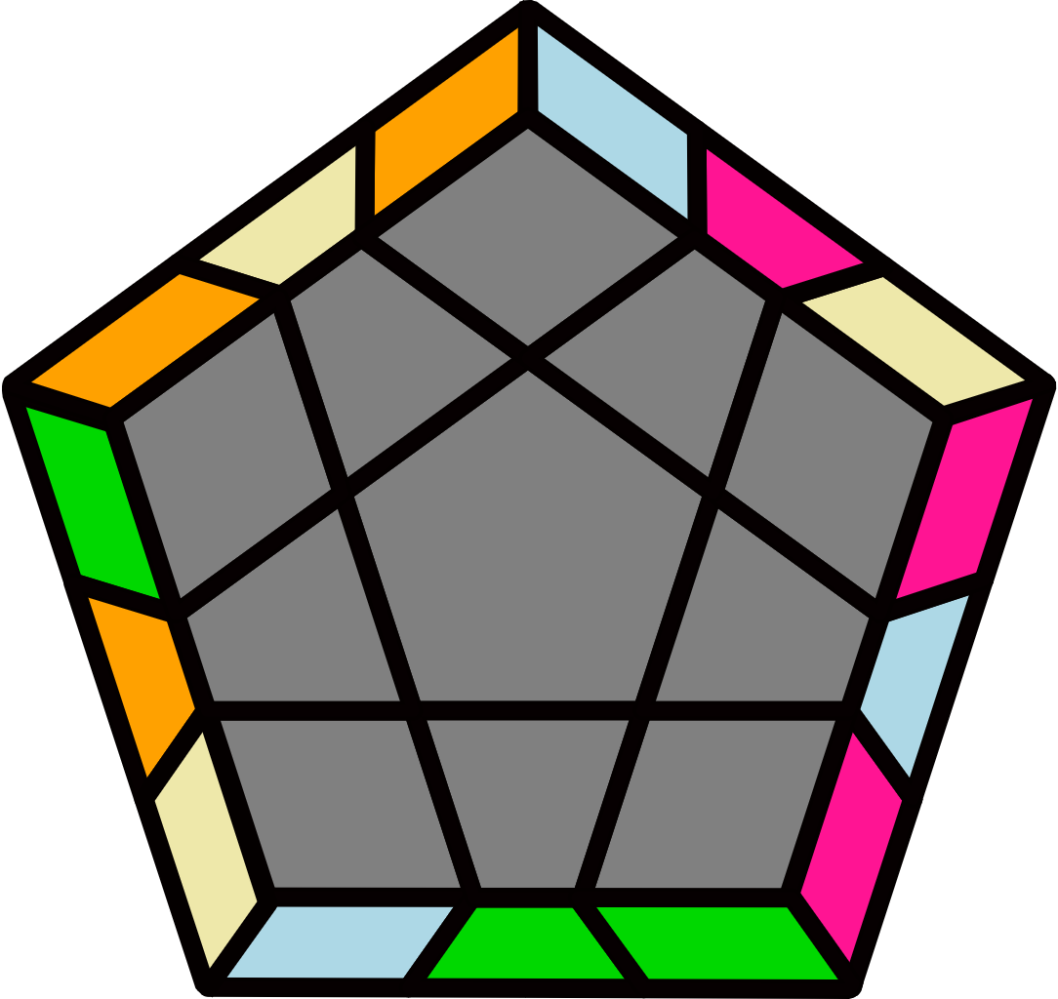 |  |  |  |  | 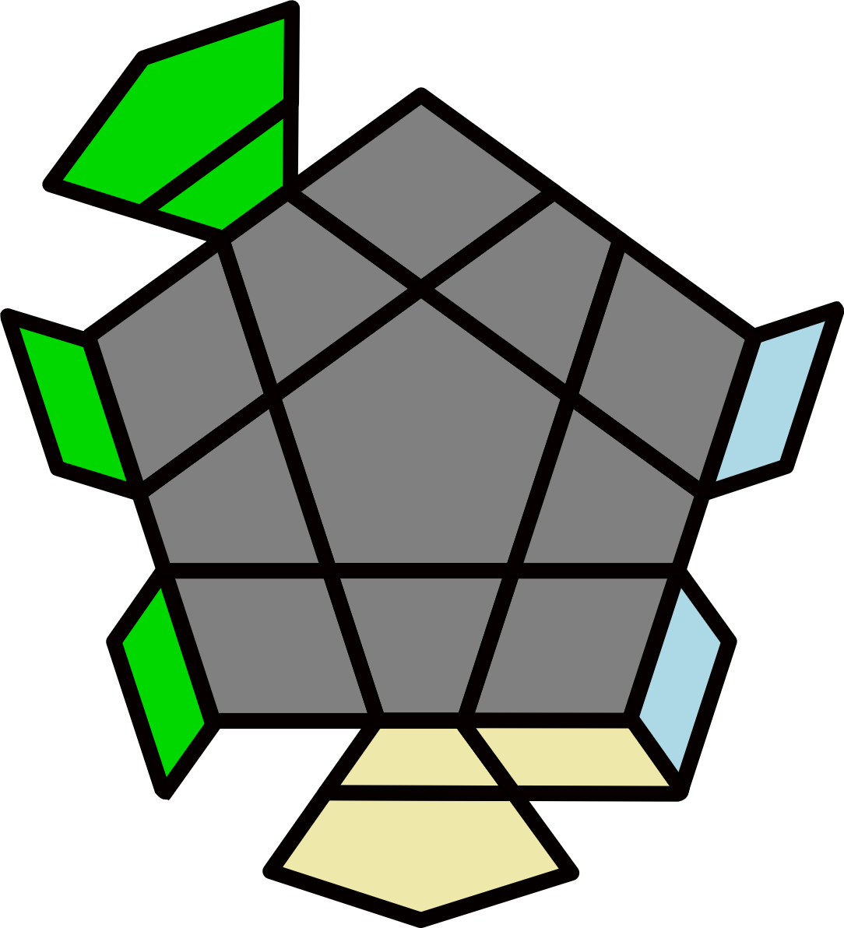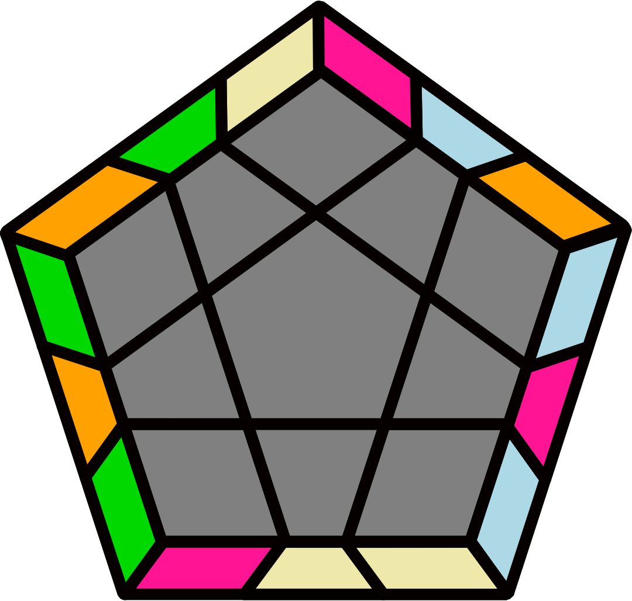 |  |  |  |  | 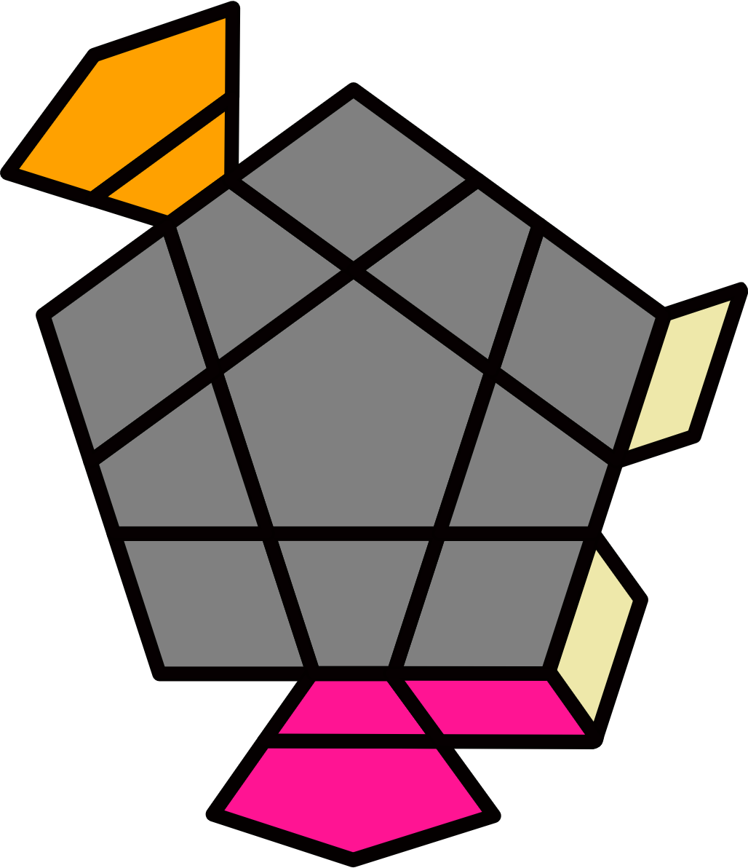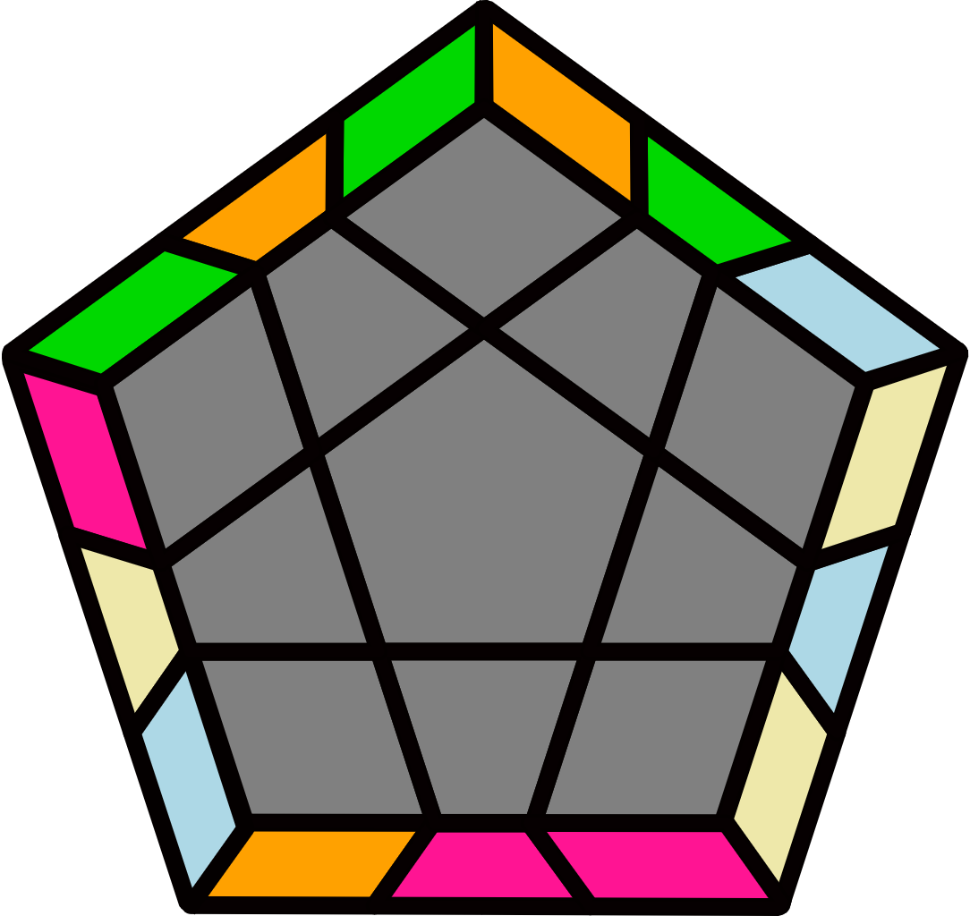
(L F R' F' L' F) (R2 U R' U R U2' R') F' |  | F (R U2 R' U' R U' R2')  F' L F R F' L' |  |  |  |  | y' (F R U R' U' F')  (L F R U' R' U F' L') |  |  |  |  | y2' (L F U' R U R' F' L')  (F U R U' R' F')
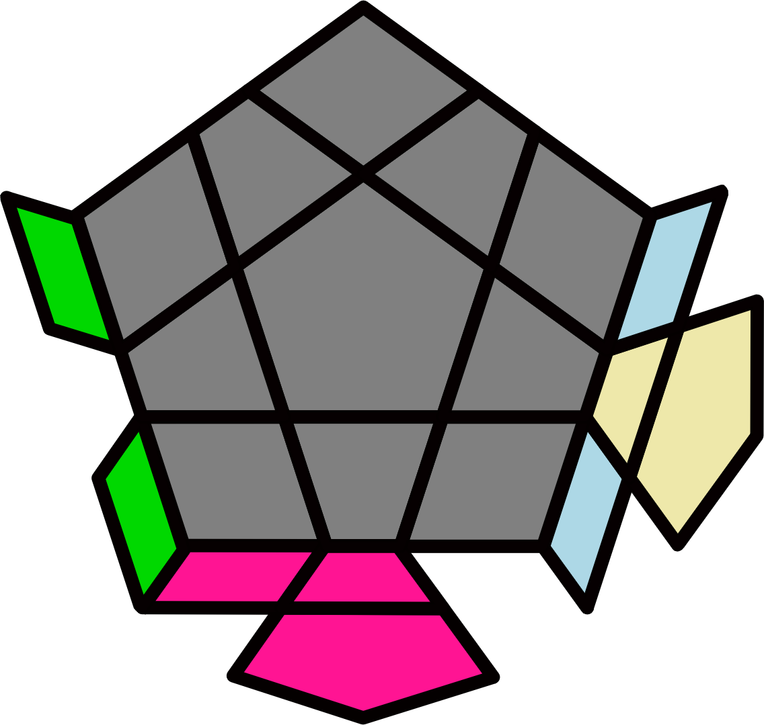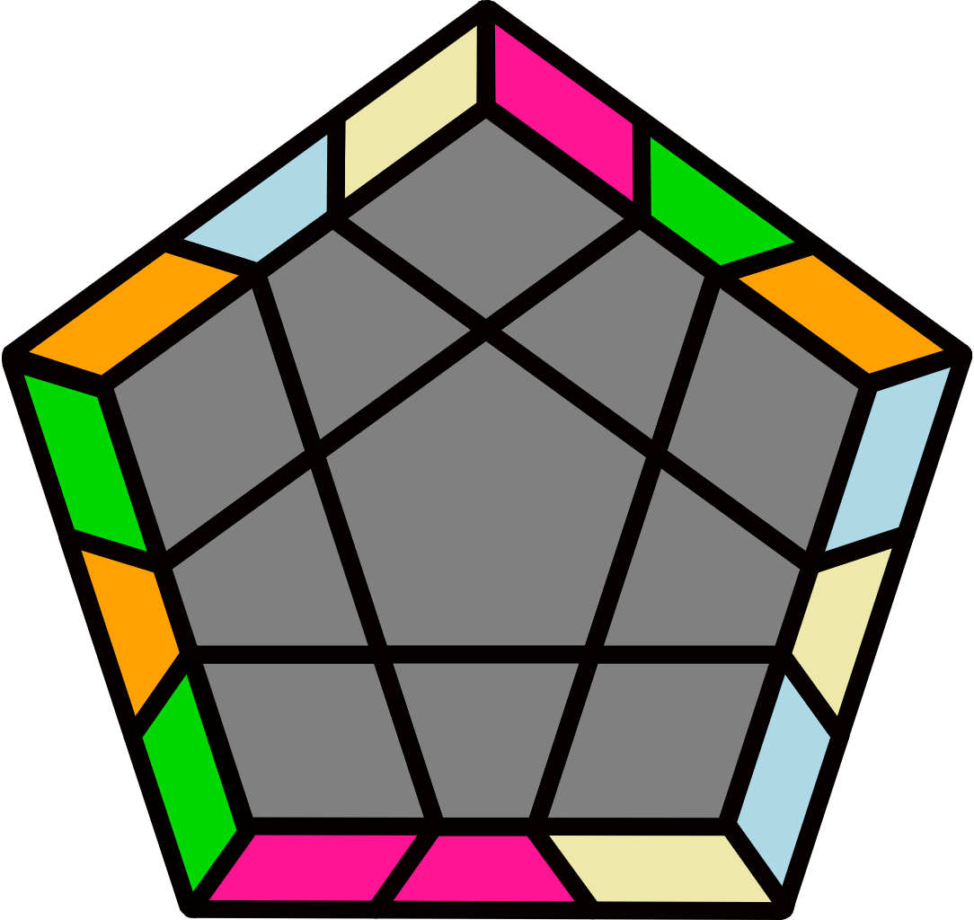 |  | 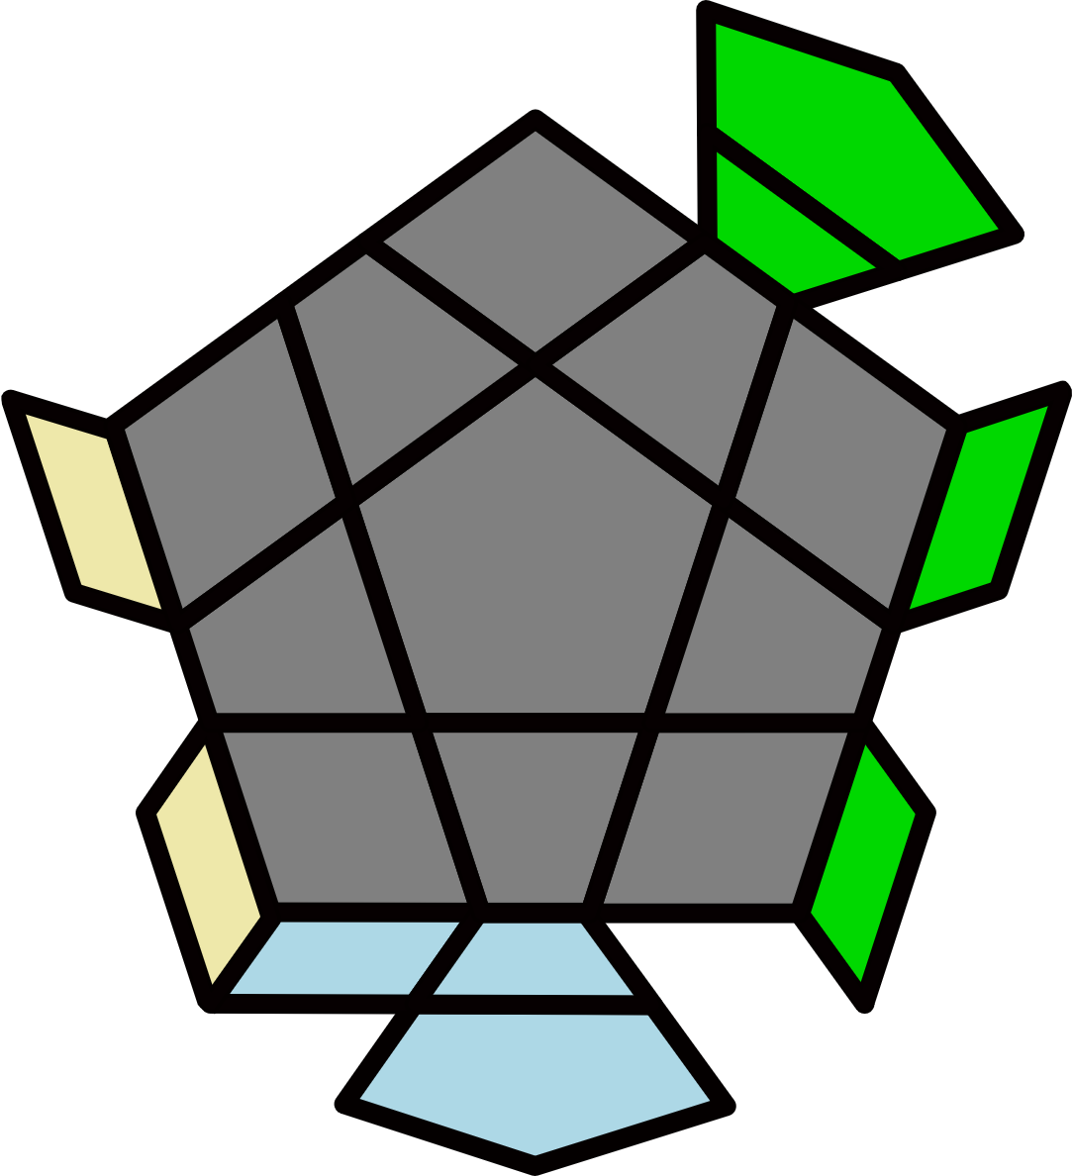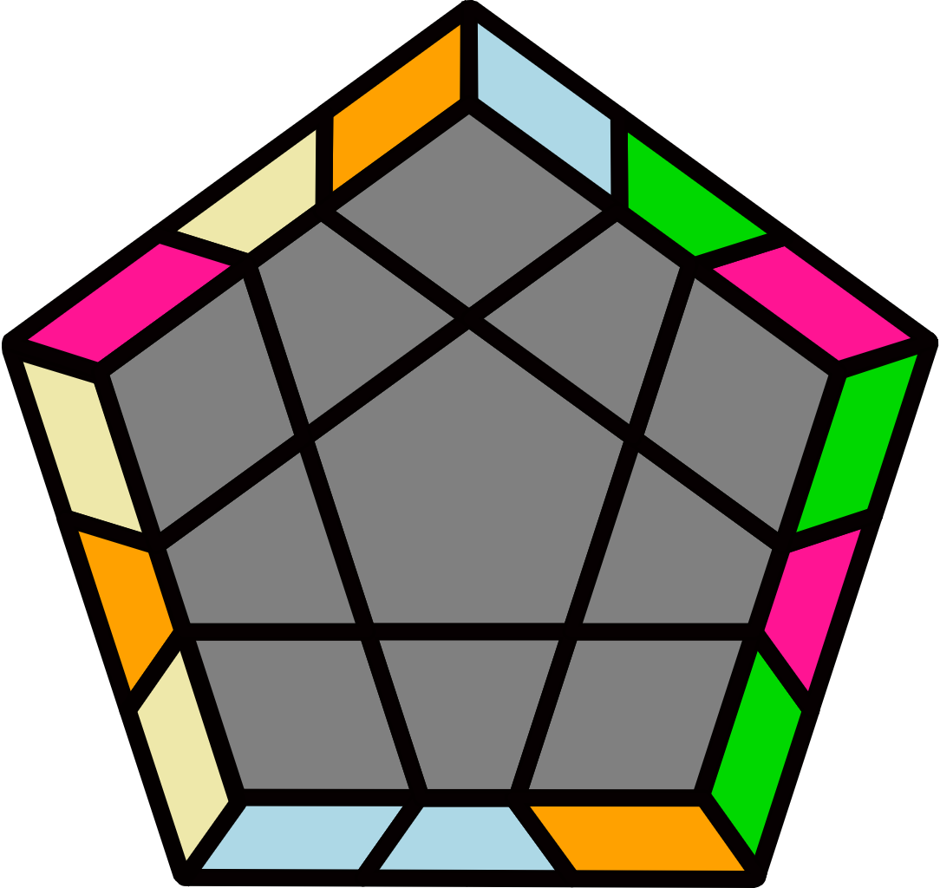 |  |  |  |  | 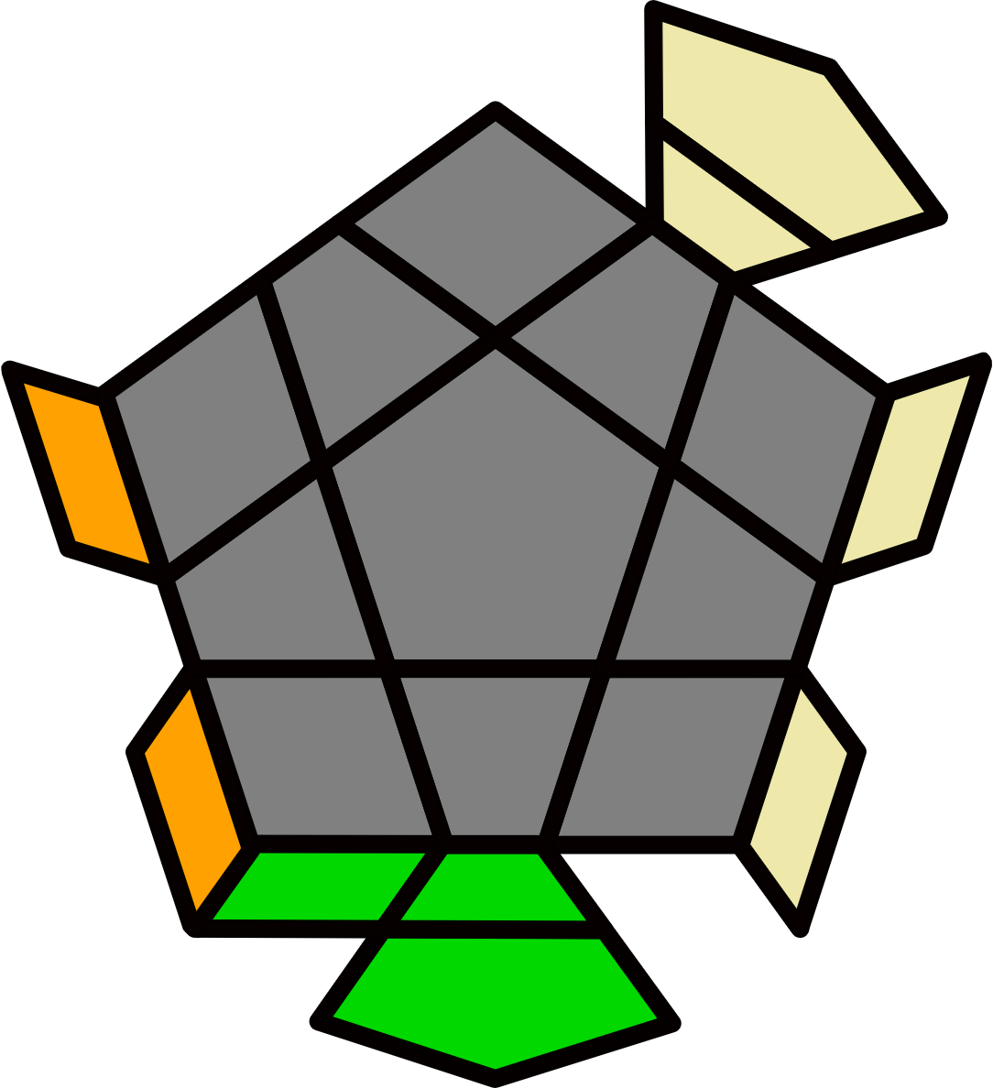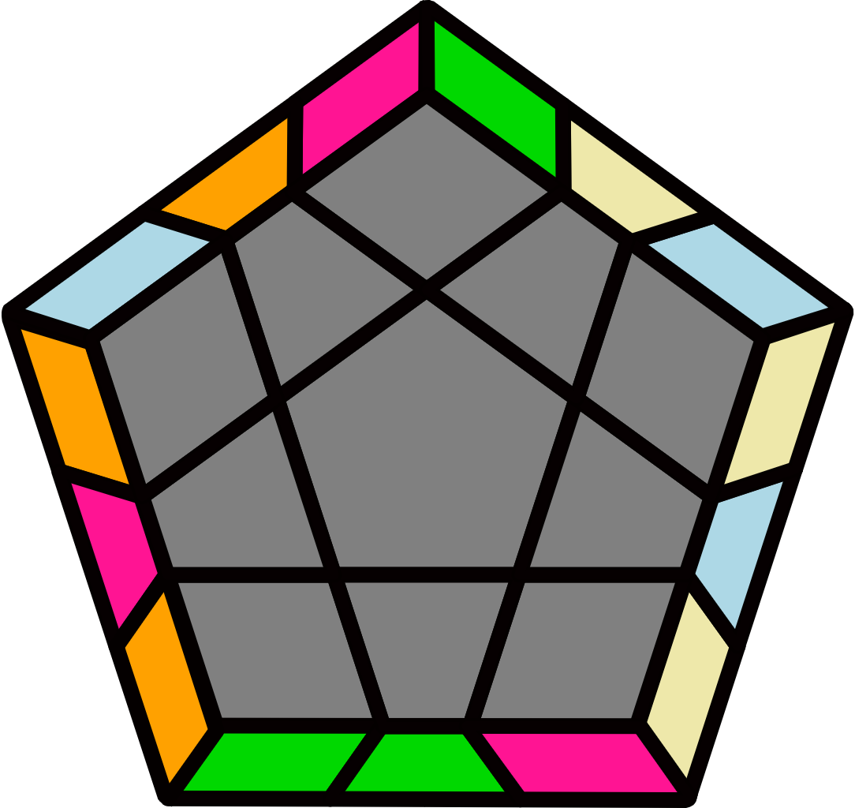 |  |  |  |  | 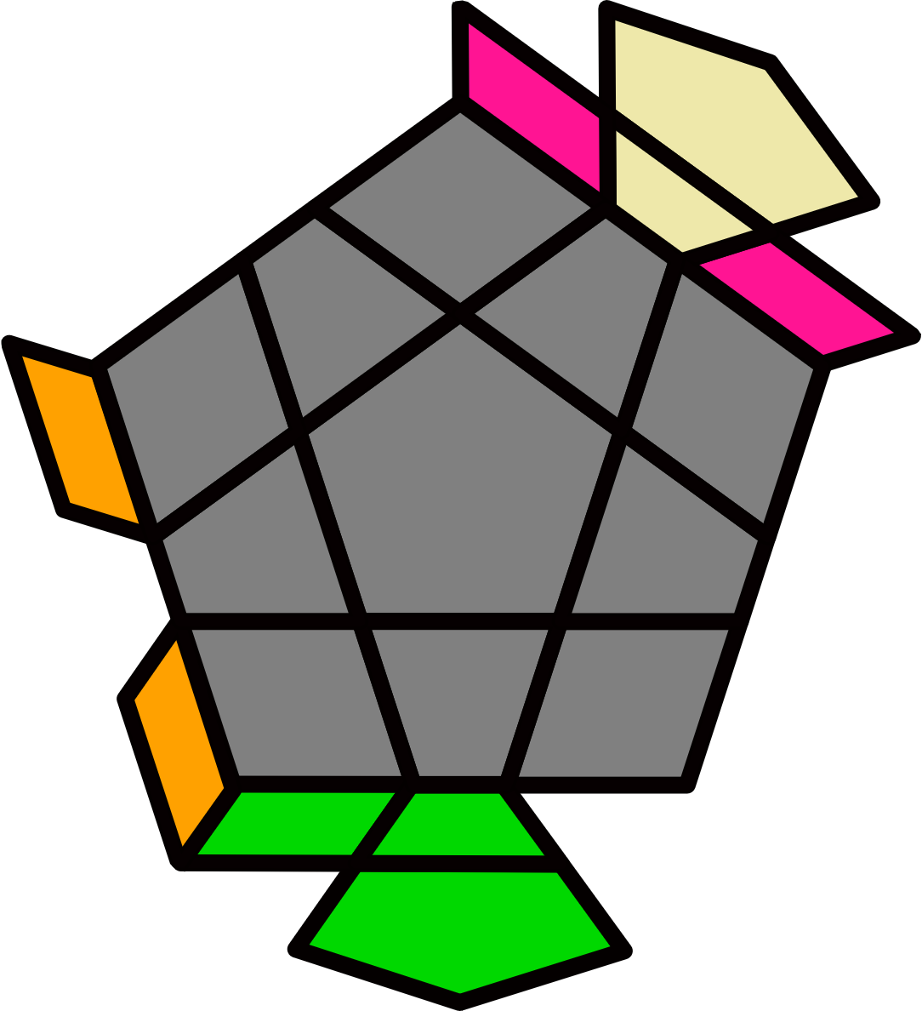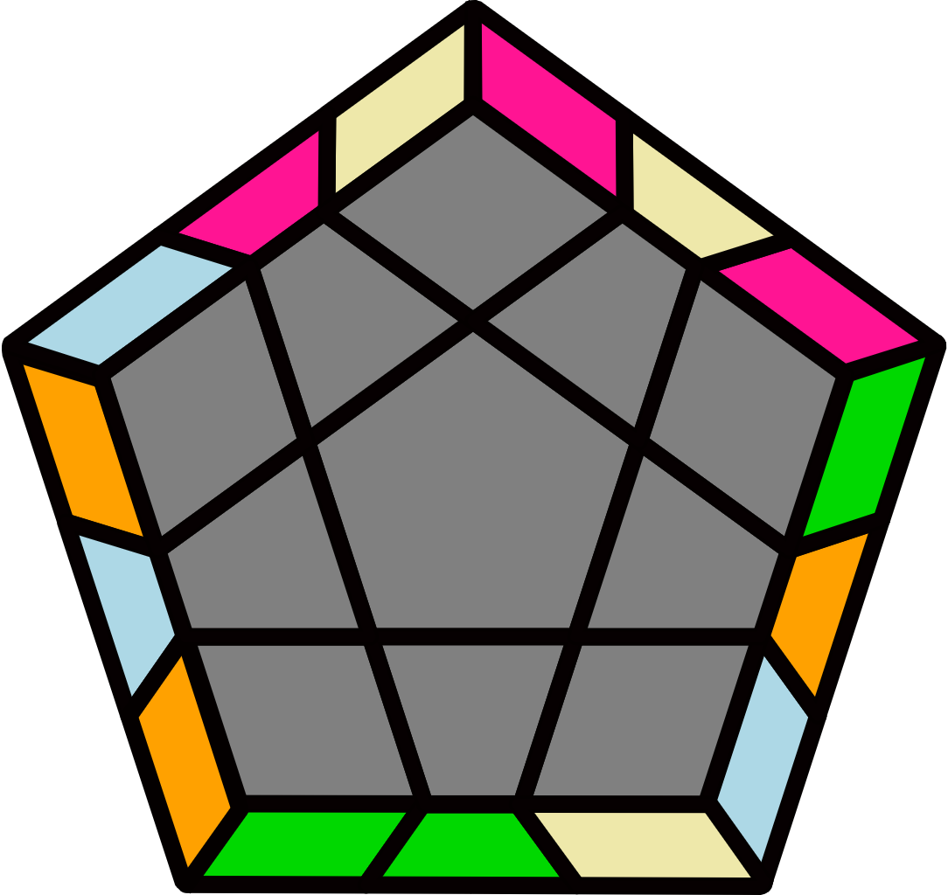
(R' U' R' F) (R U R U') R' y' (R2' U' R U') R' U2 R B |  | (R' F' U' F U R) U  (R' U' F R' F' R U R) |  |  |  |  | (R' U' R2 U') (R2' U2 R U) (R U2' R U) (R2' U R2 U2' R2') |  |  |  |  | y2 (R' U' R' F R F' U R) U' (R' U' F' U F R)
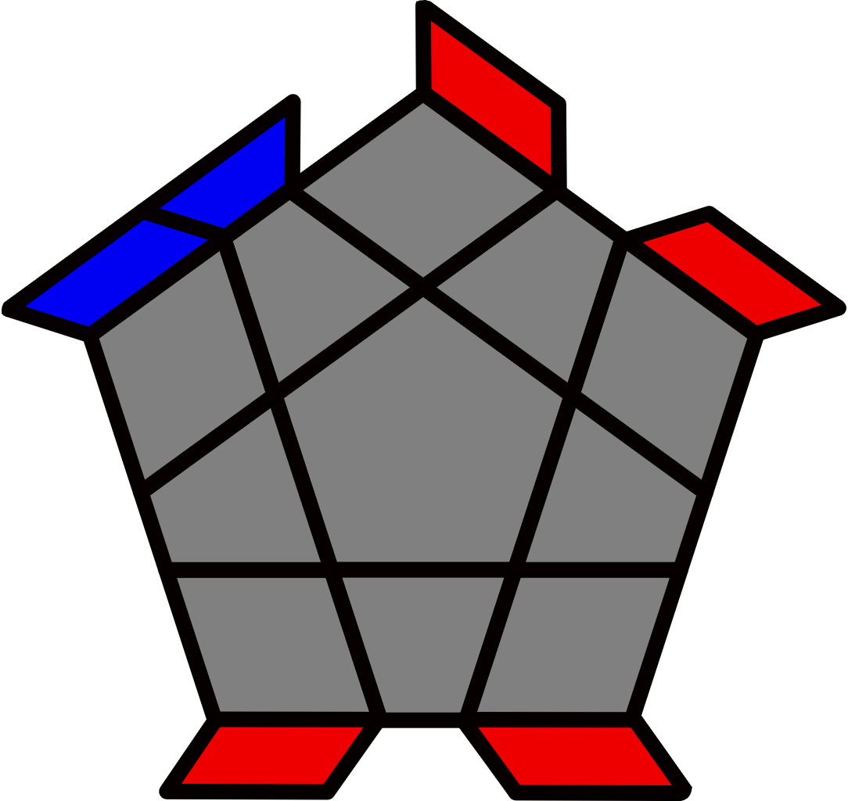Bar + Lights [4]
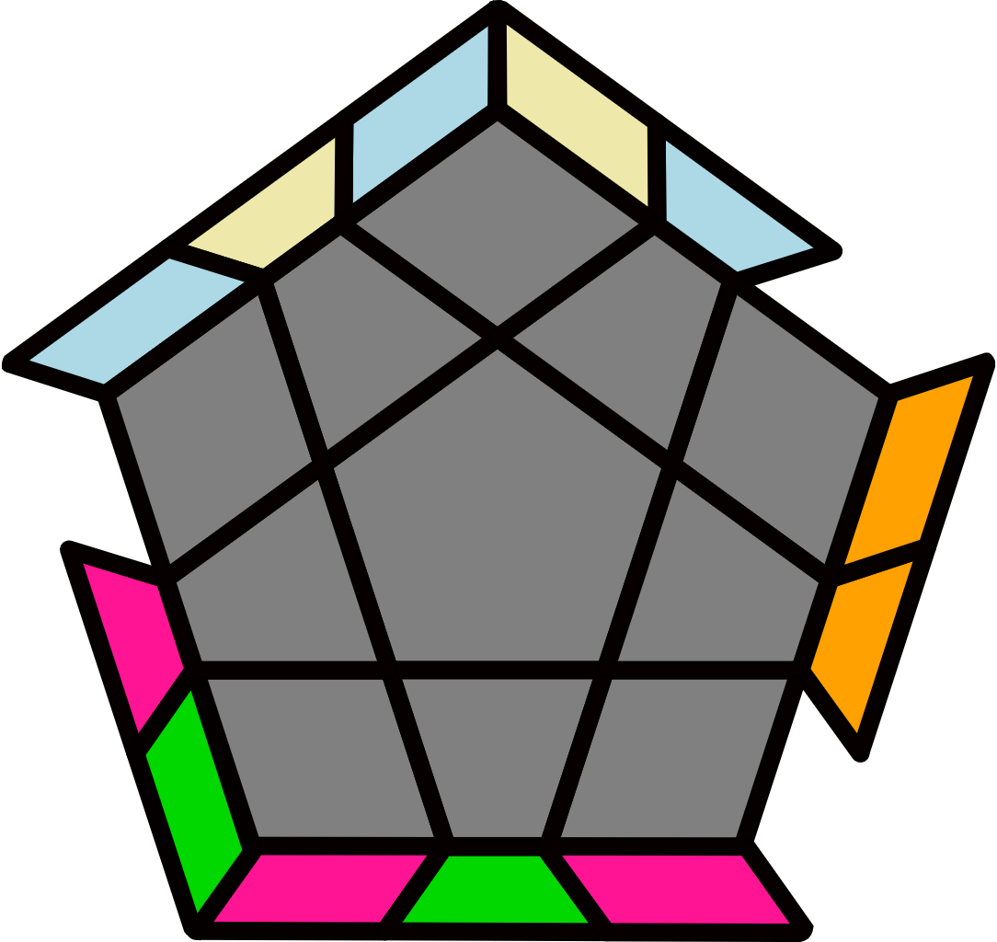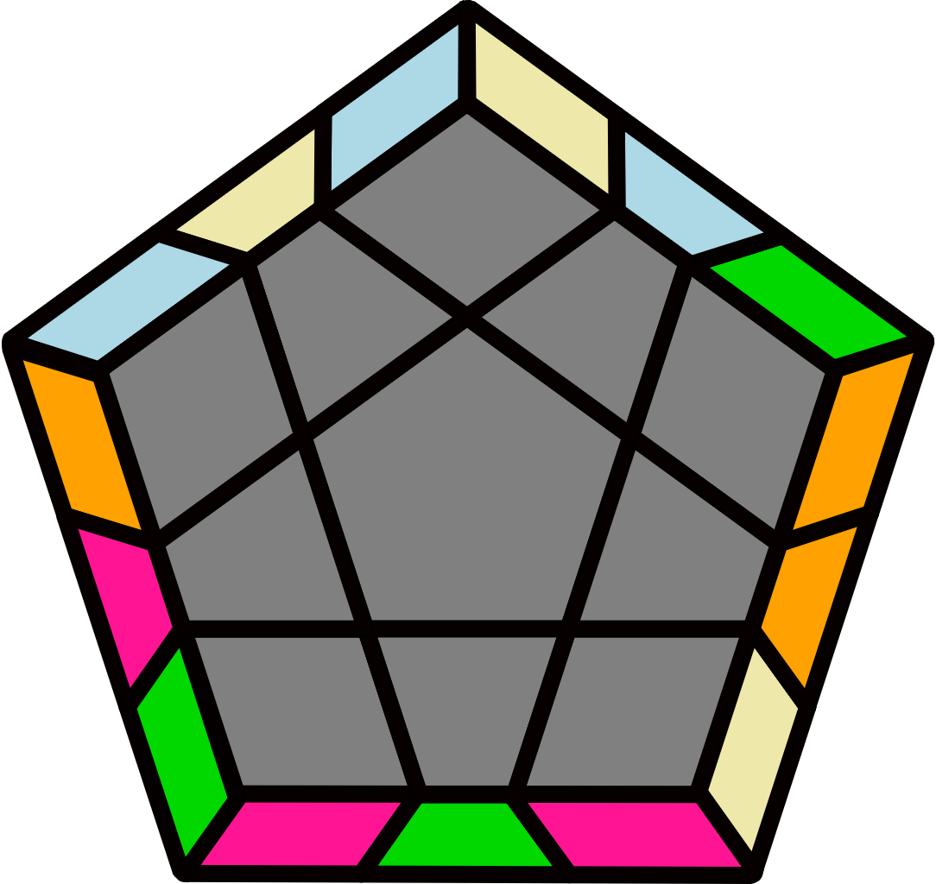 |  | 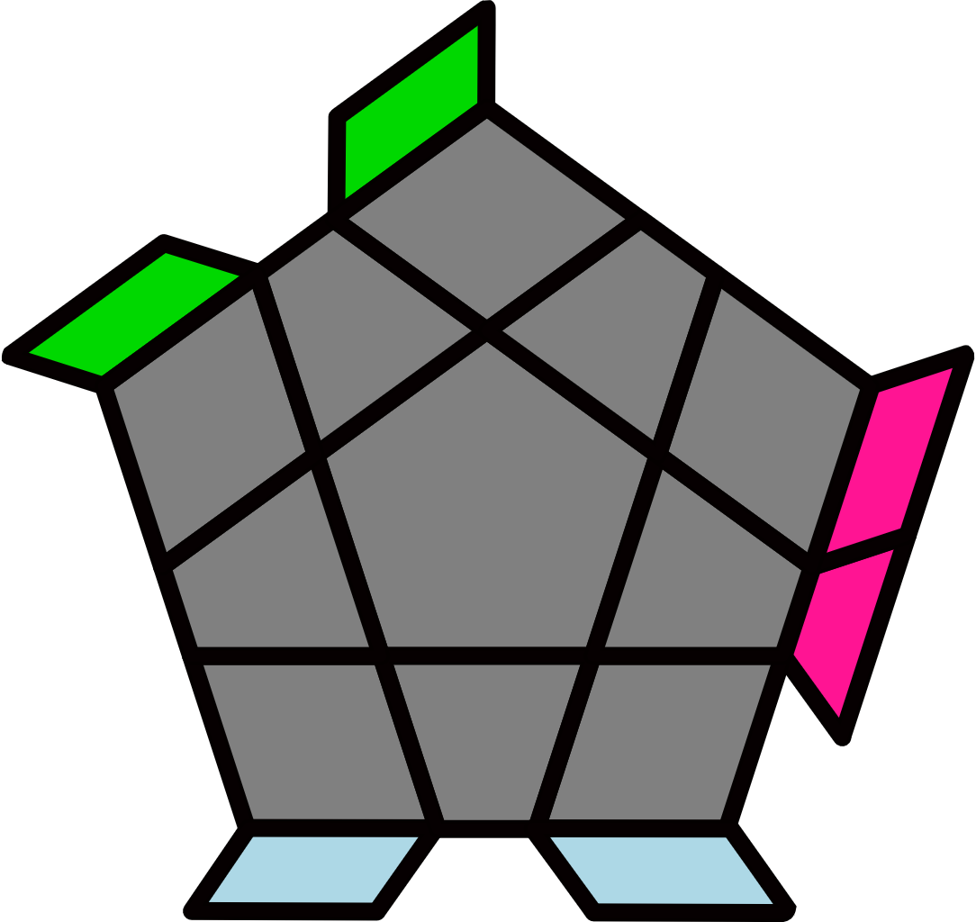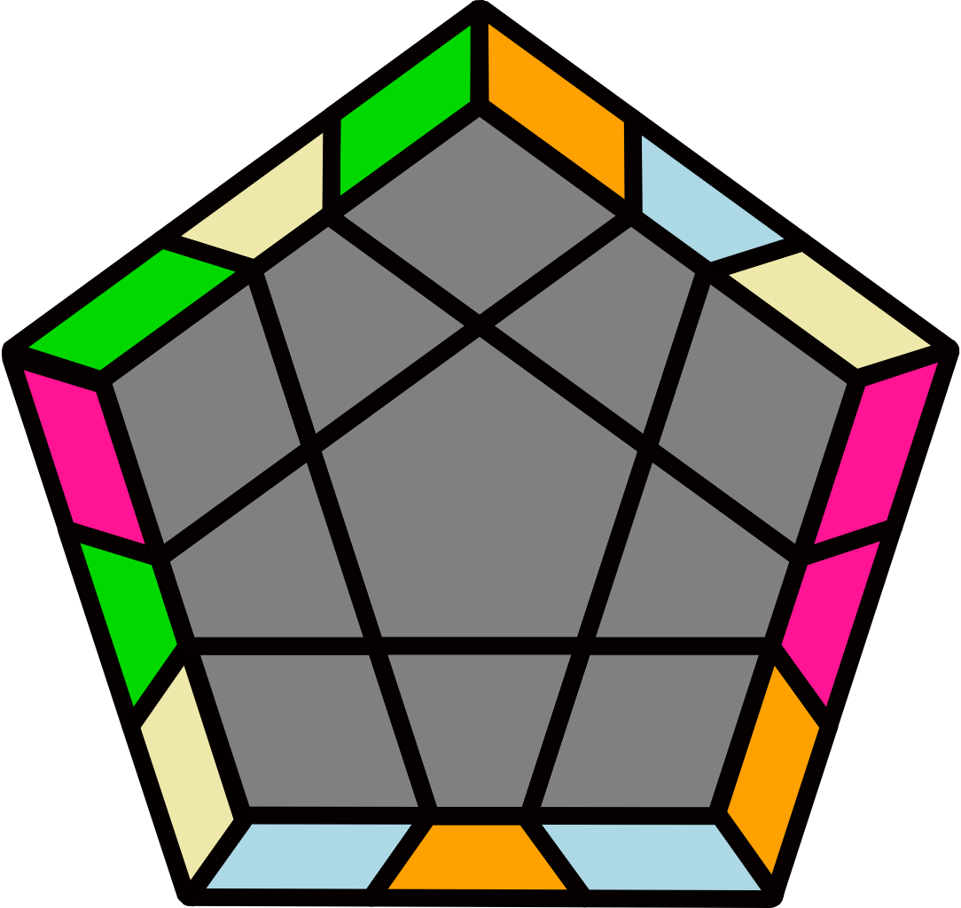 |  |  |  |  | 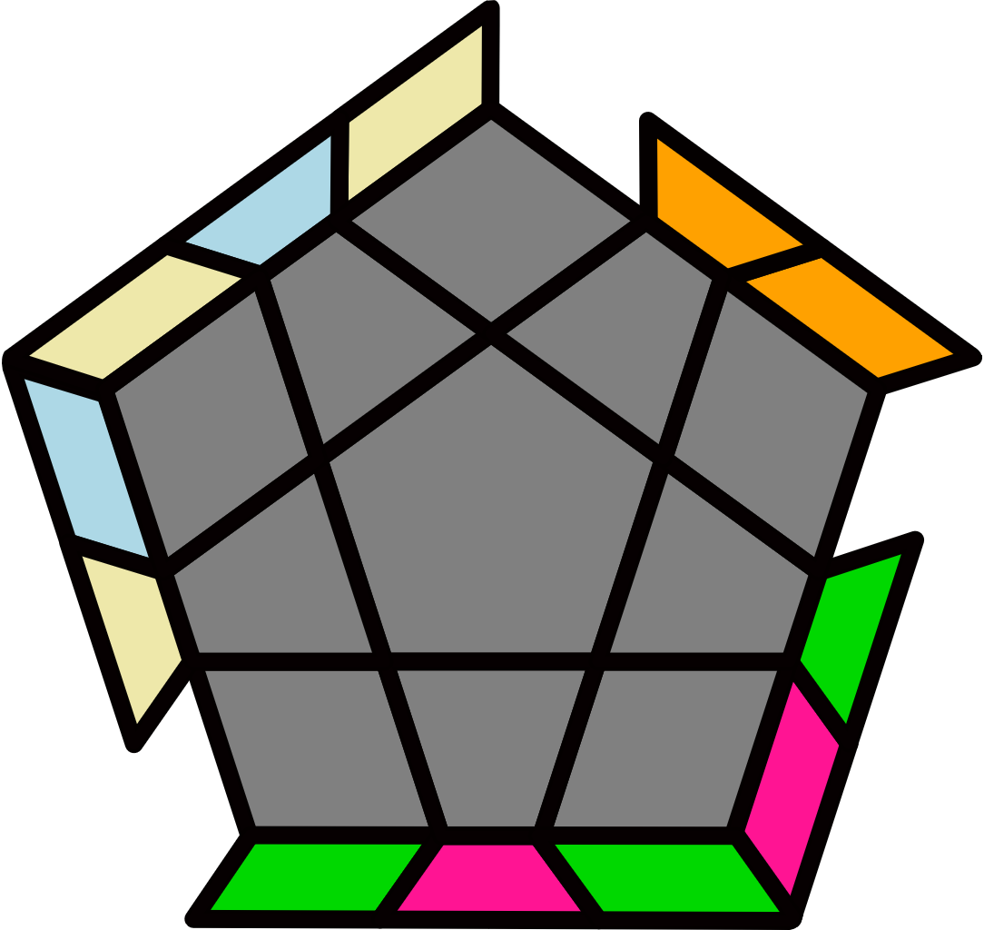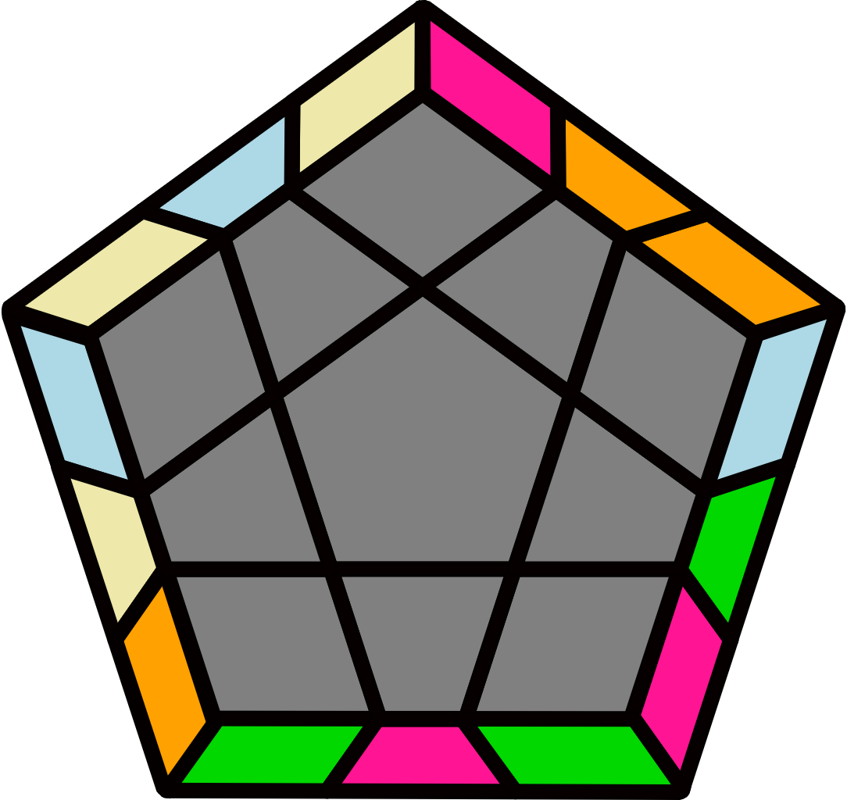 |  |  |  |  | 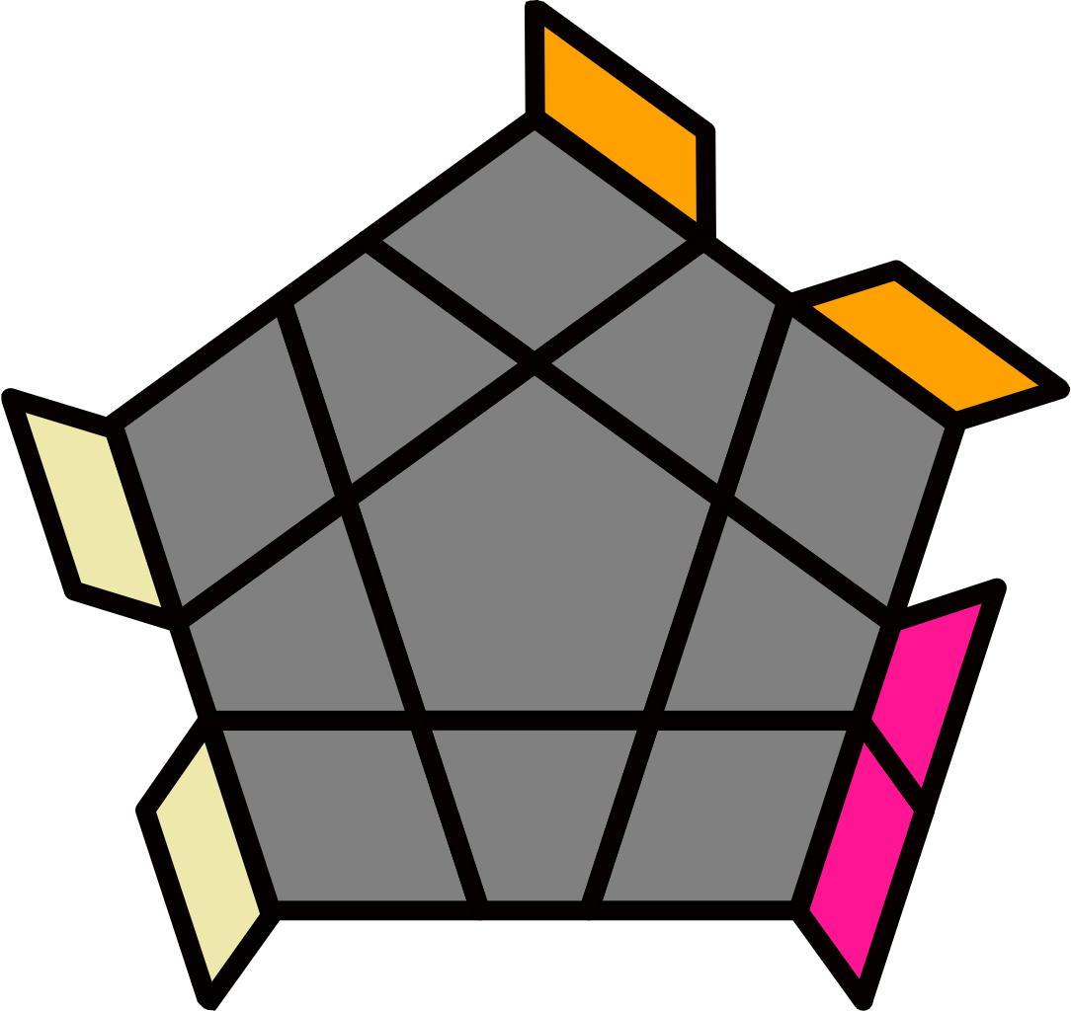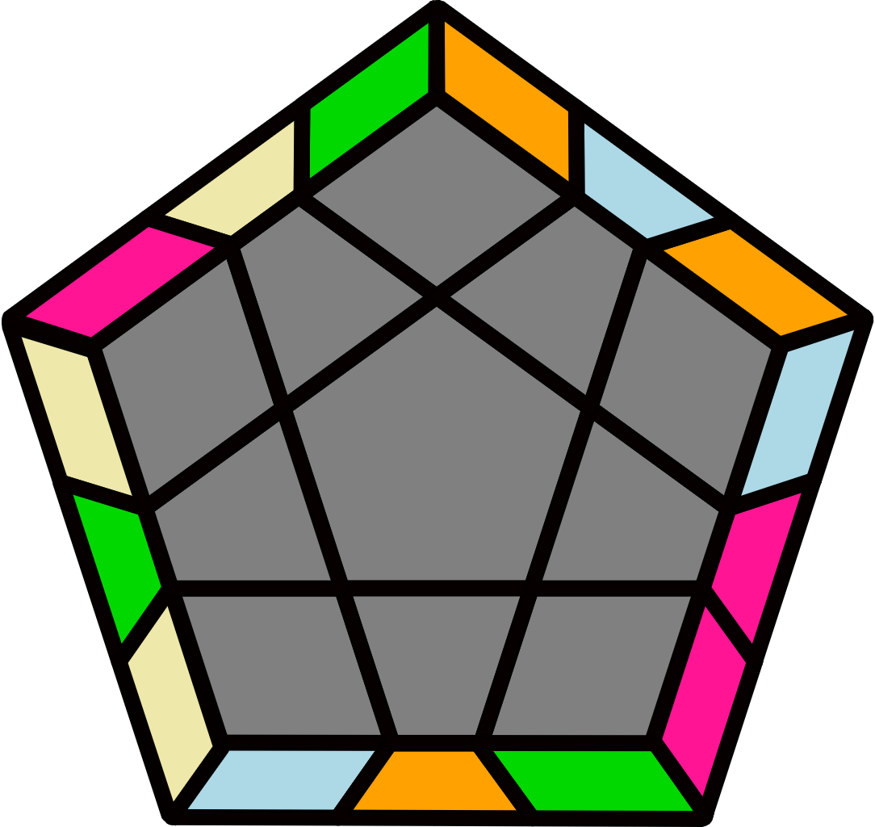
(R U2' R' U') (R U2' R2' U2) L U' R U L' R' U2' R |  | (R' U2 R2 U2') (R' U2 R' U) (R U2 R' U) (R2 U2 R2' U2' R) |  |  |  |  | F U2' (R' U' R F') (R' U' R F) U' (R' U2' R U2) F' |  |  |  |  | (R U2' R2' U2) (R U2' R U') (R' U2' R U') (R2' U2' R2 U2 R')
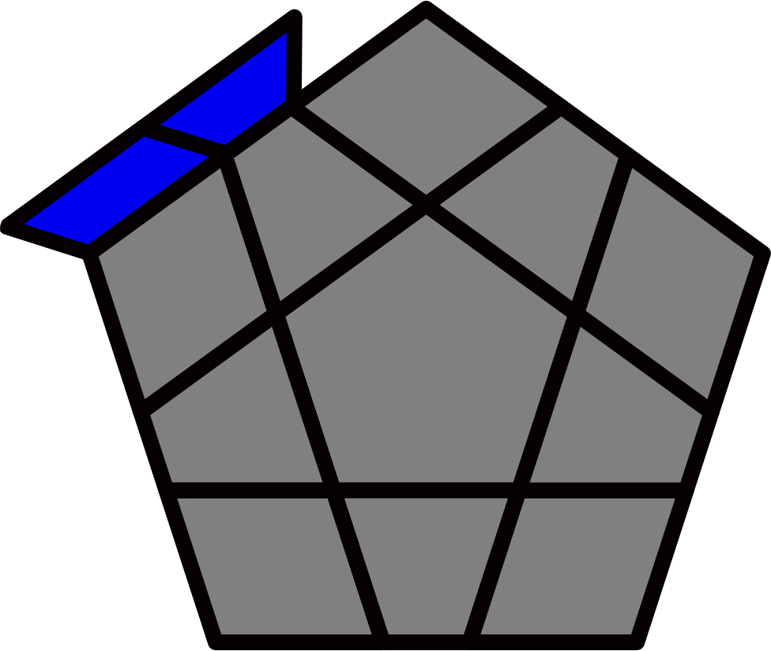Bar [12]
H+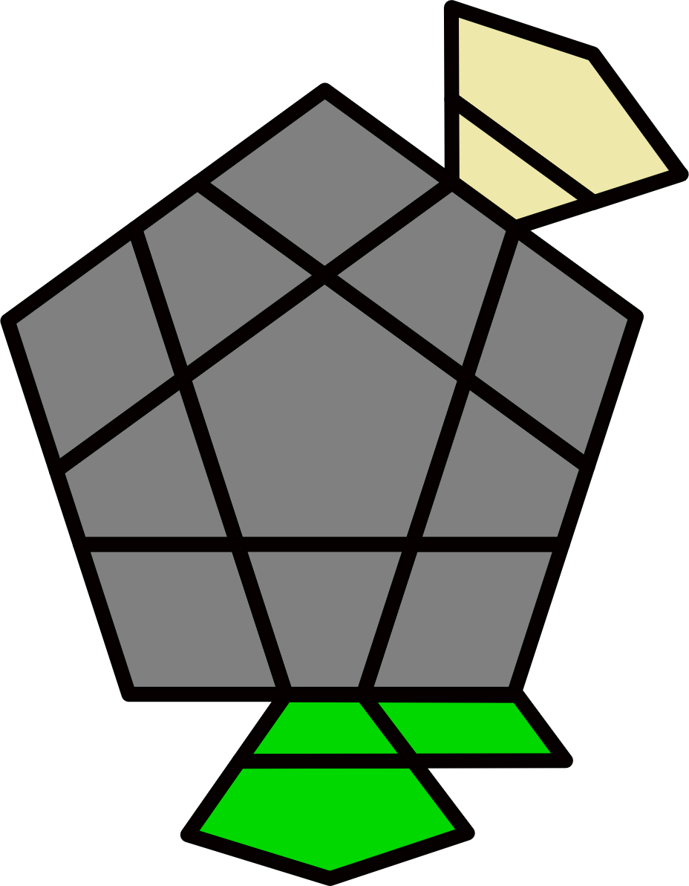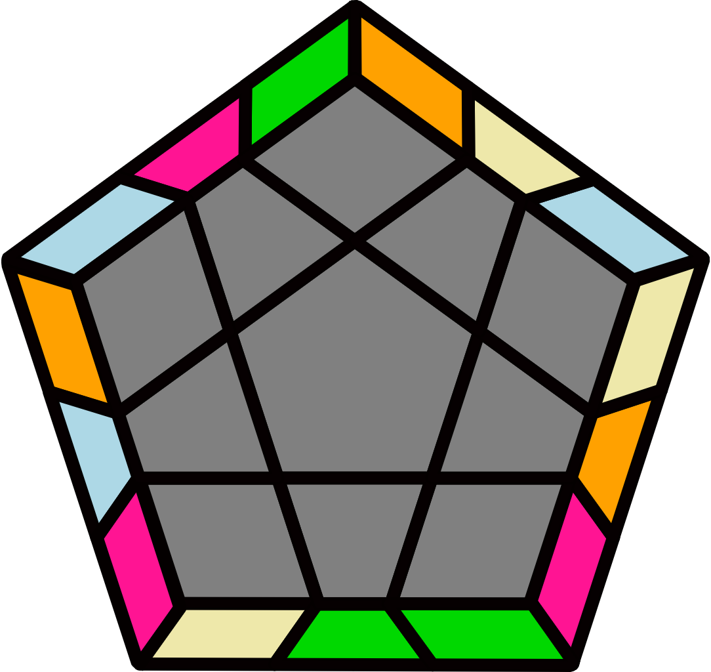 |  | H-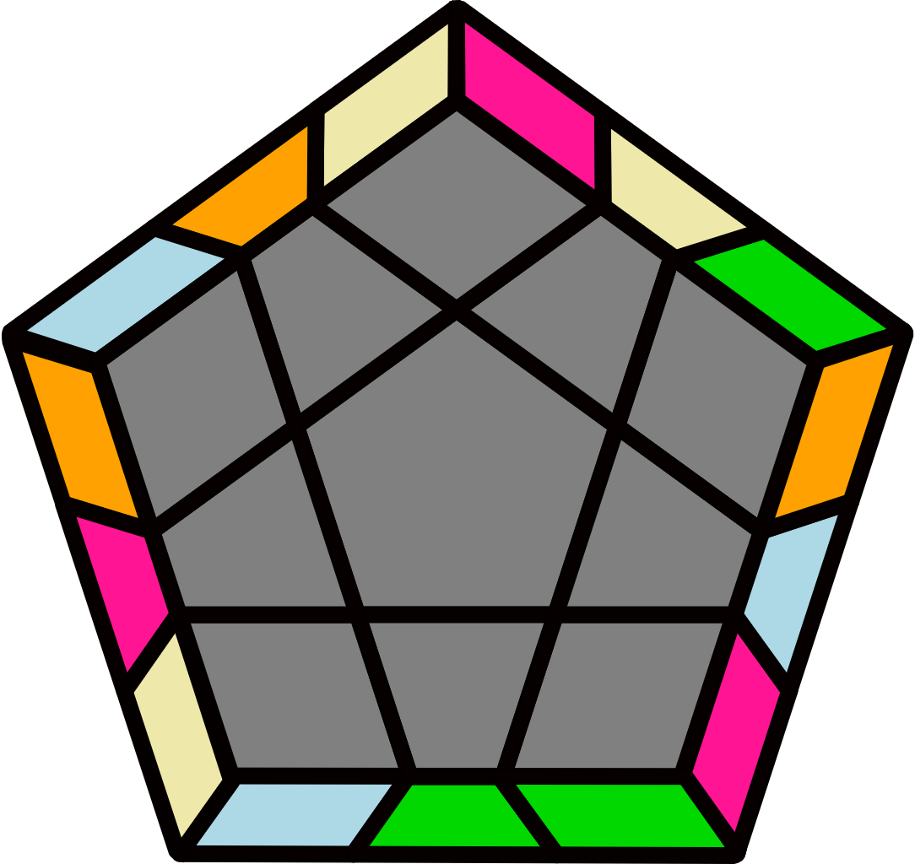 |  |  |  |  | M+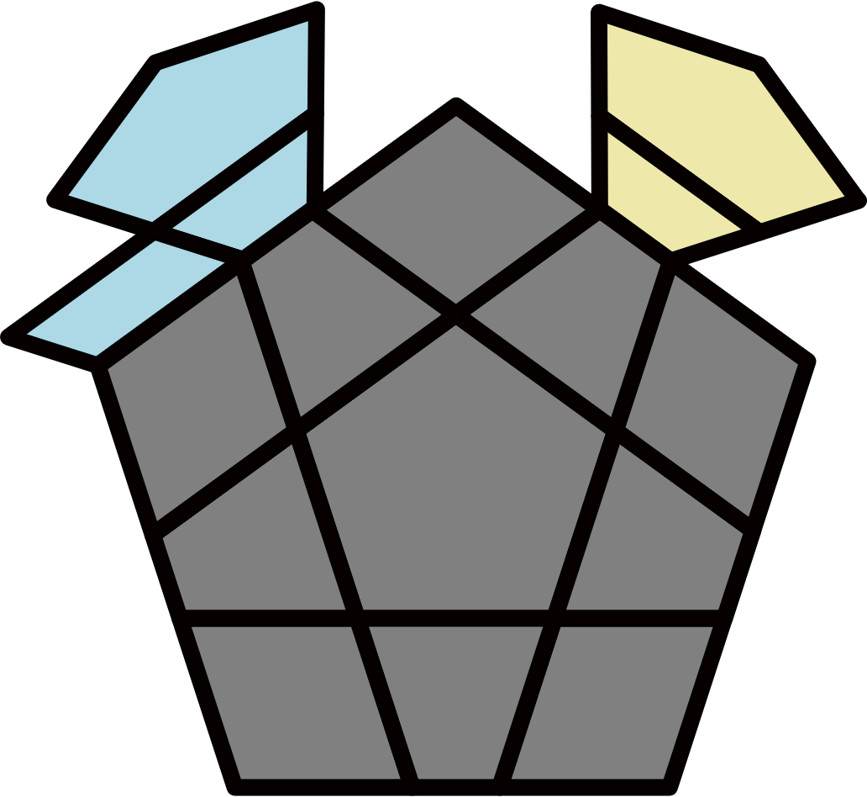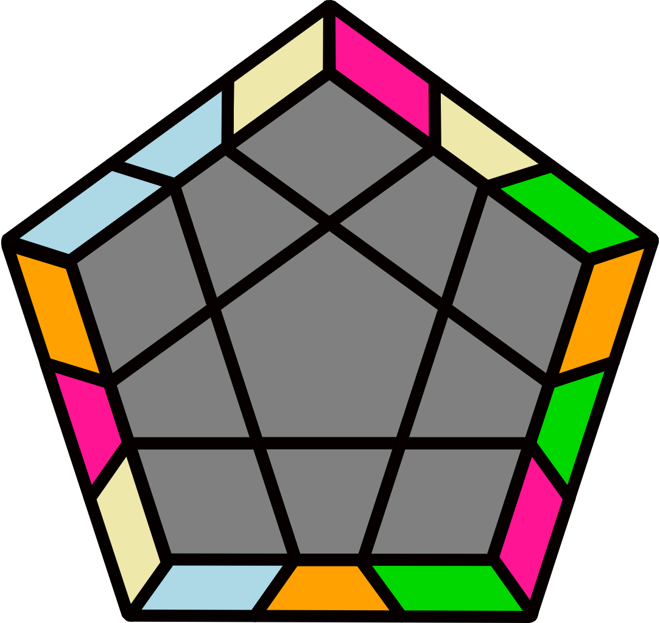 |  |  |  |  | M-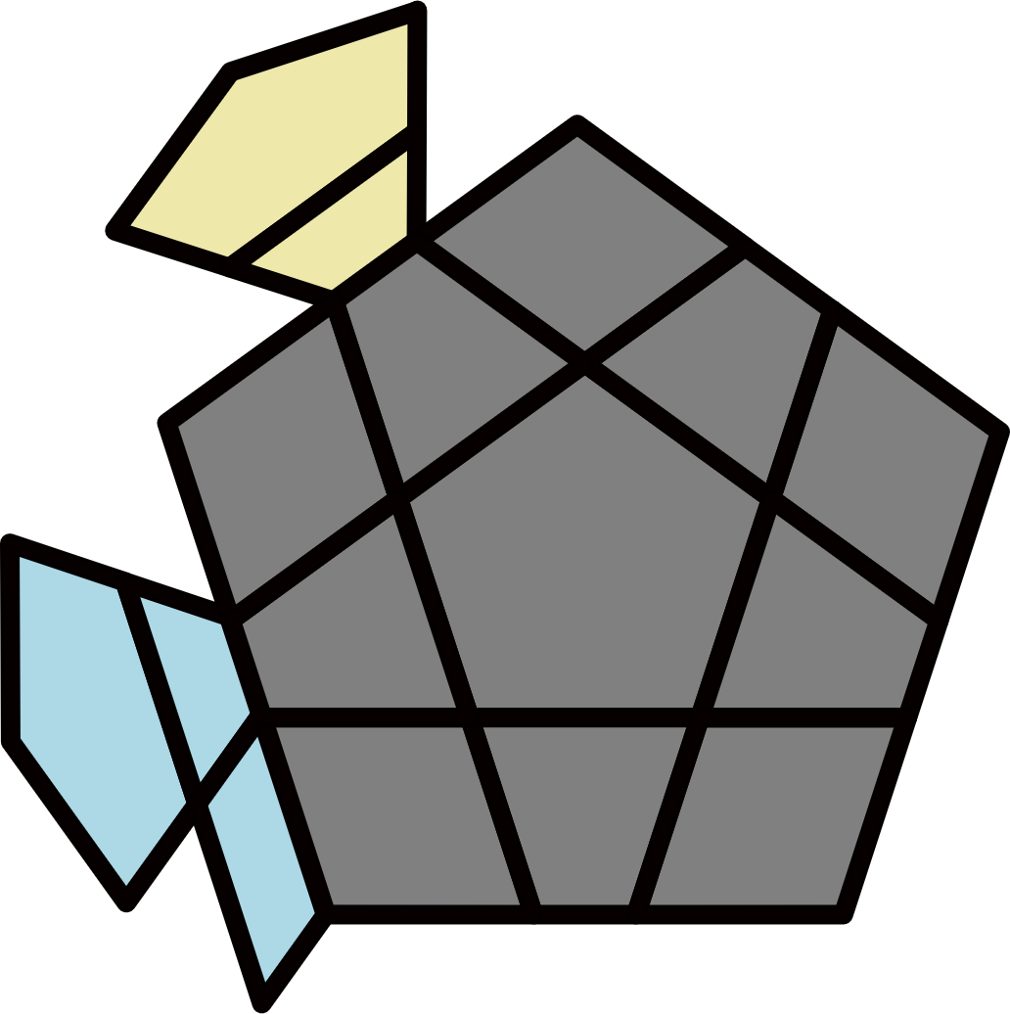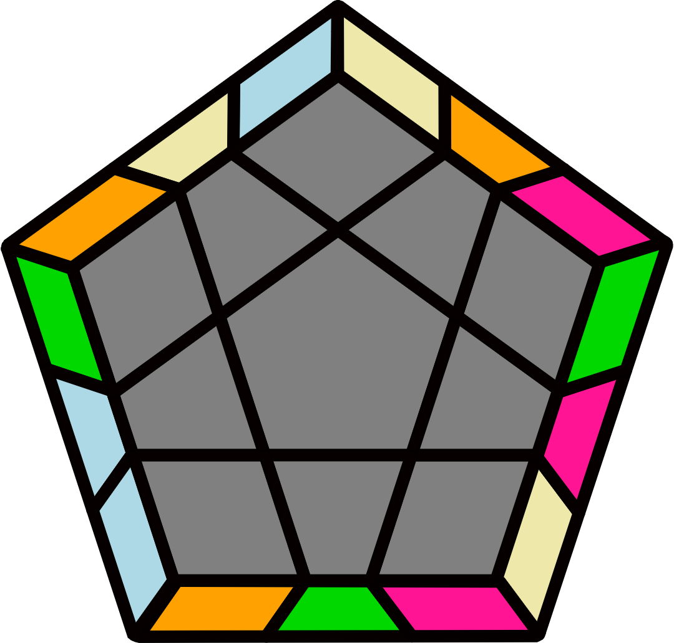
(R2' U2 R2 U) R2' F2 U' (R2 U R2' U) F2' U R2 |  | R2' U' F2 U' (R2 U' R2' U) F2' (R2 U' R2' U2' R2) |  |  |  |  | (R U2 R' U') (R2 U R' U) (R U2' R' U) (R' U R U2 R') |  |  |  |  | (R U2' R' U') (R U' R U2) (R' U' R U') (R2' U R U2' R')
X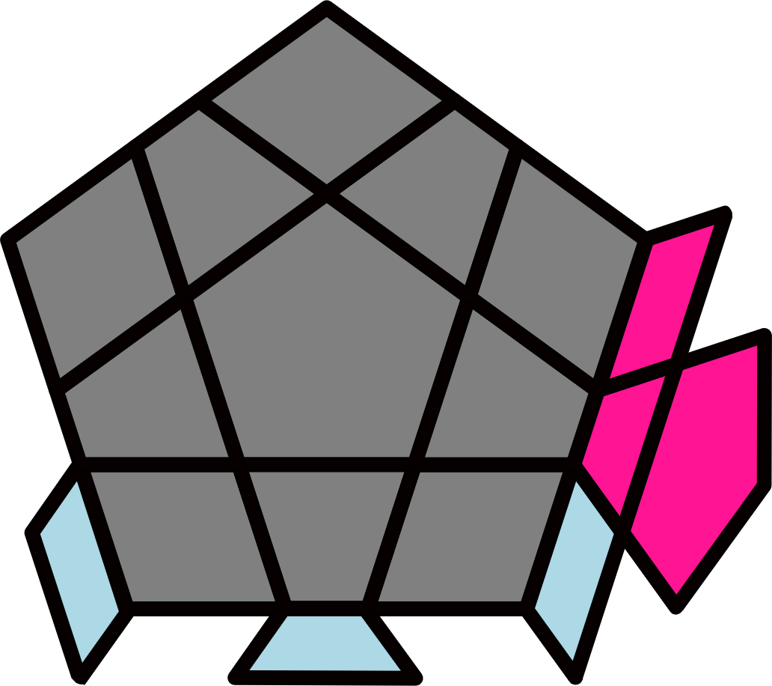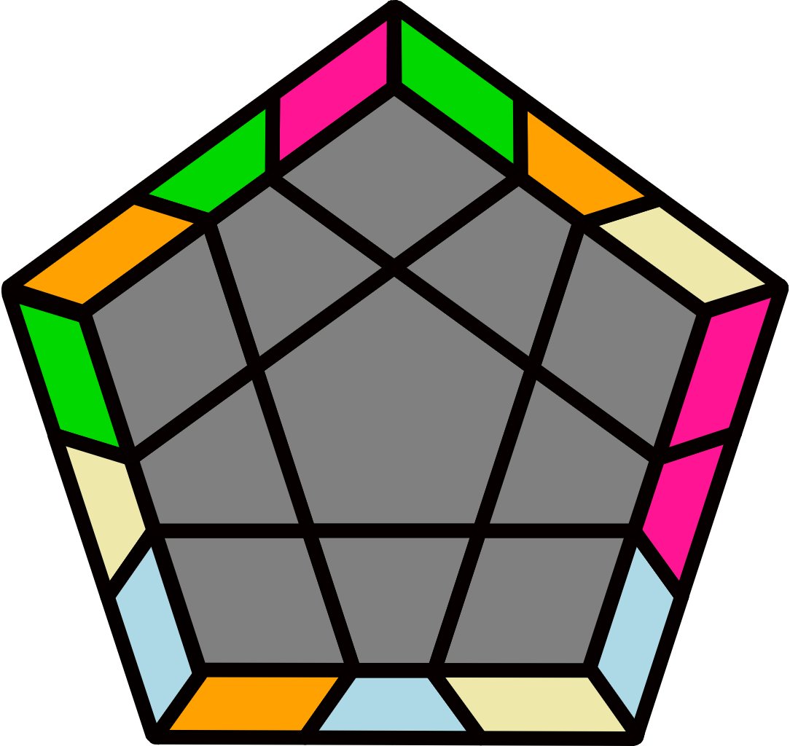 |  | X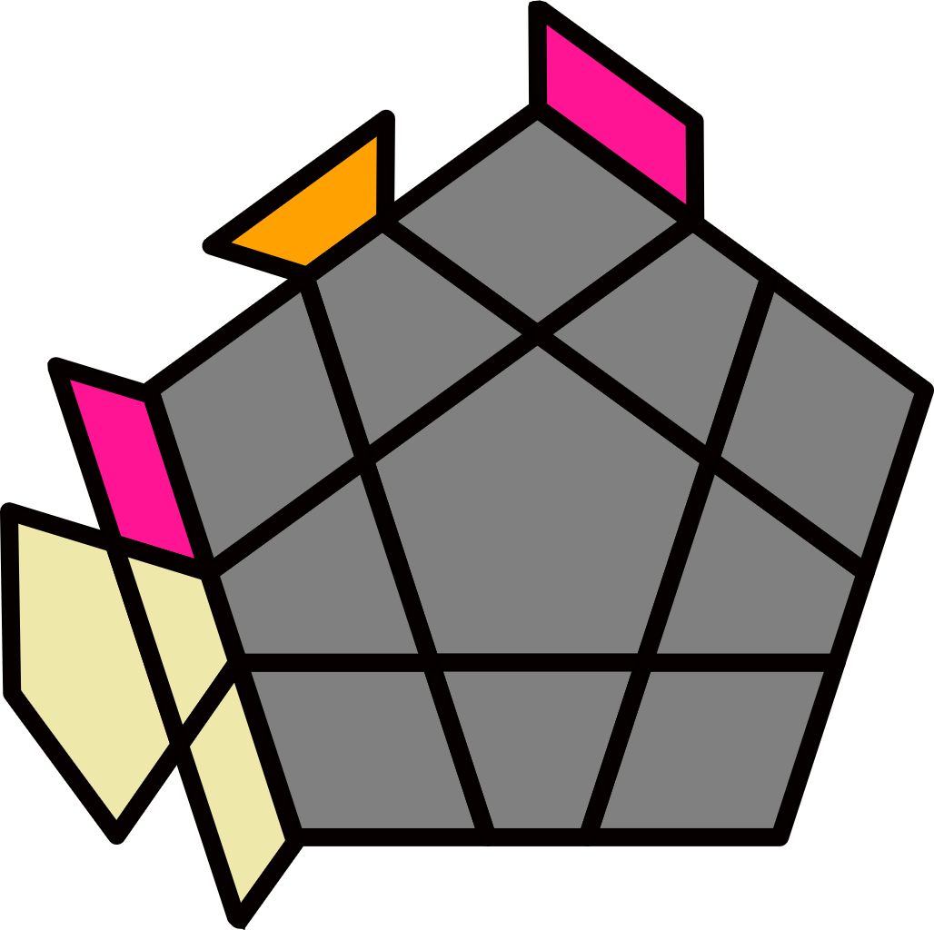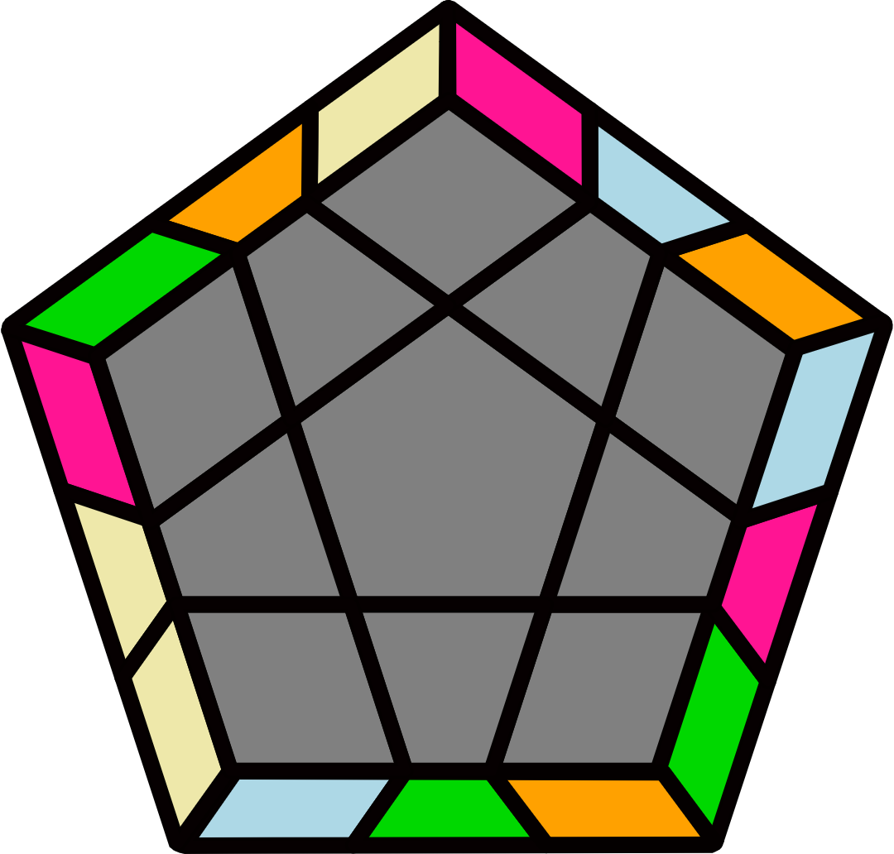 |  |  |  |  | H+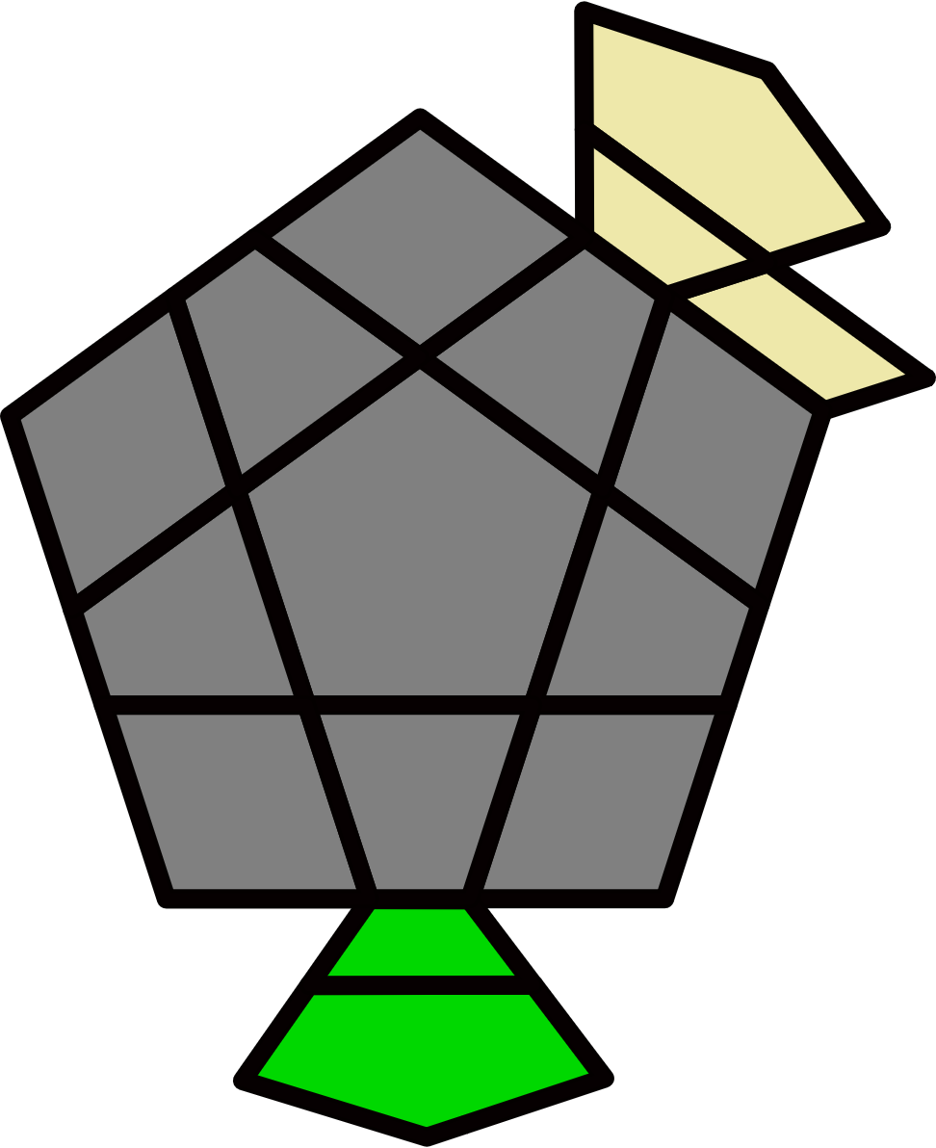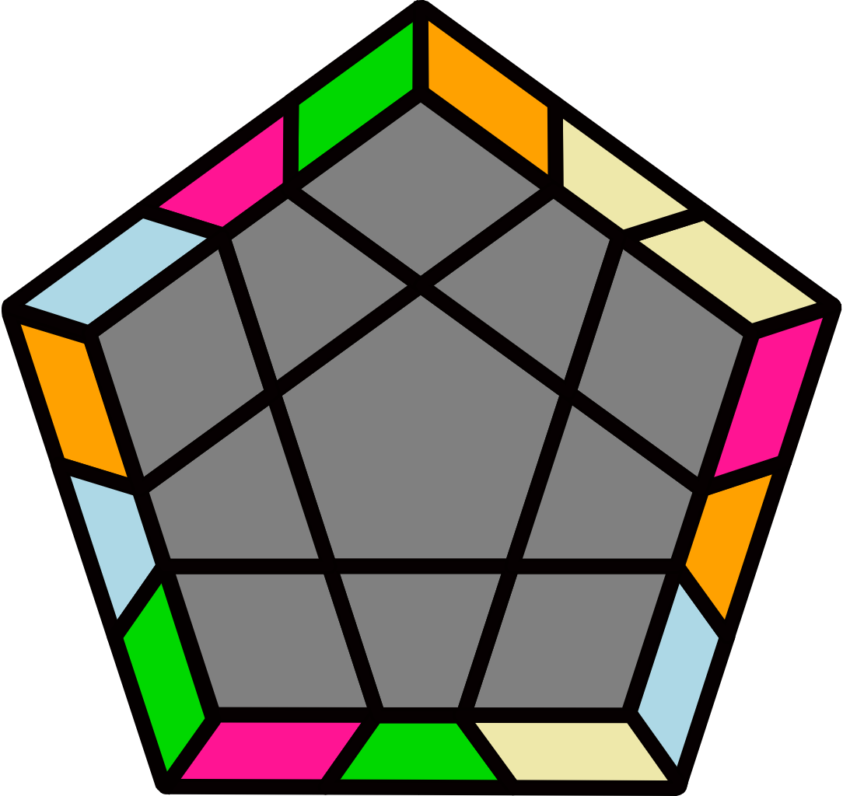 |  |  |  |  | H-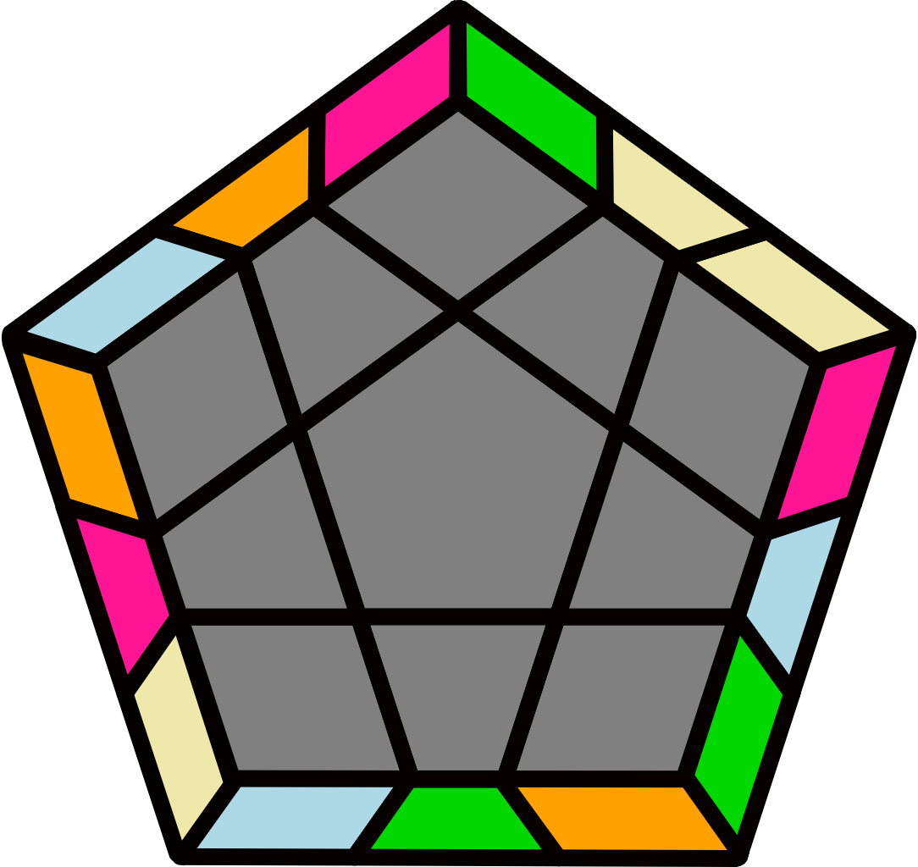
(R2 B2' R2' U') (R2 B2 R2' U2) (R2 B2' R2' U') R2 B2 R2' |  | R2 U R2' U R2 U2' R2' U2 y' R2' U' R2 U2' R2' U2' R2 |  |  |  |  | R2 U B2' U (R2' U R2 U') B2 (R2' U R2 U2 R2') |  |  |  |  | (R2 U2' R2' U') R2 B2' U (R2' U' R2 U') B2 U' R2'
M+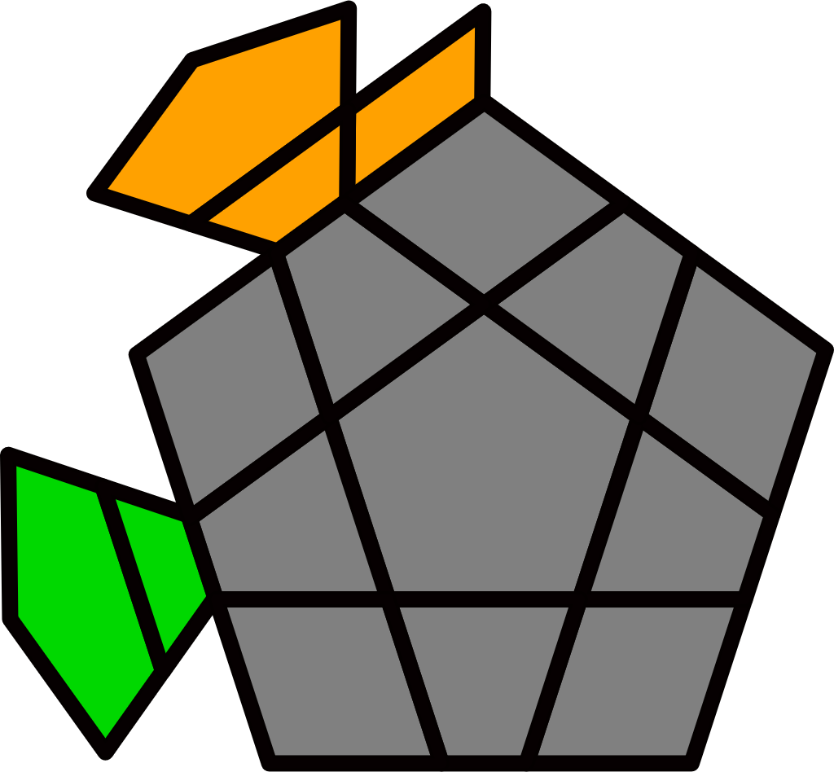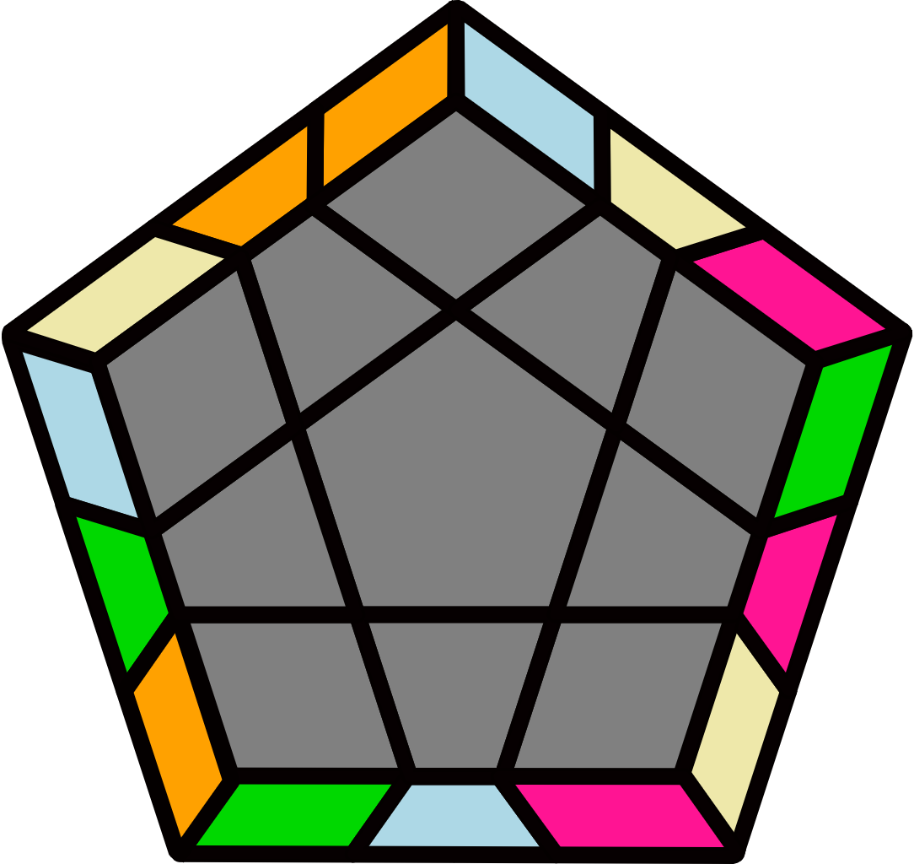 |  | M-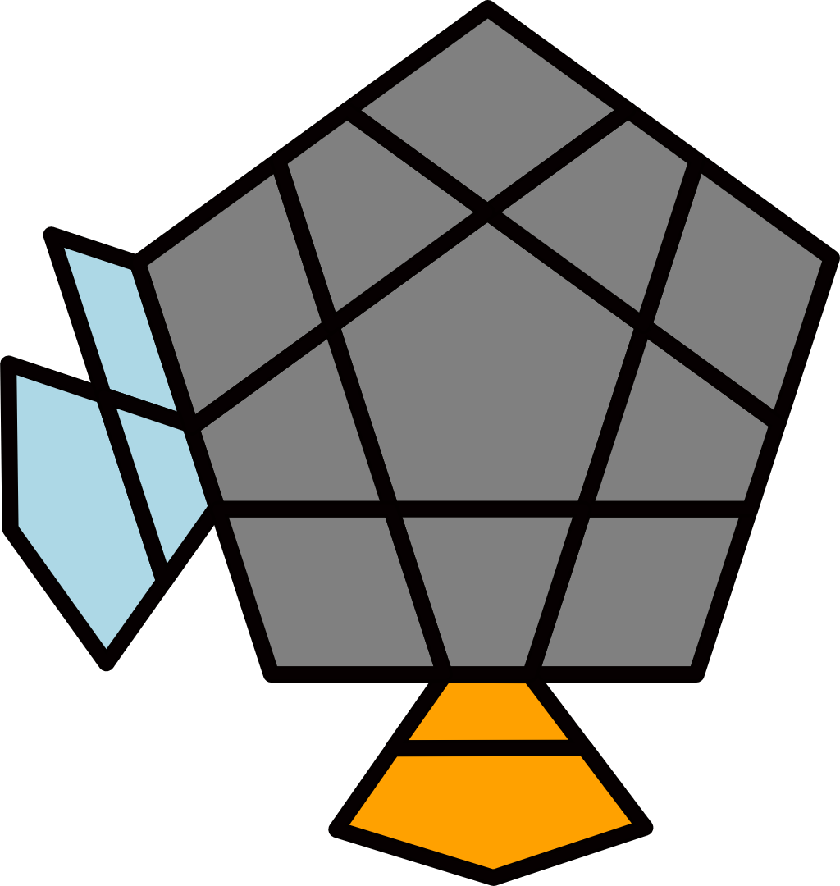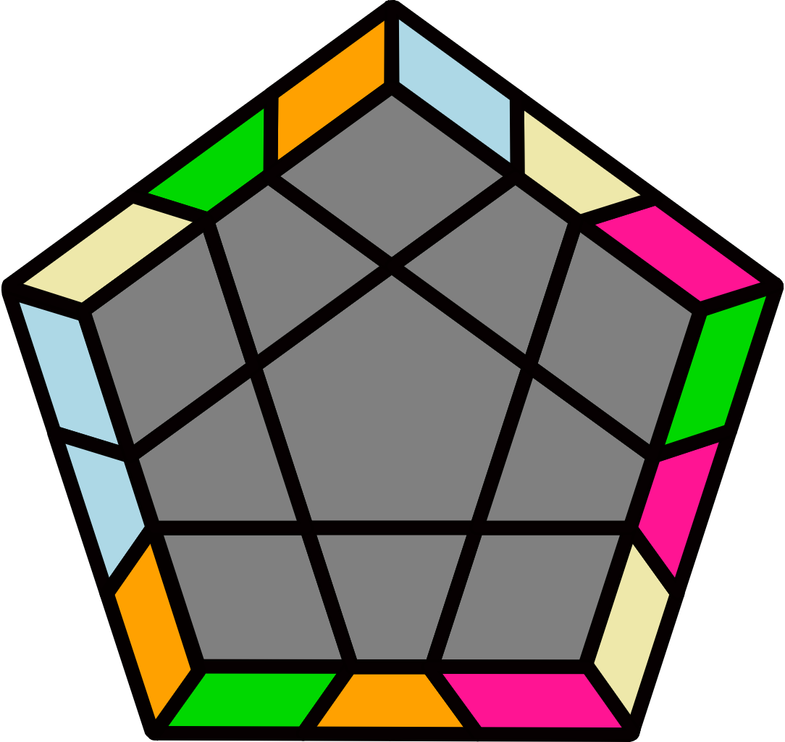 |  |  |  |  | X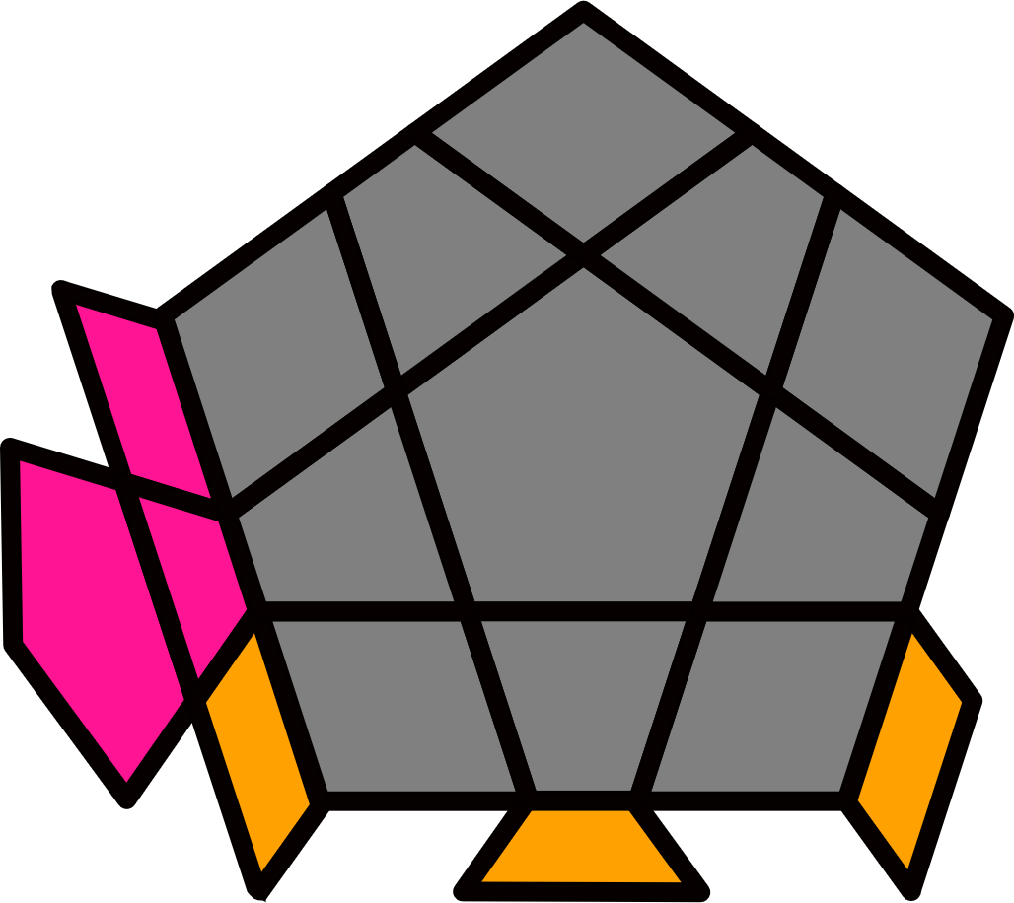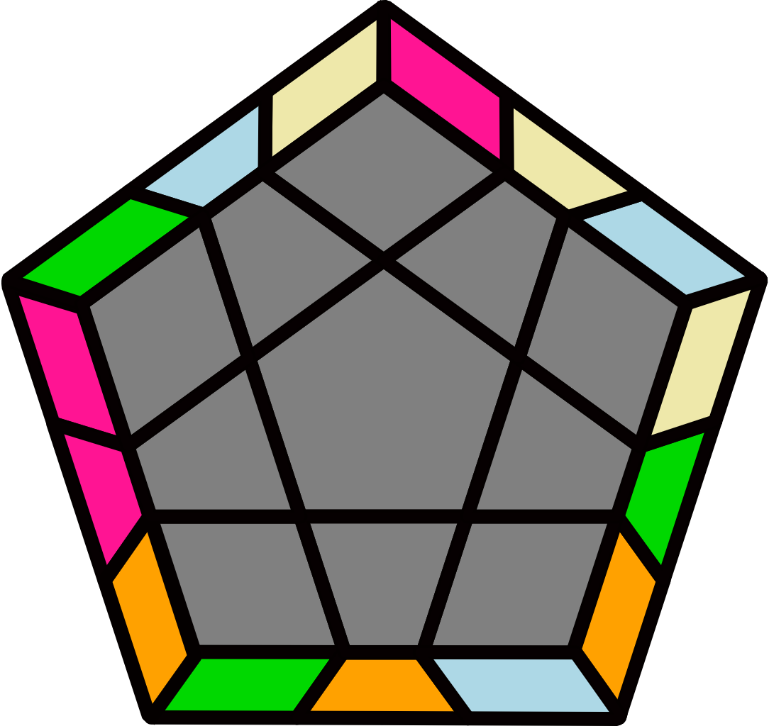 |  |  |  |  | X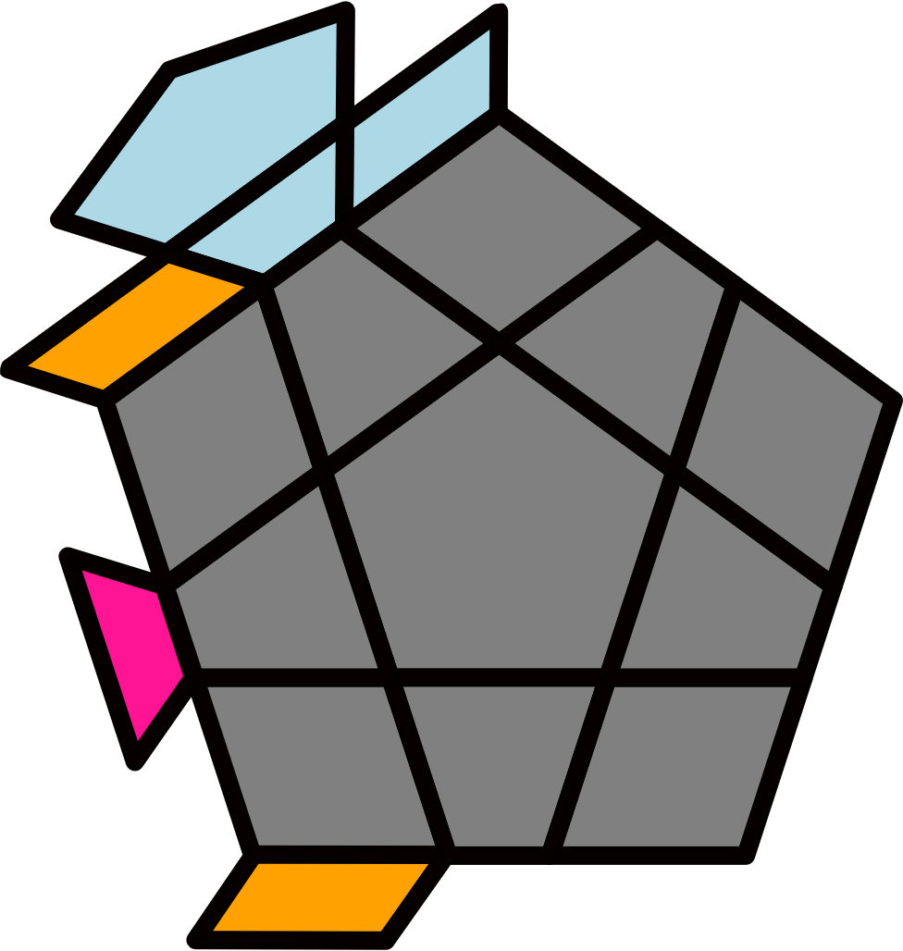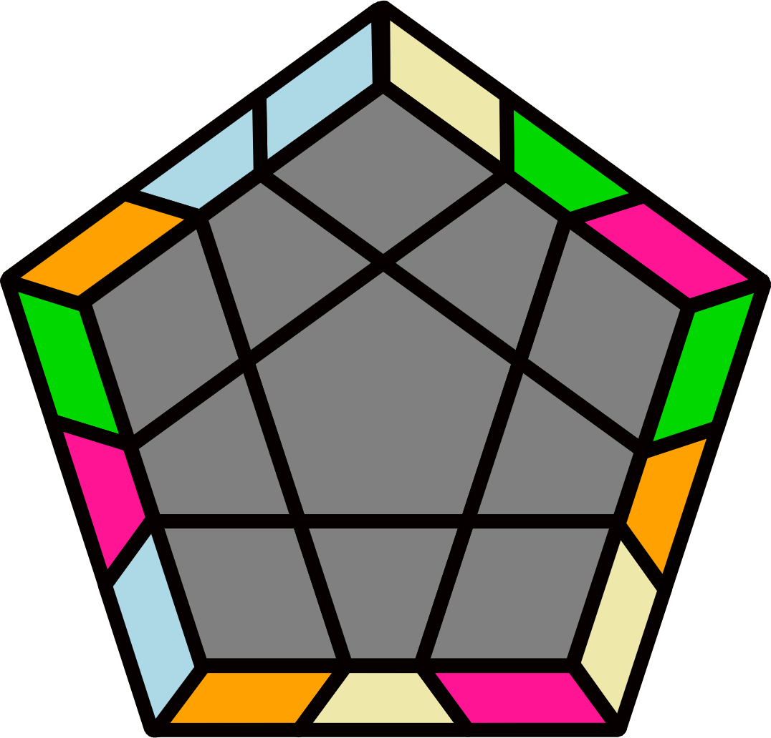
(R' U2 R U) (R' U R' U2') (R U R' U) (R2 U' R' U2 R) |  | (R' U2' R U) (R2' U' R U') (R' U2 R U') (R U' R' U2' R) |  |  |  |  | (R2' F2 R2 U') (R2' F2' R2 U2) (R2' F2 R2 U') R2' F2' R2 |  |  |  |  | R2' U' R2 U' R2' U2 R2 U2' y R2 U R2' U2 R2 U2 R2'
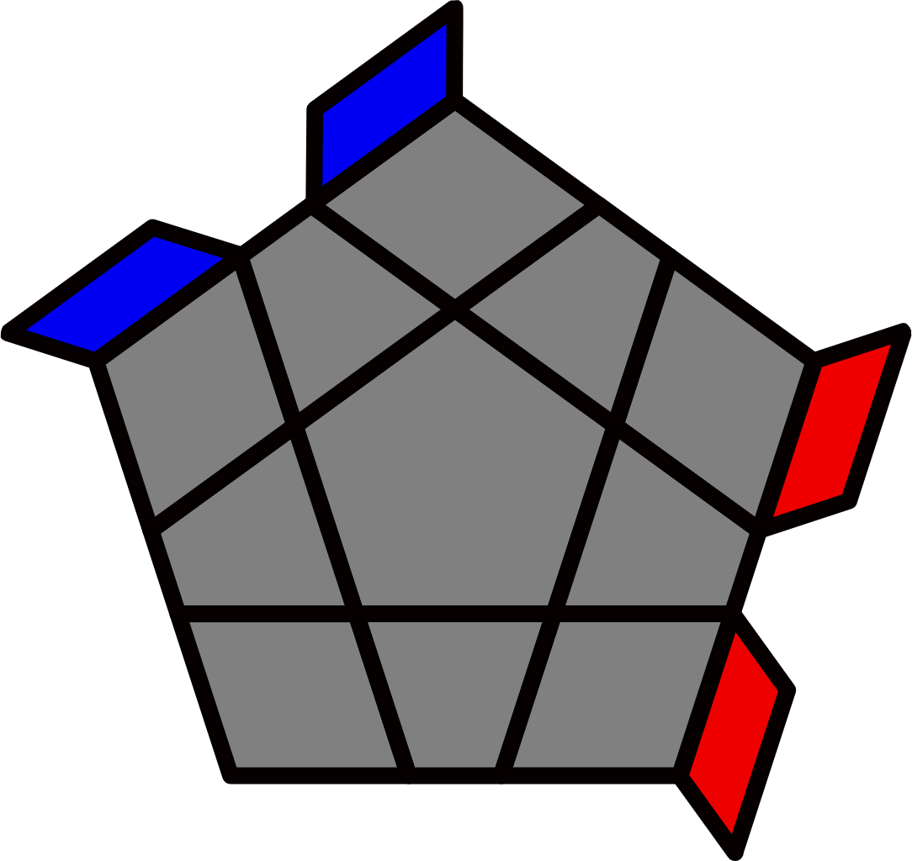 |  |  |  |  |  |  | 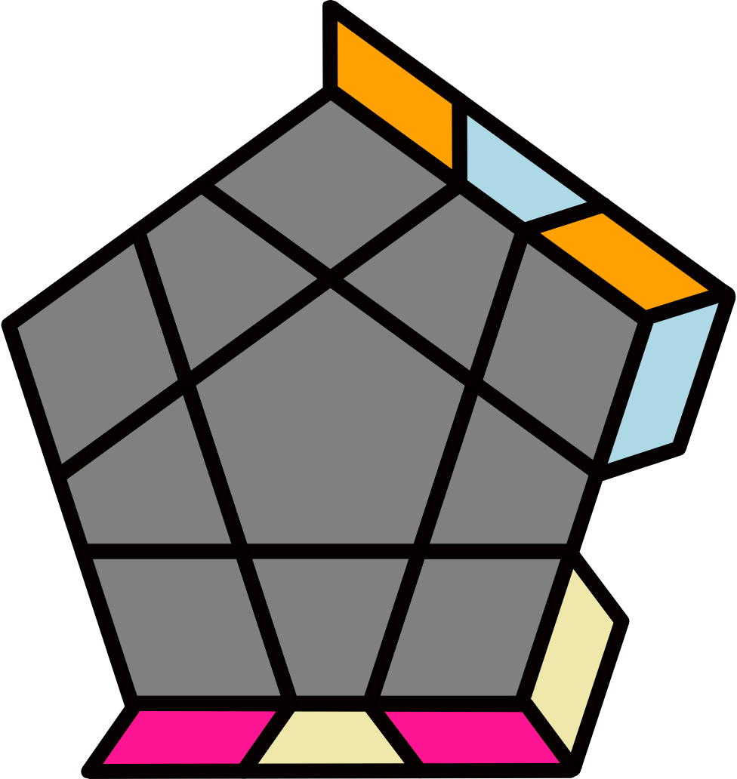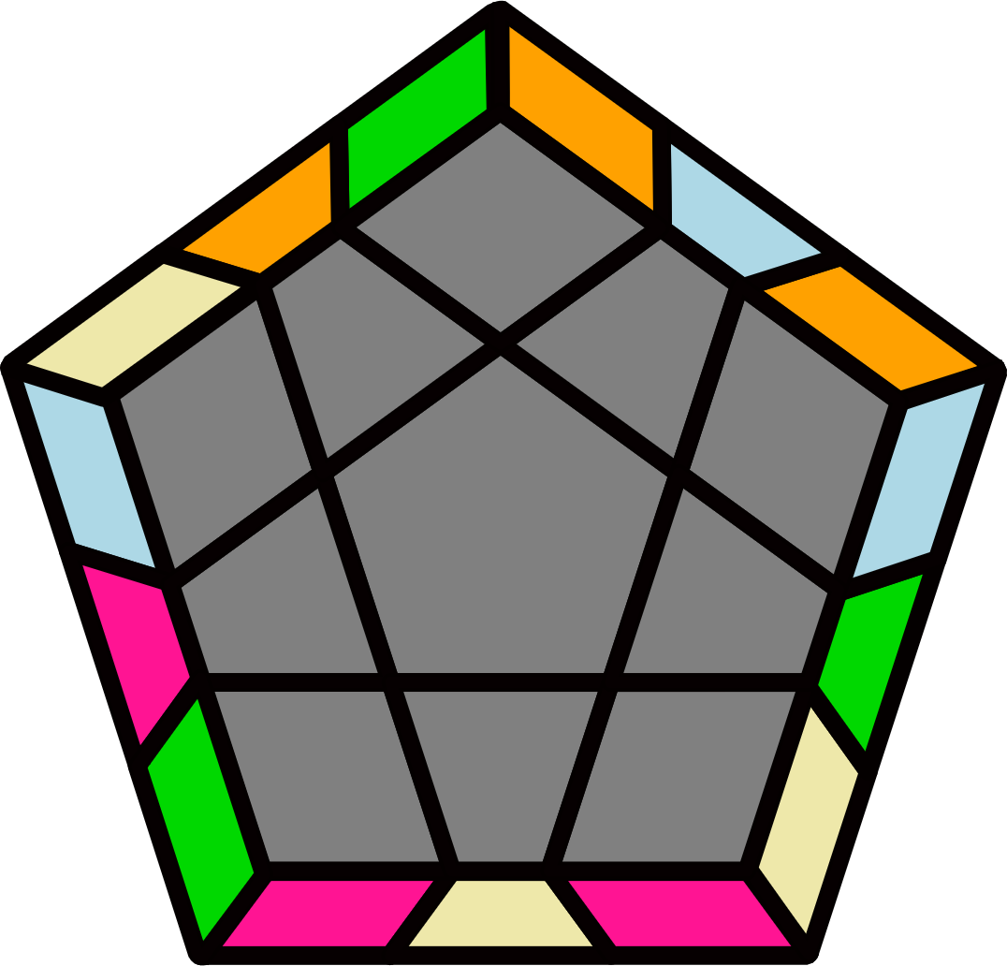 |  |  |  |  | H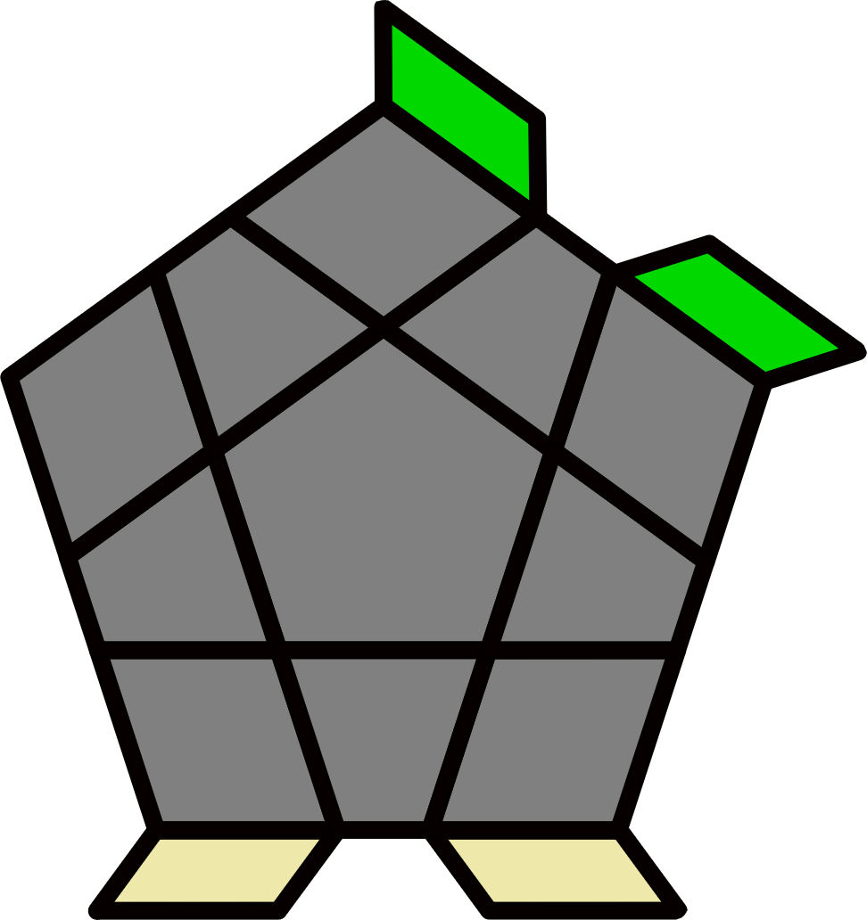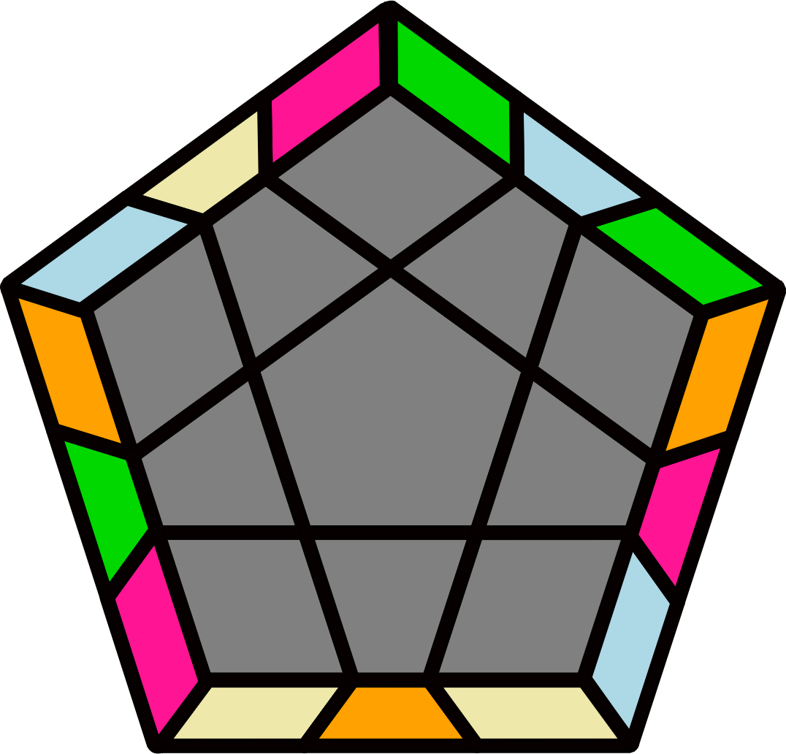
Lights [10] |  |  |  |  |  |  | y (R U R' U' R' F R2 U' R' U' R U R' F') U2' (R U R' U' R' F R2 U' R' U' R U R' F') |  |  |  |  | y' (R' U2 R U) (R' U R U') (R' U2 R U') (R U R' U) R U2' R'
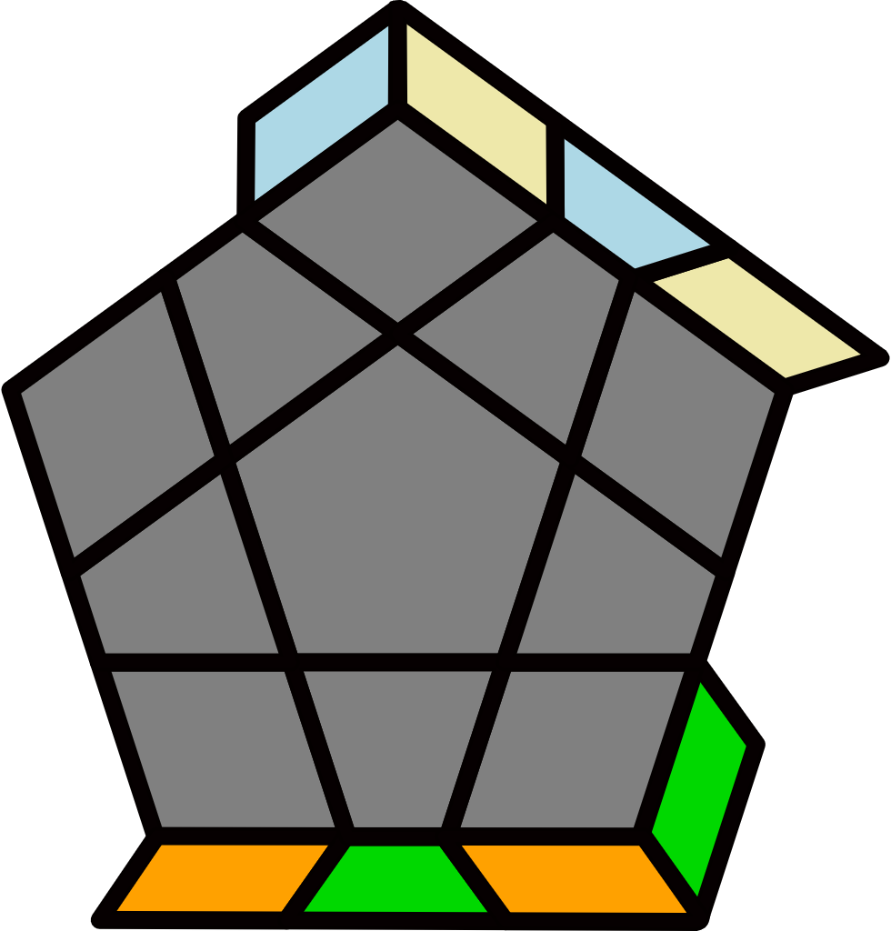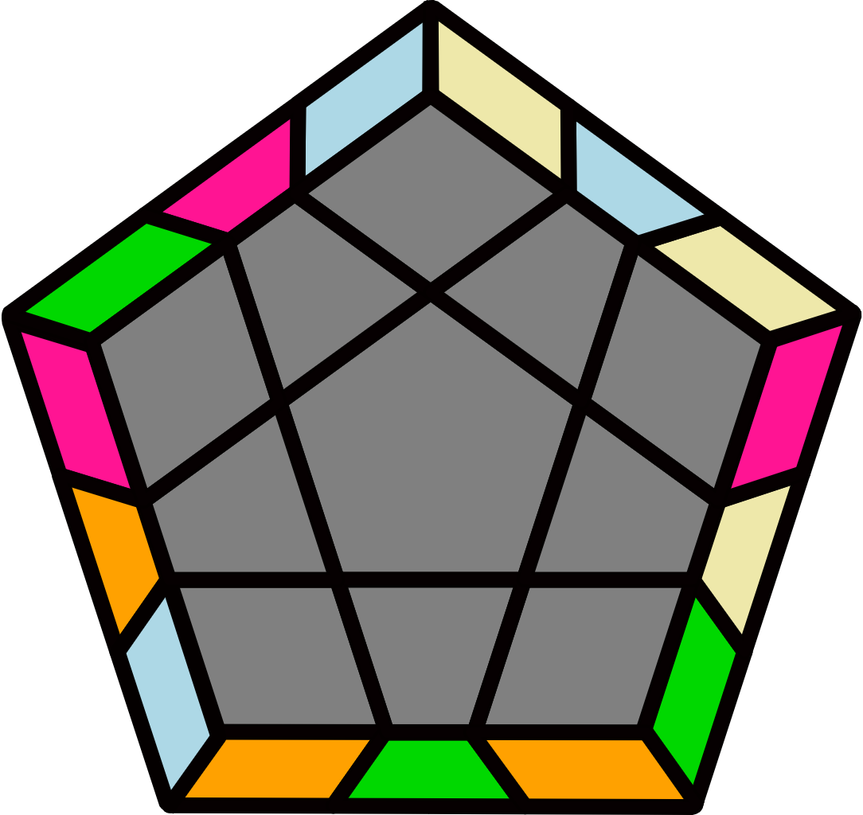 |  | 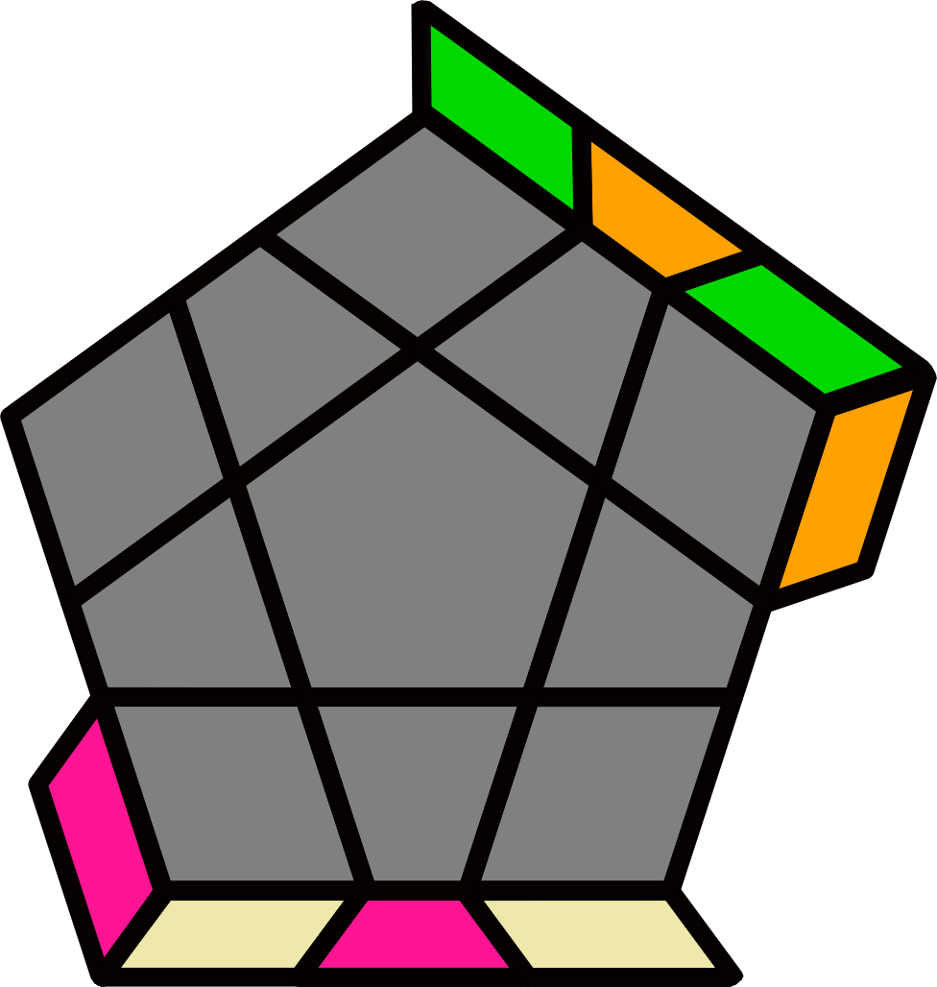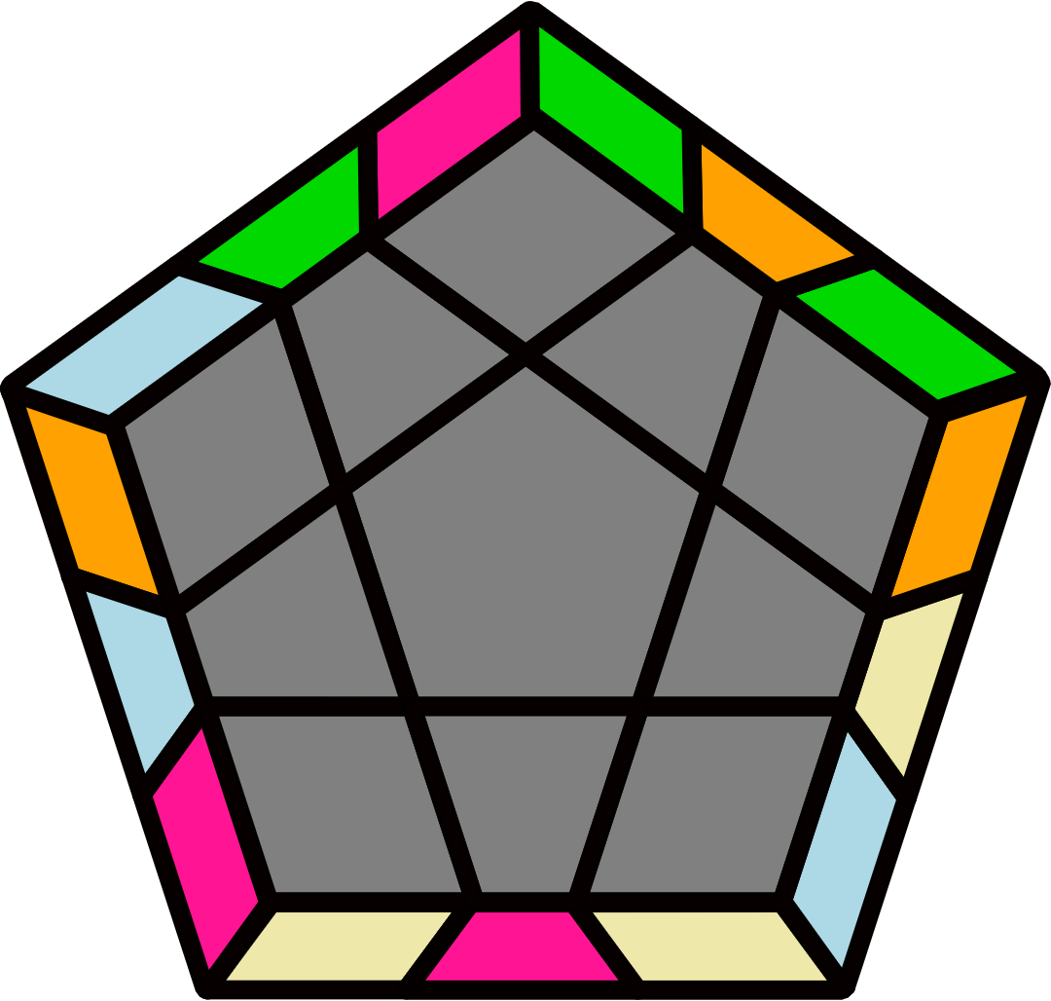 |  |  |  |  | 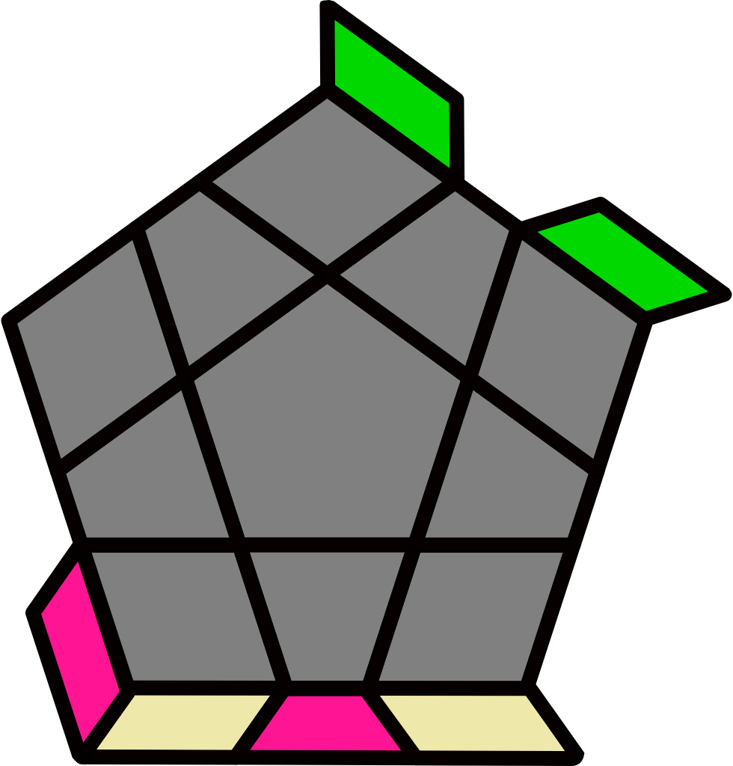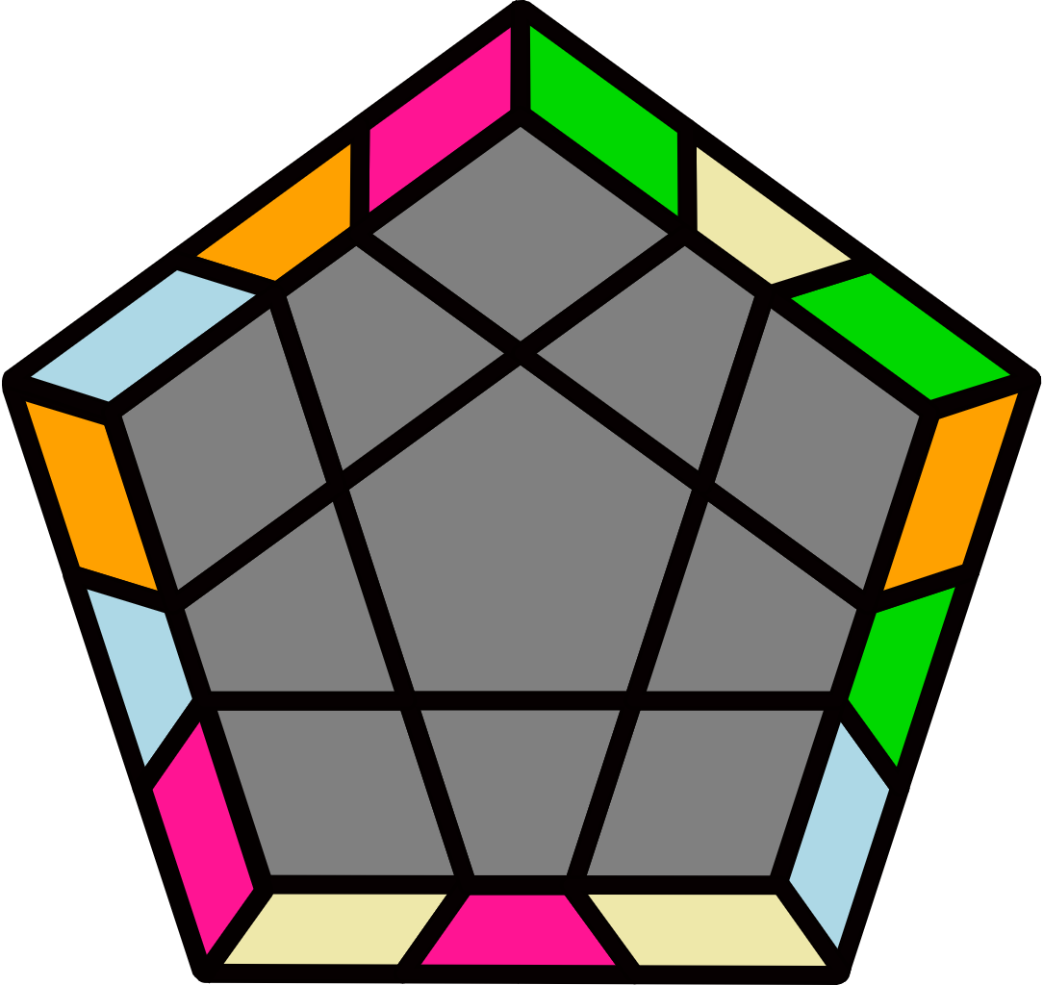 |  |  |  |  | 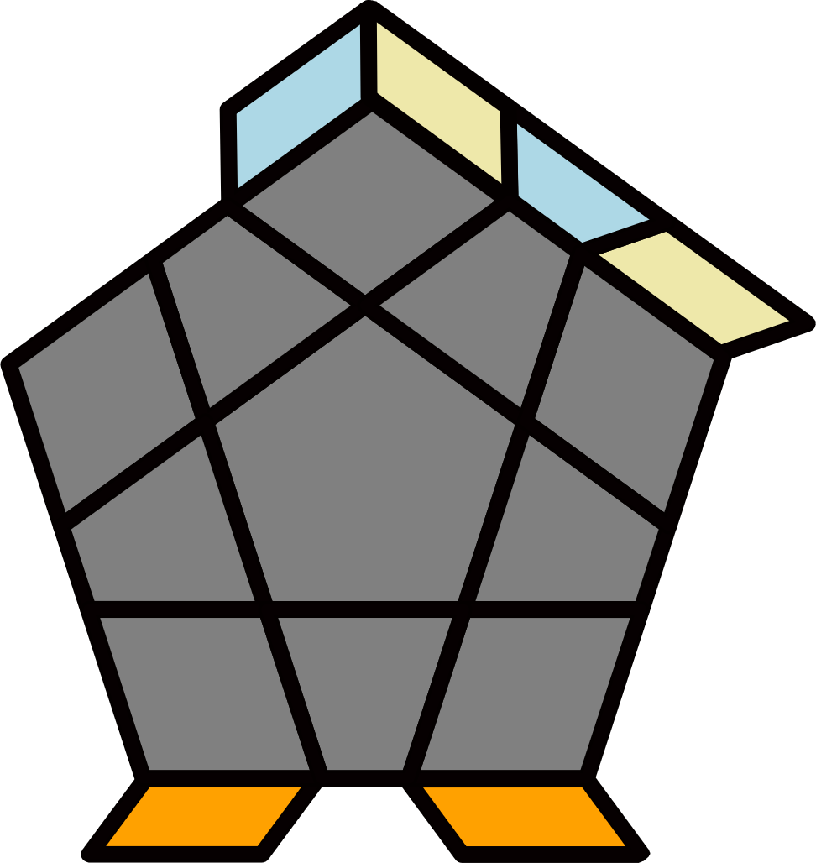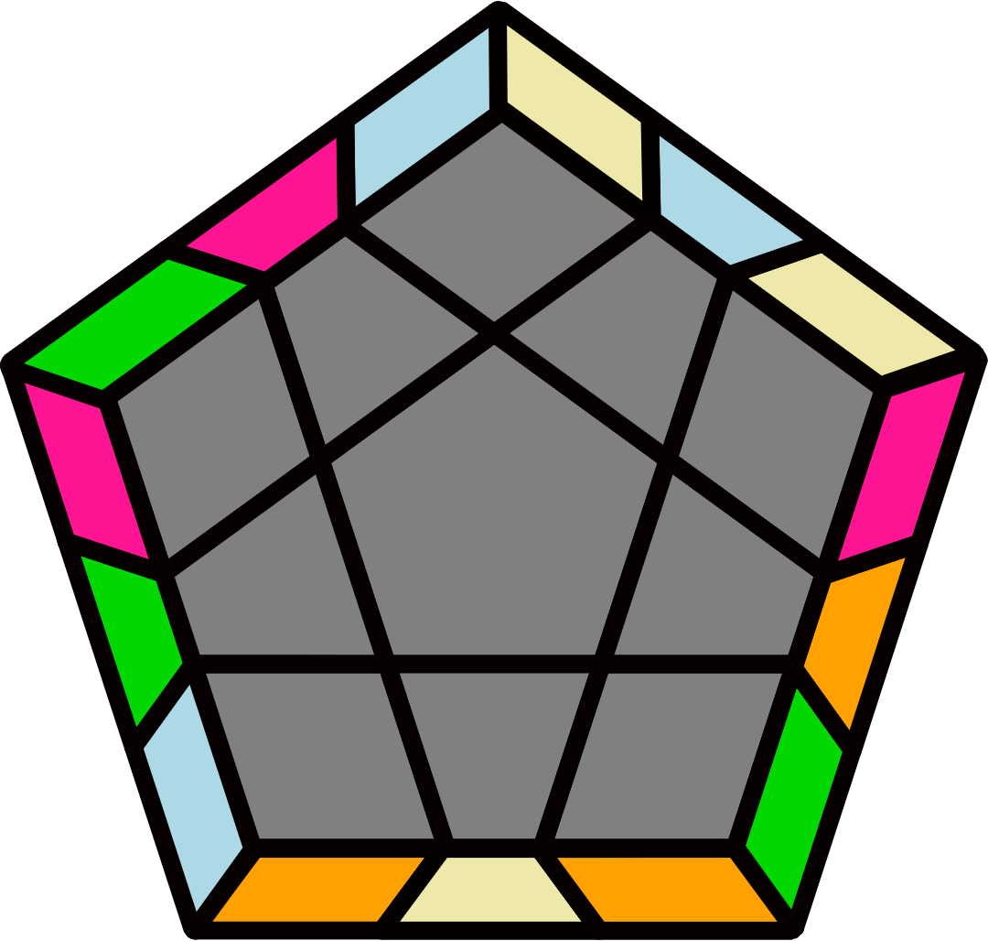
(R U R U) (R' U R' U) (R U' R U2') (R' U2' R' U') R U2 R' |  | y2' (R U2' R' U) (R U2 R U2) (R' U R' U') (R U' R U')  R' U' R' |  |  |  |  | F U2' F' U2' R F R' U' R F' U2' R' U' R U2' R' |  |  |  |  | y2' (R U R' U') (R' U2 R U) (R U R2' U) (R U' R U) (R' U' R U2' R')
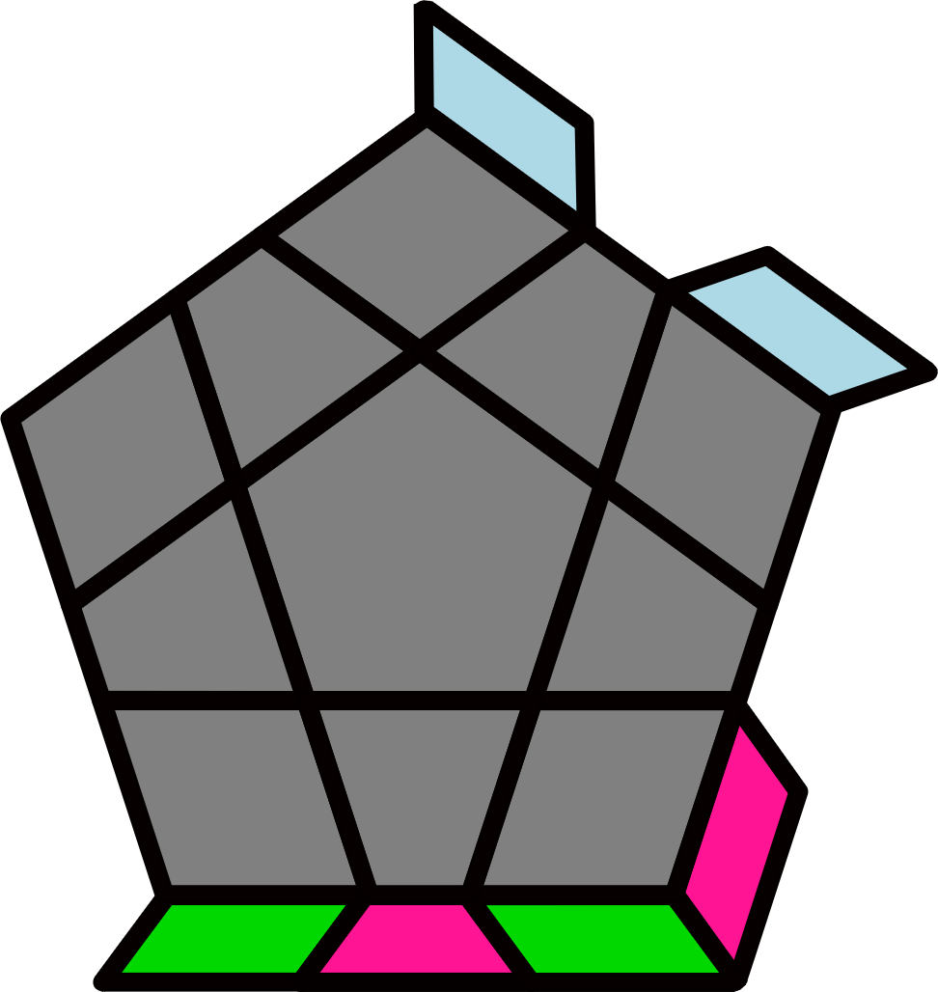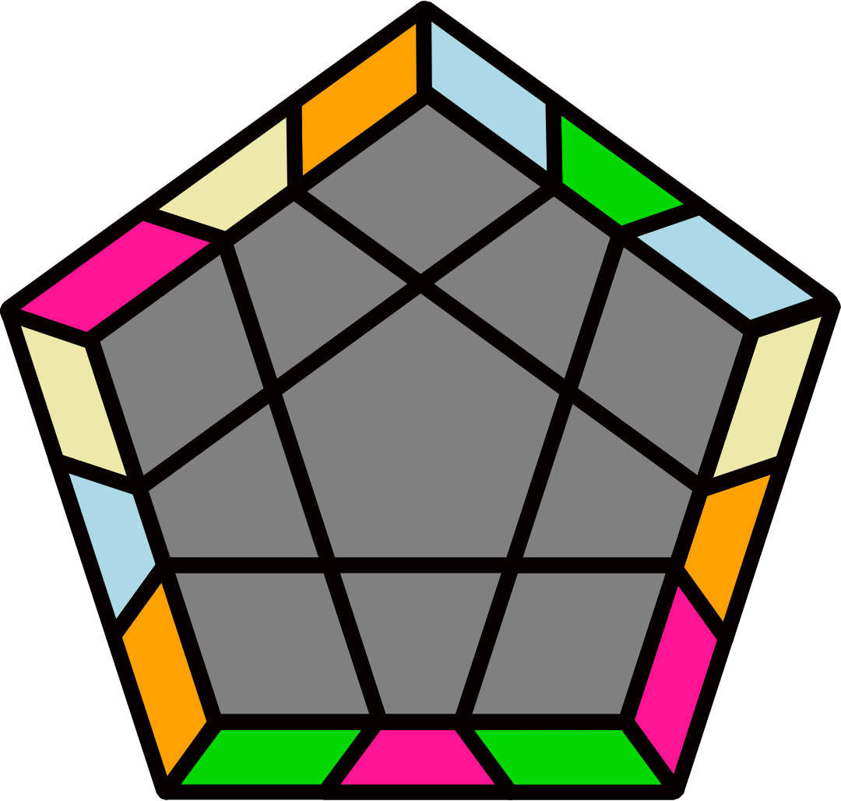 |  | 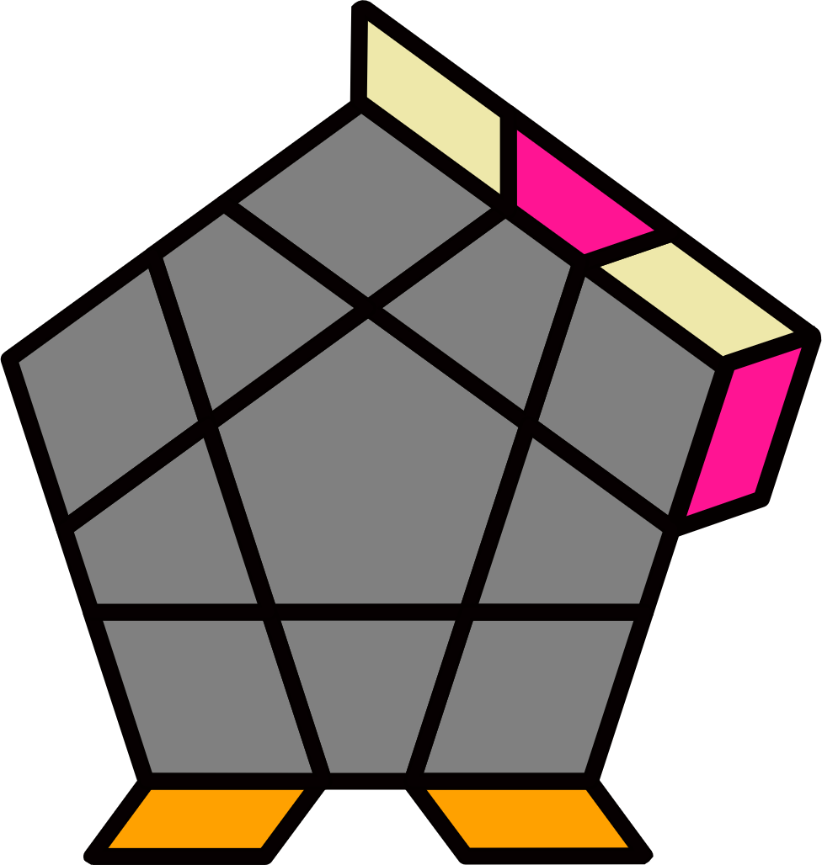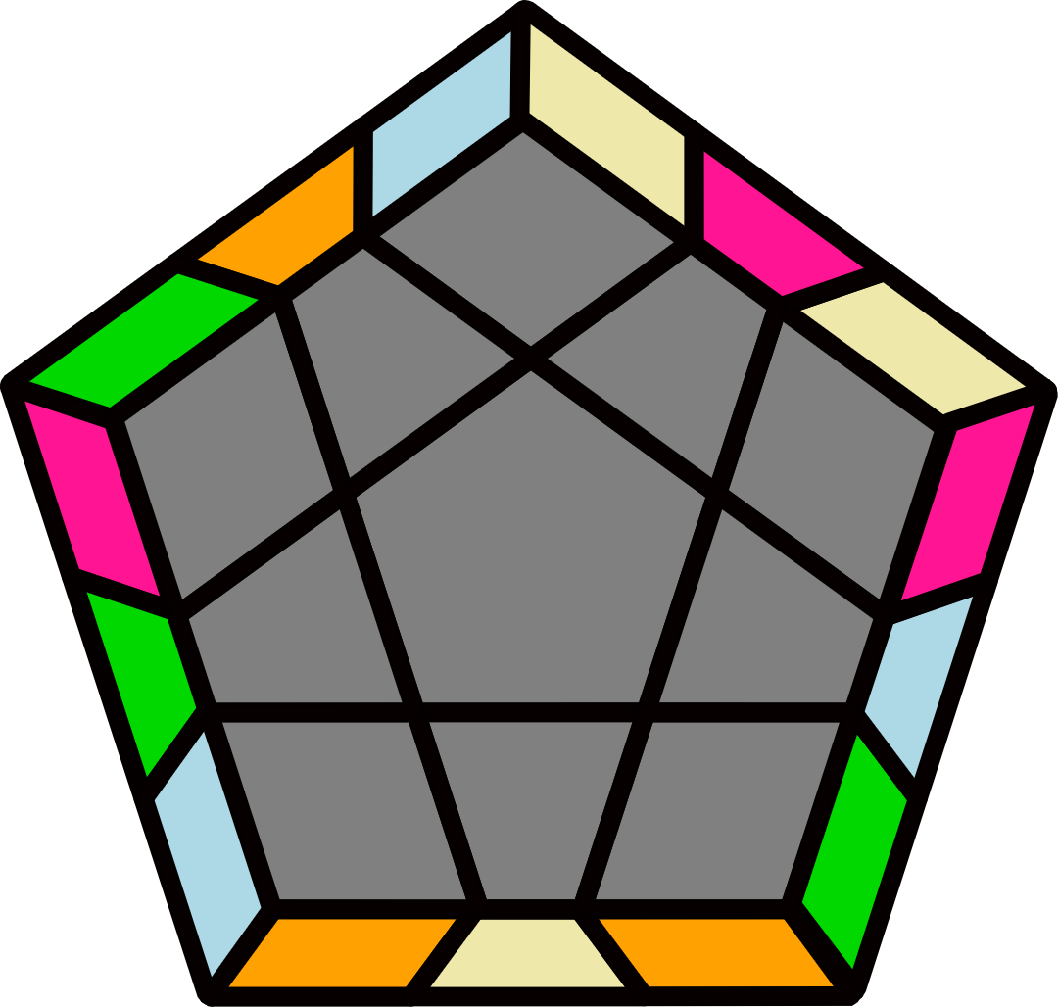 |  |  |  |  | 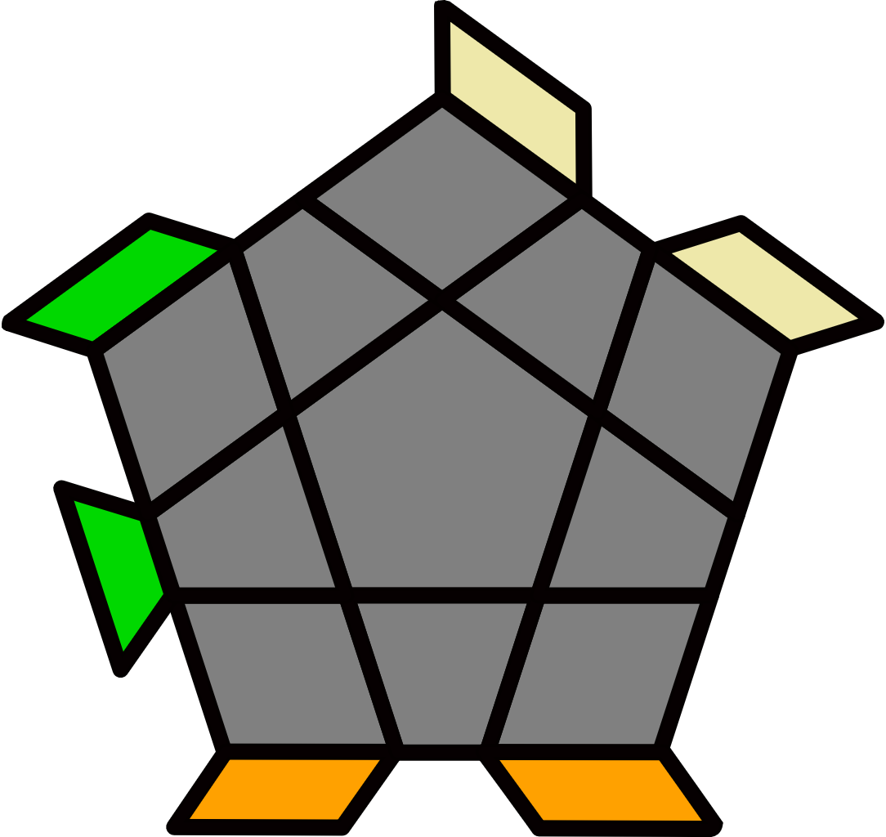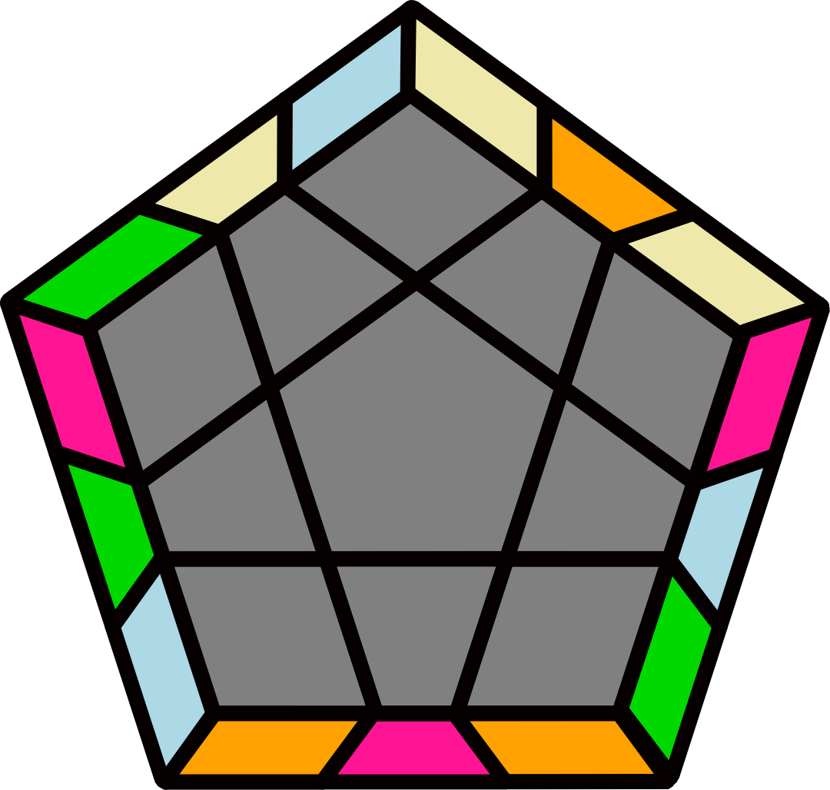 |  |  |  |  | 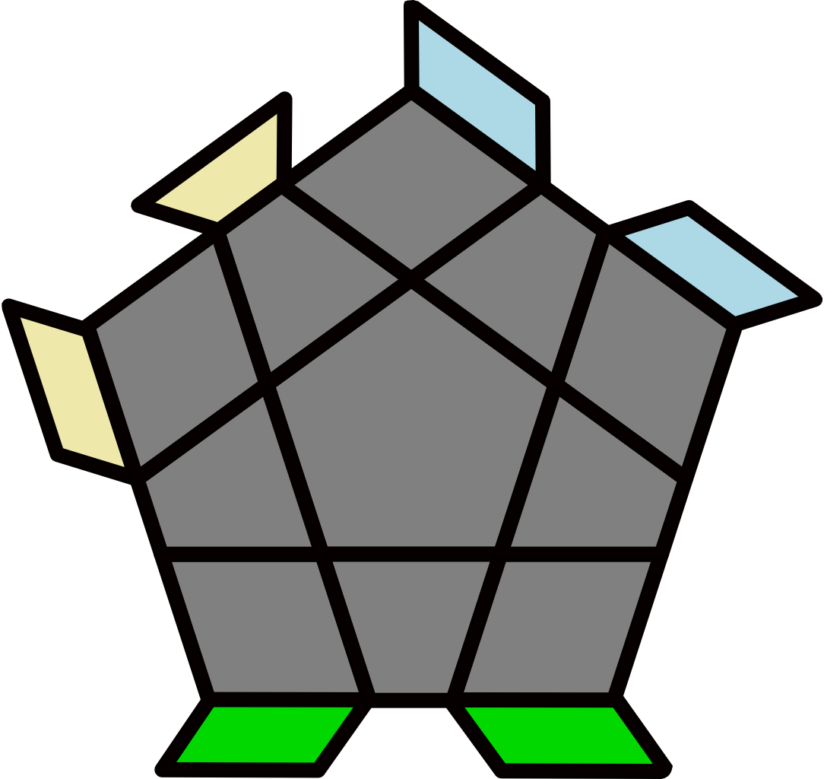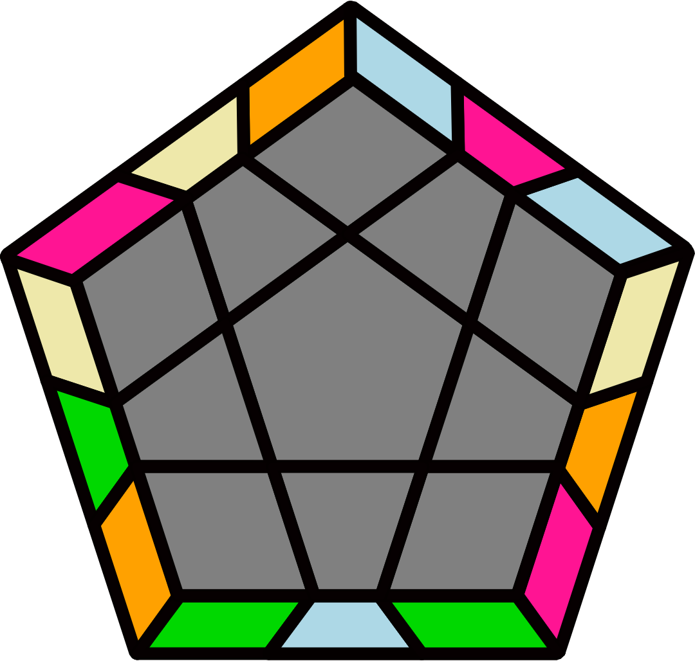
y2' (R' U2' R U) (R' U R2 U2') (R' U' R U) (R' U2' R U' R') |  | y2 (R U2 R' U') (R U' R2' U2) (R U R' U') (R U2 R' U R) |  |  |  |  | y2 (R U R' U2) (R U' R' U)  (R U2 R2' U') (R U' R' U2 R) |  |  |  |  | y2' (R' U' R U2') (R' U R U') (R' U2' R2 U) (R' U R U2' R')
 |  |  |  |  |  |  | 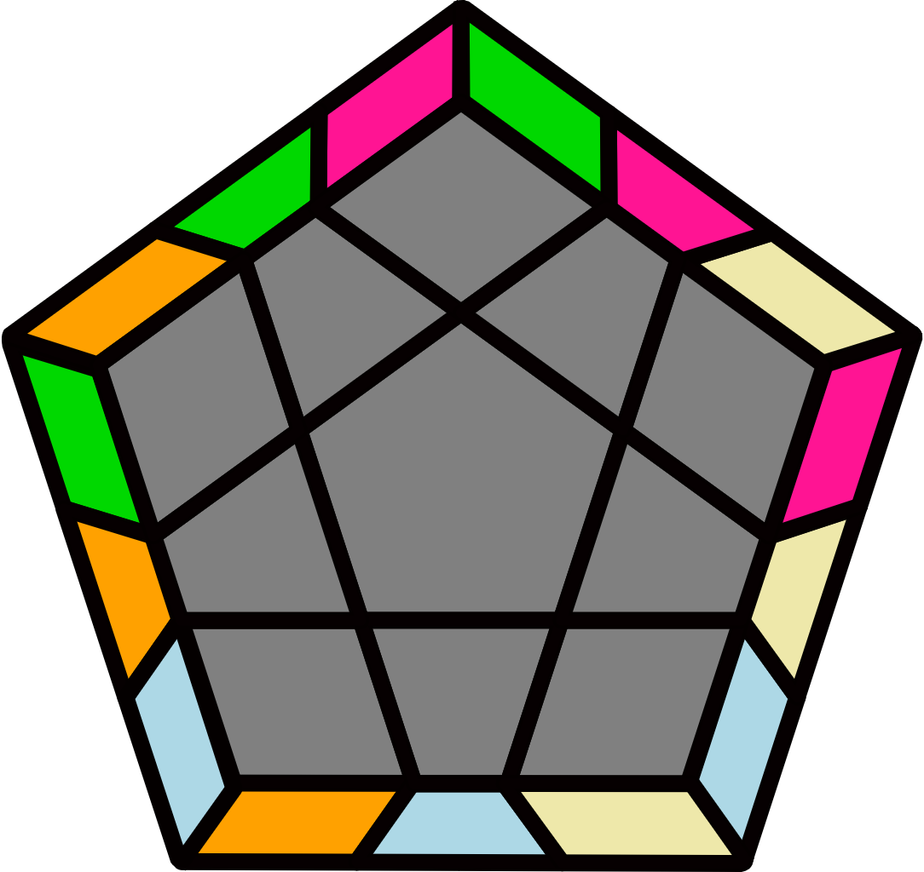 |  |  |  |  | 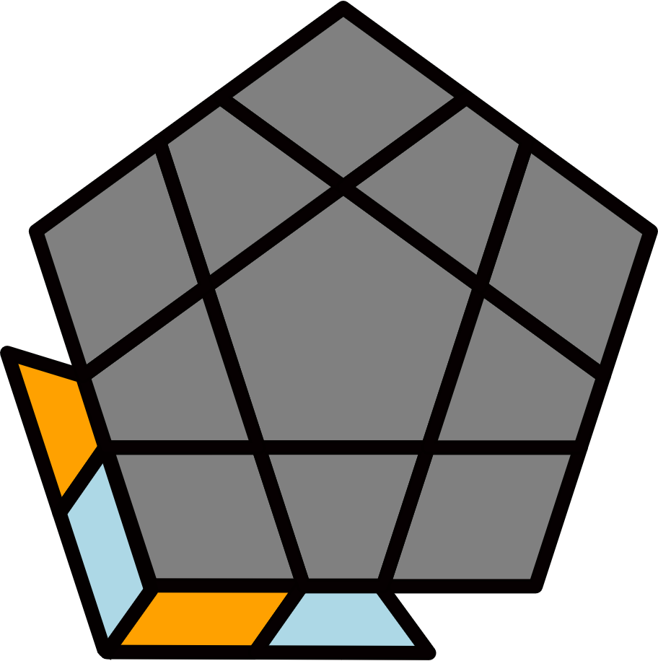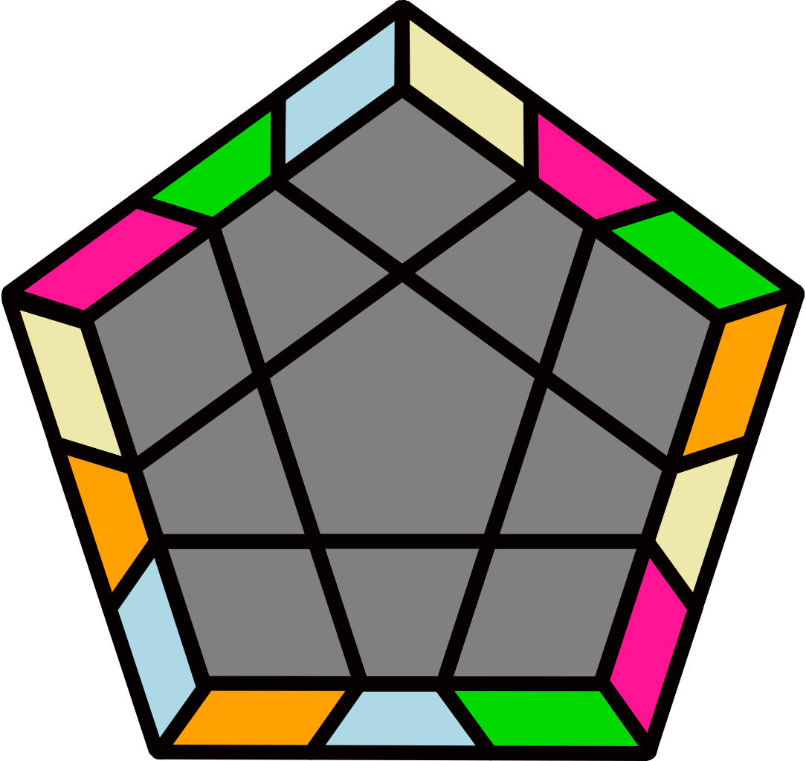
Others [10] |  |  |  |  |  |  | F U2 (R U2' R' U) (R U R' U2') F' (R' U' R U2') R' U2' R |  |  |  |  | F (R U R' F) U R' U' F' U (R2 U2' R' F')
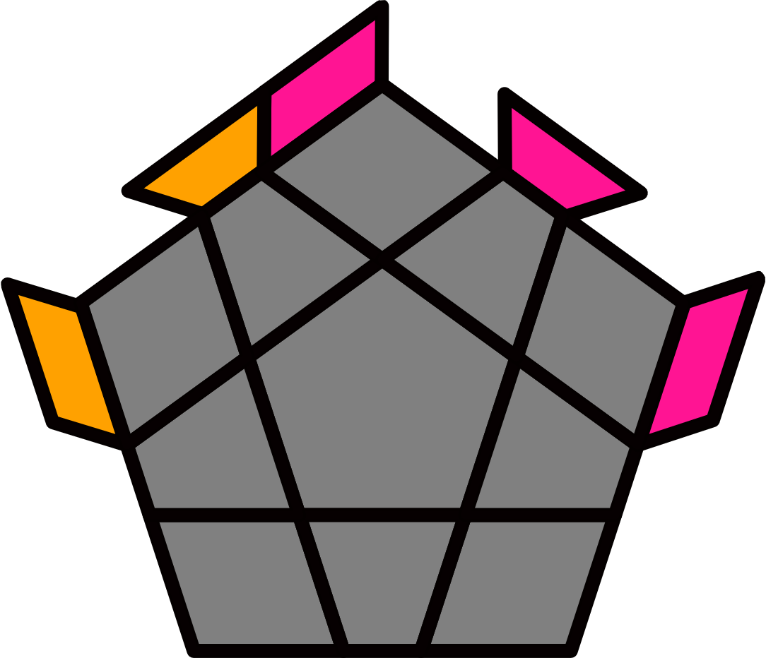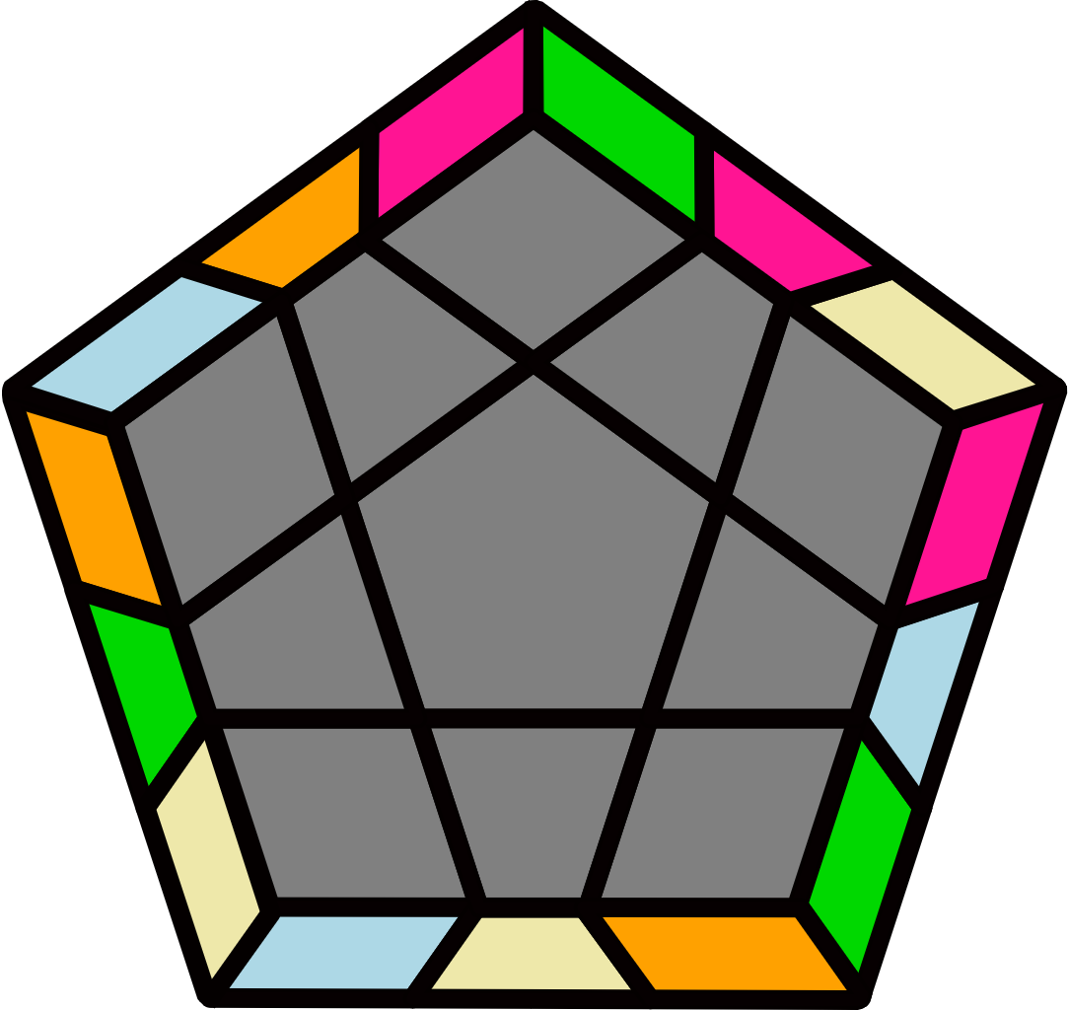 |  | 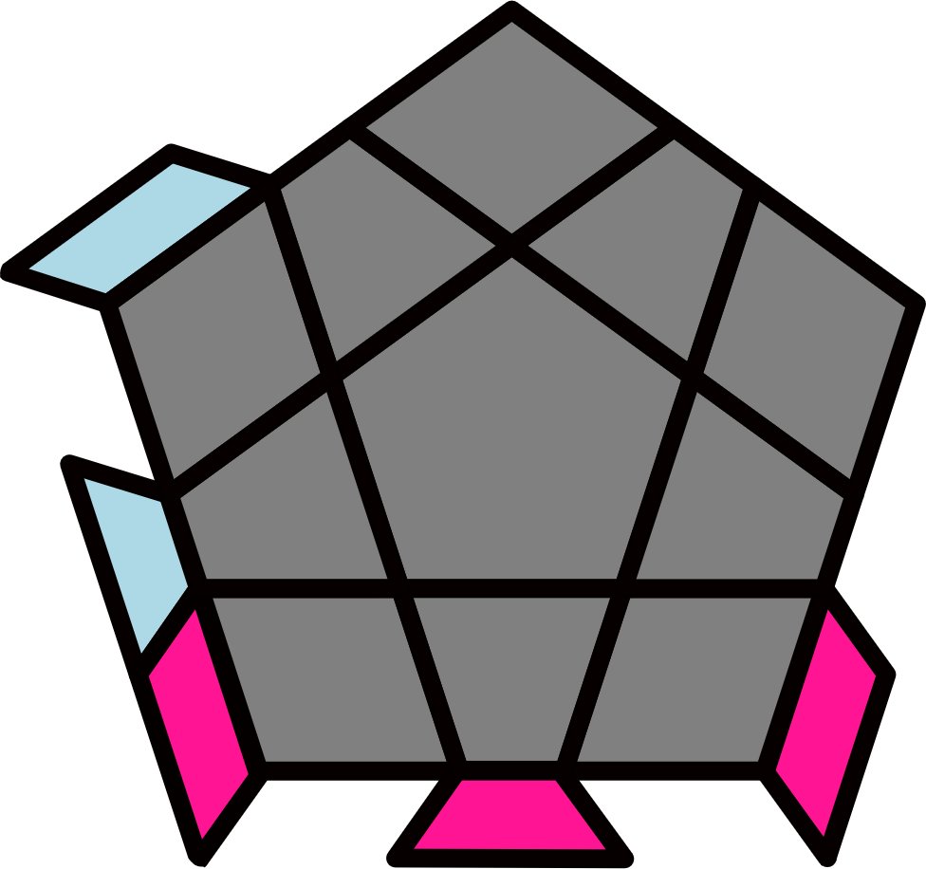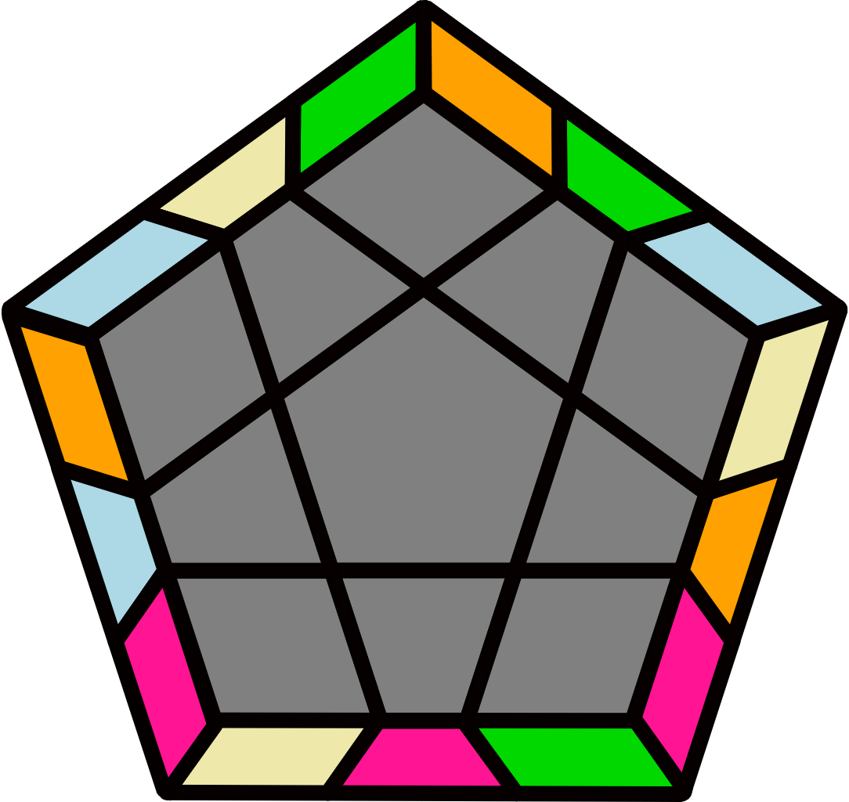 |  |  |  |  | 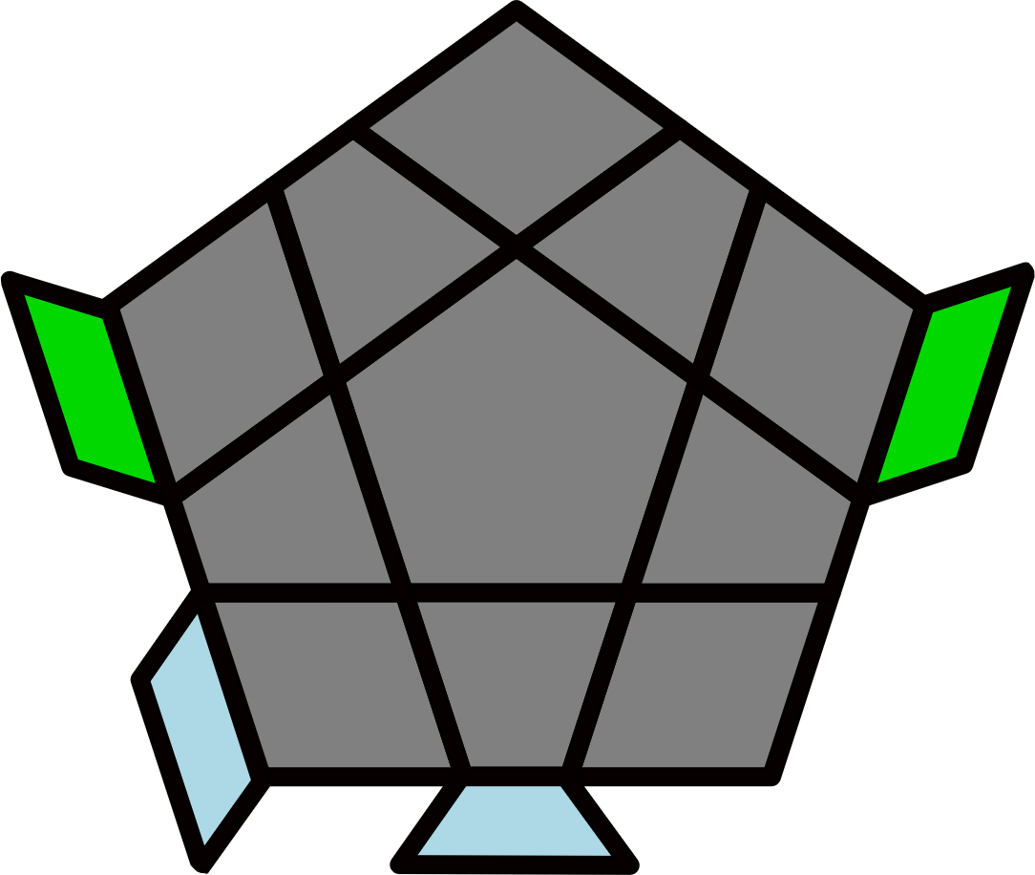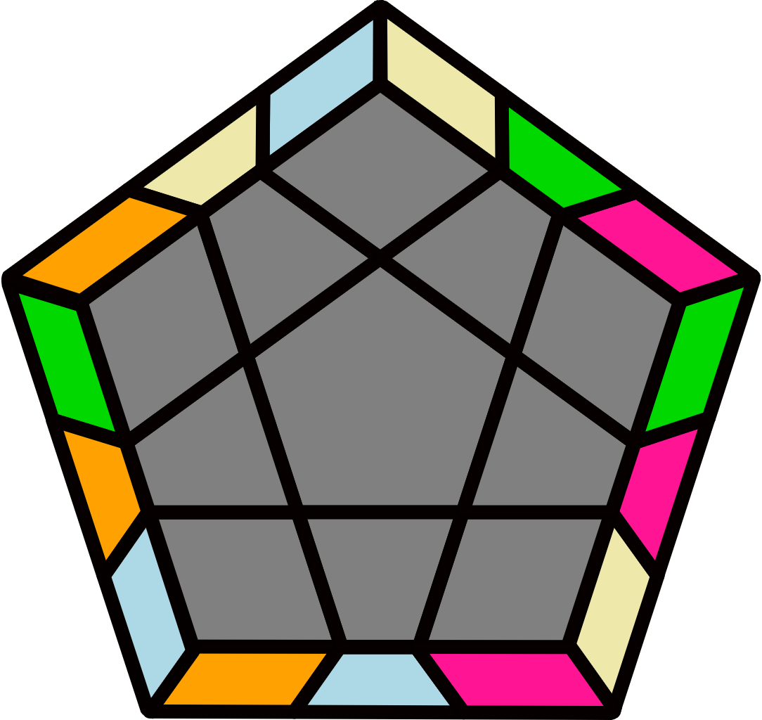 |  |  |  |  | 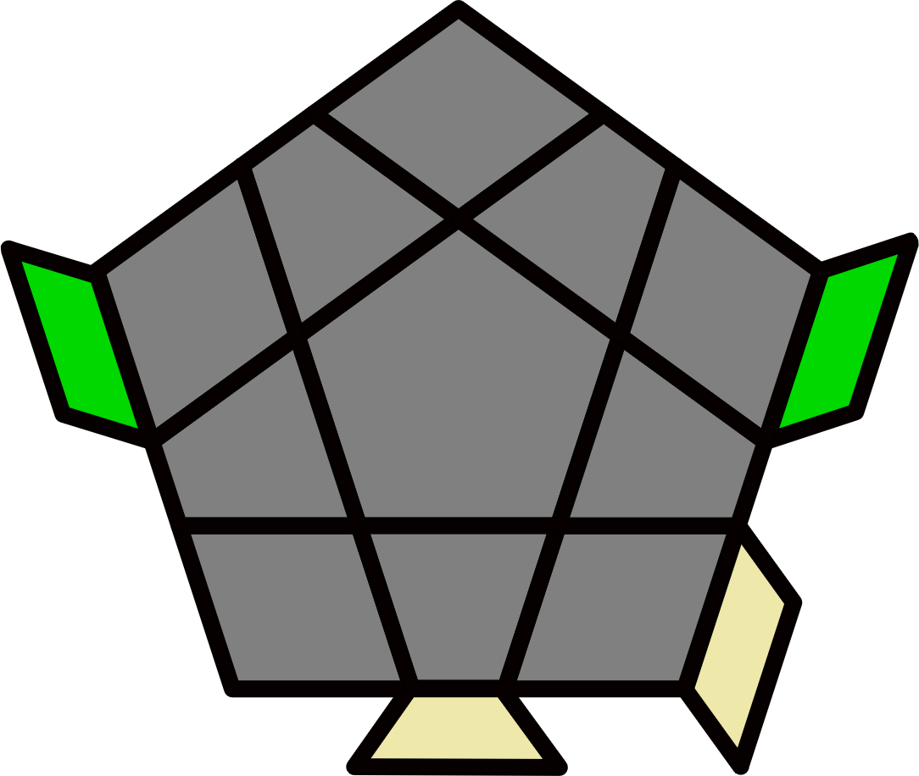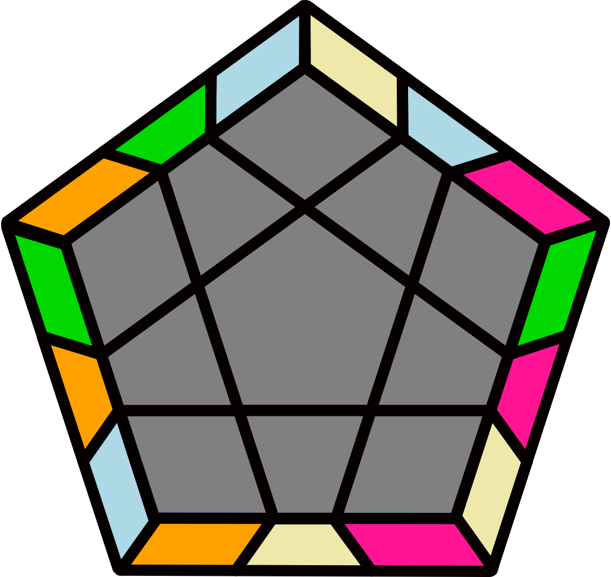
(R' U2 R' U') (R2 U' R' U') (R U R' U) (R' U R2 U')  R' U2' R |  | (R U2' R U) (R2' U R U)  (R' U' R U') (R U' R2' U)  R U2 R' |  |  |  |  | (R' U R U2) (R' U2 R U) (R2' U' R U') (R' U' R U2)  R' U R2 |  |  |  |  | (R2' U' R U2') (R' U R U) (R' U R2 U') (R' U2' R U2') R' U' R
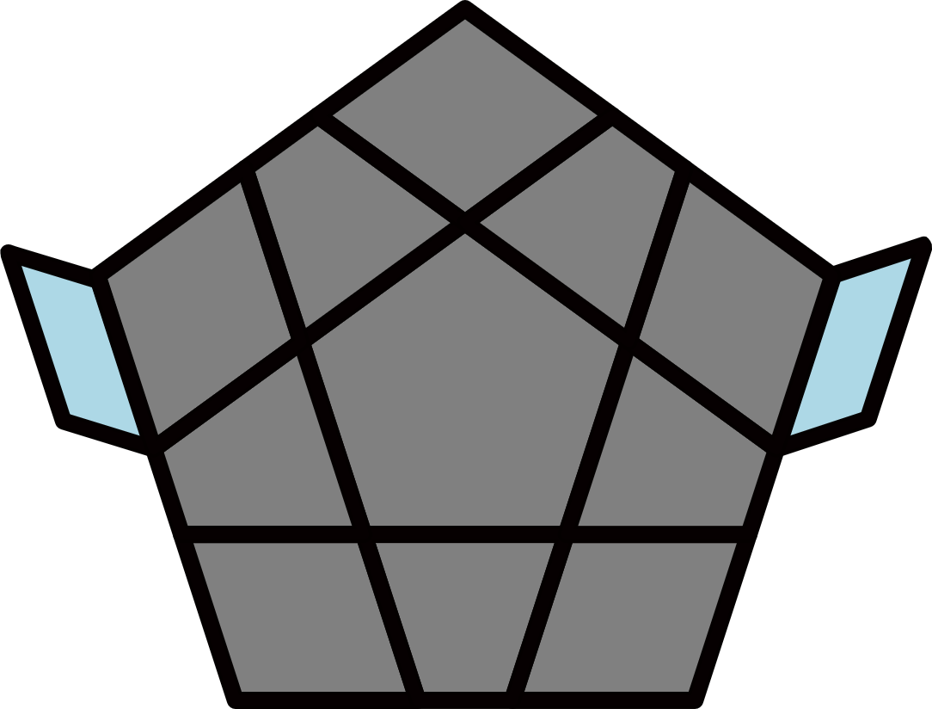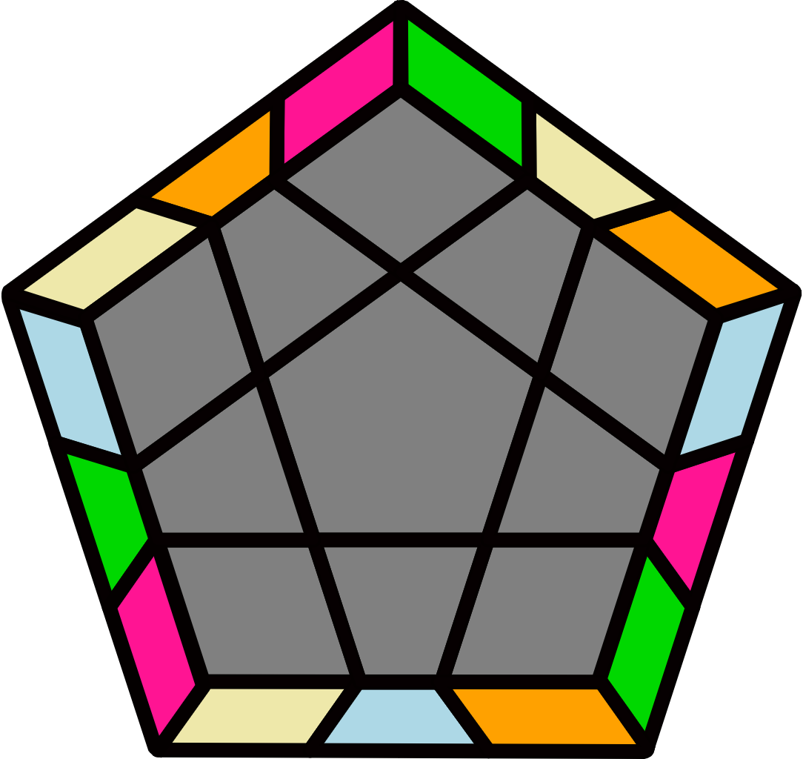 |  | 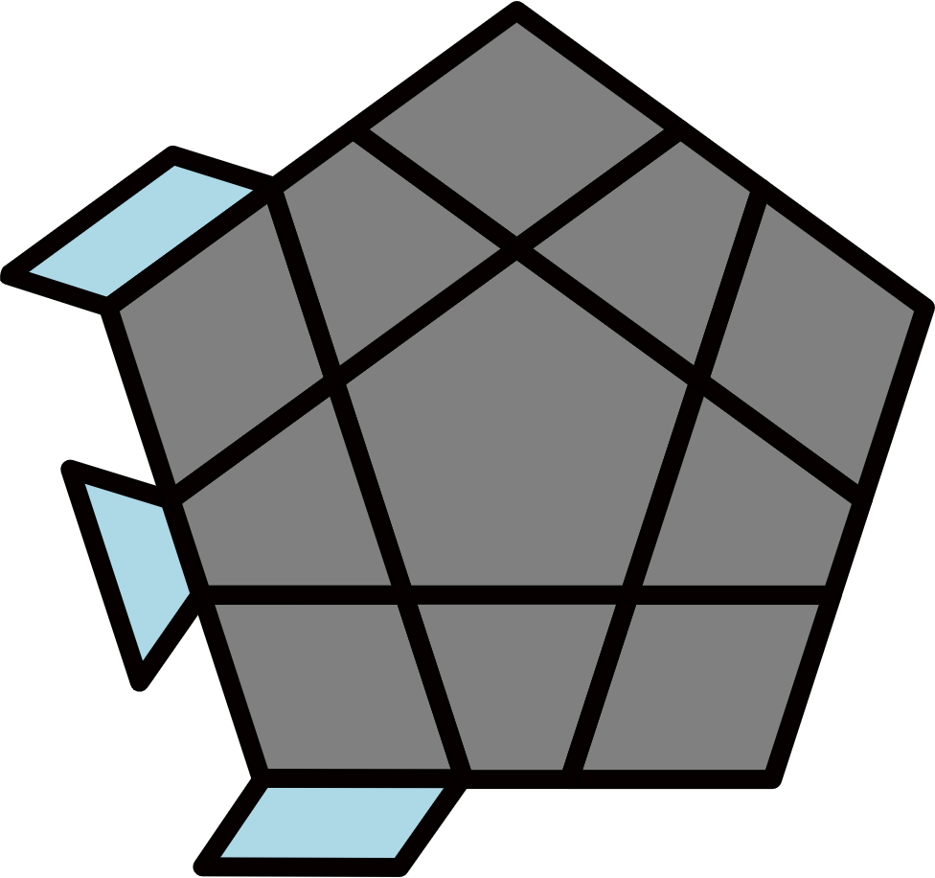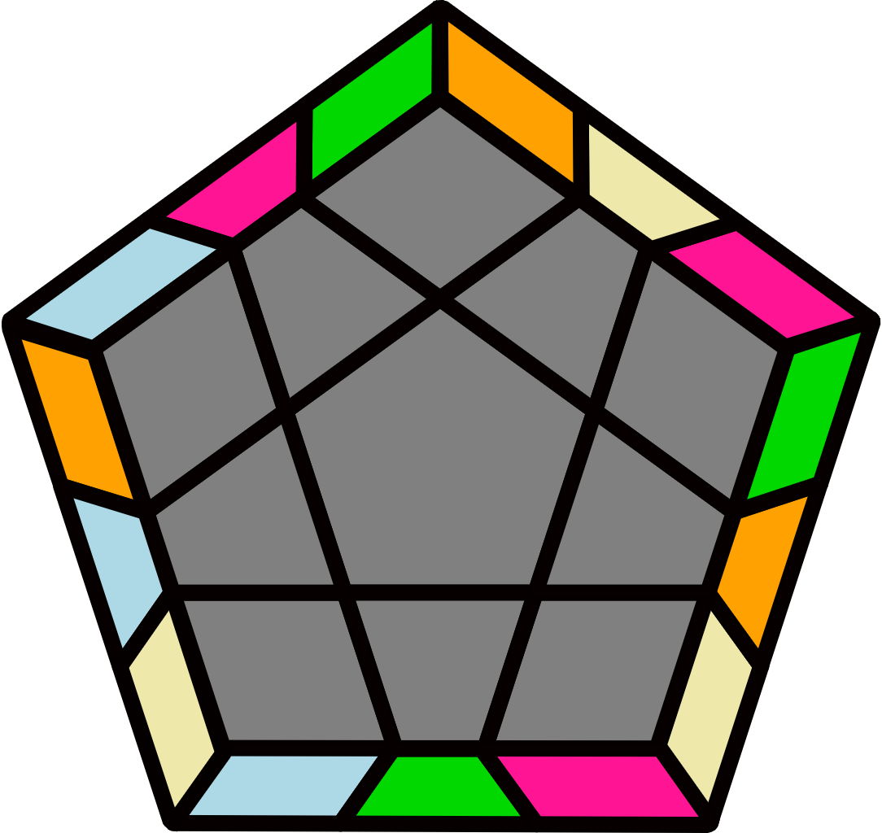 |  |  |  |  | 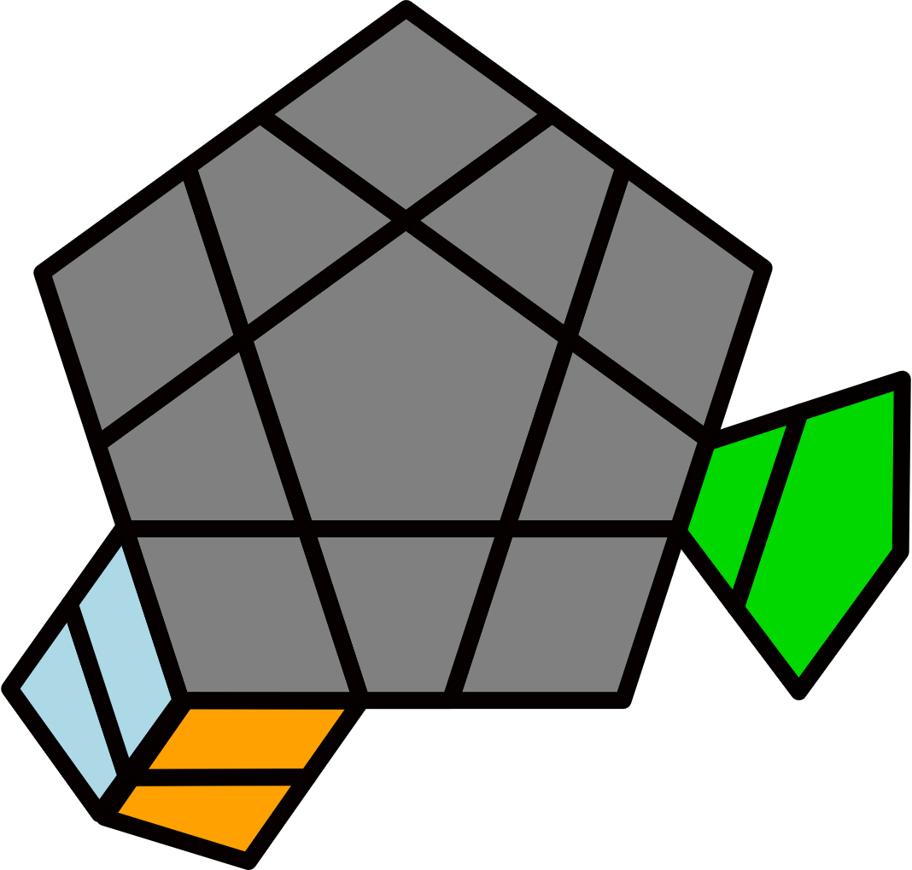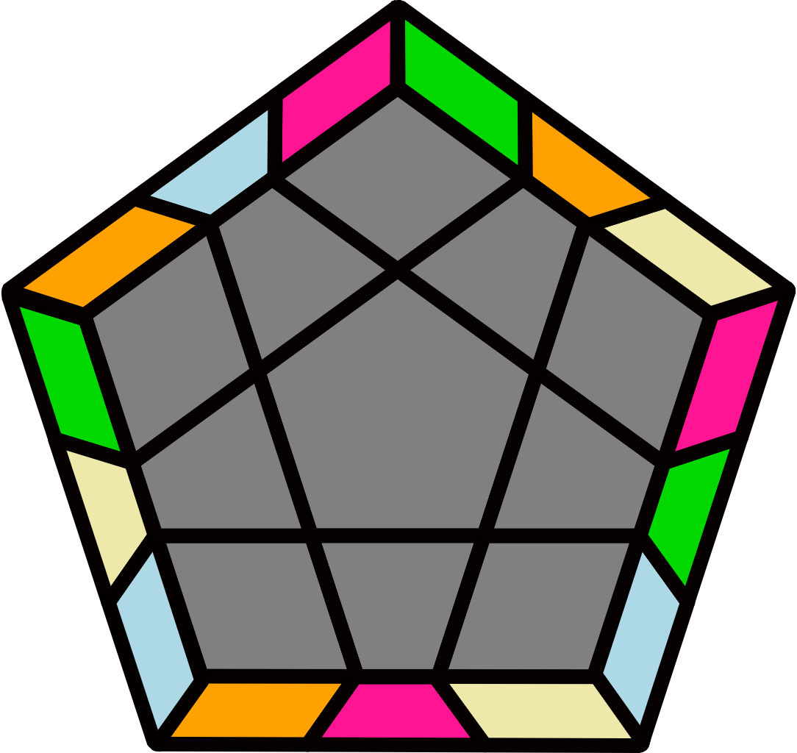 |  |  |  |  | 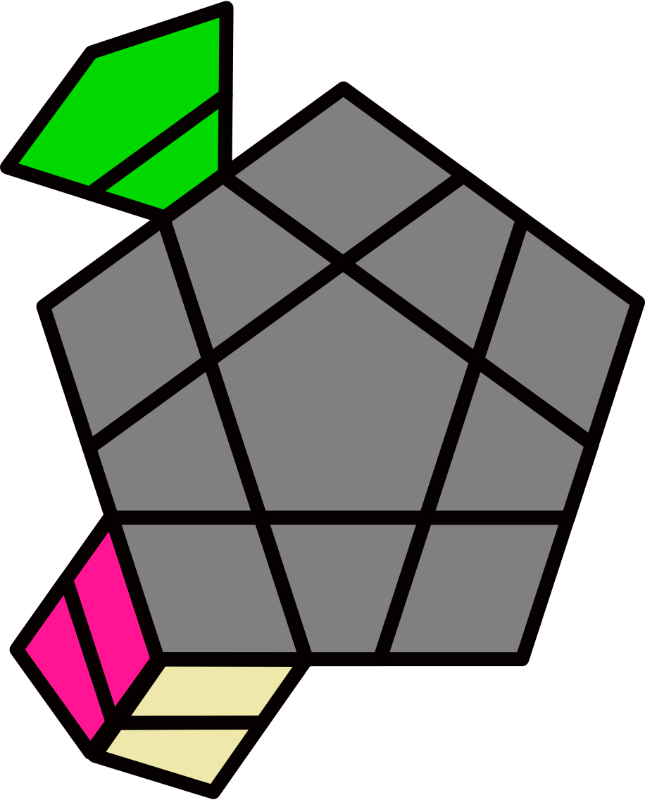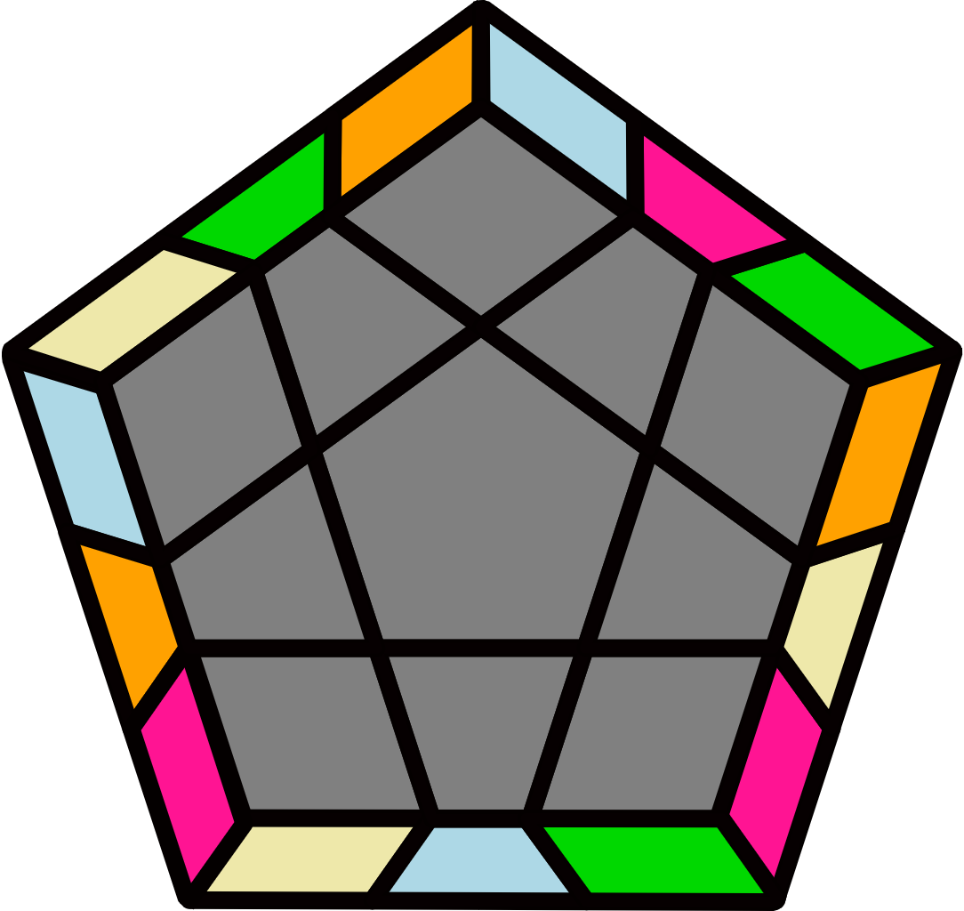
(R' U' R2 U') (R' U R U') (R2' U' R2 U) (R' U' R U) R2' U2 R |  | (R2 U R2' U) (R U2' R' U) (R' U2' R U) (R' U R2 U)  R U' R2' |  |  |  |  | R U R' y (R2' U2' R2 U') (R2' U2 R2 F) (R2' U R2 U2') F' |  |  |  |  | R' U' R y' (R2 U2 R2' U) (R2 U2' R2' B') U B U' R2 U' R2'

