4x4 F3E Algorithms (First Three Edges)

Learn F3E intuitively. The god number of every single F3E is 6. This sheet includes almost all the F3E cases both on upper or front face with at least 3 moves.

Far Diagonal
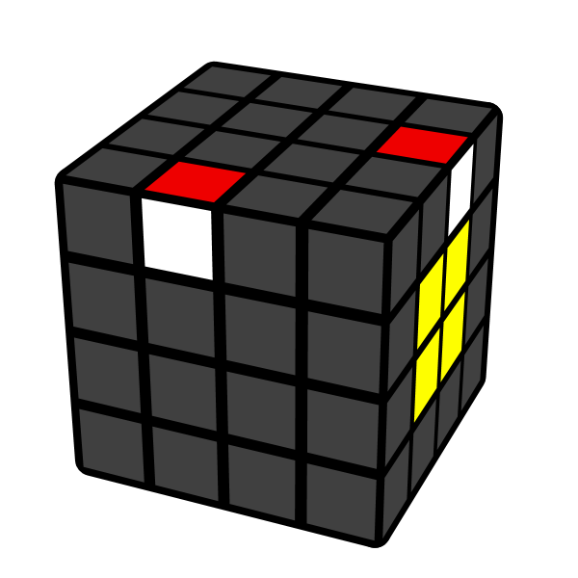 | 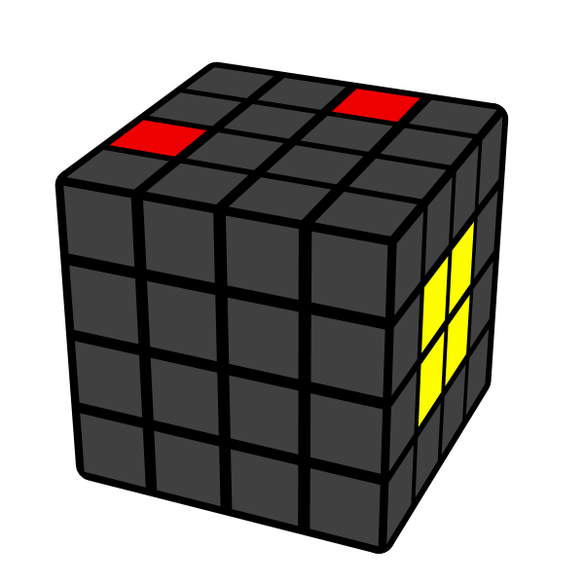 | 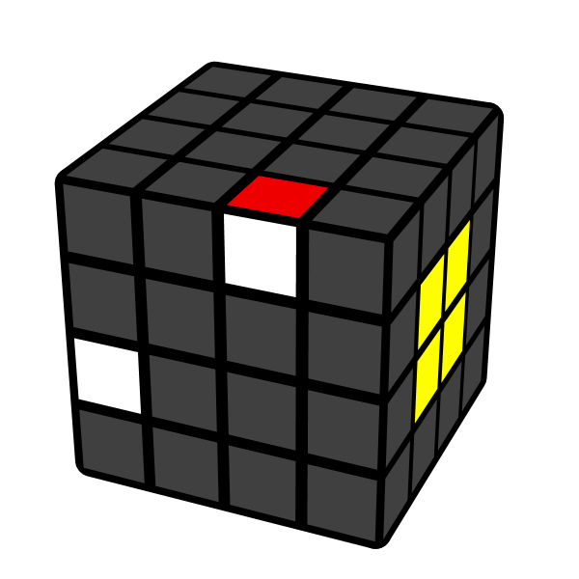 | 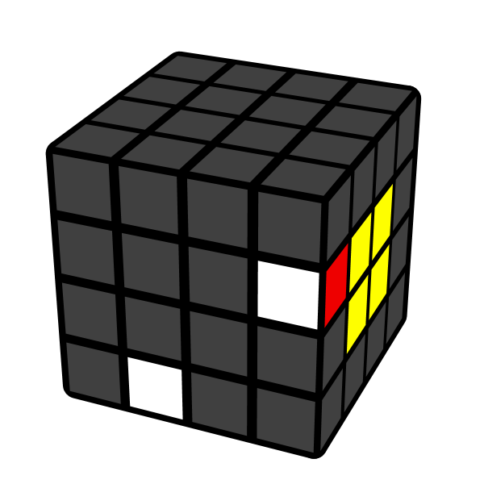
Lw U Lw' | Rw U Rw' | Lw D Lw' | Rw U Rw'
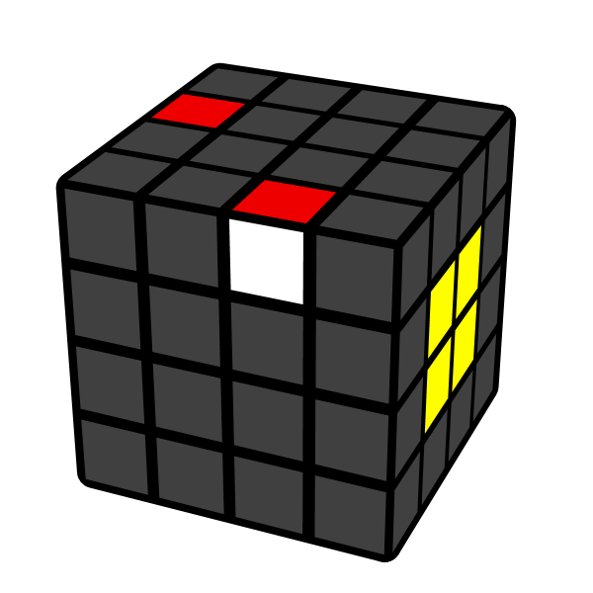 | 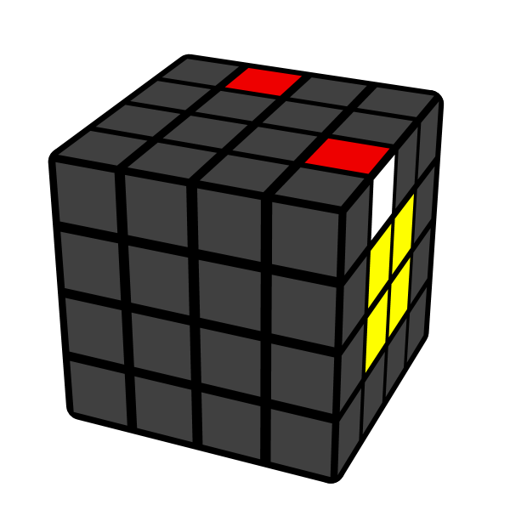 | 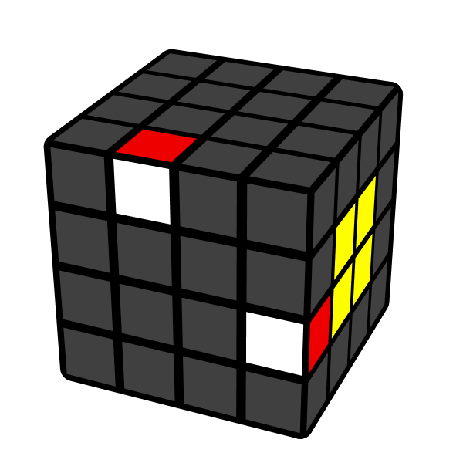 | 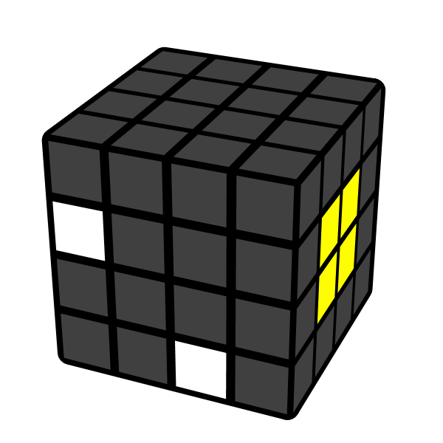
Rw' U' Rw | U' Rw U Rw'  Lw' U' Lw | U Rw U' Rw' | Lw' U' Lw
Near Diagonal
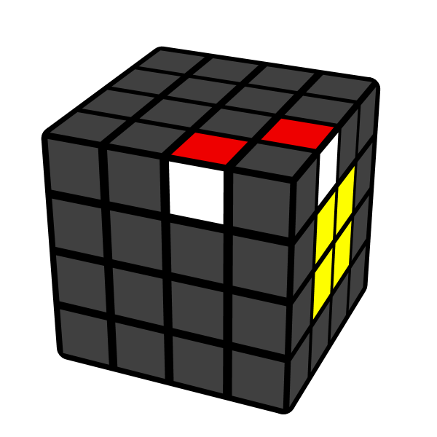 | 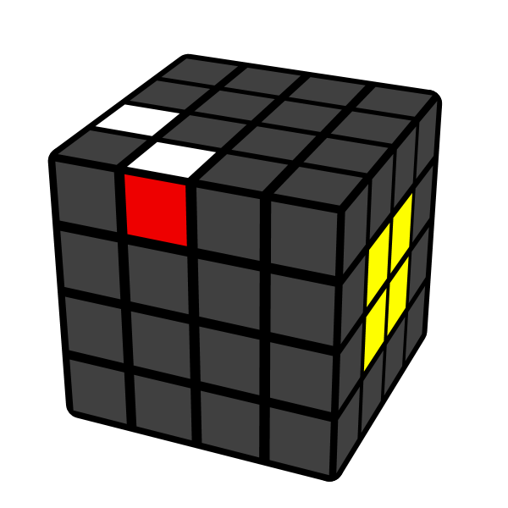 | 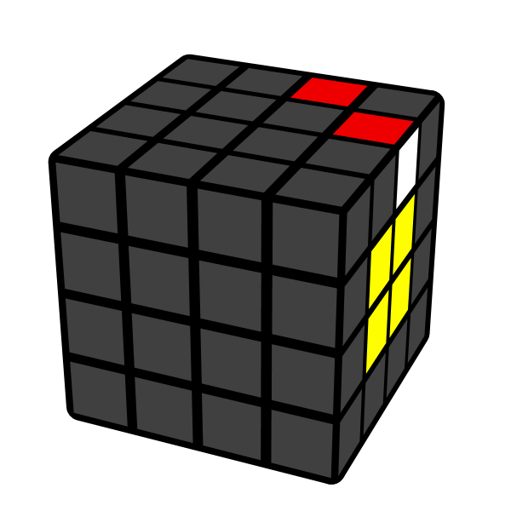 | 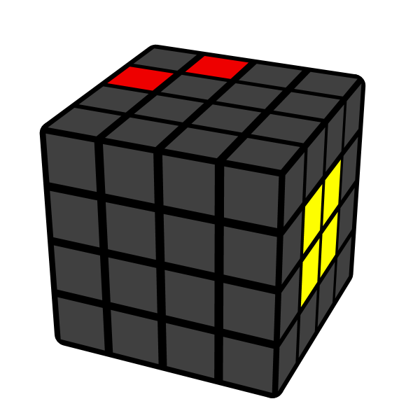
3Lw U Rw | 3Rw' U' Rw' | 3Rw R' U' Rw'  3Lw' U' Rw' | 3Rw U Rw  L F Rw
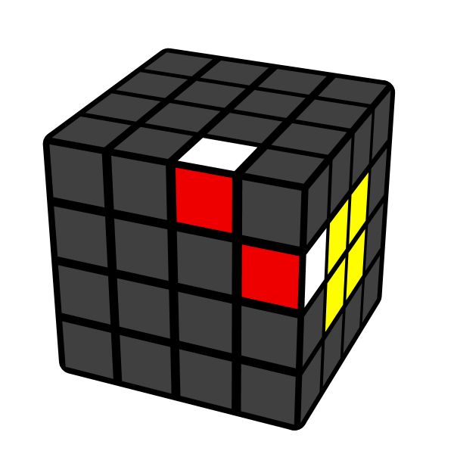 | 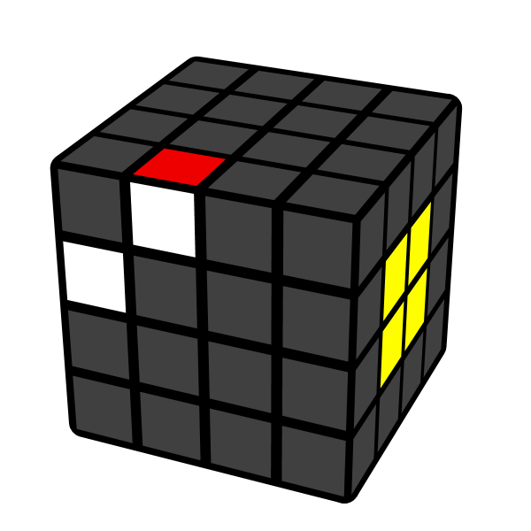 | 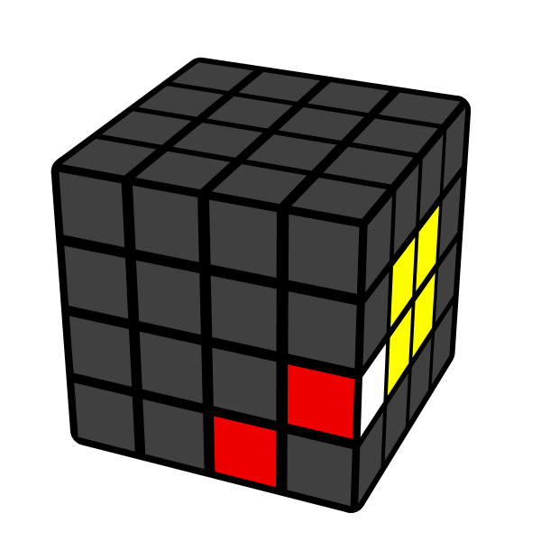 | 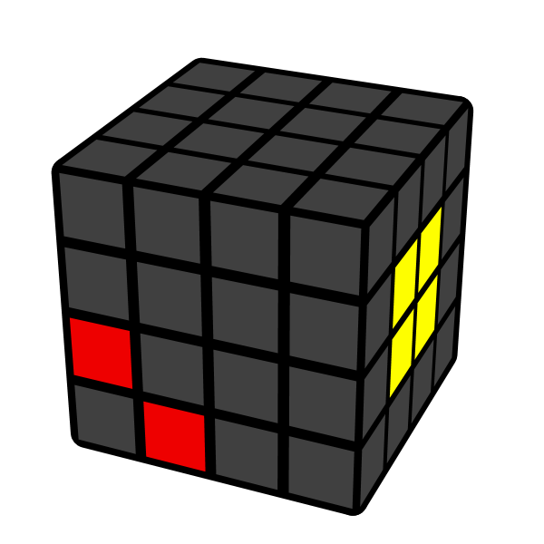
R' D' Rw' | L D Rw | R U Rw | L' U' Lw'
Headlights
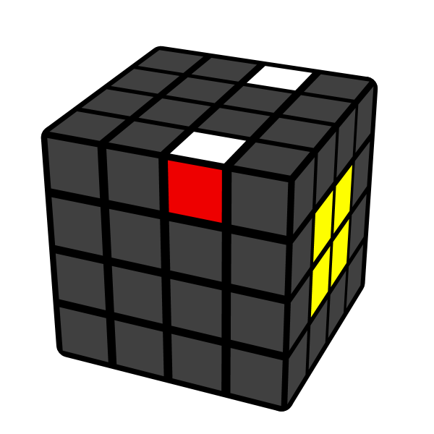 | 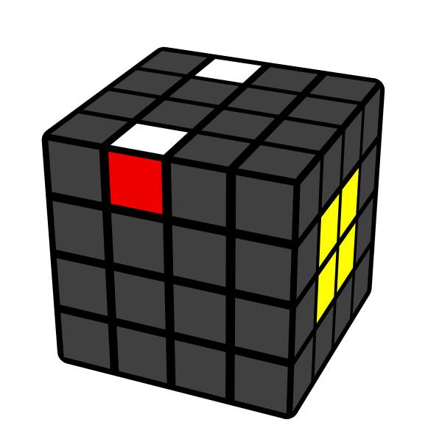 | 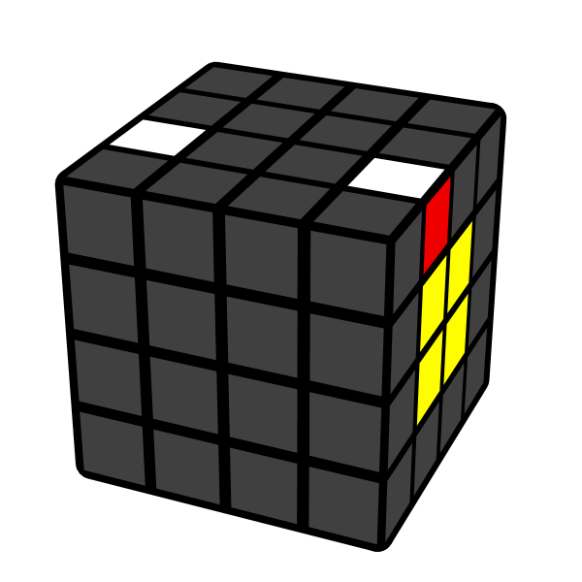 | 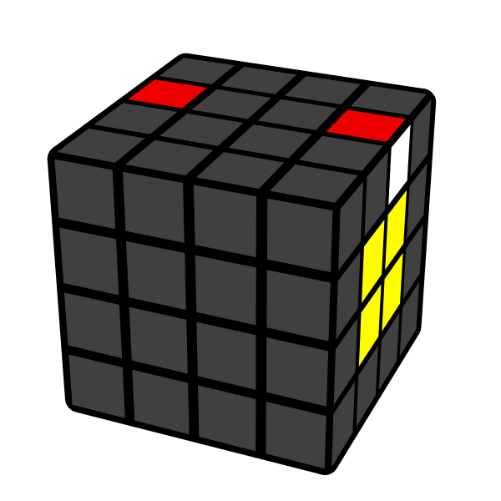
Rw U2' Rw2' | Lw' U2 Lw2 | Rw' F U' Rw' | Rw U' B Rw'
Slash
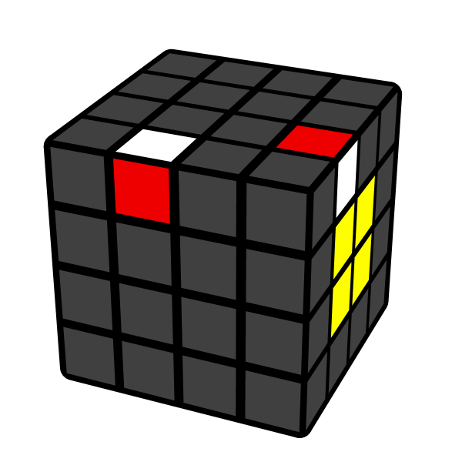 | 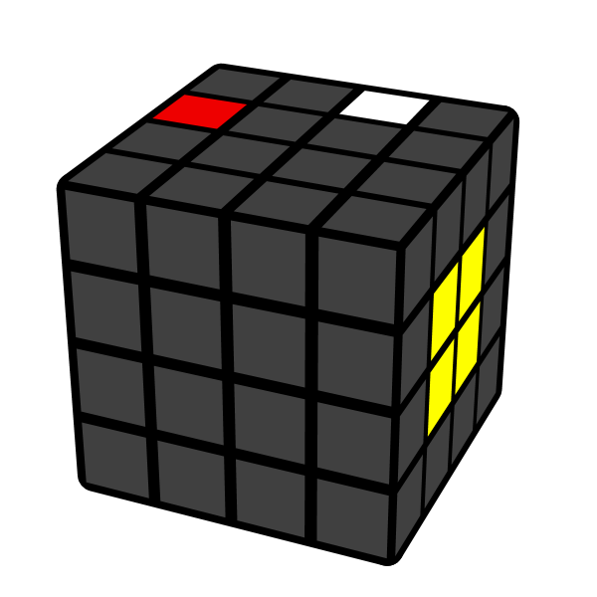 | 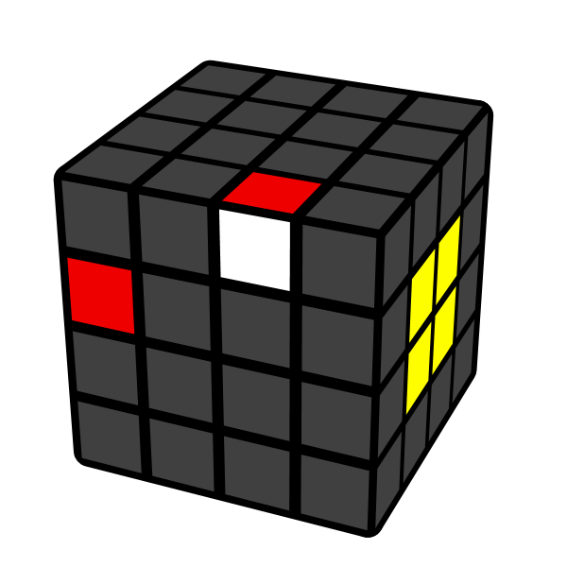 | 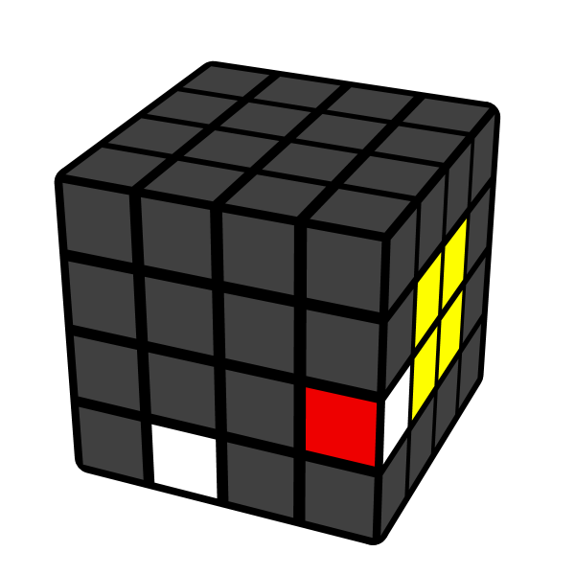
Lw U' Lw2' | Rw U' Rw2' | Lw D' Lw2' | Rw U' Rw2'
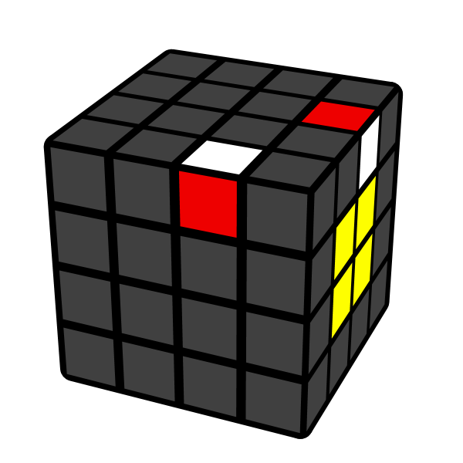 | 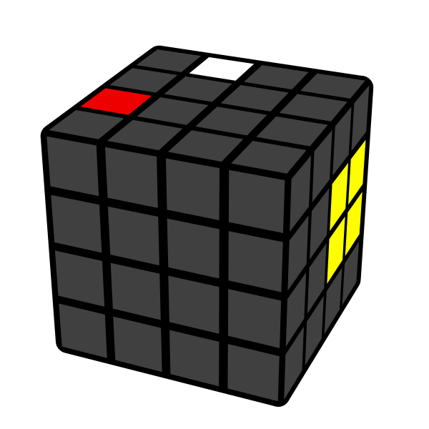 | 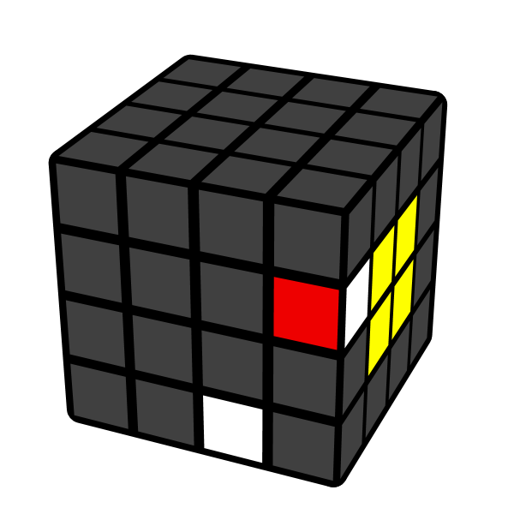 | 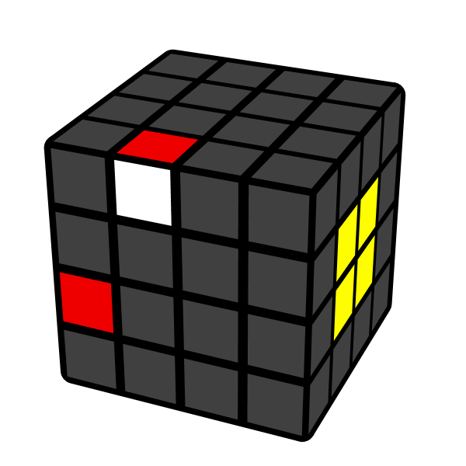
3Lw U' Rw2 | 3Rw U' Rw2 | R U' Rw2 | L D' Rw2
Backslash
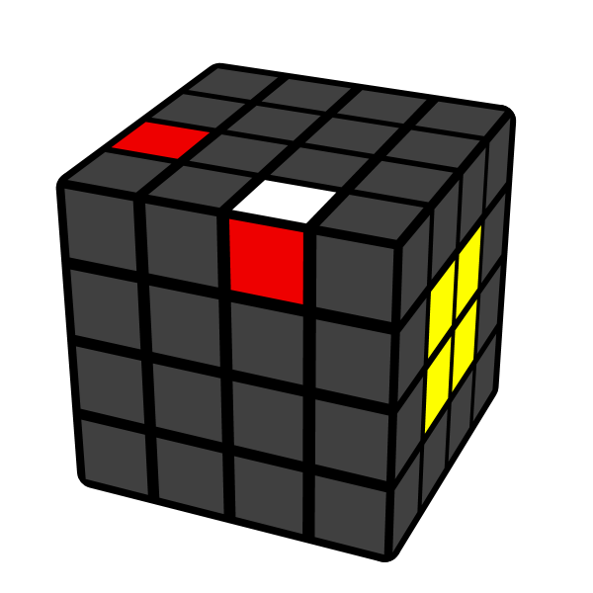 | 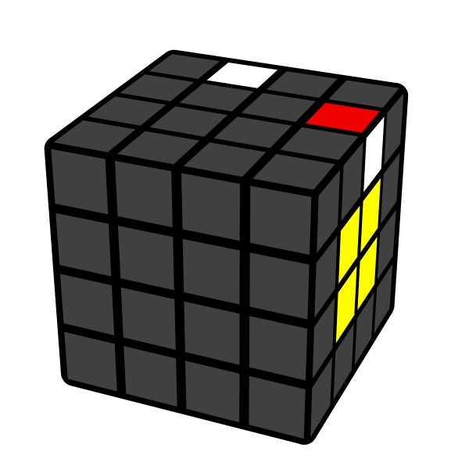 | 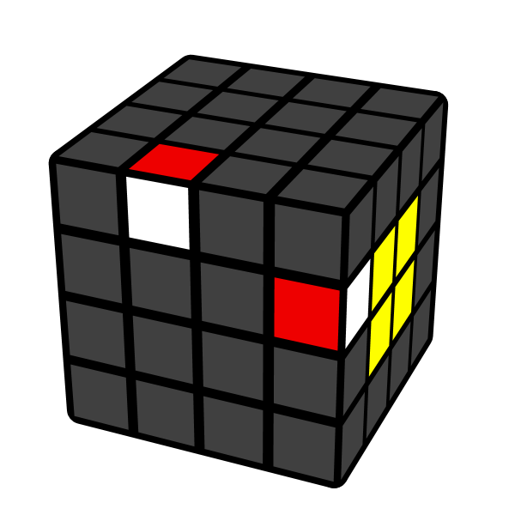 | 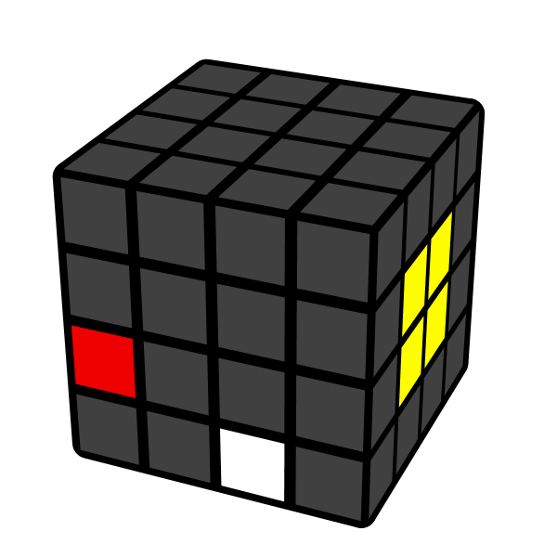
Rw' U Rw2 | Rw U' Rw U Rw  Lw' U Lw2 | Rw' D Rw2 | Lw' U Rw2
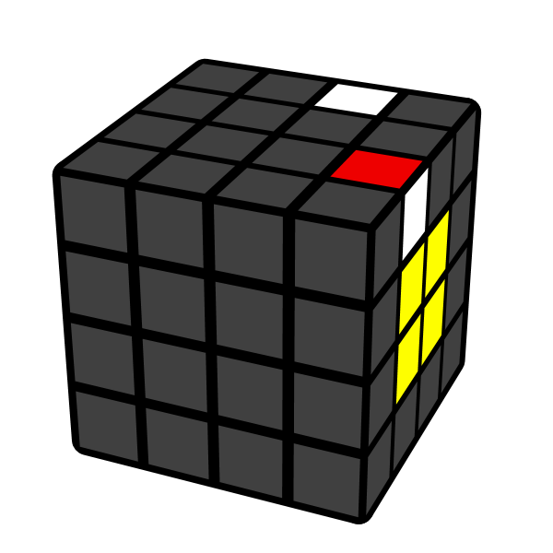 | 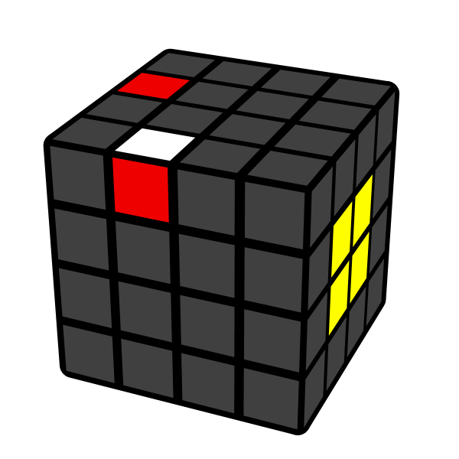 | 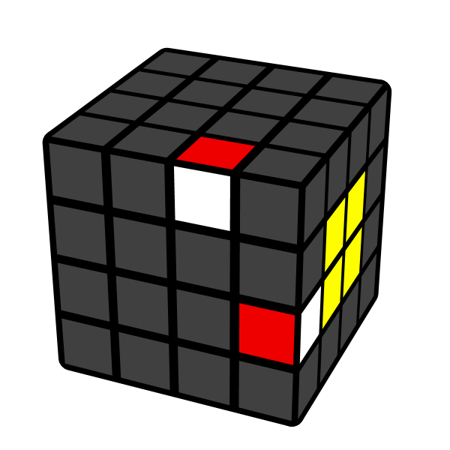 | 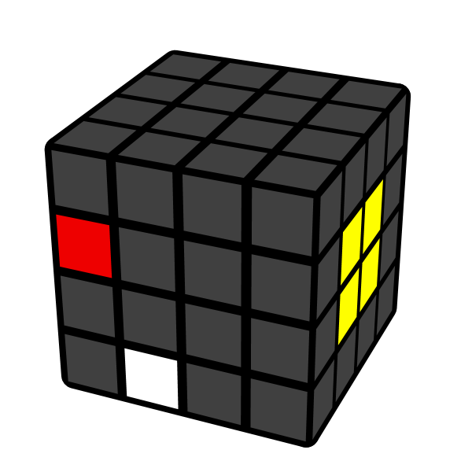
U' Rw2 U' Rw  3Lw' U Rw2 | 3Rw' U Rw2 | R' D Rw2 | L' U Rw2'

