4x4 Half Centers Method

Introduction
This method is pretty useful when at least two half centers (bars) exist.

Make Three Half Centers
After finishing three cross edges for Yau method, make three half centers (different colors),
then put them in the left side on the front, bottom and back faces.
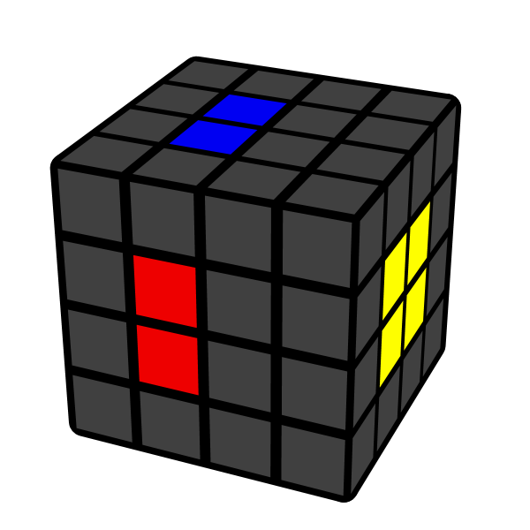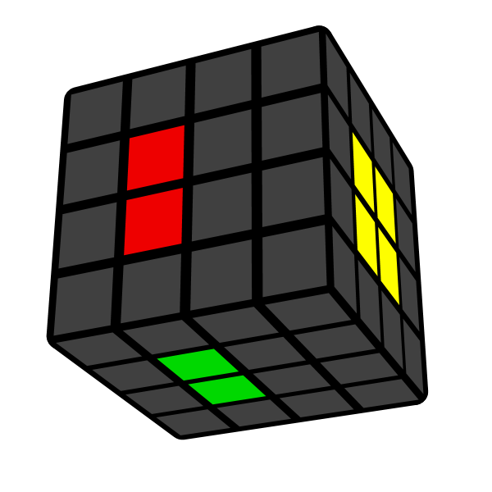

Solve Bottom Center
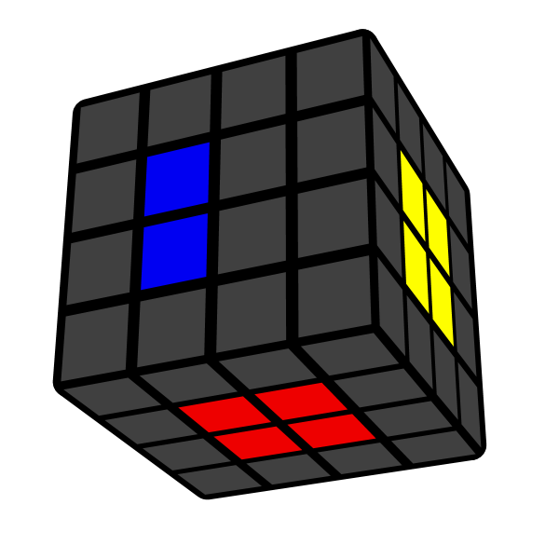

Solve Front Center
From now on, use only Rw and U moves to solve centers. You can also solve back centers first.
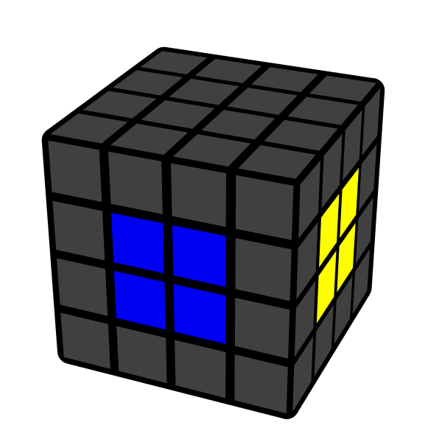

Solve Back Center
After this step, the last centers will be automatically solved.
