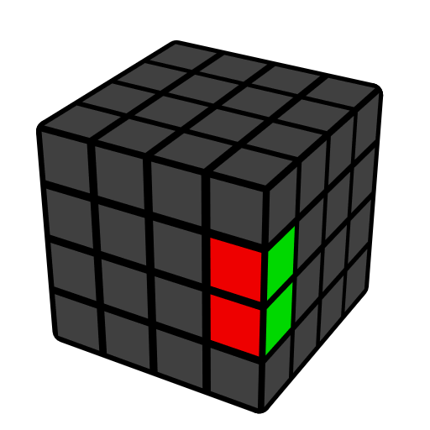
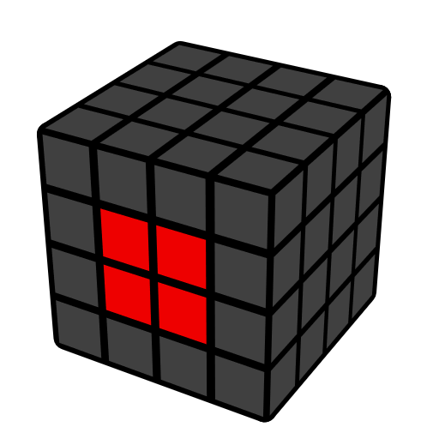
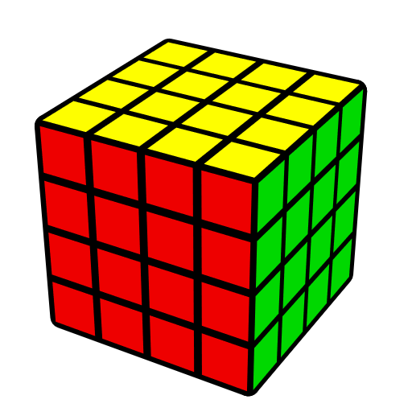
4x4 Redux Method

Notation
R Outer layer | r 2 layers | 2R Inner Slice | 3r 3 layers
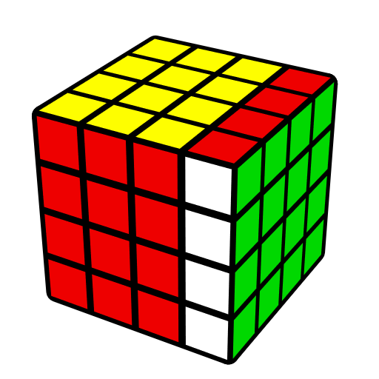 | 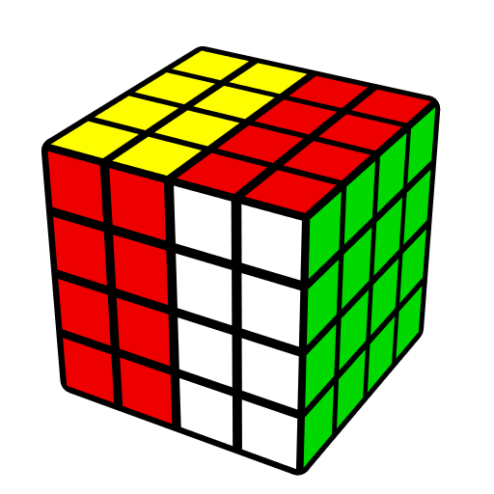 | 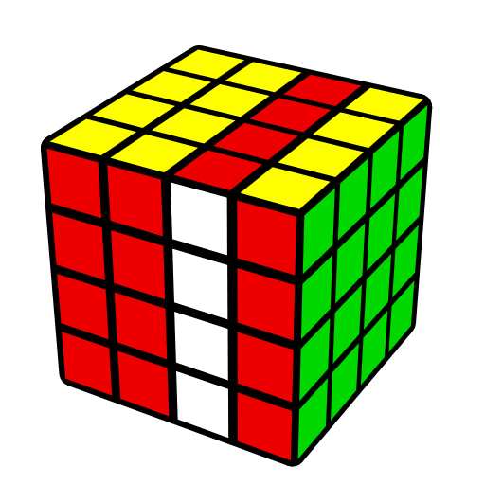 | 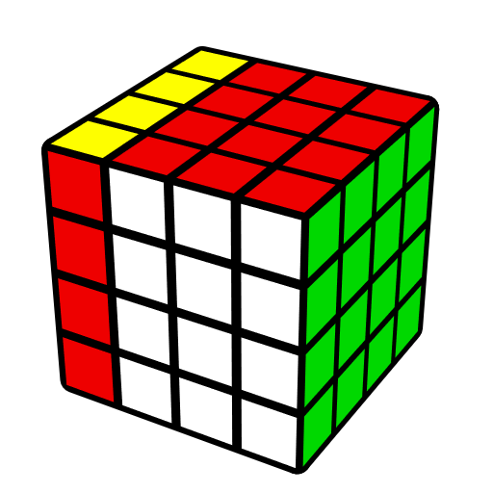

F2C (Two Opposite Center)
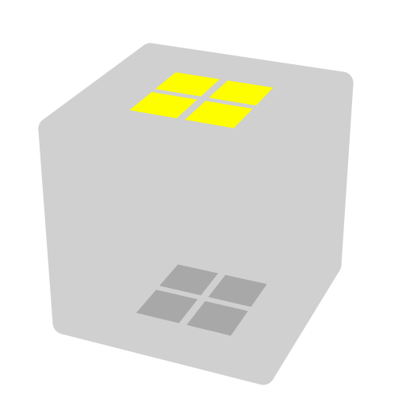

2nd Center
 | 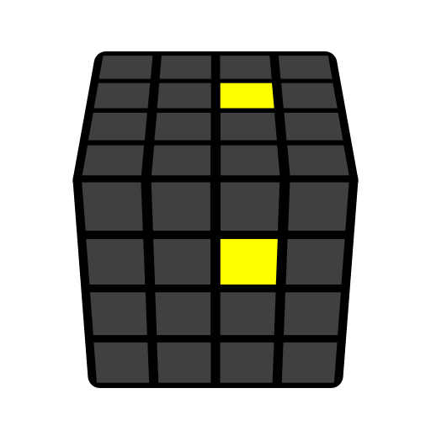 | 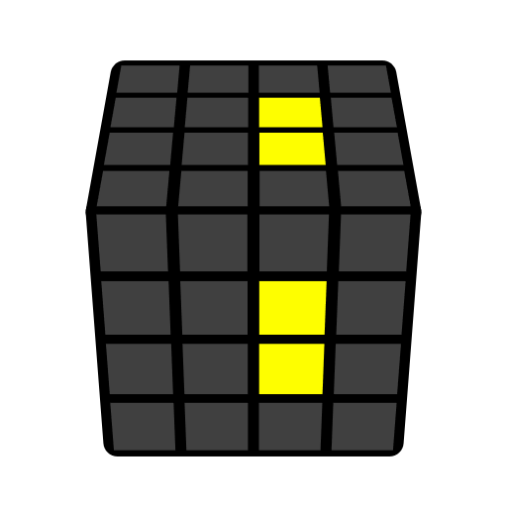
 | r U' r' | r U2' r'

L4C (Last Four Centers)
Do z move to make L4C on M slice. Solve centers into correct relative positions. Solve F center (3rd center), do x', solve current F center (4th center), do x', solve current F center (5th center), then 6th center will be solved automatically. One can also solve U center, then do x. Below is general idea on F center.

Relative Positions
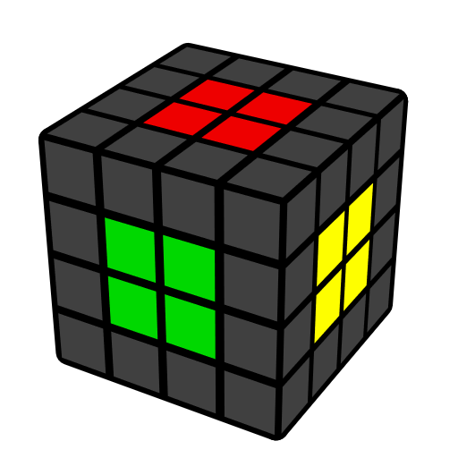 | 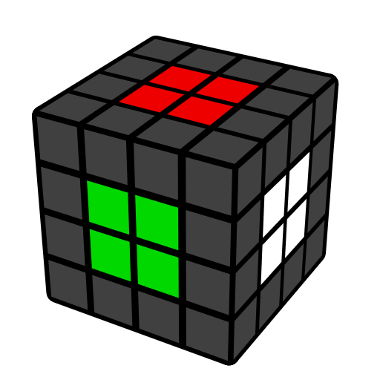 | 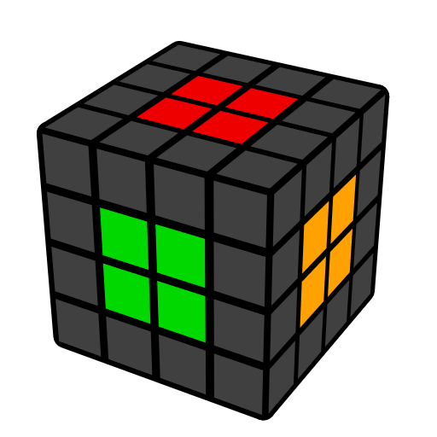
Correct | Wrong | Wrong

F Center
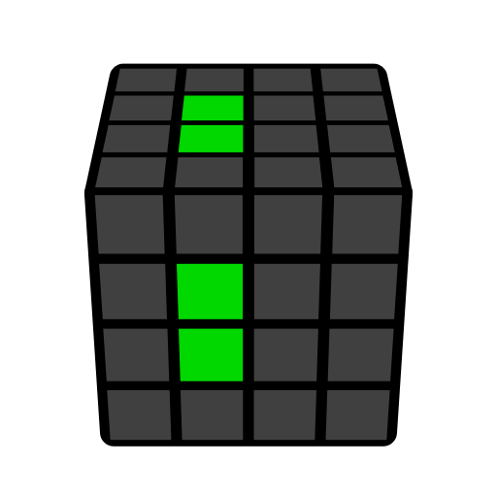 | 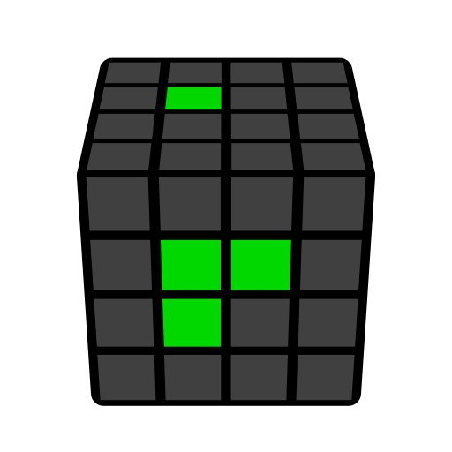 | 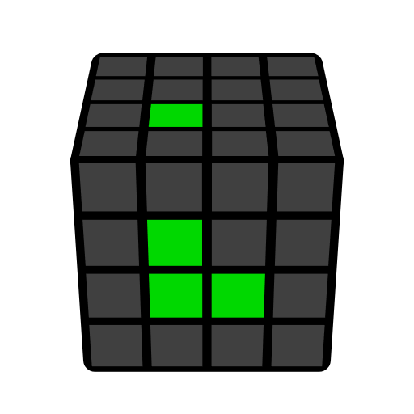 | 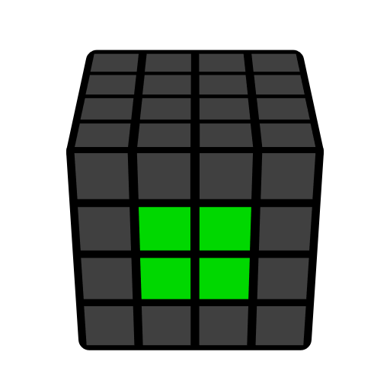
r U2' r' | r U r' | r U' r' | Solved

Edges
Unsolved edge.
F10E (First Ten Edges) |  | L2E (Last Two Edges)
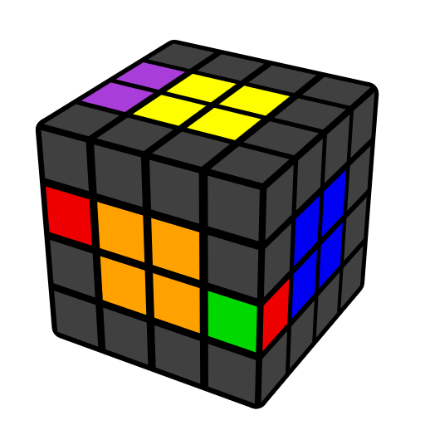 | 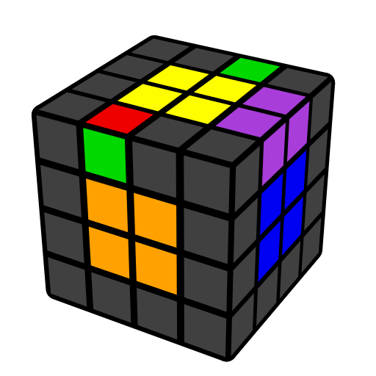 | 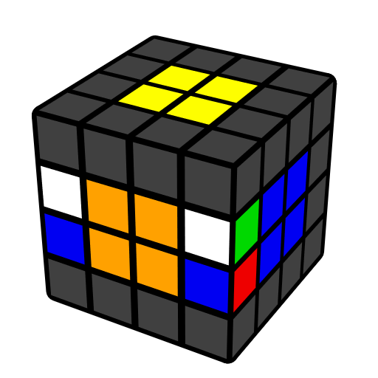 | 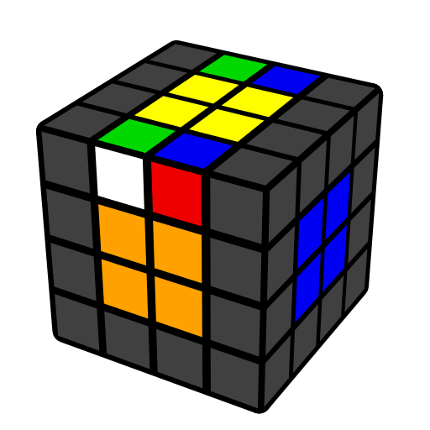
u' (R U' R') u | r' (U' R U) r | u' (R U R' F R' F' R) u | r' (U' R' U R' F R F') r

3x3
Solve the cube as if it were a 3x3.
Redux
 | 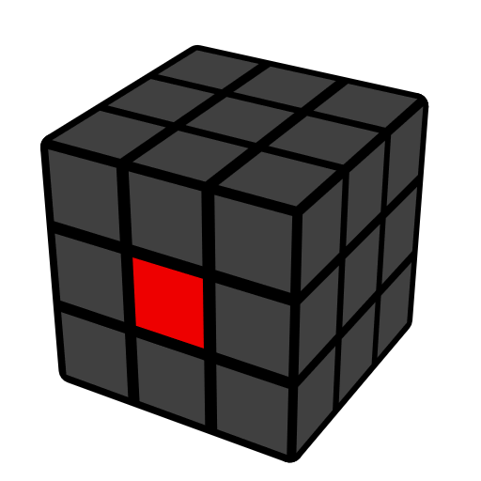 |  | 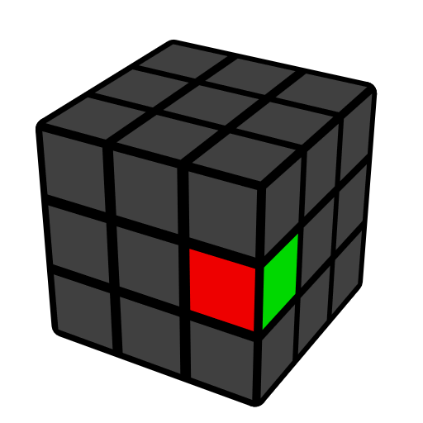 | 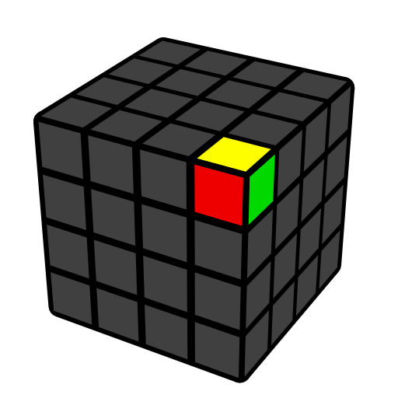 | 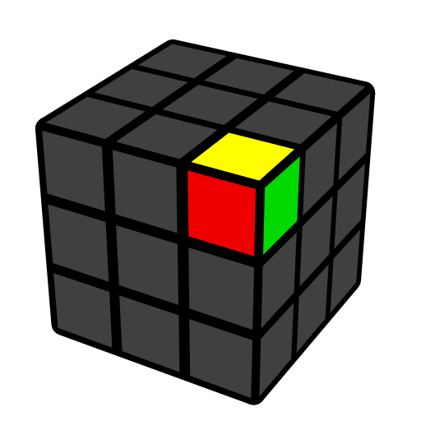

Parity Cases which are Impossible on 3x3
OLL parity  Odd flipped edges | PLL parity  Odd edge pair/corner swaps
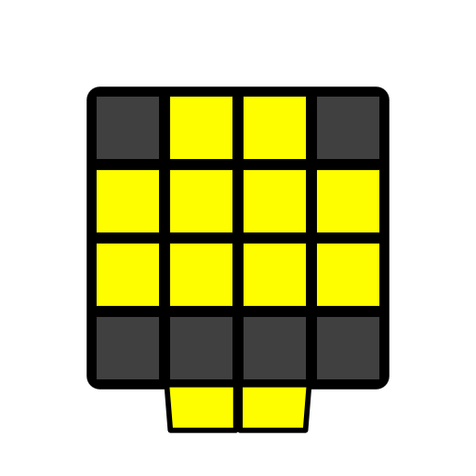 | 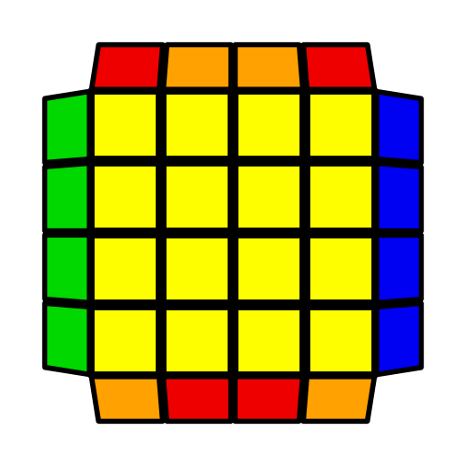
r U2 x r U2 (r U2' r' U2) l U2 (r' U2' r U2) r' U2' r' | r2 R2' U2 2R2 u2 2R2 u2 [U2]

