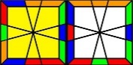

SQ1 PLL and Advanced EP Control
SQ1 PLL和高级控棱序
Shanghong Li 李尚鸿
-3J1J-1 ->x
应先熟练基础控棱, 定义J=[JJ]=/U'/UD/D'/, xy=x, y, n=nx, x为任意整数, 公式后的(n)表AUF. 高级控棱是在CP中插入棱块三循环以此简化EP, 即上下层的CP各拆成一或两个[JJ]并插入预操作, 该方法可控偶置换(PLL)为x, Ua或Ub, 控奇置换(PLL与Ax或Ox的叠加)为Ax或Ox, 本表仅给出偶置换的上层控棱, 下层可镜像处理, 奇置换复杂, 不做列举,
PLL
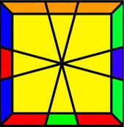U- | 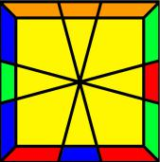U+ | 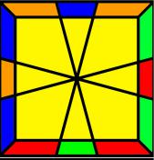Z | 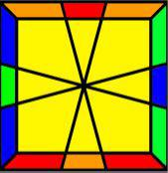H | 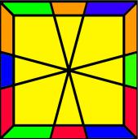E | 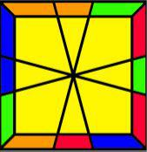Aa | 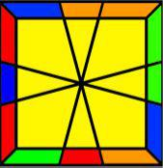Ab
1J-1J ->x | J1J-1 ->x | J1J-1 or 5 ->U- | 1J-1J(3) ->U-  N1N-1 ->x  1N-1N ->x | J-5J(2) ->U+ | 1J2J(-3) ->x | J-2J(2) ->x
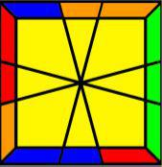Ja | 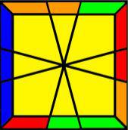Jb | 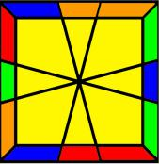T | 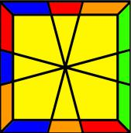F | 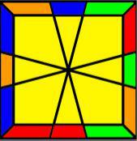Ra | 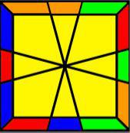Rb | 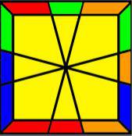V
1J3J(5) ->x  -2J(2) ->x | J-3J(6) ->x  3J(-3) ->x | J4J(5) ->x | J3J(3) ->U-  -3J ->U- | 1J-4J ->U-  4J(2) ->U+ | 1J-4J(6) ->U+  3J(-3) ->U- | J6J ->U-
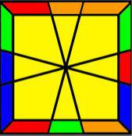Y | 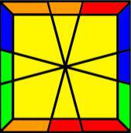Na | 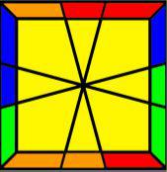Nb | 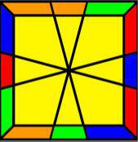Ga | 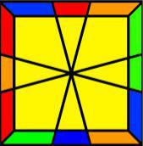Gb | 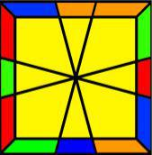Gc | 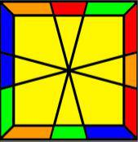Gd
J-5J(-4) ->x | J6J(3) ->x | 1J6J(2) ->x | J3J(-3) ->U+  -3J(6) ->U+ | J-3J ->U-  3J(3) ->U- | J-2J(2) ->U+  4J(5) ->U- | 1J2J ->U-  -2J(-4) ->U+

Examples 实例
高级控棱主要应用于上下层皆为偶置换, 可以通过该方法跳EP, 对多数“奇+偶”或“奇+奇”情况, 用基础控棱方法即可达到简化EP目的, 只有个别情况下需要用到控棱. 统一两个公式指将一公式中的x用另一公式中对应位置的数字代替, 其余不变.

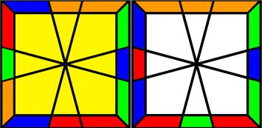 | 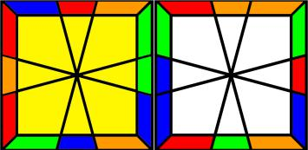
打乱 -50 J -4-1 J 01  U层 T = 00 J 4x J 5x ->x  D层 U- = x-1 J x1 J 00 ->x  控棱 T with U- = 0-1 J 41 J 50 ->xx  非控 Jx = U'/UD'/U/U'/D/U'/ ->U+U+ | 打乱 -30 J 36 J -30 J 1-1 J 24  U层 Gb = J -3x J 00 ->U-  D层 Y = J x5 J x4 ->x  控棱 Gb with Y = J-35 J 04 ->U-x  非控 JN = /D'/D/D'/D/ ->U-U-
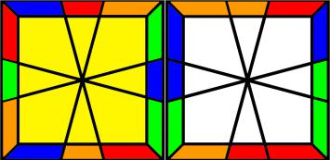 | 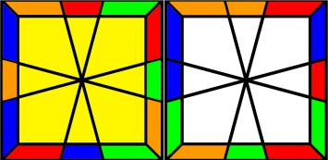
打乱 -53 J -46 J 13/-1-1/60/11/5-3  U层 T (with Opp of FB) = J 4x J 5x ->x+O=O  D层 Na (with Opp of LR) = J x6 J x-3 ->x+O=O  控棱 T with Na = J 46 J 5-3 ->OO  非控 JN = U2/D'/D/D'/D/ ->WO | 打乱 66/-3-3/05/02/04/40/40/20/10/-3-3/-2-3 J 25 J 01  U层 Ab (with Adj of RB) = 00 J -2x J 2x ->x+A=A  D层 V = x-1 J x-5 J x3 ->Ub  控棱 Ab with V = 0-1 J -2-5 J 23 ->AU  非控 JN = /D'/D/D'/D/ ->WU+

